Get the output of multi module project:

Project structure

Add artifact

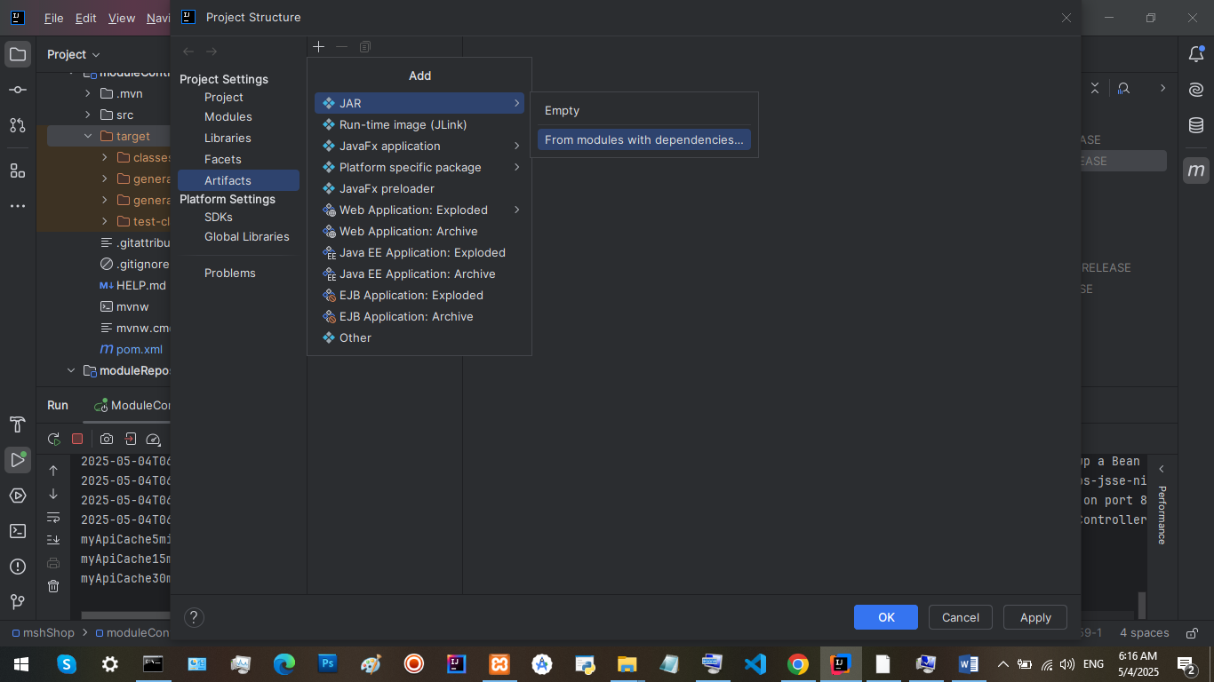

all modules

No change is needed, just click on “OK”

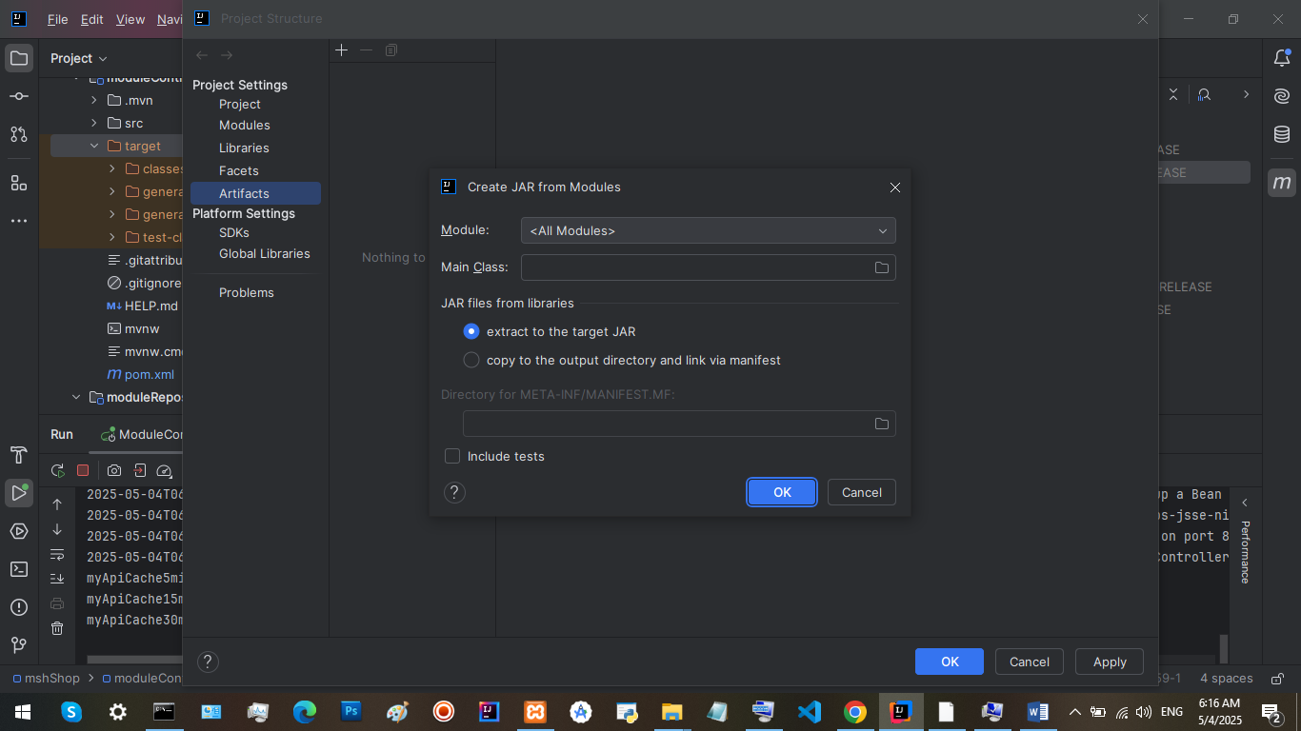

To build module target:

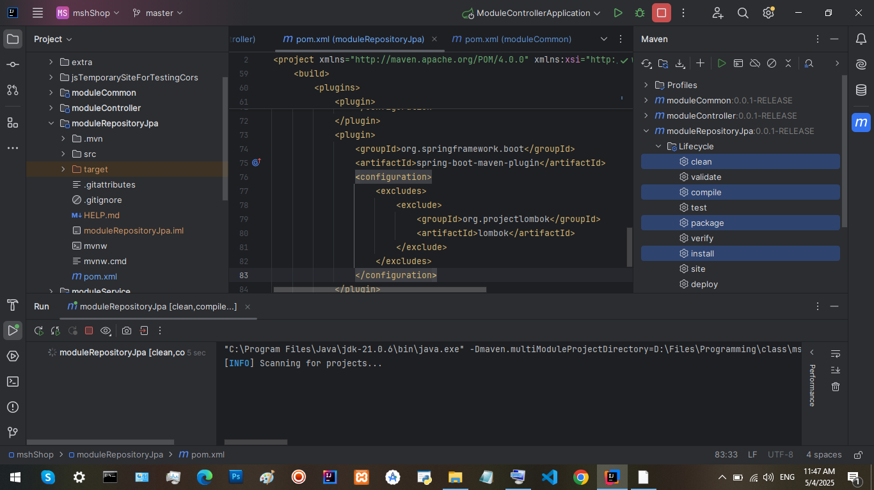

To automate increasing the version number and then generating the jar files of all modules use bat file in: mshShop\extra\automatedDeploy

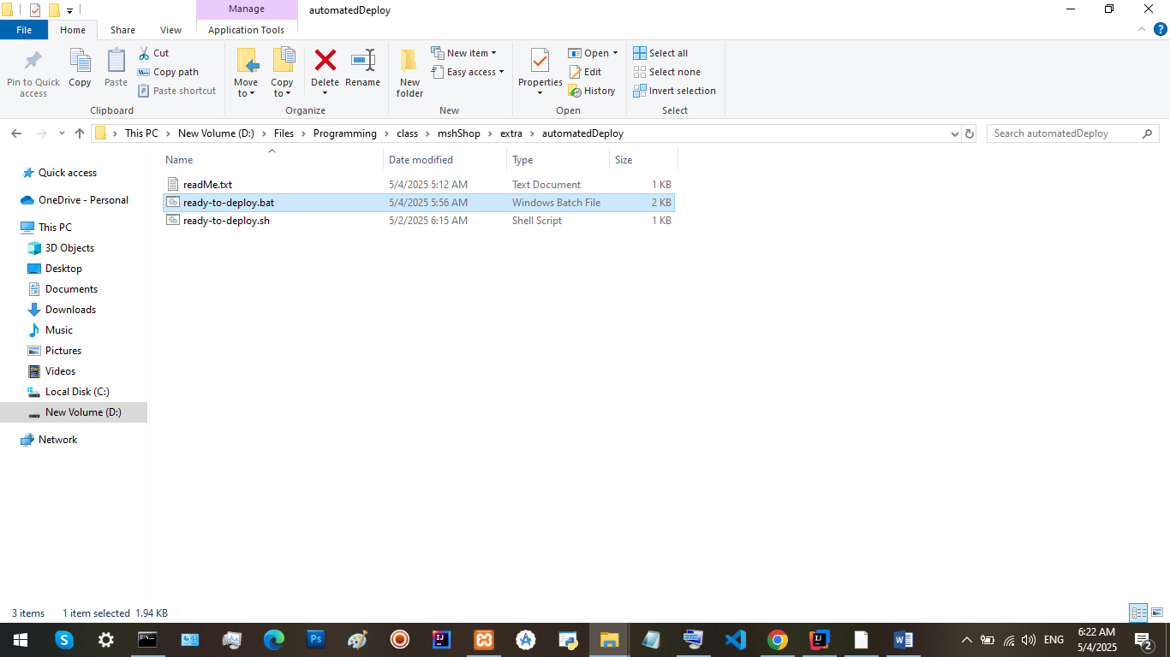

Run “ready-to-deploy.bat” from idea:

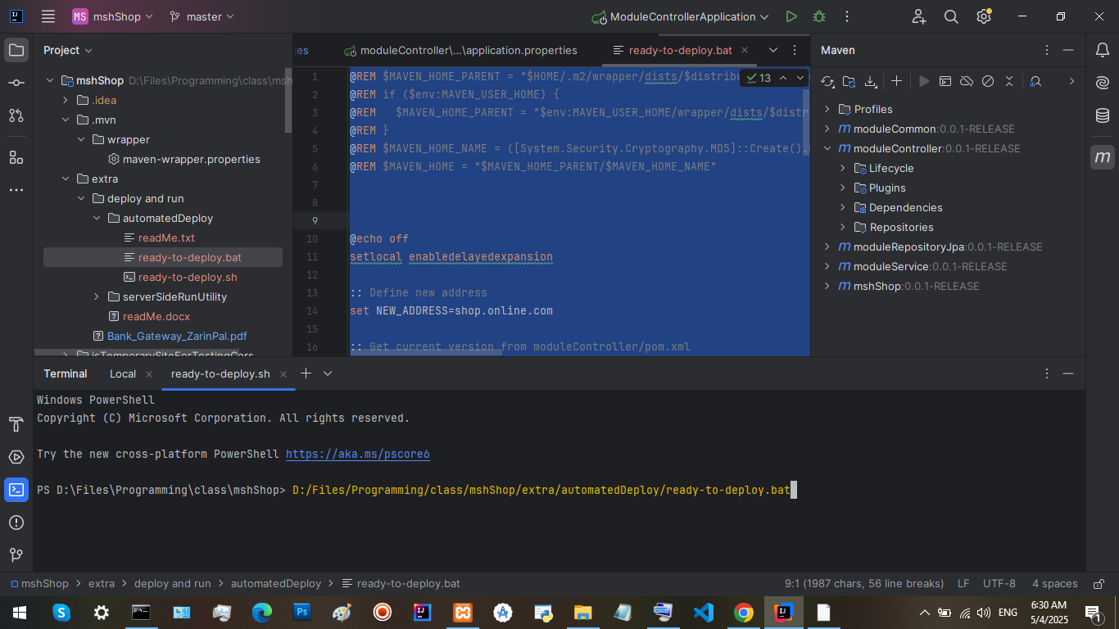

To run jar file on server use files in: mshShop\extra\serverSideRunUtility

"launch.vbs" has codes to lanuche run.bat.

if we run "run.bat" directly the cmd window will remain open. Also by closing cmd, the application will be sopped.

So we use “launch.vbs” to run “run.bat”.

