Download the jbn code and import it into eclipse.

Goto: <https://punch.cs.sfu.ca/svn/oschulte-srl/elwinjbn/>

Download the jbn.rar

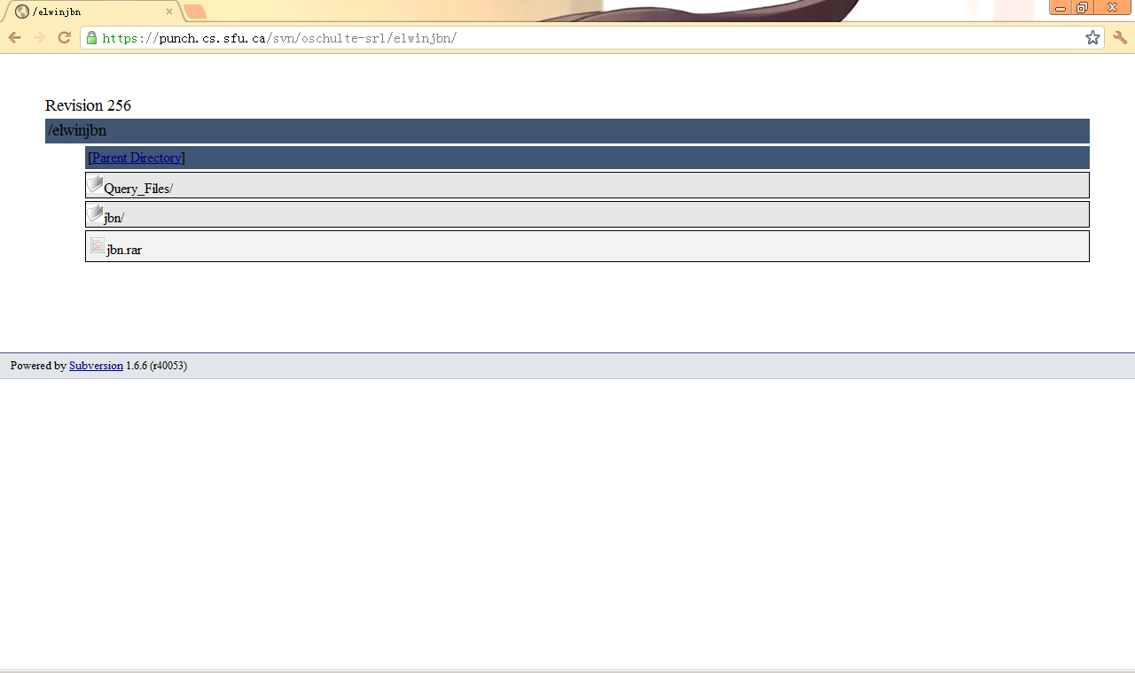

Unzip the jbn.rar

Import the jbn folder into eclipse

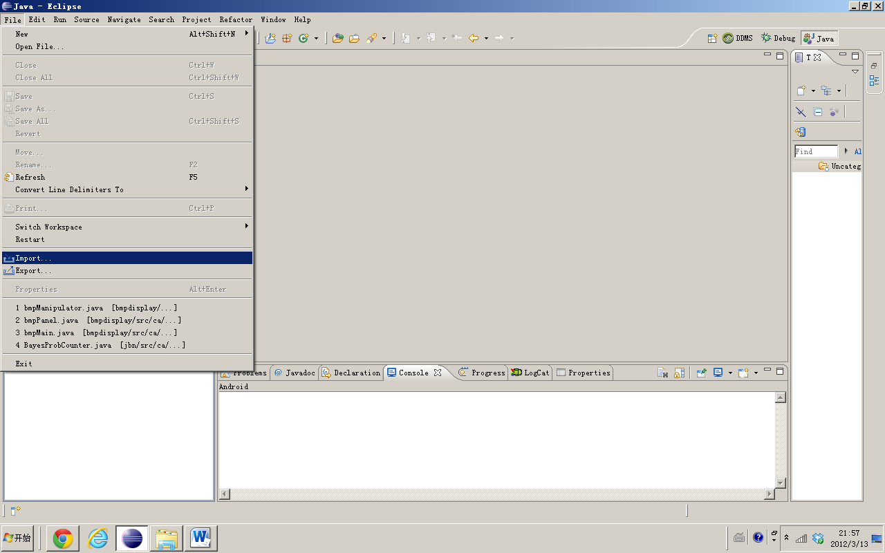

Choose ‘Existing Projects into Workspace’

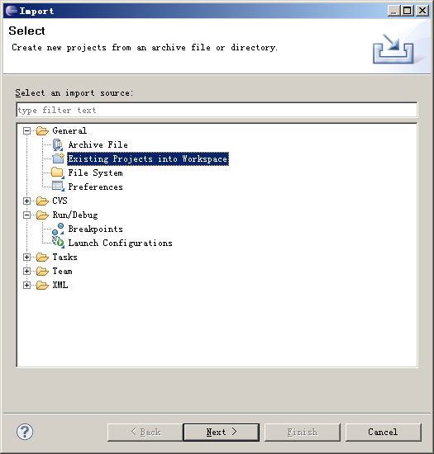

Select root directory, and click ‘Finish’

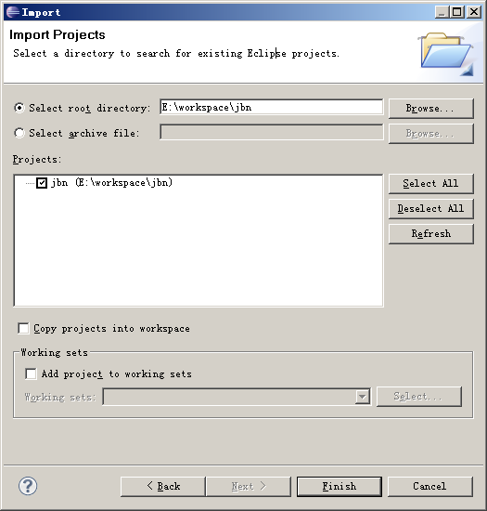

Choose the package “ca.sfu.jbn.frequency”, select the file ‘Compare_main.java’. This is the main function that we need run.

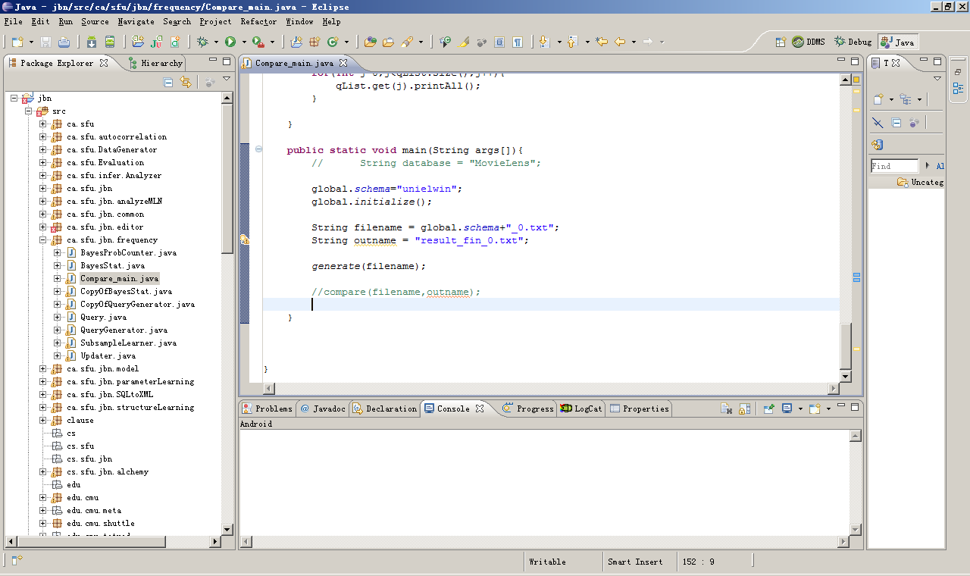

Scroll to the main function:

|  |
| --- |
| **public** **static** **void** main(String args[]){  // String database = "MovieLens";    global.*schema*="unielwin"; // Choose the database that you want to generate the random query  // for example: global.schema="MovieLens";    global.*initialize*();    String filename = global.*schema*+"_0.txt"; // the filename of the random query  String outname = "result_unielwin_0.txt";    *generate*(filename); // generate the random query file    *compare*(filename,outname);  } |

Generating the random query

It will generate a file call ‘unielwin_0.txt’ which is the ‘filename’ in the java program and located in the jbn directory.

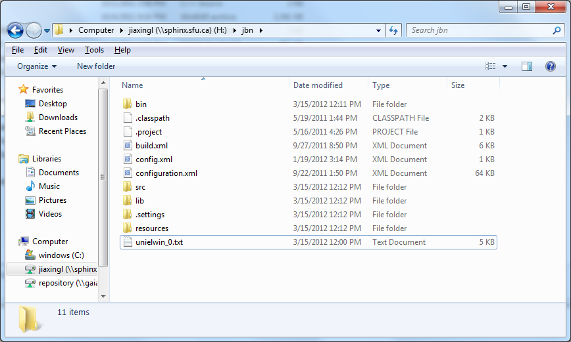

Back to Eclipse

Comment the code ‘generate(filename); // generate the random query file’

Uncomment the code ‘*compare*(filename,outname);’

|  |
| --- |
| **public** **static** **void** main(String args[]){  // String database = "MovieLens";  global.*schema*="unielwin"; // Choose the database that you want to generate the random query  // for example: global.schema="MovieLens";    global.*initialize*();    String filename = global.*schema*+"_0.txt"; // the filename of the random query  String outname = "result_unielwin_0.txt";    //generate(filename); // generate the random query file    *compare*(filename,outname);    } |

We will get txt file call ‘result_unielwin_0.txt’

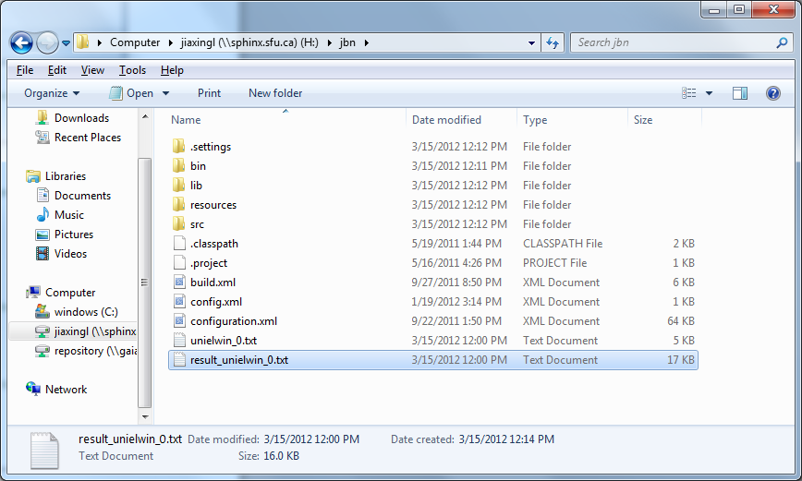

We can import the txt file into Excel

Find the ‘Data’ Button in the menu bar.

Click the Button ‘ From text’.

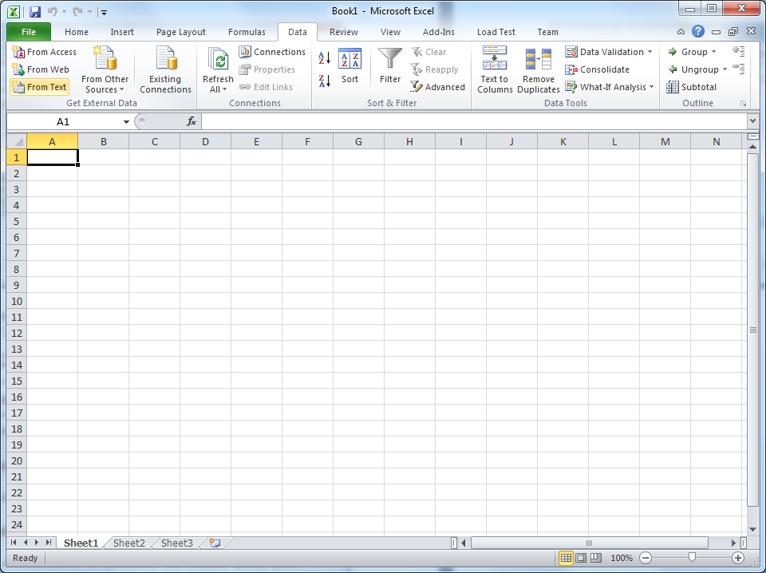

Click ‘Next’

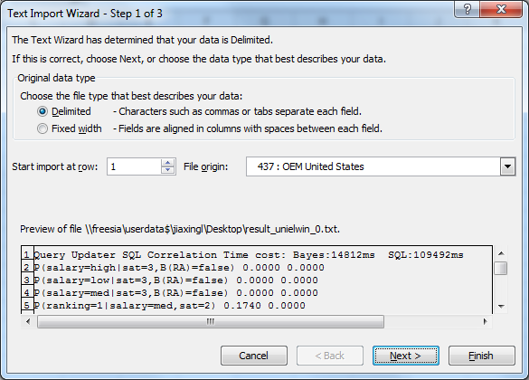

Check the box ‘Space’, and finish.

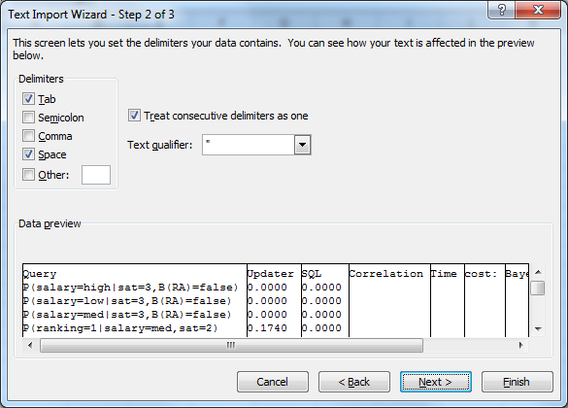

Finally, we get the random data.

