 | Isfahan University of Technology  Department of Electrical & Computer Engineering  Isfahan 84156-83111, IRAN, Tel: (+98) 3133912450, Fax: (+98) 3133912451 http://www.ece.iut.ac.ir

Dr. Abdolreza Mirzaei
Electrical and Computer Engineering department
Isfahan University of Technology
Email: mirzaei@cc.iut.ac.ir

Pre-defence report for Mahmoud Khademi

Thursday, December 12, 2019

I consider this thesis “ready to be defended”. This thesis uses graph neural network (GNN) models to solve visual question answering (VQA), scene graph generation, and automatic image caption generation problems. In all of these applications, the main goal of GNN models is to find a rich semantic representation of an input image. GNNs are able to find a contextualized representation for different nodes and edges of a graph by message passing. So, assigning nodes and edges of a graph to different locations of an input image and using a GNN, a good description of it will be produced.
One advantage of using GNNs for above mentioned applications is that unlike CNNs, which can only perform on grid cells of input image, GNNs can be applied on object bounding boxes. Also GNNs can learn any temporal structure. This is in contrast to RNNs which are only applicable in scenarios where a linear temporal structure is assumed. Beside using GNNs, this thesis uses region grounded captions (RGCs) when possible to improve image description.
For VGA, the first proposed model of this thesis, is Multimodal Neural Graph Memory Network (MN-GMN) consisting of two graph networks and a memory network. The first graph network is to describe the visual features extracted from image object bounding boxes and the second one creates a description for region grounded captions of image. For VQA, the encoded question is used to alter the initial visual and textual feature vectors of GNs. After message passing, the extracted features from visual and textual GNs are aggregated using a graph memory to describe the whole image conditioned on input question. This aggregated description is used to answer the question.
In many of the previous works on GNNs, the researchers have used a predefined fixed (complete) graph structure. It is obvious that in these methods the inherent graph structure of input data is totally ignored. Considering this fact, two generative GNNs have been proposed in chapter 4. These two models incrementally construct the graph by adding nodes and edges to an empty graph. Reinforcement learning (RL) determines which node (and edge) should be added at each step. At each step, states of RL are encoded by applying a GNN to the current graph. The proposed generative GNNs are used in VQA and scene graph generation tasks.
An image captioning method is also proposed in this thesis. The proposed method uses Bidirectional Grid-LSTM as a GNN model to learn contextualized visual features of an image in both directions. These features are integrated with region grounded texts by a two layer Bidirectional LSTM. The first layer models the global scene context and the second layer generates a caption for the image word by word. In the second layer, a dynamic attention mechanism, based on another Grid LSTM, is used in which the weight of each region is a function of its visual features and the previously generated caption till now. The attention mechanism selects relevant regions dynamically while generating the captions.

The thesis is well structured, ideas are clear and the writing is concise and argumentative. Although relocating some parts may improve the structure. For example, the (replicated parts of) related work sections in chapter 3, 4, and 5 could be moved to chapter 2 to omit repetition. In what follows, I will summarize and evaluate different chapters of the thesis and try to highlight the strength and weakness points.

The first chapter is introduction. It is managed to successfully discuss the importance of the research. The second chapter, review of the literature, is comprehensive and covers all relevant research and supporting documents to support the research. Perhaps describing some related works (for example generative GNs) in more detail will strengthen this part.

Chapter 3 proposes Multimodal Neural Graph Memory Network (MN-GMN) for VQA. As stated before two visual and textual GNs are used to extract visual features from object bounding boxes and textual features from RGCs of image. Then an external memory network is used for aggregating the information from both GNs and eliminating the redundancy introduced by overlapping bounding boxes. The answer module is a GN with a complete graph whose nods are the cell of external memory. This model has been used in VQA task. To evaluate the model an ensemble of 20 models are trained and their predictions are combined. The method performance is compared with several VGA methods on Visula7w, VQA V2.0, and CLEVR.

Strengths of this chapter include the following.
- Using GN, we can work on object bounding boxes instead of grid cells and also a rich contextualized description of image will be achieved.
- The proposed method gives a framework to aggregate the features from different modalities.
- The valuable information extractable in RGCs has been added to the image description. This can be considered a type of transfer learning.
- The performance of the proposed method has been compared with some VQA methods on different datasets to assess the proposed method. Also an ablation study is done to justify the proposed architecture.
A weakness of experiments done is that the competitor methods and also the lesion architectures used for different datasets are different. Unifying the test scenario is a direction for future work. Also, current VQA models have some common failure scenarios, for example they may give fixed answer for different images. Evaluating the proposed method against such scenarios could be another future work direction.

Chapter 4 addresses the problem of scene graph generation using GNNs. Two generative GNN models have been proposed. The first one called DG-PGNN works as follows: first a complete graph is constructed whose nodes are the object bounding boxes. Then for nodes and edges, CNN features are extracted. After that by training a bi-directional LSTM the nodes and edges type is determined. Now, the scene graph is constructed by sequentially adding nodes to the initial empty scene graph. The optimal ordering is learnt by RL where the state is current scene graph and actions choose a new node. When a node is added its feature vector and the feature vectors of new edges and nodes types and edge types are copied from the complete graph to the current partial scene graph. The features of current partial scene graph are updated through message passing. The RGCs are also used to update the features. Using nodes and edges features and an attention mechanism a graph-level description is produced which provides a summary of the current graph for RL.
DG-PGNN is also used for VQA. In this application, first the question and the answer choices are encoded. Then a question guided graph level representation is derived. Using a neural network and this information the question is answered.
The second proposed model is D-GGNN. D-GGNN constructs the scene graph by sequentially adding new nodes and edges to the initial scene graph (consisting of a single node describing the most probable object in the image). The optimal order of addition is learnt by two Q-networks. In each step the graph built so far is the current state. To code the current graph, GNN is used. Given the current graph and current object the first Q-network determines a new neighbor object and its type, and the second Q-network determine the type of the new edge from the current object to the new object.

Strengths of this chapter include the following.
- previous works proposed to learn a contextualized representation for node and edges either by message passing over a complete graph or by assuming a fixed linear ordering for bounding boxes and applying a RNN. The resulting node and edge representation are then used to infer the node-types and edge-types. The proposed methods of this chapter however learn the graph structure by RL rather than using a predefined fixed graph.
- DG-PGNN uses textual information of an image (RGCs) to build the scene graph. This can be seen as a transfer learning framework for graph scene generation.
- DG-PGNN and D-GGNN are generic generative GNN models which can be used for feature learning from latent graph structured data, when the graph structure is unknown in advance.
A weakness of this chapter is that the two proposed methods are not compared with each other. Comparing these two models (and in the case of VQA the three proposed ones) on the same dataset and determining the pros and cons of each method is a future work direction. Also analysis of the experiments and using the findings to construct a unified model will be an interesting future work. For example, if we find that the RGCs are useful in DG-PGNN why we do not use them in D-GGNN or in the unified method?

In chapter 5, the task of image captioning is addressed. In this chapter bidirectional grid-LSTM, as a GNN is used to extract a contextualized representation of image. Bidirectional grid-LSTM can learn complicated spatial patterns. A region grounded text generator is used to extract textual features. The spatial information and textual information are combined to generate a caption using a dynamic attention mechanism. A two-layer bidirectional LSTM is used for this. The first layer of bidirectional LSTM models the global scene and the second layer generates the caption.
Bidirectional LSTM incorporates another grid-LSTM to implement a dynamic attention mechanism. This attention mechanism dynamically selects relevant regions while generating a caption. The grid-LSTM attention mechanism takes into account the two dimensional spatial context and the order of the image regions.

Strengths of this chapter include the following.
- Using grid-LSTM a rich contextualized description of the input image in both spatial directions is achieved.
- The proposed method uses RGCs to enrich the image description.
- Dynamic attention mechanism, while selecting the relevant regions of the image, considers their two-dimensional spatial context and their orders. This is a better idea than using traditional fixed attention mechanisms.
A weakness of this chapter is that it uses fixed regions (the cells of a grid) as nodes, while all other chapters of this thesis are against this idea, i.e. the other chapters suggest using object bounding boxes. Using object bounding boxes have some desirable properties. Another weakness of using grid-LSTM is that it uses a fixed structure and a fixed ordering in message- passing. Using another GNN in the proposed model can be thought of as a future work.

I hope this report helps the examination committee in evaluating the thesis.

Most Sincerely,

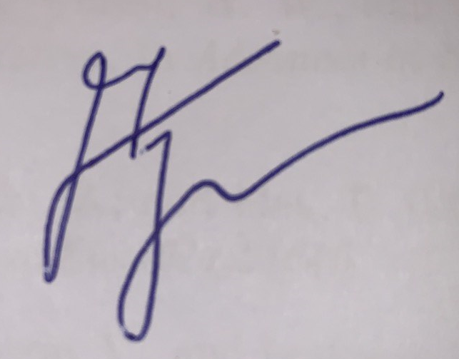
Dr. Abdolreza Mirzaei
Electrical and Computer Engineering department
Isfahan University of Technology

