Authors: Oliver Schulte, Yejia Liu, Chao Li, School of Computing Science, Simon Fraser University, Vancouver, Canada

**Model Trees for Identifying Exceptional Players in the NHL Draft**

# Introduction

Recruiting strong players is crucial for a team’s success. We describe a new data-driven interpretable approach for assessing draft prospects in the National Hockey League. Successful previous approaches have 1) built a *predictive model* based on player features [1], or 2) derived performance predictions from the observed performance of *comparable players* in a cohort [2]. This paper develops model tree learning, which incorporates strengths of both model-based and cohort-based approaches.

A model tree partitions the feature space according to the values of discrete features, or learned thresholds for continuous features. Each leaf node in the tree defines a group of players, easily described to hockey experts, with its own group regression model. Compared to a single model, the model tree forms an ensemble that increases predictive power. Compared to cohort-based approaches, the groups of comparables are discovered from the data, without requiring a similarity metric.

# Methods

Following [1], our dependent variable is the number *gi* of games that player *i* plays within his first 7 years of NHL play. Model trees are flexible and can be employed with any regression model. In this paper we employ logistic regression, where the dependent binary variable is 1 if *gi* > 0. We applied the standard LMT algorithm. To each player *i*, the learned model tree assigns a probability *pi(gi* > 0) of playing more than 0 games. Players are ranked according to *pi*. Players with *pi* < 0.5 are assigned to the zero-count bottom rank, which offers a new approach to the zero-inflation problem: almost half the draftees never play an NHL game [1].

To assess predictive accuracy as in [1], players are ranked by i) the learned model ii) the actual number of games *g*i,iii) the actual draft order. For our ranking i vs. ii, we have Spearman rank correlation *r* = 0.81. For ranking ii vs. iii, *r* = 0.48.

Table 2 illustrates the learned clusters and shows the top player in each cluster. We extract for each player their strongest feature that contributes the most to increasing their predictive score.

# Results

Figure 1 shows the model tree learned on our data set. We crawled the data from on-line sources (nhl.com, eliteprospects.com, thedraftanalyst.com), and posted the set at https://github.com/liuyejia/Model_Trees_Full_Dataset. Table 1 illustrates the two strongest groups.  
 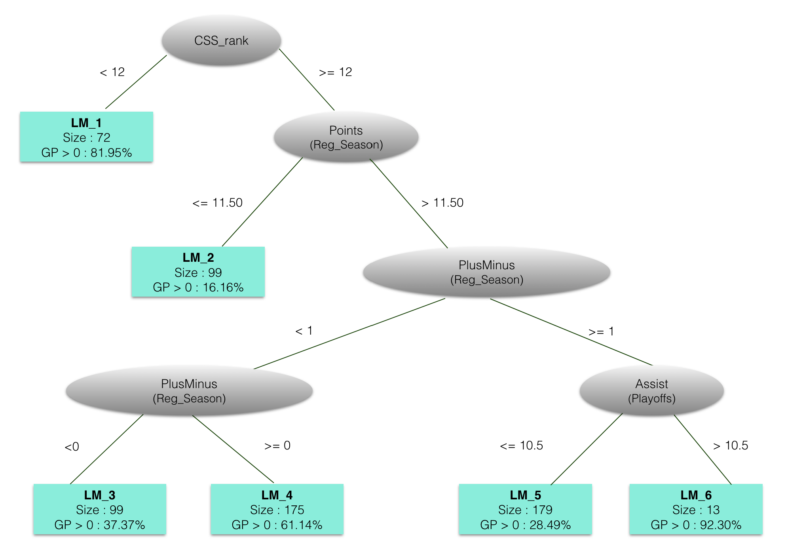

**Figure 1. A logistic regression model tree for the 200(4+5+6) draft data. Each leaf defines a player group with its own predictive model. The most relevant root attribute is the Central Scouting Service rank. The tree assigns a single logistic regression equation to players that stand out with CSS rank higher than 12. The future success of lower-ranked players is more difficult to predict; they are partitioned into 5 groups, each with its own regression equation.**

|  |  |  |  |
| --- | --- | --- | --- |
| Group  Definition | Group  Equation | Top Player | Strongest  Point |
| LM_1:  CSS_rank <= 12 | CSS_rank * -19.03 + po_PlusMinus * 4.56 + … | Patrick Kane | rs_Points = 154 vs. group mean = 41 |
| LM_6:  CSS_rank > 12 &  Points > 11.5 &  PlusMinus >= 1 &  Assists > 10.5 | (country = ‘EURO’) * -8.86 + po_GP * 1.08 + … | Brad Marchand | po_GP = 25 vs.  po_GP_group = 19 |

**Table 1. Illustrating the Two Most Successful Groups: Greatest-Magnitude Coefficients for Logistic Equation, Top Players, and their Strongest Features. Rs = Regular Season, po=Playoffs.**

# Conclusion

Model tree learning is easy to apply to draft data and produces a highly interpretable model ensemble. For each player, it can be used to predict future success, identify comparables, and highlight exceptional features. Model tree learning combines predictive modelling with descriptive analysis, in a manner that is both data-driven and intuitive for scouts, coaches, and other experts.

[1] Michael E. Schuckers (2016), 'Draft by Numbers: Using Data and Analytics to Improve National Hockey League Player Selection'. *MIT Sloan Sports Analytics*.

[2] Weissbock, J. (2015), 'Draft Analytics: Unveiling The Prospect Cohort Success Model'.

A model ensemble can easily adapt to the variability of different playing conditions, for example by learning a different model for different junior leagues, or for different seasons.

It combines descriptive modelling---identifying comparables and highlighting exceptional player features---with predictive modelling----focusing on the player features most correlated with future success. In draft decisions, the numbers are often just the beginning of the conversation [between scouts and analysts] [Florida Panthers]. Model tree learning supports drafts discussions by combining prescriptive and descriptive analysis.

## Methods

Explain LMT. Show model tree.

[Figure 1. Model tree.] [Figure 2: visualize of 2 clusters in terms of TOI, GP. Maybe pick top 3 players in cluster]

(have to write this)

|  |  |  |
| --- | --- | --- |
| Draft Year | LMT classification accuracy | LMT correlation |
|  |  |  |
|  |  |  |

Mention Shuckers, draft order

|  |  |  |  |  |  |
| --- | --- | --- | --- | --- | --- |
| Cluster Definition | Cluster equation | Cluster Size | Top Player | Strongest Point | Weakest Point |
| LM1: CSS_rank <= 12 | Show equation (maybe top three players) |  |  | Po_Assists = 20 vs. Po_Assits = 5 group mean |  |
| LM6: |  |  |  |  |  |

# Cutting Floor

## How to trade a player: Clustering and Ranking NHL Players

# Sloan Instructions

Abstracts must contain fewer than 500 words, including title and body.

* Abstracts may include up to two tables or figures combined (e.g. 1 figure and 1 table, or 2 tables)
* Each abstract should contain the following sections:
  + Introduction – What question is this research trying to answer? Why is it an important question for the industry?
  + Methods – Description of relevant statistical methods used, including data sources or data collection procedures
  + Results – Description of actual (not promised) results along with relevant statistics
  + Conclusion – The overall takeaway from the study, including how the results will impact the sports industry
* All abstracts must be submitted in one PDF through the [2017 Abstract Submission online submission page](http://www.sloansportsconference.com/activities/research-papers/research-paper-abstract-submission/)

Notes: Sep 18 form OS. Great comments. We’re working on the tables. Should think of a name for the impact. Candidates:

1. Goal Impact

2. Expected Goals Added

3. Goal Probability Added

Each of these is similar to what has been used before.

Average impact per game:

|  |  |
| --- | --- |
| ClusterId | Avg(Impact_per_Game) |
| 1 | 2.431 |
| 2 | 2.521 |
| 3 | 0.002 |
| 4 | 0.284 |
| 5 | 2.204 |
| 6 | 2.851 |
| 7 | 2.626 |
| 8 | 2.678 |
| 9 | 0.290 |
| 10 | 2.729 |
| 11 | 3.181 |