# Abstract

The purpose of this document is to demonstrate how developers can create a meaningful business application using the most agile and developer friendly stack for creating enterprise class, production ready applications. The full development stack is referred to as ANEML (AngularJS, Node.js, ExpressJS, Google Datastore NoSQL db) and is pronounced “***Animal***”. Using a clever moniker, such as ANEML, can be helpful to wining hearts and minds of the development community, similar to the MEAN stack (see <http://mean.io>)

The demonstration application is a simple application called TweetDeck. This application allows a user to search for tweets stored in a MarkLogic database and plot the geographic location of the Tweeter on Google Maps.

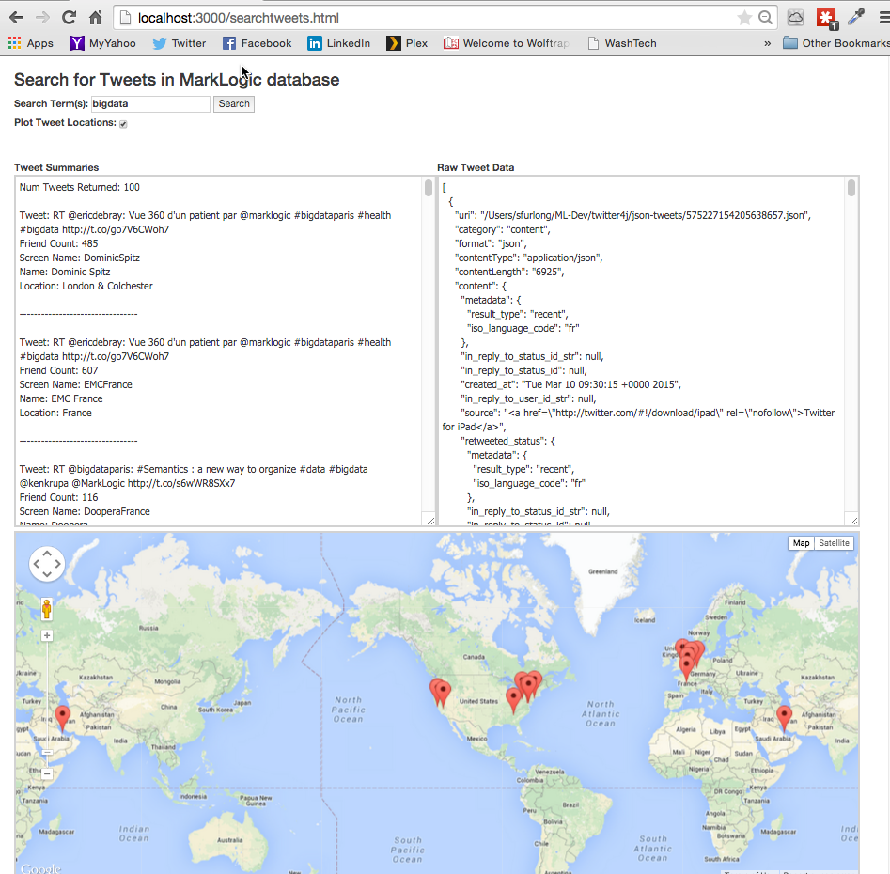

Figure TweetDeck a Sample ANEML Application

The rest of this document describes a step-by-step guide on how to recreate this sample application using the ANEML stack.

I developed this application as a way to learn the MarkLogic 8 platform after joining the company. I hope that others new to MarkLogic 8 will find this project useful. This project can be used as a stepping-stone for learning additional MarkLogic frameworks such as SampleStack and Slush. For further information, assistance, or comment, please contact Steve Furlong on Twitter @sfurlong.

# Architecture Overview

The ANEML stack is comprised of Angular JS, Node JS, Express, and the MarkLogic database platform. This stack represents a modern development stack where JavaScript is used on the client-tier, middle-tier, and database tier (using JSON document objects). This allows the full stack developer to have language and toolset fidelity through all tiers of an application development cycle.

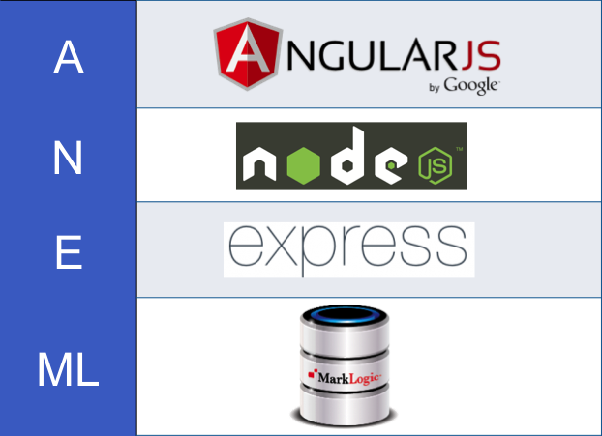

The best source for more information on each of these components can be found here:

* Angular JS – <https://angularjs.org>
* Node JS - <https://nodejs.org>
* Express JS – <http://expressjs.com>
* MarkLogic – <http://developer.marklogic.com/>

# Installing the ANEML Stack

This section provides a step-by-step guide for installing the minimal components to develop using the ANEML stack. Only the strict minimum components are used to provide the developer with a solid understanding of what layers of the stack contribute to specific architectural capabilities.

## Install Node.js

* Download node.js install binaries from <https://nodejs.org> and install like any other application for your platform (i.e. exe, pkg, rpm, etc)
* Once you've installed node, you will have an “npm” command (node package manager) available to install the remaining components of the stack. Test the installation:
  + $ node --version
* Create a directory for the TweetDeck application
  + $ mkdir aneml-workshop
  + $ cd aneml-workshop
* Create a directory for the NodeJS installation
  + $ mkdir node-js
  + $ cd node-js
* Create a package.json file in the new directory. This file holds various metadata relevant to the project and gives information to npm that allows it to identify the project as well as handle the project's dependencies. OK to just take the default prompts for this command
  + $ npm init

## Install Angular JS

* Install Angular using the Node Package Manager in the /node-js directory
  + $ npm install angular –save
  + $ npm install angular

## Install Express

* Install Express using the Node Package Manager in the /node-js directory
  + $ npm install express –save
  + $ npm install express

## Install MarkLogic Node.js Client

* Install the MarkLogic Node JS Client Module in the /node-js directory. This module is used by NodeJS to communicate with the MarkLogic database
  + $ npm install marklogic –save

## Install Bootstrap CSS Style Sheets (OPTIONAL)

* Bootstrap is a very common client side UI style sheet framework developed by Twitter and now in the public domain. This will help beautify out browser based UI page.
  + $ npm install bootstrap

## Configure Google Cloud Datastore NoSQL Database

* A very brief description of generic install steps is provided in the appendix of this document.
* Installation of MarkLogic database can be found at <http://developer.marklogic.com>

## Other Tools for Developing ANEML Applications

Additional application development tools that are helpful for developing your ANEML applications:

* A JavaScript aware editor such as Sublime or Atom
* JavaScript browser code debugging with the Chrome Developer Tools and JavaScript Console
* Git and GitHub for source control

# GCTweets Application Code Deployment

## Fetch Code from GitHub

* In your favorite browser, navigate to: https://github.com/sfurlong/gctweets
* Download the zipfile containing the code

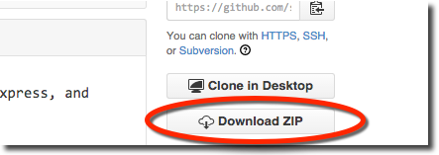

* Unzip the file into the your /aneml-workshop directory. Note: This should overlay your existing /aneml/workshop/node-js, while keeping its existing contents
* Your directory structure should now look like this:

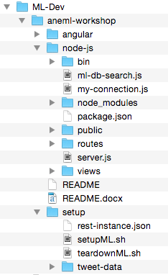

## Configure Your Google Datastore NoSQL Database

* The database configuration scripts use the MarkLogic Admin REST APIs. To execute the scripts you will need to install CURL on our system. See <http://curl.haxx.se/>
* *Load the Tweets*
  + *./myapp=>$node loadtweets.js*

# Deploy to Google Cloud

* From Google Cloud Prompt
  + ./myapp=>$ gcloud app deploy
  + gcloud app browse

# To Run The Demo Localy

## Start the Node.js Server

* Start the Node JS server using the following command. This will start the serve up the web pages.
  + $ npm start
* Open a browser and navigate to <http://localhost:3000/searchtweets.html>. Use “bigdata” as your search term, this will produce the results shown below.

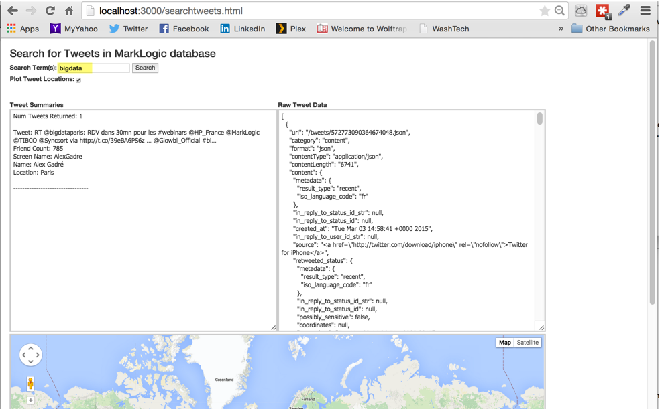

* Generate a new Google Maps API Key by following the instructions here: <https://developers.google.com/maps/documentation/business/mobile/ios/auth>
* Update the Google Maps Key in the file /aneml-workshop/node-js/public/search-tweets.html

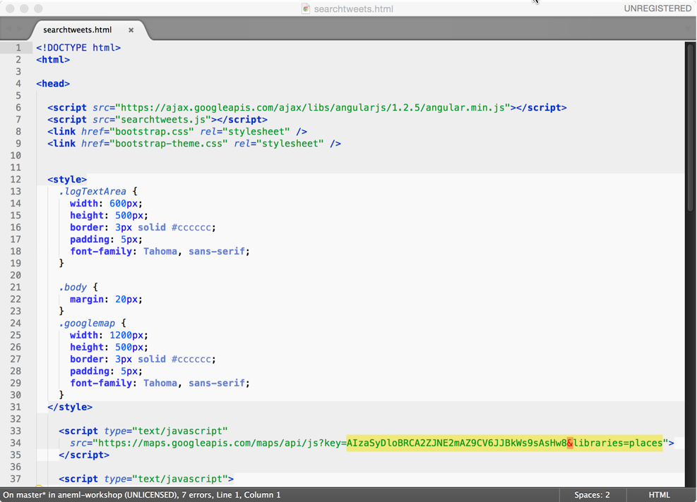

# Testing In MarkLogic Query Console

* In your browser, navigate to <http://localhost:8000>
* In the Query Console, change the Content Source to “tweet-deck-content”
* Set the “Query Type” to “JavaScript”
* Enter the code below and press the “run” button

// find all documents with the word "marklogic" and count them

var count = 0;

var results = new Array();

for (var result of cts.search(cts.andQuery([

cts.wordQuery("marklogic")])) ) {

count++;

//results.push(result);

};

results.push(fn.concat("Count = ", count));

results;

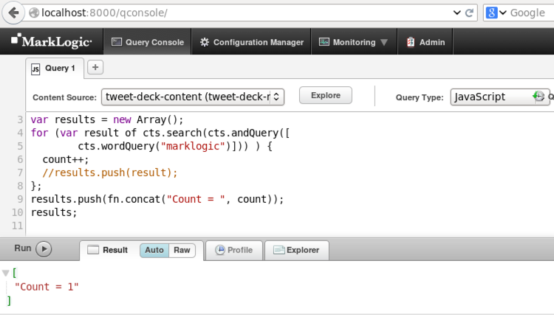

# Appendix

## Installing & Uninstalling MarkLogic Database

* Install: $ rpm –i <<marklogic-rpm-name>>
* Start: $ /etc/init.d/MarkLogic start
* Stop: $ /etc/init.d/MarkLogic stop
* Uninstall: $ rpm –e MarkLogic
* Remove DB Files: $ rm –fr /var/opt/MarkLogic
  + Note on Mac use /Users/[user name]/Library/MarkLogic

## Working with Git Command Line

Summary of useful Git command line

* Initialize a git repository
  + $ git init
* Add files to ignore from git management
  + $ vi .gitignore
  + Add any files to be ignored
* Recursively add all files to your local git repository
  + $ git add -A
* Commit files to the local repository
  + $ git commit –m “<<comment>>”
* Add a remote origin to your local git repository
  + $ git remote add origin <https://sfurlong@github.com/sfurlong/aneml.git>
* Push all local changes to the remote repository
  + $ git push -u origin master
* Status commands
  + $ git status
  + $ git log
  + $ git diff head
  + $ git push

## Future Enhancement Opportunities

1. Add Server Side JavaScript (MarkLogic stored proc)
2. Query with joins between multiple document types
3. Add pagination to the UI when > 100 tweets are returned
4. AuthN via LDAP
5. AuthZ based on user Role
6. Reporting
   1. Tableau
   2. Pentaho
   3. Qlick
7. Semantics and ontologies

# How to Get the Tweets from Twitter

This topic is out of scope for this document. I developed a java program to extract tweets from the Twitter API and write them to disk as JSON formatted files. An open source java library was used called twitter4j. Please contact me for further information.

# Change History

|  |  |  |
| --- | --- | --- |
| Date | Who | Changes |
| 4/30/15 | Steve Furlong | Initial Revision |
|  |  |  |