Install and Set up of WinCVS:
The correct version of WinCVS can be downloaded from www.wincvs.org.
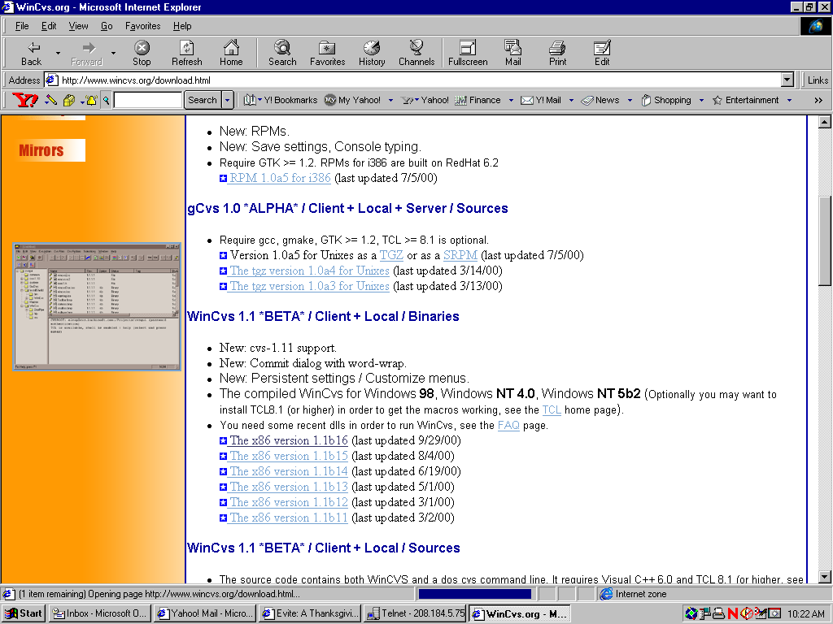
Correct Version is 1.1b16
After installing WinCVS follow the instructions below to create your working area.

Choose the Preferences option from the CvsAdmin menu. Set up the General preferences as shown below:

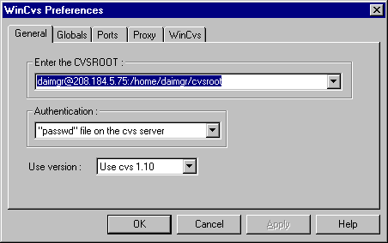
Replace “daimgr” with your login.

or for NTCVS use the following settings.

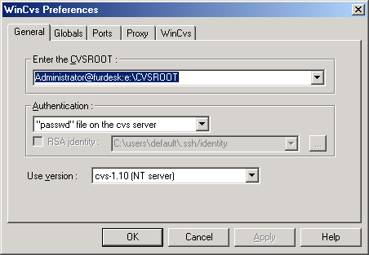
Logon to the CVS server by choosing the Login option from the CvsAdmin menu. When prompted for your password, use the password provided for you.

For CVS-NT Server
Use the following preferences:
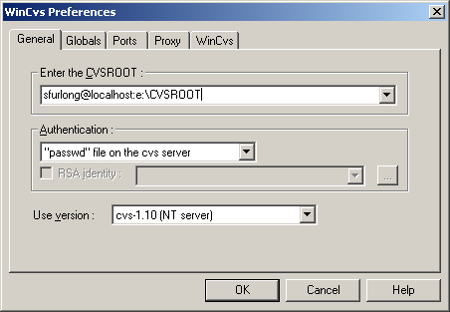

Creating your local working copy of the source:
- Make sure you are logged into the server repository. (Choose Login option from the CvsAdmin menu)
- Choose the Checkout Module option from the CvsAdmin menu. When asked for the working directory, choose the drive where the code should be copied (For example c:\)
- Next setup the checkout box as shown below:
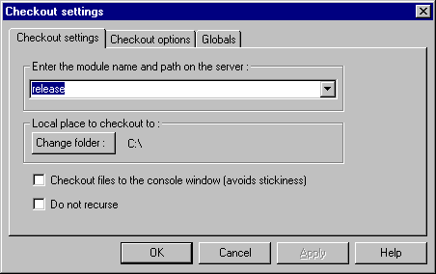
- Press OK. This will start copying the source code from the master repository on the server to your local working area. This could take some time depending on the speed of your connection.
- Change you working view by choosing the Change Browser Location from the View menu. Change browser location to the location where the source files where copied from the server repository. (for example c:\release).

Editing Session (Check Out/ Check In):
TBD.

Refreshing Your Local Workspace:
TBD.

Setting up the CVS Server Repository (Admin Only):
Creating the Repository:
- Use the command: cvs init. This will initialize the repository
- Populate the repository with the following command:
cvs import -m “Imported Sources” release base start
Where: release is the name of the directory in the CVSROOT where the repository will be copied and base is the "vendor tag", and start is a "release tag”.

Logging On To CVS:
From command line use: cvs -d :pserver:sfurlong@furnet:/home/daimgr/cvsroot login

