

microERP

Enterprise Resource Planning and Management Software

Administrators Manual

Table Of Contents

1. Installation 3
1.1 Server Install 3
1.1.1 Install the Firebird database 3
1.1.2 Change the default database password 5
1.1.3 Install the Java JDK 5
1.1.4 Install the application server 6
1.1.5 Configure the Properties file 6
1.1.6 Deploy the Web Application 7
1.1.7 Test the Install 8
1.2 Client Install 8
2. Server Administration 8
2.1 backup/Restore a database 8
2.2 Optimizing Firebird 8
2.3 JBOSS Application Server Installation (Optional) 8
3. Logging and Tracing 8
4. WebReports Admin 8
5. Financials Error! Bookmark not defined.
5.1 General Ledger Posting Events Error! Bookmark not defined.
5.2 Receive Inventory Error! Bookmark not defined.
5.3 Receive Bill Error! Bookmark not defined.
5.4 Receive Invoice Error! Bookmark not defined.
5.5 Pay Bill Error! Bookmark not defined.

Installation
The install instructions are divided into Client and Server installations. The Server installation need only take place once. The Client installation must be performed once for each user desktop.

The following files are stored on the Altaprise, microERP distribution
<cd-root>\altaprise.war
<cd-root>\micreERP2.0-setup.exe
<cd-root>\demodb.gdb
<cd-root>\doc\admin-guide.pdf
<cd-root>\vendor\dbvis41.exe
<cd-root>\vendor\Firebird_ODBC_1.2.0.69-Win32.exe
<cd-root>\vendor\Firebird-1.5.2.4731-Win32.exe
<cd-root>\vendor\firebird-jdbc-jbird.zip
<cd-root>\vendor\j2sdk-1_4_2_05-win.zip
<cd-root>\vendor\jboss-4.0.1.zip

Server Install
The Following is an overview of the Server install process.
- Install the Firebird database. The Firebird database is located in the microERP distribution
- Change the default database password
- Install the Java JDK. Version 1.5 or better (provided with the distribution)
- Install the application server. The Tomcat application server is provided with the distribution.
- Install the Crystal Reports command line utility.
- Configure the properties file.
- Deploy the Web Application (altaprise.war)
- Test the installation

Each of these steps are outlined below.

Install the Firebird database
Be sure to remove any previous versions of the Firebird DB first using the Windows Uninstall utility.
- Double click on the Firebird install executable, Firebird-1.5.2.4731-Win32.exe.
- Choose all defaults on the install dialogs. For example: 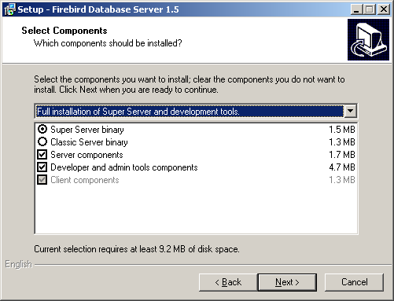
- Also choose the following defaults: 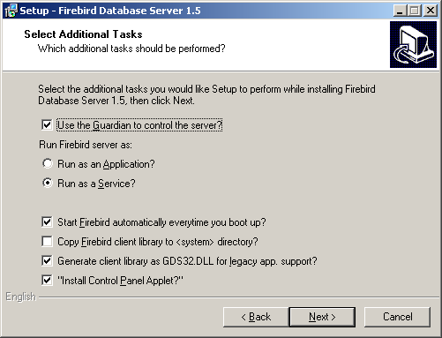
- Restart your computer.
- Using the Firebird control panel applet, ensure that the service is started: 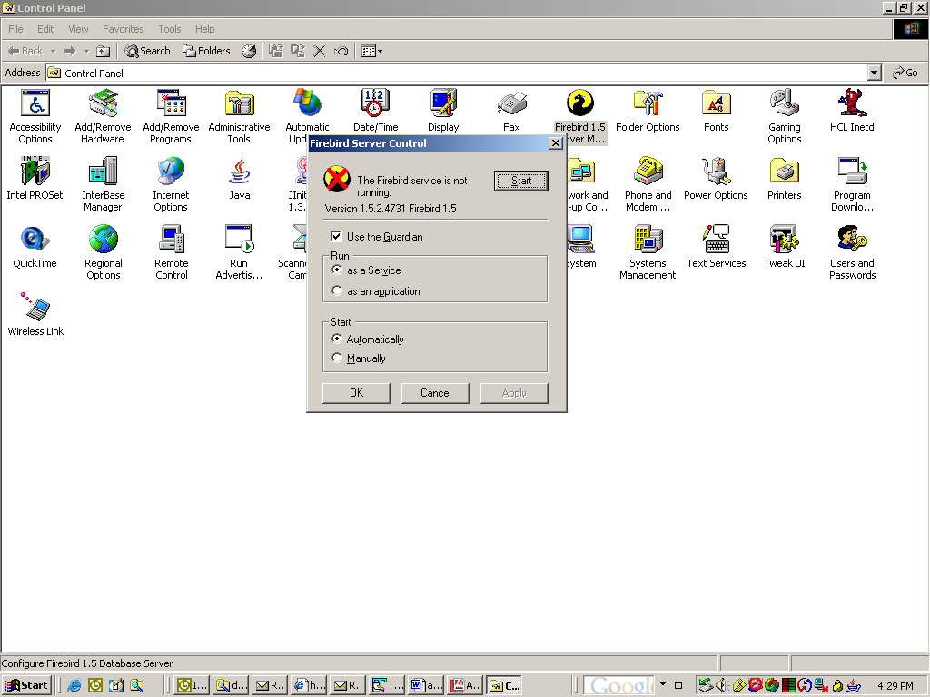
- Copy the demodb.gdb from the microERP distribution to your server. For example d:\altaprise\demodb.gdb

Change the default database password and Test Database Connection
- The Firebird system userid (SYSDBA) password must be changed before the application will run. To change the password do the following:
D:\Program Files\Firebird\bin>gsec -user SYSDBA -password masterkey
GSEC> modify SYSDBA -pw daimgr
GSEC> quit
- Test the database connectivity:
D:\Program Files\Firebird\Firebird_1_5\bin>isql.exe
Use CONNECT or CREATE DATABASE to specify a database
SQL> connect "d:\release\v20\dist\demodb.gdb" user 'SYSDBA' password 'daimgr';
Database: "d:\release\v20\dist\demodb.gdb", User: SYSDBA
SQL>
SQL> select count(*) from cust_order;

COUNT
============
1056
SQL>

Install microERP (Server)
Use the microERP installer to install the server. The same installer is used for client and server.

Install the application server
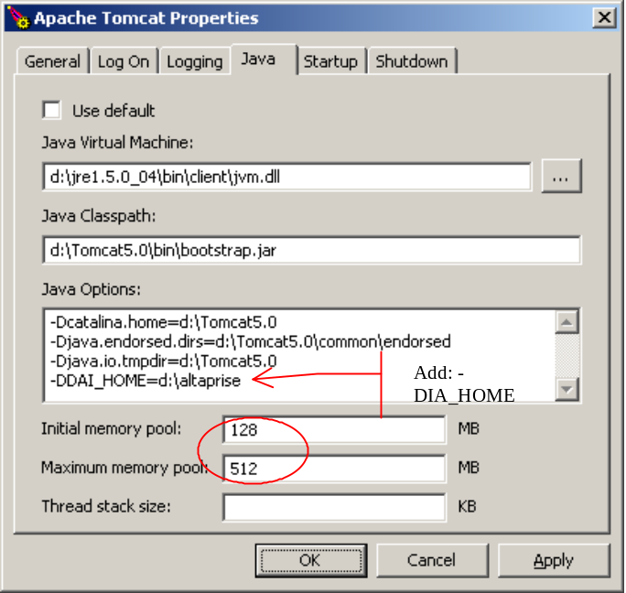

Configure the Properties file
#####################################################
# This section Specifies the Database Driver
# Valid values for plumbing type are: STUB or RMI
#####################################################
plumbingType=STUB
#plumbingType=RMI

#####################################################
# This sction specifies the host name or ip address
# where the server portion of the application will run.
# Specifically, the RMI Services and the Servlet Engine.
#####################################################
hostname=localhost
webrptshost=localhost:8080/altaprise

######################################################
# This section specifies the Database URL and
# user login and password that the server side
# portion of the application will use.
#####################################################
serverDBUrl=jdbc:firebirdsql:localhost/3050:d:/altaprise/demodb.gdb

#####################################################
# This section Specifies the Database Driver
#####################################################
jdbcDriver=org.firebirdsql.jdbc.FBDriver

#####################################################
# This section Specifies Debug Settings
# Valid Trace Levels are 1-10. Level 10 is most verbose.
# Level 1 is default.
# errLogging=(YES/NO) Logs all errors to a disk logfile
# sqlLogging=(YES/NO) Logs all SQL statements to a disk logfile.
#####################################################
errLogging=NO
sqlLogging=NO
traceLevel=10

#####################################################
# This section specifies the maximum number of rows that
# will be returned to the client when a DB select is performed.
#####################################################
maxdbselectrows=998

#####################################################
# This section specifies the Command Line prompt used
# to start the web reports
#####################################################
webrptscommand=http://localhost:8080/altaprise/daiwebrptslogin.html

#####################################################
# This section specifies the reporting options used
# to print documents.
# NOTE: Must use "windows" style path seperators "\"
#####################################################
reportengine=D:\altaprise\CML\CML.exe
reportdbdsn=artifacts
reportdbpath=d:\altaprise\demodb.gdb
reporttempdir=d:\temp
reportdocsdir=d:\altaprise\rpt
reportwebprinturl=http://localhost:8080/altaprise/doc.pdf

Deploy the Web Application
- Navigate to : http://localhost:8080/manager/html
- Use userId and Passwd to login
- Deploy the web application as shown below.
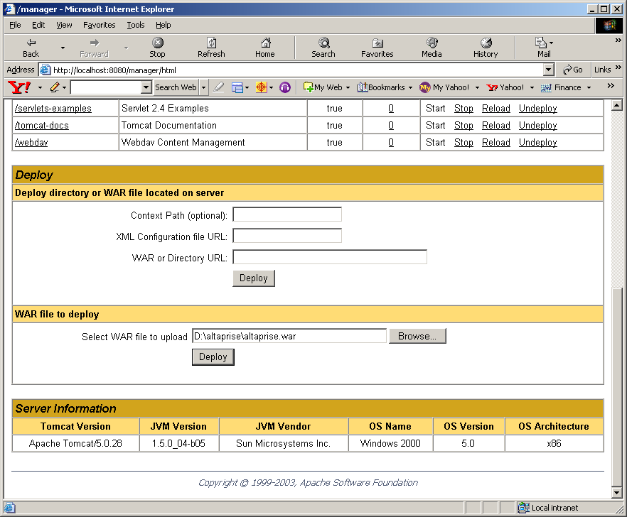

Test the Install
http://<hostname>:8080/altaprise/webrptslogin.jsp
*Note, if you get an error in the console that says (null/altaprise.conf), ensure that Tomcat is recognizing the following JVM directive: “–DDAI_HOME=<path of altaprise.conf>”

Client Install
Use the microERP installer.

Server Administration

backup/Restore a database
D:\bin\gbak –user SYSDBA –password daimgr –B <location of database file> <location of backup file>

Optimizing Firebird
Two important was to optimize Interbase are:
- The default page size is 1K. Change to 4K by backing up the database and restoring with a page size of 4K. This can be done with IBConsole.
- Bump up the cache size using GFIX.EXE –BUFFERS size DATABASE.DBG. The size should be smaller than the number of pages used in the database. The default is 256. You can tell the current size by using gstat DATABASE.DBG. The buffers parameters shows the current size.
- Use write-back-cache instead of write-through-cache. Write-through-cache is implemented by default on wintel box. To change use: GFIX.EXE –WRITE ASYNC or turning off the “Enable Forced Writes” option in IBConsole

JBOSS Application Server Installation (Optional)
- Unzip Jboss on server machine.
- Open Command Shell
- Ensure that JAVA_HOME env variable is set to JDK version 1.4.2 or better
- Enter the following environment variable: set java_opts=-DDAI_HOME=<location of altaprise.conf>
- Start the application server: <jboss_home>\bin\run.bat
- Test the webreports: http://<servername>:8080/altaprise/webrptslogin.jsp

Logging and Tracing
Trace Statements have levels

WebReports Admin
The URL to access webrports is http://localhost:8080/altaprise/webrptslogin.jsp

