
microERP

Enterprise Resource Planning and Management Software

Developer’s Guide
Table Of Contents

1. Distributed Architecture 3
2. UI Framework 3
3. Application Security 3
3.1 User access to UI Components 3
3.2 User access to Remote Services 3
4. Logging and Tracing 3
5. Financials 3
6. Module Task Explantions 4
6.1 Receive Inventory 4
6.2 Receive Bill 4
6.3 Receive Invoice 4
6.4 Pay Bill 4
7. Building the Application 4
8. JNI Components 4
9. Optimizing Interbase 5
10. Changing Interbase Password: 5
11. Create an Install Image 5
12. Create an Update Module 7
13. Using the Embedded Database 7
14. Uploading to SourceForge.net 9

Distributed Architecture

UI Framework

Application Security
There are two types of security in the application:
- User access to UI components
- 2. User access to remote services.

User access to UI Components
Any UI component can have security enforced on it. A UI component is defined as a Frame, Panel, Button, etc. Each UI component that will use security must have a ComponentId associated with it. The ComponentId is stored in the database along with the permissions associated with it. The available permissions are read, modify, create, delete, and execute. Each UI component that implements security must call a method on the singleton class ComponentSecurityManager::getComponentSecurity. The method is passed the ComponentId and UserId. The method returns and instance of component_securityObj. This will contain all the permissions for the ComponentId.

The UI Framework has support for application security. All Frames which are derived from daiFrame and use the instance variable COMPONENT_ID to define it’s ComponentId. The daiFrame class also contains a method called setComponentSecurity

User access to Remote Services

Logging and Tracing
Trace Statements have levels

Financials
The following are the events which cause postings to the General Ledger:
Event | Account | Debit | Credit | Where Specified | Note
Create Invoice | Accts Receivable | X |  |  | Total Invoice Amt
 | Sales Tax Payable |  | X |  | Amt of Sales Tax
 | Shipping - COGS |  | X
 | Materials |  | X | Item Sales Acct | Extended Price
 | Inventory Asset |  | X | Item Inventory Acct | Cost of inventory item
 | Purchases – COGS | X |  | Item Purch Acct | Cost of inventory item
Receive Payment | Accts Receivable |  | X |  | Total Invoice Amt
 | Checking Funds | X |  |  | Total Invoice Amt
Create Purch Order |  |  |  |  | No Accts updated
Receive Items | Inventory Asset | X |  | Item Inventory Acct | Extended Price only of the items received. NOT IMPLEMENTED AT THIS TIME.
 | Accts Payable |  | X |  | Extended Price only of the items received
Receive Invoice (From PO) | Accts Payable | X |  |  | Extended Price only of the items received
 | COGS- Purchases |  | X |  | Extended Price only of the items received
Receive Bill (Expense) | Accts Payable | X |  |  | Full Invoice Amt
 | Expense Account |  | X |  | Full Invoice Amt
Pay Bill | Accts Payable |  | X |  | Full Invoice Amt
 | Checking |  | X |  | Full Invoice Amt

Module Task Explantions

Receive Inventory
Calls the PurchOrderServiceImpl::receiveInventory() API

for each ItemReceived
add an entry to the purch_order_item_rcv_hist table;
update the qty received in the purch_order_item table;
Add new credit entry to the Accounts Payable journal;
Adjust the qty_on_hand and qty_vendor_backord in the item table;
End for;

Receive Bill

Receive Invoice
Calls the PurchOrderServiceImpl::postInvoiceReceipt() API
- update the purch_order table (the following fields ACCOUNT_NAME, PAYMENT_TERMS, PAYMENT_DUE_DATE);
- Add Expense amt to the Acct Detail table;
- Add Acct Payable amt to the Acct Detail table;

Pay Bill

Building the Application
The application is built using ANT. Use the batch file build.bat to build all the components of the application. This will create all the java “.class” files for the application. The batch file is located at %DAI_HOME%.

JNI Components
The application uses the Java Native Interface (JNI) for accessing the Crystal Reports report engine. The following are the steps required to use JNI:
- Create a java source file that contains a class file with methods that will be used to access the DLL.
- Compile to java file mentioned in step 1 using javac.
- Use the Java tool javah.exe to generate a header file which will be used in the c++ program. The syntax is: javah someclassfile

Optimizing Interbase
Two important ways to optimize Interbase are:
- The default page size is 1K. Change to 4K by backing up the database and restoring with a page size of 4K. This can be done with IBConsole.
- Bump up the cache size using GFIX.EXE –BUFFERS size DATABASE.DBG. The size should be smaller than the number of pages used in the database. The default is 256. You can tell the current size by using gstat DATABASE.DBG. The buffers parameters shows the current size.
- Use write-back-cache instead of write-through-cache. Write-through-cache is implemented by default on wintel box. To change use: GFIX.EXE –WRITE ASYNC or turning off the “Enable Forced Writes” option in IBConsole

Changing Interbase Password:
The Interbase system userid (SYSDBA) password must be changed before the application will run. To change the password do the following:
D:\Program Files\Firebird\bin>gsec -user SYSDBA -password masterkey
GSEC> modify SYSDBA -pw daimgr
GSEC> quit

Java Web Start Distribution:
- Sign the jars:
- First create the key database using the following: keytool -genkey -alias altaprise -keystore f:\release\webRpts\lib\daikeys. Keystore password is daikeys. Key password is altaprise.
- Now sign the jars: jarsigner – keystore f:\release\webRpts\lib\daikeys dai.jar altaprise. Altaprise is the name of the key. Use daikeys for the keystore password and altaprise for the key password.
- Add the following mime type to your web server:
Application/x-java-jnlp-file JNLP

Create an Install Image
- Use the ANT tag “dist” to create the distribution image. You will have the following directory structure after ANT completes.
- <dev_home>\dist\lib\*.*
- <dev_home>\dist \images\*.*
- <dev_home>\dist \rpt\*.*
- <dev_home>\dist\demo\*.* <<<These are the HSQL DB files.
- <dev_home>\dist\jetty\*.*
- <dev_home>\jdk\*.*
- <dev_home>\dist \altaprise.conf
- <dev_home>\dist \startdaiclient.bat
- <dev_home>\dist \license.txt
- <dev_home>\dist \readme.html
- <dev_home>\dist\version.txt
- <dev_home>\dist\startclientupdate.bat
- Use the NullSoft Install System creator to create the installation. 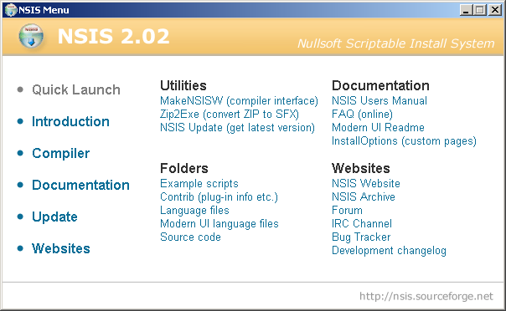
- Select the Compiler option and Start MakeNSISW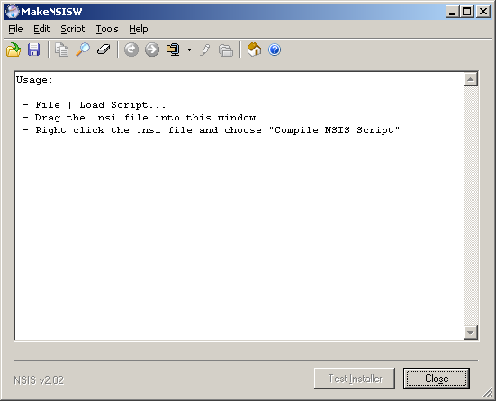
- Load the install script in <dev_home>\scripts\installscript.nsi. This will create the installation image and place it in <dev_home>\scripts

- Create a directory called <dist> and with the following directory structure:

- <dist>\microERP2.0-Setup.exe
- <dist>\ecorp.war
- <dist>\vendor\dbvis41.exe
- <dist>\vendor\Firebird_ODBC_1.2.0.69-Win32.exe
- <dist>\vendor\Firebird-1.5.1.4481-Win32.exe
- <dist>\vendor\firebird-jdbc-jbird.zip
- <dist>\vendor\j2sdk-1_4_2_05-windows-i586-p.exe
- <dist>\vendor\jakarta-tomcat-5.0.28.exe

Create an Update Module
- Create a staging directory called microERP. For example d:\microERP.
- Place the new version.txt file in the root of the new staging directory
- Place all update files (jars, txt, rpt, etc) in the correct microERP directory structure in the staging directory. For example d:\microERP\lib, d:\microERP\rpt, etc.
- create a file called microERP_patch-[VVV.PPP].zip which contains the contents of the staging directory and retains all the relative paths.
- Place the microERP file in the default directory for FTP server using userId/passwd of : daimgr/daimgr1.
- Copy an empty file to the daimgr root directory.
  - The file name must have the pattern: microERP_patchId-[VVV.PPP] (NO FILE EXTENSION). Where VVV is a a sequence of numbers representing the Version (i.e. 201) and PPP is the patch number (i.e. 001).
  - The combination of VVV.PPP will be compared numerically with the patchNumber in the version.txt file of the client.
- Copy the microERP_patch-*.zip file to the daimgr root directory of the FTP server
- Ensure that the paths inside the zip start with: microERP/lib, etc.

Using the Embedded Database
The embedded database is an option for demo purposes. An all java database is used called Hypersonic DB (HSQLDB). It is an opensource database with a wide following.

- Start the HSQLDB in server mode using the following command:
java -cp lib/hsqldb.jar org.hsqldb.Server -database <DAI_HOME>\demo\demodb.hsqldb -port 9001

- Run the runManagerSwing.bat to start the database manager tool.
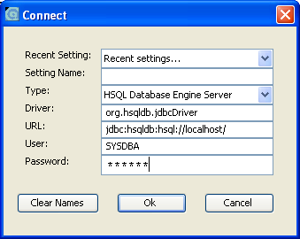

- Create the database user as follows:
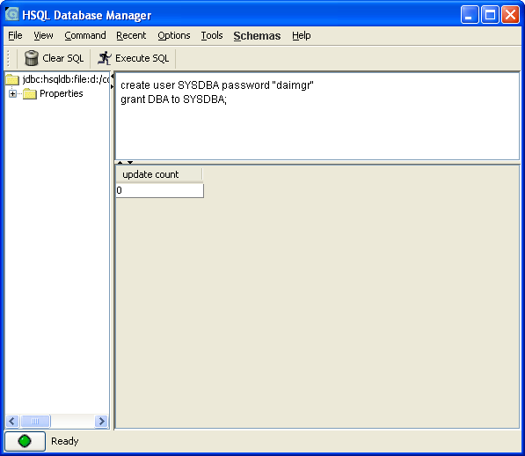

    - Login as SYSDBA
    - Run the database creation script.
Load System Data using sql script.

Uploading to SourceForge.net
How do I upload a file to include in a file release?
To release a file, generate a zip archive or tarball and place it at the root of your hard drive, for easy access. Then follow these instructions to perform the upload:
- FTP to upload.sourceforge.net
- Login as "anonymous"
- Use your e-mail address as the password for this login
- Set your client to binary mode ("bin" on command-line clients)
- Change your current directory to /incoming ("cd /incoming")
- Upload the desired files for the release ("put filename")
- Go to the FileRelease System tab of the Admin menu for the microERP project.

