Lifecycle Management of Infrastructure under Multi-Recurrent Hazards: Integrating Simulation-Informed Modelling and Reinforcement Learning
Yimo Zhu ª, Shunjie Fu ^{b}, Zhiyi Huang ª, Zhuoran Tian ^{c}, and Xiao Li ^{a,} *

ª CI³Lab, Department of Civil Engineering, The University of Hong Kong, 999077, Hong Kong
^{b} School of Civil Engineering, Monash University, Clayton, Australia
^{c} Institute of Aerospace Vehicle Dynamics and Control, School of Astronautics, Harbin Institute of Technology, Harbin, 150001, China

*Correspondence author: Xiao Li, shell.x.li@hku.hk

Abstract
Civil infrastructure is subject to progressive deterioration and abrupt disturbances arising from natural or human-induced hazards. To ensure that infrastructure systems fulfil their intended functionality, a range of intervention measures are implemented throughout the design service life. However, existing management approaches typically rely on generic project representations, subjective assumptions of hazard impacts, and pre-defined hazard scenarios, and therefore struggle to accommodate diverse infrastructure profiles, evolving hazard conditions, and high-dimensional state spaces. To bridge this gap, this paper proposes a scenario-driven lifecycle management framework for infrastructure systems under multiple hazards. Based on offline quantification using localised numerical modelling for asset-specific conditions, the initial system state, cumulative deterioration losses, and abrupt disturbance-induced drops are adaptively characterised. These quantified components are then integrated with probabilistic hazard occurrence and intervention actions to construct a lifecycle decision environment. Within this environment, the management problem is formulated as a finite-horizon Markov decision process under a reinforcement learning framework, and a state-conditioned threshold policy is optimised using CEM-based direct policy search. Finally, lifecycle cost, risk, and resilience loss are integrated into the reward function to enable multi-objective optimisation. To demonstrate its applicability, the proposed framework is applied to a highway tunnel under three representative cases. Results show that the proposed framework can effectively generate adaptive intervention strategies and interpretable lifecycle performance trajectories under varying hazard conditions and management preferences. These findings highlight its capability to support robust multi-objective decision-making for infrastructure lifecycle management under complex multi-hazard environments.

Keywords: Lifecycle management; Civil infrastructure; Multi-hazard; Numerical Modelling; Reinforcement Learning

1. Introduction
Civil infrastructure, such as bridges, tunnels, ports, and energy facilities, forms the backbone of global economic activity, energy security, and societal resilience. Throughout their lifecycle over decades, these systems are inevitably exposed to multiple natural or human-induced hazards [1, 2]. Hazards are classifiable by their intrinsic characteristics: (1) long-term (progressive) processes (e.g., ageing, corrosion, creep deformation), typically modelled through time-variant functions, and (2) abrupt disturbances (shocks) characterised by probability functions, such as earthquakes, blasting, and fire. Multi-hazard refers to the specific contexts in which hazardous events may occur simultaneously, sequentially, or successively across the spatial-temporal domain, while considering their potential interrelated effects [3-5]. Moreover, abrupt disturbances are likely to occur repeatedly, while long-term deterioration can accumulate to a non-negligible extent. The combined and potentially interrelated effects of these hazards may further amplify their impacts, leading to severe degradation of system functionality and substantial socio-economic losses [6-8].

To ensure that infrastructure systems fulfil their intended functionality, a range of intervention measures, including pre-reinforcement, periodical maintenance, and post-disturbance repair, are implemented throughout the design service life. These interventions serve distinct roles, such as enhancing initial structural performance, modifying long-term degradation rates, and determining post-disturbance recovery levels [9-12]. However, the effectiveness of infrastructure performance should not be assessed solely on the basis of isolated actions or short-term responses. Individual interventions may exhibit delayed feedback, interact with subsequent deterioration or disturbances. Consequently, infrastructure performance arises from the cumulative and interdependent effects of multiple interventions over time rather than from any single action [13-16]. From a lifecycle perspective, designing and adjusting intervention strategies holistically constitutes a critical challenge in infrastructure management.

Regarding performance evaluation, a single metric is inadequate to characterise infrastructure management effectiveness under complex environments. Resilience reflects the ability to maintain and recover functionality, risk captures the evolution of failure probability and consequences over time, and cost measures the efficiency of resource allocation. Excessive repair measures may enhance resilience but introduce redundancy and resource waste, whereas minimal investment reduces costs but significantly increases safety risks [9, 17, 18]. Therefore, optimal decision-making under multi-hazard conditions inherently involves a trade-off among resilience, risk, and cost [19-22]. In addition, hazard processes typically evolve as continuous stochastic phenomena, whereas engineering interventions are implemented at discrete time points, requiring careful coordination between hazard time modelling and intervention planning.

Intervention actions implemented at different times not only affect the immediate performance state but also influence the subsequent evolution of performance paths. When physics-driven models are adopted, this process involves constitutive and mechanical parameters; when reliability-based approaches are used, it requires probabilistic and expectation-related parameters. Regardless of the modelling strategy, a wide range of inputs, such as infrastructure profiles, hazard scenarios, and intervention strategies, must be considered, resulting in a high-dimensional interaction space [16, 23, 24]. More critically, decision-making in lifecycle management is characterised by delayed feedback, dynamic decision processes, and trade-offs among multiple performance objectives. Conventional management approaches often rely on generic project representations, simplified assumptions of hazard impacts, predefined scenarios, and single-metric control. While such approaches can be effective within their adopted formulations, their adaptability may be limited when dealing with asset-specific hazard effects, evolving lifecycle states, recurrent multi-hazard exposure, and competing performance objectives. Motivated by these challenges, reinforcement learning (RL) offers a promising paradigm that enables adaptive strategies to address delayed feedback, dynamic decision-making, and multi-objective trade-offs [25-28]. Despite its potential, applying RL to practical infrastructure lifecycle management remains non-trivial. A meaningful state-action-response environment, together with practical action spaces and reward functions, must be designed based on domain-specific knowledge of hazard mechanisms, structural performance evolution, intervention constraints, and management objectives[强化学习应用论文]. Therefore, further systematic investigation is still needed to translate general RL formulations into reliable engineering decision-support frameworks.

In conventional lifecycle management and system-level decision frameworks, input parameters and scenarios are commonly defined based on simplified assumptions [29-32]. While such formulations enable statistical abstraction and global performance evaluation, they often overlook localised structural features, damage mechanisms, and interaction effects that are critical for infrastructure systems with complex geometries and multi-hazard exposure. In engineering practice, effective decision support requires closer alignment with the underlying physical and mechanical processes. In engineering practice, effective decision support requires closer alignment with the underlying physical and mechanical processes. Existing studies have shown that interactions among hazards and deterioration processes can be nonlinear, path-dependent, and influenced by historical loading and damage conditions [33-37]. However, high-fidelity unified modelling for lifecycle multi-hazard analysis remains computationally demanding and is generally feasible only for limited representative scenarios [9, 38]. Therefore, the present work adopts a modular offline numerical quantification strategy to bridge physical simulation and lifecycle decision optimisation. Through offline simulations, the initial performance state, cumulative deterioration losses, and abrupt disturbance-induced drops can be quantified in advance and then incorporated into a simplified but physically informed lifecycle decision environment.

The main contributions of this study are summarised as follows: 1) A scenario-driven lifecycle management framework is developed for infrastructure systems subjected to progressive deterioration and recurrent abrupt hazards. 2) Offline numerical simulations are used to quantify deterioration, hazard-induced performance loss, and intervention effects, supporting the construction of a state-action-response decision environment. 3) Pre-reinforcement, maintenance, and repair actions are integrated into a finite-horizon MDP-based lifecycle decision formulation and optimised through CEM-based direct policy search. 4) Lifecycle cost, threshold-triggered risk, and resilience loss are jointly considered to support multi-objective trade-off analysis, and the case study shows improved performance over a predefined fixed-rule policy.

The remainder of this paper is organised as follows. Section 2 presents the definition of hazard classification, intervention measures, evaluation metrics, and lifecycle performance. Section 3 introduces the methodology for asset-specific localised numerical modelling and the offline quantification of modular hazards and intervention measures. Section 4 presents RL-based lifecycle decision-making formulation, including the finite-horizon MDP setting and the CEM-based direct policy-search procedure. Subsequently, the proposed framework is applied to a highway tunnel under three representative scenarios to demonstrate its applicability in Section 5. Section 6 discusses the insights drawn from the methodology and case study, acknowledges the current limitations, and outlines promising directions for future research. Finally, Section 7 summarises the main conclusions.

2. Definition
To ensure clarity and consistency throughout the paper, this section introduces the key definitions and terminology adopted in the proposed framework. Specifically, the classification of hazards, intervention measures, evaluation metrics, and the concept of lifecycle performance and management are formally defined to establish a common basis for the subsequent modelling and decision-making procedures.

2.1 Hazard classification
Typically, civil infrastructure systems are exposed to two broad categories of hazards. The first category is progressive deterioration, which is mainly driven by environmental stressors and material degradation processes, such as ageing, corrosion, creep deformation, and fatigue loading. The second category consists of abrupt disturbances, which are usually caused by natural and human-induced hazards, including earthquakes, hurricanes, floods, fires, and explosions.

Despite the combined influence of progressive deterioration and abrupt disturbances on structural performance, the analysis and modelling approaches for these two types of hazards are fundamentally different. Progressive deterioration can be characterised using a cumulative function, thereby enabling the time-variant properties of structures to be modelled continuously over their service life.
whereis the structural performance at time;is the initial performance, andrepresents the accumulated deterioration rather than the instantaneous deterioration rate,.
In contrast, the analysis of abrupt disturbances primarily focuses on structural damage induced by a given hazard event . The performance loss is closely related to the hazard intensity level . The structural performance immediately after a hazard event can be expressed as
whereanddenote the time before and after the hazard occurrence, respectively.

2.2 Intervention measures
The coexistence of long-term degradation processes and sudden hazardous events inevitably threatens the safety, serviceability, and functional continuity of infrastructure systems. To manage these risks over extended service lives, a range of intervention strategies must be implemented at different lifecycle stages. In this paper, intervention actions are conceptually grouped into three categories based on timing, purpose, and impact on system performance: pre-reinforcement, maintenance, and repair.

Pre-reinforcement refers to preventive measures implemented before the occurrence of severe hazards or excessive deterioration. These actions aim to enhance structural robustness and reduce vulnerability by increasing resistance or redundancy. Typical examples include strengthening critical components, adding supplementary bracing elements, or upgrading materials. Unlike restoration interventions, pre-reinforcement does not respond to existing damage but instead modifies the infrastructure system’s initial performance state in anticipation of future hazards. In this paper, pre-reinforcement is assumed to be implemented uniformly during the construction phase and completed prior to the commencement of the operation phase. Accordingly, the initial structural performance is expressed as a function of pre-reinforcement measures

Maintenance actions are regularly scheduled or condition-based interventions designed to slow down or mitigate progressive deterioration during the service life. Maintenance refers to periodic actions during operation, such as corrosion protection, crack sealing, and repainting protective coatings. The primary role of maintenance is to slow degradation and preserve performance. This effect is modelled by allowing the cumulative progressive deterioration to depend on maintenance actions

Repair actions are corrective interventions carried out after damage occurs due to either abrupt hazard events or accumulated deterioration. These actions focus on restoring structural performance and functionality, ranging from localised repairs to extensive rehabilitation or section replacement when damage reaches critical levels. In contrast to maintenance, repair actions are triggered as discrete post-disturbance decisions and are followed by a gradual recovery process over a prescribed duration. In this paper, repair actions are scheduled to occur after each abrupt disturbance. The recovery functionality following a hazard event occurring at time is directly related to the repair actions
whereanddenote the structural performance at time before and after repair, respectively, and represents the recovered performance. Additionally, with restrictions on the domain:,.

In real engineering practice, these intervention actions may have overlapping effects. For example, pre-reinforcement may enhance initial robustness, slow subsequent deterioration, and reduce hazard-induced damage, while maintenance and repair may also influence future vulnerability and deterioration behaviour. In the present framework, the three intervention types are abstracted according to their dominant lifecycle roles: pre-reinforcement modifies the initial performance state, maintenance mitigates progressive deterioration, and repair provides post-disturbance recovery.

2.3 Evaluation metrics
Lifecycle management under recurrent hazards requires the joint evaluation of service continuity, economic efficiency, and safety-related consequences. Therefore, resilience loss, cost, and risk are adopted as complementary metrics in this study. Resilience loss captures accumulated functionality loss and recovery performance over time, cost reflects the economic burden of interventions, and risk penalises unacceptable performance states below the critical threshold [39, 40].

2.3.1 Resilience loss
As stated previously, post-disturbance recovery is equally important for the lifecycle management of structures. The functionality recovery curve can characterize structural resilience to a hazard. Accordingly, the loss of resilience due to a hazard can be expressed.
where is the resilience loss. A structure with a small resilience loss indicates high resilience. A structure is likely to suffer from multiple hazards during its service life. Therefore, the resilience losses accrue under lifetime hazards.

It should be noted that the performance recovery after a hazard may be attributed to either a minimal repair or a replacement action. The resilience loss associated with a minimal repair is not only determined by the performance loss due to a hazard, but is also, and sometimes more importantly, influenced by the performance loss from progressive deterioration prior to a hazard. By contrast, the resilience loss associated with a replacement action is only related to the performance threshold and the recovery time. Overall, the lifetime resilience loss is a cumulative value and governed by the combined process of hazard occurrence and lifecycle performance under progressive deterioration and abrupt disturbance. Therefore, unlike conventional resilience assessment, which considers only a short period after the hazard, lifetime resilience losses are closely related to a structure’s lifecycle performance and must be assessed alongside lifecycle assessment.

2.3.2 Cost
Systematic decision-making methodologies are commonly adopted, offering insight into long-term economic viability. This section applies lifecycle cost (LCC) analysis to evaluate the economic efficiency of a structure throughout its service life. The functional implementation of LCC analysis depends on transparent and convincing assessments of direct costs, such as construction, maintenance, and repair [41-44]. The parameters considered in an LCC analysis for infrastructure can be categorised into several primary components: Initial Construction Costs (), Maintenance Costs (), Repair Costs (). Each of these components plays a critical role in determining the project’s overall economic viability. The key distinction lies in service life, infrastructure is often designed for longer service lives. The total LCC is expressed as the sum of all discounted cost components:
Integrating these parameters into a unified LCC framework highlights the trade-offs between initial investment and long-term expenditure. For example, a higher upfront investment in durable materials and advanced construction techniques may reduce future maintenance and repair costs, thereby improving the project’s overall cost efficiency.

2.3.3 Risk
In the lifecycle management of civil infrastructure exposed to multiple and recurrent hazards, risk is fundamentally determined by the combined effects of hazard occurrence, exposure duration, and the severity of consequences. From this perspective, risk should explicitly reflect not only the likelihood of adverse events but also the extent to which the system operates in unacceptable or hazardous performance states over time. Conventional formulations that continuously penalise performance degradation tend to conflate risk with general service-level loss, thereby obscuring the distinction between routine deterioration and rare but high-consequence outcomes.

To address this issue, lifecycle risk is formulated by focusing on the infrastructure system’s exposure to unacceptable performance states and their associated consequences. Risk accumulation is triggered only when system functionality falls below a predefined critical threshold, indicating conditions such as severe service disruption, partial closure, or safety concerns. The lifecycle risk is defined as
Where is the critical threshold below which the system is considered to operate in an unacceptable state. The indicator function ensures that risk is accumulated only during periods of unacceptable performance. The term represents the risk penalty per unit time associated with operating in an unacceptable state and is defined as a state-dependent function that captures the increasing severity of consequences as functionality further deteriorates (assuming that, ,,). When the functionality remains moderately degraded (), the infrastructure is assumed to operate under restricted or downgraded conditions, such as load limitation or reduced service capacity, and a relatively low risk penalty is assigned. For more severe degradation (), partial closure or significant service disruption is assumed, leading to a higher risk penalty . When functionality falls below a critical low level (), the system is considered to experience full closure or serious safety risk, and a substantially higher risk penalty is imposed, with. This formulation allows the representation of diverse socio-economic impacts, such as traffic disruption, economic loss, emergency intervention, and potential safety implications, without requiring continuous penalisation of minor performance fluctuations.

2.4 Lifecycle performance and management
Lifecycle performance describes the ability of an infrastructure system to sustain its intended functionality over the entire service life under the combined effects of progressive deterioration, abrupt hazard events, and intervention actions. By embedding abrupt hazards into long-term deterioration modelling and coupling it with intervention measures, lifecycle performance can be consistently represented by a function that evolves over time. The overall performance evolution path is governed by the combined effects of pre-reinforcement through the initial condition, continuous progressive deterioration over time, instantaneous performance drops induced by abrupt disturbances, and performance recovery resulting from post-disturbance repair actions. In general, lifecycle performance can be described by the following equation.
Eq. (10) should be interpreted as a first-order lifecycle performance representation rather than a fully coupled mechanics model. In this formulation, progressive deterioration and abrupt disturbance-induced drops are accumulated at the functionality level to support long-horizon decision analysis. The term represents an intensity-dependent performance loss calibrated from offline simulations, rather than a state-dependent fragility function explicitly related to the pre-event deterioration state. Similarly, different abrupt hazard types are assumed to have independent occurrence processes in the case implementation for tractability. Cascading or conditional hazard mechanisms, are therefore not explicitly resolved in the present model and are discussed as limitations and future extensions.

The relevant definitions and their interrelationships are summarised in Figure 1. The top part of the figure represents the hazard input space, including hazard types and their occurrence times, which are represented as probabilistic inputs in the current lifecycle decision model. Each abrupt disturbance triggers a corresponding repair action. Long-term deterioration is modelled as a piecewise, gradually evolving process, with the deterioration rate adjusted according to periodically updated maintenance strategies. The initial functionality is directly determined by pre-reinforcement actions. Together with repair and maintenance, pre-reinforcement defines the intervention action space and establishes decision points throughout the service life. The upper part of the figure represents the functionality evolution of various performance curves. The faded trajectories shown in the figure represent alternative potential performance paths at decision points, while the bold black solid line denotes the realised performance path for a selected scenario, which is strongly dependent on the system history. Three evaluation criteria are considered from different perspectives: resilience loss (represented by the shaded area), risk (characterised by the duration for which performance falls below a critical threshold), and cost (evolving synchronously with decisions along the lower axis).

Despite a given hazard scenario, lifecycle performance evolution remains highly uncertain owing to stochastic hazard occurrence, variability in deterioration processes, and the availability of alternative intervention strategies. Different decisions regarding intervention timing and intensity may lead to markedly different performance trajectories, highlighting the strong path dependency of infrastructure behaviour. This motivates a lifecycle management perspective that allows intervention strategies to be dynamically adjusted in response to evolving system states and hazard histories.

The lifecycle management of infrastructure systems under multiple hazards inherently involves competing objectives. Intervention strategies that effectively reduce lifecycle risk and mitigate performance degradation often require increased investment, whereas cost-driven strategies tend to elevate the exposure to unacceptable performance states and amplify adverse consequences. Therefore, the lifecycle management problem is formulated as a multi-objective decision problem, in which intervention actions are optimised by jointly considering lifecycle cost, lifecycle risk, and resilience loss, while accounting for uncertainty, temporal evolution, and engineering constraints.

Specifically, the problem can be described as follows:

Given:
• Hazard, performance evolution, and consequence models governing the lifecycle behaviour of the infrastructure system;
Find:
• A lifecycle intervention strategy defining the timing and type of intervention actions over the service life;
So that:
• Lifecycle intervention cost, lifecycle risk, and cumulative resilience loss are jointly reduced;
Subjected to:
• Performance thresholds and practical engineering constraints, such as minimum intervention intervals and feasibility limits.
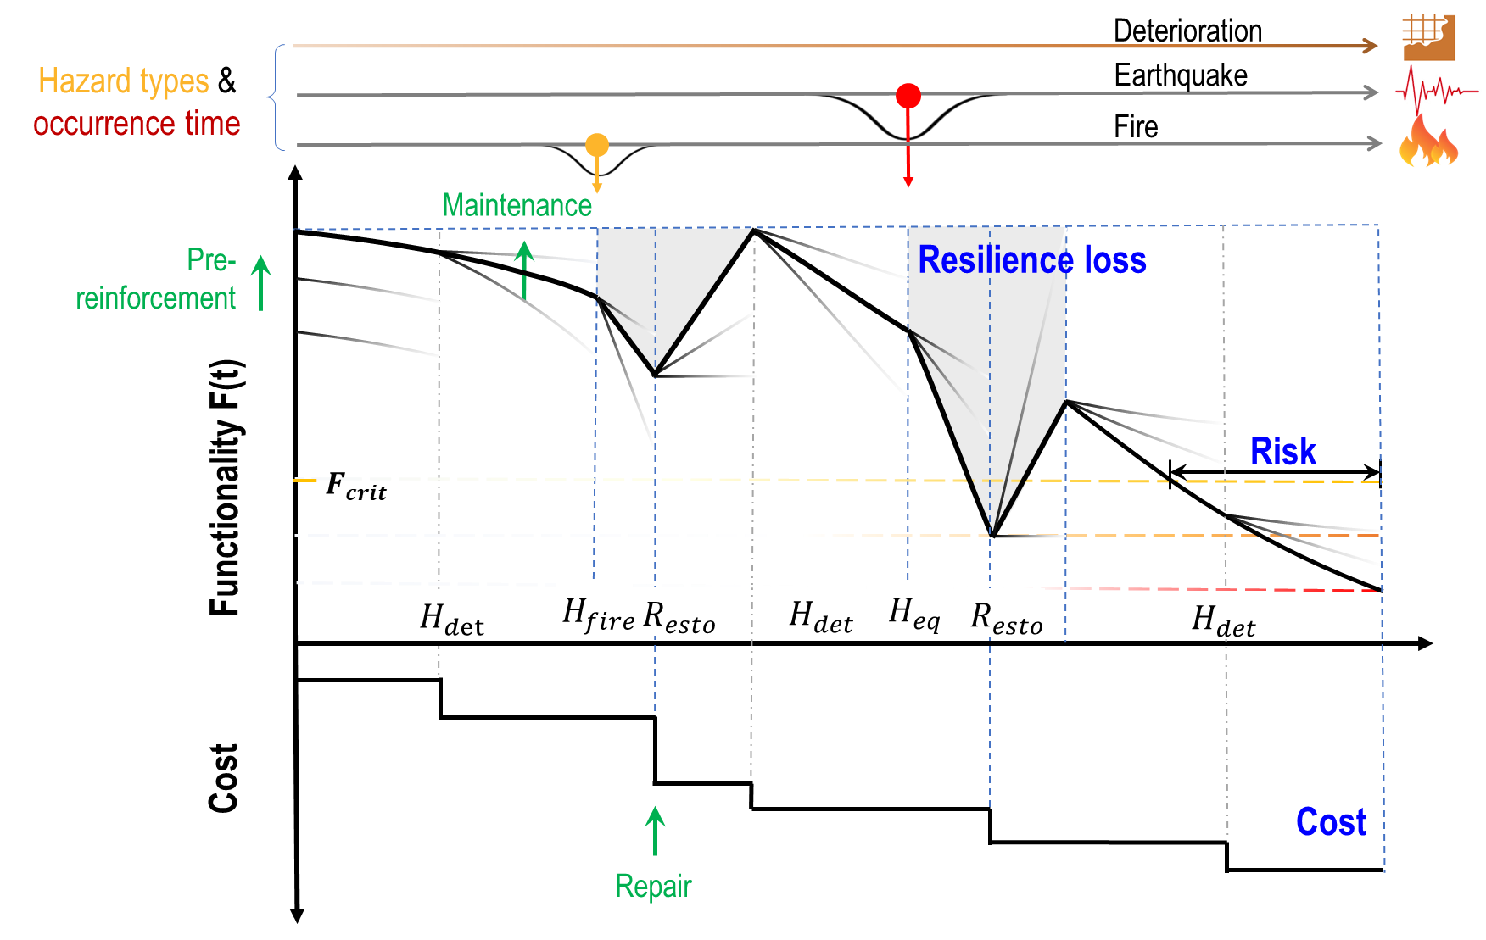
Figure 1. Conceptual plot of lifecycle performance, total cost, resilience loss, and exposure risk under a multi-hazard scenario ($H_{det}$, $H_{fire}$, $H_{eq}$, and $R_{esto}$ denote deterioration hazard, fire hazard, earthquake hazard, and repair-induced restoration, respectively).

3. Simulation-informed modelling
This section presents the proposed methodology for lifecycle performance modelling and management of infrastructure systems under multiple hazards. The approach starts with localised numerical modelling to enable offline quantification of progressive deterioration and abrupt hazard effects, based on which performance degradation levels, deterioration rates, and intervention effects at different grades are calibrated. These quantified models are then integrated into a RL framework for adaptive lifecycle decision-making under uncertainty, and the overall workflow is finally summarised in a unified framework diagram.

3.1 Modelling of initial state and hazards
Traditional reliability-based analyses often rely on simplified empirical assumptions to characterize progressive deterioration and disturbance-induced functionality loss. However, the linkage between these empirical assumptions and the underlying physical mechanisms is generally weak. Moreover, developing differentiated representations for infrastructure systems with diverse functional roles, complex spatial geometries, and heterogeneous geological conditions remains a significant challenge. To address these limitations, this paper adopts localized numerical modelling to a priori quantify progressive deterioration, abrupt disturbances, and the effects of intervention measures. A set of discrete states is introduced to represent typical intensity levels, enabling a graded and physically interpretable description of these processes.

A horseshoe-shaped highway tunnel is adopted as a case study to demonstrate the proposed framework and analysis procedure. The structure layout is illustrated in Figure 2a: a deep-buried tunnel with a single-layer concrete lining 0.5 m thick. The model has dimensions of 50 m × 100 m × 100 m (Figure 2b). The tunnel depth is 50 m, and groundwater influence is not considered in this paper. Structural functionality is evaluated using a generalized indicator, namely the damage level (D), defined as the ratio of the failed lining volume (V_{D}) to the total volume (V_{total}) within the observed section. This indicator provides a direct and physically interpretable measure of the structural performance of the tunnel lining (Figure 2c). The damage level D is used as a structural-state proxy rather than a direct measure of socio-economic loss. This macro-scale indicator of tunnel lining condition can be consistently quantified from numerical simulations. The higher-level consequences considered in the risk model, such as traffic disruption, partial closure, emergency response, and safety concern, are not simulated directly from traffic-flow or economic models. Instead, they are conditionally mapped from ranges of D. To ensure modelling consistency and comparability, widely accepted constitutive models are employed. The surrounding rock mass is represented using an elasto-plastic constitutive model based on the Mohr-Coulomb failure criterion. A concrete damage model is adopted for the tunnel lining and invert backfill, while an elastic constitutive model is used for the rock bolts. The simulation procedures and mechanical parameters for the initial state are summarized in Appendix A1.

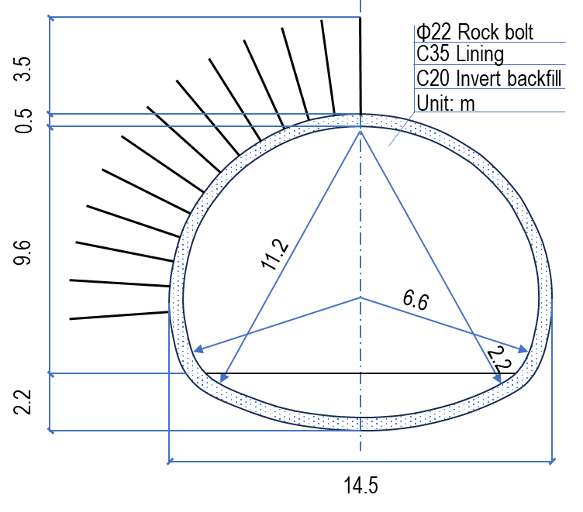 | 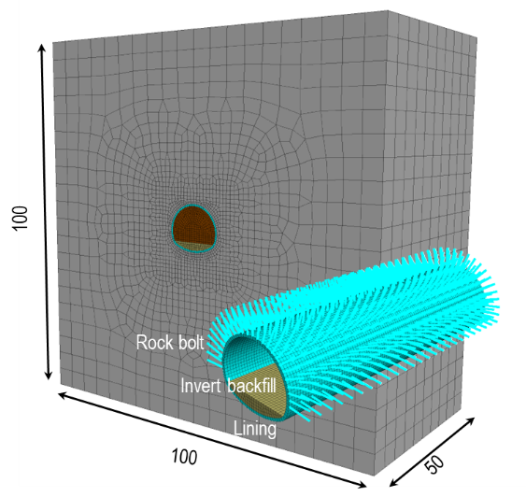
(a) | (b)
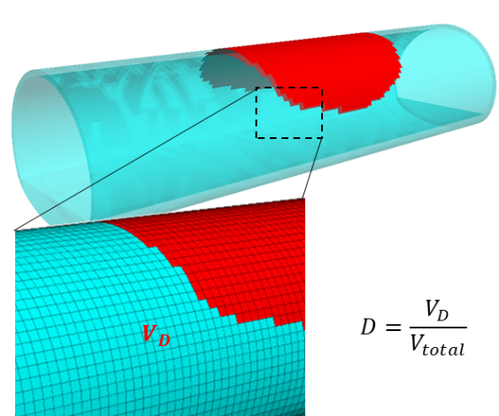
(c)
Figure 2. Modelling setup and functionality definition: (a) tunnel section design, (b) numerical model layout, and (c) definition of damage level D
Based on the established highway tunnel model, multiple hazard scenarios can be simulated. In this paper, three representative hazards are selected for demonstration: progressive deterioration, earthquake, and fire. Progressive deterioration is considered first, as the capacity of newly constructed tunnels to withstand abrupt hazards of the same intensity can differ significantly from that of tunnels subjected to long-term degradation. In this study, deterioration arises primarily from the coupled effects of structural ageing of the lining and creep deformation of the surrounding rock mass, as detailed in Appendix A2. Earthquakes are taken as a representative low-frequency but high-consequence abrupt hazard affecting infrastructure systems, and the corresponding numerical implementation is described in Appendix A3. Fire is considered a relatively high-frequency abrupt hazard in highway tunnels and is typically triggered by traffic accidents; its modelling procedure is provided in Appendix A4. The representative results and corresponding damage level evolution for each hazard scenario are summarised in Table 1.
Table 1. Representative results and damage level evolution for each hazard
Hazard type | Representative results from light/moderate to severe damage | Damage level evolution
$$H_{det}$$ | 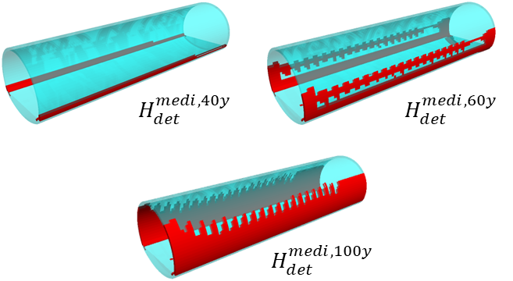
$$H_{eq}$$ | 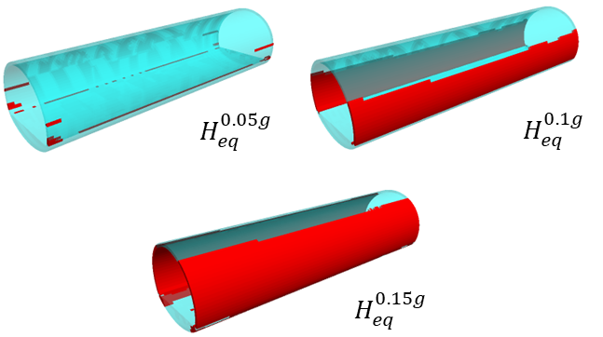
$$H_{fire}$$ | 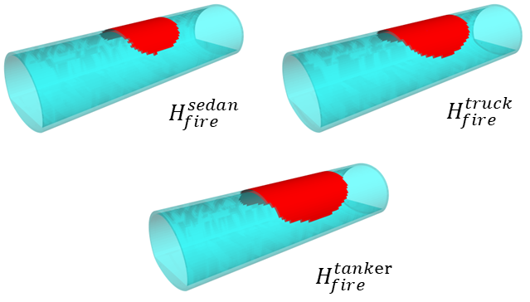

3.2 Offline quantification

3.2.1 Abrupt disturbances
The occurrence timeof abrupt disturbance events is assumed to follow a Poisson process. The hazard intensityis discretised into three representative levels (low, medium, and high), resulting in a compound Poisson process defined as
wheredenotes the total number of hazard events occurring within the service life T. Multiple types of abrupt disturbances may occur during the lifecycle. In the present case implementation, the occurrence processes of earthquakes and fires are assumed to be statistically independent to construct a tractable stochastic lifecycle environment for policy optimisation. This assumption does not imply that cascading hazard mechanisms are physically negligible. Conditional occurrence effects, such as earthquake-induced fire, are not explicitly modelled in the current implementation and are identified as an important extension for future work.

The consequences associated with different hazard intensity levels have been quantified in advance through numerical simulations. In this paper, earthquakes and fires are selected as two typical abrupt disturbances with distinct characteristics: the former has a lower frequency but greater destructive power, while the latter has a higher frequency but lower destructive power. In the present study, both hazard intensity and intervention levels are discretised into three representative grades to obtain a tractable, interpretable policy space for a proof-of-concept demonstration. The performance losses associated with each type of abrupt disturbance and intensity level, quantified via numerical simulation, are summarized in Table 2.
Table 2. The calibrated performance losses ($ΔF$) corresponding to each hazard
Level\Hazard type | Earthquake | Fire
Low | 0.1 | 0.1
Medium | 0.4 | 0.2
High | 0.7 | 0.3

3.2.2 Progressive deterioration
The progressive deterioration of the infrastructure system is characterised using a damage-based representation calibrated from quantified numerical simulation results. The average deterioration trend is approximated using a Weibull-type saturating function, expressed as
wheredenotes the normalised accumulated damage at time,is the prescribed damage level at the end of the service life T,is a characteristic time parameter governing the deterioration rate, andis a shape parameter controlling the nonlinearity of the damage evolution. In this project, denote low, medium, and high deterioration levels, respectively,years,, and years, as shown in Figure 3.
Figure 3. Weibull-type progressive deterioration function

3.3 Intervention actions setting
At a discrete decision time, the system state vector is defined as [45]
Whererepresents the normalised lifecycle time. The action spaceconsists of three categories of intervention actions, each described by discrete intensity levels [46]:
where 0, 1, and 2 denote no, moderate, and high levels of intervention, respectively. Pre-reinforcement actions are implemented only at the initial stage of the service life. Maintenance decisionsare updated periodically during operation (e.g., every 10 years). Repair actionsare triggered exclusively upon the occurrence of abrupt disturbance events.

The discrete action spaceis defined to represent different levels of intervention actions, where 0, 1, and 2 denote no, moderate, and high levels of intervention, respectively. Pre-reinforcement actionsare implemented only at the initial stage of the service life. Since the damage level D is adopted as the performance indicator, the functionality is defined as F=1−D. For an initially intact structure, D=0, and therefore . Directly increasing ​ to represent pre-reinforcement would exceed the physical range of the normalised functionality indicator. Therefore, the pre-reinforcement effect is represented by an equivalent reduction in the critical threshold , which reflects an enlarged effective safety margin under the same damage-based functionality scale. This treatment is an equivalent representation within the current simplified intervention setting, rather than a complete physical description of all possible pre-reinforcement mechanisms.
Maintenance decisionsare updated periodically during operation (e.g., once every 10 years) and correspond to high, medium, and low levels of progressive deterioration, respectively, reflecting the effectiveness of maintenance in slowing deterioration. Repair actionsare triggered exclusively following the occurrence of abrupt disturbance events and correspond to performance recovery levels, and the upper limit is 1.0.

4. RL-based evaluation

4.1 Problem formulation
The lifecycle management problem is formulated as a sequential decision process, in which intervention actions are selected at discrete decision epochs based on the evolving system state [47-49]. The state representation captures the current functionality and lifecycle stage, while the action space comprises pre-reinforcement, maintenance, and repair measures. To support adaptive decision-making over a long-term horizon, a RL framework is adopted, in which intervention strategies are represented by a parameterised policy and optimised with respect to cumulative lifecycle performance. The policy is updated through interaction with the environment to maximise the expected return over the service life, thereby accounting for the delayed effects of early-stage decisions. The mathematical formulation of the policy optimisation process is introduced as follows.

In the present study, the multi-objective lifecycle management problem is addressed through a weighted-sum scalarisation of resilience loss, lifecycle cost, and lifecycle risk. The lifecycle decision problem is formulated as a finite-horizon Markov decision process (MDP). The objective of policy optimisation is to maximise the expected cumulative reward over the entire service life,
wheredenotes the number of decision steps.
The instantaneous rewardis defined based on the evaluation metrics introduced previously,
where,, and represent the incremental resilience loss, lifecycle cost, and lifecycle risk at time, respectively, and,, andare weighting coefficients [50-52].
Consider the discount factor () for cost evaluation, its metric can be expressed in terms of Net Present Value (NPV). In subsequent RL training and result analysis, three metrics are evaluated by following form.
The methodological framework adopted in this paper is illustrated in Figure 4. The process starts with numerical modelling of the target infrastructure system based on its geometric configuration, ground conditions, and structural profiles, from which the initial performance state is established. On this basis, different levels of progressive deterioration functions and abrupt disturbance-induced damage are quantified and calibrated in advance through numerical simulations. These calibrated models collectively define a physics-informed environment, within which a large number of potential lifecycle performance paths can be generated. Each lifecycle performance path represents a possible evolution trajectory of system functionality over the service life. Any instant along a path corresponds to a snapshot of system performance, which is formalised as a statein the state space. Starting from the initial state, lifecycle performance evolves under the combined effects of continuous progressive deterioration and stochastic abrupt disturbances. This evolution is further influenced by intervention actions, including pre-reinforcement, maintenance, and repair, which together constitute the action space. The selection of intervention actions dynamically alters the subsequent performance trajectory by modifying initial conditions, deterioration characteristics, or post-disturbance recovery levels. Decision-making within this environment is guided by a state-dependent reward function, which evaluates the incremental lifecycle consequences of resilience loss, risk, and cost at each decision step. A cross-entropy method (CEM) based optimisation updates the intervention strategy adaptively based on observed states and accumulated rewards, thereby enabling the identification of optimal lifecycle performance paths through continuous interaction with the environment.
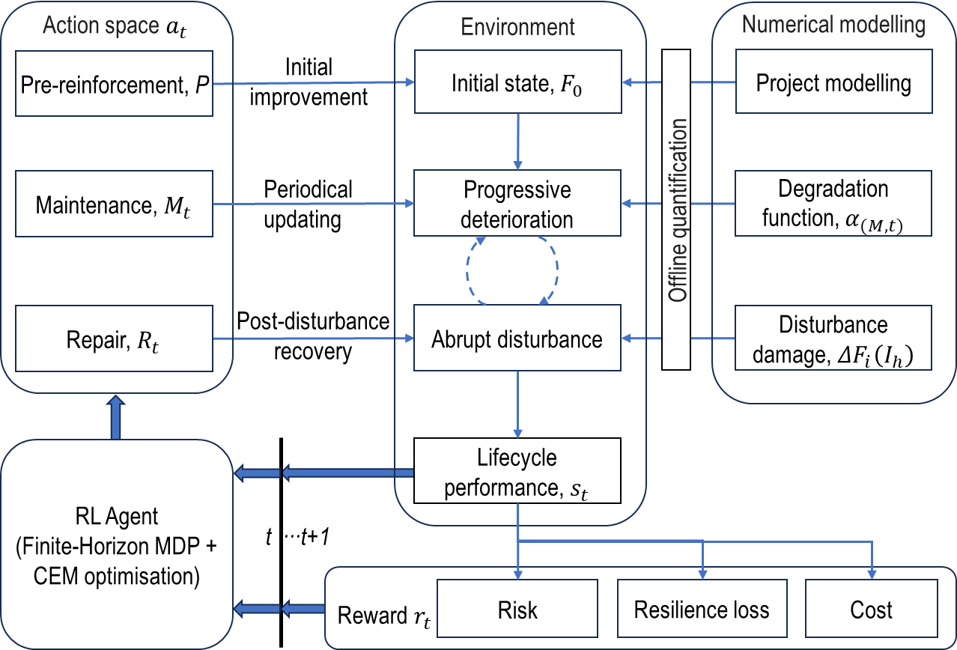
Figure 4. Overall framework of the proposed RL-based lifecycle management approach

4.2 Policy optimisation formulation
While the general RL formulation described above allows flexible policy representations, directly optimising a high-dimensional policy may lead to unstable training and limited interpretability in engineering decision-making. To ensure practical applicability and improve the transparency of intervention strategies, the lifecycle management policy is represented as a piecewise decision policy, in which intervention levels are determined by the current functionality state of the infrastructure system. To improve engineering interpretability and training stability, the intervention strategy is represented by a phase-threshold-based policy and optimised using the CEM, a population-based stochastic search scheme suitable for simulation-based lifecycle decision problems [53].
Under this formulation, the lifecycle intervention strategy is parameterised by a finite set of policy variables that govern the selection of pre-reinforcement, maintenance, and repair actions during the service life. The goal is to optimise a lifecycle intervention policy under progressive deterioration and recurrent hazards by minimising a weighted sum of resilience loss, lifecycle cost, and threshold-triggered risk, with an additional feasibility penalty. Three types of intervention actions are considered in the policy (policy parameters):
  - Pre-reinforcement level.
  - Maintenance levelis selected periodically based on the current functionality state.
  - The repair levelis determined based on the post-disturbance functionality state.
Through this piecewise formulation, the lifecycle decision strategy can be expressed as a parameterised policy, where and define the functionality intervals governing maintenance and repair actions that may be updated repeatedly during the operational lifecycle.
The objective is to identify the policy parameters that minimise the expected lifecycle consequence,
Under this formulation, the lifecycle decision problem is transformed into an optimisation problem over the policy parameter space.

4.3 Lifecycle environment and objective
To evaluate candidate intervention policies, a lifecycle simulation environment is constructed to represent the combined effects of progressive deterioration, stochastic disturbances, and intervention actions on infrastructure performance. The environment integrates deterioration and disturbance, and their reductions are enabled by the intervention rules introduced in Section 3.2, enabling the generation of possible lifecycle performance trajectories under different policies. Within this environment, system functionality evolves due to progressive deterioration and abrupt disturbance-induced damage, while intervention actions modify the evolution path by enhancing initial performance, mitigating deterioration, or restoring functionality after disturbances. The lifecycle evaluation is conducted through episodic simulation, where each episode represents a possible realisation of infrastructure performance over the service life.

The lifecycle environment adopted in this paper is intended as a decoupled, first-order approximation of tunnel performance evolution rather than a real-time coupled RL-mechanics simulation engine. Specifically, the effects of progressive deterioration arising from lining ageing and surrounding-rock creep, as well as earthquake- and fire-induced damage, are quantified offline through localised numerical simulations and then mapped to a macro-scale functionality indicator, namely the damage level, which is defined as the ratio of failed lining volume to total lining volume. At this aggregated performance level, separately calibrated deterioration trajectories and hazard-induced performance drops provide a computationally tractable surrogate for generating a large number of lifecycle trajectories for Monte Carlo-based policy evaluation and CEM optimisation. This representation is appropriate for long-horizon screening of intervention strategies with respect to resilience loss, lifecycle cost, and threshold-triggered risk. The simplifications adopted in this paper, including the decoupled lifecycle environment, the macro-scale damage indicator, and the coarse-grained intervention/action levels, are introduced not as claims of full physical realism, but as necessary abstractions to make long-horizon stochastic policy screening computationally feasible and interpretable.

Starting from the initial state, the system state is updated sequentially as deterioration, disturbances, and intervention actions occur. At each decision step, the intervention action is selected based on the policy parameters, and the incremental resilience loss, lifecycle cost, and lifecycle risk are calculated and accumulated. Because disturbance occurrence and intensity are stochastic, multiple episodes are simulated to estimate the expected lifecycle performance of a candidate policy. The recovery time is defined in three levels: 0.5, 1, and 1.5 years, respectively, which correspond to the typical repair times for tunnel fire and earthquake damage [54]. These durations are explicitly used to define the post-hazard recovery trajectory. In the implementation, the repair rate is kept consistent across repair schemes (such as ), and the selected recovery duration determines the corresponding recovered functionality magnitude. During the recovery period, resilience loss and risk are accumulated according to the time-dependent functionality path. The simulation procedure is summarised in Algorithm 1.
Algorithm 1 SIMULATEEPISODE (cfg, , seed)
- Require: Lifecycle configuration cfg; policy parameters ; random seed seed
- Ensure: Trajectory and metrics ()
- Initialise RNG with seed
- Set effective threshold
- for to do
- if and maintenance is due then
- Select
- end if
- Apply deterioration increment:
- Sample hazard counts
- if then
- Sample event losses by hazard type/level and set total hazard drop;
- Select repair and update with the discounted repair cost
- Start a short transition process (drop+recovery) with total duration and recovery magnitude , using equal-magnitude up/down slopes
- end if
- Accumulate resilience loss:
- if then
- end if
- if then
- end if
- end for
- return
- return episode metrics and trajectories

4.4 CEM optimisation
The optimisation of the lifecycle intervention policy is performed using the CEM, a population-based stochastic optimisation approach suitable for simulation-based decision problems[55-57]. Since the threshold-based policy is evaluated through lifecycle simulations under stochastic hazard realisations, analytical gradients of the expected return are generally unavailable. For the low-dimensional and interpretable policy representation adopted in this study, CEM provides a suitable derivative-free direct policy-search approach by iteratively sampling candidate policies and updating the sampling distribution using elite samples.

In each CEM iteration, a population of 𝑁 candidate parameter vectors is sampled from the current search distribution. Each candidate is evaluated over 𝑀 Monte Carlo lifecycle episodes using independent random seeds to estimate the expected objective. The top 𝜌𝑁 elite samples are retained, and the distribution parameters are updated from the elite subset. Continuous threshold parameters are updated through their elite means and standard deviations, while discrete action parameters are updated through elite categorical frequencies. Threshold-order constraints are enforced after sampling to maintain an interpretable policy structure. The optimisation runs for iterations, and the final policy is selected as the best-performing candidate, re-evaluated under an independent seed set. The optimisation is governed by the CEM population size, the elite fraction, the distribution-update rule, and the number of evaluation episodes. For policy search, each candidate is evaluated on 𝑀_{train} Monte Carlo episodes per iteration. After optimisation, the selected policy is re-evaluated on an independent set of 𝑀_{test} episodes with different random seeds to report the final performance.

For each sampled parameter vector, lifecycle simulations are conducted to evaluate the cumulative consequences in terms of resilience loss, lifecycle cost, and lifecycle risk. Candidate policies are then ranked by performance, and an elite subset is used to update the sampling distribution. Through repeated iterations, the distribution gradually concentrates around high-performing policy parameters. Algorithm 2 evaluates a candidate policy parameter vector by averaging its lifecycle return over multiple Monte Carlo episodes. Algorithm 3 performs CEM-based direct policy search by iteratively sampling candidate policy parameters, selecting elite policies, and updating the sampling distribution.
Algorithm 2 EVALUATEPARAMS (cfg, , baseSeed,)
- Require: cfg, policy parameters , base seed, number of episodes
- Ensure: Monte Carlo estimates of
- fortodo
- Run SIMULATEEPISODEand store metrics
- end for
- return best policy $θ^{⋆}$ and logs/trajectories

Algorithm 3 TRAINCEM (cfg, cemCfg)
- Require: cfg; CEM settings (iterations, population size, elite fraction, eval episodes, seed)
- Ensure: Best policy parametersand optimisation history
- Initialise sampling distribution over continuous thresholds and categorical
- forto cemCfg.iterations−1 do
- Sample a populationfrom the current distribution
- Evaluate each candidate by EVALUATEPARAMS
- Select top-K elites by highest expected return
- Update distribution parameters using elite samples (means/stds; categorical probabilities)
- Record best-of-iteration metrics and a representative trajectory for plotting
- end for
- return best policyand logs/trajectories

5. Specific cases
For each case in this section, two intervention policies are compared: a predefined fixed-rule policy and a CEM-optimised threshold policy. The predefined fixed-rule policy uses manually specified functionality thresholds and serves as a transparent reference. Specifically, when, no intervention is applied; when, a moderate intervention level is adopted; and when, the highest intervention level is triggered. The CEM-optimised threshold policy is trained separately for each case using the corresponding hazard occurrence rates and objective weights, so that the reported optimised policy is scenario-specific rather than transferred from the baseline case.
Three groups of cases are considered to demonstrate the learned policy: (i) baseline lifecycle policy, (ii) hazard-dominant comparison, and (iii) preference-driven decision trade-offs. For each case, we report a representative lifecycle performance pathwith intervention timing, along with the corresponding cost trajectory. The baseline case represents a balanced multi-hazard management scenario, while the hazard-dominant cases highlight how the intervention strategy adapts when one hazard becomes more prominent. The preference-driven cases further illustrate how different objective weightings influence the trade-offs among resilience, lifecycle cost, and risk. The parameter settings for the considered cases, including hazard occurrence rates and objective weights, are summarised in Table 3. The cost-related and risk penalty parameters used in the cases are summarised in Table 4. The cost values are expressed in dimensionless relative cost units, rather than actual monetary values. They are used to represent the relative economic burden among different intervention levels. The discount factor γ is set as 3%, which is typical for the public infrastructure projects [43, 58, 59].
Table 3: Case scenarios and associated parameters (hazard rates and objective weights)
Case | Subgroup | Hazard rates $(λ_{Eq},λ_{Fire})$ | Weights $(ω_{1},ω_{2},ω_{3})$
1 | Baseline | $$(1/35,1/3.42)$$ | $$(1/3,1/3,1/3)$$
2a | Fire-dominant | $$(1/70,2/3.42)$$ | $$(1/3,1/3,1/3)$$
2b | Earthquake-dominant | $$(2/35,1/6.84)$$ | $$(1/3,1/3,1/3)$$
3a | Cost-oriented | same as Case 1 | $$(0.15,0.70,0.15)$$
3b | Risk-oriented | same as Case 1 | $$(0.15,0.15,0.70)$$
3c | Resilience-oriented | same as Case 1 | $$(0.70,0.15,0.15)$$

Table 4: Relative cost and risk-penalty parameters
Parameter | Low | Medium | High
Pre-reinforcement cost | 10 | 20 | 30
Maintenance cost | 0.0 | 0.8 | 2.0
Repair cost | 0.0 | 3.0 | 10.0
Risk penalty | 1.0 | 4.0 | 10.0

5.1 Case 1: Baseline scenario
Case 1 serves as a baseline to verify that the framework operates stably and produces an interpretable lifecycle performance path under a common multi-hazard environment. The learned policy should coordinate periodical maintenance with post-disturbance repair to maintain functionality above, while controlling discounted lifecycle expenditures [45, 46, 60]. Figure 5a illustrates the evolution of lifecycle functionality under case 1. The red curve represents the initial fixed-ruled policy, which is introduced at the beginning of this section. The blue curves show intermediate trajectories obtained during the optimisation process, while the green curve represents final RL-optimised policy. It should be noted that the recovery segments may appear nearly vertical in the lifecycle plots because the recovery duration is relatively short compared with the 100-year horizontal time scale. The recovery process is nevertheless evaluated as a finite-duration trajectory in the simulation. Compared with the initial policy, the optimised policy results in a slight increase in lifecycle cost, from approximately 95.8 to 94.5 (about 1.4%; Figure 5b). In addition, the resilience loss decreases from approximately 16.0 to 7.6 (about 52.5%, Figure 5c), and the risk decreases from about 14.6 to 5.6 (about 61.6%, Figure 5d). Overall, the optimised policy yields simultaneous improvements in functionality, lifecycle cost, resilience loss, and risk relative to the initial policy in the baseline scenario.

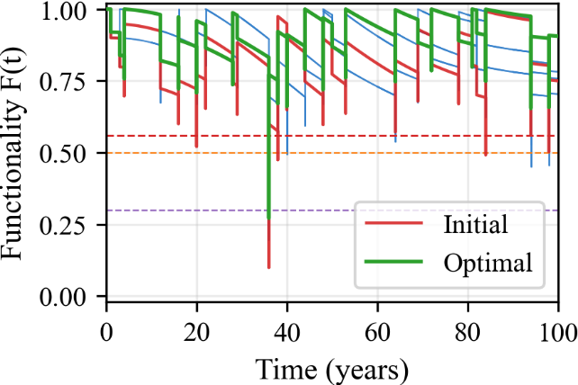 | 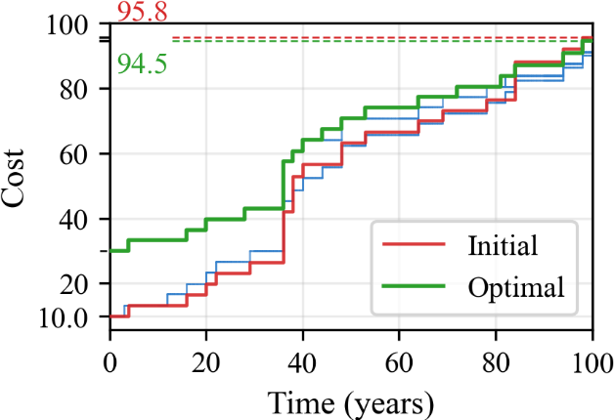
(a) F(t) | (b) Cost
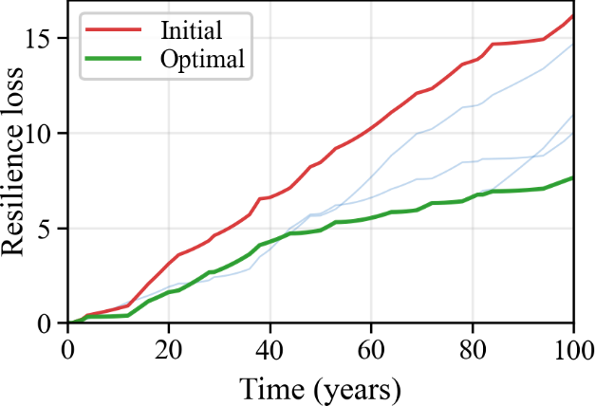 | 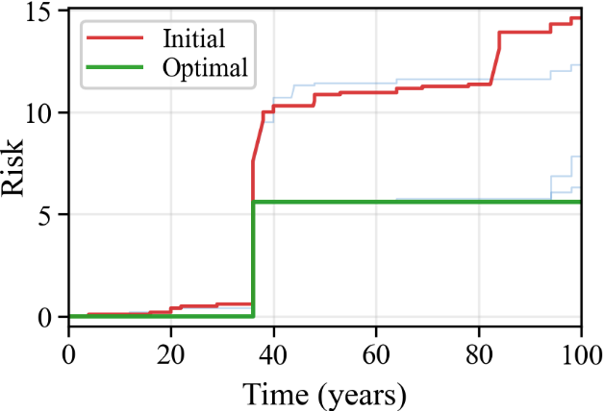
(c) Resilience loss | (d) Risk
Figure 5. Baseline: iteration trajectories for functionality, cost, resilience loss, and risk (case 1)

5.2 Case 2: Hazard-dominant scenarios
Cases 2a and 2b investigate hazard-specific adaptations by altering the frequencies of hazard occurrences. For the fire-dominant case (Case 2a), the optimised policy tends to respond more frequently to hazard-induced performance drops through timely repair actions, allowing the system functionality to recover rapidly after disturbance events (Figure 6a). Compared with the initial policy, the lifecycle cost changes from approximately 123.6 to 111.2 (about 10.0%, Figure 6b), while the risk varies from 18.5 to 14.0 (about 24.3%, Figure 6c). Meanwhile, the resilience loss decreases from 17.0 to 5.0 (about 70.6%, Figure 6d), indicating that the optimised policy effectively mitigates repeated performance degradation under frequent hazard occurrences. For the earthquake-dominant case (Case 2b), the intervention strategy shifts towards more conservative lifecycle management [61-63]. In this scenario, maintenance and repair actions are scheduled to better prepare the system for rare but severe disturbances (Figure 7a). As a result, the lifecycle cost changes from approximately 100.4 to 85.9 (about 14.4%, Figure 7b), while the risk varies from 16.8 to 11.8 (about 29.8%, Figure 7c). The resilience loss is reduced from 31.0 to 6.0 (about 80.6%, Figure 7d), reflecting improved system robustness against high-impact hazard events. Overall, the results demonstrate that the proposed optimisation framework can adapt intervention strategies to different hazard characteristics, achieving appropriate trade-offs among resilience, lifecycle cost, and risk across varying disturbance regimes.
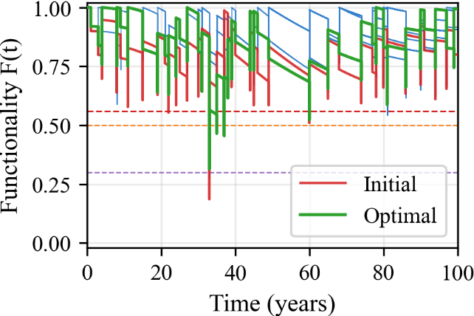 | 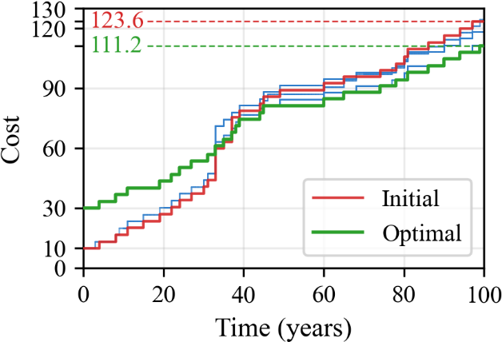
(a) F(t) | (b) Cost
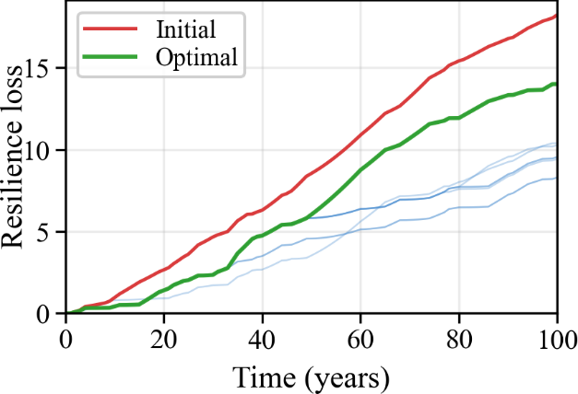 | 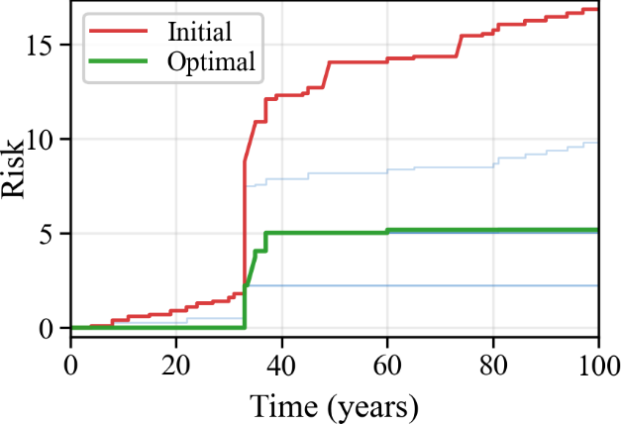
(c) Resilience loss | (d) Risk
Figure 6. Hazard-dominant scenarios: fire-dominant (case 2a)
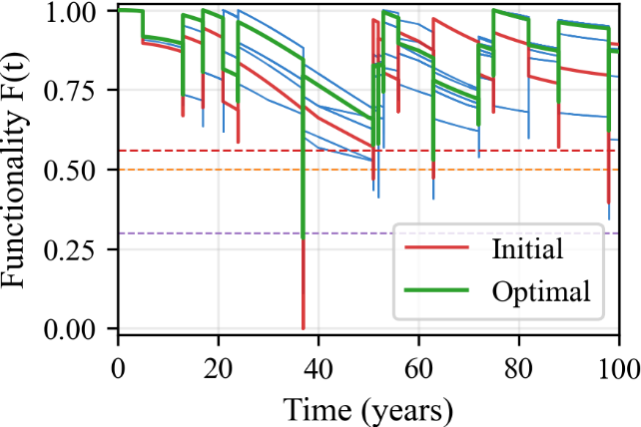 | 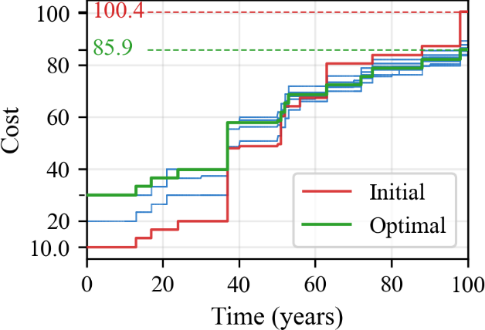
(a) F(t) | (b) cost
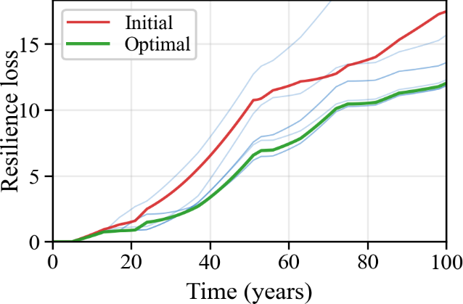 | 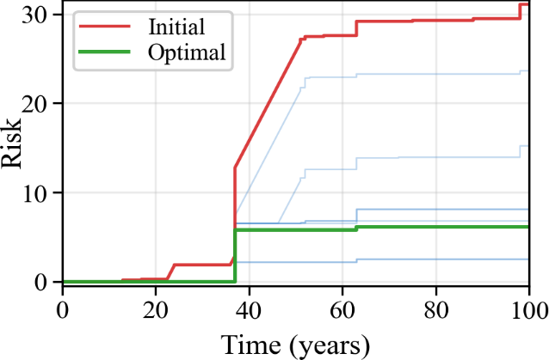
(c) Resilience loss | (d) Risk
Figure 7. Hazard-dominant scenarios: earthquake-dominant (case 2b)

5.3 Case 3: Preference-driven decision trade-offs
Cases 3a, 3b, and 3c study the effect of preference weights by adjusting objective weights while keeping hazard rates consistent with the baseline. Cost-oriented settings encourage conservative spending with increased tolerance of performance degradation; risk-oriented settings favour avoiding prolonged exposure below $F_{crit}$; resilience-oriented settings primarily reduce the performance-loss area. Comparing these cases highlights how the framework supports explicit trade-offs among resilience, risk, and cost [51, 52]. Under the cost-oriented setting (Case 3a, Figure 8a), the optimisation prioritises minimising lifecycle expenditure. As a result, the intervention strategy becomes more conservative, allowing greater tolerance for temporary functionality degradation. The lifecycle cost changes from approximately 95.8 to 86.8 (about 9.3%, Figure 8b), while the resilience loss and risk vary from 15.7 to 15.2 (about 3.2%, Figure 8c) and 14.6 to 21.2 (an increase of about 45.2%, Figure 8d), respectively. Under the cost-oriented setting (case 3a), the optimisation prioritises minimising lifecycle expenditure. As a result, the intervention strategy becomes more conservative, with fewer or weaker maintenance and repair actions over the service life. This reduction in intervention effort lowers lifecycle costs but also allows the system to remain in degraded or unacceptable functionality states for longer. Since the risk term in this paper is activated when functionality falls below the critical threshold, the increased duration of low-functionality states directly leads to higher accumulated lifecycle risk. Therefore, the higher risk observed in Case 3a is a reasonable consequence of the cost-oriented preference: spending less on intervention is achieved at the expense of accepting greater risk exposure. In the risk-oriented scenario (Case 3b, Figure 9a), the learned policy focuses on reducing the duration of system states below the critical threshold. Compared with the baseline policy, the risk decreases from 14.6 to 5.6 (about 61.6%, Figure 9d), while the lifecycle cost and resilience loss change from 95.8 to 94.5 (about 1.4%, Figure 9b) and 16.4 to 7.6 (about 53.7%, Figure 9c), respectively. For the resilience-oriented case (Case 3c, Figure 10a), the optimisation primarily aims to minimise the performance-loss area. Consequently, the intervention policy maintains higher functionality levels throughout the lifecycle. The resilience loss is reduced from 15.7 to 7.7 (about 51.0%, Figure 10c), while the lifecycle cost and risk change from 95.8 to 101.0 (an increase of about 5.4%, Figure 10b) and 14.6 to 5.6 (about 61.6%, Figure 10d), respectively. Overall, these results demonstrate that the proposed framework enables explicit control of trade-offs among lifecycle cost, risk, and resilience through adjustable objective weights. This case can serve as a simple non-learning threshold heuristic for the following case reference.
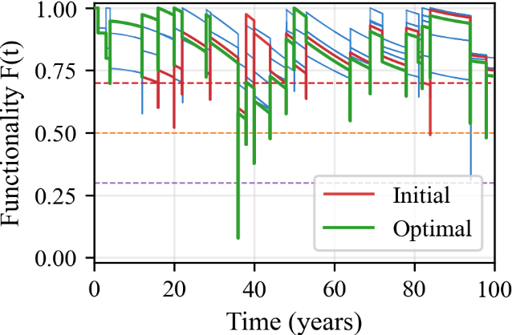 | 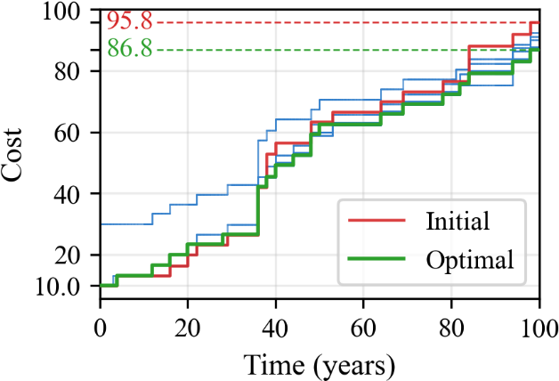
(a) F(t) | (b) Cost
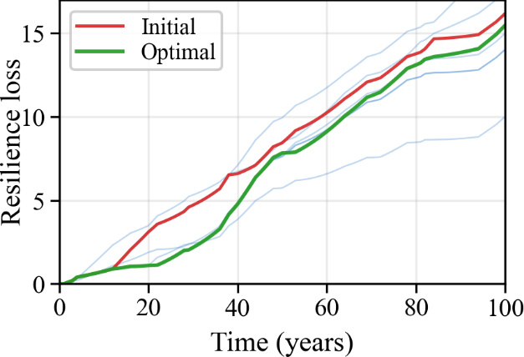 | 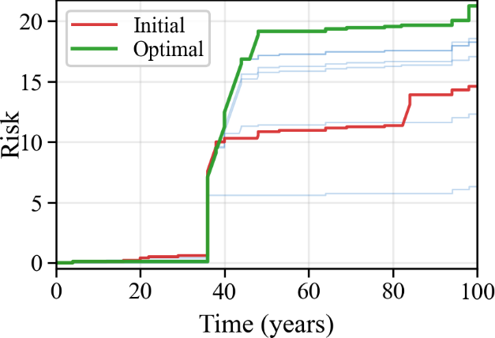
(c) Resilience loss | (d) Risk
Figure 8. Weight-orientation scenarios: cost-oriented (case 3a)
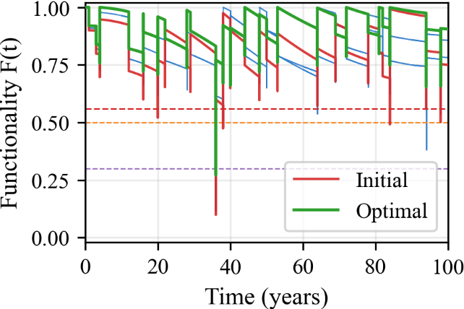 | 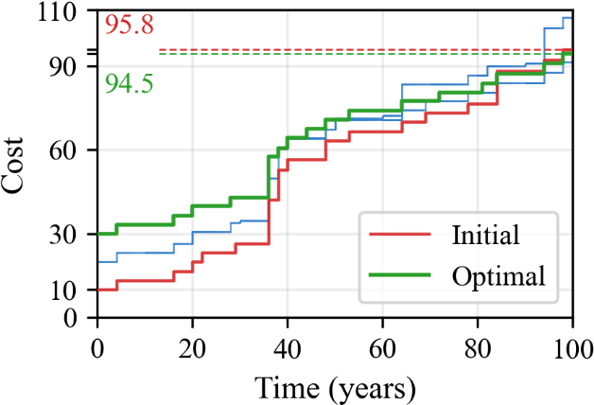
(a) F(t) | (b) Cost
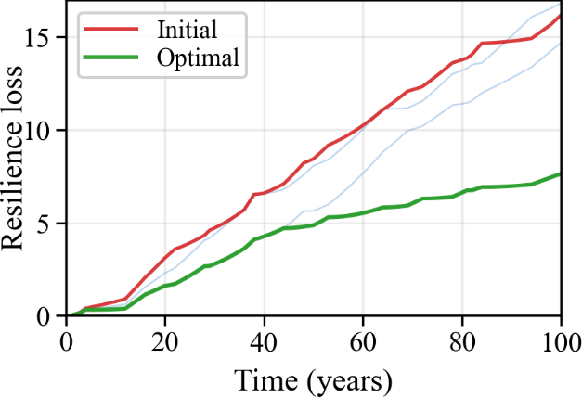 | 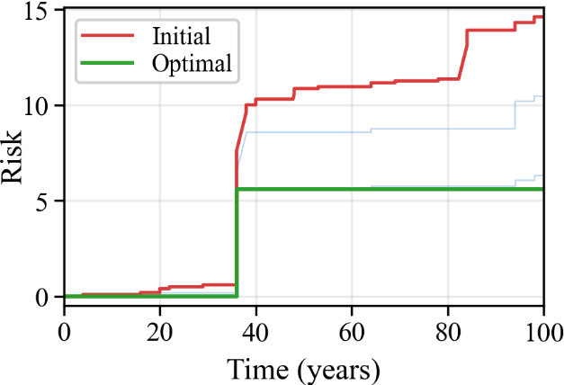
(c) Resilience loss | (d) Risk
Figure 9. Weight-orientation scenarios: risk-oriented (case 3b)
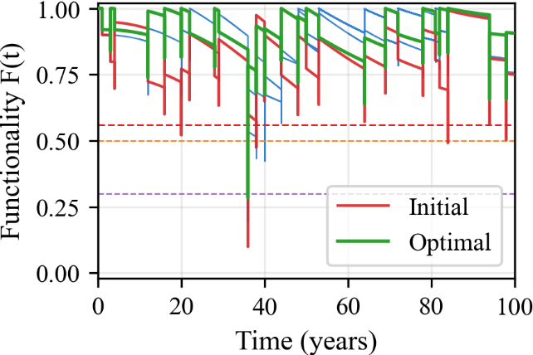 | 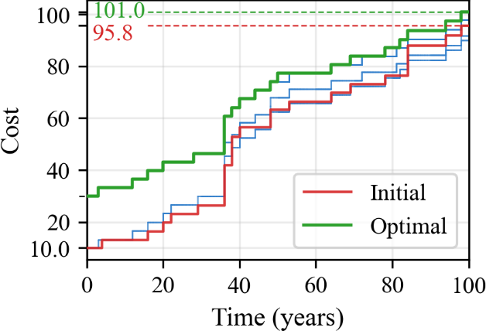
(a) F(t) | (b) Cost
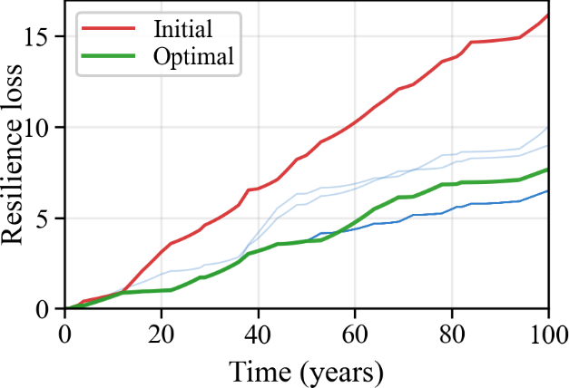 | 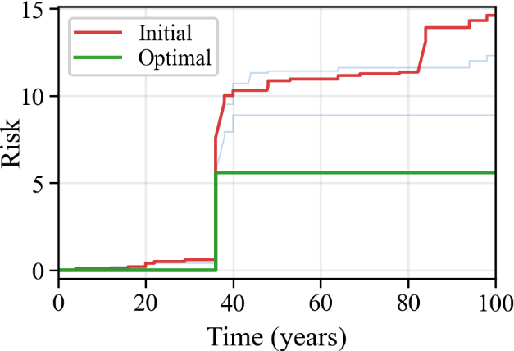
(c) Resilience loss | (d) Risk
Figure 10. Weight-orientation scenarios: resilience-oriented (case 3c)

5.4 Training dynamics and model convergence
To further interpret the optimisation behaviour of the proposed RL framework, Figure 11 summarises the learning and evaluation signals over 200 optimisation iterations. Figure 11a presents the normalised loss per step, which shows a clear decreasing trend and indicates stable convergence of the policy optimisation process. Notably, the convergence occurs relatively quickly (within approximately 30 iterations). This behaviour is expected because the lifecycle model represents a 100-year service horizon in which decisions are only triggered at discrete disturbance events, resulting in a relatively low number of decision points and a well-structured policy space. Figure 11b and c illustrate the evolution of resilience loss and risk per episode during training. Both indicators exhibit a generally decreasing trend, suggesting that the learned policy progressively improves lifecycle performance under stochastic hazard realisations. Figure 11d presents the reward per episode, which integrates resilience loss, threshold-triggered risk, and discounted cost into a single objective. The increasing (less negative) reward confirms that the CEM-based policy search gradually identifies intervention strategies that achieve better overall lifecycle performance. Together, these results demonstrate that the proposed RL framework can efficiently converge to a stable policy while improving resilience, risk control, and cost performance.
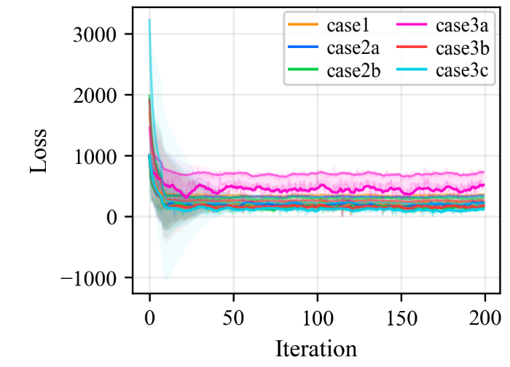 | 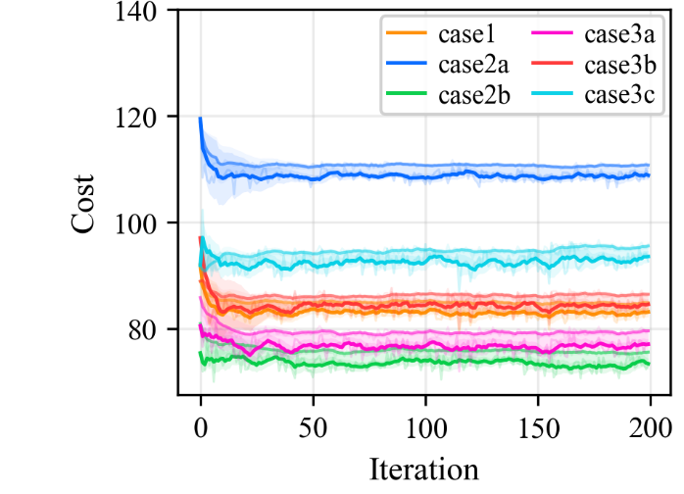
(a) Loss per step (normalised) | (b) Cost per episode
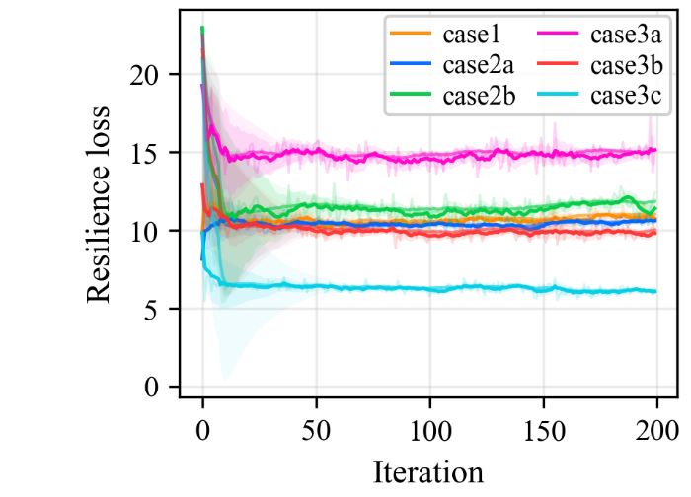 | 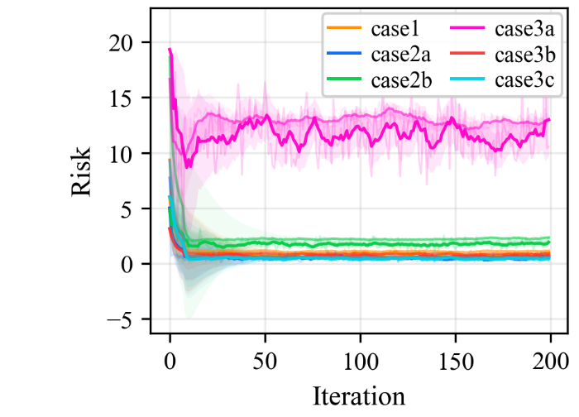
(c) Resilience loss per episode | (d) Risk per episode
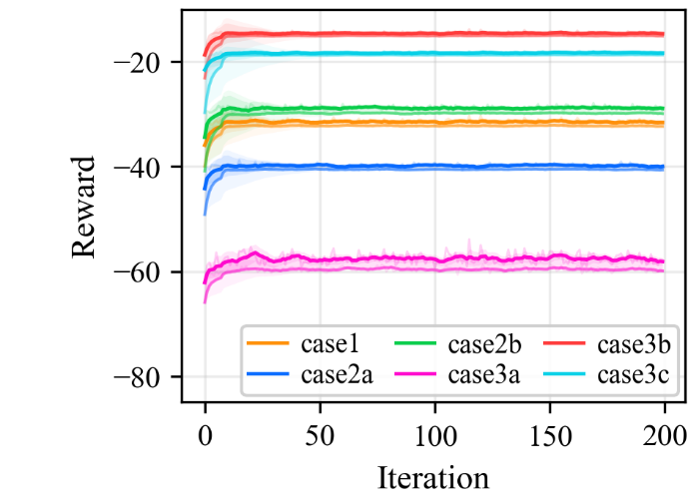
(e) Reward per episode
Figure 11. Training/evaluation curves over 200 optimisation iterations: (a) Loss per step (normalised), (b) Cost per episode, (c) Resilience loss per episode, (d) Risk per episode, and (e) Reward per episode

5.5 Ablation study on the RL model
Ablation studies are a standard method for evaluating the contribution of different components in a model by systematically removing or modifying them and observing the resulting performance changes [64-67]. In this paper, the baseline hazard setting is kept unchanged. To reduce stochastic bias, five scenarios are considered: the full default setting, no risk control, no resilience control, no cost control, and no pre-reinforcement control, shown in Table 5.
These selected indicators are designed to cover objective consistency, engineering safety, and economic sustainability simultaneously. Return is considered because it is the direct optimisation target and reflects the net effect of all weighted terms. Resilience loss is included because it captures long-duration functional degradation that may not trigger immediate repair but still reduces service quality over time. Risk is a key indicator because it measures risk exposure, which is safety-critical and warrants significant reward. Cost is used to represent discounted lifecycle expenditure and to reveal whether improved technical performance is achieved economically over the whole lifecycle. Min F is an indicator of the worst functional state encountered during operation. Together, these metrics provide a complete evaluation of whether a policy is balanced, rather than merely optimal in one dimension.
Table 5: Ablation study outcome of each metric
Variant | Return | Resilience loss | Risk | Cost | Min F
Default (baseline) | -33.4085 | 10.696 | 1.360 | 88.17 | 0.723
No risk | -48.9650 | 12.947 | 11.246 | 84.98 | 0.661
No resilience | -44.3841 | 14.314 | 2.468 | 86.30 | 0.687
No cost | -1.2068 | 1.940 | 0.474 | 223.19 | 0.900
No pre-reinforcement | -35.9014 | 10.397 | 7.293 | 90.01 | 0.707
No maintenance
No repair

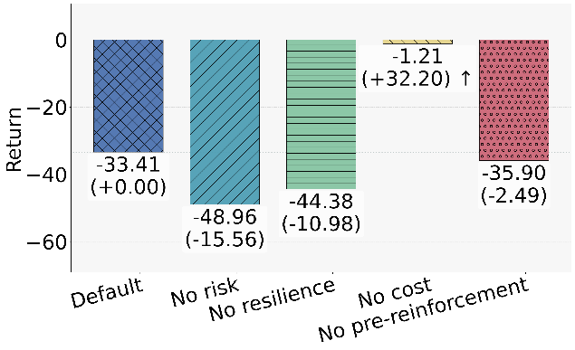 | 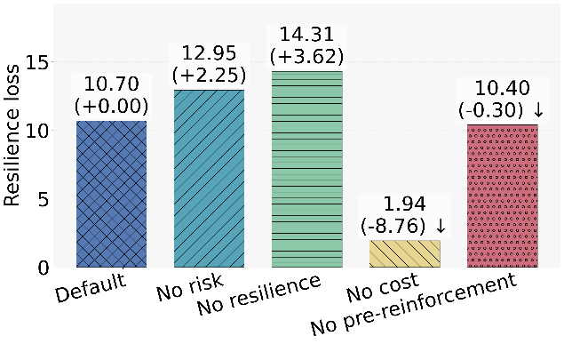
(a) Return | (b) Resilience loss
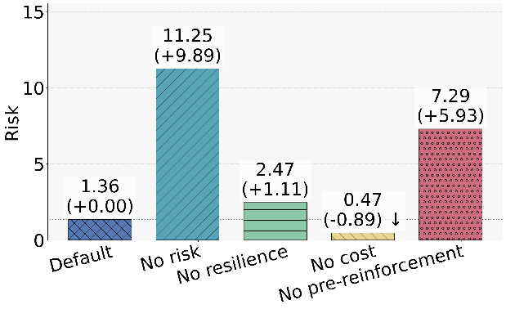 | 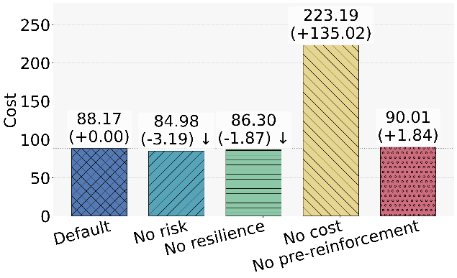
(c) Risk | (d) Cost
Figure 12. Ablation study on the RL model
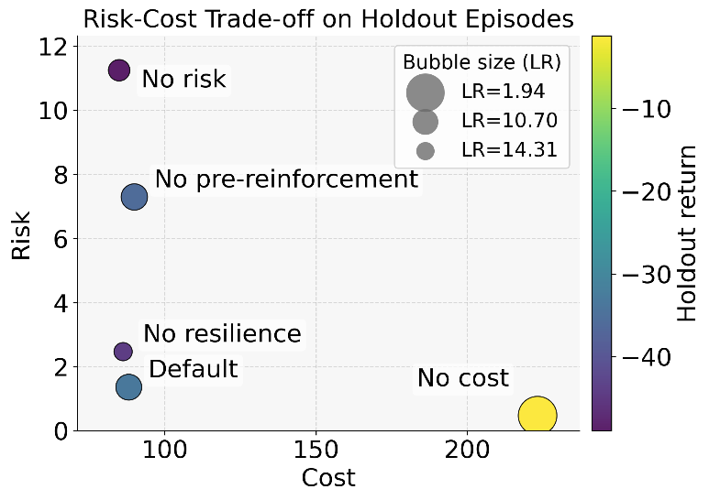
Figure 13. Multi-objective performance evaluation
Figure 12 highlights the complementary role of the four indicators. Each metric captures a distinct dimension of lifecycle performance, and no single metric is sufficient to represent the full engineering trade-off. From the ablation outcomes, none of the metrics can be ignored; each shows a clear functional role for each module. Removing risk control (no risk) sharply increases risk from 1.36 to 11.25, indicating that threshold-oriented risk penalisation is indispensable for suppressing high-consequence exposure. Removing resilience loss control (no resilience) increases resilience loss from 10.70 to 14.31, confirming that resilience loss control is essential for maintaining long-term functionality, not just for avoiding cost and risk. Removing pre-reinforcement (no pre-reinforcement) also causes a pronounced increase in risk from 1.36 to 7.29, highlighting that early strengthening provides effective protection throughout the lifecycle. The most informative contrast is no-cost control: this metric achieves the best return (- 1.21) and the lowest Resilience loss/risk (1.94/0.47), but at the cost of a dramatic increase from 88.17 to 223.19. This outcome shows that when the economic penalty is removed, the optimiser tends to over-invest in interventions to get better performance and safety. Therefore, high technical scores alone do not imply practical superiority unless lifecycle cost is jointly constrained. A geometric interpretation of the policy structure is provided in Figure 13. The horizontal axis represents cost in the economic evaluation, and the vertical axis represents safety exposure. Therefore, lower-left movement corresponds to jointly improved economic-safety efficiency. The bubble size for lower Resilience loss corresponds to larger bubbles, indicating that low risk is achieved with stable functional performance rather than aggressive expenditure. The return summarises objective-level preference consistency. This trade-off view shows that two policies with similar returns may differ substantially in practical acceptability once risk, cost, and resilience are examined simultaneously.

In summary, the ablation study supports the conclusion that this paper’s policy is a balanced design. It does not dominate every single metric, but it maintains a stable compromise among resilience loss, risk, and lifecycle expenditure under stochastic multi-hazard uncertainty. This paper’s method provides effective engineering decision support, where robustness and implementability are generally preferred over single-metric evaluation.

6. Discussion
The proposed RL framework provides a bridge between physics-informed lifecycle performance modelling and adaptive decision-making [34, 45, 68]. Its key strengths include: (i) explicit representation of multi-hazard scenarios through calibrated hazard processes, (ii) interpretable intervention actions aligned with practical management stages, and (iii) a reward structure that integrates resilience loss, risk exposure, and discounted cost within a unified optimisation objective.

Compared with manual decision-making and experience-driven strategy design, such as fixed maintenance schedules or hand-tuned threshold rules, the RL-based approach offers several practical advantages. First, it enables systematic exploration of high-dimensional decision spaces in which the interactions among reinforcement, maintenance, and repair are often non-intuitive under stochastic hazard arrivals. This reduces reliance on repeated manual tuning and helps avoid inconsistent or locally satisfactory decisions. Second, by optimising expected cumulative reward, the learned policy explicitly accounts for uncertainty and delayed consequences, thereby balancing immediate expenditure against long-term lifecycle benefits in a time-consistent manner [33-35, 37, 46]. Third, the threshold-triggered risk formulation allows the learning process to focus on rare but high-consequence states while still penalizing frequent moderate degradations through resilience loss, which is difficult to achieve reliably through manual weighting alone. In addition, once a calibrated environment is available, the same training framework can be reused across multiple scenarios, such as different hazard rates, cost structures, discount factors, or preference weights, allowing efficient sensitivity analysis and policy benchmarking. Finally, although CEM is used as the optimiser for RL, the resulting strategies remain interpretable in terms of threshold-based intervention logic and discrete action levels, which is important for engineering review and practical deployment.

Several limitations should nevertheless be acknowledged. The quality of the learned policies depends on the fidelity of the calibrated deterioration and hazard-impact models; uncertainties in hazard arrival rates, intensity distributions, or recovery effects may influence the resulting decisions. In addition, long-horizon optimisation under stochastic hazards remains computationally demanding when robust policy evaluation requires many simulated trajectories. The present study also adopts a three-level discretisation of intervention actions, which should be regarded as a coarse-grained engineering representation for proof-of-concept analysis rather than a full description of real intervention design. In practice, maintenance and repair involve more continuous choices in terms of material type, intervention extent, and execution quality, while hazard intensity is also continuous. More choices would enlarge the optimization space and may yield better strategies, but it would also substantially expand the search domain and increase the computational time. Under the current CEM-based optimisation setting, more granular decision rules are also in principle feasible, but would require larger sample sizes, more iterations, and tighter specification of the policy parameter space.

A further limitation concerns the construction of the lifecycle environment itself. In the present study, the effects of progressive deterioration and abrupt disturbances are first quantified through localised offline numerical simulations, from which representative patterns of functionality evolution are extracted and then linearly combined to form the RL optimization environment. This treatment makes policy search computationally tractable and enables the efficient exploration of a large number of lifecycle trajectories. However, the framework should therefore be understood as a first-order, decoupled approximation of the underlying physics rather than a fully coupled RL-mechanics model. In real infrastructure systems, interactions among hazards and deterioration processes may be nonlinear, path-dependent, and influenced by historical loading conditions [33-37], as discussed in the authors’ previous studies [9, 38]. Ideally, RL could be directly coupled with a high-fidelity mechanical model such that each decision sequence triggers a full lifecycle numerical analysis. However, at present, such an approach is computationally prohibitive, since a single lifecycle mechanical simulation may require days of iterative computation, making the number of trajectories needed for RL training infeasible in practice. From this perspective, the current framework is more appropriately viewed as an efficient screening tool for exploring a large scenario space and identifying a limited set of promising lifecycle strategies, which can then be examined in greater detail using higher-fidelity simulations in future work.

Finally, the present study adopts a weighted-sum scalarisation of resilience loss, lifecycle cost, and threshold-triggered risk in the reward function. This is a multi-target optimization task and does not recover the full Pareto set, which is more advanced in a nonlinear multi-objective RL task. But the present study focuses more on multi-discrete decision optimization. The full Pareto set is not suitable for the current task. At the same time, the scalarisation adopted here has several practical advantages for the present proof-of-concept study. It provides a transparent way to encode management preference through explicit objective weights and supports direct comparison across scenarios under a unified metric. This framework is more efficient and easier to implement than more advanced set-valued or Pareto-based formulations. These features are particularly important for long-horizon engineering problems that require repeated Monte Carlo evaluations, where computational tractability and interpretability remain critical considerations. Therefore, future research may proceed in two complementary directions: first, towards richer multi-objective policy search capable of generating non-dominated strategy sets for stakeholder selection; and second, towards a fully coupled RL-mechanics framework in which optimisation is performed directly on high-fidelity lifecycle simulations. These extensions would further improve both the physical fidelity and the decision richness of lifecycle infrastructure management under recurrent hazards.

The choice of CEM is also consistent with the interpretable policy design adopted in this study. Rather than learning a high-dimensional neural-network policy, the intervention strategy is represented by a small number of functionality-based thresholds that correspond to practical engineering rules. This leads to a low-dimensional direct policy-search problem, for which CEM is suitable and computationally efficient. Deep RL methods may become more advantageous in future extensions involving high-dimensional monitoring data, partially observable states, or large-scale infrastructure networks.

7. Conclusion
This paper presents a scenario-driven lifecycle management framework for infrastructure systems under multiple recurrent hazards. Through offline numerical modelling under asset-specific conditions, progressive deterioration processes and abrupt hazard-induced performance drops are characterised to construct a simulation-informed lifecycle decision environment. Within this environment, RL is employed to explore adaptive intervention strategies that coordinate pre-reinforcement, maintenance, and repair actions in response to probabilistic hazard occurrences. By comprehensively evaluating resilience loss, lifecycle cost, and risk exposure, the framework enables balanced decision-making for long-term infrastructure management. The following conclusions are drawn from this paper:

(1) A modular lifecycle modelling framework is established to characterise infrastructure performance evolution under both progressive deterioration and abrupt disturbances. Through localised numerical modelling and offline quantification of asset-specific conditions, key components, including initial performance, degradation trajectories, and hazard-induced performance drops, are systematically represented. This provides a physically interpretable basis for describing lifecycle behaviour and supports the construction of scenario-driven infrastructure management environments.

(2) An RL-based lifecycle decision-making formulation is developed to address the high-dimensional and stochastic nature of the problem. By modelling lifecycle performance as the environment, intervention measures (pre-reinforcement, maintenance, and repair) as actions, and resilience loss, cost, and risk as reward functions, a state-action-response learning structure is established. This enables the incorporation of probabilistic hazards, dynamic strategies, and delayed feedback within a unified optimisation framework.

(3) Scenario-based case studies demonstrate that the learned intervention policies can improve lifecycle performance compared with a predefined fixed-rule policy under the considered recurrent-hazard scenarios. Comparing a baseline policy, the RL framework shows substantial improvements across all considered scenarios. In addition, the learned policies exhibit strong adaptability to different hazard-dominance patterns and preference-driven objectives, thereby accommodating diverse operational requirements.

(4) The cross-entropy method (CEM) is employed to optimise the policy parameters by jointly considering resilience loss, lifecycle cost, and risk. The ablation analysis confirms that these three indicators are complementary and provide a more comprehensive basis for lifecycle decision-making than any single objective alone. The proposed framework, therefore, establishes a practical and effective decision-support paradigm for infrastructure lifecycle management under multi-recurrent hazards.

CRediT authorship contribution statement
Yimo Zhu: Conceptualization, Methodology, Writing-original draft, Writing-review & editing, Validation, Visualization, Formal analysis, Software; Shunjie Fu: Software, Visualization, Data curation, Writing-review & editing; Zhiyi Hunag: Conceptualization, Methodology; Zhuoran Tian: Software, Formal analysis, Data curation; Xiao Li: Supervision, Resources, Project administration, Writing-review & editing.

Declaration of competing interest
The authors declare that they have no known competing financial interests or personal relationships that could have appeared to influence the work reported in this paper.

Data availability
We share the data and code in our team’s https://github.com/sfuu0027-sys/Multi-hazard_RL

Acknowledgements
This work was financially supported by the Public Policy Research Funding Scheme (PPRFS, 2025.A8.168.25C). The first author would like to thank the financial support from Itasca Educational Partnership.

Appendix

A1. Initial state
The end state of the construction stage can be regarded as the initial state of the operational phase. Owing to the definition of functionality and variations in construction quality, the initial state does not necessarily correspond to 100% performance. In this paper, a mechanical cyclic excavation process with gradual advancement (2 m per cycle) is adopted for simulation, and each excavation cycle is solved until a steady state is reached. To account for support delay, the activation of lining zones is designed to lag behind the tunnel face by several excavation cycles, corresponding to a delay distance of 8 m in this paper. The parameters of geomaterials and tunnel structures involved are given in Table A1.
Table A1. The parameters of geomaterials and tunnel structures
Rock mass | Unit weight $γ$  (kN/m³) | Deformation modules $E_{m}$  (GPa) | Friction angle $ϕ$ (°) | Cohesion $c$  (MPa) | Poisson’s ratio $υ$ | Tensile strength $f_{t}$  (MPa)
 | 22 | 2 | 30 | 1 | 0.3 | 0.3
 | Dilation angle $ψ$ (°)
 | 5
Concrete | Young modules $E$  (GPa) | Poisson’s ratio $υ$ | Tensile strength $f_{t}$ (MPa) | Tension energy fracture$G_{t}$ | Tension length reference $l_{t}$ | Compressive strength $f_{c}$  (MPa)
Lining | 20 | 0.20 | 6 | 40 | 0.08 | 15
Backfill | 10 | 0.25 | 3 | 25 | 0.08 | 7.5
 | Compression energy fracture$G_{c}$ | Compression length reference $l_{c}$ | Initial tensile yield strength $f_{t0}$(MPa) | Initial compressive yield strength $f_{c0}$(MPa) | Damage in compression $d_{c}$ | Damage in tension $d_{t}$
Lining | 5500 | 0.08 | 3 | 9 | 300 | 1500
Backfill | 3000 | 0.08 | 1.5 | 4.5 | 200 | 1000
Rock bolt | Unit weight $γ$  (kN/m³) | Young modules $E$  (GPa) | Poisson’s ratio $υ$ | Spacing (m)
 | 78 | 200 | 0.3 | 2.5

A2. Deterioration
The effect of either structural ageing or creep deformation alone may be relatively negligible; however, it becomes significant when the two processes act in combination [38, 69]. From a numerical modelling perspective, creep modelling establishes a feasible long-term simulation domain for capturing parameter decay associated with structural degradation. Since both creep and ageing are long-term hazards, their combined effect is incorporated and referred to as the deterioration hazard in this paper. The Burgers-Mohr model is employed to describe the time-dependent behaviour of the formation, and the parameters are listed in Table A2. The square brackets in the table indicate the range of rock creep parameters. Long-term creep is considered only for the surrounding rock mass, as it dominates time-dependent deformation and stress redistribution, while concrete creep is neglected due to its limited influence over the service life and to avoid unnecessary expansion of the lifecycle optimisation state space. The degradation of concrete structural parameters with age is illustrated in Figure 14. Ageing effects are assumed to initiate after a specified onset time, which is set to 10 years in this paper. The parameters adjusted to account for ageing can be broadly classified into strength-related and stiffness-related properties. A linear degradation model is adopted, with three degradation levels (low, medium, and high). At 100 years, the corresponding residual ratios are 0.8, 0.6, and 0.4, respectively.
Table A2. The creep parameters in the Burgers-Mohr model
 | Unit weight $γ$ (kN/m³) | Deformation modules  $E$ (GPa) | Poisson’s ratio $υ$ | Friction angle  $ϕ$ (°) | Cohesion $c$ (MPa)
Rock mass | 22 | 2 | 0.3 | 30 | 1
 | Maxwell shear modulus $G^{M}$ (GPa) | Maxwell viscosity property $η^{M}$ (GPa∙year) | Kelvin shear modulus $G^{K}$  (GPa) | Kelvin viscosity property $η^{K}$ (GPa∙year)
Rock mass | [0.1, 0.5] | [11, 84] | [0.1, 0.7] | [1.2, 4.5]

Figure 14. Degradation curves of concrete structure

A3. Earthquake
An earthquake is a typical abrupt hazard to the underground infrastructure, especially in a seismic-prone area. A local group of synthetic seismic waves is established according to the Eurocode 8 [70], as shown in Figure 15. Ground motion intensity is characterised by the peak ground acceleration (PGA), with values of 0.05 g, 0.1 g, and 0.15 g, respectively. This intensity range is commonly adopted in seismic design and assessment of underground infrastructure, as it is sufficiently strong to induce structural damage while maintaining a non-negligible probability of occurrence. Extreme seismic events with much lower probabilities that would almost certainly lead to structural failure are therefore not considered in this paper. The duration and the maximum frequency are 10s and 20Hz, respectively. Dynamic configurations are enabled as shown schematically in Figure 16: the model’s side boundaries are simulated using free-field boundary conditions for an infinite domain. A viscous boundary is applied at the bottom, and seismic loads are converted into stress forms [71] and input from the bottom of the model. The damping model adopts Maxwell damping, with a 0.5% damping ratio [72]. A linear increase in seismic intensity does not necessarily correspond to a linear increase in structural damage. Once the tunnel lining enters a nonlinear damage-propagation stage, the same increment in acceleration may lead to a much larger increase in the damage indicator. Therefore, compared with subjective assumptions, numerical quantification provides a more physically grounded basis for characterising hazard-induced performance loss under asset-specific structural and geological conditions.

 | 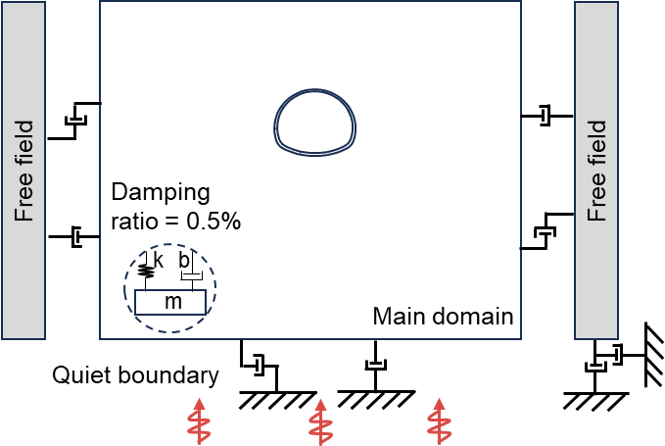
Figure 15. Synthetic wave based on Eurocode 8 | Figure 16. Boundary conditions in dynamic modelling

A4. Fire
Fires in road tunnels are primarily caused by traffic accidents involving vehicles. In numerical simulations of tunnel fires, thermal loading is commonly prescribed using empirical temperature-time fitting curves. Several typical empirical fire curves are illustrated in Figure 17 [73, 74]. In this paper, the RABT-ZTV (car) fire curve is adopted to represent the tunnel fire scenario.

High temperatures affect concrete materials and structural behaviour, resulting in irreversible loss of strength and stiffness due to thermal damage and thermal decohesion. These equations have proven reliable for normal-weight concrete. Concrete at high temperatures exhibits a strain-softening behaviour [75-77]. This paper adopts a linear simplification in which the strength of concrete decreases linearly with increasing temperature and decays to 100 at 1200℃, as shown in Figure 18.
$$f_{c,t}^{'}=k_{T}f_{c,t}$$
where $f_{c,t}^{'}$ (MPa) is temperature-dependent compressive/tensile strength, calculated from the original compressive design strength $f_{ck}$ (MPa), using a strength reduction factor $k_{T}$.

In this paper, three fire scenarios with increasing severity are considered, corresponding to a sedan, a truck, and a tanker, with fire durations of 30, 60, and 90 minutes, respectively. The flow of that methodology is illustrated in Figure 19 below. The first step is to select a temperature-time curve of tunnel fire, and the flame plume location is determined based on the fire source position, wind speed, and tunnel height, which then defines the applied range of the thermal field. Finally, the mechanical state and damage zones resulting from the tunnel fire are calculated using thermal-coupling simulations and a thermal-damage function. It is worth noting that the thermo-mechanical coupling simulation conducted in FLAC3D in this section adopts a one-way coupling approach. The thermal field influences the mechanical field through thermal strain and thermal damage, but the mechanical field does not reciprocally affect the thermal field. The soil and concrete parameters for the thermal-mechanical model are listed in Table A3.
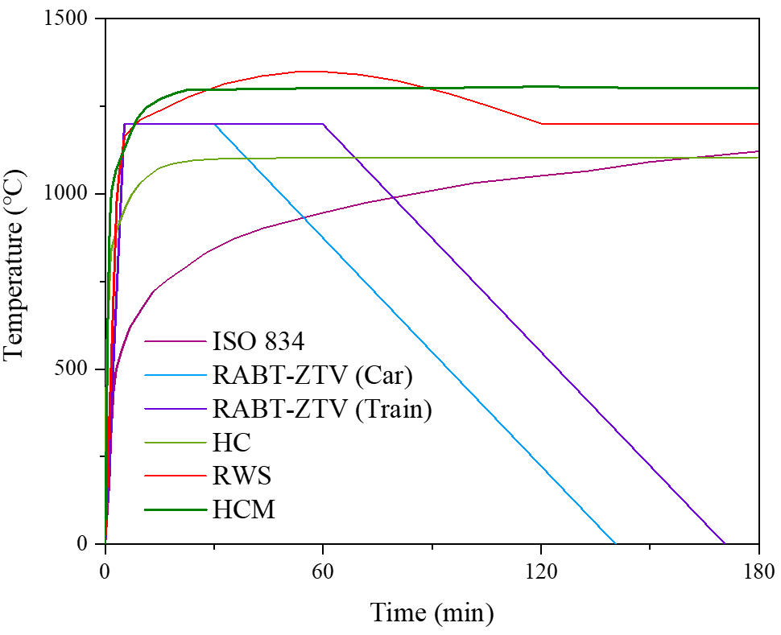
Figure 17. Empirical temperature-time curves for tunnel fire | Figure 18. Strength reduction curve for concrete under thermal damage

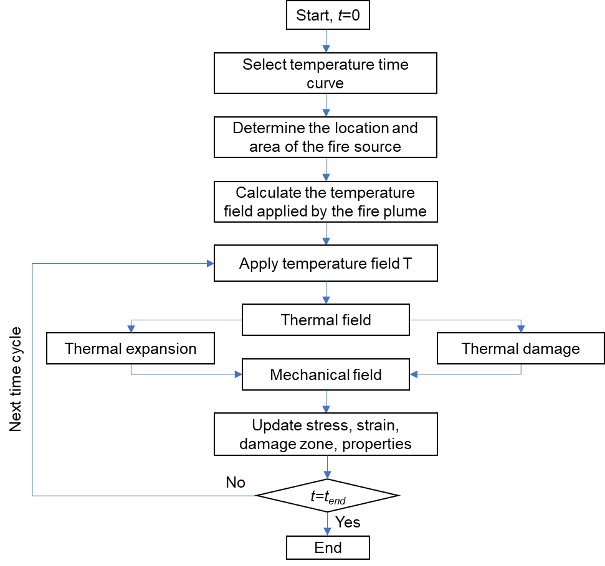
Figure 19. Fire damage modelling in FLAC3D
Table A3. The parameters of soil and concrete in the thermal-mechanical model
Materials | Thermal conductivity $λ$ (W/(m∙K)) | Specific heat capacity $C_{p}$ (J/(kg∙K)) | Thermal expansion coefficient α  (×10⁻⁶/°C) | Thermal degradation factor $k_{T}$
Rock mass | 1.5 | 1000 | 10 | -
Concrete | 2.3 | 1000 | 9 | 1-(T-100)/1100
$T$ is temperature (°C)

Reference
[1] Gutiérrez F, Parise M, De Waele J, Jourde H. A review on natural and human-induced geohazards and impacts in karst. Earth-Science Reviews. 2014;138:61-88.
[2] Young S, Balluz L, Malilay J. Natural and technologic hazardous material releases during and after natural disasters: a review. Science of the total environment. 2004;322:3-20.
[3] UNDRR. Sendai Framework Terminology On Disaster Risk Reduction: Hazard 2023.
[4] Klein RJ, Nicholls RJ, Thomalla F. Resilience to natural hazards: How useful is this concept? Global environmental change part B: environmental hazards. 2003;5:35-45.
[5] Hao H, Bi K, Chen W, Pham TM, Li J. Towards next generation design of sustainable, durable, multi-hazard resistant, resilient, and smart civil engineering structures. Engineering Structures. 2023;277:115477.
[6] FEMA. Multi-Hazard Mitigation Planning Guidance Under the Disaster Mitigation Act of 2000. In: Agency FEM, editor.2008.
[7] Dilley M. Natural disaster hotspots: a global risk analysis: World Bank Publications; 2005.
[8] Schipper L, Pelling M. Disaster risk, climate change and international development: scope for, and challenges to, integration. Disasters. 2006;30:19-38.
[9] Zhu Y, Zhang Q-B. Lifecycle resilience and sustainability trade-offs for underground infrastructure under multi-hazard scenarios. Reliability Engineering & System Safety. 2026;267:111797.
[10] Gomez C, Baker JW. An optimization-based decision support framework for coupled pre-and post-earthquake infrastructure risk management. Structural Safety. 2019;77:1-9.
[11] Frangopol DM, Bocchini P. Bridge network performance, maintenance and optimisation under uncertainty: Accomplishments and challenges. Structure and Infrastructure Engineering. 2012;8:341-56.
[12] Mazumder RK, Salman AM, Li Y. Post-disaster sequential recovery planning for water distribution systems using topological and hydraulic metrics. Structure and Infrastructure Engineering. 2022;18:728-43.
[13] Frangopol DM, Saydam D, Kim S. Maintenance, management, life-cycle design and performance of structures and infrastructures: a brief review. Structure and infrastructure engineering. 2012;8:1-25.
[14] Frangopol DM. Life-cycle performance, management, and optimisation of structural systems under uncertainty: accomplishments and challenges 1. Structure and Infrastructure Engineering. 2011;7:389-413.
[15] Wang T, Chen H-M. Integration of building information modeling and project management in construction project life cycle. Automation in Construction. 2023;150:104832.
[16] Junnila S, Horvath A. Life-cycle environmental effects of an office building. Journal of Infrastructure systems. 2003;9:157-66.
[17] Zuluaga S, Sánchez-Silva M. The value of flexibility and sequential decision-making in maintenance strategies of infrastructure systems. Structural Safety. 2020;84:101916.
[18] Otárola K, Iannacone L, Gentile R, Galasso C. Multi-hazard life-cycle consequence analysis of deteriorating engineering systems. Structural Safety. 2024;111:102515.
[19] Bocchini P, Frangopol DM, Ummenhofer T, Zinke T. Resilience and Sustainability of Civil Infrastructure: Toward a Unified Approach. Journal of Infrastructure Systems. 2014;20:04014004.
[20] Frangopol DM, Liu M. Maintenance and management of civil infrastructure based on condition, safety, optimization, and life-cycle cost. Structures and Infrastructure Systems. 2019:96-108.
[21] Argyroudis SA, Mitoulis SA, Hofer L, Zanini MA, Tubaldi E, Frangopol DM. Resilience assessment framework for critical infrastructure in a multi-hazard environment: Case study on transport assets. Science of The Total Environment. 2020;714:136854.
[22] Dong Y, Frangopol DM. Risk and resilience assessment of bridges under mainshock and aftershocks incorporating uncertainties. Engineering Structures. 2015;83:198-208.
[23] Peng Z, Li J, Hao H. Structural damage detection via phase space based manifold learning under changing environmental and operational conditions. Engineering Structures. 2022;263:114420.
[24] Jia G, Taflanidis AA. Kriging metamodeling for approximation of high-dimensional wave and surge responses in real-time storm/hurricane risk assessment. Computer Methods in Applied Mechanics and Engineering. 2013;261-262:24-38.
[25] Abdulhai B, Kattan L. Reinforcement learning: Introduction to theory and potential for transport applications. Canadian Journal of Civil Engineering. 2003;30:981-91.
[26] Jeong JH, Jo H. Deep reinforcement learning for automated design of reinforced concrete structures. Computer‐Aided Civil and Infrastructure Engineering. 2021;36:1508-29.
[27] Wu J, Ye Y, Du J. Multi-objective reinforcement learning for autonomous drone navigation in urban areas with wind zones. Automation in construction. 2024;158:105253.
[28] Lee D, Kim M. Autonomous construction hoist system based on deep reinforcement learning in high-rise building construction. Automation in Construction. 2021;128:103737.
[29] Zhang N, Alipour A. A stochastic programming approach to enhance the resilience of infrastructure under weather-related risk. Computer-Aided Civil and Infrastructure Engineering. 2023;38:411-32.
[30] Barone G, Frangopol DM. Reliability, risk and lifetime distributions as performance indicators for life-cycle maintenance of deteriorating structures. Reliability Engineering & System Safety. 2014;123:21-37.
[31] Ellingwood BR. Risk-informed condition assessment of civil infrastructure: state of practice and research issues. Structure and infrastructure engineering. 2005;1:7-18.
[32] Smilowitz K, Madanat S. Optimal inspection and maintenance policies for infrastructure networks. Computer‐Aided Civil and Infrastructure Engineering. 2000;15:5-13.
[33] Achiam J, Held D, Tamar A, Abbeel P. Constrained policy optimization. International Conference on Machine Learning: PMLR; 2017. p. 22-31.
[34] Arcieri G, Hoelzl C, Schwery O, Straub D, Papakonstantinou KG, Chatzi E. POMDP inference and robust solution via deep reinforcement learning: an application to railway optimal maintenance. Machine Learning. 2024;113:7967-95.
[35] Cheng J, Cheng M, Liu Y, Wu J, Li W, Frangopol DM. Knowledge transfer for adaptive maintenance policy optimization in engineering fleets based on meta-reinforcement learning. Reliability Engineering & System Safety. 2024;247:110127.
[36] Taherkhani A, Mo W, Bell E, Han F. Towards equitable infrastructure asset management: Scour maintenance strategy for aging bridge systems in flood-prone zones using deep reinforcement learning. Sustainable Cities and Society. 2024;114:105792.
[37] Wang B, Nguyen H, Lu Q, Zhang Q, Li M. A reinforcement learning approach to network-level maintenance planning of co-located road and water infrastructures with interdependencies. Reliability Engineering & System Safety. 2026;267:111889.
[38] Zhu Y, Zhang Q-B. Modelling and assessing lifetime resilience of underground infrastructure to multiple hazards: Toward a unified approach. Tunnelling and Underground Space Technology. 2025;156:106212.
[39] Yang DY, Frangopol DM. Life-cycle management of deteriorating civil infrastructure considering resilience to lifetime hazards: A general approach based on renewal-reward processes. Reliability Engineering & System Safety. 2019;183:197-212.
[40] Lounis Z, McAllister TP. Risk-Based Decision Making for Sustainable and Resilient Infrastructure Systems. Journal of Structural Engineering. 2016;142:F4016005.
[41] Highways ONs. Federal Highway Administration. US Department of Transportation. 2011.
[42] Boussabaine A, Kirkham R. Simulation of maintenance costs in UK local authority sport centres. Construction Management and Economics. 2004;22:1011-20.
[43] Walls J, Smith MR. Life-cycle cost analysis in pavement design: Interim technical bulletin. United States. Federal Highway Administration; 1998.
[44] Wang J, Koizumi A, Tanaka H. Framework for maintenance management of shield tunnel using structural performance and life cycle cost as indicators. Structure and Infrastructure Engineering. 2017;13:44-54.
[45] Wei S, Bao Y, Li H. Optimal policy for structure maintenance: A deep reinforcement learning framework. Structural Safety. 2020;83:101906.
[46] Andriotis CP, Papakonstantinou KG. Deep reinforcement learning driven inspection and maintenance planning under incomplete information and constraints. Reliability Engineering & System Safety. 2021;212:107551.
[47] Kaelbling LP, Littman ML, Moore AW. Reinforcement Learning: A Survey. Journal of Artificial Intelligence Research. 1996;4:237-85.
[48] Li Y. Deep reinforcement learning: an overview. 2018.
[49] Szepesvári C. Algorithms for reinforcement learning: Springer Nature; 2022.
[50] García J, Fernández F. A comprehensive survey on safe reinforcement learning. Journal of Machine Learning Research. 2015;16:1437-80.
[51] Hayes CF, Rădulescu R, Bargiacchi E, Källström J, Macfarlane M, Reymond M, et al. A practical guide to multi-objective reinforcement learning and planning. Autonomous Agents and Multi-Agent Systems. 2022;36:26.
[52] Moffaert KV, Nowé A. Multi-objective reinforcement learning using sets of pareto dominating policies. Journal of Machine Learning Research. 2014;15:3663-92.
[53] Sigaud O, Stulp F. Policy search in continuous action domains: an overview. Neural Networks. 2019;113:28-40.
[54] Caliendo C. EXPERIENCE WITH SIGNIFICANT INCIDENTS IN ROAD TUNNELS. EXPERIENCE WITH SIGNIFICANT INCIDENTS IN ROAD TUNNELS: World Road Association (PIARC); 2017. p. 1-68.
[55] Pinneri C, Sawant S, Blaes S, Achterhold J, Stueckler J, Rolinek M, et al. Sample-efficient cross-entropy method for real-time planning. Conference on Robot Learning: PMLR; 2021. p. 1049-65.
[56] Pourchot A, Sigaud O. CEM-RL: Combining evolutionary and gradient-based methods for policy search. arXiv preprint arXiv:181001222. 2018.
[57] Mannor S, Rubinstein RY, Gat Y. The cross entropy method for fast policy search. Proceedings of the 20th international conference on machine learning (ICML-03)2003. p. 512-9.
[58] Beatty TL. Life-cycle cost analysis primer. US Department of Transportation: Federal Highway Administration. 2002.
[59] Babashamsi P, Yusoff NIM, Ceylan H, Nor NGM, Jenatabadi HS. Evaluation of pavement life cycle cost analysis: Review and analysis. International Journal of Pavement Research and Technology. 2016;9:241-54.
[60] Du A, Ghavidel A. Parameterized deep reinforcement learning-enabled maintenance decision-support and life-cycle risk assessment for highway bridge portfolios. Structural Safety. 2022;97:102221.
[61] Li S, Wu T. Deep reinforcement learning-based decision support system for transportation infrastructure management under hurricane events. Structural Safety. 2022;99:102254.
[62] Liang H, Moya B, Chinesta F, Chatzi E. Resilience-based post disaster recovery optimization for infrastructure system via deep reinforcement learning. Reliability Engineering & System Safety. 2026;265:111478.
[63] Memarzadeh M, Pozzi M. Model-free reinforcement learning with model-based safe exploration: Optimizing adaptive recovery process of infrastructure systems. Structural Safety. 2019;80:46-55.
[64] Meyes R, Lu M, De Puiseau CW, Meisen T. Ablation studies in artificial neural networks. arXiv preprint arXiv:190108644. 2019.
[65] Sheikholeslami S, Ghasemirahni H, Payberah AH, Wang T, Dowling J, Vlassov V. Utilizing large language models for ablation studies in machine learning and deep learning. Proceedings of the 5th Workshop on Machine Learning and Systems2025. p. 230-7.
[66] Zhou Z-H. Machine learning: Springer nature; 2021.
[67] Aotani T, Kobayashi T, Sugimoto K. Meta-optimization of bias-variance trade-off in stochastic model learning. IEEE Access. 2021;9:148783-99.
[68] Lei X, Xia Y, Deng L, Sun L. A deep reinforcement learning framework for life-cycle maintenance planning of regional deteriorating bridges using inspection data. Structural and Multidisciplinary Optimization. 2022;65:149.
[69] Ma G, He Z, He C, Kang X, Wang S, Xu G. Time-dependent performance assessment of mountain tunnels considering the hazards associated with squeezing soft rock and nonuniform steel corrosion in RC lining structure. Computers and Geotechnics. 2023;164:105808.
[70] EN1998-1. Eurocode 8: Design of structures for earthquake resistance. Part. 2005;1:1998-1.
[71] Joyner WB, Chen AT. Calculation of nonlinear ground response in earthquakes. Bulletin of the Seismological Society of America. 1975;65:1315-36.
[72] Dawson E, Cheng Z. Maxwell Damping: An Alternative to Rayleigh Damping. Geo-Extreme 20212021. p. 34-45.
[73] Franssen J-M, Real PV. Fire Design of Steel Structures: EC1: Actions on structures; Part 1-2: Actions on structure exposed to fire; EC3: Design of steel structures; Part 1-2: Structural fire design: John Wiley & Sons; 2016.
[74] Lee WM, Fragomeni S, Monckton H, Guerrieri M. A review of test Methods, issues and challenges of Large-Scale fire testing of concrete tunnel linings. Construction and Building Materials. 2023;392:131901.
[75] Stucchi R, Amberg F. A Practical Approach for Tunnel Fire Verification. Structural Engineering International. 2020;30:515-29.
[76] Institution BS. Eurocode 2: Design of Concrete Structures-Part 1-2: General Rules-Structural Fire Design: British Standards Institution; 2005.
[77] En B. 1-1. Eurocode 2: Design of concrete structures–Part 1-1: General rules and rules for buildings. European Committee for Standardization (CEN). 2004.

