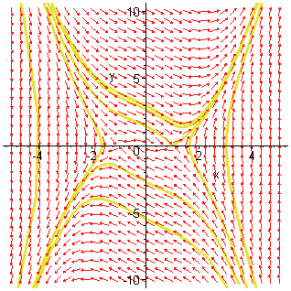
> DEtools[phaseportrait]
> ([diff(x(t),t)=y(t),diff(y(t),t)=-x(t)-y(t)+x(t)^3],[x(t),y(t)],t=-100..100,[[x(0)=0,y(0)=0],[x(0)=-4,y(0)=2],[x(0)=0,y(0)=3],[x(0)=3,y(0)=0],[x(0)=2,y(0)=2],[x(0)=2,y(0)=-2],[x(0)=-2,y(0)=-2],[x(0)=-2,y(0)=-4],[x(0)=-2,y(0)=2],[x(0)=-2,y(0)=4]],x=-5..5,y=-10..10,dirgrid=[30,30],stepsize=0.1,arrows=SLIM);

