HTML 5 WebApp页面布局 Day03
- RGBA颜色表
实现下面图片所示的效果，要求是尽可能使用CSS3新增的属性及div布局
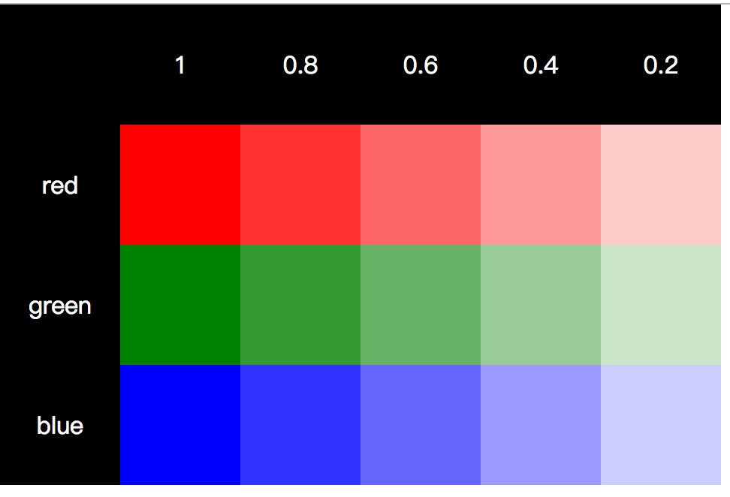
- 参考答案
此案例需要使用选择合适的标签div来进行布局，通过css选择器获取到某个元素，并进行颜色设置。实现此案例需要按照如下步骤进行：
步骤一：使用标签div来进行布局
<div>
<div class="row">
<div></div>
<div>1</div>
<div>0.8</div>
<div>0.6</div>
<div>0.4</div>
<div>0.2</div>
</div>
<div class="row">
<div>red</div>
<div></div>
<div></div>
<div></div>
<div></div>
<div></div>
</div>
<div class="row">
<div>green</div>
<div></div>
<div></div>
<div></div>
<div></div>
<div></div>
</div>
<div class="row">
<div>blue</div>
<div></div>
<div></div>
<div></div>
<div></div>
<div></div>
</div>
</div>
步骤二：设置色块的大小
.row div {
width: 80px;
height: 80px;
line-height: 80px;
text-align: center;
float: left;
}
步骤三：设置第一行及第一列的单元格的颜色
.row:nth-of-type(1) div {
background: #000;
color: #fff;
}
.row div:nth-child(1) {
background: #000;
color: #fff;
}
步骤四：设置其他单元格的颜色
.row:nth-of-type(2) div {
background: rgb(255, 0, 0);
}

.row:nth-of-type(3) div {
background: rgb(0, 128, 0);
}

.row:nth-of-type(4) div {
background: rgb(0, 0, 255);
}

.row:nth-of-type(2) div:nth-child(3) {
background: rgba(255, 0, 0, 0.8);
}

.row:nth-of-type(2) div:nth-child(4) {
background: rgba(255, 0, 0, 0.6);
}

.row:nth-of-type(2) div:nth-child(5) {
background: rgba(255, 0, 0, 0.4);
}

.row:nth-of-type(2) div:nth-child(6) {
background: rgba(255, 0, 0, 0.2);
}

.row:nth-of-type(3) div:nth-child(3) {
background: rgba(0, 128, 0, 0.8);
}

.row:nth-of-type(3) div:nth-child(4) {
background: rgba(0, 128, 0, 0.6);
}

.row:nth-of-type(3) div:nth-child(5) {
background: rgba(0, 128, 0, 0.4);
}

.row:nth-of-type(3) div:nth-child(6) {
background: rgba(0, 128, 0, 0.2);
}

.row:nth-of-type(4) div:nth-child(3) {
background: rgba(0, 0, 255, 0.8);
}

.row:nth-of-type(4) div:nth-child(4) {
background: rgba(0, 0, 255, 0.6);
}

.row:nth-of-type(4) div:nth-child(5) {
background: rgba(0, 0, 255, 0.4);
}

.row:nth-of-type(4) div:nth-child(6) {
background: rgba(0, 0, 255, 0.2);
}

步骤五：完善代码
根据标签以及页面的最终效果，完善代码
本案例的完整代码如下所示：
代码量较大，请参考：02_练习源码/1RGBA颜色表

- HSLA颜色表
实现下面图片所示的颜色表，要求是尽可能使用CSS3新增颜色属性和table布局
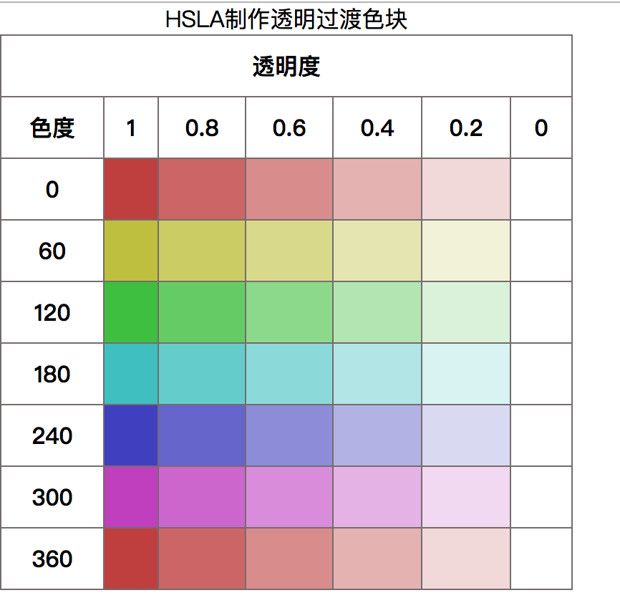
- 参考答案
此案例需要使用table+thead+tbody+tr+th+td标签进行布局，并对相应的单元格进行修饰。实现此案例需要按照如下步骤进行：
步骤一：使用table+thead+tbody+tr+th+td标签进行布局
<table>
<caption>HSLA制作透明过渡色块</caption>
<thead>
<tr>
<th colspan="7">透明度</th>
</tr>
<tr>
<th>色度</th>
<th>1</th>
<th>0.8</th>
<th>0.6</th>
<th>0.4</th>
<th>0.2</th>
<th>0</th>
</tr>
</thead>
<tbody>
<tr>
<th>0</th>
<td></td>
<td></td>
<td></td>
<td></td>
<td></td>
<td></td>
</tr>
<tr>
<th>60</th>
<td></td>
<td></td>
<td></td>
<td></td>
<td></td>
<td></td>
</tr>
<tr>
<th>120</th>
<td></td>
<td></td>
<td></td>
<td></td>
<td></td>
<td></td>
</tr>
<tr>
<th>180</th>
<td></td>
<td></td>
<td></td>
<td></td>
<td></td>
<td></td>
</tr>
<tr>
<th>240</th>
<td></td>
<td></td>
<td></td>
<td></td>
<td></td>
<td></td>
</tr>
<tr>
<th>300</th>
<td></td>
<td></td>
<td></td>
<td></td>
<td></td>
<td></td>
</tr>
<tr>
<th>360</th>
<td></td>
<td></td>
<td></td>
<td></td>
<td></td>
<td></td>
</tr>
</tbody>
</table>
步骤二：设置表格样式样式
table {
width: 400px;
border: 1px solid #756c6c;
border-left: none;
border-collapse: collapse;
border-spacing: 0;
}

th,
td {
border-top: 1px solid #756c6c;
border-left: 1px solid #756c6c;
padding: 10px;
text-align: center;
vertical-align: middle;
}
步骤三：获取每一个单元格的颜色
tbody tr:nth-child(1) td:nth-of-type(1) {
background: hsla(0, 50%, 50%, 1);
}

tbody tr:nth-child(1) td:nth-of-type(2) {
background: hsla(0, 50%, 50%, .8);
}

tbody tr:nth-child(1) td:nth-of-type(3) {
background: hsla(0, 50%, 50%, .6);
}

tbody tr:nth-child(1) td:nth-of-type(4) {
background: hsla(0, 50%, 50%, .4);
}

tbody tr:nth-child(1) td:nth-of-type(5) {
background: hsla(0, 50%, 50%, .2);
}

tbody tr:nth-child(1) td:nth-of-type(6) {
background: hsla(0, 50%, 50%, 0);
}

tbody tr:nth-child(1) td:nth-of-type(1) {
background: hsla(0, 50%, 50%, 1);
}

tbody tr:nth-child(1) td:nth-of-type(2) {
background: hsla(0, 50%, 50%, .8);
}

tbody tr:nth-child(1) td:nth-of-type(3) {
background: hsla(0, 50%, 50%, .6);
}

tbody tr:nth-child(1) td:nth-of-type(4) {
background: hsla(0, 50%, 50%, .4);
}

tbody tr:nth-child(1) td:nth-of-type(5) {
background: hsla(0, 50%, 50%, .2);
}

tbody tr:nth-child(1) td:nth-of-type(6) {
background: hsla(0, 50%, 50%, 0);
}

/*h=60 s=50% l=50%*/

tbody tr:nth-child(2) td:nth-of-type(1) {
background: hsla(60, 50%, 50%, 1);
}

tbody tr:nth-child(2) td:nth-of-type(2) {
background: hsla(60, 50%, 50%, .8);
}

tbody tr:nth-child(2) td:nth-of-type(3) {
background: hsla(60, 50%, 50%, .6);
}

tbody tr:nth-child(2) td:nth-of-type(4) {
background: hsla(60, 50%, 50%, .4);
}

tbody tr:nth-child(2) td:nth-of-type(5) {
background: hsla(60, 50%, 50%, .2);
}

tbody tr:nth-child(2) td:nth-of-type(6) {
background: hsla(60, 50%, 50%, 0);
}

tbody tr:nth-child(2) td:nth-of-type(1) {
background: hsla(60, 50%, 50%, 1);
}

tbody tr:nth-child(2) td:nth-of-type(2) {
background: hsla(60, 50%, 50%, .8);
}

tbody tr:nth-child(2) td:nth-of-type(3) {
background: hsla(60, 50%, 50%, .6);
}

tbody tr:nth-child(2) td:nth-of-type(4) {
background: hsla(60, 50%, 50%, .4);
}

tbody tr:nth-child(2) td:nth-of-type(5) {
background: hsla(60, 50%, 50%, .2);
}

tbody tr:nth-child(2) td:nth-of-type(6) {
background: hsla(60, 50%, 50%, 0);
}

/*h=120 s=50% l=50%*/

tbody tr:nth-child(3) td:nth-of-type(1) {
background: hsla(120, 50%, 50%, 1);
}

tbody tr:nth-child(3) td:nth-of-type(2) {
background: hsla(120, 50%, 50%, .8);
}

tbody tr:nth-child(3) td:nth-of-type(3) {
background: hsla(120, 50%, 50%, .6);
}

tbody tr:nth-child(3) td:nth-of-type(4) {
background: hsla(120, 50%, 50%, .4);
}

tbody tr:nth-child(3) td:nth-of-type(5) {
background: hsla(120, 50%, 50%, .2);
}

tbody tr:nth-child(3) td:nth-of-type(6) {
background: hsla(120, 50%, 50%, 0);
}

tbody tr:nth-child(3) td:nth-of-type(1) {
background: hsla(120, 50%, 50%, 1);
}

tbody tr:nth-child(3) td:nth-of-type(2) {
background: hsla(120, 50%, 50%, .8);
}

tbody tr:nth-child(3) td:nth-of-type(3) {
background: hsla(120, 50%, 50%, .6);
}

tbody tr:nth-child(3) td:nth-of-type(4) {
background: hsla(120, 50%, 50%, .4);
}

tbody tr:nth-child(3) td:nth-of-type(5) {
background: hsla(120, 50%, 50%, .2);
}

tbody tr:nth-child(3) td:nth-of-type(6) {
background: hsla(120, 50%, 50%, 0);
}

/*h=180 s=50% l=50%*/

tbody tr:nth-child(4) td:nth-of-type(1) {
background: hsla(180, 50%, 50%, 1);
}

tbody tr:nth-child(4) td:nth-of-type(2) {
background: hsla(180, 50%, 50%, .8);
}

tbody tr:nth-child(4) td:nth-of-type(3) {
background: hsla(180, 50%, 50%, .6);
}

tbody tr:nth-child(4) td:nth-of-type(4) {
background: hsla(180, 50%, 50%, .4);
}

tbody tr:nth-child(4) td:nth-of-type(5) {
background: hsla(180, 50%, 50%, .2);
}

tbody tr:nth-child(4) td:nth-of-type(6) {
background: hsla(180, 50%, 50%, 0);
}

tbody tr:nth-child(4) td:nth-of-type(1) {
background: hsla(180, 50%, 50%, 1);
}

tbody tr:nth-child(4) td:nth-of-type(2) {
background: hsla(180, 50%, 50%, .8);
}

tbody tr:nth-child(4) td:nth-of-type(3) {
background: hsla(180, 50%, 50%, .6);
}

tbody tr:nth-child(4) td:nth-of-type(4) {
background: hsla(180, 50%, 50%, .4);
}

tbody tr:nth-child(4) td:nth-of-type(5) {
background: hsla(180, 50%, 50%, .2);
}

tbody tr:nth-child(4) td:nth-of-type(6) {
background: hsla(180, 50%, 50%, 0);
}

/*h=240 s=50% l=50%*/

tbody tr:nth-child(5) td:nth-of-type(1) {
background: hsla(240, 50%, 50%, 1);
}

tbody tr:nth-child(5) td:nth-of-type(2) {
background: hsla(240, 50%, 50%, .8);
}

tbody tr:nth-child(5) td:nth-of-type(3) {
background: hsla(240, 50%, 50%, .6);
}

tbody tr:nth-child(5) td:nth-of-type(4) {
background: hsla(240, 50%, 50%, .4);
}

tbody tr:nth-child(5) td:nth-of-type(5) {
background: hsla(240, 50%, 50%, .2);
}

tbody tr:nth-child(5) td:nth-of-type(6) {
background: hsla(240, 50%, 50%, 0);
}

tbody tr:nth-child(5) td:nth-of-type(1) {
background: hsla(240, 50%, 50%, 1);
}

tbody tr:nth-child(5) td:nth-of-type(2) {
background: hsla(240, 50%, 50%, .8);
}

tbody tr:nth-child(5) td:nth-of-type(3) {
background: hsla(240, 50%, 50%, .6);
}

tbody tr:nth-child(5) td:nth-of-type(4) {
background: hsla(240, 50%, 50%, .4);
}

tbody tr:nth-child(5) td:nth-of-type(5) {
background: hsla(240, 50%, 50%, .2);
}

tbody tr:nth-child(5) td:nth-of-type(6) {
background: hsla(240, 50%, 50%, 0);
}

/*h=300 s=50% l=50%*/

tbody tr:nth-child(6) td:nth-of-type(1) {
background: hsla(300, 50%, 50%, 1);
}

tbody tr:nth-child(6) td:nth-of-type(2) {
background: hsla(300, 50%, 50%, .8);
}

tbody tr:nth-child(6) td:nth-of-type(3) {
background: hsla(300, 50%, 50%, .6);
}

tbody tr:nth-child(6) td:nth-of-type(4) {
background: hsla(300, 50%, 50%, .4);
}

tbody tr:nth-child(6) td:nth-of-type(5) {
background: hsla(300, 50%, 50%, .2);
}

tbody tr:nth-child(6) td:nth-of-type(6) {
background: hsla(300, 50%, 50%, 0);
}

tbody tr:nth-child(6) td:nth-of-type(1) {
background: hsla(300, 50%, 50%, 1);
}

tbody tr:nth-child(6) td:nth-of-type(2) {
background: hsla(300, 50%, 50%, .8);
}

tbody tr:nth-child(6) td:nth-of-type(3) {
background: hsla(300, 50%, 50%, .6);
}

tbody tr:nth-child(6) td:nth-of-type(4) {
background: hsla(300, 50%, 50%, .4);
}

tbody tr:nth-child(6) td:nth-of-type(5) {
background: hsla(300, 50%, 50%, .2);
}

tbody tr:nth-child(6) td:nth-of-type(6) {
background: hsla(300, 50%, 50%, 0);
}

/*h=360 s=50% l=50%*/

tbody tr:nth-child(7) td:nth-of-type(1) {
background: hsla(360, 50%, 50%, 1);
}

tbody tr:nth-child(7) td:nth-of-type(2) {
background: hsla(360, 50%, 50%, .8);
}

tbody tr:nth-child(7) td:nth-of-type(3) {
background: hsla(360, 50%, 50%, .6);
}

tbody tr:nth-child(7) td:nth-of-type(4) {
background: hsla(360, 50%, 50%, .4);
}

tbody tr:nth-child(7) td:nth-of-type(5) {
background: hsla(360, 50%, 50%, .2);
}

tbody tr:nth-child(7) td:nth-of-type(6) {
background: hsla(360, 50%, 50%, 0);
}

tbody tr:nth-child(7) td:nth-of-type(1) {
background: hsla(360, 50%, 50%, 1);
}

tbody tr:nth-child(7) td:nth-of-type(2) {
background: hsla(360, 50%, 50%, .8);
}

tbody tr:nth-child(7) td:nth-of-type(3) {
background: hsla(360, 50%, 50%, .6);
}

tbody tr:nth-child(7) td:nth-of-type(4) {
background: hsla(360, 50%, 50%, .4);
}

tbody tr:nth-child(7) td:nth-of-type(5) {
background: hsla(360, 50%, 50%, .2);
}

tbody tr:nth-child(7) td:nth-of-type(6) {
background: hsla(360, 50%, 50%, 0);
}

步骤四：完善代码
根据标签以及页面的最终效果，完善代码
本案例的完整代码如下所示：
代码量较大，请参考：02_练习源码/ 2HSLA颜色表

- 文字修饰
实现下面图片所示的效果，要求是尽可能使用CSS3新增的属性
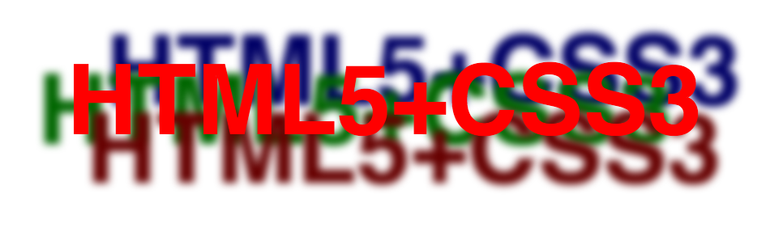
- 参考答案
此案例需要使用选择合适的标签p来进行布局，通过元素进行文字修饰。实现此案例需要按照如下步骤进行：
步骤一：使用标签p来进行布局
<p>HTML5+CSS3</p>
步骤二：使用标签p来进行修饰
p {
margin-top: 100px;
text-align: center;
font: bold 60px helvetica, arial, sans-serif;
color: red;
text-shadow: 0.2em 0.5em 0.1em #600, -0.3em 0.1em 0.1em #060, 0.4em -0.3em 0.1em #006;
}
步骤三：完善代码
根据标签以及页面的最终效果，完善代码
本案例的完整代码如下所示：
<!DOCTYPE html>
<html lang="en">

<head>
<meta charset="UTF-8">
<!-- 强制IE浏览器采用最新的edge引擎解析，chrome采用最新版本 -->
<meta http-equiv="X-UA-Compatible" content="IE=edge,chrome=1">
<!-- 双模式浏览器优先使用 webkit -->
<meta name="renderer" content="webkit">
<!-- 移动端视窗设置 -->
<!-- <meta name="viewport" content="width=device-width, initial-scale=1.0, user-scalable=no"/> -->
<!-- title 标题 -->
<title>text-shadow</title>
<!-- 描述 -->
<meta name="description" content="你的描述内容，一段完整的描述，150字以内">
<!-- 关键字 -->
<meta name="keywords" content="多个关键词用英文,号分割">
<!-- 引入CSS -->
<link rel="stylesheet" type="text/css" href="css/reset.css" />
<style type="text/css">
p {
margin-top: 100px;
text-align: center;
font: bold 60px helvetica, arial, sans-serif;
color: red;
text-shadow: 0.2em 0.5em 0.1em #600, -0.3em 0.1em 0.1em #060, 0.4em -0.3em 0.1em #006;
}
</style>
</head>

<body>
<p>HTML5+CSS3</p>
</body>

</html>

