Registration_of_ 2D_LIDAR_Data have 6 source codes of experiment about the our paper, *”Registration of 2D LIDAR data with large motion using line features and density clustering”*. These source codes are contained in 6 folders as follow.

1. ***01_ICP*** includes the code of standard ICP algorithm, basing on the paper *“A Method for Registration of 3-D Shapes”*. The main function is *“IcpAlgorithm.m”.*
2. ***02_TrICP*** includes the code of TrICP algorithm, basing on the paper *“The Trimmed Iterative Closest Point Algorithm”*. The main function is *“TrIcpAlgorithm.m”*.
3. ***03_SICP_IterativeReweighting*** includes the code of SICP algorithm, basing on the paper *“Sparse Iterative Closest Point”*. The main function is *“SicpAlgorithm.m”*.
4. ***04_Holy2018-adam*** includes the code of Holy2018 algorithm, basing on the paper *“Registration of Lines in 2D LIDAR scans via functions of angles”*. The main function is *“Holy2018Algorithm.m”*.
5. ***05_MyMethod*** includes the code of our paper, basing on the paper *”Registration of 2D LIDAR data with large motion using line features and density clustering”*. The main function is *” MyAlgorithm.m”*.
6. ***06_PSM*** includes the code of PSM algorithm, basing on the paper, *“Laser Scan Matching in Polar Coordinates with Application to SLAM”*.

# INSTALLATION INSTRUCTIONS

These source codes of ICP, TrICP, SICP, Holy2018 and MyMethod are based on Windows10 64 bit system coded by matlab language. PSM is based on Linux system and C++ language. In particular, we provide two sources of data. One is saved as a csv files whose detailed sampling process in *“ExperimentalRecord.pptx”*. The other provide the maps which can generate new LIDAR data.

## ICP, TrICP, SICP, Holy2018 and MyMethod

These source codes of ICP, TrICP, SICP, Holy2018 and MyMethod are used in the same way. We take MyMethod as an example.

We use “MATLAB R2016a” to open *“IcpAlgorithm.m”*, and run it as follow.

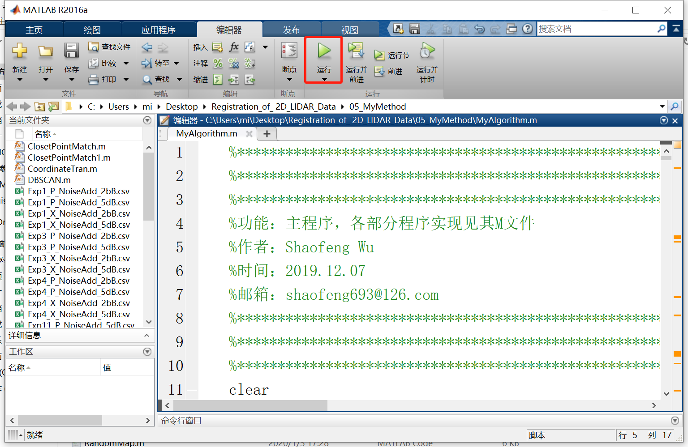

You can choose two sources of data:

1. **use these data provided by us.**

We save the data as csv files of experiments about the our paper *”Registration of 2D LIDAR data with large motion using line features and density clustering”*. You can set “DataSource=false” to choose this model. Specially, you can choose different data by the value of ExpData1FromCsv and ExpData2FromCsv. More details in *“ExperimentalRecord.pptx”*.

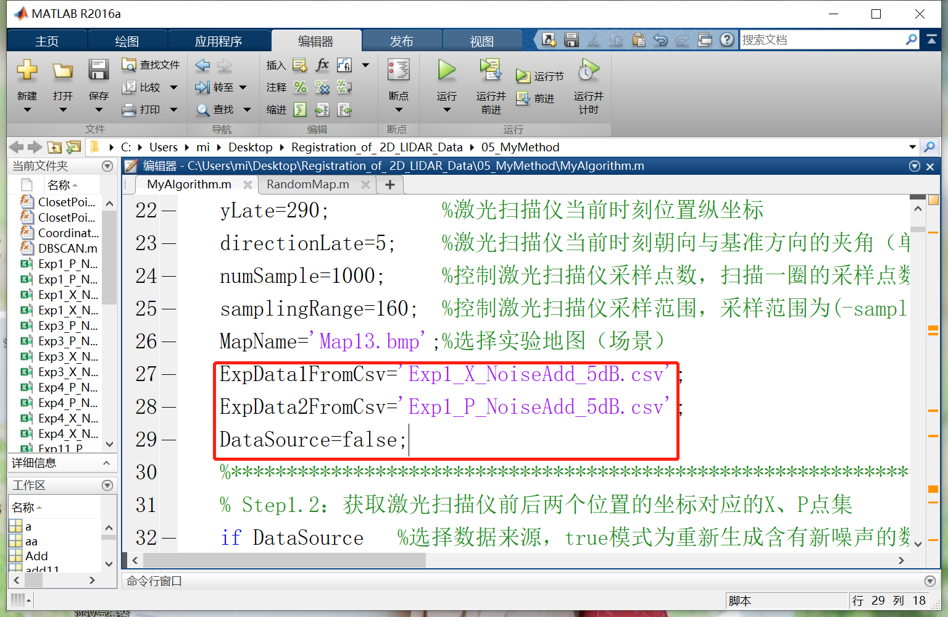

**2) Generate new data**

We provide some simulation map which can generate new LIDAR data. If these maps don't meet your needs, new maps can be generated randomly by the function *“RandomMap.m”*.

You can set “DataSource=true” to choose this model. Besides, the following parameters also need to be set.

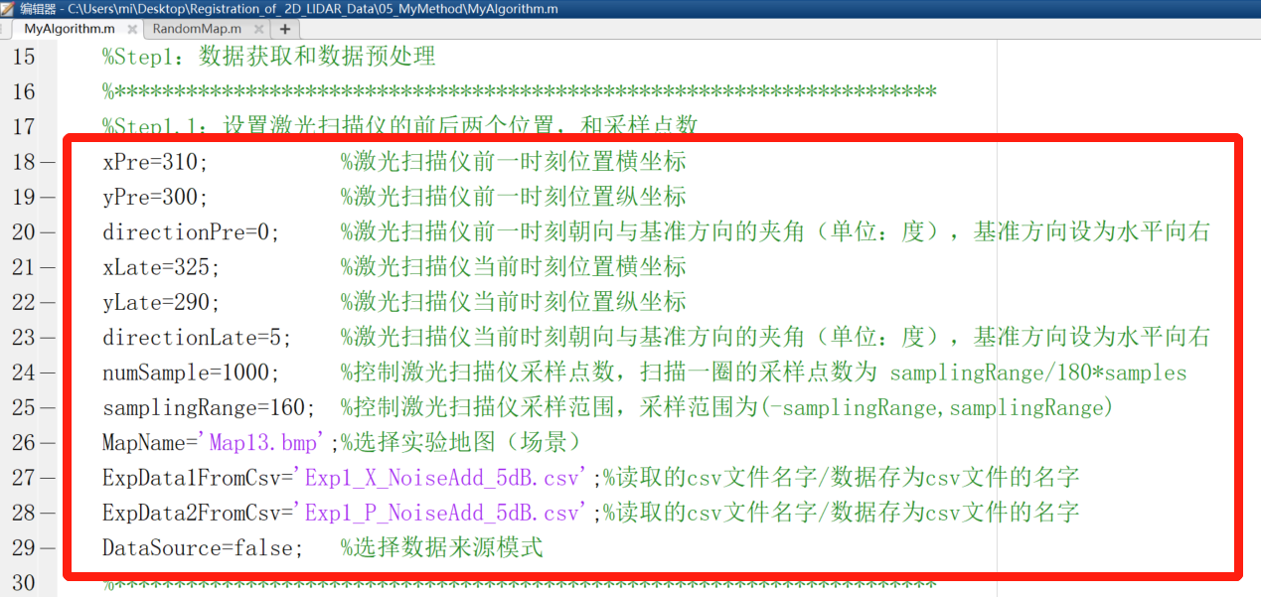

Firstly, you have to choose a simulation map by *“MapName”*. (*xPre*, *yPre*) and (*xLate*, *yLate*) are the position of LIDAR in the simulation map. You can't put the LIDAR on an obstacle of the map, if you want LIDAR generate data. *directionPre* and *directionLate* are the orientation. *numSample* controls the number of sampling points of the LIDAR, and the number of sampling points for a circle of scanning is *“samplingRange/180×samples”.* *samplingRange* controls the sampling range of the LIDAR. You can set the names of the data to be saved as a csv file by *ExpData1FromCsv* and *ExpData1FromCsv*.

## PSM

The source code is from libpsm-v0.31 provided by Albert Diosi and Lindsay Kleeman. For the convenience of importing data and reading the matched parameters, we changed some code in folder “*02_PSM_SourceCode*”.

Firstly, we use “*CreateDataForPSM.m*” and “*CreateDataForPSM_FromCSV.m*” to generate scan files in matlab R2016a. Secondly, we modify the PSM code to import our data in “*example.cpp*” as follow.

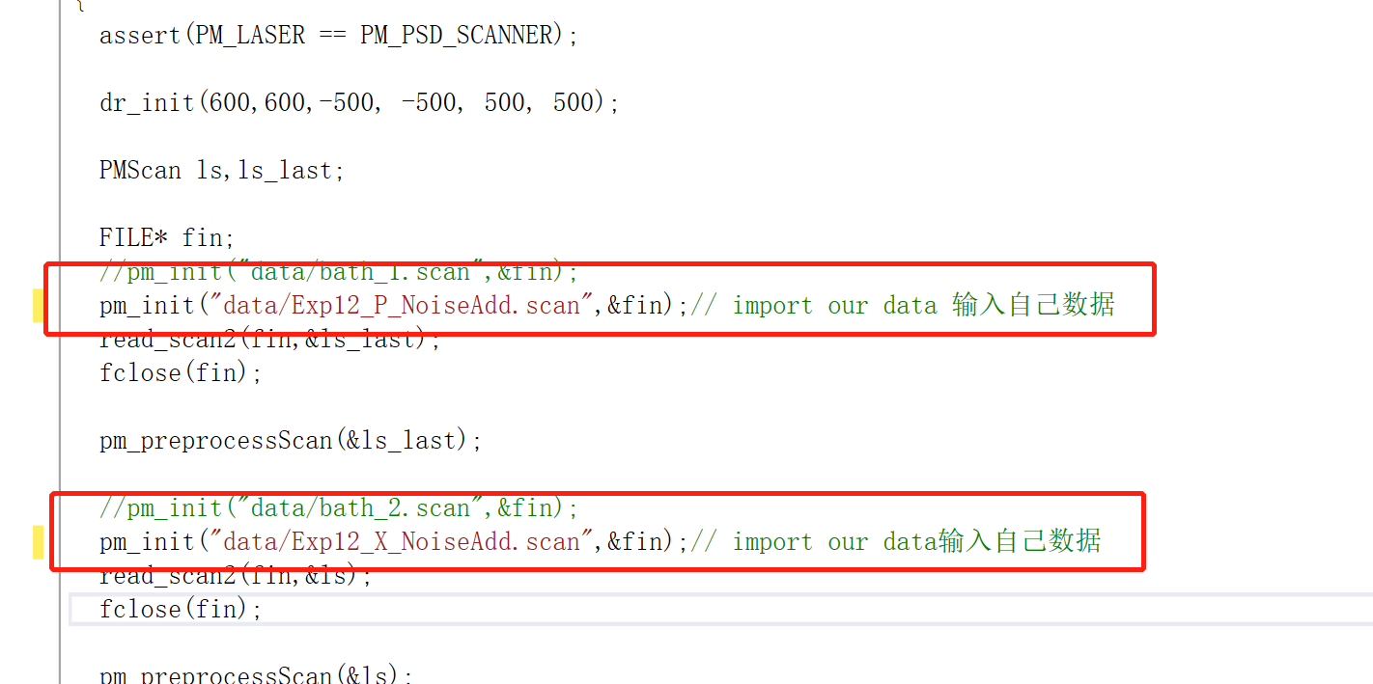

We can get the rotation angle and the translation matrix after running the “*example.cpp*”. We use “*ResultShow.m*” to show the result of data matching. For more details about PSM code, you can refer to “*README*” in “*02_PSM_SourceCode*”.