Alpha2 Developer Setup

# Introduction

The Alpha2 project has been delivered as a C# web application. The development is done locally using Visual Studio 2015, with source code stored in a GIT repository. The code is built automatically by a CI server, and there is an automated build to deploy the application into Microsoft Azure.

This document explains the setup of the Alpha2 environment for a new developer.

# Prerequisites

For a build machine, the following software will need to be installed:

* .Net Framework V4.5 *(do we want to target 4.6.2?)*;
* .Net Framework V4.5 SDK *(tbc – is this needed?)*.

All other binaries/dependencies are contained in source control.

For a developer, in addition to the above, the following software will need to be installed:

* Visual Studio 2015;
* Git version control system.

# Source Control

Git is used for source control for Alpha2. Detailed information on using git can be found here: <https://git-scm.com/doc>

There are many git clients; this guide describes how to obtain the source using Git Bash, which is part of git for Windows downloadable from here: <https://git-for-windows.github.io/>

In order to obtain the source code, the developer will need to be given permission to the git repository. Once access is granted, the developer should be given a URL to the repository that should look something like: https://sga2.visualstudio.com/_git/Scottish%20Alpha%202

Open a Git Bash prompt, change the current directory (in the example below S:\is used), then clone the source code:

1. Open Git Bash
2. type ‘cd S:\’
3. type ‘git clone https://sga2.visualstudio.com/_git/Scottish%20Alpha%202 Alpha2’

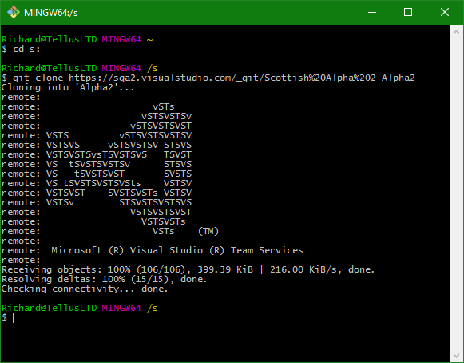

You should now have the source code cloned into a directory named Alpha2.

# Build