JAVA 1.8 CONCEPTS BY JAVA BRAINS: KOWSHIK
- What are the Java 1.8 Features and its necessity to introduce Java 1.8v?
Ans:- Java 1.8v was released in the year March 2014 for introducing functional programing language in java, by adopting a concept called LAMDA’S in java world.
Advantages of Lambda’s
* using lambdas in java makes java supporting function programming and it makes code concise (reduces the lines of code) but the syntax of a Java code with change from Java 1.8v
* it enables Parallel programming or process by using streams API
* it makes java code more readable, maintainable, and concise code.
* we can use API library in very efficiently & easy to use.
- What are the Features introduced in Java 1.8v?
Ans:- There are many features were intro in Java 1.8 but few popularly used in current industries are as below.
* Lambda Expression (➞)
* Functional Interfaces (FI)
* Default and Static methods inside Interfaces in Java
* Predefined Functional Interfaces
- Predicate - DoublePredicate
- Function - DoubleFunction
- Consumer - DoubleConsumer
- Supplier - DoubleSupplier
- BiPredicate
- BiFunction
- BiConsumer
- BiSupplier
* Method reference & Constructor reference using Double colon operator (: :)
* Date and Time API or Joda API
* Stream API
- What is mean by LAMBDA Expression in Java?
Ans:- It’s an Anonymous function. Which has NO Name, NO Modifiers, NO ReturnType
- How do you convert normal method to Lambda expression?
Ans:- From a Normal method Remove following things
* Access Modifier
* Return Type
* Method Name
Then add the below
* add LAMDA Expression ➜ after the parenthesis [ ( ) ]
- Example for Java Lambda Expression to convert from normal method to Java 8 Lambda expression?
Ans:- As per Question number 4
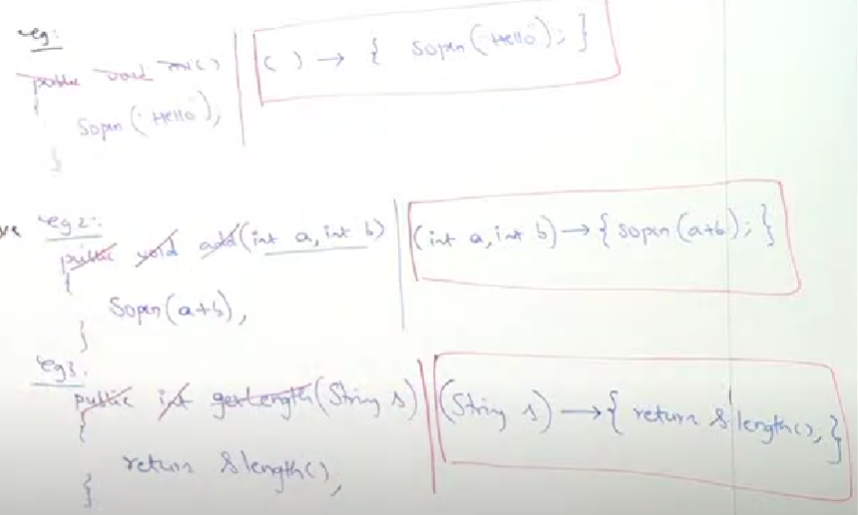
Example 2:-
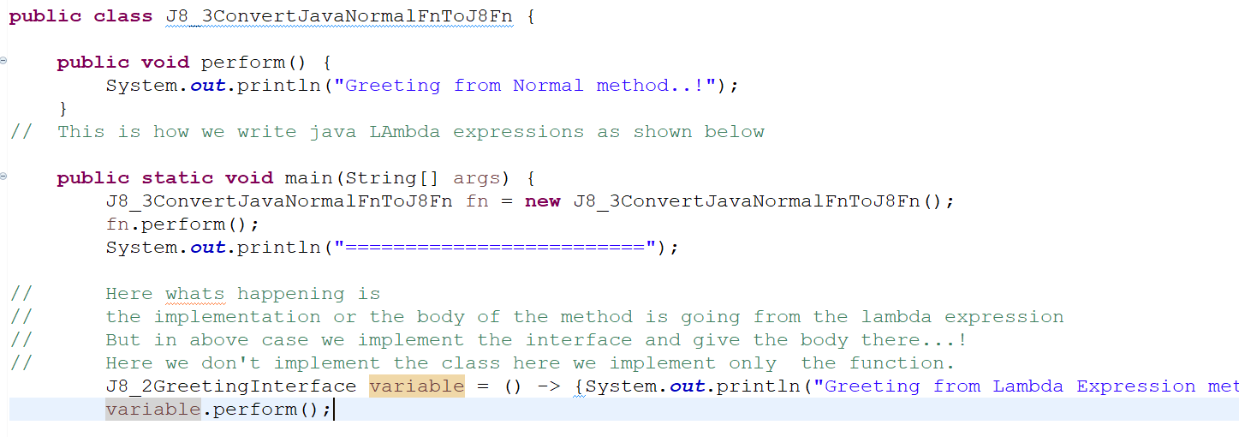
NOTE:-
- In above example J8_2GreetingInterface is an Functional Interface created by us.
- in that FI we have a method called perform() and we provide implementation to it via lambda expression as shown in last two lines.
OUTPUT:-
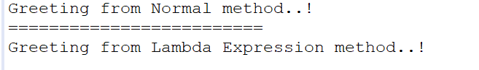
- Why we need Lambda Expressions in java programming language, is there any extra features other than OOP’s Concept?
Ans:- Till java 1.7v we did not use Lambda Expression but suddenly in Java 1.8v they introduced Lambda Expression which does same work as Java till 1.7v
BUT the functional programming in java 1.8v will do same what OOP does, the importance of functional programming is, It will reduce the Developers efforts by conciseing (reducing the lines of code) the code. And it increases the readability of a code.
Biggest Advantage of Functional Programming:-
* A block of code is executed as a function without creating the Object for that block of code, particularly using functional programming in java 1.8v, in-order it will increase the performance of the execution during run time.
- What is mean by Functional Interface ?
Ans:- It is a type of Interface with contains SINGLE ABSTRACT METHOD (SAM).
- How can we simplify the Lambda Expressions from minimum concise to maximum concise of code.
Ans:-
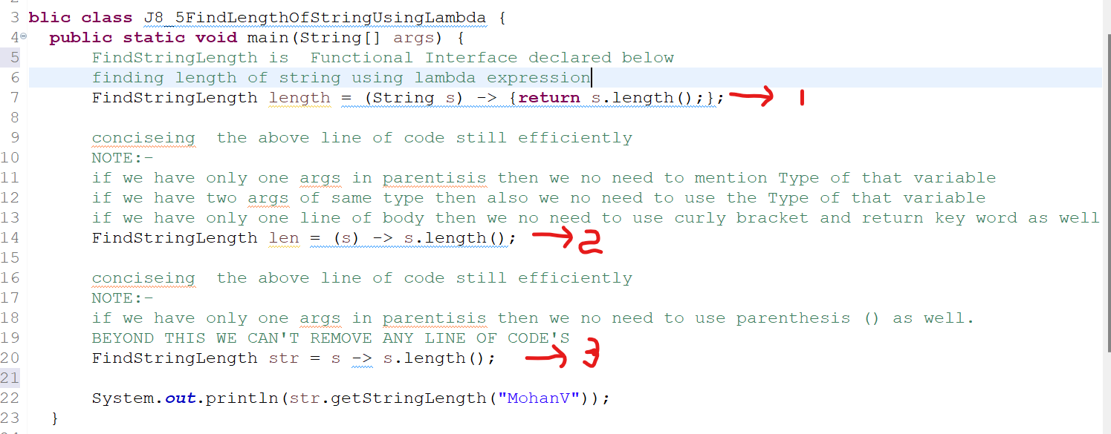
- What is mean by Anonymous Inner-Class in java?
Ans:- A class inside an another class, which has NO-NAME is called as Anonymous inner class.
Example:-
In below example we have created an instance for J8_2GreetingInterface interface BUT as per Java we can’t create Object for interface but we can create an implementation class for it, this Anonymous class is also equivalent to implementation class but it has NO-NAME
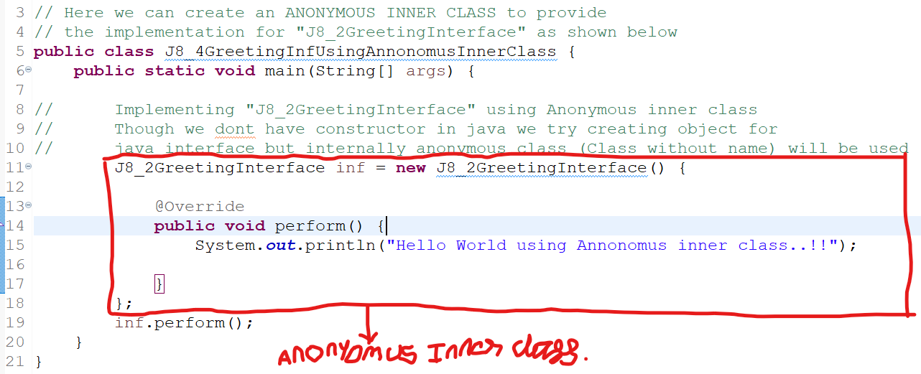
- What is mean by Backward compatibility in software system design?
Ans:- Which means that the Software system that are designed has to be in such a way that, the interface of the system has to support both NEW feature as well as the OLD legacy feature without any issues, this type of design is called as BACKWARD COMPATIBILITY in System design.
Example:- In java we can implement the Runnable Interface using Java 8 or else we can implement using Java 7 as well, this type of design is called as BACKWARD COMPATIBILITY
- Using lambda expression with List of objects?
Ans:-
Refer this class J8_1UsePersonClassToSort and Person class at location :-> S:\TECHNO_ELEVATE_WORK_SPACE\TNS_TO_TY_B2B_WORKSPACE\JAVA_WORKSPACE\Java_1.8_By_Java_Brains\src\com\learn\Java8Practice
- What are the predefined Functional interface?
Ans:-
Functional Interface | Method Name | Return type of method | ShortCut to remember
Predicate<T> | boolean test(T t) | Boolean | PTB
Supplier<T> | T get() | Obj of given Type -> (T) | SGT
Function<T, R> T = input type & R = return type | R apply(T t) | Returns given type -> R | FAR
Consumer<T> | void accept(T t) | void -> No Return type | CAN
- In how many ways we can create a Thread in java?
Ans:-
In Java we can create a Thread in 2 ways:-
1. By Extending Thread class
2. By implementing Runnable Interface
Traditional way of implementing the runnable Interface with Java 7 version:-
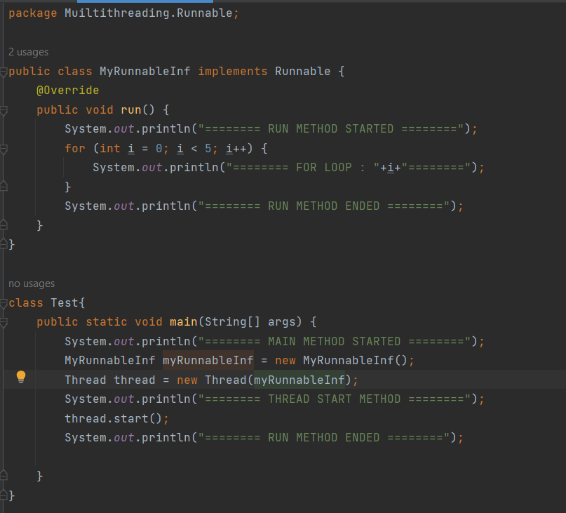
Implementing same Runnable interface using Lambda Expressions & Java8:-
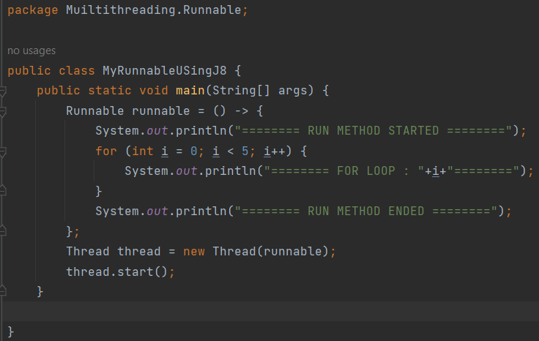
- Custom sorting order using Java8 Lambda Expressions?
Ans:-
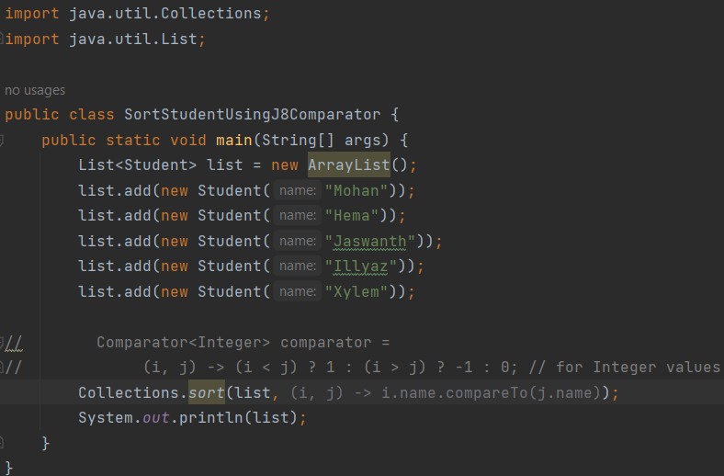
- How to use method reference and Constructor reference using java 8 feature?
Ans:-
Syntax For Static method Reference:-
Class_Name : : Static_Method_Name
Syntax For Non-Static method Reference:-
Object_Reference : : Non_Static_Method_Name
Syntax For Constructor Reference:-
Class_Name : : new (java keyword)
NOTE:-
For Method Reference, the parameter of the method should be same as the parameter of the Functional Interface, for Both Static and Non-Static methods
For Constructor Reference we just need to invoke using new key word BUT the parameter of the Constructor should be same as the Functional Interface
Example:-
For Single args Costructor we can use Consumer (FI), where it takes single parameter for its Abstract method, where Both Should match
For No Constructor we can use Supplier (FI), where it takes ZERO parameter for its Abstract method, where Both Should match

