SPRING ANNOTATIONS AND ITS DETAILS
SLNO | ANNOTATION | CAN BE USED ON | DESCRIPTION
 | @Required | Fields, bean setter Methods | This annotation is used to indicate spring that the affected bean must be populated at the time of configuration. Else it will throw BeanIntializationException
 | @Autowired | Field or Property, setter Method, constructor | It is used to inject the dependency object implicitly during Runtime.  TYPES: [Property Injection, setter Injection, and Constructor Injection]
 | @Qualifier | Field | It is used to avoid the confusions, if we have two beans of same type and using this annotation, we can specify spring to inject bean of one type and ignore other bean of same type
 | @Bean | Method level | It is used to create a spring bean, and that bean will be maintained by spring container.
 | @Value | Field level, method parameter level, constructor parameter level | It is used to inject the value into a field or to a parameter from the properties file during the run time. [it works same as @Autowire but here it will fetch the value from properties file and inject during runtime.] it supports two placeholders they are :- “#{…}” and “${…}”
STEREOTYPE ANNOTATIONS
 | @Component | Class Level | It is used to specify a java class as a bean or as a component, so that the component scanning mechanism of spring will add to its application context.
 | @Controller | Class Level | It is used to specify a java class as a Spring controller, this annotation can be used to identify the controllers of Spring MVC and Spring WebFlux.
 | @Service | Class Level | This annotation is a specialized version of @Component annotation, where it is used to specify a java class that performs some operation or calculation’s such as executing the Business logics/performing some calculations/calling external API’s/ etc…
 | @Repository | Class Level | This is used to specify java class as a Repository layer which is capable of direct access with the Database.  NOTE:- Its optional provided that extended class must be annotated with this @Repository Annotation.  SPL NOTE:- If any Exception occurs in this layer, there is an handler which handles this Exceptions and Developer no need to worry about this and no need of using try and catch block to handle it.
 | @Configuration | Class level | It’s a class level or Stereotype annotation, this annotation is replacement for XML configuration file, when this annotation is used on a class then it means, that class is a configuration file using Java classes and it will be responsible for creating and configuring the beans for our application.
 | @Lazy | Class level | All the Autowired beans will be created or instantiated during the application startup only, but when we use this annotation along with an @component class the Autowired beans will be created or instantiated when they are first time required instead of creating or instantiating it on the app startup.
 | @ComponentScan | Class level | It is used at base package in spring application where it will scan its packages and if any specific package is not defined, then scanning will occur from the package of class where this annotation is declared.
SPRING BOOT ANNOTATIONS
 | @EnableAutoConfiguration | Class level | This is usually used on main application class. Where it will define the base package implicitly, and tells the spring boot to add the beans based on the class path, other beans and various properties.
 | @SpringBootApplication | Class level | It must be used on main application class, where it will be created during the SpringBoot project creation, and the class annotated with this annotation must be kept inside the BasePackage, it enable the spring component-scan mechanism to scan its sub packages.  NOTE:- This annotation is a combination of following annotations  - @Configuration  - @EnableAutoConfiguration  - @ComponentScan
 | @RequestMapping | Class Level, Method Level | It is used to map the web request to the appropriate controller or to the appropriate request handler method.  When it is used on top of class it creates the Base URI for which controller will be used, When it is used on top of the method it will create the URI, where that method is responsible for handling the particular web request, when the URI is triggered it will be executed.  Some time two diff handler methods can have same or diff requestMapping, if we have same requestMapping then type of both the handler methods should be diff we can achieve this using “method” of this annotation
 | @CrossOrigin | Class and Method Level

- What is the diff btw Spring IOC and Spring Container?
Ans:- In all framework IoC containers are common characters which implements the IoC, in spring framework the Interface ApplicationContext will represents the IoC Container, the spring container is responsible for instantiating, configuring, assembling objects which is known as BEANS as well as managing their lifecycles.
Spring framework provides several implementation to the ApplicationContext Interface such as:
ClassPathXmlApplicationContext and FileSystemXmlApplicationContext are the two implementation for standalone application
and
WebApplicationContext implementation for web applications
- In how many ways we can assemble(Configure) the beans (Objects) in Spring framework?
Ans:- Spring uses the configuration metadata to assemble the to assemble the beans
We can assemble the beans in 2 ways
1. By XML Configuration file
2. By Annotations
- How to instantiate or create the Spring Beans manually?
Ans:- we can instantiate the Spring Beans by implementing any one of the IoC container example as showed below
ApplicationContext context = new ClassPathXmlApplicationContext("applicationContext.xml");
or
ApplicationContext context = new FileSystemXmlApplicationContext("<System Location of XML Config File>");
- What is Dependency Injection in Spring framework?
Ans:- Dependency Injection (DI) is functionality provided by Spring IoC Container, and Dependency Injection is a Design Pattern which allows Object to declare their Dependencies, This approach is same a traditional way of Creating the Objects and Passing (using) then were ever they needed.
But In Spring FW instead of developer creating the Object, Spring IoC Container will Creates and Manages for us using technique called as Dependency Inject.
Benefits of Dependency Injection:-
1. Loose coupling
2. Reusable
3. Testable
4. Reduces the Boiler plate code
5. Managed objects (Spring IoC is responsible for Creating & Destroying the Obj, instead of we manually doing it.)
Types of Dependency Injection:-
1. Constructor Injection
2. Setter Injection
NOTE:-
1. Spring Container uses the Dependency Injection (DI) to manage the components that makes up the Application, Spring Container manage both Spring Beans as well as Other Objects
2. But Spring IoC Container is responsible for Creating, Managing & till Destroying the Object, Spring IoC manages only the Spring Beans (Objects)
- which component of Spring framework will take care of CREATING and DELETING the objects?
Ans:- In Spring FW, Spring IoC (Inversion of Control) container is Responsible for Creating, Managing & Deleting (ie:- Managing their Life Cycle) the Objects, this happens using a Technique called as Dependency Injection. And the Objects created by Spring IoC is called as “BEANS”
Spring IoC is responsible for Creating the Object, Configuring the Object & Managing their entire Life Cycle of an Object, in Spring FW
- What are the Features of IoC in Spring FW?
Ans:-
1. Creating Objects for Us
2. Managing our Objects
3. Helping our application to Configure
4. Managing Dependencies
- What is the Difference between @Controller and @RestController
Ans:-
@Controller
This Annotation will represent the Class Annotated with this Annotation as a Controller class
This is a Class level or Stereotype annotation
This Annotation is used, when we need to return the HTML VIEW page from our Spring application
This Annotation is used mostly in Spring MVC, if our application is used by the End User and if our application need to respond a HTML page
NOTE:-
If our application is used by other application or if we want to return or responded our client in HTTP format (JSON or XML) then we need to add @ResponseBody Annotation on the same class where @Controller is added, so that this is equivalent to @RestController
@ResponseBody was introduced in Spring before Spring Version 4
@RestController
This Annotation will represent the Class Annotated with this Annotation as a Controller class
This is a Class level or Stereotype annotation
This Annotation is used, when we need to return the response in JSON or XML format from our Application
This Annotation is mostly used in Spring Boot/Spring Rest API’s, when our API’s or Application is being consumed by other API’s or the Services
NOTE:-
This Annotation @RestController is a combination of @Controller + @ResponseBody
This Annotation @RestController was introduced in Spring version 4
- What is the Difference between Spring Boot & Spring Framework ?
Ans:-
Spring Boot:-
It is a Framework for Java, where it will reduce the application configurations significantly and provides the production ready application, so that developer can reduce the configuration time and concentrate on Business logics
Here the configurations are taken care by AutoConfiguration component of Spring Boot where it will configure based on the Dependencies that are present on the class path, Hence it will reduces the manual configuration time of a developer and allows us to focus on Business logic.
NOTE:-
Here the External Configuration of the application will be very limited, and majority will be taken care by Spring Boot itself
Spring Framework:-
Here, the Configurations provided by the Spring Framework will be very limited
It provides more flexibility to the developer to configure the application as per his requirements.
web.xml under WEB-INF/ directory of Spring application is used as a Configuration file, which has the Classes, Resources and Configurations of the application, and using that web server will redirect the incoming request to the respective services to map, so that respective services will handle the incoming request.
web.xml is nothing but a Deployment Descriptor file in Spring Framework
NOTE:-
Here, configurations can be Done in multiple ways
1. XML based Configurations
2. Java Bean configurations
3. Annotation based configurations
- How do you connect your Spring Boot application with the database and What are the different types of connecting Spring Boot application with Database?
Ans:-
- Explain elaborately about @SpringBootApplication along with the each and every annotations of its combination?
Ans:-
@SpringBootApplication is a powerful annotation, which reduces the configuration time of an spring-boot application, and it is a combination of 3 Individual annotations they are:-
1. @ComponentScan
2. @Configuration
3. @EnableAutoConfiguration
NOTE:-
For more Explanation on all 3 annotations, check the above Annotations Table.
- What is caching mechanism and what are the Types of caching available in java Spring boot framework?
Ans:-
- What is the Importance of @Autowired annotations on Spring framework?
Ans:-
- How can you handle the Exceptions on Spring framework and its types ?
Ans:-
GlobalExceptionHandler
CustomExceptionHandler
by Using try/catch block
- Explain the concept of Profiles in Springboot and how you can use them
Ans:-
spring.profile.active = dev/qa/prod
If we have multiple environments such as dev/QA/UAT and those environments have diff configurations for each, then we can have separate .properties/.yml files for each environments using profile’s dynamically use respective config files, based on the Environments.
- What is the role of actuator in Spring boot application?
Ans:-
Actuator is a powerful, feature/tool in spring boot for Monitoring & Managing the Spring application in Production environment, it provides a set of EndPoints to expose/fetch the information such as Health Check, Metrics, Information of an Application, Environment details, Etc...!
All this can be accessed using HTTP Get method, and it (Actuator) returns the response in JSON Format.
- What is mean by spring-boot-stater-* Dependency?
Ans:-
Spring-boot-stater Dependency is a one-stop-shop to all the required dependency for the spring and spring related technology projects, where we no need to manually go to browser and copy-paste the dependencies, and moreover, the versions of the dependencies are more complex problems to solve. Hence “Spring-Boot” provides us the “POM.xml” where it will resolve all the required dependencies, by just analyzing the given “stater-dependency”
For Example:-
If we want to create a project on “Spring-Boot” with “JPA” for Database connection, then just by including spring-boot-starter-data-jpa Dependency in “POM.xml” It will resolve all the library/Jar files related to Database such as “Java Persistence API” including spring-data-jpa, spring-orm and Hibernate.
ie:- spring-boot-starter-data-jpa is a combined package of “JPA” + “spring-data-jpa”, “spring-orm” and “Hibernate”.
More Such Examples are below:-
DEPENDENCY NAME | DESCRIPTION
spring-boot-starter-data-mongodb | Support for the MongoDB NoSQL Database, including spring-data-mongodb.
spring-boot-starter | The core Spring Boot starter, including auto-configuration support, logging and YAML.
spring-boot-starter-data-mongodb | Support for the MongoDB NoSQL Database, including spring-data-mongodb
spring-boot-starter-jdbc | Support for JDBC databases.
spring-boot-starter-security | Support for spring-security
spring-boot-starter-amqp | Support for the “Advanced Message Queuing Protocol” via spring-rabbit.
spring-boot-starter-actuator | Production ready features to help you monitor and manage your application.
- How Spring Boot latest version is not using Web.xml (Dispatcher Servlet) for configuring the URL mapping? And how it map’s the incoming request?
Ans:-
In Spring Boot latest version Web.xml (Dispatcher Servlet) is being replaced by an Interface called (WebApplicationInitializer), if we need any custom mapping spec, then we need to create a class and implement this Interface, and provide the mapping configuration (Then this class acts as a Dispatcher Servlet)
Example:-
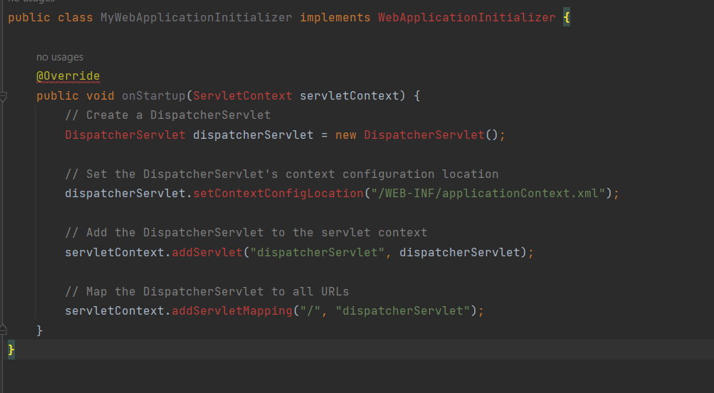
once we create this class, we can need to register with the Spring boot Main class by adding annotation called @SpringBootApplication
which means that in Spring Boot @SpringBootApplication is bootstrapped with the configurations of mapping and other default configs, so that Developer time will be reduced for configuration, and focus on business logics
when we start our Spring Boot Application, then this config class will also be initialized and Dispatcher Servlet will be configured.
- How Spring Boot Data JPA is used to perform the database operation & what it internally uses?
Ans:-
Spring Boot Data JPA, helps us to connect our Java application with the Database, with the help of spring-boot-stater-data-jpa dependency
where, it internally uses Hibernate for connecting with the database, spring boot makes it easy to configure Hibernate with JPA provider, spring boot will automatically configure the hibernate and provides the default EntityManagerFactory bean, if we need to customize then we can provide our own EntityManagerFactory bean with our own logic.
Where, Hibernate is a Framework for JDBC with ORM (Object Relational Mapping) library that provide the framework support for mapping Java Objects to Relational Database tables.
Advantages:-
1. Easy to use and configure
2. Performance will be boosted by using ORM for variety of Databases
3. Flexibility – as we are using Hibernate and ORM internally it provides support to multiple RDBMS vendors such as (MySQL, PgSQL, MsSQLServer, etc…)

