CORE JAVA INTERVIEW QUESTIONS WITH ANSWERS:-
- What is the difference between static and final variable in Java?
Ans:-

static | final
static is a keyword in java which is used to represent a class member. | Final is a keyword in java, which is used to represent a constant’s in java.
Static keyword can be used with methods, Block and variables but can not be used with class | Final keyword can be used with method, variable, and class as well
When a variable is declared with static keyword we can override the value associated with that variable. | When a variable is declared with final keyword we can not override the value associated with that variable.
A class cannot be static. | A class can be final class.
Static variables are not mandatory to initialize while declaring it (it can be reinitialized) | Final variables are mandatory to initialize while declaring itself. (it cannot be reinitialized)
Static variables can only be accessed by static members of the class. | Non-static final variable cannot be accessed inside the static methods (static final variable can be done)
Only static methods can invoke the static variables but not the non-static methods (if needed we need to use Class name to invoke it inside the non-static method) | Only static final variables can be accessed by static methods but not the non-static methods.
Static class cannot be created. | Final class can be created but it cannot be inherited
Static block is used to initialize the static variables | Here there is nothing like final block
- How static block and normal block will work in the given example?
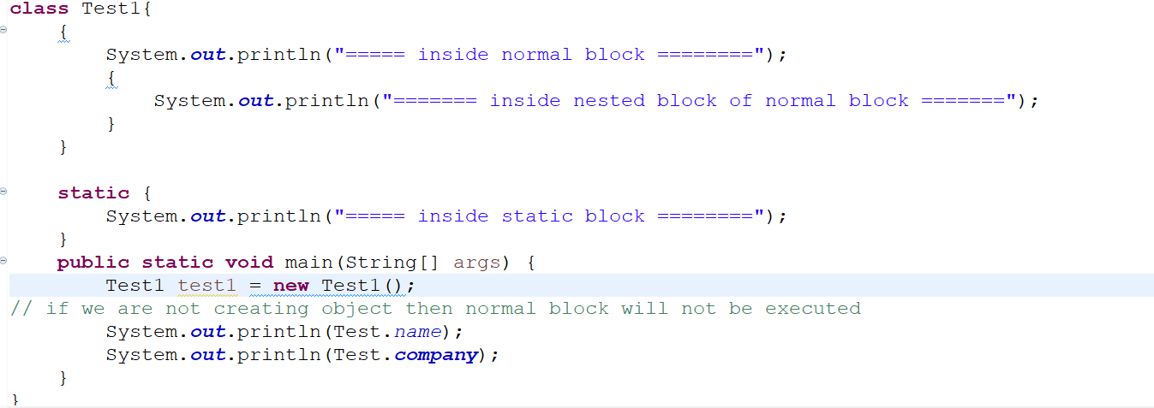
Output will be: -
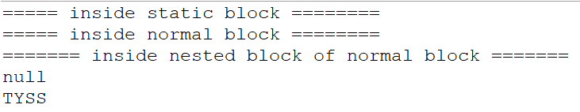

- How does static and final variables will work in java?
Ans
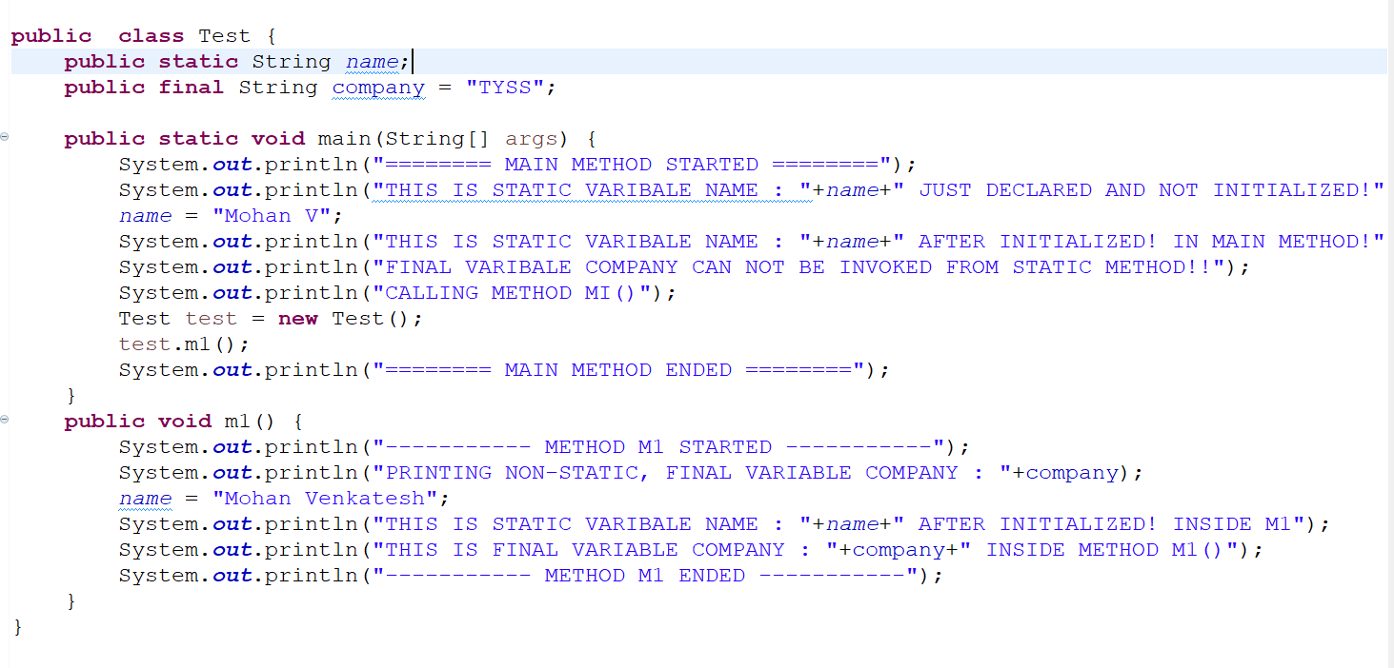
OUTPUT WILL BE:-
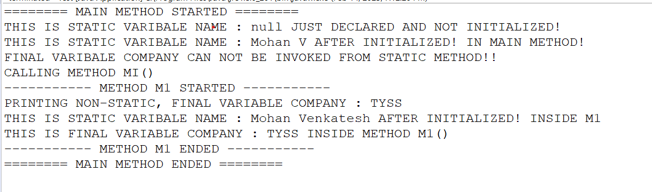
- Can we modify/override & access the static variable using object reference?
Ans:- Yes.! We can modify/override & access the static variable using Object reference, As shown in below Example:-
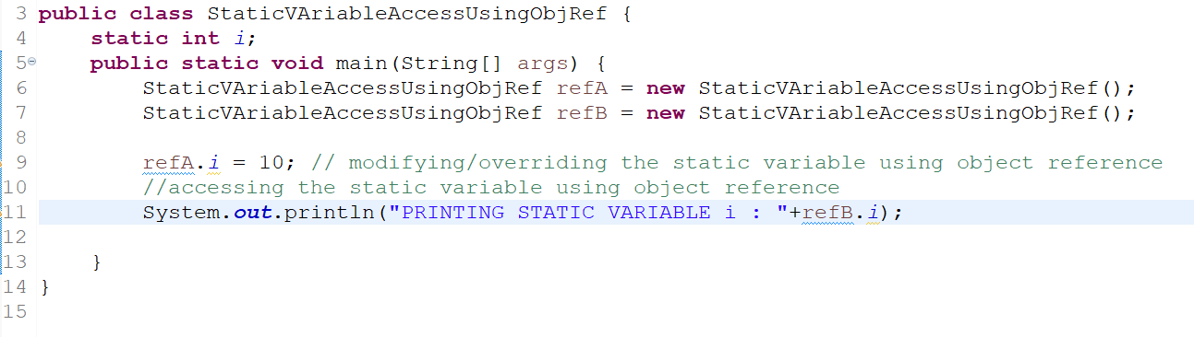
OUTPUT:-

- Why we need to use if-else conditional statements in java?
Ans:- we use if-else conditional statements in order to automate the decision making processes
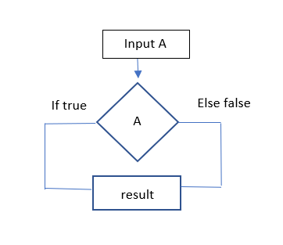
- What is Demon thread?
Ans:- * Demon thread is a thread which runs in background and performs task like garbage collector
* Demon thread is a supporting thread ie:- demon thread provides support (Service) for the user thread to complete its task.
* Life of a (Scope of a) Demon thread is -> when all the user thread is died JVM will automatically kills the Demon thread (bcz it’s just a supporting thread to all the user created thread).
* Demon thread will provide support for user thread by performing task like (Garbage collector/ finalize method invoking/… etc!)
- What are 4 pillars of OOPS of JAVA and Explain it?
Ans:- 1. Inheritance -> (Extends & Implements)
2. Polymorphism -> (overloading and overriding)
3. Abstraction -> (using interface hide the implementation)
4. Encapsulation -> (binding data member with its getters and setters)
- Can break and continue keyword can be used outside the loop or switch?
Ans:- No, we can’t use both keywords outside the loop or switch statements, it will give compile time error (ie:- Syntax error)
- What are the Thread priority in Thread class?
Ans:- Priority of a thread in java is represented by a number between 1 to 10, most of the cases thread scheduler will schedule the thread based on the priority number, and implementation of thread scheduler is purely depends on JVM vendor.
-> We Have 3 constants defined in thread class?
- public static int MIN_PRIORITY
- public static int NORM_PRIORITY
- public static int MAX_PRIORITY
Default priority of a thread is = 5
Maximum priority of a thread is = 10
Minimum priority of a thread is = 1
-> We can set the priority of a thread using thread class method called -> th.setPriority(int number);
-> We can get the priority of a thread using thread class method called -> th.getPriority();
- Compare JVM vs JRE vs JDK?
Ans:-
JDK | JVM | JRE
It is a Software development Kit | It is a virtual machine which has set of rules and regulations. | It’s a Runtime envi to java applications.
It contains set of libraries which helps to develop Java application. | It’s a Specification for JRE. | It’s a physical implementation of JVM.
JDK internally contains JVM + JRE + dev tools = JDK | JVM is a contains interpreter and JIT compiler | JVM + set of lib files = JRE
Dev tool are like compiler, Debugger, Etc…! | JVM is a specification for JRE | JRE contains = JVM + set of lib files + class loader
JDK helps developers to develop Java applications | JVM will convert byte code to machine level language. | JRE provides the run time env to run the Java app
Compiler inside JDK is responsible for checking the syntax errors. | Java understands Byte code | JRE is responsible for Memory allocation
JDK is platform Dependent | JVM is platform independent | JRE is platform Dependent
REFER PICTURE BELOW: -
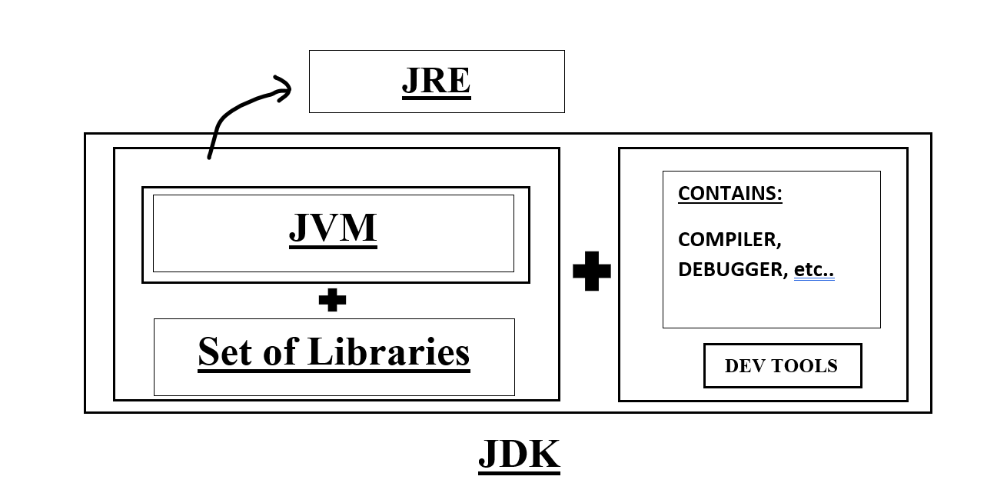
- What are wrapper class?
Ans:- wrapper classes are nothing but the Object wrapper’s which contains a primitive data types.
By default wrapper class are final classes present in java.lang package.
Wrapper classes are: -
Integer, Long, Double, Float, Character, Byte, Short, Boolean.
- How Dimond problem is occurred in java (or InOther words) why Java class does not support multiple inheritance?
Ans:- In Java Inheritance means relationship btwn two Object, this can be achieved by the extends KeyWord.
TYPES OF INHERITANCE: -
-> Single level Inheritance
-> Multi level inheritance
-> Hierarchical inheritance
-> Multiple inheritance
-> Hybrid inheritance
Example :-
public class A extends B{
}
* The class which inherits the property of another class is called as sub-class or child-class
* The class whose properties are inherited is called as parent-class
* HOW INHERITANCE WORKS :- In Inheritance a copy of parent class members is created in sub-class object, therefore using the sub-class object we can access the parent class members as well as the sub-class members.
* In Multiple inheritance one class inherits the properties of multiple parent classes, in other words
one sub-class or child class can have N no of parent classes. (Which Java does not support multiple inheritance with class)
CREATING DIAMOND PROBLEM :-
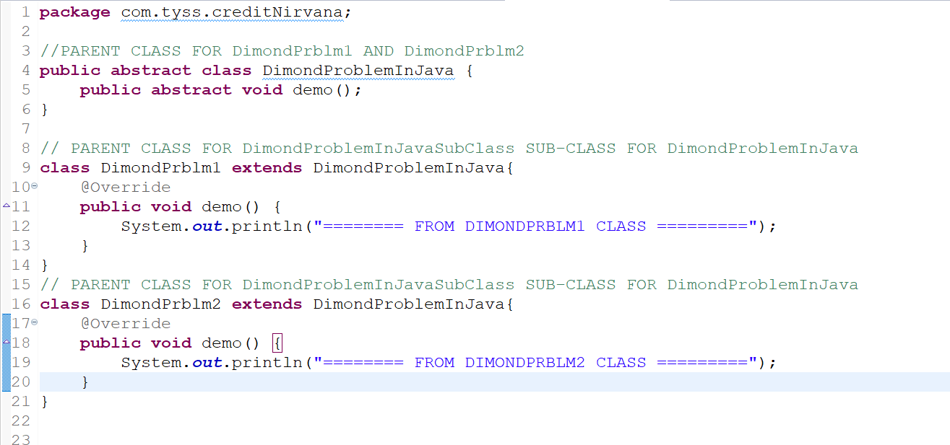
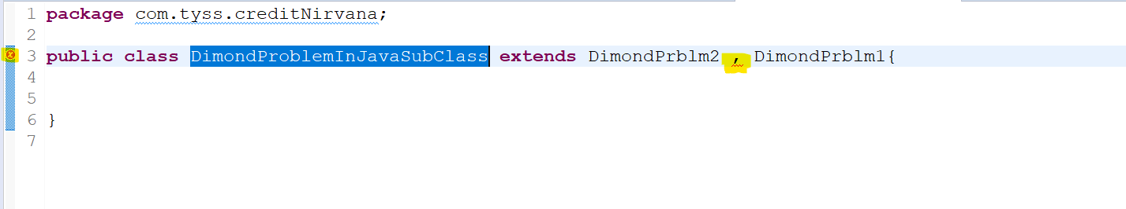
* According to our assumption, since java supports multiple inheritance, in above example we are trying to inherit both DimondPrblm1 and DimondPrblm2 in DimondProblemInJavaSubClass but when we try to do this we will get COMPILATION ERROR (As shown in snippet 2)
* as per basic rule of inheritance java tries to copy parent class method demo() in sub class which has same method signature, hence it will not satisfy the java basic rule hence we get COMPILATION ERROR (As shown in snippet 2)
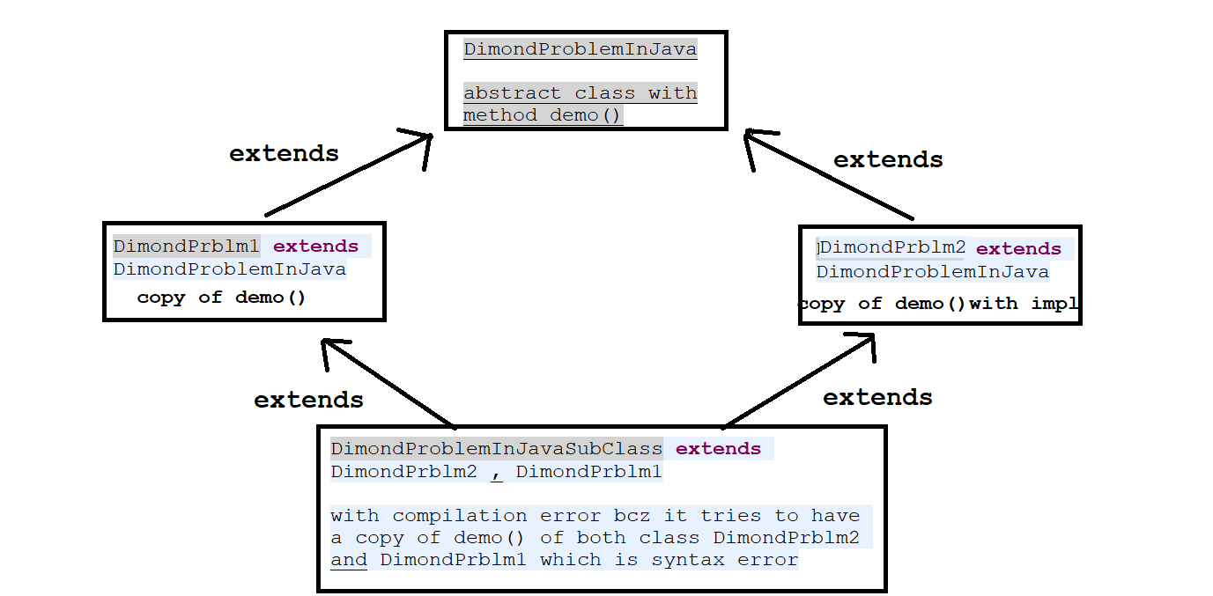
SOLUTION TO OVERCOME DIAMOND PROBLEM :-
we can overcome this Diamond problem by 2 components:-
-> Interface
-> default methods (Java 8)
* From Java 1.8v we can declare default methods in interface, which has a default implementation, hence the implementation class is not mandatory to override that method and provide the implementation (provide body to it)
* But when a class is implementing both the interface which has (same name and signature) in two diff interface we can provide implementation to that default method from the implementation class for that default methods.
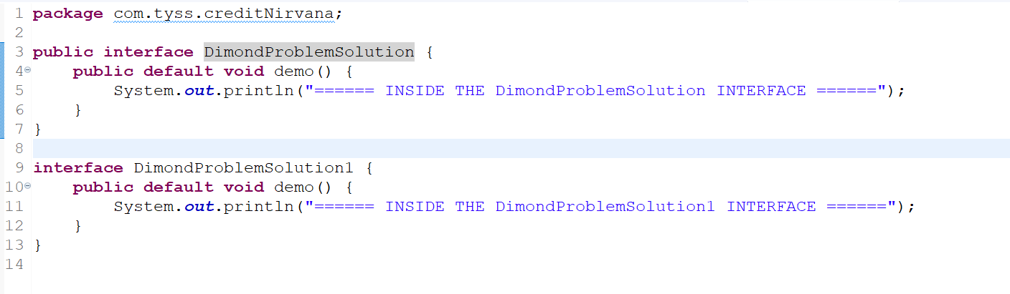
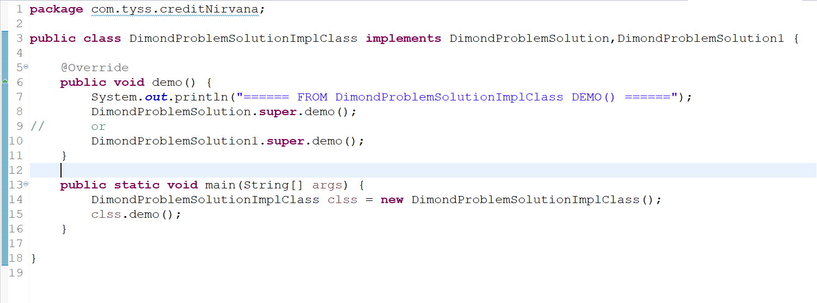
OUTPUT WILL BE :-
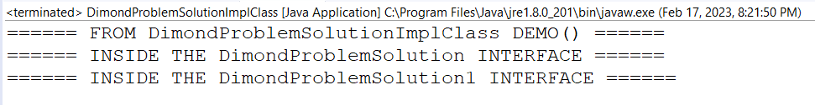
- What happens when class A extends Thread and contains method m1() which is synchronized and we create 2 Thread and both the threads are acting on the synchronized method at a time, What will be the behavior of the thread?
Ans:-
Code Snippet
OUTPUT 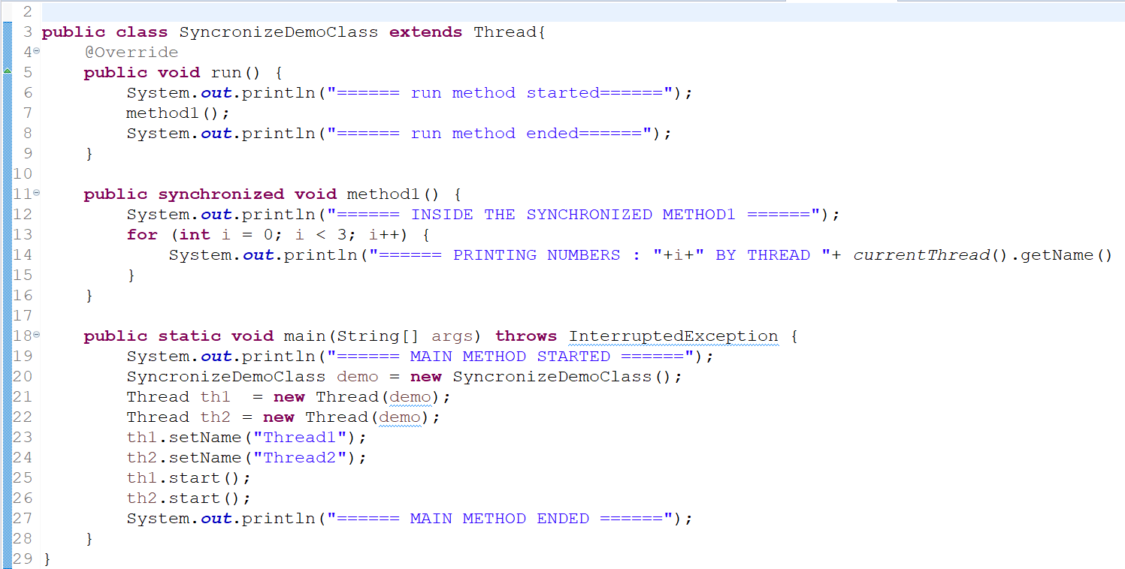
OUTPUT IS:-
CONCLUTIONS IS:- (Refer Below Screen shoot) Always Synchronized method will not allow multiple thread to act on it, At a time it will only single Thread work on it, Once 1st thread completes its work, then 2nd thread will get a chance
NOTE:- But which Thread will get 1st chance to execute, then 2nd and so on, is purely depending on THREAD SCHEDULER.
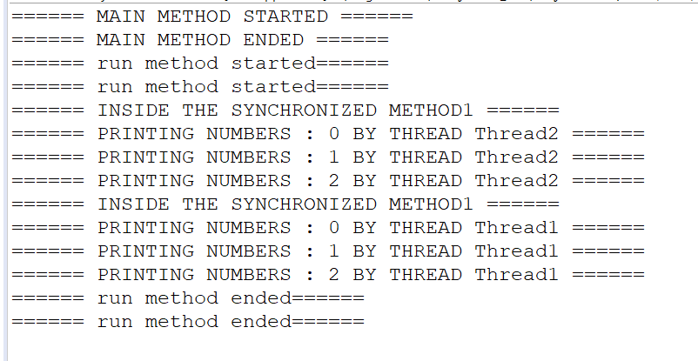
- In Java can we just declare the final variable without initialing it and later during object creation can we initialize it?
ANS:- YES!! We can do that with the help of constructor, we can assign the value to the final variable during the object creation. As shown below!! This is perfectly possible without any compilation error!!
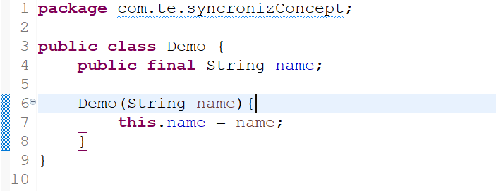
- Difference between String vs StringBuffer vs StringBuilder
STRING | STRING BUFFER | STRING BUILDER
It is immutable in nature (ie:- if a String (literal) is declared with variable s1 (String s1 = "abc";) and if we try to change it using -> s1 = s1+"xyz"; this will not happen and s1 will remain as "abc" only due to its immutably instead it will create the new object) | It is mutable in nature | It is mutable in nature
String Objects are thread safe in nature (ie: Only one thread can act at a time on any String Objects) | StringBuffer Objects are thread safe in nature (ie: Only one thread can act at a time on any String Objects) | StringBuilder Objects are not thread safe (ie: multiple threads can act simultaneously)
- | StringBuffer is slower when compared to Builder | StringBuilder is faster when compared to Buffer
When to use String (ie:- if your String remains constant for entire program than go for String) | When to use StringBuffer(ie:- if your String declaration varies and need to achieve thread safe then go for StringBuffer ) | When to use StringBuilder (ie:- if your String declaration changes and I need access by multiple thread simultaneously then go for StringBuilder)
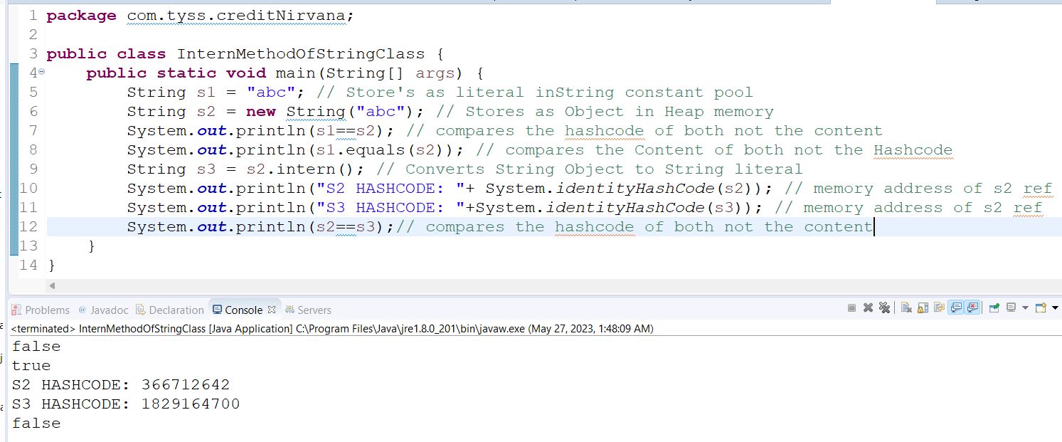
- Can we override the static and private method in java?
Ans:- NO!! we cannot override the static and private methods in java, Bcz static methods belong to class instance not to the Object instance, but if we need to invoke a overridden method we invoke using object reference, Hence we cannot override Static and private method in java.
- Does finally block of statement executed always?
Ans:- NO!! there are situations where finally block of statement will not be executed, when we use System.exit(0); in try or catch block then in this case finally block of statements will not be executed.
- What is try with resource statement in java?
Ans:- In java, if any resources (like Scanner, FileReader, BufferReader.. Etc which is costly resources) are used in try block of our program then it has to be closed at the and of the program. Else resource will be in use even after the program is terminated.
Eg:- try(FileOutputStream fileOutputStream =newFileOutputStream("/java7-new-features/src/abc.txt")){
//logic here.
}catch(){ // catch block statements }
- What do intern() [ie:- intern method] in String class do in Java?
Ans:- intern method in Java, helps us to create an exact copy of String from Object form [String str = new String(“abc”)] to String literal form [String s = “abc”] with the help of intern(), But NOTE that before creating the object it will check weather the same value with already existing reference is present or not, if exist it will not create new one, if not exist it will create the new one. Ref Example below
- What is the Difference btw ERROR and EXCEPTION in java?
Ans:-
ERROR:- Error is an incident, occurs during compile time as well as runtime due to the wrong user’s input or sometimes due to Developers mistakes. Example: - Syntax Error are compilation error [ Error is nothing but a BUG]
TYPE OF ERRORS:-
- Syntax Error
- Logical Error
- Runtime Error
EXCEPTION:- Exception is an unexpected incident occurred during the Runtime execution of a program, due to this there is a chance of incomplete execution of program, and may be crash of entire system.
TYPE OF EXCEPTIONS:-
- Checked Exception
- Unchecked Exception
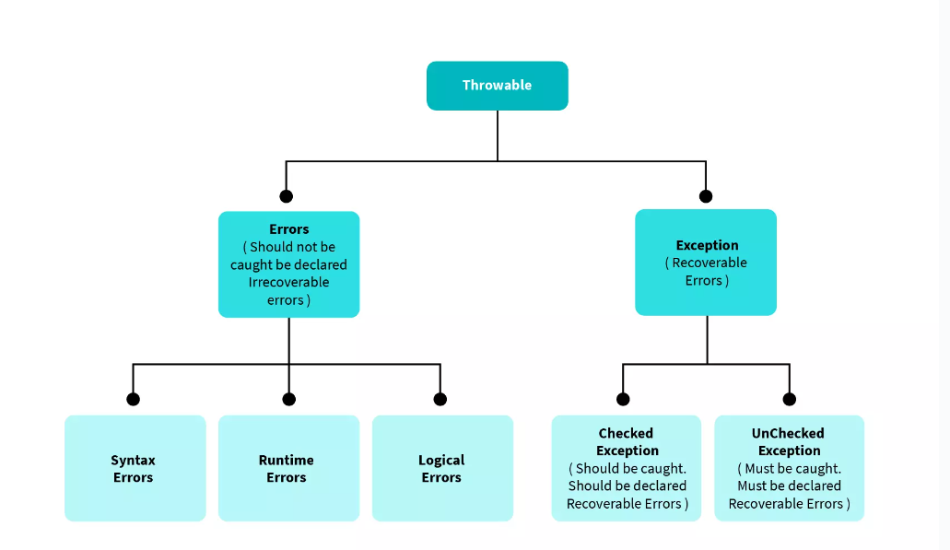
CHECKED EXCEPTION:-
This is a type of exception occurs, and it can be detected or predicted during the compile time is known as Checked Exception.
Example:- SQLException, IOException, FileNotFoundException, ClassNotFoundException, etc…
UNCHECKED EXCEPTION:-
This is a type of exception occurs during the runtime and interrupts the normal flow of execution is called as Unchecked Exception.
Example:- ArithmeticException, NullPointerException, NumberNotFoundException ,All custom Exception, etc..
NOTE:-
- Throwable is the super most class all Exceptions for both Checked & Unchecked Exceptions
- Why String is Immutable and how it is immutable, what are the advantages of being String as Immutable?
Ans:-
Why String is immutable:-
- First of all String is a Final class, hence we cannot change the Final class properties once it is defined
- Second is the memory issue, if we have same value of String (ie:- Duplication of already existing String) and if we keep creating the Objects then there is a chance of becoming the Out of memory.
- Third is the Security issue, if not then anyone can change URL’s, username or password by appending the String and modifying the Original String.
How String is immutable:-
- By not changing (Overriding) the original String value, but NOTE that we can update the String reference value, while doing this old value associate with that same String reference will be eligible for Garbage collector.
Advantages over String as immutable:-
- Security since in Java Application we use String for majority of the fields, hence String is Immutable in nature so we cannot alter the Original String and hence fields like URL’s/username/password etc.. are safer in nature.
- Memory since java is immutable and as we saw above First it will check for the existing values if no values are present, it will create the new Object of String literal else it will point to the same.
- Synchronized since String class Objects are Synchronized there is a thread safe which means if one thread is creating the String Object then other thread will not modify it, Bcz of its synchronized in nature.
- What is mean by Method Hiding?
Ans:- If a SubClass (child class) is having a static method with a same signature, as in SuperClass (parent class) then the static method in sub class will conceals (hide) the parent class static method
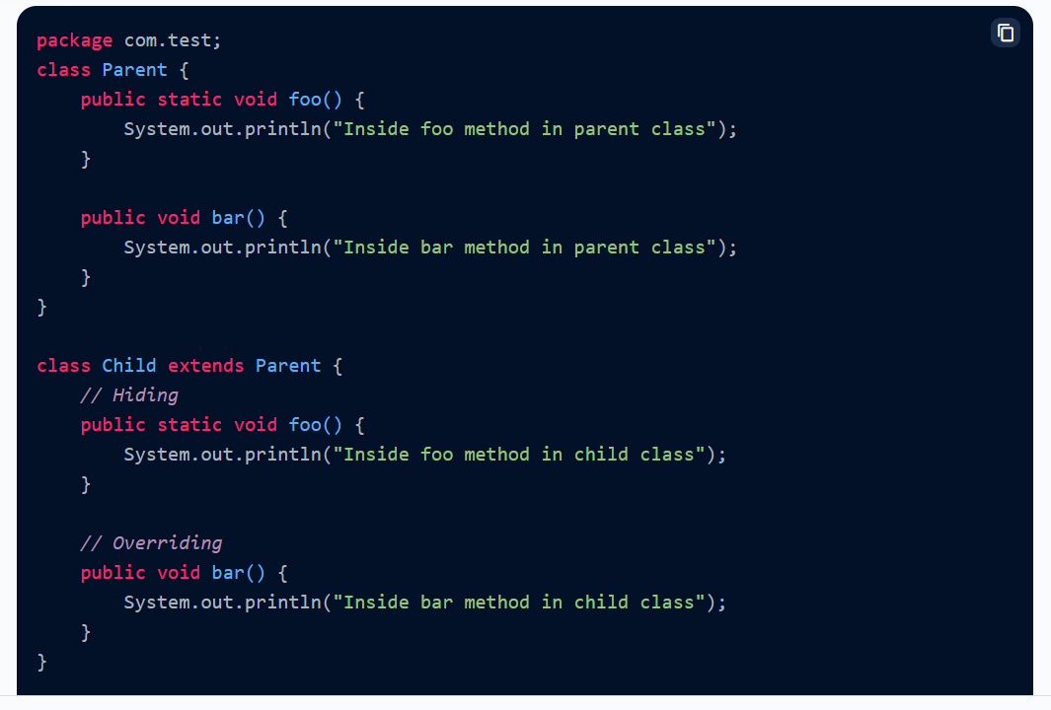
From the above example, foo() in child class is hiding the foo() of Parent class.
- What is the diff btw ClassNotFoundException and NoClassDefFoundError?
Ans:-
NoClassDefFoundError:-
* This comes under Error (RunTimeError), where it is an Unchecked Exception (Compiler cannot predict) occurs during runtime
* This occurs, when an Java Object is hardcoded in the other java classes, and the Hardcoded class exist during compile time But during Runtime the respective .class file is missing. In this scenario NoClassDefFoundError occurs.
ClassNotFoundException:-
* This comes under Expectation (CheckedException), where it is an Checked Exception (Compiler will predict and force the developer to handle it) occurs during runtime
* This occurs, when and Java class is loading during runtime (loading respective .class file with its name via input arguments ie: Object obj = Class.forName(args[0]).newInstance()) and during runtime if the class loader fails to find the respective .class file then, In this scenario ClassNotFoundException occurs.
- What is the default value of a local variable in java?
Ans:- There are NO DEFAULT VALUE for local variables, we need to initiate during the declaration itself or else we need to initialize before using it, else we will get compile time error.
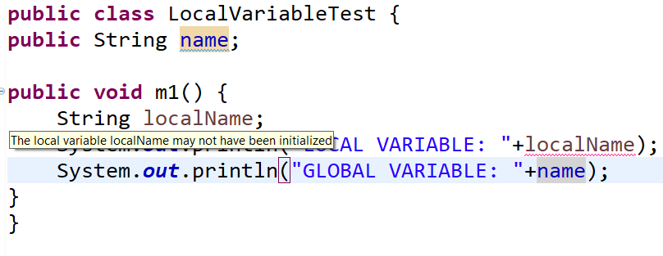
- What is Dead Lock situation in Java Threads? and How to resolve it in java?
Ans:- If TWO THREADS are waiting for each other forever, then this situation is called as DEAD LOCK SITUATION
Example:- If Thread T1 is holding Object O1 and Thread T2 is holding Object O2, but both are associated with synchronized methods, after completing the task of T1 with O1, T1 is waiting for T2 to release lock and T2 is waiting for T1 to release lock for long time this causes the DEAD LOCK SITUATION
- There is NO resolution for Dead Lock situation but we can prevent this situation by Removing any one of the Synchronized keyword from the method.
- Hence we need to be very careful while using Synchronized keyword in threads.
- NOTE:- So we can conclude that synchronized keyword is the main cause of DEAD LOCK situation.
====================== CODING PART HAS TO BE DONE AND ATTACHED HERE ======================
Want to access
Is Holding
Is Holding
Object O2
Object O1
Thread T2
Thread T1
- What are the Methods that will prevent a Thread from its Execution and its Explanation?
Ans:- There are 3 Methods that will prevent the Thread from its Execution, They are:-
* yield()
* join()
* sleep()
yield()
- yield is a method in java Thread Class, which enables the current execution thread to put in waiting area and thread with same priority will get chance to execute its task.
- If all the threads in waiting area, has lower priority than the current executing thread, then the thread scheduler will allow same thread again for its execution
- If any thread in waiting area has same priority then we cannot predict which thread will get chance to execute, its purely depends on Thread Scheduler
NOTE:- Thread Scheduler algorithm is purely depending on the JVM Architecture.
join()
- join is a method in java Thread class, where if any thread in waiting area, wants the current execution thread to put in waiting state, till the thread (ie:- Thread which needs to, go to execution which is in waiting state) completes its execution work completely.
- Example:- Real world Example
If Boy1 and Boy2 are going to Jspiders for Course
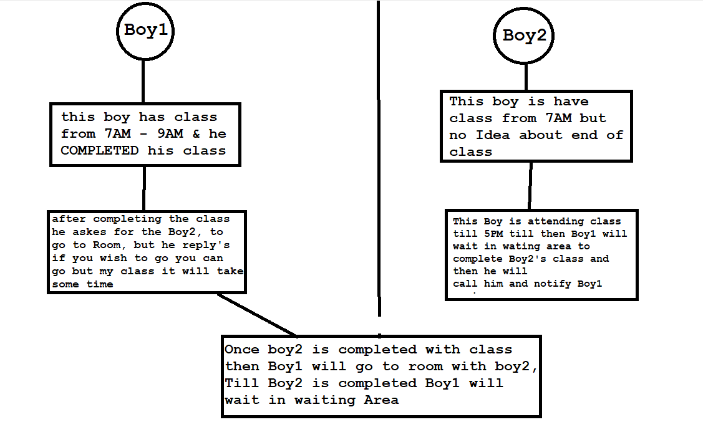
Similarly, if T1 Thread is Executing and T2 Thread is in waiting area then, if T1 finds any code like t2.join() then, immediately T1 should stop its execution and allow T2 to complete its work fully, after that only T1 is allowed to go for Execution.
NOTE :-
- Once T2 is entered into execution it will enable the lock btw that thread and app, till it completes its execution it will not allow any of the thread to enter into it.
- If MainThread is calling join() on child thread & child thread is calling join() on MainThread then this situation will lead to DEADLOCK situation
- both the Thread will be waiting in above case to release the lock and ends up in DEADLOCK situation
- we have 3 diff constructor in Join()
--- public final void join() throws InterruptedException
--- public final void join(long milliSeconds) throws InterruptedException
--- public final void join(long milliSeconds, int nanoSeconds) throws InterruptedException
- Every join() will throw InterruptedException that has to be handled using try&catch or using throws keyword else Compilation Error
sleep()
- sleep is a method in Java Thread Class, if a Thread don’t want to execute for certain period of time and if program want to put that thread in waiting area then we use sleep()
- we have 2 diff constructor in sleep()
--- public static native void sleep(long milliSeconds) throws InterruptedException
--- public static void sleep(long milliSeconds, int nanoSeconds) throws InterruptedException
- What is mean by Synchronization in Threads concept?
Ans:- Synchronization is a concept of establishing lock btwn the current execution thread and Synchronized method, which means that, A method with synchronized keyword will allow only one thread to act on it at a time.
- What is mean by interrupt() in Java Thread Concept?
Ans:- This method is used to interrupt the thread from one state to another state, But this interruption happens only at WAITING AREA only. (ie: - if thread enters to waiting area then interruption happens, or else if already thread is in waiting area then also interruption takes place.)
NOTE:-
-- if thread is not at all entering into the waiting area then, interruption will never takes place at all.
MENTION ALL THE THREAD RELATED QUESTION HERE ONLY
- What is mean by co-variant return type?
Ans:- If we have an Overridden method in a class, and if we are able to changing the return type in its method signature by its sub-class or any of it’s same type (Where it can be its sub-class as well) without any casting (Up casting or Down Casting) then, that method is called as CO-VARIANT return type
NOTE:-
- This can be DONE only with NON_PRIMITIVE DATA TYPES
EXAMPLE:-
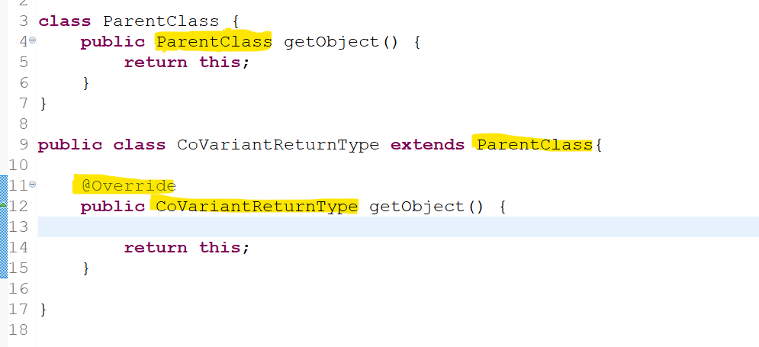
- From above example we can see that, we have overridden a method called getObject() from ParentClass into CoVariantReturnType Class (Which is a sub-class of Parent class).7
- but if we observe the screen short above, an overridden method signature is different and return type is replaced by its sub-class or child class
- But also, the compiler is accepting it HAPPYLY this is called as CO-VARIANT return type.
- What is the Difference btw printf() and print() in Java PrintStream class?
Ans:-
printf() :-
- printf is a function in PrintStream class in java, which enables the developer to print the content in console
- but here we don’t want to make any appending operation, it happens automatically with the help of appropriate regex expression (Such as “%d” for integer and “%s for String” and “%n for line break” and) used in it.
- Refer below snap short line number 12
print() :-
- print is a function in PrintStream class in java, which enables the developer to print the content in console
- but here we need to appending operations either by using “+” or by using concate() function to append the values with String
- Refer below snap short line number 07
Example:-
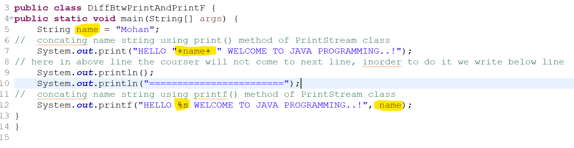
OutPut:-
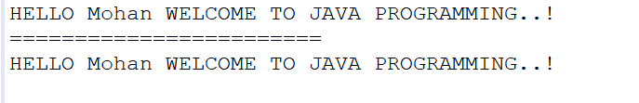
- What is the difference btw & and && operator in java?
Ans:- In java we use & symbol as two types:- 1. Relational Operator 2. Bitwise operator
- Relational Operator :-(&&) Using relational operator (&&) we will be able to validate the given condition, such as it work as follows, if we provide more than one condition to validate with && operator, then if all the condition is true then it will print TRUE else if any one condition is false then it will not check for the next condition, immediately it will print FALSE
- Relational Operator :-(&) Using bitwise operator (&) will perform the same as Relational operator and produces the same output, but the difference is that it will validate all the conditions even, if the pervious condition is failed.
EXAMPLE:-
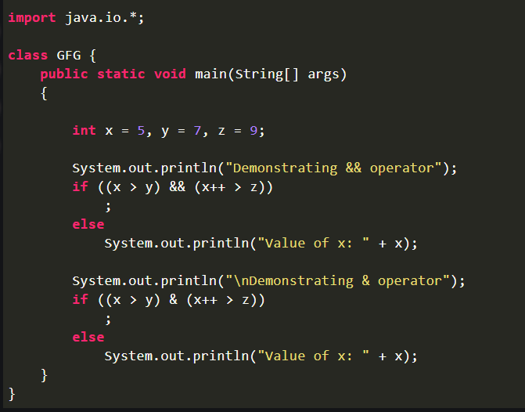
OUTPUT:-
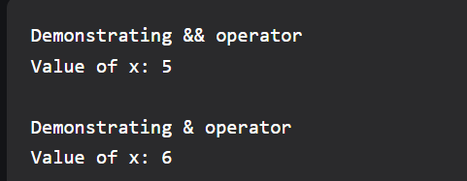
- Bitwise Operator :-(&) Using bitwise operator (&) is used to do LOGICAL AND OPERATION on integer values, same as how we do in BINARY AND, since it deals with the binary bits, hence it is called as Bitwise Operator.
NOTE: -
- Behind the Sean, the passed int value is converted to a Binary digit (ie:- 0’s and 1’s) and then the LOGICAL AND OPERATION is done.
- But we may have doubt saying that, Why cant we use the traditional way of execution using +, -, *, /, % instead of bitwise? The answer is that behind the Sean all the operations are executed in binary form in computer hence using BITWISE OPERATOR will be efficient one.
- Can we create an INSTANCE for Abstract class? And Explain why?
Ans:-
* NO..! We CAN NOT create an Instance/Object for an Abstract class,
* Bcz Abstract class can have both Abstract Methods (which means that those methods are IN-COMPLETE METHODS only method signature NO body), as well as Concreate method, hence we cannot create an Object for Abstract class.
* If a class is declared with ABSTRACT key word, Then it must have SUBCLASS and that sub class should inherit and implement all the Abstract Methods, else SUBCLASS also MUST be declared as ABSTRACT CLASS.
* An Abstract Method cannot be a STATIC and FINAL, bcz Static and Final methods cannot be overridden.
Though we cannot create an Object WE HAVE CONSTRUCTOR IN ABSTRACT CLASS, then why it is used?
* Constructor in Abstract class is used to instantiate -> Instance Variables & static variable.
* we cannot create an Object of Abstract class Directly but we can assign the SubClass Object to the Abstract class.
Abstract class refVariable = new SubClassImpliAbstractClass();
Can we create an ANONYMOUS class for Abstract class?
* YES..! we can create an Anonymous inner class for an Abstract class.
* we can also implement the abstract method using Anonymous inner class.
