

ADT Algorithm Deliverables

Adaptive Digital Technologies, Inc.
Oct 15, 2012
Issue 2

Copyright © 2012 Adaptive Digital Technologies Inc.

Revision History

Issue | Revision History | Date | Initials
1 | Creation | 1/30/2012 | SDK
2 | CCS4 test project | 10/15/2012 | HFZ

Table of Contents
1. Introduction 1
2. Directory Structure 1
2.1 common -> doc 1
2.2 common -> include 2
2.3 common -> utilities 2
2.4 common -> xdais_test 2
2.5 common -> xdm_packages 2
2.6 algorithm -> doc 2
2.7 algorithm -> include 2
2.8 algorithm -> platform 2
2.9 algorithm -> test 2
2.10 algorithm -> vectors 3
3. Conventions 3
3.1 Function Names 3
3.2 Library Names 3
4. Windows DLLs 3
5. Code Composer Studio Test Projects 4
5.1 CCS v3.3 4
5.2 CCS v4 4
5.2.1 CCS v4 Workspace 4
5.2.2 Target 6
5.2.3 Import CCS v4 project 6
5.2.4 Building and Running the CCS v4 Projects 7

Introduction

The purpose of this document is to describe the format and content of Adaptive Digital’s algorithm software deliverable packages.

Note that this document covers newer algorithm packages. Many older packages still exist, and those packages don’t conform to the descriptions in this document. Older packages are easily distinguished in that they tend to be delivered with a flat directory format. In other words, all files reside in the same directory.

Directory Structure

The directory structure of the deliverable package has two components: common and algorithm-specific. Each component has its own directory structure as shown below.

ADT_Algorithms
common
doc
include
utilities
xdais_test
xdm_packages
<algorithm>
doc
include
<platform>
libs
<test projects>
test
vectors
<algorithm…>

Note that items in braces (<item>) are placeholders. For example, <algorithm> would be replaced by the name of the particular algorithm.

The common folder contains files that are common to more than one algorithm. There is one <algorithm> folder for each algorithm. For example, g.729ab, aec.

The individual directories are described in further detail in the sections that follow.

common -> doc

This folder contains documentation about the items that reside in the common folder. For example, this document resides in that location because this document discusses the overall directory structure and is not specific to any algorithm.

common -> include

This folder contains include files that are common to many algorithms. The most important of these files is adt_typedef_user.h. This header file defines “C” type definitions that are used in the algorithm’s header files.

common -> utilities
This folder contains utility functions that may be used in our test programs.

common -> xdais_test

This folder contains TI XDAIS support files that are used for the purpose of testing TI XDAIS compliant algorithms.

common -> xdm_packages

This folder contains TI XDM packages and are used for the purpose of testing XDM compliant algorithms.

algorithm -> doc

This folder contains algorithm-specific documentation such as users guide, data sheet, and release notes. The users guide describes the algorithm and its API. The users guide is common across all platforms (win32, arm, dsp). The data sheet contains information that is specific to the various platforms. For example, the data sheet contains the algorithm’s CPU and memory utilization on the various platforms.

algorithm -> include

This folder contains the algorithm-specific header file(s). In general, there is only one such header file and it is typically named <algorithm>_user.h.

algorithm -> platform

This folder contains platform-specific files such as test projects. For example, a Windows package might include the following:

win32 (<platform>)
algtestusinglib

Where algtestusinglib contains a visual studio project that performs tests on the algorithm using the supplied algorithm library.

algorithm -> test

This folder contains test software that exercises the algorithm. Often this test program reads test vectors, runs them through the algorithm, and compares the results to reference test vectors. Alternately, the program may read test vectors, run them through the algorithm, and write the results to output files.

algorithm -> vectors

This folder contains test vector files that are used to test the algorithm.

Conventions

Function Names

Algorithm APIs usually follow the following convention:
<ALG_ADT_function>

For example, the AGC algorithm has the following functions:

AGC_ADT_init
AGC_ADT_computeGain
AGC_ADT_applyGain

Library Names

Library names follow the following general convention.

ADT_<ALG>_<PLATFORM>_V<version>_E<B/L>_M<memorymodel>_CG<codegentoolversion>.<ext>

where:

ALG is the algorithm name
Platform is the target platform such as armv7a or c64xp
EB: big endian, EL: little endian. If omitted,d the default for the platform is used
Memory model is specific to the platform. If omitted, the default for the platform is used

The extension is typically .lib, .dll, .a, or .lxxx where xxx is indicative of the platform.

Windows DLLs

Windows DLLs require a bit of additional explanation, especially since our DLLs differ from the older format significantly.

When we deliver a DLL package, we deliver both a DLL and a static library. The static library is intended to make it easier to use the DLL. It eliminates the need for the host application to load the DLL and extract API addresses from the library.

This should not be confused with static library packages. In the case of a static library, there is a single library delivered.

A typical DLL may be delivered with libraries named:
ADT_algdll_vxyz_CGVS2008.dll (DLL)
ADT_algdll_vxyz_CGVS2008.lib (static helper library)

A static library may be delivered with a singe library named:

ADT_alglib_vxyz_CGVS2008.lib (static library)

Code Composer Studio Test Projects

CCS v3.3
CCS v3.3 test project is located in

ADT_Algorithms
<algorithm>
<platform>
<test projects>

For example, for the AGC C55X product, the test project file is ADT_Algorithms\AGC\c55x\AGCTestUsingLib\agcc55xobj.pjt

To run the test project in CCS v3.3, you may follow the steps below:

- To run the CCSv3.3 example projects, connect your Target, via a suitable emulator.
- Load the .pjt file from <test projects>.
- Build the project and load the program to the target.
- Run the program and observe the test result.

CCS v4

The CCS v4 test projects are different from CCS3.3. Before we create or run the test project we need to select the “Workspace” location, and setup “Target Configuration”.
- Create folder as the workspace, if no such folder exists.
- Open CCSv4, select the workspace folder
- Open or create Target Configuration for desired target board.
- Import or create the test project.
- Build the test project.
- Load and run program.

The step 1 is only needed once if there is no folder as the “workspace”, once the folder is created, you may keep using it.

Currently a subfolder under ADT_Algorithms is needed for the CCS v4 workspace. The CCS v4 projects should be located under this subfolder. For example, ADT_Algorithms\ccs4TestWork\c55x

CCS v4 Workspace

You need to select a folder as the CCS work space while opening then CCS v4 application. This “Woprkspace” folder should be created under ADT_Algorithms\ccs4TestWork\c55x, For example,

ADT_Algorithms\ccs4TestWork\c55x

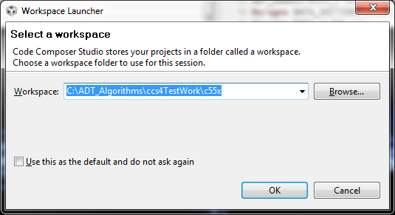

Next, Click on the CCS logo (looks like a small Rubik’s cube) to start the CCS work bench.
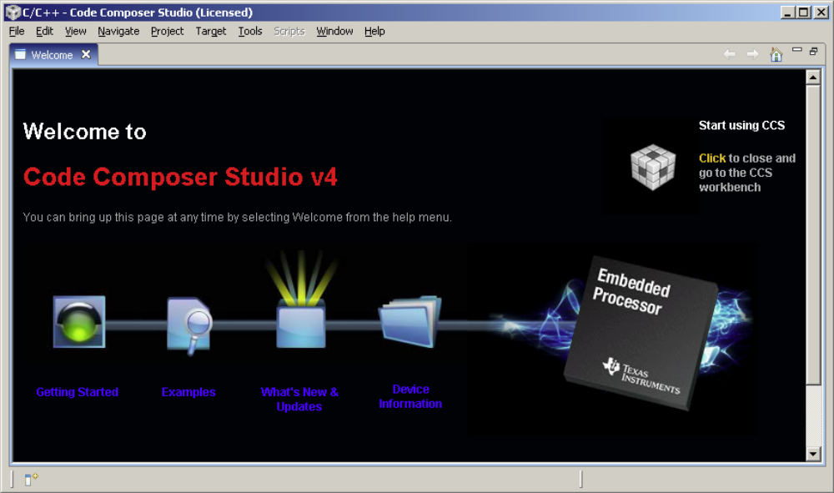

Target

To run CCS v4 projects, you have to connect your Target, via a suitable emulator such as the “XDS510”, “XDS100” or the EVM’s “Onboard” emulator, to CCS. To use the Onboard emulator, connect a USB A/B cable from your host PC’s USB port to port 'EMU USB'(J201) on the EVM.

For example, to run the CCS v4 test project on the VC5535 EZDSP which has the XDS-100 emulator built in.

Please be aware of that, before bring up the CCS v4, you may need to install the driver (from the CDROM that comes along with EVM).

You can generate the Target Configuration (.ccxml file) easily.

- In CCS 4.x, select Target, select “New Target Configuration”,
- On the popup window, after “File name”, you may fill in the target config file name. For example, EZ5535Configuration.ccxml.
- In the .ccxml, under Basic, then General Setup, Select “Texas Instruments XDS100v2 USB Emulator” for Connection,
and for Device, pick “EZDSP5535”.
- After new target configuration created, right click the .ccxml under “User Defined”, then click “Launch Selected Configuration” to start the debug session.
Note:
The .ccxml file only need to create once for one device. Next time to use target, just click “View”, the “Target Configuration”, then “User Defined”, you will find the existing target.

Import CCS v4 project

- Click the menu “File”, then “Import”, Select “General” then Select ”Import Existing Project into Workspace”
- Then select “Select archive file”
- Browse for the archived project file, then click “OK”.
For example, ADT_Algorithms\ccs4TestWork\import\aecg4test.zip
- All the CCS v4 projects will be displayed in the list of projects. Check the project you need to import in. For example, bfTestUsingLibCcs4
- Leave the “Copy projects into workspace” box unchecked. Click on “Finish”. Projects will be loaded to the CCS.
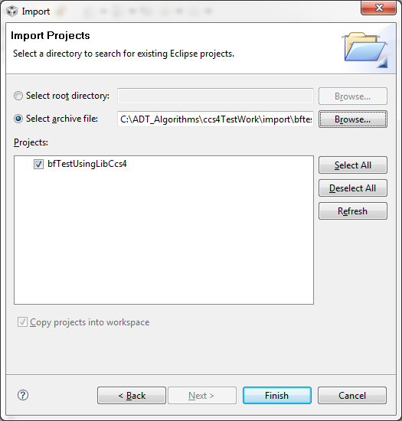

Building and Running the CCS v4 Projects

- Click “View” Then “C/C++ Projects”, right click on the project that you want to test and select Set as Active Project.
- Right click on the project that you want to test and select “Build Project”. If you need to change the build option, you may Right click on the project that you want to test and select Build Properties to change the compiler and linker options.
- Launch the Target Configuration. Click “View” Then “Target Configurations”. Right click on the project that you want to test and select “Launch Target Configuration”.
- Click “Target”, Then click “Connect Target”.
- Click “Target”, Then click “Load Program”. Then browser for the DSP program, for example, C:\ADT_Algorithms\ccs4TestWork\c55x\AECG4TestUsingLibCcs4\Debug\ AECG4TestUsingLibCcs4.out. Then click “OK” to load the program on the target.
- Click “Target”, Then click “Run” to run the DSP program. If the program runs OK, normally there will be print out on the console. For example, “ Test passed”.

