

ADT Algorithm Test Project Quick Start Notes

Adaptive Digital Technologies, Inc.
Oct 18, 2012
Issue 1

Copyright © 2012 Adaptive Digital Technologies Inc.

Revision History

Issue | Revision History | Date | Initials
1 | Creation | 10/18/2012 | HFZ

Table of Contents
1. Introduction 1
2. Directory Structure 1
3. Code Composer Studio Test Projects 2
3.1 CCS v4 Test Projects 2
3.1.1 Workspace - Step 1 2
3.1.2 Start CCS v4 - Step 2 2
3.1.3 Target Configuration – Step 3 3
3.1.4 Import CCS v4 project - Step 4 4
3.1.5 Building CCS v4 Projects - Step 5 5
3.1.6 Running CCS v4 Projects – Step 6 6
3.2 CCS v3.3 6

Introduction

The purpose of this document is to quick notes to cover how to use Adaptive Digital’s algorithm software deliverable packages and test projects. For more information, please read ADTAlgorithmDeliverables.pdf .

Note that this document covers newer algorithm packages. It shows an example of the deliverable, please be aware of that it might be different between the releases.

Directory Structure

The directory structure of the deliverable package has at least two components: common and algorithm-specific. For example, if customers licenses AECG4, NR2(noise reduction2), AGC, BF(beamformer), ADT 4800 codec, then after unpack the deliverable, the following structure should created.

ADT_Algorithms
common
adt_4800
AECG4
AGC
BF
NR2

The common folder contains files that are common to more than one algorithm.
ADT_Algorithms
common
doc
include
utilities
xdais_test
xdm_packages

There is <algorithm> folder for each algorithm. For example, adt_4800 is the release folder for the ADT 4800 codec, the library, document, header file, test code and vectors are located under this folder like this,
ADT_Algorithms
adt_4800
doc
include
c55x
libs
TestUsingLib
test
vectors

For example, the ADT 4800 c55x object library is located under, C:\ADT_Algorithms\adt_4800\c55x\libs,
and the test vectors are under C:\ADT_Algorithms\adt_4800\c55x\vectors.

Code Composer Studio Test Projects

CCS v4 Test Projects

Before we create or run the test project we need to select the “Workspace” location, and setup “Target Configuration”. Here are brief procedures.
- Create folder as the workspace, if no such folder exists.
- Open CCSv4, select the workspace folder
- Open or create Target Configuration for desired target board.
- Import or create the test project.
- Build the test project.
- Load and run program.

Workspace - Step 1

Other that the directory structures of common and algorithm-specific folders, the workspace folder must be present or created.

For example, C:ADT_Algorithms\ccs4TestWork..
ADT_Algorithms
ccs4TestWork
c55x
import

In this example we have C:\ADT_Algorithms\ccs4TestWork\c55x as the workspace folder (described in the section below). And there are archived ccs v4 test projects available under C:\ADT_Algorithms\ccs4TestWork\import.

The step 1 is only needed once if there is no folder as the “workspace”, once the folder is created, you may keep using it.

Start CCS v4 - Step 2

Start the Code Composer V4. CCS v4 will prompt a window to ask the workspace, please browser or fill in the C:\ADT_Algorithms\ccs4TestWork\c55x

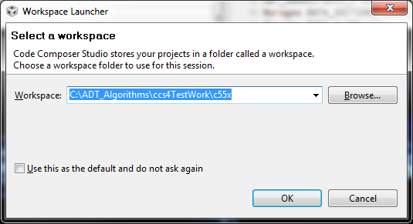

Next, Click on the CCS logo (looks like a small Rubik’s cube) to start the CCS work bench.
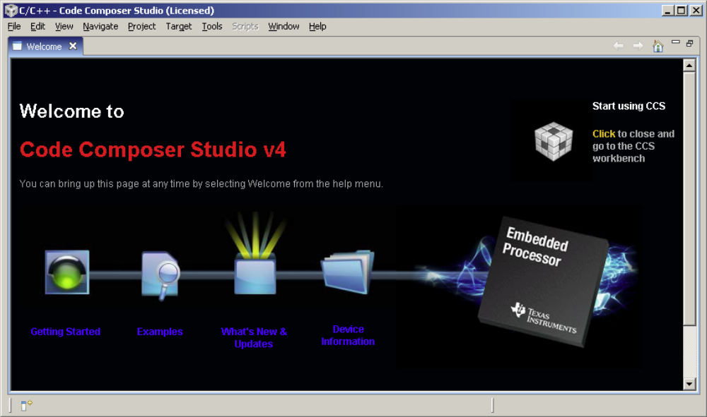

Target Configuration – Step 3

To run CCS v4 projects, you have to connect your Target, via a suitable emulator.

For example, to run the CCS v4 test project on the VC5535 EZDSP which has the XDS-100 emulator built in

Please be aware of that, before bring up the CCS v4, you may need to install the driver (from the CDROM that comes along with EVM board).

You can generate the Target Configuration (.ccxml file) easily.

- In CCS 4.x, select Target, select “New Target Configuration”,
- On the popup window, after “File name”, you may fill in the target config file name. For example, EZ5535Configuration.ccxml.
- In the .ccxml, under Basic, then General Setup, Select “Texas Instruments XDS100v2 USB Emulator” for Connection,
and for Device, pick “EZDSP5535”.
- After new target configuration created, you may click View on the main menu, click the “Target Configuration”, then under “User Defined”, you would find EZ5535Configuration.ccxml
Note:
The .ccxml file only need to create once for one device. Next time to use target, just click “View”, the “Target Configuration”, then “User Defined”, you will find the existing target.

Import CCS v4 project - Step 4

- Click the menu “File”, then “Import”, Select “General” , Select ”Import Existing Project into Workspace”, Then Select “Next”
- Then select “Select archive file”
- Browse for the archived project file, then click “OK”.
For example, ADT_Algorithms\ccs4TestWork\import\bftest.zip
- All the CCS v4 projects will be displayed in the list of projects. Check the project you need to import in. For example, bfTestUsingLibCcs4
- Leave the “Copy projects into workspace” box unchecked. Click on “Finish”. Projects will be loaded to the CCS.
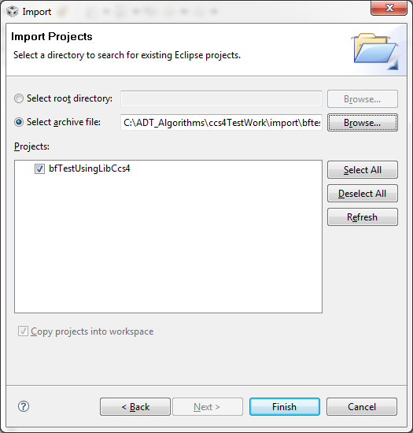

Building CCS v4 Projects - Step 5

After import the test project in the workspace, you may build the project.

- Click “View” Then “C/C++ Projects”, right click on the project that you want to test and select Set as Active Project.
- Right click on the project that you want to test and select “Build Project”. If you need to change the build option, you may Right click on the project that you want to test and select Build Properties to change the compiler and linker options.
- If the project built OK, you would see the print out on the console.
For example,
Build complete for project bfTestUsingLibCcs4

Running CCS v4 Projects – Step 6

- Launch the Target Configuration. Click “View” Then “Target Configurations”, Click “User Defined” then select the target from the list that you want and right click the target select “Launch Target Configuration”. For example, right click on the EZ5535Configuration.ccxml, then click “Launch Selected Configuration” to start the debug session.
- Click “Target”, then click “Connect Target”.
- Click “Target”, Then click “Load Program”. Then browser for the DSP program.
For example, C:\ADT_Algorithms\ccs4TestWork\bfTestUsingLibCcs4\Debug\bfTestUsingLibCcs4.out. Then click “OK” to load the program on the target.
- Click “Target”, Then click “Run” to run the DSP program. If the program runs OK, normally there will be print out on the console. For example, “ Test passed”.

CCS v3.3
CCS v3.3 test project is located in

ADT_Algorithms
<algorithm>
<platform>
<test projects>

For example, for the AGC C55X product, the test project file is C:\ADT_Algorithms\adt_4800\c55x\TestUsingLib\TestUsingLib.pjt

To run the test project in CCS v3.3, you may follow the steps below:

- Start CCS 3.3, connect your Target via a suitable emulator.
- Load the .pjt file from <test projects>.
- Build the project and load the program to the target.
- Run the program and observe the test result.

