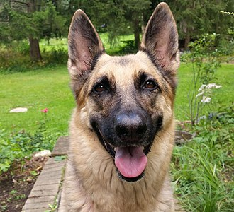

**Name: Luther**

Age: 6 years

Breed: German Shepherd

Personality:

I am really energetic, love long walks and new places.

Kids are all right but I can do without them.

I prefer to be the center of your attention.

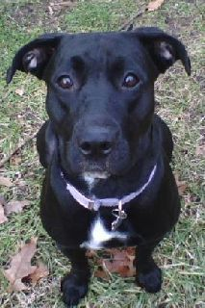

Name: Luna

Age: 4 years

Breed: Pitador (Pitbull Labrador mix)

I am really shy but I wouldn’t mind going out with you on a long walk.

I love yoghurt like seriously. No joke.

I will make sure you get your daily dose of licks to show you how much I adore you.

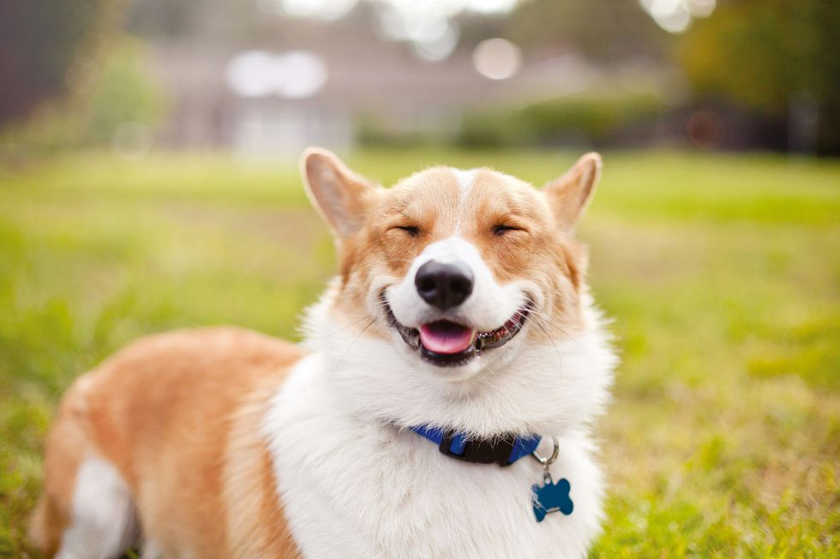

Name: Finn

Age: 3 years

Breed: Corgi

I mean c’mon just look at me I am beautiful.

I am extremely friendly and love kids.

I also will need you to play catch with me everyday or I am going to pout in the corner.

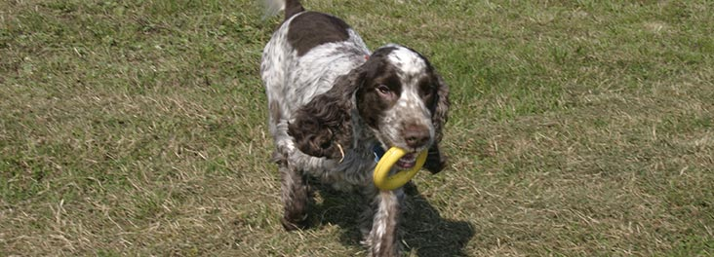

Name: Dorothy

Age: 9 years

Breed: Cocker Spaniel

I am loyal friend.

I like playing frizbee.

I prefer to be with adults

I also like to relax by watching Tv on the sofa with my dog biscuits (the good kind don’t skimp).

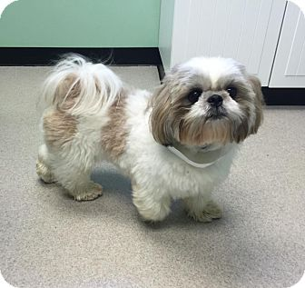

Name: Beatrice

Age: 2 years

Breed: Shi Tzu

I love sitting in your handbag while you shop for me.

I like kids because they usually shower me with attention.

Also no long walks please have you seen my little legs they are not made for running.