Text Summarization

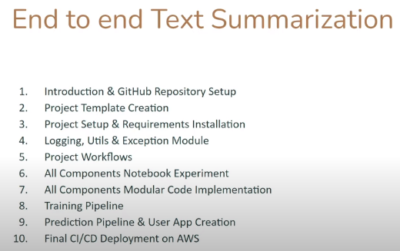

We will be using transformer based model in this project. We will be using the hugging face API. Logging, utils and exception modules are important when implementing end to end projects. It is important to perform notebook experiment of components before implementing modular code components. We will be using Python OOPS concepts. Then we will implement training pipelines. We will integrate all the training pipelines together so that when we hit a route then it starts data ingestion, data validation, data transformation, pick the model, model training, model evaluation and then in the end we will get our model. We will also implement a prediction pipeline and the user app as well. We will use the Fast API to build this simple application. In the end we will build CI/CD deployment on AWS using GitHub action.

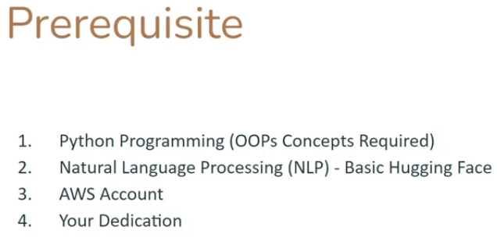



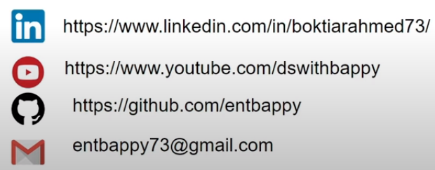

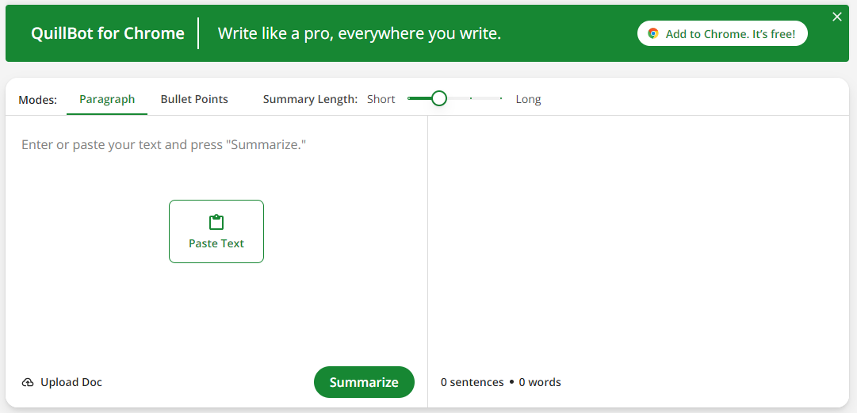

We will be doing the task from scratch. We will be using a transformer based model from hugging face which is already trained on a huge data and we will fine tune that model for our custom data.

Now we will create the project template where we will write the entire project folder structure so that we need not to create the complete structure from scratch. The logic to create the folder structure will be there in the file templete.py.

.github folder is for setting up deployment with ci/cd along with YAML files so that when we do the commit on github it will auto deploy updates to AWS.

