1.
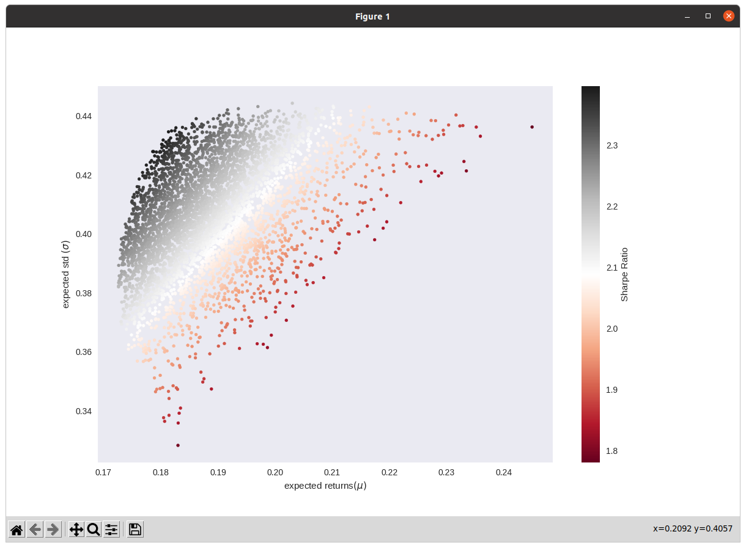

2.
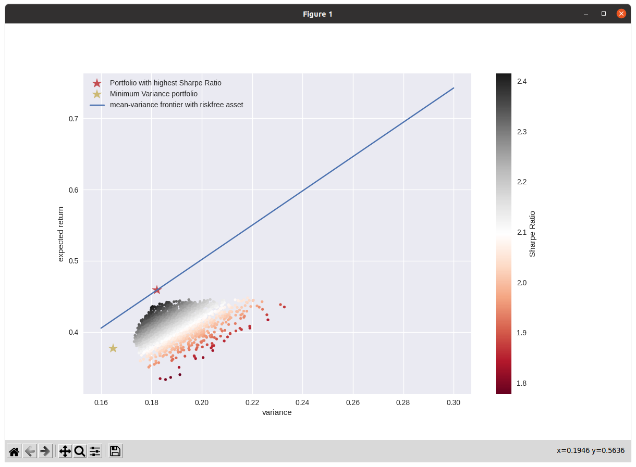

3.
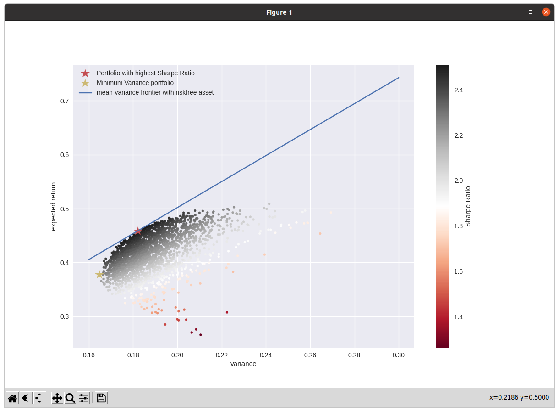

I would recommend latter one,which is not restricting compound ratio of portfolio, because latter one is touching portfolio with highest sharpe ratio(red star) and mean-variance frontier

