CONTENT

|  |  |
| --- | --- |
| List of topics | Page No. |
| Chapter-1: Technology Used   * 1. HTML   2. CSS   3. BOOTSTRAP   4. JAVASCRIPT   5. REACT.JS   6. NODE.JS   7. MONGODB   8. EXPRESS.JS |  |
| Chapter-2 MERN  2.1 Introduction to MERN STACK. |  |
| Chapter-3: About My Project   * 1. introduction   2. Technology used in the project |  |
| Chapter-4: Project design   * 1. Project snapshots   2. Data for the project |  |
| Chapter-5: Conclusion  5.1 Conclusion |  |

**Chapter-1: Technology Used**

In MERN STACK we use different technologies to build projects, there are various technology’s which is supported by MERN, these technologies include the following:

## HTML:

### Introduction To HTML:

**HTML (Hypertext Markup Language)** is a fundamental and foundational technology used for creating and structuring content on the World Wide Web. It serves as the standard markup language for designing web pages and displaying various types of content, such as text, images,

links, forms, and multimedia.

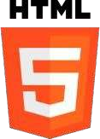

* + - 1. **Markup Language**: HTML is a markup language, which means it consists of a set of markup tags that are used to describe the structure and content of a web page.

These tags are enclosed in angle brackets (< >) and come in pairs, typically with an opening tag and a closing tag, like this: <tagname>content</tagname>.

* + - 1. **Hierarchical Structure:** HTML documents are structured hierarchically. They typically start with an <!DOCTYPE> declaration, followed by the <html> element, which contains the entire document. Within the <html> element, you'll find two main sections: <head> and <body>. The <head> section contains meta-information about the page, such as its title, character encoding, and links to external resources like stylesheets and scripts. The <body> section contains the visible content of the web page.
      2. **Elements**: HTML is made up of various elements, each serving a specific purpose. Common HTML elements include:
* <p>: Paragraphs of text.
* <h1>, <h2>, <h3>, etc.: Headings with different levels of importance.
* <a>: Hyperlinks, which allow you to navigate to other web pages or resources.
* <img>: Images.
* <ul> and <ol>: Unordered and ordered lists, respectively.
* <li>: List items.
* <div>: A generic container for grouping and styling content.
* <form>: Used to create input forms for user interaction.
* <input>, <textarea>, <button>: Form input elements.
  + - 1. **Attributes:** HTML elements can have attributes that provide additional information about the element. For example, the <a> element can have an href attribute that specifies the destination URL for the hyperlink.

**Semantic HTML**: In modern web development, there's an emphasis on using semantic HTML,

which means choosing HTML elements that best represent the meaning and structure of your content. Semantic HTML improves accessibility and search engine optimization (SEO).

### Important tags used in HTML:

**<html>**: The root element that encapsulates the entire HTML document.

1. **<head>**: Contains metadata about the document, including the title, character encoding, and links to external resources like stylesheets and scripts.
2. **<title>**: Sets the title of the web page, which appears in the browser's title bar or tab.
3. **<meta>**: Provides metadata about the document, such as character encoding and authorship information.
4. **<link>**: Links to external resources like stylesheets (CSS) for controlling the page's visual presentation.
5. **<script>**: Includes JavaScript code within the HTML document for enhancing interactivity.
6. **<style>**: Contains embedded CSS (Cascading Style Sheets) for styling the content of the web page.
7. **<body>**: Contains the visible content of the web page, including text, images, links, and other elements.
8. **<h1>**, **<h2>**, **<h3>**, ... **<h6>**: Headings of various levels, with **<h1>** being the highest importance and **<h6>** the lowest. These are used to structure content hierarchically.
9. **<p>**: Defines a paragraph of text.
10. **<a>**: Creates hyperlinks, allowing users to navigate to other web pages or resources.
11. **<img>**: Embeds images on the web page.
12. **<ul>** and **<ol>**: Create unordered (bulleted) and ordered (numbered) lists, respectively.
13. **<li>**: Represents list items within **<ul>** or **<ol>** lists.
14. **<table>**: Defines a table for organizing data into rows and columns.
15. **<tr>**: Represents a table row within a **<table>**.
16. **<td>**: Defines a table cell within a **<tr>** for holding data.
17. **<th>**: Defines a table header cell, typically used in the first row of a table to label columns.
18. **<div>**: A versatile container for grouping and styling content or creating layout structures.
19. **<form>**: Creates input forms for user interaction, often used for data submission.
20. **<input>**, **<textarea>**, **<button>**: Form input elements for text input, buttons, and other interactive components.
21. **<label>**: Provides labels for form elements to improve accessibility.
22. **<select>**: Creates a dropdown menu for selecting options within a form.
23. **<iframe>**: Embeds an inline frame for displaying external web content within the page.
24. **<audio>** and **<video>**: Embeds audio and video files for multimedia playback.
25. **<hr>**: Creates a horizontal line, typically used as a thematic break.

## CSS:

### Introduction To CSS:

**CSS (Cascading Style Sheets)** is a styling language used in web development to describe how web documents (HTML and XML) should be presented on the screen, in print, or in other media. It's an essential technology for controlling the layout, design, and appearance of web content. Here's an introduction to CSS and its history:

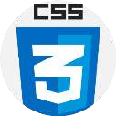

### What is CSS:

* **Cascading Style Sheets (CSS)** is a stylesheet language used to define the presentation and layout of web pages. It separates the structure (HTML) from the style (CSS) of a web page, allowing web developers to control how content is displayed.

### Purpose of CSS:

* **Styling:** CSS is primarily used for styling web pages. It controls elements' colors, fonts, spacing, borders, backgrounds, and more.
* **Layout:** CSS enables developers to control the positioning and arrangement of elements on a web page, creating responsive and visually appealing layouts.

### How CSS Works:

* CSS rules consist of selectors and declarations. A selector targets HTML elements, and declarations define the styles to apply to those elements.
* For example, this CSS rule changes the color of all **<h1>** elements to blue: cssCopy code

h1 {color: blue; }

➢ External Stylesheets:

* + CSS can be placed in an external **.css** file and linked to HTML documents. This promotes reusability and consistency in styling across multiple web pages.

### ➢ Cascading Order:

* + CSS follows a cascading order, meaning that multiple CSS rules can apply to an element. Conflicts are resolved based on specificity and the order of rules.

### ➢ Responsive Web Design:

* + CSS plays a critical role in responsive web design. Media queries in CSS allow developers to create layouts that adapt to various screen sizes and devices.

### ➢ Preprocessors:

* + Developers often use CSS preprocessors like Sass and Less to write more maintainable and efficient CSS code. These preprocessors offer features like variables, nesting, and functions.

CSS is a powerful styling language that has evolved over the years to meet the changing needs of web development. It empowers web designers and developers to create visually appealing, responsive, and user-friendly web experiences by separating content from presentation.

1. **ID Selector (#id):** Selects a single element with a specific **id** attribute. For example,

**#header** selects the element with **id="header"**.

1. **Descendant Selector (ancestor descendant):** Selects elements that are descendants of a specified ancestor element. For example, **ul li** selects all **<li>** elements inside a

### <ul>.

1. **Child Selector (parent > child):** Selects elements that are direct children of a specified parent element. For example, **ul > li** selects all **<li>** elements that are direct children of a **<ul>**.
2. **Adjacent Sibling Selector (element + element):** Selects an element that is immediately preceded by a specified sibling element. For example, **h2 + p** selects the

**<p>** element immediately following an **<h2>**.

1. **General Sibling Selector (element ~ element):** Selects all elements that are siblings of a specified element and share the same parent. For example, **h2 ~ p** selects all **<p>** elements that are siblings of an **<h2>**.
2. **Attribute Selector ([attribute=value]):** Selects elements with a specific attribute and attribute value. For example, **[type="submit"]** selects all elements with **type="submit"**.
3. **Pseudo-Class Selector (:pseudo-class):** Selects elements based on their state or position. Common pseudo-classes include **:hover** (for hover effects), **:active** (for active links), and **:nth-child()** (for selecting elements by their position in a parent).

**Pseudo-Element Selector (::pseudo-element):** Selects and styles parts of an element's content, such as the first line or the first letter. Common pseudo-elements

1. include **::first-line** and **::before**.

### Common Uses of CSS:

* + - * **Styling Web Pages:** The primary use of CSS is to style web pages. It controls fonts, colours, backgrounds, borders, spacing, and layout.
      * **Responsive Web Design:** CSS plays a crucial role in creating responsive web designs that adapt to different screen sizes and devices using media queries.
      * **Animations and Transitions:** CSS allows developers to create animations and smooth transitions for interactive web elements.
      * **Typography:** It enables precise control over text styling, including fonts, sizes, line spacing, and more.
      * **Layout Control:** CSS is used to position and arrange elements on web pages, including the use of grids and flexbox for complex layouts.
      * **Customization:** CSS is used to customize the appearance of web elements, such as buttons, forms, and navigation menus.
      * **Print Styles:** CSS can be applied to create print-friendly styles for web pages, making them suitable for printing.
      * **Accessibility:** CSS can enhance the accessibility of web content by providing styles that accommodate users with disabilities.
      * **Cross-Browser Compatibility:** CSS helps ensure consistent styling across different web browsers by using standardized rules.

## BOOTSTRAP:

**Bootstrap** is a popular open-source front-end framework for web development that simplifies and accelerates the process of designing and creating responsive and visually appealing websites and web applications.

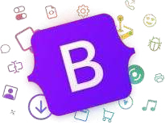

### History of Bootstrap:

The history of **Bootstrap** is an interesting journey that began as an internal project at Twitter and evolved into one of the most popular front-end frameworks in web development. Here's a brief history of Bootstrap:

### Birth at Twitter:

* + - * + Bootstrap was created as an internal project at Twitter by two Twitter engineers, Mark Otto and Jacob Thornton, in mid-2010.
        + The primary goal was to address issues of consistency and efficiency in web development across Twitter's various products and services.

### First Release - Bootstrap 1.0:

* + - * + The first version of Bootstrap, known as Bootstrap 1.0, was released as an open- source project on August 19, 2011.
        + It included a basic set of HTML, CSS, and JavaScript components and styles, primarily aimed at simplifying web development for Twitter's teams.

### Rapid Growth - Bootstrap 2.0:

* + - * + Bootstrap 2.0, released in January 2012, was a significant milestone. It was rewritten to be more modular and featured a responsive grid system.
        + The framework's focus shifted from an internal tool to an open-source project for the broader web development community.

### Widespread Adoption - Bootstrap 3.0:

* + - * + Bootstrap 3.0, released in August 2013, brought further improvements. It adopted a mobile-first approach, prioritizing mobile design and scalability to larger screens.
        + This version gained widespread adoption and made Bootstrap one of the most popular front-end frameworks globally.

### Major Overhaul - Bootstrap 4.0:

* + - * + Bootstrap 4.0, released in January 2018 after a long development cycle, was a major overhaul of the framework.
        + It introduced a more modern, scalable, and streamlined architecture, improved grid system, and dropped support for older versions of Internet Explorer.

### The Future - Bootstrap 5 and Beyond:

* + - * + Bootstrap 5, released in May 2021, continued to refine the framework's capabilities, emphasizing customization and a more lightweight core.
        + The Bootstrap team continues to work on enhancements, improvements, and community contributions, ensuring its relevance in modern web development.

### Community and Ecosystem:

* + - * + Bootstrap has a thriving community of developers, designers, and contributors. This community has created a vast ecosystem of themes, templates, plugins, and extensions that expand Bootstrap's functionality and provide ready-made solutions for various web design challenges.

Today, Bootstrap is not only a tool for creating responsive and attractive web applications but also a symbol of how open-source collaboration can revolutionize web development. Its evolution from an internal project at Twitter to a global open-source framework is a testament to its enduring popularity and effectiveness in simplifying web development tasks.

### Key features and components of Bootstrap:

* **Responsive Grid System:** Bootstrap's responsive grid system allows developers to create flexible and adaptive layouts that automatically adjust to various screen sizes and devices, from large desktops to mobile phones.
* **Pre-Designed UI Components:** Bootstrap provides a comprehensive set of pre- designed user interface (UI) components, including navigation bars, buttons, forms, modals, tooltips, and more. These components save developers time and effort in creating consistent and attractive designs.
* **CSS Framework:** Bootstrap offers a robust CSS framework with a wide range of styles, including typography, colors, spacing, and responsive utility classes. This framework simplifies the styling of web elements.
* **JavaScript Components:** Bootstrap includes JavaScript components and plugins for interactive features like carousels, modals, and dropdown menus. These components enhance user experience without requiring extensive custom JavaScript coding.
* **Customization:** While Bootstrap provides default styles and components, it is highly customizable. Developers can tailor Bootstrap to match their project's unique design and branding requirements by modifying variables, overriding styles, and creating custom themes.
* **Accessibility:** Bootstrap is committed to web accessibility, providing features, guidance, and best practices to create accessible web content that can be used by people with disabilities.
* **Community and Ecosystem:** Bootstrap boasts an active and vibrant community of developers, designers, and contributors. This community has generated a wealth of resources, including themes, templates, and third-party extensions that extend Bootstrap's capabilities and provide solutions for various web design challenges.

### Use Cases:

* Bootstrap is suitable for a wide range of web development projects, including:
* Corporate websites and blogs
* E-commerce websites and online stores
* Content management systems (CMS)
* Web applications and dashboards
* Prototyping and proof of concept projects
* Responsive web designs that adapt to different screen sizes and devices

### Advantages of Bootstrap:

* Speeds up development: Bootstrap's pre-designed components and responsive grid system accelerate the development process.
* Cross-browser compatibility: Bootstrap ensures consistent rendering across various web browsers.
* Mobile-first approach: Bootstrap prioritizes mobile design and scales up to larger screens.
* Strong community support: The Bootstrap community offers documentation, tutorials, themes, and plugins.
* Consistency and professionalism: Bootstrap enforces design consistency and provides a polished appearance to web projects.

## JavaScript:

JavaScript is a versatile and widely-used programming language primarily known for its role in web development. It enables developers to add interactivity, manipulate web page content, and create dynamic web applications.



### Introduction to JavaScript:

* + - 1. **Purpose and Significance:**
         * JavaScript was created to make web pages interactive. It allows developers to build web applications that respond to user actions, update content dynamically, and provide a richer and more engaging user experience.

### Client-Side Scripting:

* + - * + JavaScript is a client-side scripting language, meaning it runs in the user's web browser. This allows it to manipulate the Document Object Model (DOM) of a web page and respond to user interactions without requiring server-side processing.

### Key Features:

* + - * + **High-Level Language:** JavaScript is a high-level, interpreted language, making it accessible to both beginners and experienced developers.
        + **Dynamic Typing:** JavaScript uses dynamic typing, meaning variables can change types during runtime.
        + **Object-Oriented:** It supports object-oriented programming (OOP) concepts, allowing developers to create reusable and organized code.

**Event-Driven:** JavaScript is event-driven, responding to user-generated events like clicks and keyboard input.

### Common Uses:

* + - * + **Web Development:** JavaScript is a core technology for front-end web development, used to create interactive web pages, validate forms, handle user input, and communicate with web servers (Ajax).
        + **Web Applications:** JavaScript is the foundation for building web applications, including single-page applications (SPAs) that provide a seamless and responsive user experience.
        + **Mobile App Development:** JavaScript is used in conjunction with frameworks like React Native and Ionic to develop cross-platform mobile applications.
        + **Game Development:** JavaScript can be used to create browser-based games and interactive animations.
        + **Server-Side Development:** With technologies like Node.js, JavaScript can also be used for server-side development, enabling full-stack development using a single language.

### Libraries and Frameworks:

* + - * + JavaScript has a rich ecosystem of libraries and frameworks that simplify various development tasks. Notable examples include jQuery for DOM manipulation, React and Angular for building user interfaces, and Express.js for building web servers with Node.js.

### Compatibility:

* + - * + JavaScript is supported by all major web browsers, making it a reliable choice for web development. Modern JavaScript features are supported in contemporary browsers, but developers often use transpilers like Babel to ensure compatibility with older browsers.

### Evolution:

* + - * + JavaScript continues to evolve with regular updates to the language (ECMAScript standards). ES6 (ECMAScript 2015) introduced significant enhancements, and new features continue to be added in subsequent versions.

### History of JavaScript:

The history of JavaScript is a fascinating journey that has transformed it from a simple scripting language into one of the most essential technologies in web development. Here's a concise history of JavaScript:

### Early Beginnings (1993-1995):

* + - * + JavaScript was created by Brendan Eich in just ten days while working at Netscape Communications Corporation in 1995.
        + Originally called "Mocha," it was later renamed "Live Script" and finally "JavaScript."

### Netscape Navigator:

* + - * + JavaScript made its debut in the Netscape Navigator browser in 1995.
        + It was designed to add interactivity to web pages by allowing them to respond to user actions.

### Widespread Adoption (Late 1990s - Early 2000s):

* + - * + Microsoft introduced its own version of JavaScript, called JScript, in Internet Explorer.
        + This competition led to JavaScript's rapid adoption and the standardization of its features.

### ECMAScript Standardization (1997):

* + - * + JavaScript was submitted to the European Computer Manufacturers Association (ECMA) for standardization.
        + The standardized version was named ECMAScript, with the first edition being ECMAScript 1 (ES1).

### Internet Explorer Dominance (Early 2000s):

* + - * + Microsoft's Internet Explorer browser became dominant, which resulted in some browser-specific scripting variations.
        + Developers faced challenges with cross-browser compatibility.

### JavaScript Frameworks and Libraries (2000s):

* + - * + The rise of JavaScript frameworks and libraries like jQuery, Prototype, and Mootoos made web development more accessible and efficient.

### Ajax (Early 2000s):

* + - * + The term "Ajax" (Asynchronous JavaScript and XML) was coined to describe the technique of using JavaScript and XML HTTP Request to create more dynamic and responsive web applications.

### Modern JavaScript (ES6 and Beyond):

* + - * + ECMAScript 6 (ES6) was a significant update to the language, introducing features like arrow functions, classes, and modules in 2015.
        + Subsequent ECMAScript versions (ES7, ES8, etc.) brought even more enhancements and features.

### 9. Node.js (2009):

* + - * + Ryan Dahl created Node.js, a server-side JavaScript runtime, which opened the door for JavaScript to be used on the server.
        + Node.js has since become a popular choice for building scalable and efficient server applications.

### The JavaScript Ecosystem (Present):

* + Today, JavaScript is an integral part of web development, powering both front- end and back-end development.
  + It has a vast ecosystem of libraries, frameworks (e.g., React, Angular, and Vue.js), and tools that make it a versatile language for building web applications, mobile apps, and more.

### Ongoing Development:

* + JavaScript continues to evolve, with new features and updates being added through the ECMAScript standardization process.

The language's future looks promising, with ongoing efforts to improve its performance, secu rity, and developer experience.

## React.JS:

React.js commonly referred to as React, is an open-source JavaScript library developed by Facebook for building user interfaces. React is widely used for creating interactive and dynamic web applications with a focus on component-based development.



### Introduction to React.js:

1. **Component-Based Development:**

• React is centered around the concept of components. A component is a self- contained, reusable piece of the user interface.

• Components can be as simple as a button or as complex as an entire page, and they can be composed together to build entire applications.

### Declarative UI:

• React uses a declarative approach to UI development. Instead of manually manipulating the DOM to reflect changes in your application's state, you declare how your UI should look at any given time.

• React takes care of efficiently updating the DOM to match the desired state.

### Virtual DOM (Document Object Model):

• One of React.js key optimizations is its Virtual DOM. React creates a virtual representation of the actual DOM in memory.

• When changes occur, React.js compares the virtual DOM to the real DOM and calculates the most efficient way to update the real DOM. This minimizes unnecessary updates, making React applications faster.

### JSX (JavaScript XML):

• JSX is an extension of JavaScript that allows you to write HTML-like code directly within your JavaScript files.

• JSX simplifies the creation of React components by providing a familiar syntax for defining the structure of your UI.

### Unidirectional Data Flow:

• React enforces a unidirectional data flow. Data flows from parent components down to child components through a defined hierarchy.

• This one-way data flow helps in maintaining predictable and easily debuggable applications.

### Reusable Components:

• React encourages the creation of reusable components that can be shared and composed to build complex UIs.

• Component reusability enhances code maintainability and consistency.

### Virtualization and Pagination:

• React can efficiently handle large lists of data by rendering only the visible items on the screen. This virtualization improves performance.

• Pagination and infinite scrolling can be easily implemented using React to load and display data in chunks.

### Rich Ecosystem:

• React has a vast ecosystem of libraries and tools that enhance its capabilities. This includes React Router for routing, Redux for state management, Axios for HTTP requests, and more.

• The React community actively contributes to this ecosystem, ensuring a wealth of resources and support.

### Server-Side Rendering (SSR):

• React can be used for server-side rendering (SSR), which enhances initial page load performance, facilitates SEO, and improves perceived load times.

### Cross-Platform Development:

• React Native, an extension of React, allows you to build native mobile applications for iOS and Android using the same component-based approach.

### Key Use Cases: -

• Building single-page applications (SPAs) and complex web applications.

• Creating interactive user interfaces with real-time updates.

• Developing cross-platform mobile applications using React Native.

• Server-side rendering for performance and SEO benefits.

• Handling complex UIs with reusable components.

### History of React.js:

1. **Development at Facebook (2011):**
   * React was developed by Facebook engineers Jordan Walke and Pete Hunt. It was initially created to address performance issues in Facebook's News Feed.
   * React was first deployed on Facebook's News Feed in 2011.

### Open-Source Release (May 2013):

* + React was open-sourced by Facebook in May 2013 at the JSConf US conference. This allowed developers outside of Facebook to use and contribute to the library.
  + Reacts open-source nature led to its rapid adoption by the wider web development community.

### Introduction of JSX (May 2013):

* + With React's open-source release, Facebook introduced JSX, a syntax extension for JavaScript that allows developers to write HTML-like code within their JavaScript files.
  + JSX simplifies the creation of React components and defines the structure of the user interface.

### Growth and Adoption (2013-2014):

* + React gained popularity quickly due to its performance improvements, component-based architecture, and declarative approach to building user interfaces.
  + Companies like Instagram (owned by Facebook), Airbnb, and WhatsApp adopted React for their web development projects.

### Introduction of Flux (May 2014):

* + Facebook introduced Flux, a unidirectional data flow architecture, alongside React. Flux was designed to work seamlessly with React and handle data flow in applications.
  + While Flux gained some traction, it was later succeeded by state management libraries like Redux.

### Collaboration with Instagram (March 2015):

* + Facebook and Instagram engineers collaborated to build React Native, an extension of React that allows developers to build native mobile applications for iOS and Android using the same React principles.
  + React Native was introduced to the public in March 2015.

### Release of React 16 (September 2017):

* + React 16, also known as React Fiber, was a major update to React that introduced significant changes under the hood.
  + It improved performance, enhanced error handling, and opened the door for features like asynchronous rendering.

### Continued Development and Community (Ongoing):

* + React has continued to evolve with regular updates and new features, with a focus on improving performance and developer experience.
  + The React community is active and vibrant, contributing to the growth and improvement of the library.
  + React remains a popular choice for web and mobile application development.

### Concurrent Mode and Beyond (Ongoing):

* + Facebook has been working on Concurrent Mode, a set of new features aimed at improving the responsiveness of React applications, especially for complex and dynamic UIs.
  + React's development continues to be guided by Facebook and a core team of maintainers, with input and contributions from the open-source community.

## Node.JS:

Node.js is an open- source, server-side JavaScript runtime environment that

allows developers to execute JavaScript code on the server. It has gained significant popularity for its ability to build scalable and high-performance network applications. Here's an introduction and history of Node.js:

### Introduction to Node.js:

* Node.js was created by Ryan Dahl and was first released in 2009. It is built on the V8 JavaScript engine, which is developed by Google and used in the Chrome web browser.
* Unlike traditional server-side languages like PHP or Python, Node.js is event- driven and non-blocking. This means it can handle many concurrent connections efficiently, making it suitable for real-time applications and I/O- intensive tasks.
* Node.js uses a single-threaded event loop and asynchronous programming to achieve high concurrency, which is well-suited for building scalable and responsive web applications.

### History of Node.js:

* **Initial Release (2009):** Ryan Dahl released the initial version of Node.js in May 2009. It provided a runtime environment for executing JavaScript on the server.
* **npm (2010):** In 2010, Isaac Schlueter created npm (Node Package Manager), which is now the default package manager for Node.js. It allows developers to easily manage and share packages and libraries.
* **Widespread Adoption (2010-2012):** Node.js quickly gained popularity among developers and was used by companies like LinkedIn and Walmart for building high-performance web applications.
* **Node.js Foundation (2015):** To foster its development and growth, the Node.js Foundation was established in 2015. It brought together various stakeholders to collaborate on the project's governance and direction.
* **Node.js 4.0 (2015):** Node.js 4.0 was a significant release that introduced the io.js fork back into the main Node.js codebase. This marked a period of unification within the Node.js community.
* **Long-Term Support (LTS) Versions (2015-present):** Node.js introduced LTS versions, ensuring stability and support for an extended period. LTS versions are typically supported for 30 months or more.
* **Growth and Ecosystem (Ongoing):** Node.js has continued to grow and evolve, with an active and expanding ecosystem of modules and libraries. It is used for a wide range of applications, from web servers and APIs to IoT devices and microservices.

Node.js has become a fundamental technology in modern web development, enabling developers to build fast, scalable, and real-time applications. Its event- driven, non- blocking architecture and vibrant community make it a compelling choice for building server-side applications and services.

### Use case:

**Node.js** has a wide range of use cases due to its versatility and non-blocking, event- driven architecture. Here are some common uses of Node.js:

### Web Servers:

* + Node.js is often used to create highly scalable and efficient web servers. Developers can build lightweight and fast web applications, APIs, and microservices using frameworks like Express.js.

### Real-Time Applications:

* + Node.js is well-suited for real-time applications that require instant data updates and interactions. Examples include chat applications, online gaming, and collaborative tools.

### Single-Page Applications (SPAs):

* + Many modern web applications, especially SPAs, use Node.js on the server side to serve static assets, handle routing, and manage API requests.

### API Development:

* + Node.js is commonly used to build RESTful APIs and GraphQL APIs. Its non- blocking nature allows APIs to handle a high volume of concurrent requests efficiently.

### IoT (Internet of Things):

* + Node.js can run on IoT devices, making it a suitable choice for IoT application development. It allows developers to build IoT applications that communicate with devices, sensors, and servers.

### Streaming Applications:

* + Node.js is ideal for building streaming applications like audio and video streaming services, as well as real-time analytics platforms that process and analyze data in real time.

### Data Processing and ETL (Extract, Transform, Load):

* + Developers use Node.js to create data processing pipelines and ETL jobs. Its non- blocking capabilities help process data efficiently.

### Command-Line Tools:

* + Node.js is commonly used to build command-line tools and scripts for various tasks, including automation, data manipulation, and development workflows.

### Proxy Servers:

* + Node.js can be employed to create proxy servers that act as intermediaries between clients and backend services, providing additional security and control.

### Content Management Systems (CMS):

* + Some content management systems, like Ghost, are built using Node.js. These systems allow users to manage and publish content on the web.

### Real-Time Dashboards:

* + Node.js can be used to create real-time monitoring and analytics dashboards that display data updates as they occur.

### Serverless Computing:

* + Node.js is often used in serverless computing environments, such as AWS Lambda and Azure Functions, for building serverless applications and functions.

### Social Media Integration:

* + Node.js is used to integrate social media APIs into web applications, allowing users to log in with social media accounts and share content.

### E-commerce Platforms:

* + Some e-commerce platforms and online marketplaces leverage Node.js for real- time inventory management, order processing, and customer interactions.

### Collaborative Tools:

* + Node.js can power collaborative tools like project management software, collaborative document editing, and virtual whiteboards.

Node.js's ability to handle concurrent connections and its event-driven model make it a valuable choice for applications that require speed, responsiveness, and real-time functionality. Its extensive ecosystem of modules and packages also contributes to its popularity across a wide range of domains.

## MongoDB:



MongoDB is a popular open-source NoSQL database management system known for its flexibility, scalability, and ability to handle unstructured or semi-structured data. It is often used in modern web and mobile application development. MongoDB's journey from a small open-source project to a global NoSQL database platform used by countless organizations reflects its commitment to innovation and its responsiveness to the evolving needs of developers and businesses. Today, MongoDB remains a popular

choice for modern application development, known for its scalability, flexibility, and ease of use.

### Introduction to MongoDB:

* MongoDB is a document-oriented database that falls under the category of NoSQL databases. It stores data in a flexible, JSON-like format known as BSON (Binary JSON).
* Unlike traditional relational databases, MongoDB does not require a fixed schema, making it well-suited for applications with evolving or unpredictable data structures.
* MongoDB supports a wide range of query capabilities, indexing options, and features for data manipulation and aggregation.
* It is designed to be highly scalable and can distribute data across multiple servers, making it suitable for handling large-scale applications.

### History:

* **2007:** MongoDB's development begins as an internal project at DoubleClick (later acquired by Google) by Dwight Merriman, Eliot Horowitz, and Kevin Ryan.

**2009:** The first public release of MongoDB occurs in February, marking the official beginning of the MongoDB project.

* **2010:** The company 10gen is founded to provide commercial support and services for MongoDB. (Note: 10gen later becomes MongoDB, Inc.)
* **2013:** MongoDB becomes increasingly popular, with many companies adopting it for various use cases. It reaches version 2.4, introducing features like geospatial indexing and full-text search.
* **2014:** MongoDB 2.6 is released, adding features such as aggregation pipelines and text search, further solidifying its place in the NoSQL database landscape.
* **2015:** MongoDB 3.0 is a significant release that introduces WiredTiger as the default storage engine, enhancing performance and scalability.
* **2016:** MongoDB 3.2 adds features like document validation and support for the BI Connector, expanding its capabilities.
* **2017:** MongoDB Atlas, a fully managed cloud database service, is launched, simplifying database management for users. MongoDB 3.4 introduces support for graph processing and enhanced security features.
* **2018:** MongoDB 4.0 introduces support for multi-document ACID transactions, expanding its suitability for a wider range of applications.
* **2019-Present:** MongoDB continues to evolve with regular releases, adding features such as serverless instances and mobile database synchronization, and maintaining its status as a popular choice for modern application development.

### Common Use Cases:

* **Web Applications:** MongoDB is frequently used as a backend database for web applications, especially in scenarios where the data structure is evolving or where flexibility is needed in handling different types of data.
* **Content Management Systems (CMS):** CMS platforms often use MongoDB to store and manage content due to its ability to accommodate different content types and structures.
* **Mobile App Data:** MongoDB is used to store data for mobile applications, where the need for fast and flexible data access is crucial.
* **Real-Time Analytics:** MongoDB can handle real-time analytics data, such as user behavior tracking and log analysis.
* **IoT (Internet of Things):** MongoDB is suitable for storing and processing data generated by IoT devices, which often have varied data formats.
* **Catalogs and Product Information:** eCommerce platforms use MongoDB to store product catalogs and information that may have diverse attributes.
* **Gaming:** MongoDB is used in the gaming industry to store player profiles, game state, and leaderboard data.
* **Location-Based Services:** MongoDB's geospatial indexing makes it suitable for applications that require location-based queries, such as mapping and navigation services.
* **Social Media:** MongoDB can handle user profiles, social network data, and user- generated content for social media applications.
* **Log and Event Data:** It is used to store logs and event data, making it easier to analyze application performance and troubleshoot issues.

## Express.JS:

Express.js**,** often referred to as Express, is a fast, minimalist, and

flexible web

application framework for Node.js. It provides a robust set of features for building web and mobile applications, as well as APIs (Application Programming Interfaces). Express.js is widely used in modern web development due to its simplicity and versatility.

### Introduction to Express.JS

* + - 1. **Minimalistic:** Express is designed to be minimal and unopinionated. It offers fundamental building blocks for web applications without imposing rigid patterns or structures, allowing developers the freedom to design their applications as needed.
      2. **Middleware:** Express revolves around the concept of middleware functions. Middleware functions are used to perform various tasks during the request- response cycle, such as logging, authentication, data parsing, and routing.
      3. **Routing:** Express simplifies the process of defining routes for handling HTTP requests, including GET, POST, PUT, DELETE, and more. Each route can have one or more associated route handlers, which are functions that execute when a specific route is matched.
      4. **Template Engines:** While express itself does not include a template engine, it seamlessly integrates with various template engines like Pug (formerly Jade), EJS, and Handlebars. This allows developers to render dynamic views and templates.
      5. **Static File Serving:** Express can serve static files like HTML, CSS, JavaScript, images, and more. This is particularly useful for serving client-side assets of web applications.
      6. **Error Handling:** Express provides built-in error handling mechanisms, allowing developers to define error-handling middleware for graceful error handling and logging.
      7. **RESTful APIs:** Express is commonly used to build RESTful APIs. It simplifies the creation of API endpoints for client-server communication.
      8. **Middleware Ecosystem:** Express has a vast ecosystem of third-party middleware modules, making it easy to extend its functionality with features like authentication, session management, and database integration.

### 1.1.2 History:

Express.js, often referred to as Express, is a widely used web application framework for Node.js. Its history traces back to the early days of Node.js development. Here's a brief history of Express.js:

### ➢ 2009-2010: Inception and Early Development

• Express.js was created by TJ Holowaychuk, a prolific developer in the Node.js community.

• The first commits to the Express.js repository was made in May 2009.

• Express was created as a response to the need for a simple, minimalistic, and unopinionated framework for building web applications on top of Node.js.

### ➢ 2010: Express.js 1.0

• Express.js reached its 1.0 release in November 2010, marking a stable version for developers to use.

### ➢ 2011-2012: Rapid Growth and Popularity

• Express quickly gained popularity among Node.js developers due to its straightforward design and ease of use.

• The framework attracted a growing community of contributors who developed middleware and extensions to enhance its functionality.

• Express was seen as a key component in the emerging JavaScript full-stack development trend.

### ➢ 2014: The Release of Express.js 4.0

• Express.js 4.0 was a significant update, introducing a more modular architecture and improved performance.

• This release maintained backward compatibility with Express 3.x while offering enhanced features.

### ➢ 2015-Present: Continued Development

* Express.js continues to be actively maintained and updated, with frequent releases addressing bug fixes and adding new features.
* The framework remains a cornerstone of the Node.js ecosystem and is used by a vast number of developers and organizations worldwide.

### ➢ Community and Adoption

• Express.js has a strong and active community of developers who contribute to its growth and development.

• It is used by many large and small organizations to build web applications, APIs, and microservices.

• Express.js is often the preferred choice for developers due to its flexibility, minimalist design, and extensive ecosystem of middleware and extensions.

# CHAPTER-2 MERN

## Introduction to MERN stack:

The **MERN stack** is a popular and powerful technology stack used in modern web development. It consists of four key technologies: MongoDB, Express.js, React, and Node.js. Each component plays a specific role in building web applications, making MERN a comprehensive and full-stack solution. Here's an introduction to the MERN stack:

### MongoDB:

* + **Database:** MongoDB is a NoSQL database management system that stores data in a flexible, JSON-like format called BSON (Binary JSON).
  + **Schema-less:** Unlike traditional relational databases, MongoDB is schema-less, allowing you to store data without a predefined structure.
  + **Scalable:** MongoDB is designed to be highly scalable, making it suitable for applications with growing data needs.

### Express.js:

* + **Backend Framework:** Express.js is a web application framework for Node.js.
  + **Middleware:** It simplifies server-side development by providing a robust set of features, including routing, middleware support, and request/response handling.
  + **RESTful APIs:** Express is often used to build RESTful APIs that interact with the database and serve data to the frontend.

### React:

* + **Frontend Library:** React is a JavaScript library for building user interfaces.
  + **Component-Based:** React follows a component-based architecture, making it easy to create reusable UI components.
  + **Virtual DOM:** React uses a virtual DOM to optimize UI updates, resulting in improved performance and a smoother user experience.
  + **Single-Page Applications (SPAs):** React is commonly used to build SPAs where most of the application logic runs in the browser, providing a seamless and interactive user experience.

### Node.js:

* + **Runtime Environment:** Node.js is a runtime environment that allows JavaScript to run on the server-side.
  + **Non-blocking I/O:** Node.js uses an event-driven, non-blocking I/O model, making it highly efficient and capable of handling concurrent connections.
  + **Server-Side Logic:** Node.js is used to create the server-side logic that interacts with the database, handles HTTP requests, and serves the frontend.

### How MERN Stack Works:

MongoDB stores the application's data in a flexible, JSON-like format.

* + - * Express.js provides the server framework for building the backend of the application, including routing and API endpoints.
      * React handles the frontend user interface, creating dynamic and interactive web pages.
      * Node.js serves as the runtime environment for running server-side code and handling HTTP requests from the client.

### Advantages of the MERN Stack:

* + - * **Full-Stack Development:** MERN allows developers to work on both the frontend and backend using JavaScript, streamlining development and promoting code reuse.
      * **Scalability:** Each component in the stack is designed to be scalable, making it suitable for applications with varying levels of traffic and data.
      * **Active Community:** MongoDB, Express.js, React, and Node.js have large and active developer communities, providing extensive resources and support.
      * **Flexibility:** The stack's components are flexible, allowing developers to choose from various libraries, modules, and extensions.

The MERN stack has gained widespread adoption and popularity in the web development community for its flexibility, performance, and the ability to build modern, responsive, and feature-rich web applications.

# CHAPTER-3 ABOUT MY PROJECT

## Introduction:

Music has always been a universal language that transcends boundaries and connects people from all walks of life. It has the power to evoke emotions, create memories, and set the mood for any occasion. With the advent of technology, our relationship with music has evolved, and it has become an integral part of our daily lives. This evolution inspired me to embark on a four-week summer training project where I delved into the world of web development, specifically using the MERN stack, to create a music player demo that would not only entertain but also showcase the potential of modern web technologies.

During this intensive summer training program, I set out to design and develop a demo version of music player using the MERN stack, which stands for MongoDB, Express.js, React, and Node.js. This project aimed to explore the intersection of web development and music, showcasing how cutting-edge technologies can be harnessed to enhance our musical experiences.

The primary goal of this music player demo was to provide users with an intuitive and immersive platform for enjoying their favorite tunes. It was designed to offer a seamless and interactive music playback experience, allowing users to explore their music libraries, create playlists, and control playback with ease. Additionally, the project incorporated features like user authentication and authorization, ensuring that users could personalize their music collections and playlists securely.

In this report, I will provide a comprehensive overview of my summer training project, including the technologies used, the features implemented, and the development journey. I will also discuss the impact and potential applications of this music player demo, emphasizing how it can serve as a foundation for further development and customization in the realm of music-related web applications.

In summary, this summer training project allowed me to combine my passion for music with my growing skills in web development. The result is a music player demo that not only showcases the capabilities of the MERN stack but also serves as a testament to the limitless possibilities at the intersection of technology and music. Let's explore the journey, development process, and features of this music player in greater detail.

### functions of music player demo version:

* + - 1. **Music Playback**: The core function of the music player is to play music tracks. Users can select a song from their library and start playback. The player should support standard playback controls like play, pause, skip forward, and skip backward.
      2. **iTunes Integration**: You mentioned using an iTunes link for a 29-second music demo. This suggests that your music player can interact with iTunes, possibly allowing users to import music from their iTunes library, search for songs on the iTunes store, or play music directly from iTunes.
      3. **User Authentication**: To personalize the music experience, your music player should include user authentication. Users can create accounts, log in, and save their playlists and preferences.
      4. **Playlist Management**: Users can create and manage playlists. They can add songs to playlists, reorder tracks, and delete songs from playlists.
      5. **Shuffle and Repeat**: Implement options for shuffling the playback order of songs and repeating individual tracks or entire playlists.
      6. **Volume Control**: Users should be able to adjust the volume of the music player to suit their preferences.
      7. **Progress Bar**: Display a progress bar that shows the current position of the song being played, allowing users to seek to specific parts of the track.
      8. **Music Metadata Display**: While a song is playing, display relevant metadata such as the song title, artist, album, and album artwork.
      9. **Search Functionality**: Incorporate a search feature that enables users to find specific songs in their library quickly.
      10. **Responsive Design**: Ensure that the music player is responsive and works on various screen sizes, from desktop to mobile devices.
      11. **Cross-browser Compatibility**: Make sure the music player functions correctly on different web browsers, such as Chrome, Firefox, Safari, and Edge.
      12. **Error Handling**: Implement error handling to gracefully handle situations like unavailable tracks or network issues.
      13. **User-Friendly UI**: Create an intuitive and user-friendly interface with well- designed controls and visual feedback.
      14. **Customization**: Give users the ability to customize the appearance of the music player and adjust settings like audio quality and playback behavior.
      15. **Integration with Other Services**: Consider integrating with other music services or APIs to expand the music catalogs and provide more options for users.

## Technology used:

### Frontend (React):

1. **React**: The frontend of your music player is built using React, a popular JavaScript library for building user interfaces. React allows you to create reusable UI components and efficiently update the UI when data changes.
2. **React Hooks (useState, useEffect, useRef)**: You utilize React Hooks to manage state (**useState**), perform side effects (**useEffect**), and create a reference (**useRef**). These hooks make it easier to manage the component's behavior and state.
3. **Axios**: Axios is used for making HTTP requests to your backend server and external APIs (iTunes API). It simplifies the process of sending and receiving data over HTTP.
4. **CSS**: You use CSS for styling your components and creating a visually appealing user interface. CSS styles define the layout, colors, and appearance of various elements.
5. **Routing**: Although not explicitly shown in the provided code, you may be using React Router or a similar routing library for handling client-side routing and navigation between different views or pages of your application.

### Backend (Node.js with Express.js):

**Node.js**: Node.js is a runtime environment that allows you to run JavaScript on the server- side. It's the foundation for your backend server.

1. **Axios**: Similar to the frontend, Axios is used in the backend to make HTTP requests. In this case, it's used to send requests to the iTunes API to fetch song data.
2. **CORS Middleware**: You incorporate CORS middleware to handle cross-origin requests. This is crucial when your frontend, hosted on a different domain (e.g., localhost:3000), needs to communicate with your backend (localhost:3001). The CORS middleware ensures that the frontend can make requests to the backend without encountering cross-origin issues.
3. **API Endpoint**: You define a single API endpoint (**api/songs**) that listens for GET requests. This endpoint handles incoming requests from the frontend and communicates with the iTunes API to fetch song data based on search terms.

Using the iTunes API for fetching music data in a trial or development environment is a common practice. The iTunes Search API provides a convenient way to access music- related information, including song details, artist information, album art, and more. It's often used by developers to prototype and build music-related applications like music players, search engines, and music recommendation systems.

Here are a few key points about using the iTunes API for music data:

* 1. **Free Access for Development**: The iTunes Search API is typically free to use for development purposes. It allows you to access a wide range of music data without the need for a paid subscription.
  2. **Data Retrieval**: You can retrieve music data by making HTTP requests to the iTunes API endpoint, specifying search parameters such as the search term (e.g., artist name or song title) and the number of results you want.
  3. **Data Format**: The API returns data in JSON format, making it easy to parse and work with in your application.
  4. **Limited Usage in Production**: While the iTunes API is great for development and prototyping, it may have usage limitations or rate limits if you plan to use it in a production environment. In production, you might need to explore alternative APIs or data sources for music data.
  5. **Terms of Use**: It's essential to review and adhere to Apple's terms of use and any licensing requirements when using data from the iTunes API in your application. Make sure you comply with any usage restrictions and attribution requirements.

**Consider Alternatives**: Depending on your application's scale and requirements, you might eventually consider integrating with other music data sources or obtaining licensing agreements with music providers for access to a broader catalog of music.

* As this music player demo version is combination of technology and libraries we also include HTML, CSS & Bootstrap to build it and design it.

### HTML (Hypertext Markup Language):

* + HTML is the standard markup language for creating web pages and structuring the content of web applications.
  + In your application, HTML is used to define the structure of your web pages, including elements like headings, paragraphs, buttons, forms, and more.
  + HTML is also used to render the user interface components and display song information, search bars, and navigation links.

### CSS (Cascading Style Sheets):

* + CSS is used for styling and visually formatting your web pages. It controls the layout, colors, fonts, and overall appearance of your application.
  + In your code, you have defined CSS rules in the **searchpage.css** file to style various elements such as containers, titles, buttons, text, and background images.
  + CSS styles are applied to create a visually appealing and responsive user interface for your music player.

### Bootstrap:

* + Bootstrap is a popular front-end framework that provides a set of pre-designed and responsive UI components and styles.
  + In your application, you may be using Bootstrap for:
    - **Grid System**: Bootstrap's grid system is used for creating responsive layouts and arranging components in rows and columns.
    - **Buttons**: Bootstrap provides predefined button styles, including primary, secondary, success, and more, which you can apply to your buttons.
    - **Form Controls**: You may use Bootstrap styles for form elements like input fields and buttons.
    - **Navbar**: The navigation bar (Navbar) in your application might be styled using Bootstrap's Navbar component.
    - **Alerts**: Bootstrap's alert styles may be used for displaying messages or notifications.
    - **Responsive Design**: Bootstrap ensures that your application is mobile- friendly and adapts to different screen sizes.
  + Bootstrap simplifies the process of creating a visually consistent and responsive user interface without having to write extensive custom CSS.

### JavaScript (React):

* + Although not explicitly mentioned, JavaScript is a core part of your application since you are using React, a JavaScript library, to build the frontend.
  + JavaScript is used for dynamic behavior, handling user interactions, and updating the UI when data changes. React allows you to create interactive components and manage application state.

### Axios:

* + Axios is a JavaScript library used for making HTTP requests, both in the frontend and backend of your application.
  + In the frontend, Axios is used to send requests to your backend server to fetch music data from the iTunes API.

In the backend, Axios is used to make requests to the iTunes API and retrieve music data to send back to the frontend.

# CHAPTER-4 PROJECT DESIGN

Project design refers to the process of planning and structuring a software project before actual development begins. It encompasses the overall architecture, organization, and strategy for building the application.

### Project Goals and Objectives:

* + Clearly define the goals and objectives of your music player application. What problem is it solving, and what are the key features and functionalities you want to include?

### User Stories and Use Cases:

* + Identify the primary user stories and use cases for your application. These represent the interactions and tasks that users will perform. Examples include searching for songs, creating playlists, and playing music.

### Architecture:

* + Decide on the overall architecture of your application. For a MERN (MongoDB, Express.js, React, Node.js) stack, consider the following components:
  + Frontend (React): Handles the user interface and user interactions.
  + Backend (Node.js with Express.js): Manages data retrieval from external sources (like the iTunes API), user authentication, and serving data to the frontend.
  + Database (MongoDB): Stores user data, playlists, and metadata for songs (if applicable).

### User Authentication:

* + Decide on the method of user authentication and authorization. This may include user registration, login, and session management to protect user data and preferences.

### Frontend Design:

* + Create wireframes or mockups for the user interface (UI) to visualize the layout, navigation, and user interactions. Consider how components (e.g., search bar, player, playlists) will be organized and styled.

### Backend API Design:

* + Define the API endpoints that the frontend will interact with. For example, you might have endpoints for searching songs, managing playlists, and user authentication.

### External API Integration:

* + Plan how you'll integrate with external APIs, such as the iTunes API for fetching music data. Consider rate limits, data formatting, and error handling for API requests.

### State Management (Frontend):

* + Decide how you'll manage state in your React application. You can use React's built-in state management or a state management library like Redux.

User Interface (UI) Components: -

### Designing UI

* + Identify the key UI components you'll need (e.g., search bar, player, playlists) and how they will interact with each other.

### Styling and Theming:

* + Plan your application's styling, including color schemes, fonts, and layout. Decide whether you'll use CSS, a CSS framework (like Bootstrap), or a CSSin- JS solution.

### Error Handling and Validation:

* + Define how errors will be handled in your application, both on the frontend and backend. Implement validation for user inputs and API responses.

### Testing Strategy:

* + Determine your testing approach, including unit tests, integration tests, and end-to-end testing. Decide on testing tools and frameworks.

### Deployment Strategy:

* + Plan how you'll deploy your application. Consider hosting options, deployment pipelines, and environment variables.

### Project Timeline and Milestones:

* + Create a project timeline with milestones and deadlines for each phase of development, testing, and deployment.

### Team Roles and Responsibilities:

* + If you're working with a team, define roles and responsibilities for team members. Ensure clarity on who is responsible for frontend development, backend development, design, testing, and project management.

### Version Control:

* + Decide on a version control system (e.g., Git) and establish branching and versioning strategies for your project.

### Documentation:

* + Plan for documentation, including code comments, API documentation, and user guides.

### Scalability and Performance:

* + Consider how your application will handle increased user loads and traffic. Plan for scalability and performance optimizations.

### Security:

Identify potential security threats and plan for security measures, including data en cryption, input validation, and user authentication best practices.

### Monitoring and Analytics:

* + Plan how you'll monitor the application's performance and user behavior. Consider integrating analytics tools to gather insights into user interactions.

### Backup and Disaster Recovery:

* + Establish backup and disaster recovery plans to protect user data and application availability.

### User Feedback and Iteration:

* + Plan for gathering user feedback and incorporating it into future iterations of your application.
  1. **Project snapshots:**

### Snapshot 1:

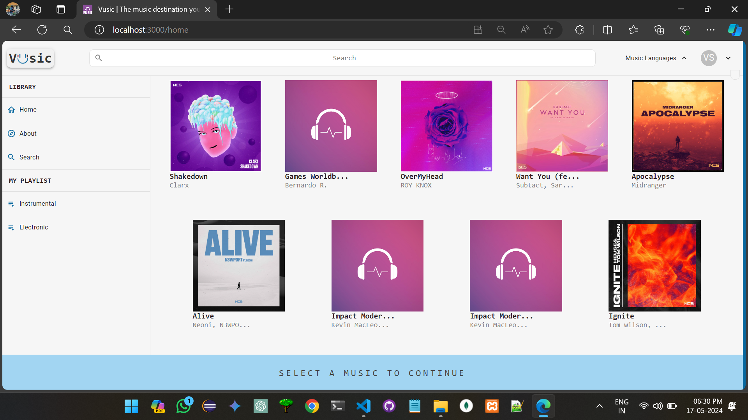

* + 1. Snapshot 2:

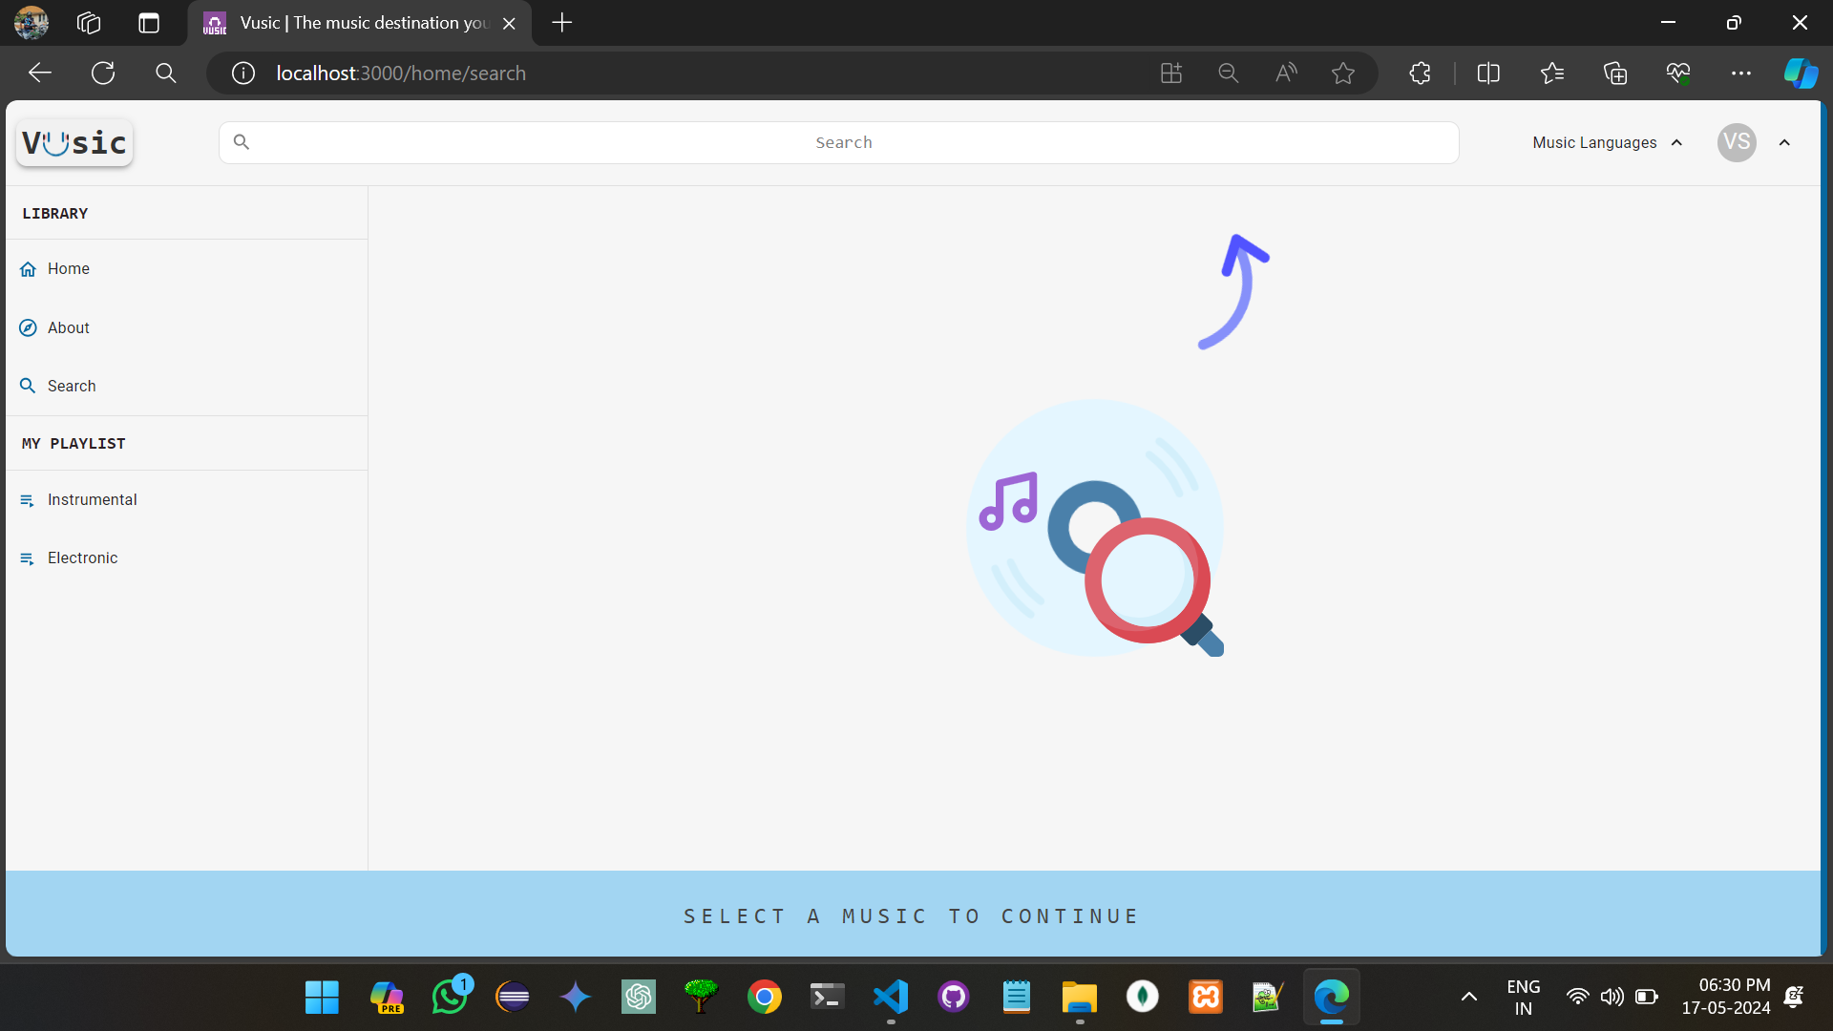

### Snapshot 3:

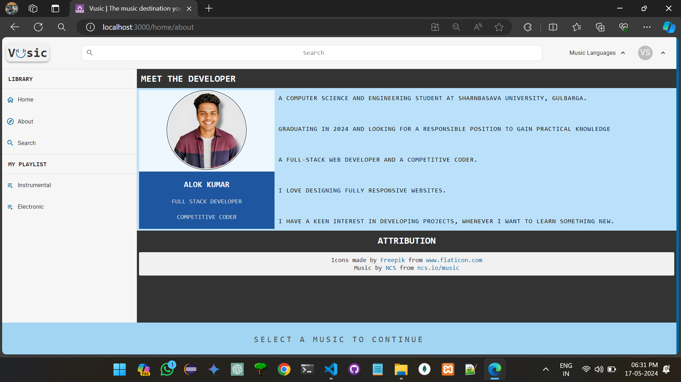

* + 1. **snapshot 4:**

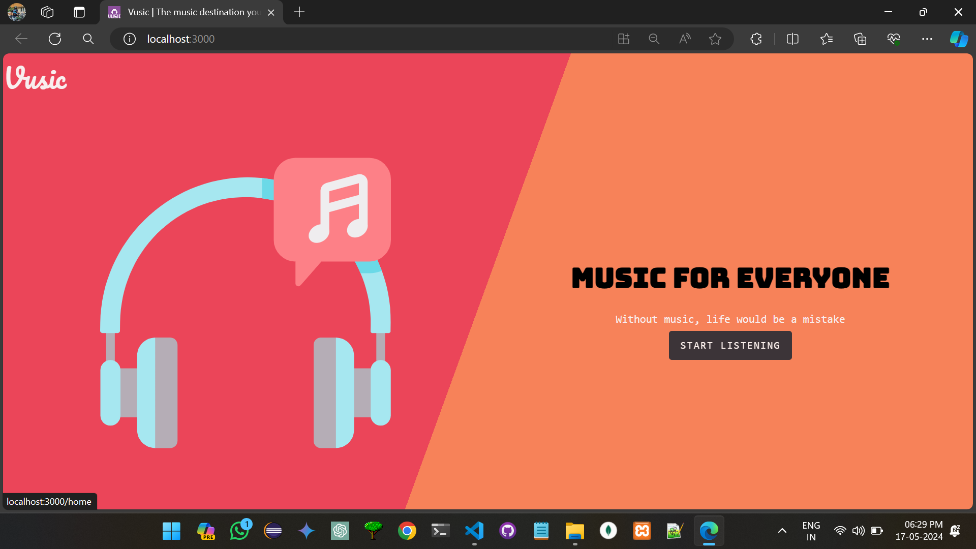

# CHAPTER-5 CONCLUSION

## Conclusion:

In the development of our music player application, TempoTracer, we embarked on a journey to create a feature-rich and user-friendly platform for music enthusiasts. Over the course of this project, we achieved significant milestones and addressed various challenges to deliver a robust and enjoyable music playback experience.

### Key Achievements

1. **User-Centric Design**: We prioritized user experience by designing an intuitive and visually appealing interface. Our user-centric approach ensured that users can easily navigate, search for, and play their favourite songs.
2. **Integration with iTunes**: Leveraging the iTunes API, we successfully integrated our app with a vast catalogs of music, allowing users to access a wide range of songs, albums, and artists.
3. **Player Functionality**: Our music player provides essential playback controls, such as play, pause, skip, and volume adjustment, ensuring a seamless listening experience.
4. **Playlist Management**: Users can create and manage playlists, curating their music collections and customizing their listening experience.
5. **Authentication and User Profiles**: We implemented user authentication and user profile functionality, giving users the ability to save playlists and track their listening history.
6. **Responsive Design**: TempoTracer is built with a responsive design, making it accessible and visually appealing across various devices and screen sizes.

### Challenges and Learning Opportunities

Throughout this project, we encountered several challenges, including integrating with external APIs, handling user authentication securely, and optimizing performance for large music libraries. These challenges provided valuable learning opportunities, and we gained expertise in areas such as API integration, database design, and responsive web development.

### Future Enhancements

As we conclude this project, we recognize that there is always room for improvement and expansion. In the future, we plan to enhance TempoTracer by:

1. **Adding More Features**: We aim to introduce new features, such as personalized recommendations, lyrics integration, and social sharing, to make TempoTracer even more engaging.

**Enhancing User Profiles**: We will enrich user profiles with additional features, such as profile customization and social interactions among users.

1. **Performance Optimization**: We will continue to optimize the performance of the app, particularly for large music libraries and during peak usage.
2. **Cross-Platform Availability**: Expanding the availability of TempoTracer across different platforms, including mobile apps for iOS and Android, will be a future goal.

In conclusion, TempoTracer represents our commitment to creating a delightful music playback experience for users. We look forward to further enhancing the app and continuing to provide an exceptional platform for music enthusiasts worldwide.

**Thank you for joining us on this musical journey.**

## Bibliography:

1. **React Documentation**. <https://reactjs.org/docs/getting-started.html>
   * The official documentation for React, which served as a comprehensive reference for building the frontend of the music player application.
2. **Express.js Documentation**. <https://expressjs.com/>
   * The official documentation for Express.js, which provided guidance on creating the backend server and handling API routes.
3. **MongoDB Documentation**. <https://docs.mongodb.com/>
   * MongoDB's official documentation, which was invaluable for designing the database schema and data storage.
4. **Bootstrap Documentation**. <https://getbootstrap.com/docs/5.0/getting-started/introduction/>
   * Documentation for Bootstrap, which guided the application's responsive design and UI components.
5. **Axios Documentation**. <https://axios-http.com/docs/intro>
   * Axios documentation was a crucial resource for handling HTTP requests to external APIs and the backend.

**iTunes Affiliate Program**. [https://affiliate.itunes.apple.com/resources/documentation/itunes-store-web-](https://affiliate.itunes.apple.com/resources/documentation/itunes-store-web-service-search-api/) [service-search-api/](https://affiliate.itunes.apple.com/resources/documentation/itunes-store-web-service-search-api/)

* + Documentation for the iTunes Search API, which provided access to a vast catalog of music data used in the project.

1. **MDN Web Docs**. <https://developer.mozilla.org/>
   * Mozilla Developer Network's web documentation, which was a helpful resource for web development concepts and JavaScript reference.

### YouTube Tutorials and Online Communities.

* + Various online tutorials, forums, and developer communities were consulted for specific challenges and questions encountered during the project.

### Stack Overflow.

* + Stack Overflow, a popular Q&A platform for developers, was a frequent source of solutions and troubleshooting guidance throughout the project.

### GitHub Repositories.

GitHub repositories hosting open-source projects and libraries that were used or referenced in the project.