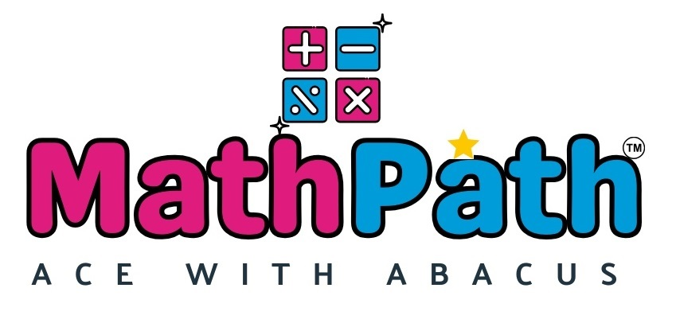
ANNUAL COMPETITION STUDIO
Completed Response to the Developer Questionnaire
Prepared by | MathPath
Date | 3 September 2026
Source | MathPath Annual Competition - Information We Need

CORE PRINCIPLE Across Preparatory and Intermediate Modules, students compete one level below their current enrolled level. Practice is intended to help every child repeatedly improve and beat their own previous score.

1. Student groups and competition levels
The platform should assign the competition paper automatically using the following rules.
Current student group | Competition level | Assignment rule
YLP-2 and YLP-3 | YLM | Young Learner competition category
PL-1 | YLM | Entry-level YLM category
PL-2 | PL-1 | One level below
PL-3 | PL-2 | One level below
PL-4 | PL-3 | One level below
IM-1 | PL-4 | One level below across module boundary
IM-2 | IM-1 | One level below
IM-3 | IM-2 | One level below
IM-4 | IM-3 | One level below

Bridge Module placement
Bridge progress milestone | Competition level
Completed Lesson 15 | PL-1
Completed Lesson 25 | PL-2
Completed Lesson 35 | PL-3
Completed the entire Bridge Module | PL-4

Master Module placement
Master Module progress | Competition level
Below Lesson 16 (Lessons 1-15) | IM-4
Lesson 16 or above, but Master Module not completed | MM-1
Completed the full Master Module | MM-2

CONFIRMATION NEEDED YLP-1 eligibility has not yet been specified. Bridge milestone ranges between Lessons 15, 25 and 35 should also be confirmed for automatic assignment.

2. Deciding Master Module students between MM-1 and MM-2
2.1 Manual or automatic assignment?
MathPath response: Automatic. The system should use the student's recorded Master Module lesson progress and completion status.
2.2 What counts as finishing the Master Module?
MathPath response: Completion of the entire Master Module syllabus. Students below Lesson 16 compete in IM-4; students at Lesson 16 or above who have not completed the module compete in MM-1; students who have completed the full module compete in MM-2.

3. When and how the competition runs
3.1 Competition date and duration
MathPath response: The competition will be held on Sunday, 11 October 2026. It is a single-day competition.
3.2 Exact start time or open window?
MathPath response: Students should begin at the assigned scheduled start time. The competition is not an unrestricted all-day window.
3.3 Do all levels run together?
MathPath response: No. Offline and online students participate in assigned slots as shown below.
Mode | Scheduled slot | Students | Location/supervision
Offline | 12:00-12:30 PM | YLP, PL-1, PL-2 and PL-3 students | Respective MathPath centres
Offline | 1:00-1:30 PM | PL-4, IM-1, IM-2 and IM-3 students | Respective MathPath centres
Offline | 2:00-2:30 PM | IM-4, MM-1 and MM-2 students | Respective MathPath centres
Online - India | 7:00-7:30 PM | Students residing outside West Bengal | Home, supervised by MathPath
Online - International | 8:00-8:30 PM | International students | Home, supervised by MathPath

3.4 One sitting or pause and return?
MathPath response: Students should complete all applicable sections in one sitting, back-to-back. Pausing is allowed only for a genuine technical disconnection; in that case the active section timer must pause and resume from the exact remaining time.

Competition section timers
Competition level | Section-wise timers | Total
YLP / PL-1 | 20 minutes continuously | 20 minutes
PL-2 | Abacus 15 min; Visual 15 min | 30 minutes
PL-3 | Abacus 10 min; Visual 10 min; Multiplication 10 min | 30 minutes
PL-4 | Abacus 10 min; Visual 10 min; Mixed Multiplication and Division 10 min | 30 minutes
IM-1 | Abacus 10 min; Visual 10 min; Multiplication and Division 10 min | 30 minutes
IM-2 | Abacus 10 min; Visual 10 min; Multiplication and Division 10 min | 30 minutes
IM-3 | Abacus 8 min; Visual 8 min; Multiplication 7 min; Division 7 min | 30 minutes
IM-4 | Abacus 8 min; Visual 8 min; Multiplication 7 min; Division 7 min; Squares 5 min | 35 minutes
MM-1 | Abacus 5 min; Visual 5 min; Multiplication 5 min; Division 5 min; Squares 5 min; Percentage 5 min | 30 minutes
MM-2 | Abacus 5 min; Visual 5 min; Multiplication 5 min; Division 5 min; Squares and Cubes 5 min; Percentage 5 min; Square Roots and Cube Roots 10 min | 40 minutes

SCHEDULING CONFLICT The published 2:00-2:30 PM offline slot is 30 minutes, but IM-4 requires 35 minutes and MM-2 requires 40 minutes. The corresponding online windows are also only 30 minutes. These slots must be extended or separately scheduled before implementation.

4. Question-paper fairness
4.1 Should students receive the same questions?
MathPath response: Yes. Every student assigned to the same competition paper must receive the exact same questions in the exact same order. Randomized numbers or separately shuffled question sets should not be used for the final competition.
YLM PAPER DECISION YLP students are limited to direct sums, while PL-1 students cover direct, Small Boss and Big Boss concepts. Because both groups are currently assigned to YLM, please confirm whether YLM will contain separate YLP and PL-1 paper variants or one common paper limited to shared concepts.

5. Results, ranking and certificates
5.1 How is the final result calculated?
MathPath response: To be confirmed: whether ranking is based only on correct answers, accuracy percentage, completion time, or a combination. A tie-break rule is also required.
5.2 Leaderboard and visibility
MathPath response: Practice performance must remain private. Students and parents should see only the child's own scores and improvement history; they must not see another student's practice results. Competition ranking, winner visibility and any final leaderboard access remain to be confirmed.
5.3 Automatic certificate or scorecard
MathPath response: To be confirmed: whether every participant receives an automatically generated certificate or scorecard, and which fields it should contain.
5.4 When are results released?
MathPath response: Results should not be treated as final immediately after submission. The formal Results and Prize Distribution is scheduled for Sunday, 1 November 2026, from 3:00-6:00 PM at NKDA Community Hall, Action Area IIC, Newtown. The exact portal release time remains to be confirmed.

6. Number of attempts
6.1 One competition attempt or retakes?
MathPath response: Everyday practice mocks may be attempted as many times as a student wishes. The permitted number of attempts for the final competition and the exceptional retake approval process, if any, remain to be confirmed.

7. Technical interruption during competition
7.1 What happens if a connection or device drops?
MathPath response: The active timer must stop immediately. The system must save submitted answers, current section and remaining time. When the student reconnects, the same section should resume from the exact point and remaining time at which the student was disconnected.

8. Competition location and supervision
8.1 Where do students take the competition?
MathPath response: Offline students participate under physical supervision at their respective MathPath centres. Students residing in India but outside West Bengal, and international students, participate online from home under MathPath supervision.

9. Percentage, Squares, Cubes and Roots
9.1 Should these questions differ from the Master Module format?
MathPath response: No. Use the same question format and rules already followed in the Master Module.

10. Practice run in the final competition format
10.1 Should students experience the final format beforehand?
MathPath response: Yes. Competition-format practice should follow the same section sequence, section timers and instructions as the final competition day. Practice mocks should remain available for unlimited attempts, and each student should see only their own performance and previous-score improvement.

11. Additional competition requirements
11.1 Additional rules, special cases or content requirements
MathPath response: YLP papers contain direct sums only. PL-1 papers contain direct, Small Boss and Big Boss concepts using abacus sums only, with no visual section. Visual sums begin from PL-2 onward. The final competition uses a fixed identical paper for all students assigned to the same competition paper. Automatic level assignment must follow the progression, Bridge Module and Master Module rules in Section 1.

Outstanding confirmations before development sign-off
No. | Decision required | Confirmation needed
1 | YLP-1 eligibility | Confirm whether YLP-1 participates.
2 | YLM paper structure | Confirm separate YLP/PL-1 variants or one common paper.
3 | Bridge ranges | Define assignment for students between the stated lesson milestones.
4 | Final scoring | Confirm ranking formula, speed tie-break and treatment of unanswered sums.
5 | Competition visibility | Confirm Top 3/Top 10, parent/student visibility and certificate fields.
6 | Final competition attempts | Confirm one attempt and any administrator-approved retake exception.
7 | Slot duration | Extend or reschedule IM-4 (35 min) and MM-2 (40 min), including online slots.

DEVELOPMENT STATUS All confirmed requirements in this response may be used for the build plan. The outstanding items above should remain configurable or blocked from final sign-off until MathPath confirms them.

