**JAVA**

**Access Modifier: (they provide access restrictions, which will be used to enhance the data security)**

Public :

Private

Protected

Default

NOTE: we can use only 3 access modifiers for a java class, those are public & default.

**In java there are ‘3’ basic programming elements are there:**

**Class** **Interface** **Enum**

**Class Syntax:**

<AccessModifier>**class**<ClassName>

{

---------;

---------;

}

Ex: public class Demo  
{

--------;

---------;

}

**Interface Syntax:**

<accessModifier>interface<InterfaceName>

{

----------;

----------;

}

Ex:

interface FirstInterface // access modifier is default

{

----;

----;}

**Enum Syntax:**

<accessModifier>enum<enumName>

{

----------;

----------;

}

Ex:

Public enum Colors

{

--------;

--------;

}

__________________________________________

**1. Class ===🡺 90%**

**2. Interface=🡺less than 10% interface Most of used in the Project.**

**3. Enum=🡺 less than 2%**

**___________________________________________**

In Java there are 50 keywords are there

Class

Interface

Every Java language keyword starts with a small letter

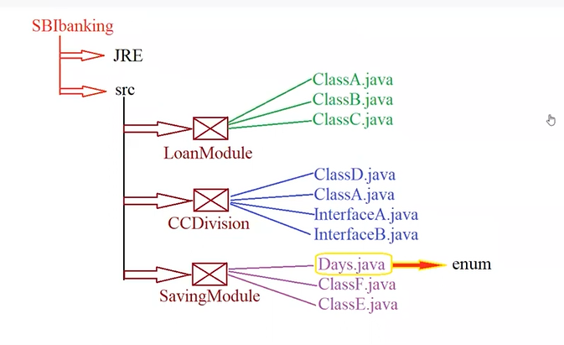

Syntax of Java class:

<AccessModifier>class<ClassName>

{

//Variables;

//Methods;

//Blocks;

//Create Objects

}

**Example for a java class:**

Public class Student{

public static void main(String []args)

{

System.out.println(“java is awesome”);

}

}

NOTE:

1. Every java program execution should start from main() and end with main().

**Java Method:**

It is used to write the business logic

<AccessModifier><ReturnType><MethodName>()

{

-------; //Method Body/Method Functionality/ Method Implementation

-------;

}

**ReturnType**: (4):-🡪 void + 8 Primitive datatypes + Class + Objects

[byte, short, int, long, float, double, char, Boolean]

Void method : it does not return anything

**Example:**

Public void sum(){

}

Q1) How many methods we can write inside a class?

Ans:- we can write numbers of methods.

Q2) When a method will be executed?

Ans:- a method will be executed only if we are calling that method.(OR)

If we are starting that method. (OR)

If we are invoking that method.

Q3) How to call a method?

Ans:- we need to call a method with the help of “its” respective CLASS OBJECT.

Q4) How to create an Object?

Ans:- we need to create an object with the help of the ‘new’ keyword, and we need to initialize that Object with the help of a constructor. (Constructor name will be same as Class Name)

Ex:-

ClassA obj=new ClassA(); // ClassA Object

**Program:-**

Public class ClassA{

Public void method1(){

s.o.pln(“hii”);

ClassA aobj=new ClassA();//created a object

Aobj.method2(); //calling a method2

}

Public void method2(){

s.o.pln(“hello”);

}

p.s.v.main(String []args){

ClassA aobj=new ClassA();//created a object

aobj.method1(); //calling a method1

aobj.method2();//calling a method2

s.o.pln(“java is awesome!!!!”);

}

}