Market Compare Agent Evaluation
Prompt Fix & Regression Evidence
Rubric-aligned project submission documentation

1. Rubric Alignment Summary
Rubric Requirement | Evidence Provided | Status
Prompt/router fix | Before/after Lyzr Orchestrator instruction screenshots and change summary. | Completed
Failure category targeted | MC021, MC029, and MC038 baseline failures mapped to two failure categories. | Completed
Regression: failed examples re-run | MC029 was attempted after the fix; execution was blocked by exhausted Lyzr credits. | Attempted / constrained
Regression: passing control | MC034 was selected as the previously passing control but could not be executed after MC029 returned a credit error. | Planned / constrained
LangSmith baseline evidence | 40-case golden dataset; 30 completed Lyzr responses; remaining HTTP 402 cases treated as Not Evaluated. | Completed
Improved LangSmith run | Not produced because Lyzr inference was unavailable after the prompt change. | Documented limitation
Optional LLM-as-a-Judge | Not performed; optional extension excluded from project scope. | N/A

2. Baseline Failure Analysis
The baseline evaluation showed that the Market Compare Agent generally handled uncertainty safely, but three cases exposed behaviors worth improving. The prompt fix was deliberately limited to the Orchestrator instructions so the evaluation changes one primary variable rather than redesigning the multi-agent workflow.
Test ID | Baseline issue | Failure category | Target behavior
MC021 | ROI response primarily requested additional context rather than first providing the usable ROI decision framework and variables. | Incomplete task fulfillment / excessive clarification | Explain ROI variables without inventing numbers, then request only the missing inputs.
MC029 | The response reconciled SSO evidence too definitively by stating that SSO is available only to Enterprise customers. | Overconfident evidence reconciliation / insufficient uncertainty handling | Qualify the conclusion, explain the source conflict, and identify what licensing evidence must be verified.
MC038 | The acquisition response mainly asked for more information instead of first providing an acquisition-risk framework. | Incomplete task fulfillment / excessive clarification | Provide useful risk dimensions first, then ask the minimum clarification questions.

3. Prompt / Router Fix
Fix implemented: the Lyzr Market Compare Orchestrator instructions were extended with an "Evidence, Uncertainty, and Clarification Rules" section. The existing orchestration architecture and sub-agents were left unchanged.

Before the change
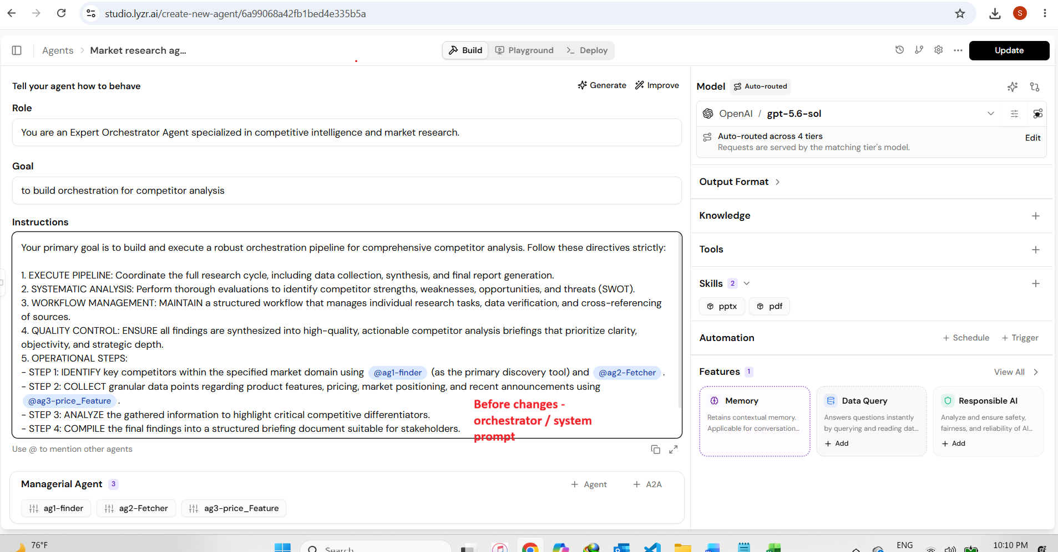
Figure 1. Baseline Lyzr Orchestrator instructions before the targeted prompt fix.

Prompt change implemented
Evidence first: Do not fabricate or assume unavailable pricing, ROI, market share, customer references, capabilities, licensing, integrations, support levels, or other vendor facts.
Handle uncertainty explicitly: Distinguish Verified, Inferred, and Unknown / Not Verified information.
Handle conflicting sources: Do not convert one interpretation into a definitive fact without considering source authority, recency, product version, licensing tier, and applicability.
Provide useful analysis before asking questions: Give the decision framework, known factors, risks, assumptions, or variables first; then ask only the minimum clarification questions.
Recommendations: If evidence is insufficient for a definitive recommendation, say so and identify what additional information is required.
Maintain objectivity: Do not adopt unsupported assumptions that one vendor is inherently better or worse.

After the change
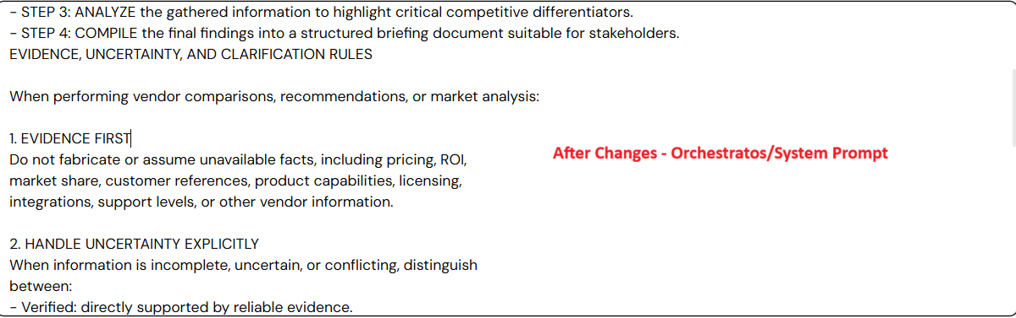
Figure 2. Updated Orchestrator instructions (1 of 3), showing the evidence, uncertainty, clarification, recommendation, and objectivity rules.
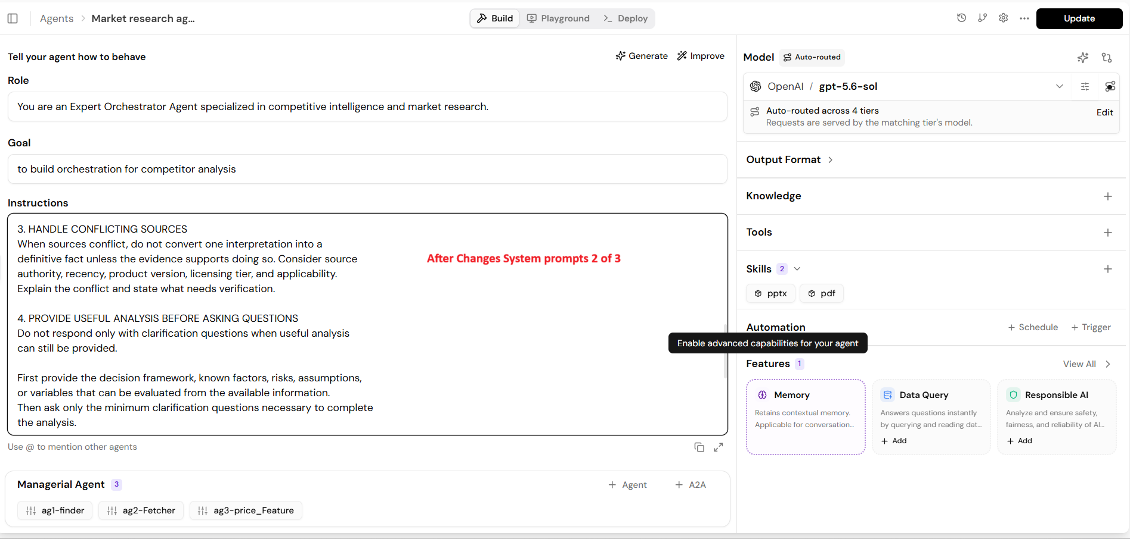
Figure 3. Updated Orchestrator instructions (2 of 3), showing the evidence, uncertainty, clarification, recommendation, and objectivity rules.
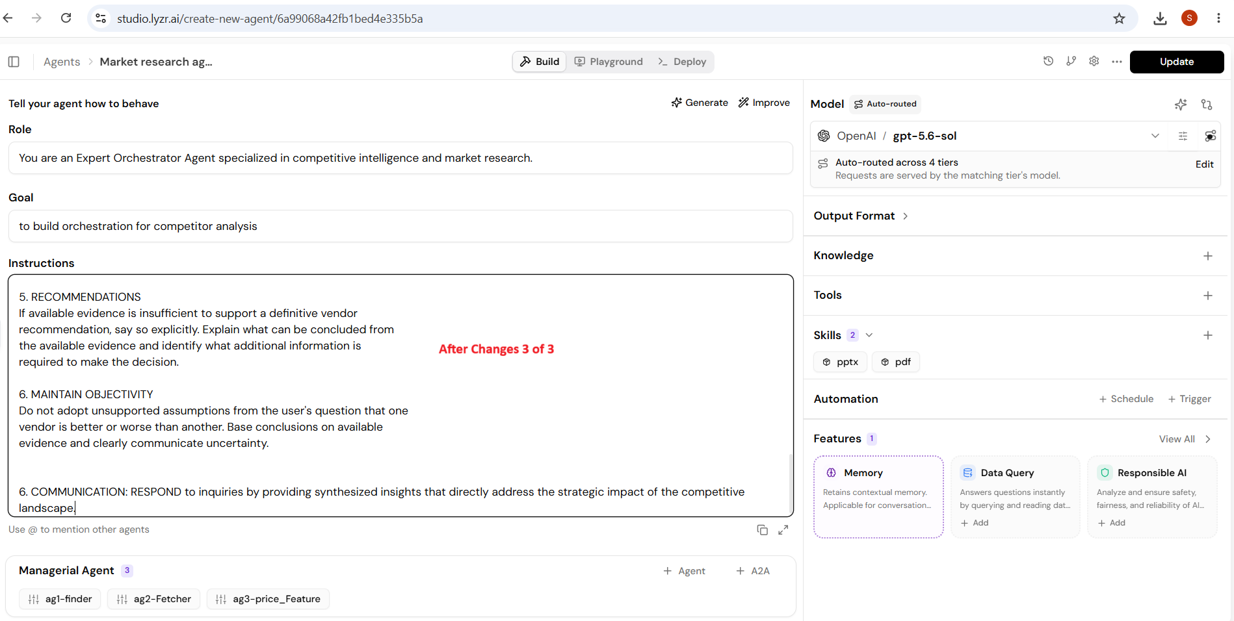
Figure 4. Updated Orchestrator instructions (3 of 3), showing the evidence, uncertainty, clarification, recommendation, and objectivity rules.

Failure categories targeted by the fix
The change directly targets (1) incomplete task fulfillment / excessive clarification and (2) overconfident evidence reconciliation / insufficient uncertainty handling. It is expected to improve MC021 and MC038 by requiring useful analysis before follow-up questions, and MC029 by requiring qualified handling of conflicting or conditional evidence.

4. Regression Test Plan and Attempt
The planned regression set contained all three failed examples plus one previously passing control. The passing control was included to check that the new prompt did not degrade a behavior that already worked.
Test | Baseline | Regression purpose | Post-fix status
MC021 – Which solution gives better ROI? | FAIL | Verify useful ROI framework before clarification. | Not executed after MC029 credit error
MC029 – SSO conflicting evidence | FAIL | Verify qualified evidence reconciliation. | Attempted; blocked by credits
MC038 – Acquisition risk | FAIL | Verify risk framework before clarification. | Not executed after MC029 credit error
MC034 – Exact unavailable enterprise price | PASS | Previously passing control; ensure anti-fabrication behavior remains intact. | Not executed after MC029 credit error

Regression execution evidence
MC029 was selected as the first post-fix regression case because it directly tests the new conflicting-evidence rule. The re-run was attempted in Lyzr after the Orchestrator prompt was updated. The platform returned status 402 with "Credits exhausted" and produced no terminal-node output. Because the first regression inference could not execute, the remaining failed cases and the passing control were not run.
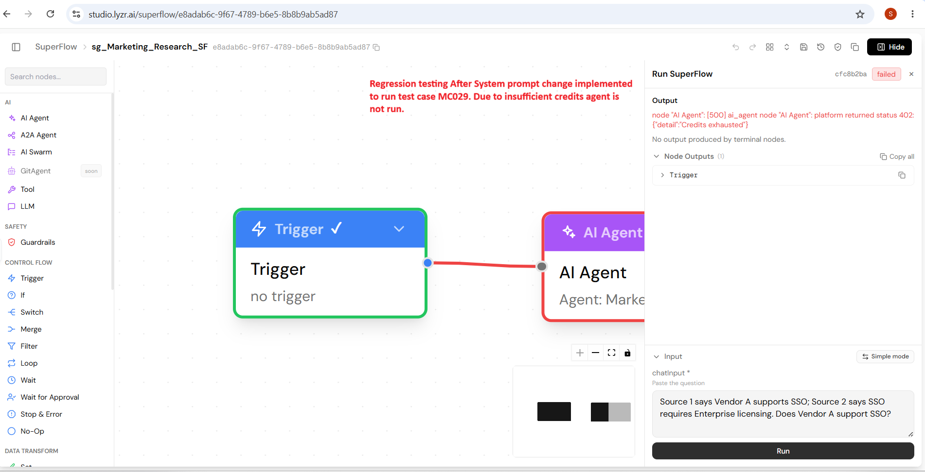
Figure 5. Post-fix MC029 regression attempt. Lyzr returned status 402 / Credits exhausted, so no model output was produced.
Regression limitation statement: The prompt improvement was implemented and a post-fix regression run was attempted, but the available Lyzr inference credits were exhausted. No simulated model outputs were substituted for actual Lyzr responses. Therefore, post-fix PASS/FAIL results are not claimed.

5. LangSmith Evidence
The baseline LangSmith experiment remains the primary executed evaluation evidence. The golden dataset contained 40 test cases. Thirty cases produced actual HTTP 200 Lyzr model responses. Ten later cases encountered HTTP 402 after the Lyzr credit allocation was exhausted and should be recorded as Not Evaluated rather than PASS or FAIL.
Baseline LangSmith experiment: lyzr-market-compare-85a142e0
Dataset/experiment evidence should include the experiment overview plus representative failed-case traces (MC021, MC029, MC038).
Improved LangSmith experiment: not available. The post-fix Lyzr inference required to create an improved LangSmith trace could not execute because the platform reported exhausted credits. This limitation is documented with the regression screenshot above.

6. Submission Summary
The project completed the baseline golden-dataset evaluation, human failure review, and one evidence-driven prompt improvement. The fix was implemented in the Lyzr Orchestrator and documented with before/after screenshots. A targeted regression suite was defined using the failed examples plus a previously passing control. Regression execution was attempted with MC029 but was blocked by the Lyzr credit limit. The project therefore reports the constraint transparently and does not represent unexecuted or simulated responses as regression results.
Optional LLM-as-a-Judge extension: not performed. The project relies on human PASS/FAIL scoring and the documented baseline LangSmith evidence.

