Embedded: Command Line process

# Install CCS

1. Click on the following link: <http://processors.wiki.ti.com/index.php/Download_CCS#Download_the_latest_CCS>

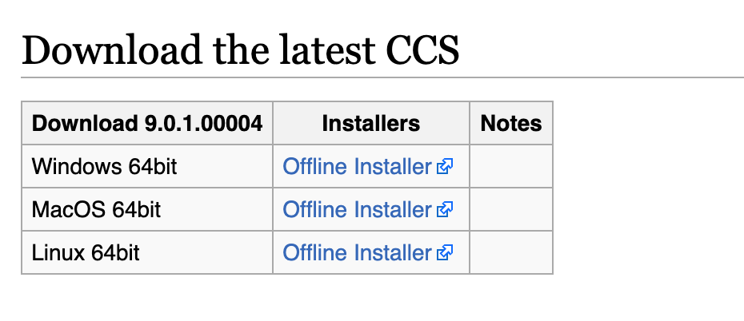

1. Download the installer for your system.
2. Unzip it.
3. Click on ccs_setup_<version_number> to launch the installer.
4. Follow the instructions on the installer, and keep track of where you installed ccs.

# Build

1. Download the TI msp430-gcc tool from this link for your machine:

<http://software-dl.ti.com/msp430/msp430_public_sw/mcu/msp430/MSPGCC/latest/index_FDS.html> (Free TI account required, choose Civil if prompted)

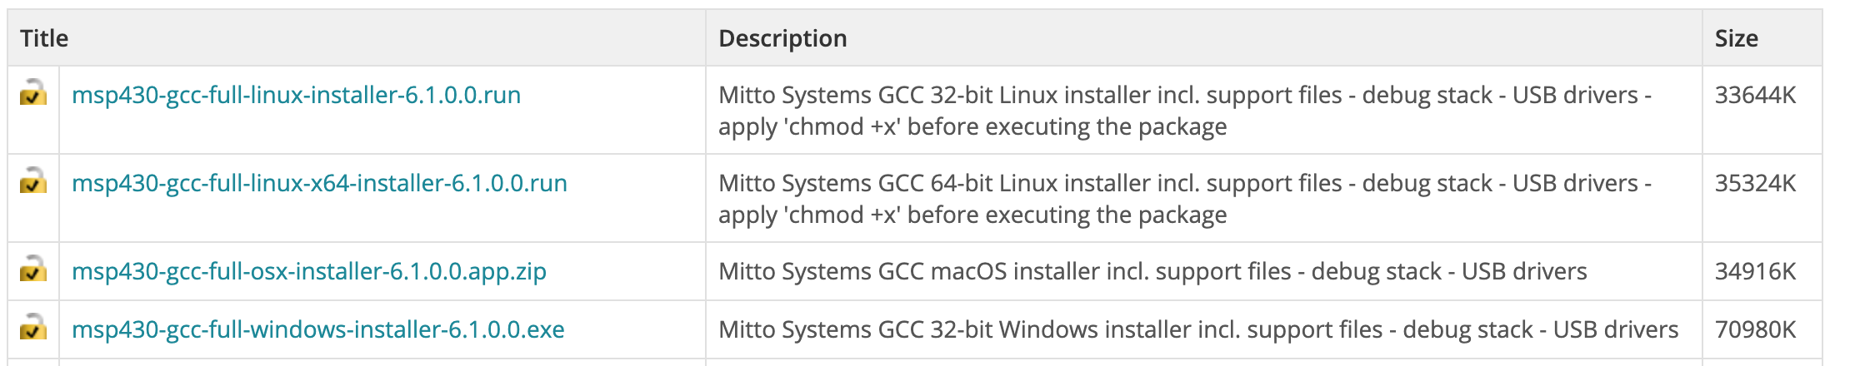

1. Before opening the file change ownership setting[ask Professor Delong how to]
2. Follow the instructions in the installer. Keep track of where the file is being installed.
3. Go into the folder->examples->msp430g2553 and run make in command line.
4. This will give you the msp430g2553.out

# Flash

1. Go to command line
2. Go into the TI folder created for ccs[defaults to /Applications/ti for mac]
3. Go to the folder:

$cd /Applications/ti/ccs901/ccs/ccs_base/scripting/examples/uniflash/cmdLine/

1. Make the uniflash.sh file executable. To do so on Mac, simply type:  
   $chmod +x ./uniflash.sh
2. Copy over “MSP430G2553.ccxml” into uniflash/configs (parent folder to cmdLine /configs)
3. Copy over “msp430g2553.out” into uniflash/programs
4. Run:

./uniflash.sh -ccxml ../configs/MSP430G2553.ccxml -program ../programs/msp430g2553.out

1. You have successfully flashed the device

# Debug

1. Install Homebrew if you don’t already have it installed
2. Run:  
   brew install mspdebug
3. Go to:  
   cd ..  
   cd ..  
   cd usr/local/Cellar/mspdebug/0.25/bin
4. Copy “libmsp430.so” into the folder
5. Run:  
   ./mspdebug tilib
6. See flashing lights!