Pennington Biomedical Research Center
Pennington Knowledge Graph
User Guide
What this tool does: Lets you explore 35+ years of Pennington publications — find collaborators, track research themes, discover co-occurring concepts, and ask plain-English questions — all from your browser with no software to install.

9,038  Publications (1988–2026) | 23,727  Unique authors | 14,180  Biomedical entities

1. Getting Started
The tool runs in your web browser — no installation needed. Open any browser (Chrome, Edge, Firefox, or Safari) and navigate to the internal URL provided by your IT department:

http://pubmap.pbrc.edu

The home screen loads immediately — no login required. You will see a sidebar on the left with three pages:

- Dashboard — an always-on overview of the corpus
- Query Explorer — pre-built research questions you can run in seconds
- Ask a Question — type a question in plain English

Tip: Bookmark the URL so you can return quickly. The tool works on your laptop, desktop, or tablet.

2. The Dashboard Page
The Dashboard is the first thing you see. It gives an at-a-glance summary of Pennington's publication output and requires no interaction.

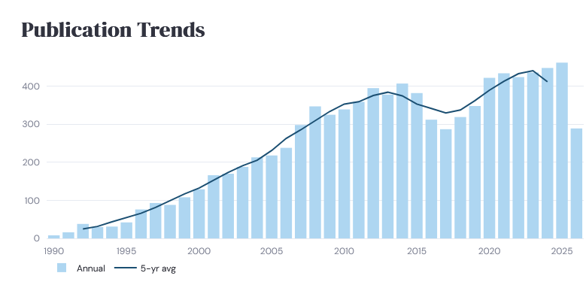
Publication trends chart with 5-year rolling average

What you will see
- Four summary cards at the top: total publications, unique authors, biomedical entities, and year range
- A publication trends chart showing annual output from 1990 to present, with a 5-year rolling average line
- A horizontal bar chart of the top 12 most-studied diseases
- A bar chart of the 15 most prolific Pennington authors

Use case: The Dashboard is a great starting point for grant writers — it shows Pennington's track record at a glance and can be included as a screenshot in grant narratives.

3. The Query Explorer Page
The Query Explorer gives you 20 pre-built research questions organized into five categories. No knowledge of databases or programming is required.

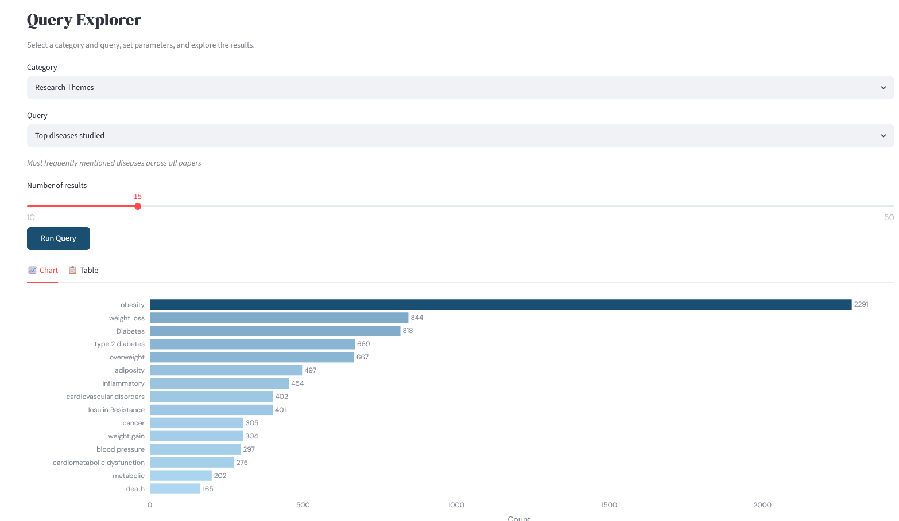 Query Explorer — Category and Query dropdown menus

How to run a query

1 | Choose a category  Click the Category dropdown and select one of six groups: Research Themes, Authors, Collaborations, Entity Co-occurrence, Corpus Statistics, or Disease-Specific.
2 | Choose a query  Click the Query dropdown to see the available questions in that category. Select the one you want.
3 | Set parameters  Some queries ask for a name (e.g. author name, disease name) or a number of results. Fill these in. Default values are provided.
4 | Click Run Query  Results appear below as an interactive chart. Switch between the Chart tab and the Table tab to change the view.
5 | Download if needed  In the Table tab, click the Download CSV button to export the results to a spreadsheet.

Complete query reference

# | Query | Parameters needed | Typical use case
Research Themes
1 | Top diseases studied | Number of results | What diseases does Pennington study most?
2 | Top chemicals/compounds | Number of results | What drugs or compounds appear most in our publications?
3 | Top genes studied | Number of results | Which genes are most studied at Pennington?
4 | Publication trends by year | None | How has our output grown over time?
5 | Top research topics | Number of results | What are our dominant research themes?
Authors
6 | Most prolific authors | Number of results | Who has published the most at Pennington?
7 | Papers by a specific author | Author name (partial) | Find all papers by a particular researcher
8 | Top co-authors for a researcher | Author name (partial) | Who does a given researcher collaborate with most?
9 | Authors publishing on a specific disease | Disease name, number | Who works on a specific disease?
Collaborations
10 | Top collaborating institutions | Number of results | Which external institutions work with us most?
11 | International collaboration countries | Number of results | Which countries does Pennington collaborate with?
Entity Co-occurrence
12 | Papers mentioning two entities together | Entity 1, Entity 2, number | Find papers where two concepts appear together
13 | Most common disease-gene pairs | Number of results | What gene-disease connections appear most?
14 | Overall corpus summary | None | Key statistics: total papers, year range, citations, and date of last update
Corpus Statistics
15 | Most cited papers | Number of results | What are our highest-impact publications?
16 | Top journals publishing Pennington research | Number of results | Where does Pennington publish most?
17 | Publication count by work type | None | Breakdown of articles, reviews, preprints, etc.
18 | Top funding sources | Number of results | Which funders support Pennington research most?
Disease-Specific
19 | Research on a specific disease over time | Disease name | How has publication volume on a disease changed by year?
20 | Chemicals co-occurring with a disease | Disease name, number | What compounds are studied with a given disease?

Special feature: Query 8 (Top co-authors for a researcher) renders as an interactive network diagram — the researcher you searched for appears at the center with collaborators arranged around them, sized by number of shared papers.

4. The Ask a Question Page
The Ask a Question page lets you type a research question in plain English. An AI translates your question into a database query, runs it, and gives you a plain-English summary of the results alongside the data.
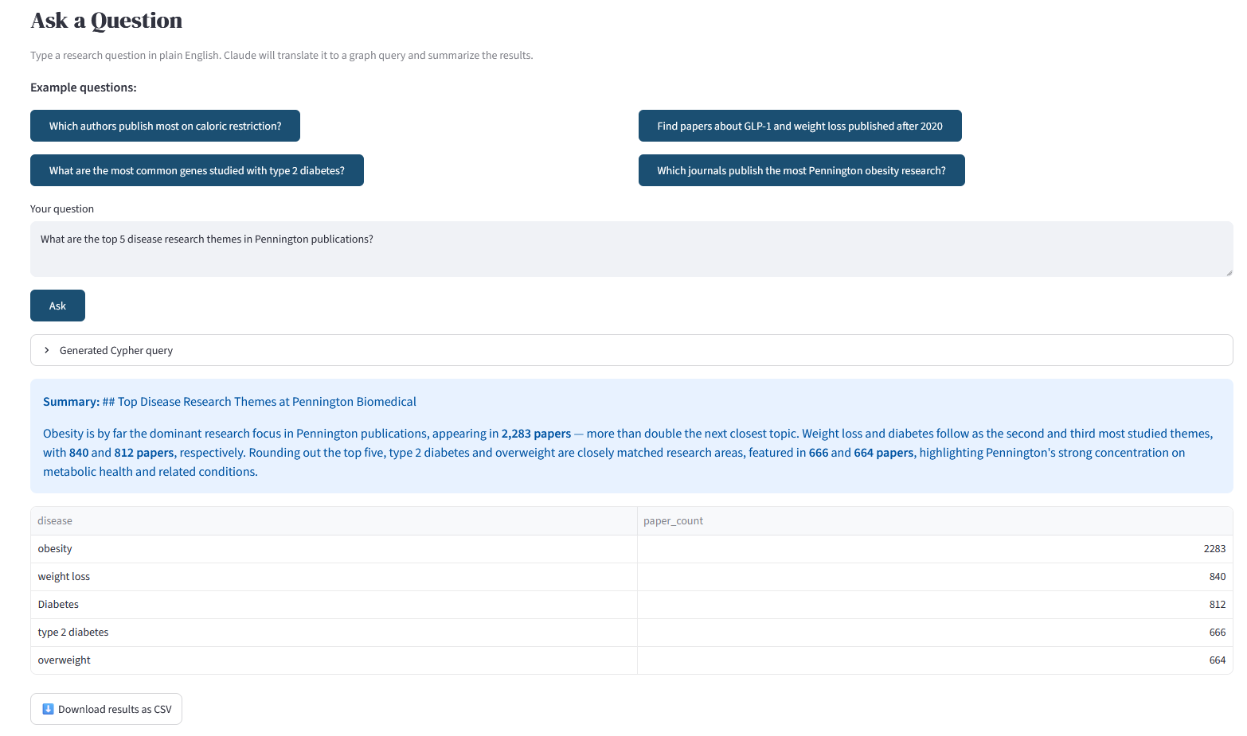
Ask a Question page showing a typed question and the AI summary + results

How to use it
- Click one of the four example question buttons to pre-fill a question, or type your own in the text box
- Click the Ask button
- A summary of the key findings appears in a blue box at the top
- The full results table appears below — you can download it as CSV
- Expand the Generated Cypher query section if you want to see exactly what database query was run

Example questions that work well
- Which authors publish most on caloric restriction?
- Find papers about GLP-1 and weight loss published after 2020
- What are the most common genes studied with type 2 diabetes at Pennington?
- Which journals publish the most Pennington obesity research?
- Who are the top collaborators of Eric Ravussin?
- How many papers on gut microbiome were published each year since 2010?

Tip: Be specific. Questions like 'Tell me about obesity research' are too broad. Questions like 'Who at Pennington has published most on adipose tissue inflammation since 2015?' give much more useful results.

Note: This feature requires an internet connection to reach the AI service. If you are on a restricted network connection, use the Query Explorer instead — it works entirely offline.

5. Common Workflows

Grant writing — documenting Pennington's track record
- Go to Query Explorer → Research Themes → Publication trends by year to show output growth
- Run Query 1 (Top diseases) to show the breadth of disease focus
- Run Query 9 with your disease of interest to identify key Pennington investigators
- Run Query 15 (Most cited papers) to identify landmark publications
- Export all results as CSV for use in tables or figures

Finding a collaborator
- Run Query 9 (Authors by disease focus) with your research area
- Run Query 8 (Top co-authors) on a known Pennington investigator to see their network
- Use Ask a Question: 'Who at Pennington works on both exercise and type 2 diabetes?'

Preparing a literature review or research summary
- Run Query 12 (Papers mentioning two entities) with your two key concepts
- Run Query 7 (Papers by a specific author) if you want one investigator's full output
- Export results to CSV and open in Excel for further filtering

Onboarding as a new trainee or faculty member
- Start with the Dashboard to understand the overall research landscape
- Run Query 5 (Top research topics) to see the dominant themes
- Run Query 10 (Top collaborating institutions) to understand external partnerships
- Use Ask a Question to explore any specific area you are interested in

6. Frequently Asked Questions
How current is the data?
The database is updated periodically by the research team. The current corpus covers publications through early 2026. The date of the most recent update is shown in the corpus summary (Query 14 in the Query Explorer).

Can I search for a paper by title or keyword?
The Query Explorer does not have a keyword search box, but the Ask a Question page can handle this. Try: 'Find Pennington papers about [your topic] published after [year].'

The chart looks cut off — how do I see the full list?
Switch to the Table tab next to the chart. The table shows all results and can be scrolled. You can also increase the 'Number of results' slider before running the query.

Can I download the results?
Yes. In the Table tab of any Query Explorer result, click the Download CSV button. Results from the Ask a Question page also have a download button.

A query returned no results — what should I try?
- Check your spelling — the search is case-insensitive but spelling must be correct
- Try a shorter or more general term — 'diabetes' will match more than 'type 2 diabetes mellitus'
- Some entities use their common abbreviation — try 'T2DM' or 'insulin resistance' as alternatives

Is my search activity private?
Yes. All queries run against an internal database on Pennington's own servers. Your search terms are not logged or shared externally. Right now, the only exception is the Ask a Question feature, which sends your question text to an AI service, but no publication data is shared, only your typed question.

Can I request a new pre-built query?
Yes! Please contact the research team with your suggestion. Common requests will be added to the Query Explorer in future updates.

Need a quick reminder?
See the separate Quick Reference Card for a one-page summary of all queries and tips.

