ART 3870 PROJECT SUBMISSION TEMPLATE   
**Complete this template for every assignment!**

Export to pdf and submit on blackboard. Include your sketches and screenshots in this document. Do not upload any other files to blackboard.

Your code should be hosted on GITHUB and the pages should be published on GITHUB.IO

## Personal Information

NAME: Oscar Gomez

NET ID: **sg4662**

COURSE: YEAR (2017)/ QUARTER (FA) /SECTION (01)

## Project Information

Project Title: animation lab

Project Description: this project about my personal portfolio where I include information about ­my skills and background.

Project URL on github.com: https://github.com/sg4662/animation

Project URL on github.io: <https://sg4662.github.io/animation/>

## Project Documentation

**Scanned Project Sketches, Branding worksheets, style tiles and other prep work:**

(one for each page in the project – scaled to take the whole page width, not distorted/stretched)

**Project Screenshots:**

(one for each page in the project – scaled to take the whole page width, not distorted/stretched) _ USE <http://www.awesomescreenshot.com/> to help get the best results

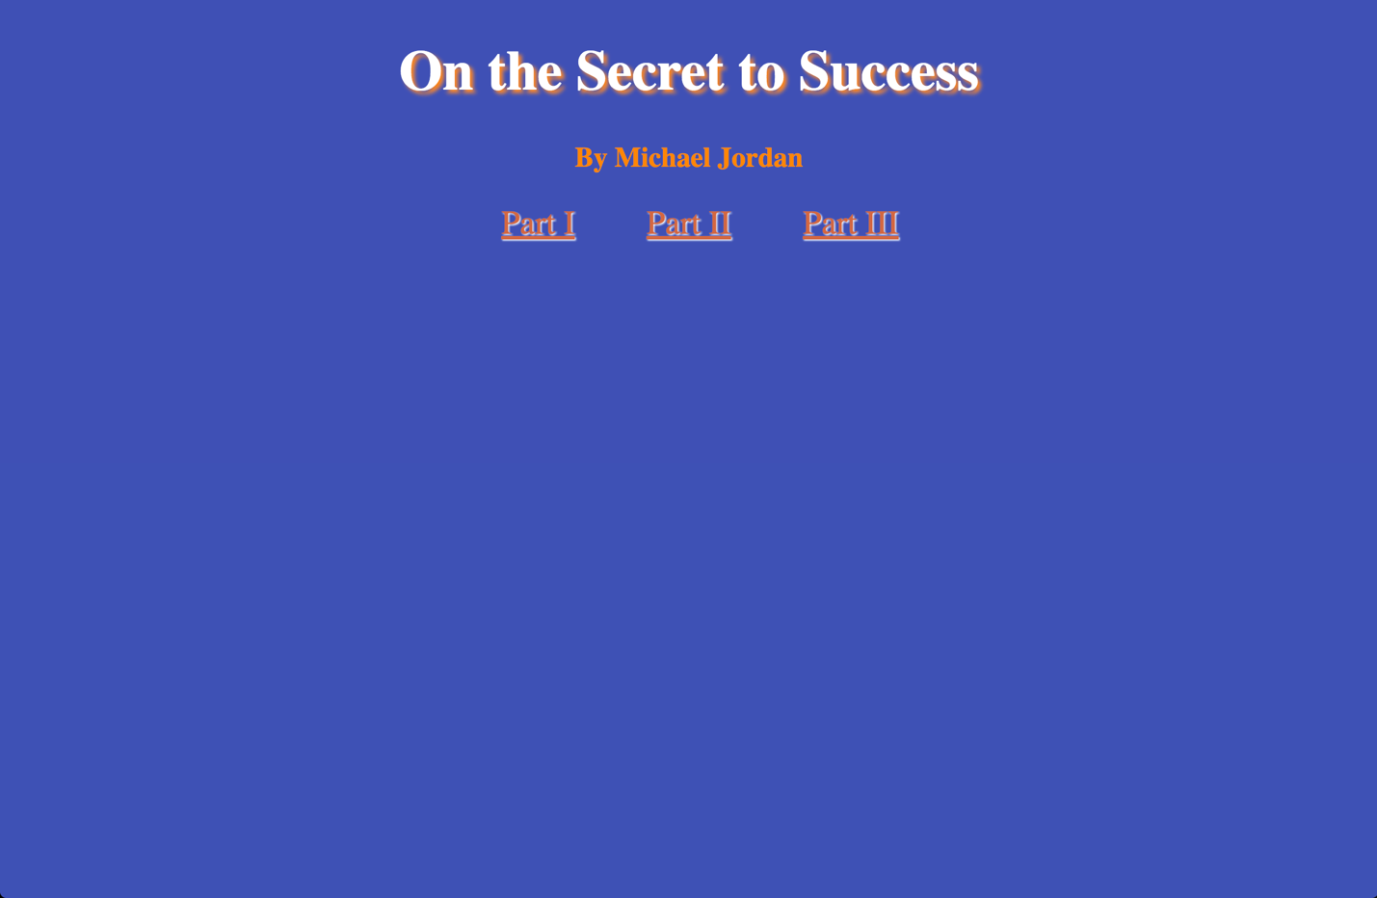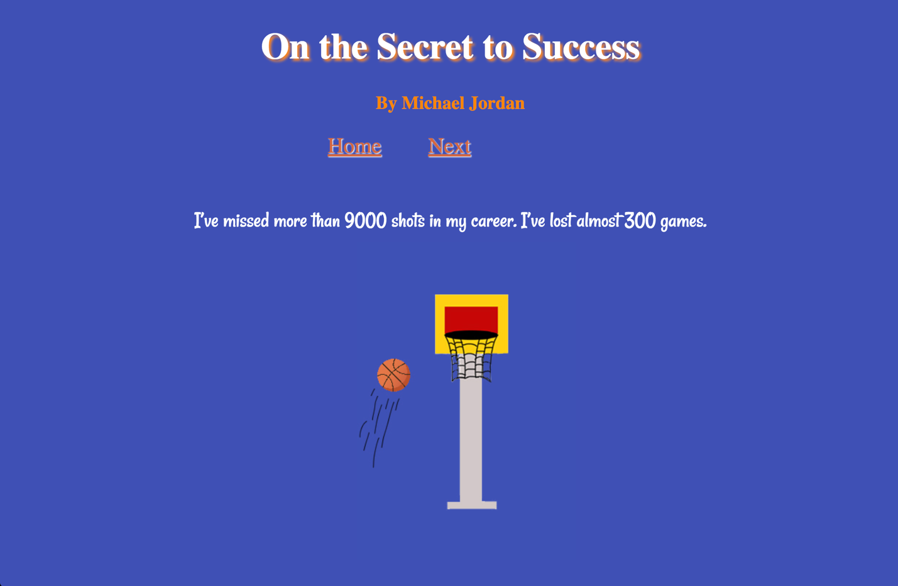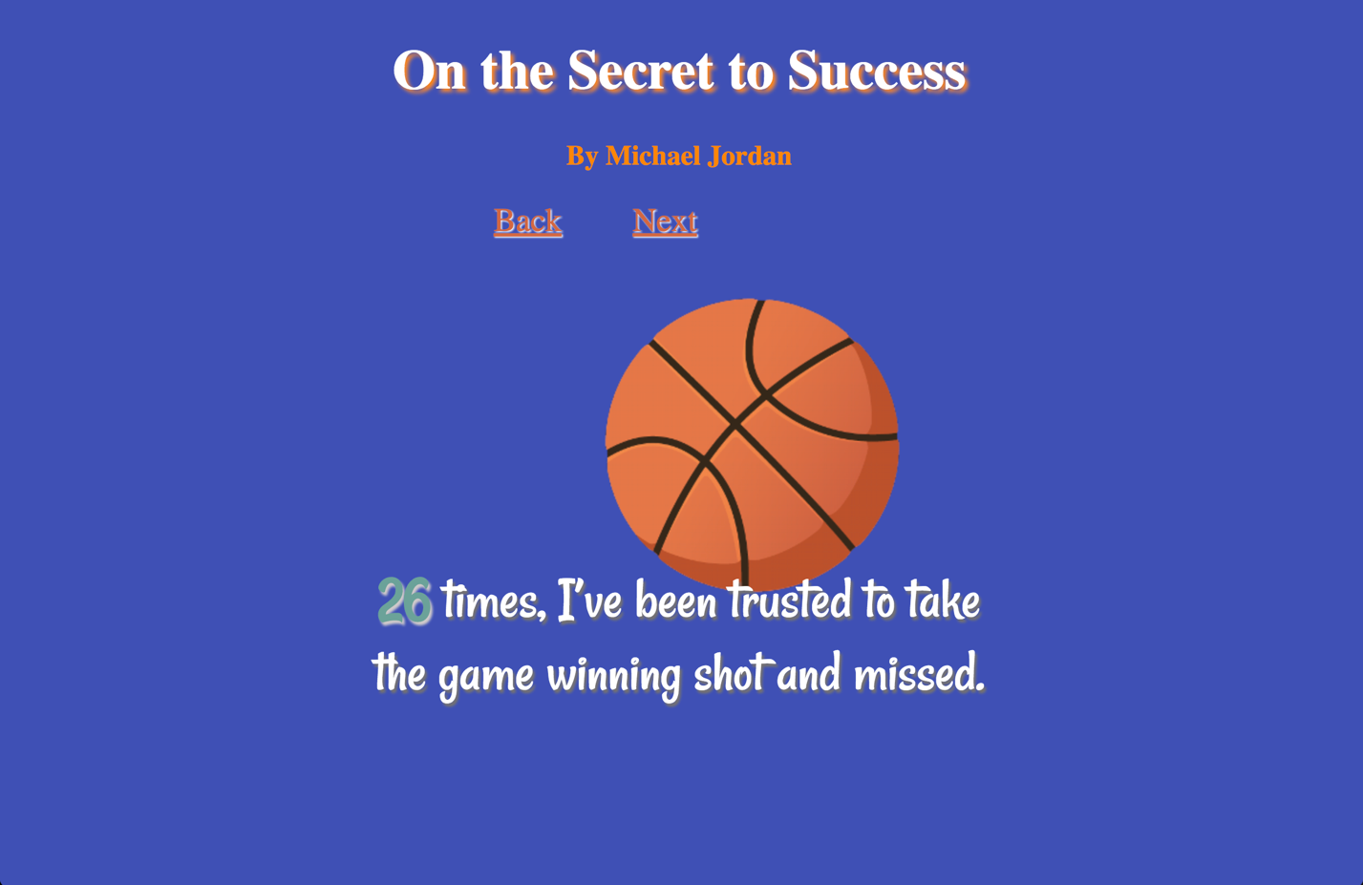

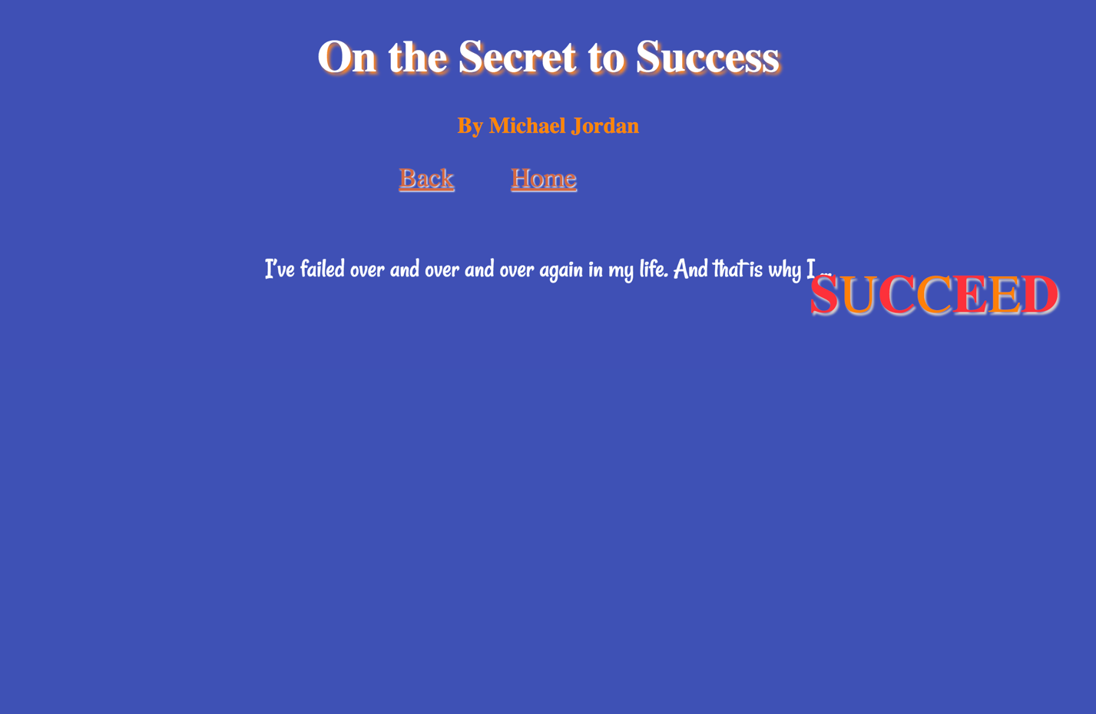

### Project Reflection:

(250 words – reflective writing –What was the most challenging part? What was the most exciting part now that the project is done? What did you learn in this assignment, what is your biggest takeaway?)

This assignment was really interesting to work on, not only because I was able to play with animation on our page but because I had to create most of my images on this page myself. To create this page, I came across with some obstacles such as what to make this website about. I decided to do this page about a quote from Michael Jordan because I like basketball even though I am not a huge fan of it. One more challenge I came across with, was when doing the css page of this assignment because I had to play with the positioning property and making sure I positioned the items where I wanted it and making sure the animations that I used were playing as I used them. I played with some animations and deiced to use those because I did some research on them and I learned I how to use them correctly. I decided to make the background color blue because since my quote is from a basketball player I choose blue because since we are in the Bay Area and the trending basketball team Is the Golden State Warriors so I decided to use their official colors which are blue, orange and white.

One thing I take away from this project is how to use animation without using javascript and only css. It is fun to play with this different animation and learned how to use a sprite sheet. It is really impressive how to make an image play as a GIF. I also learned how to integrate different king of animations into a webpage using divs and classes.