|  |  |
| --- | --- |
| **Assignment Case** | Description: LogoBINUS-University |
| DBH2S2 |
| **Periode Berlaku** Semester Genap 2020/2021  ***Valid on*** *Even Semester Year 2020/2021* | **Software Laboratory Center**  **Assistant Recruitment 21-2** |

## Materi

*Material*

* **Cursor**
* **Trigger**

## Soal

*Case*

**Cheviot Police Station**

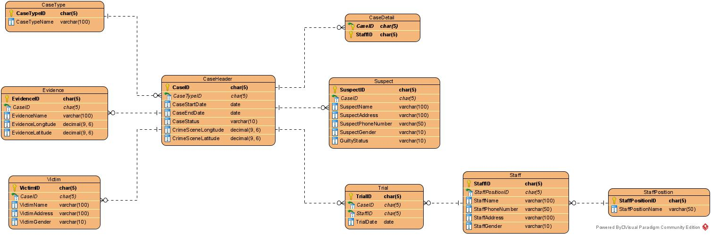

1. Create a cursor named **‘cursor_suspect_view’** that will print **all the suspect’s name** and **guilty status** of the suspect that has **‘Guilty’** as their **guilty status**.

**(declare cursor)**

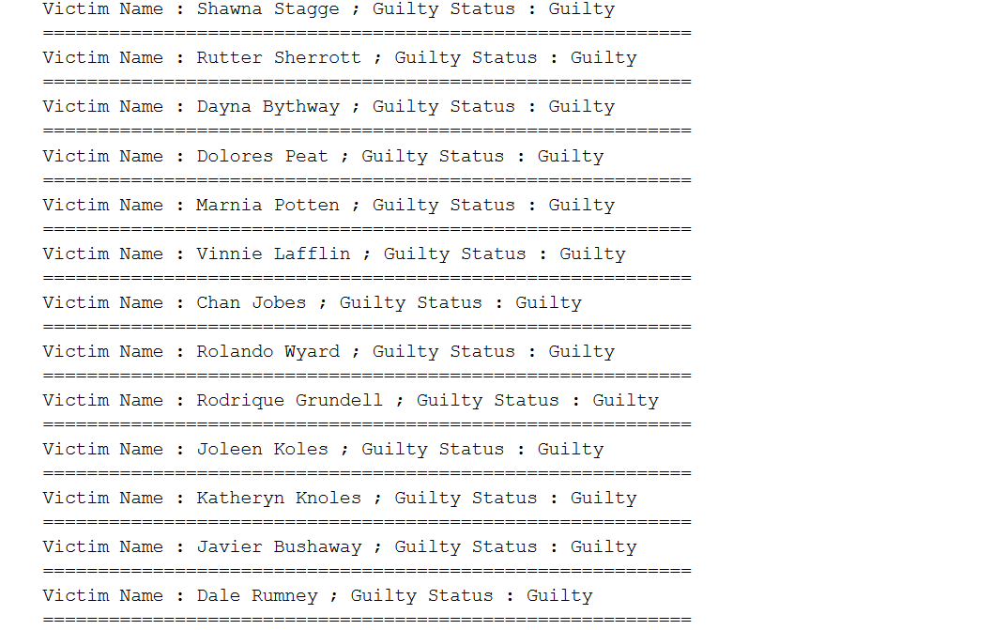

1. Create trigger named **‘trigger_deleted_evidence’** on **Victim** **table** that will show the **EvidenceID** and **EvidenceName** of the **deleted evidence**.

**(create trigger)**

BEGIN TRAN

DELETE FROM Evidence

WHERE EvidenceID = 'EV027'

ROLLBACK

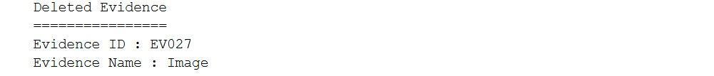

1. Create trigger named **‘trigger_new_trial’** on **Trial** **table** that will show the **TrialID** and the **TrialProcessDate** (obtained by **adding 7 days after the TrialDate**) for **every new inserted trial.**

**(create trigger, dateadd)**

BEGIN TRAN

INSERT INTO Trial

VALUES ('TR101', 'CA020', 'ST027', GETDATE())

ROLLBACK

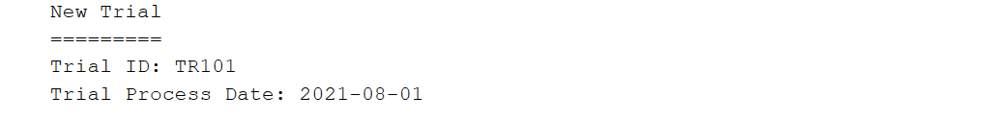

1. Create a cursor named **‘cursor_case_view’** that will print **all** data in **CaseHeader** **table**.

**(declare cursor)**

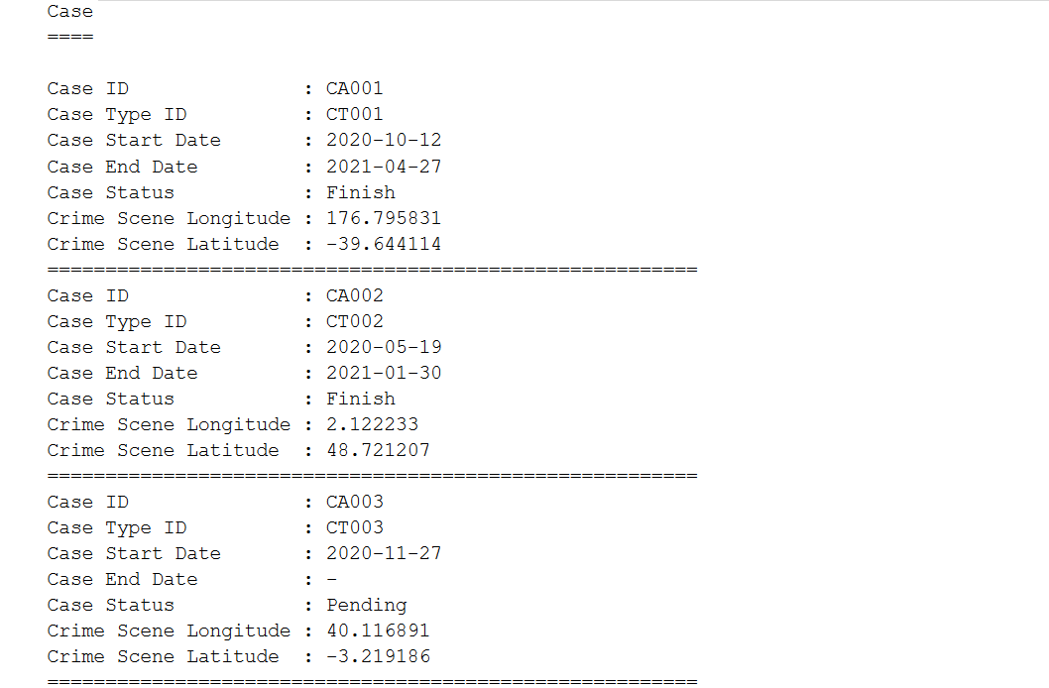

1. Create a cursor named **‘cursor_victim_suspect_count’** that will print **CaseID**, **VictimCount** (obtained from **how many victims in each case**) and **SuspectCount** (obtained from **how** **many suspects in each case**).

**(declare cursor, count, cast)**

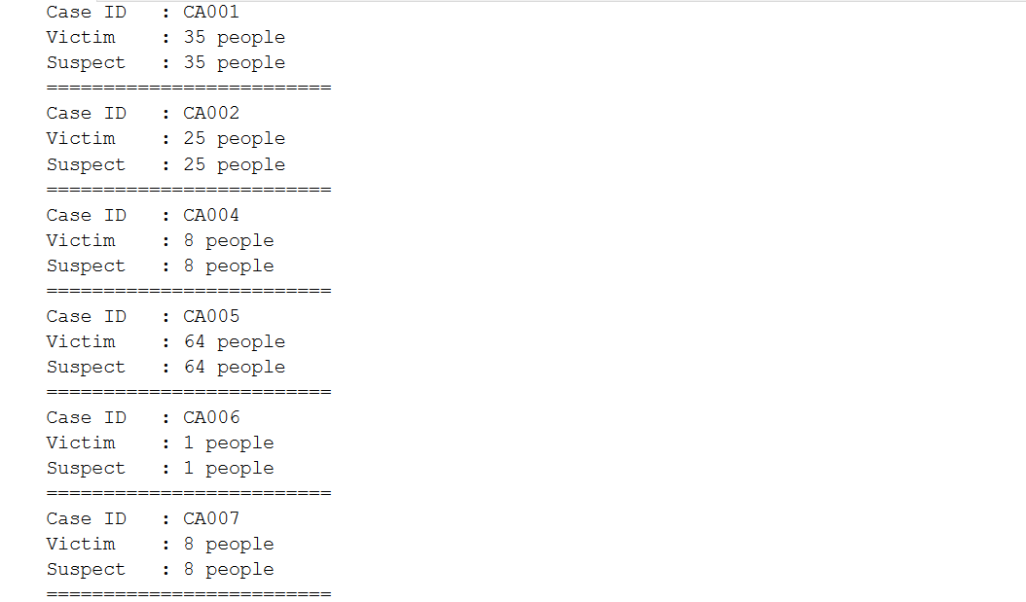

1. Create a cursor named **‘cursor_case_type’** that will print **all** data in **CaseType** **table**.

**(declare cursor)**

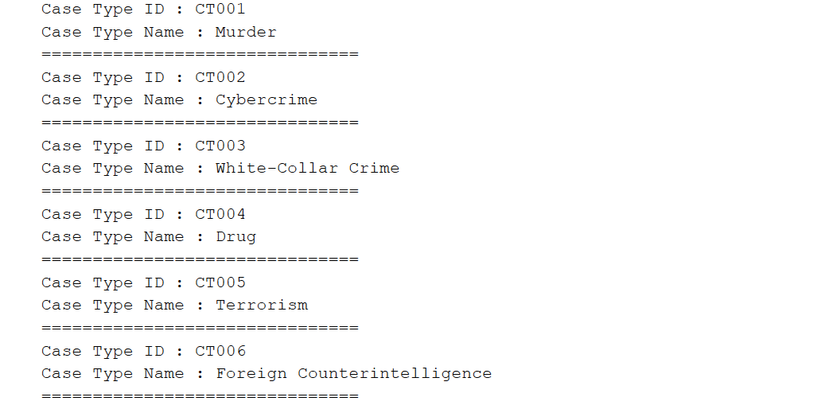

1. Create trigger named **‘trigger_delete_victim’** that will print **success** **message** when a **data from Victim table deleted.**

**(create trigger)**

BEGIN TRAN

DELETE FROM Victim

WHERE VictimID = 'VI070'

ROLLBACK



1. Create trigger named **‘trigger_drop_table’** that will **prevent** the **user** from **dropping** **table** in **the** **database.**

**(create trigger)**

BEGIN TRAN

DROP TABLE Trial

ROLLBACK



1. Create trigger named **‘trigger_new_position’** and a cursor named **‘cursor_new_position’** that will print **all** data from **StaffPosition** **table** and **the new data** when **the user insert new position.**

**(create trigger)**

BEGIN TRAN

INSERT INTO StaffPosition VALUES ('SP008', 'Undercover Agent')

ROLLBACK

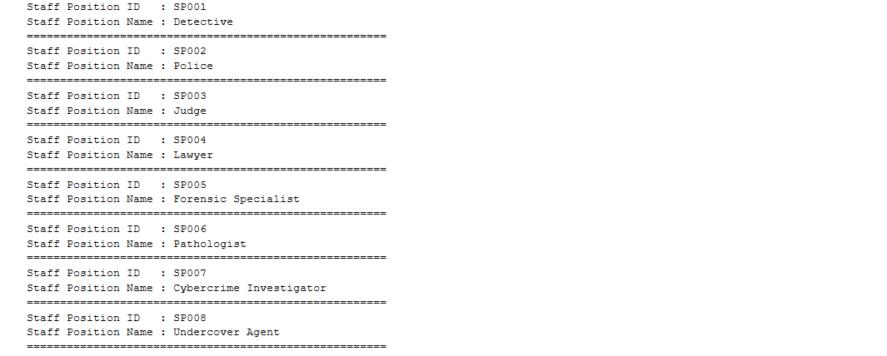

1. Create trigger named **‘trigger_new_staff’** and a cursor named **‘cursor_new_staff’** that will print **all** **new** **data that the user insert.**

**(create trigger)**

BEGIN TRAN

INSERT INTO Staff

VALUES

('ST036', 'SP002', 'Orelle Mawd', '849-619-4129', '56891 Delaware Street', 'Male'),

('ST037', 'SP002', 'Elana Yurmanovev', '772-163-6077', '22 Independence Court', 'Male')

ROLLBACK

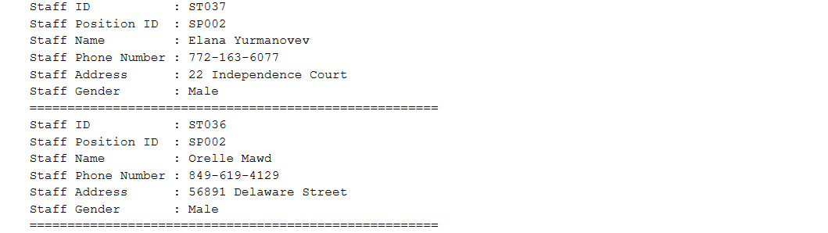

1. Create trigger named **‘trigger_prevent_future_case’** that **can** **prevent** the user from **inserting new case** that **has** **start** **date** **more** **than** **the current date**.

**(create trigger)**

BEGIN TRAN

INSERT INTO CaseHeader VALUES('CA021', 'CT003', DATEADD(DAY, 1, GETDATE()), NULL, 'On Going', 51.678158, 15.4217858)

ROLLBACK



Figure 1. When the user insert case more that current date

BEGIN TRAN

INSERT INTO CaseHeader VALUES('CA021', 'CT003', GETDATE(), NULL, 'On Going', 51.678158, 15.4217858)

ROLLBACK



Figure 2. When the user insert case less or equal with the current date

1. Create a cursor named **‘cursor_role’** that will print **SuspectName**, **VictimName** and **StaffName** and **their** **role** (obtained from **each person role**).

**(create trigger, union)**

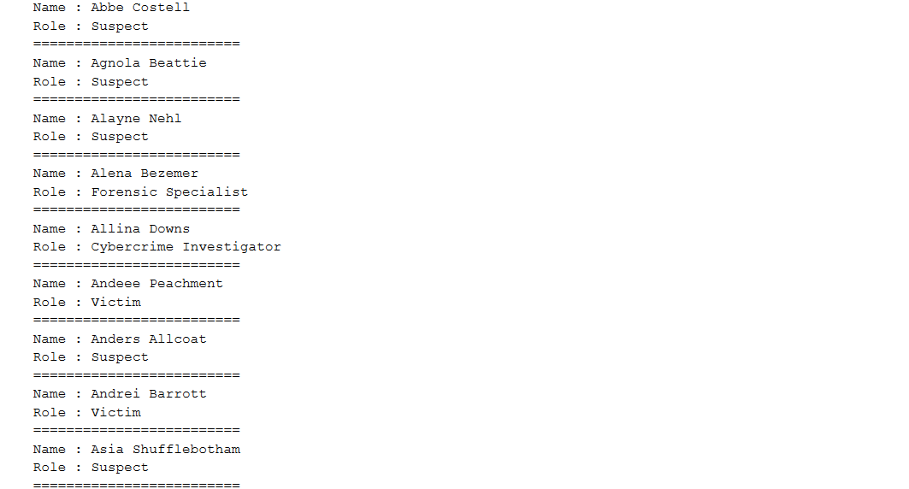

1. Create cursor named **‘cursor_staff_view’** that will print **StaffName** and **StaffPhoneNumber** by **skipping** **one** **data** each **time you print one**.

**(declare cursor)**

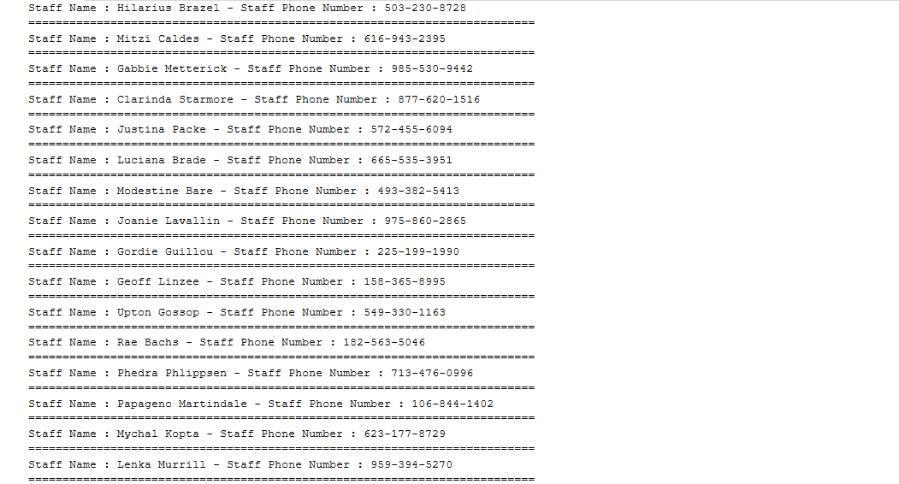

1. Create a cursor named **‘cursor_staff_position’** that will print **all** data in **Staff** **table** **backwards**.

**(declare cursor)**

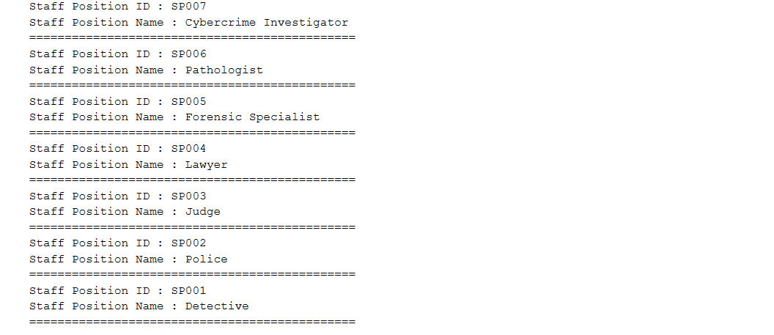

1. Create **case** **report** using **cursor** for case that has **‘CA001’** as it’s **CaseID**. The case report will contain of **CaseID**, **CaseStartDay** (obtained from **case** **start** **day**) and **Date** (obtained from **CaseStartDate** with **‘dd mon yyyy’** **format**), **CaseStatus**, **CaseType**, **PerpretorName** (obtained from **SuspectName** that has **‘Guilty’ as GuiltyStatus**), **DetectiveName** (obtained from **staff** that **handle** **that** **case** and the **role** is **‘Detective’**), **VictimName** and **VictimGender**.

**(declare cursor)**

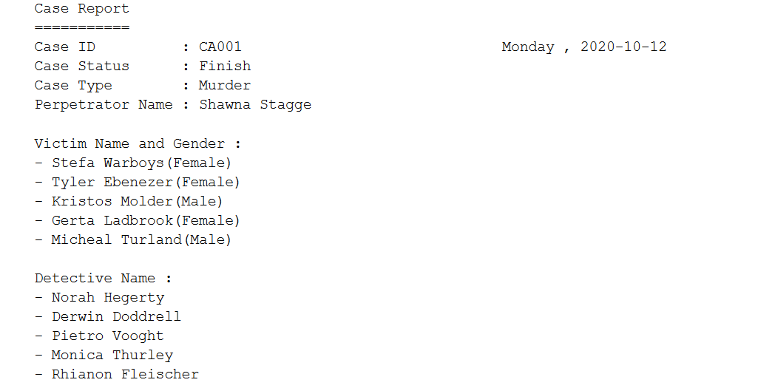

1. Create a cursor named **‘cursor_crime_evidence_distance’** to display **CaseID** and **all** the **EvidenceName** and **EvidenceLocation** (obtained from the **distance** from **crime** **scene** **location** and **evidence** **location** in **kilometer**) for case that has **‘CA007’** as the **CaseID**.

**(declare cursor, join, geography, cast)**

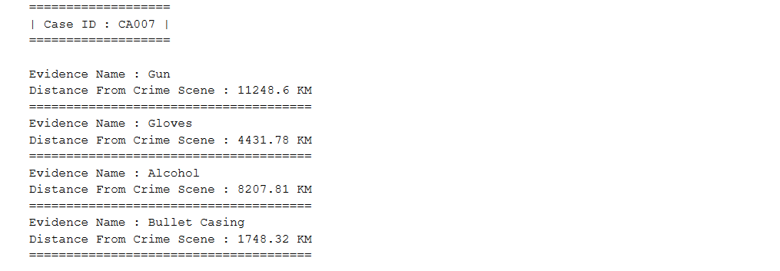

1. Create a cursor named **‘cursor_case_handled’** that will print **StaffID**, **StaffName**, and **CaseHandled** (obtained from **how many cases** that **each** **staff** **handled**) where the **case handled** **less** **than** **average**.

**(declare cursor, count, avg, cast, alias subquery)**

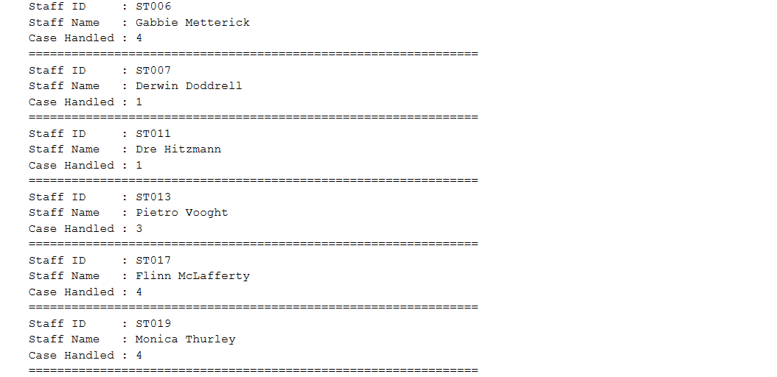

1. Create a cursor named **‘cursor_first_case’** that will print **CaseTypeName** and **CaseStartDate** of the **first** **case** that **happened** for **each** **type** **of** **case**.

**(declare cursor, join, cast, in, alias subquery)**

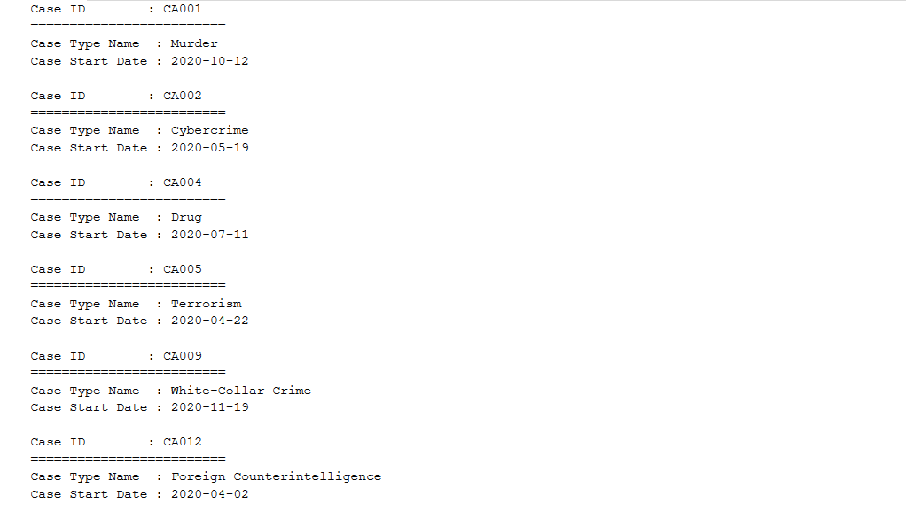

1. Create trigger named **‘cheviot_security_trigger’** that will print **system** **user** (obtained from the **system** that **used** to **perform the update or delete**), **current** **user** (obtained from **user** **login** that **used** to **perform the update or delete**). If the **user** **perform** **update** than print the **old** **data** of the **evidence** that the **user** **update** (**EvidenceID**, **CaseID**, **EvidenceName**, **EvidenceLongitude**, **EvidenceLatitude**) and the **new** **data** (**EvidenceID**, **CaseID**, **EvidenceName**, **EvidenceLongitude**, **EvidenceLatitude**). If the **user** **performs** **delete** than print the **Evidence** **data** that the user **tries** to **delete** (**EvidenceID**, **CaseID**, **EvidenceName**, **EvidenceLongitude**, **EvidenceLatitude**).

**(create trigger, exists)**

BEGIN TRAN

UPDATE Evidence

SET EvidenceName = 'Evidence'

WHERE EvidenceID = 'EV050'

ROLLBACK

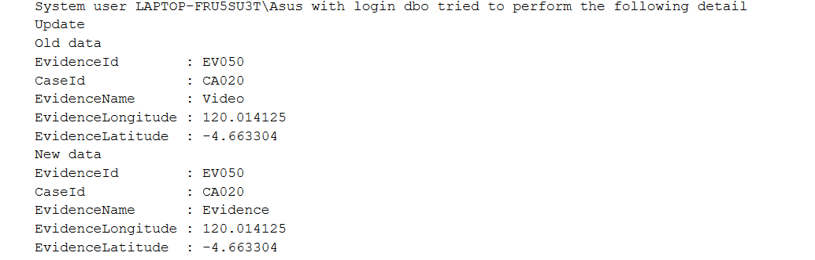

Figure 3. When User Perform Update

BEGIN TRAN

DELETE Evidence

ROLLBACK

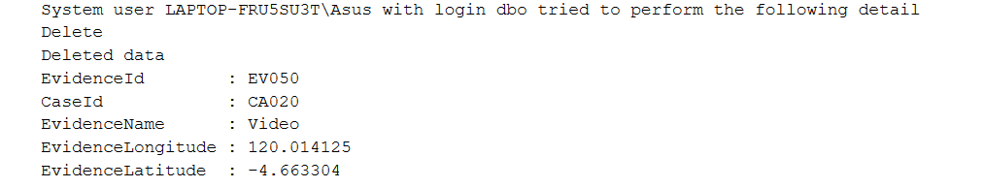

Figure 4. When User Perform Delete

1. Drop all triggers you have made.

**(drop trigger)**

**Notes:**

You don’t have to print the data in pretty format!

## Komponen

*Component*

|  |  |  |
| --- | --- | --- |
| **No.** | **Criteria** | **Persentage** |
| **1** | **Query** | **5% per case** |