Performing Quality Control and analysis in GWAS Studies
Sarah Gagliano and Jo Knight

Adapted from:
Anderson, C.A., et al. (2010) Data quality control in genetic case-control association studies. Nat Protoc. 5:1564-1573. doi:10.1038/nprot.2010.116
Clarke, G.M., et al. (2011) Basic statistical analysis in genetic case-control studies. Nat Protoc. 6: 121-133. doi:10.1038/nprot.2010.182.
Weale, Michael. (2011, Sept. 23) Notes on GWAS QC/QA. from https://sites.google.com/site/mikeweale/software/gwascode

Resources:
1. PLINK (http://pngu.mgh.harvard.edu/~purcell/plink/)
2. R (http://cran.r-project.org/)
3. Unix-based command terminal
4. A text editor

Files:
1. Raw_DATA.ped, Raw_DATA.map (adapted from Anderson et al.)
3. HapMapMini.bed, HapMapMini.bim, HapMapMini.fam. (Adapted HapMap data)
4. prune.prune.in, CEPHMINI.fam, YRIMINI.fam, JPTMINI.fam, IBS_HM_DATA.genome, res.assoc (extras so you can skip steps)
5. manhattan_v1.R, qq_plot_v5.R (Michael Weale’s R codes)

INSTRUCTIONS:
Execute the commands without # in front of them. Commands with # take too long. You can copy and paste but you also need to understand what you are doing! Awk commands need to be executed in the command window and R scripts need to be run in R!

Box 1. Plink format for PED/MAP files
PED format: first six columns: FID(family ID), IID(individual ID), Paternal ID, Maternal ID, Sex(1=male, 2=female, 0=missing) and Phenotype(1=unaffected, 2=affected, 0=missing); and the subsequent columns denote genotypes for the SNPs (a column per SNP, where a missing genotype is represented by 0); there are NO headers
MAP format: one row per marker with four columns: chromosome number, marker name, genetic distance in Morgans, and base-pair position; there are no headers; MAP file has the SNPs in the same order as the PED file and has the same name as the PED file but with the .map instead of .ped ending

I. Check for markers with no data
./plink --file Raw_DATA --noweb --out noGeno
#Markers missing all data are listed in the file called noGeno.nof

II. Create binary files (time efficient) including samples/people without completely missing data
./plink --file Raw_DATA --noweb --exclude noGeno.nof --mind 0.999 --make-bed --out DATA
#which creates DATA.bed (genotypes), DATA.fam (ped file without genotypes) and DATA.bim (map file).

QUALITY CONTROL FOR INDIVIDUALS
III. Identify and list individuals with discordant sex information
#requires X chromosome information
./plink --bfile DATA --noweb --check-sex --out sex
#which produces the file DATA.sexcheck with the following columns:
#FID IID PEDSEX SNPSEX STATUS F
#where “STATUS” is either “OK” or “PROBLEM”

#using awk create a file for exclusion of problem people:

awk '($5=="PROBLEM") {print}' sex.sexcheck > fail-sexcheck-qc.txt

Box 2. Flags for isolating subsets of individuals or markers from Plink-formatted files
Removal of individuals:
--remove {file containing two columns FID and IID}
Keep individuals
--keep {file containing two columns FID and IID}
Removal of markers:
--exclude {file containing one column: a list of SNPs}
Keep markers
--extract {file containing one column: a list of SNPs}
Specifying the name of an output file (after a subset has been chosen)
--out {name}

IV. Identify individuals with excessive missing data rates and determine threshold (Figure 1)
./plink --bfile DATA --noweb --missing --out imiss
#DATA.imiss (individual) and DATA.lmiss (locus).
#FID IID MISS_PHENO N_MISS N_GENO F_MISS
#where N_MISS is the number and F_MISS is the proportion of missing SNPs per individual

#plot in R
IMISS<-read.table("imiss.imiss", header=T, as.is=T)
pdf("individualcallrate.pdf")
plot( (1:dim(IMISS)[1])/(dim(IMISS)[1]-1), sort(1-IMISS$F_MISS), main="Individual call rate cumulative distribution", xlab="Quantile", ylab="Call Rate" ); grid()
dev.off()
#example: remove inds with missing rate > 0.05 --mind 0.05

V. Identify individuals with outlying heterozygosity rates and determine threshold (Figure 2)
./plink --bfile DATA --noweb --het --out het
#which produces the file het.het with the following columns
#FID IID O(HOM) E(HOM) N(NM) F
#O(HOM) = observed # homozygous genos; N(NM) = nonmissing genos per individual

#plot in R
#(N(NM) – O(HOM)]/N(NM)=mean heterozygosity rate per individual)
het<-read.table("het.het", h=T)
het$meanHet <- (het$N.NM. - het$O.HOM.)/het$N.NM.
pdf("het-histogram.pdf")
hist(het$meanHet, col="green", ylab="Heterozygosity Rate", xlab="Heterozygosity", main= "Distribution of heterozygosity per individual")
linea<- mean(het$meanHet) + 2*sd(het$meanHet)
lineb<- mean(het$meanHet) - 2*sd(het$meanHet)
abline(v=linea, col="red") #red lines on the graph represent +/- 2 standard deviations from the mean
abline(v=lineb, col="red")
linea<- mean(het$meanHet) + 3*sd(het$meanHet)
lineb<- mean(het$meanHet) - 3*sd(het$meanHet)
abline(v=linea, col="blue") #blue lines on the graph represent +/-3 standard deviations from the mean
abline(v=lineb, col="blue")
dev.off()
# Still in R. Make list, example: exclude +/-3sd from the mean
errora<- subset(het, het$meanHet > mean(het$meanHet) + 3*sd(het$meanHet))
errorb<- subset(het, het$meanHet < mean(het$meanHet) - 3*sd(het$meanHet))
errorall<-rbind(errora[1:2], errorb[1:2])
write.table(errorall, "fail-het-qc.txt", col.names=FALSE, row.names=FALSE, quote=FALSE)

VI. Identify duplicated or highly related individuals (ie. IBD>0.185) (Figure 3)
# Exclude SNPs in high LD. (See Box 3 for details on the --indep-pairwise command in PLINK.)
#./plink --bfile DATA --noweb --exclude high-LD-regions.txt --indep-pairwise 1500 150 0.2 --out prune
#Produces two files prune.prune.in and prune.prune.out.
Box 3. Details on independent-pairwise pruning out of SNPs in high linkage disequilibrium.
--indep-pairwise N M r^2 is the command in PLINK
where N is the kb SNP window; M is the number of SNPs to shift the window at each step; r^2 signifies the r^2 cut-off
One member in all pairs of SNPs with a r^2 greater than the specified threshold are written to DATA.prune.out
Note that more SNPs will be in the prune.out file: the larger the window size, and/or the smaller the r^2 (ie. closer to zero)

#Generate pairwise IBS for all individuals
./plink --bfile DATA --noweb --extract prune.prune.in --genome --out IBS
#FID1 IID1 FID2 IID2 RT EZ Z0 Z1 Z2 PI_HAT PHE DST PPC RATIO
#PI_HAT= proportion (IBD) per pair of individuals (P(IBD=2)+0.5*P(IBD=1))
#Typically, one individual in a pair that achieved an IBD of over 0.1875 (ie. halfway between 1 = #duplicates /monozygotic twins, and 0.5= first degree relatives) is removed

# plot in R
IBS<-read.table("IBS.genome", h=T)
pdf("IBSplot.pdf")
hist(IBS$PI_HAT, col="green", breaks=100, xlab= "Estimated mean pairwise IBD", main="Pairwise Identity-by-descent")
abline(v=c(0.185)) #related individuals are assumed to have a pairwise IBD of over 0.185
dev.off()
# Still in R. Make list
out<- subset(IBS, IBS$PI_HAT>0.185) #pick first individual in pair
#NB// Explore list. Sometimes one person appears to be related to lots of people. If you remove them you remove the problem.
write.table(out[ , 1:2], "fail-IBD.txt", col.names=F, row.names=F, quote=F)

VII. Identify individuals of divergent ancestry (Figure 4)
#Prepare HapMap reference data
#Download hapmap3_r2_b36_fwd.qc.poly.tar.bz2 from
ftp://ftp.ncbi.nlm.nih.gov/hapmap/genotypes/2009-01_phaseIII/plink_format/

#Merge Populations
#create a MergeList.txt, this lists the other HapMap pops you will use.
#./plink --file hapmap3_r2_b36_fwd.CEU.qc.poly --noweb --merge-list MergeList.txt --extract prune.prune.in --filter-founders --make-bed --out HapMapMini

#Extract independent SNPs from main data
./plink --bfile DATA --noweb --extract prune.prune.in --make-bed --out DATA-pruned

#Merge study sample with HapMap (use --geno flag to remove SNPs with high missing rates in HapMap population(s))
./plink --bfile DATA-pruned --noweb --bmerge HapMapMini.bed HapMapMini.bim HapMapMini.fam --geno 0.03 --make-bed --out 4Flips
# Get a list of unaligned SNPs (ERROR: Stopping due to mis-matching SNPs --check +/- strand?)

# Get a list of symmetrical SNPs
#awk '($5=="G"&&$6=="C"){print $2}' DATA-pruned.bim > syms.txt
#awk '($5=="C"&&$6=="G"){print $2}' DATA-pruned.bim >> syms.txt
#awk '($5=="A"&&$6=="T"){print $2}' DATA-pruned.bim >> syms.txt
#awk '($5=="T"&&$6=="A"){print $2}' DATA-pruned.bim >> syms.txt

# Remove unaligned flip
#and would also remove unaligned symmetrical SNPs in previous step using --exclude syms.txt
./plink --bfile DATA-pruned --noweb --flip 4Flips.missnp --make-bed --out DATA_Align

# Merge (use --geno flag to remove SNPs with high missing rates in HapMap population(s))
./plink --bfile DATA_Align --noweb --bmerge HapMapMini.bed HapMapMini.bim HapMapMini.fam --geno 0.03 --make-bed --out HM_DATA

./plink --bfile DATA-pruned --noweb --bmerge HapMapMini.bed HapMapMini.bim HapMapMini.fam --geno 0.03 --make-bed --out HM_DATA

#Generate pairwise IBS estimates
#./plink --bfile HM_DATA --noweb --genome --out IBS_HM_DATA

#Perform Multidimensional Scaling (MDS)
./plink --bfile HM_DATA --noweb --read-genome IBS_HM_DATA.genome --cluster --mds-plot 4 --out MDS

#Plot (Can also use R to make exclusion list if necessary)
data<-read.table("DATA.fam")
ceu<-read.table("CEPHMINI.fam")
jpt<-read.table("JPTMINI.fam")
yri<-read.table("YRIMINI.fam")
mds<-read.table("MDS.mds", h=T)
sample<-merge(data, mds, by.x=c("V1","V2"),by.y=c("FID","IID"))
pop1<-merge(ceu, mds, by.x=c("V1","V2"),by.y=c("FID","IID"))
pop2<-merge(jpt, mds, by.x=c("V1","V2"),by.y=c("FID","IID"))
pop3<-merge(yri, mds, by.x=c("V1","V2"),by.y=c("FID","IID"))
pdf("PCA-plot.pdf")
plot(pop1[ ,8], pop1[ ,9], xlab= "Principal component 1", ylab="Principal component 2", col= "red", xlim=c(-0.10, 0.20), ylim=c(-0.20, 0.20))
par(new=T)
plot(pop2[ ,8], pop2[ ,9], main="Ancestry Clustering", xlab= "Principal component 1", ylab="Principal component 2", col= "purple", xlim=c(-0.10, 0.20), ylim=c(-0.20, 0.20))
par(new=T)
plot(pop3[ ,8], pop3[ ,9], xlab= "Principal component 1", ylab="Principal component 2", col= "green", xlim=c(-0.10, 0.20), ylim=c(-0.20, 0.20))
legend("bottomleft", title="Population", c("study sample", "CEU", "JPT", "YRI"), pch=c(21, 21, 21, 21), col=c("black", "red", "purple", "green"))
par(new=T)
plot(sample[ ,8], sample[ ,9], xlab= "Principal component 1", ylab="Principal component 2", xlim=c(-0.10, 0.20), ylim=c(-0.20, 0.20))
#as well as excluding individuals of divergent ancestry minor population #stratification can be accounted for by including principal components as #covariates in association tests.
write.table(sample[ , c(1, 2, 8)], "Ancestry.cov", row.names=F, col.names=F, quote=F)
dev.off()

Box 4. Graphing Tips for PCA Plotting of sample data with HapMap reference populations
HapMap Population descriptors:
YRI : Yoruba in Ibadan, Nigeria
JPT+CHB : Japanese in Tokyo, Japan + Han Chinese in Beijing, China
CEU : CEPH (Utah residents with ancestry from northern and western Europe
a) Plot all groups on the same graph using the par() function
b) Be sure to specify the same x and y limits for all the graphs
c) play around with the dimensions (ie. give both axes a large range to see the distribution of the data, and then make the range more precise); and also with the location of the legend

VIII. Make a master list of all the individuals in: fail-sexcheck-qc, fail-het-qc.txt & fail-IBD
cat fail-* | sort -k1 | uniq > fail_inds.txt
wc fail_inds.txt #check total number

QUALITY CONTROL FOR MARKERS

Box 5. Marker QC
--hwe 0.000001 - markers with HWE P values less than 0.000001 (select case/control)
--maf 0.01 - markers with a minor allele frequency less than 0.01
--geno 0.01 - markers with a call-rate threshold of less than 1% (see plot)

I. Identify markers with excessive missing data rate and determine threshold (Figure 5)
./plink --bfile DATA --noweb --remove fail_inds.txt --mind 0.02 --missing --out lmiss

#which produces the files clean-inds-qc-DATA.imiss and clean-inds-qc-DATA.lmiss, of which the CHR SNP N_MISS N_GENO F_MISS
#where N_MISS is the number of individuals missing this SNP, N_GENO is the number of non-#obligatory missing genotypes, and F_MISS is the proportion of the sample missing for this SNP

#plot
x<-read.table("lmiss.lmiss", header=T, as.is=T)
pdf("SNPcoverage.pdf")
plot( (1:dim(x)[1])/(dim(x)[1]-1), sort(1-x$F_MISS), main="SNP coverage cumulative distribution", xlab="Quantile", ylab="Coverage" ); grid()
dev.off()
#SNPs that fail his step will be removed using the --geno flag

II. Remove all markers and samples failing quality control
./plink --bfile DATA --noweb --remove fail_inds.txt --mind 0.05 --maf 0.01 --hwe 0.0000001 --geno 0.05 --make-bed --out clean-DATA

ANALYSIS

./plink --bfile clean-DATA --noweb --assoc --out res

I. QQ plot (Figure 6)
#In R
x<-read.table("res.assoc", h=T, as.is=T) #or use clean-DATA.assoc.linear
source('qq_plot_v5.R')
pdf("qqPlot_clean-DATA.assoc.pdf")
qq.plot(x[ ,9], xlab= "Expected P value", ylab= "Observed P value", main="qqPlot for SNPs in clean-DATA")
dev.off()

II. Manhattan Plot (Figure 7)
#In R
data<-read.table("res.assoc", h=T, as.is=T)
source('manhattan_v1.R')
pdf("Manhattan_res.assoc.pdf")
X<-data.frame(CHR=data$CHR, BP=data$BP, P=data$P)
manhattan( X, GWthresh=5e-8, GreyZoneThresh=1e-5, DrawGWline=TRUE )
dev.off()

III. Locus Zoom (Figure 8)
Go to website: http://csg.sph.umich.edu/locuszoom/.
Go to “Plot your data”.
Upload the your file and plot data.(Choose File (res.assoc), specify column names (P, SNP), click “Set for PLINK data”, specify a SNP, and “plot data”)

For example, specify rs11185543
Appendix A
QUALITY CONTROL FOR INDIVIDUALS- Visualization

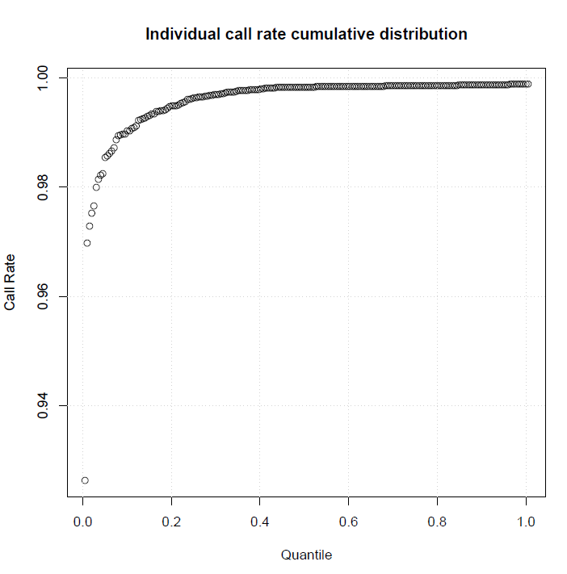
Figure 1. Identify and eliminate individuals with elevated missing data rates.
Individual call rate distribution. The exclusion cut-off is decided by looking at the elbow region in the graph. In this example, individuals with a call rate of less than 98% (which corresponds to an over 3% missing data rate) were excluded from further analysis.

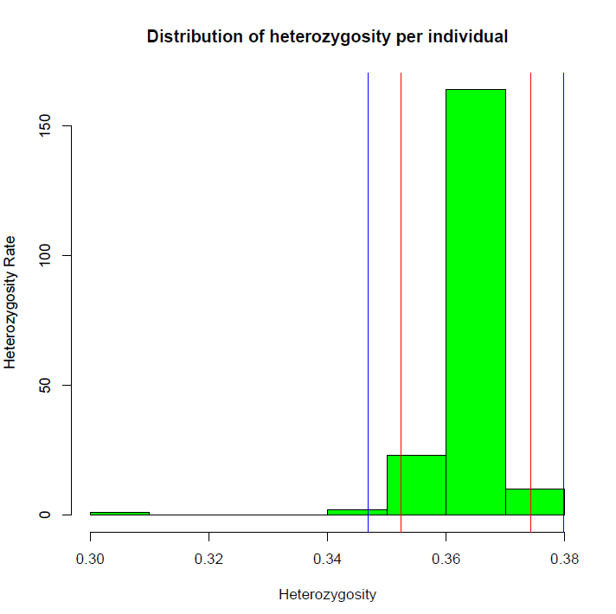
Figure 2. Identify and eliminate individuals with outlying mean heterozygosity rates.
Plot of mean heterozygosity values for individuals in a sample. The red lines represent +/- 2 standard deviations from the mean values. The blue lines represent +/-3 standard deviations from the mean. Individuals with a mean heterozygosity of over +/-3 standard deviations from the mean were excluded.

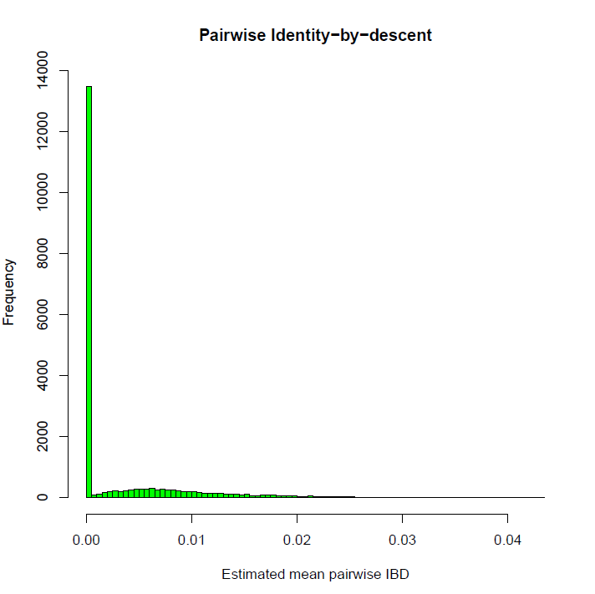

Figure 3. Identify and eliminate duplicated or highly related individuals. (Although not applicable in the above example), one member in each pair with an IBD>0.185 is removed.

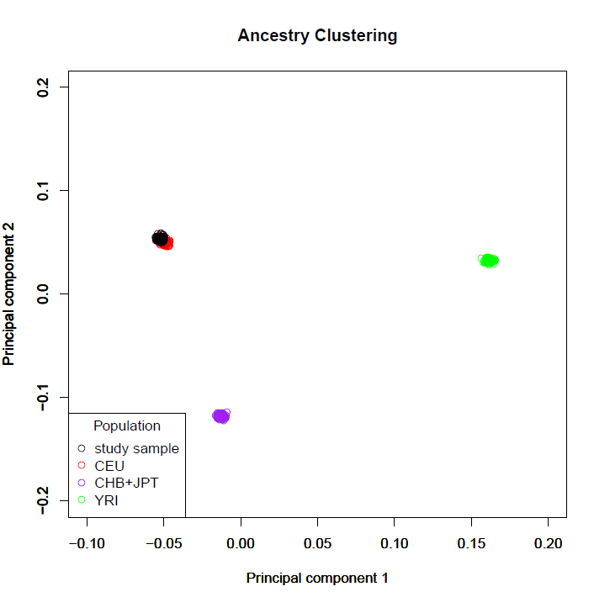

Figure 4. Identify ancestry.
An ancestry plot for a sample of individuals merged with populations from HapMapIII. Note that most of the individuals in the sample (represented by the black circles) are Caucasian (because they have principal components that aggregate with HapMapIII CEU red circles).
This plot can be used to isolate only individuals of a certain ancestry in order to avoid false positives due to population stratification.

QUALITY CONTROL FOR MARKERS- Visualization

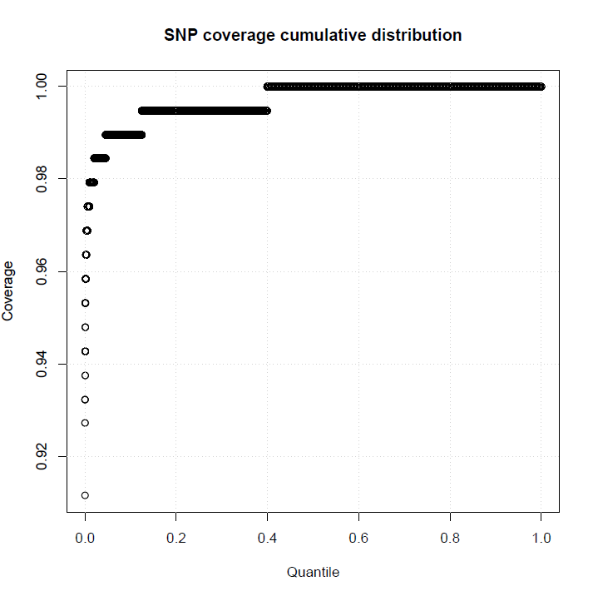

Figure 5. Identify and eliminate of markers with an excessive missing data rate.
Distribution of missing genotypes in the markers. In this example, markers with less than a 99% call rate (a value corresponding to the location of the elbow in the plot) were eliminated from the analysis.

ANALYSIS-Visualization
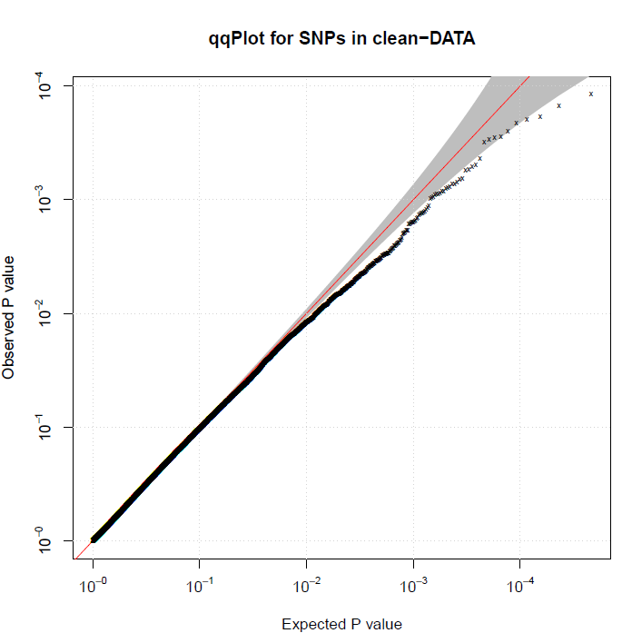

Figure 6. Quantile-quantile plot.
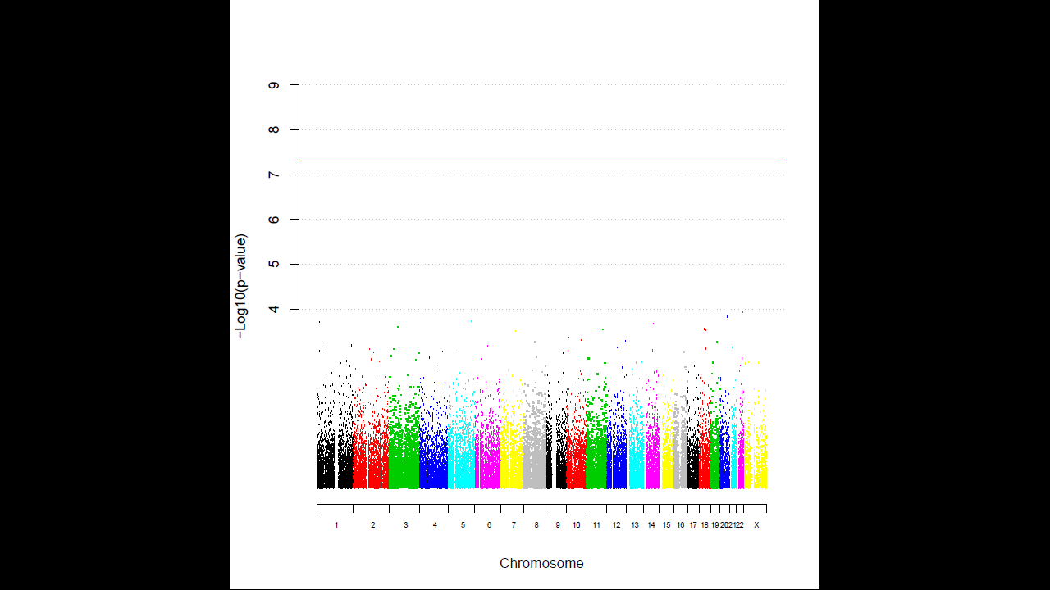
Figure 7. Manhattan plot.

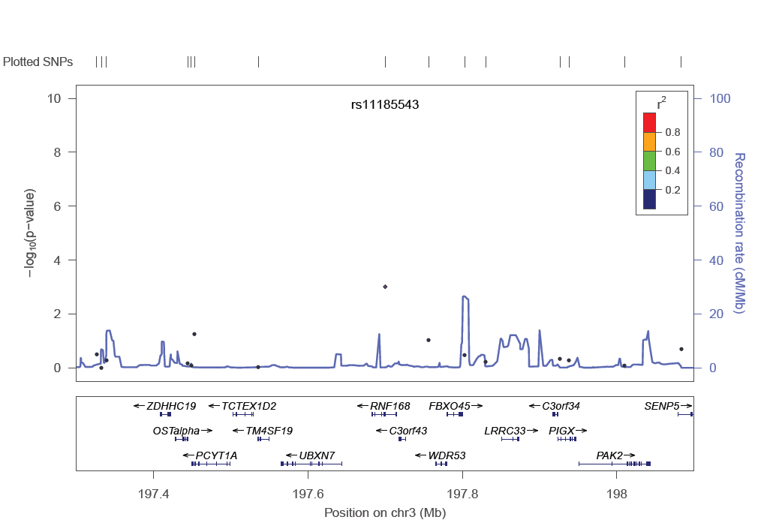
Figure 8. Regional plot for SNP rs11185543.

Appendix B. Basic Unix Commands used in the Quality Control Protocol
cat filename1 filename2 . . . . . . . . . . . concatenate filename1 filename2 together
join filename1 filename2 > newfile . . . creates a new file called newfile which only contains the lines that are in common between filename1 and filename2
sort filename . . . . . . . . . . . . . . . . . . . . sorts (e.g. numerically) lines of the file
uniq filename . . . . . . . . . . . . . . . . . . . . makes a unique list of variables in the file
wc filename . . . . . . . . . . . . . . . . . . . . . line/word/character count of the file

