

Wbem WMI Mapper

Abstract:

This document describes the XML/Cim to WMI Mapper to be developed from the Pegasus open source.

Note : This document is a work in progress.

Table of contents
Document history

DateAuthorReason13-Jan-02Barbara PackardDocument Creation18-Jan-02Barbara PackardUpdate22-Jan-02Barbara PackardUpdate after feedback30-Apr-02Barbara PackardUpdate28-Aug-02Barbara PackardUpdate
1 Overview 2
2 Pegasus Project 2
2.1 Pegasus Components 2
3 WMI Mapper Structure 2
3.1 Mapper execution 2
3.1.1 Security and authentication 2
3.1.2 Configuration 2
3.1.3 Caveats 2
4 Events 2
5 Supported Methods 2
5.1 General Discussion 2
5.2 GetClass 2
5.2.1 Format 2
5.2.2 Errors 2
5.2.3 Example 2
5.3 GetInstance 2
5.3.1 Format 2
5.3.2 Errors 2
5.3.3 Example 2
5.4 EnumerateClasses 2
5.4.1 Format 2
5.4.2 Errors 2
5.4.3 Example 2
5.5 EnumerateClassNames 2
5.5.1 Format 2
5.5.2 Errors 2
5.5.3 Example 2
5.6 EnumerateInstances 2
5.6.1 Format 2
5.6.2 Errors 2
5.6.3 Example 2
5.7 EnumerateInstanceNames 2
5.7.1 Format 2
5.7.2 Errors 2
5.7.3 Example 2
5.8 ExecQuery 2
5.8.1 Format 2
5.8.2 Errors 2
5.8.3 Example 2
5.9 GetProperty 2
5.9.1 Format 2
5.9.2 Errors 2
5.9.3 Example 2
6 References 2

Overview
The Nimbus project will require the access of WMI data from Windows platform systems. The preferred method is XML/CIM over http, a protocol not currently supported by Microsoft. The function of the XML/ CIM to WMI Mapper will be:
- Convert incoming XML/Cim requests to Microsoft WMI requests
- Execute the request
- Convert the results to XML/Cim
- Return the results to the client
The open source code from the Pegasus group will form the code base for this mapper.

Pegasus Project
The Pegasus project was started in 2000 to provide an open-source implementation of the DMTF CIM and WBEM standards. Several major companies are heavily involved in this effort. HP has decided to implement a WBEM interface for its HP-UX platform and to use the Pegasus code as a base. This decision has led to major HP involvement in the Pegasus project. The code design is extremely modular with the objective of producing a package of production quality.
The goal of the Pegasus project is a production quality implementation of the WBEM standards as defined by DMTF CIM and CIM-XML. A major objective is commonality of interfaces among platforms. It was felt that this would not be attainable without a valid implementation.
The objectives are:
- Open source. The code and documentation will be freely available to all.
- Standards based. The implementation will be based on the DMTF CIM and CIM-XML standards. Along this line, some attempts will be made to influence those standards.
- Production quality. The code will be efficient, lightweight, readily portable, and of production quality. It will also be modular and extensible.
- Multi-platform.

Pegasus Components
Pegasus is a complete CIMOM. In the latest proposed module design the main functional components are:
- Server – The server accepts incoming XML/CIM requests via HTTP or a local API. The requests are translated into message objects and sent to the dispatcher. It receives replies from the dispatcher and responds to the client.
- Dispatcher – The dispatcher receives messages and determines the destination component. It performs any necessary translating and sends the result to that component.
- Repository – The repository responds directly to the requesting component. It provides static, persistent class and instance objects.
- Provider Manager – The provider manager receives messages, translates them, and invokes the corresponding method of the appropriate provider. The provider’s response is then translated into a message and sent to the dispatcher.
- Subscription Processor – The subscription processor receives messages for indication subscription instances. It updates the repository with the appropriate information, translates the subscription into ‘enable indication’ messages.
- Indication Processor – The indication processor receives messages from the repository or provider manager when an indication has been created. It then sends the message back to the dispatcher (loop back) or forwards to zero or more indication handlers.

Figure 1 and Figure 2 show the control flow for XML/CIM requests to the Pegasus CIMOM.

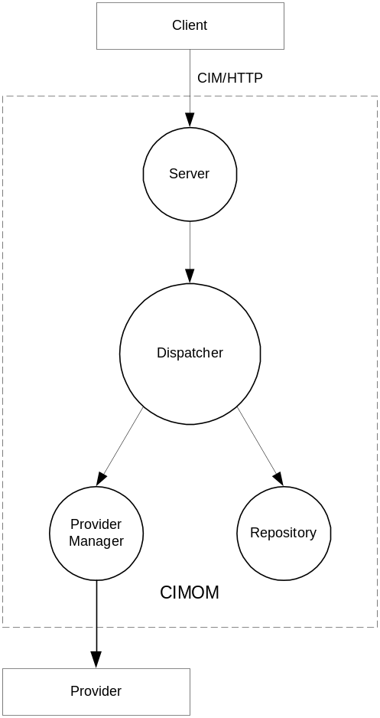

Figure 1. Get/Set Request

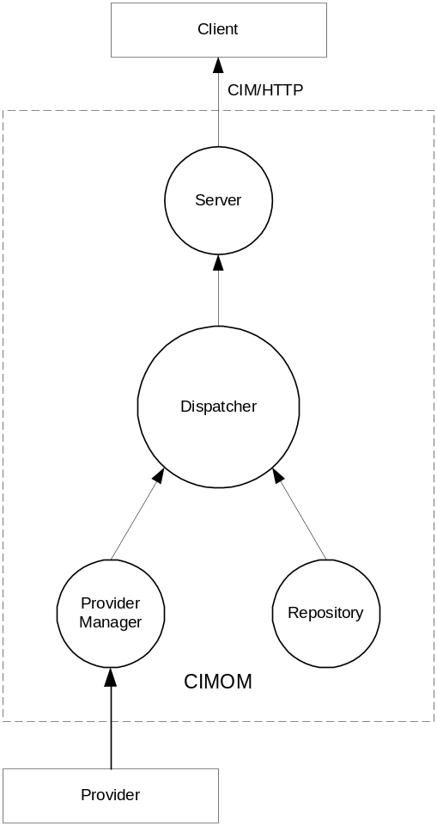
Figure 2. Get/Set Response

WMI Mapper Structure
The WMI Mapper will execute as an NT service. It will utilize the server, dispatcher, and provider manager modules from Pegasus. The repository module will be removed and the provider manager extended in order to access WMI directly for static class and instance data. It will accept requests in XML/CIM format. (See references 1 and 2.) The provider makes the actual WMI API calls.
Figure 3 and Figure 4 show the proposed module construction for the WMI Mapper.

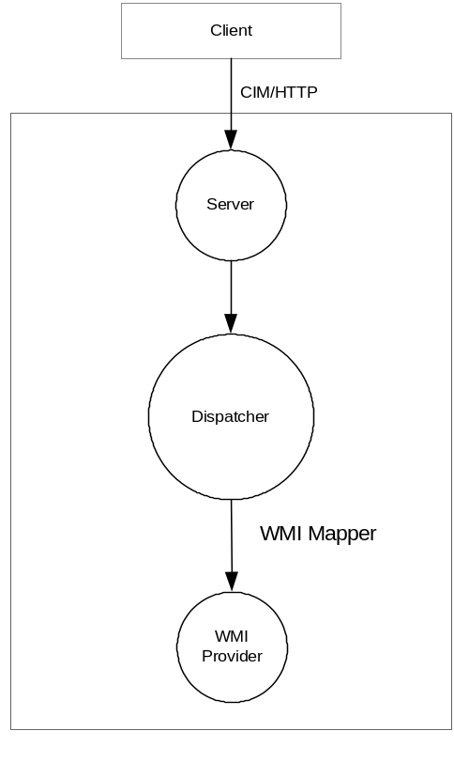
Figure 3. WMI Mapper request

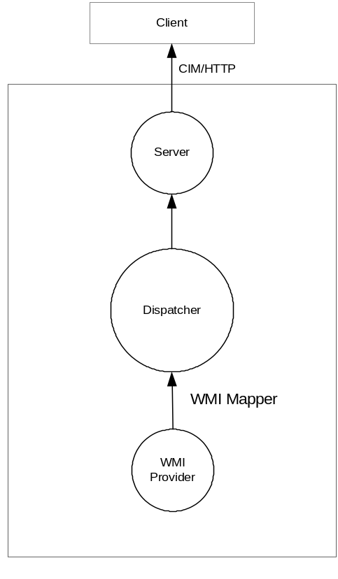

Figure 4. WMI Mapper response

Mapper execution
The WMI Mapper will execute as an NT service. For the first release it will reside on the managed node. If there is time, the option of execution on a proxy server will be investigated.

Security and authentication
<To be updated>
We need to authenticate the validity of the client when receiving the HTTP request. We will also need a user name/password with administrative capabilities for the WMI requests themselves. Among other options, we are investigating the possibility of:
- Use Apache and SSL authentication to verity the client user, as is done in the HP-UX Wbem CIMOM.
- Configure the WMI Mapper at installation to run as a process with admin capabilities, as is done in TopTools.
There is also the possibility of having the client user name and password passed to the WMI provider where it will be verified.

Issue: If (1) is used, the Apache web server must be installed on the managed node.

Other methods, such as IIS and ISAPI will also be investigated. At this time it appears that (2) is feasible

Configuration
Configuration parameters are set by reading a configuration file. Tracing, port, log files are among the parameters that can be set. Presumably, more can be added. There is a CLI program to set the configuration file. (See reference 3.)

Tracing. The Pegasus CIMOM has extensive tracing capabilities with several levels available. (See reference 5.) The WMI Mapper will incorporate this facility.

Errors. The errors that the Pegasus CIMOM returns in the XML response are those described in reference 2. Additional information will be output using the Trace facility.

Caveats
The following caveats are present for first release.
- It will be assumed that the WMI Mapper will not be installed on a system that also has a full-blown Pegasus CIMOM agent.
- Some of the XML/CIM methods may not be transferable to WMI, either because of Pegasus non-support or because there is no mapping. In these cases a CIM_ERR_NOT_SUPPORTED exception will be thrown.

Events
For the first release, events will not be supported. If time permits, using Pegasus for indication subscription and handling will be investigated.

Supported Methods
The following methods will be supported in the first release of Nimbus.
- GetClass( )
- GetInstance( )
- EnumerateClasses( )
- EnumerateClassNames( )
- EnumerateInstances( )
- EnumerateInstanceNames( )
- ExecQuery( )
- GetProperty( )
- Associators( )
- AssociatorNames( )

General Discussion
The parameters discussed in this section are found in several of the methods.

- LocalOnly: If LocalOnly is true, only the CIM elements (properties, methods and qualifiers) overridden within the definition of the Class are returned [1]. If false, all elements are returned.
- IncludeQualifiers: If IncludeQualifiers is true, all the qualifiers, on the Class and any returned Properties, will be returned.

Note: The default parameters for LocalOnly and IncludeQualifiers in this document are those specified in the DMTF CIM over HTTP reference [2]. They are not necessarily those used by Pegasus. It is suggested that the user specifically include these parameters.

- IncludeClassOrigin: If IncludeClassOrigin is true, the CLASSORIGIN attribute will be returned on all appropriate elements in the returned Class.
- Property List:
  - If the PropertyList parameter is missing, the default value of NULL is provided. In this case, all the properties meeting the specifications of the LocalOnly parameter will be returned.
  - If the PropertyList parameter is an empty list, no property values will be returned.
  - If a PropertyList is specified, the properties included in that list will be returned.

Note: If the PropertyList parameter references an Instance, contains one or more properties, and the key value[s] are not included in the list, they will be added. Pegasus cannot create the Response message without the key value[s].

GetClass
The GetClass method retrieves a single CIM Class from the target Namespace.
IncludeCLassOrigin attribute: Currently there is a bug in Pegasus. If IncludeClassOrigin is false, the WMI provider does not return the CLASSORIGIN attribute. However, Pegasus automatically inserts the current subclass. Hopefully, this will be fixed before release.

Format
<class> GetClass (
[IN] <className> ClassName,
[IN,OPTIONAL] boolean LocalOnly = true,
[IN,OPTIONAL] boolean IncludeQualifiers = true,
[IN,OPTIONAL] boolean IncludeClassOrigin = false,
[IN,OPTIONAL,NULL] string PropertyList [] = NULL
)

Errors
The following errors may be returned by the GetClass( ) method:
- CIM_ERR_ACCESS_DENIED
- CIM_ERR_INVALID_NAMESPACE
- CIM_ERR_INVALID_PARAMETER (including missing, duplicate, unrecognized or otherwise incorrect parameters)
- CIM_ERR_NOT_FOUND (the request CIM Class does not exist in the specified namespace)
- CIM_ERR_FAILED (some other unspecified error occurred)

Example
The request

<?xml version="1.0" encoding="utf-8"?>
<CIM CIMVERSION="2.0" DTDVERSION="2.0">
<MESSAGE ID="00001" PROTOCOLVERSION="1.0">
<SIMPLEREQ>
<IMETHODCALL NAME="GetClass">
<LOCALNAMESPACEPATH>
<NAMESPACE NAME="root"/>
<NAMESPACE NAME="cimv2"/>
</LOCALNAMESPACEPATH>
<IPARAMVALUE NAME="ClassName">
<CLASSNAME NAME="Win32_LogicalDisk"/>
</IPARAMVALUE>
<IPARAMVALUE NAME="LocalOnly">
<VALUE>
FALSE
</VALUE>
</IPARAMVALUE>
<IPARAMVALUE NAME="IncludeQualifiers">
<VALUE>
FALSE
</VALUE>
</IPARAMVALUE>
<IPARAMVALUE NAME="IncludeClassOrigin">
<VALUE>
FALSE
</VALUE>
</IPARAMVALUE>
<IPARAMVALUE NAME="PropertyList">
<VALUE.ARRAY>
<VALUE> BlockSize </VALUE>
<VALUE> Caption </VALUE>
</VALUE.ARRAY>
</IPARAMVALUE>
</IMETHODCALL>
</SIMPLEREQ>
</MESSAGE>
</CIM>

will return the following response

<?xml version="1.0" encoding="utf-8"?>
<CIM CIMVERSION="2.0" DTDVERSION="2.0">
<MESSAGE ID="00001" PROTOCOLVERSION="1.0">
<SIMPLERSP>
<IMETHODRESPONSE NAME="GetClass">
<IRETURNVALUE>
<CLASS NAME="Win32_LogicalDisk" SUPERCLASS="CIM_LogicalDisk">
<PROPERTY NAME="BlockSize" CLASSORIGIN="CIM_StorageExtent" TYPE="uint64">
</PROPERTY>
<PROPERTY NAME="Caption" CLASSORIGIN="CIM_ManagedSystemElement" TYPE="string">
</PROPERTY>
</CLASS>
</IRETURNVALUE>
</IMETHODRESPONSE>
</SIMPLERSP>
</MESSAGE>
</CIM>

If the IncludeQualifier parameter is changed to true, the response will be

<?xml version="1.0" encoding="utf-8"?>
<CIM CIMVERSION="2.0" DTDVERSION="2.0">
<MESSAGE ID="00001" PROTOCOLVERSION="1.0">
<SIMPLERSP>
<IMETHODRESPONSE NAME="GetClass">
<IRETURNVALUE>
<CLASS NAME="Win32_LogicalDisk" SUPERCLASS="CIM_LogicalDisk">
<QUALIFIER NAME="Description" TYPE="string" OVERRIDABLE="false">
<VALUE>
The Win32_LogicalDisk class represents a data source that resolves to an actual local storage device on a Win32 system.
</VALUE>
</QUALIFIER>
<QUALIFIER NAME="dynamic" TYPE="boolean" OVERRIDABLE="false" TOSUBCLASS="false" TOINSTANCE="true">
<VALUE>
TRUE
</VALUE>
</QUALIFIER>
<QUALIFIER NAME="Locale" TYPE="sint32" OVERRIDABLE="false" TOSUBCLASS="false">
<VALUE>
1033
</VALUE>
</QUALIFIER>
<QUALIFIER NAME="provider" TYPE="string" OVERRIDABLE="false" TOSUBCLASS="false" TOINSTANCE="true">
<VALUE>
CIMWin32
</VALUE>
</QUALIFIER>
<QUALIFIER NAME="UUID" TYPE="string" OVERRIDABLE="false" TOSUBCLASS="false" TOINSTANCE="true">
<VALUE>
{8502C4B7-5FBB-11D2-AAC1-006008C78BC7}
</VALUE>
</QUALIFIER>
<PROPERTY NAME="BlockSize" CLASSORIGIN="CIM_StorageExtent" PROPAGATED="true" TYPE="uint64">
<QUALIFIER NAME="CIMTYPE" TYPE="string" OVERRIDABLE="false" TOINSTANCE="true">
<VALUE>
uint64
</VALUE>
</QUALIFIER>
<QUALIFIER NAME="Description" TYPE="string" OVERRIDABLE="false">
<VALUE>
Size in bytes of the blocks which form this storage extent. If unknown or if a block concept is not valid (for example, for aggregate extents, memory or logical disks), enter a 1.
</VALUE>
</QUALIFIER>
<QUALIFIER NAME="MappingStrings" TYPE="string" OVERRIDABLE="false">
<VALUE.ARRAY>
<VALUE>
MIB.IETF|HOST-RESOURCES-MIB.hrStorageAllocationUnits
</VALUE>
</VALUE.ARRAY>
</QUALIFIER>
<QUALIFIER NAME="read" TYPE="boolean" OVERRIDABLE="false">
<VALUE>
TRUE
</VALUE>
</QUALIFIER>
<QUALIFIER NAME="Units" TYPE="string" OVERRIDABLE="false">
<VALUE>
Bytes
</VALUE>
</QUALIFIER>
</PROPERTY>
<PROPERTY NAME="Caption" CLASSORIGIN="CIM_ManagedSystemElement" PROPAGATED="true" TYPE="string">
<QUALIFIER NAME="CIMTYPE" TYPE="string" OVERRIDABLE="false" TOINSTANCE="true">
<VALUE>
string
</VALUE>
</QUALIFIER>
<QUALIFIER NAME="Description" TYPE="string" OVERRIDABLE="false">
<VALUE>
The Caption property is a short textual description (one-line string) of the object.
</VALUE>
</QUALIFIER>
<QUALIFIER NAME="MaxLen" TYPE="sint32" OVERRIDABLE="false">
<VALUE>
64
</VALUE>
</QUALIFIER>
<QUALIFIER NAME="read" TYPE="boolean" OVERRIDABLE="false">
<VALUE>
TRUE
</VALUE>
</QUALIFIER>
</PROPERTY>
</CLASS>
</IRETURNVALUE>
</IMETHODRESPONSE>
</SIMPLERSP>
</MESSAGE>
</CIM>

GetInstance
The GetInstance method retrieves a single CIM Instance from the target Namespace.

Format

<instance> GetInstance (
[IN] <instanceName> InstanceName,
[IN,OPTIONAL] boolean LocalOnly = true,
[IN,OPTIONAL] boolean IncludeQualifiers = false,
[IN,OPTIONAL] boolean IncludeClassOrigin = false,
[IN,OPTIONAL,NULL] string PropertyList [] = NULL
)

Errors
The following errors may be returned by the GetInstance( ) method:
- CIM_ERR_ACCESS_DENIED
- CIM_ERR_INVALID_NAMESPACE
- CIM_ERR_INVALID_PARAMETER (including missing, duplicate, unrecognized or otherwise incorrect parameters)
- CIM_ERR_INVALID_CLASS (the CIM Class does not exist in the specified namespace)
- CIM_ERR_NOT_FOUND (the CIM Class does exist, but the requested CIM Instance does not exist in the specified namespace)
- CIM_ERR_FAILED (some other unspecified error occurred)

Example
The request
<?xml version="1.0" encoding="utf-8"?>
<CIM CIMVERSION="2.0" DTDVERSION="2.0">
<MESSAGE ID="6006" PROTOCOLVERSION="1.0">
<SIMPLEREQ>
<IMETHODCALL NAME="GetInstance">
<LOCALNAMESPACEPATH>
<NAMESPACE NAME="root"/>
<NAMESPACE NAME="cimv2"/>
</LOCALNAMESPACEPATH>
<IPARAMVALUE NAME="InstanceName">
<INSTANCENAME CLASSNAME="Win32_LogicalDisk">
<KEYBINDING NAME="DeviceID">
<KEYVALUE VALUETYPE="string">
C:
</KEYVALUE>
</KEYBINDING>
</INSTANCENAME>
</IPARAMVALUE>
<IPARAMVALUE NAME="LocalOnly">
<VALUE>
FALSE
</VALUE>
</IPARAMVALUE>
</IMETHODCALL>
</SIMPLEREQ>
</MESSAGE>
</CIM>

returns the response

<?xml version="1.0" encoding="utf-8"?>
<CIM CIMVERSION="2.0" DTDVERSION="2.0">
<MESSAGE ID="6006" PROTOCOLVERSION="1.0">
<SIMPLERSP>
<IMETHODRESPONSE NAME="GetInstance">
<IRETURNVALUE>
<INSTANCE CLASSNAME="Win32_LogicalDisk">
<PROPERTY NAME="Access" TYPE="uint16">
</PROPERTY>
<PROPERTY NAME="Availability" TYPE="uint16">
</PROPERTY>
<PROPERTY NAME="BlockSize" TYPE="uint64">
</PROPERTY>
<PROPERTY NAME="Caption" TYPE="string">
<VALUE>
C:
</VALUE>
</PROPERTY>
<PROPERTY NAME="Compressed" TYPE="boolean">
<VALUE>
FALSE
</VALUE>
</PROPERTY>
<PROPERTY NAME="ConfigManagerErrorCode" TYPE="uint32">
</PROPERTY>
<PROPERTY NAME="ConfigManagerUserConfig" TYPE="boolean">
</PROPERTY>
<PROPERTY NAME="CreationClassName" TYPE="string">
<VALUE>
Win32_LogicalDisk
</VALUE>
</PROPERTY>
<PROPERTY NAME="Description" TYPE="string">
<VALUE>
Local Fixed Disk
</VALUE>
</PROPERTY>
<PROPERTY NAME="DeviceID" TYPE="string">
<VALUE>
C:
</VALUE>
</PROPERTY>
<PROPERTY NAME="DriveType" TYPE="uint32">
<VALUE>
3
</VALUE>
</PROPERTY>
<PROPERTY NAME="ErrorCleared" TYPE="boolean">
</PROPERTY>
<PROPERTY NAME="ErrorDescription" TYPE="string">
</PROPERTY>
<PROPERTY NAME="ErrorMethodology" TYPE="string">
</PROPERTY>
<PROPERTY NAME="FileSystem" TYPE="string">
<VALUE>
FAT32
</VALUE>
</PROPERTY>
<PROPERTY NAME="FreeSpace" TYPE="uint64">
<VALUE>
7371227136
</VALUE>
</PROPERTY>
<PROPERTY NAME="InstallDate" TYPE="datetime">
</PROPERTY>
<PROPERTY NAME="LastErrorCode" TYPE="uint32">
</PROPERTY>
<PROPERTY NAME="MaximumComponentLength" TYPE="uint32">
<VALUE>
255
</VALUE>
</PROPERTY>
<PROPERTY NAME="MediaType" TYPE="uint32">
<VALUE>
12
</VALUE>
</PROPERTY>
<PROPERTY NAME="Name" TYPE="string">
<VALUE>
C:
</VALUE>
</PROPERTY>
<PROPERTY NAME="NumberOfBlocks" TYPE="uint64">
</PROPERTY>
<PROPERTY NAME="PNPDeviceID" TYPE="string">
</PROPERTY>
<PROPERTY NAME="PowerManagementCapabilities" TYPE="uint16">
</PROPERTY>
<PROPERTY NAME="PowerManagementSupported" TYPE="boolean">
</PROPERTY>
<PROPERTY NAME="ProviderName" TYPE="string">
</PROPERTY>
<PROPERTY NAME="Purpose" TYPE="string">
</PROPERTY>
<PROPERTY NAME="Size" TYPE="uint64">
<VALUE>
9433382912
</VALUE>
</PROPERTY>
<PROPERTY NAME="Status" TYPE="string">
</PROPERTY>
<PROPERTY NAME="StatusInfo" TYPE="uint16">
</PROPERTY>
<PROPERTY NAME="SupportsFileBasedCompression" TYPE="boolean">
<VALUE>
FALSE
</VALUE>
</PROPERTY>
<PROPERTY NAME="SystemCreationClassName" TYPE="string">
<VALUE>
Win32_ComputerSystem
</VALUE>
</PROPERTY>
<PROPERTY NAME="SystemName" TYPE="string">
<VALUE>
PACKARD0
</VALUE>
</PROPERTY>
<PROPERTY NAME="VolumeName" TYPE="string">
<VALUE>
XXXXPXXABA
</VALUE>
</PROPERTY>
<PROPERTY NAME="VolumeSerialNumber" TYPE="string">
<VALUE>
3A181AF2
</VALUE>
</PROPERTY>
</INSTANCE>
</IRETURNVALUE>
</IMETHODRESPONSE>
</SIMPLERSP>
</MESSAGE>
</CIM>

EnumerateClasses
The EnumerateClasses method enumerates the subclasses of a CIM class in the target Namespace.

Format

<class>* EnumerateClasses (
[IN,OPTIONAL,NULL] <className> ClassName=NULL,
[IN,OPTIONAL] boolean DeepInheritance = false,
[IN,OPTIONAL] boolean LocalOnly = true,
[IN,OPTIONAL] boolean IncludeQualifiers = true,
[IN,OPTIONAL] boolean IncludeClassOrigin = false
)

The ClassName parameter defines the Class that is the basis for the enumeration. If it is NULL, the Namespace is used as the base class.
If DeepInheritance is true, all subclasses of the specified class are returned. If false, only immediate child subclasses are returned.

Errors
The following errors may be returned by the EnumerateClasses( ) method:
- CIM_ERR_ACCESS_DENIED
- CIM_ERR_NOT_SUPPORTED
- CIM_ERR_INVALID_NAMESPACE
- CIM_ERR_INVALID_PARAMETER (including missing, duplicate, unrecognized or otherwise incorrect parameters)
- CIM_ERR_INVALID_CLASS (the CIM Class that is the basis for this enumeration does not exist)
- CIM_ERR_FAILED (some other unspecified error occurred)

Example

EnumerateClassNames
The EnumerateClassNames method is used to enumerate the names of subclasses of a CIM Class in the target Namespace.

Format

<className>* EnumerateClassNames (
[IN,OPTIONAL,NULL] <className> ClassName = NULL,
[IN,OPTIONAL] boolean DeepInheritance = false
)

The ClassName and DeepInheritance parameters are as defined in the previous section.

Errors

- CIM_ERR_ACCESS_DENIED
- CIM_ERR_NOT_SUPPORTED
- CIM_ERR_INVALID_NAMESPACE
- CIM_ERR_INVALID_PARAMETER (including missing, duplicate, unrecognized or otherwise incorrect parameters)
- CIM_ERR_INVALID_CLASS (the CIM Class that is the basis for this enumeration does not exist)
- CIM_ERR_FAILED (some other unspecified error occurred)

Example
<tba>

EnumerateInstances
The EnumerateInstances method enumerates instances of a CIM Class in the target Namespace.

Format

<namedInstance>* EnumerateInstances (
[IN] <className> ClassName,
[IN,OPTIONAL] boolean LocalOnly = true,
[IN,OPTIONAL] boolean DeepInheritance = true,
[IN,OPTIONAL] boolean IncludeQualifiers = false,
[IN,OPTIONAL] boolean IncludeClassOrigin = false,
[IN,OPTIONAL,NULL] string PropertyList [] = NULL
)

The ClassName parameter defines the Class that is the basis for the enumeration.
If the DeepInheritance parameter is true, for each returned Instance, all properties of the of the Instance must be present, subject to constraints imposed by the other parameters.

Errors
The following errors may be returned by the EnumerateInstances( ) method:
- CIM_ERR_ACCESS_DENIED
- CIM_ERR_NOT_SUPPORTED
- CIM_ERR_INVALID_NAMESPACE
- CIM_ERR_INVALID_PARAMETER (including missing, duplicate, unrecognized or otherwise incorrect parameters)
- CIM_ERR_INVALID_CLASS (the CIM Class that is the basis for this enumeration does not exist)
- CIM_ERR_FAILED (some other unspecified error occurred)

Example

The request

<?xml version="1.0" ?>
<CIM CIMVERSION="2.0" DTDVERSION="2.0">
<MESSAGE ID="51000" PROTOCOLVERSION="1.0">
<SIMPLEREQ>
<IMETHODCALL NAME="EnumerateInstances">
<LOCALNAMESPACEPATH>
<NAMESPACE NAME="root"/>
<NAMESPACE NAME="cimv2"/>
</LOCALNAMESPACEPATH>
<IPARAMVALUE NAME="ClassName">
<CLASSNAME NAME="Win32_LogicalDisk"/>
</IPARAMVALUE>
<IPARAMVALUE NAME="LocalOnly">
<VALUE>
FALSE
</VALUE>
</IPARAMVALUE>
<IPARAMVALUE NAME="PropertyList">
<VALUE.ARRAY>
<VALUE> Caption </VALUE>
<VALUE> DriveType </VALUE>
<VALUE> DeviceID </VALUE>
</VALUE.ARRAY>
</IPARAMVALUE>
</IMETHODCALL>
</SIMPLEREQ>
</MESSAGE>
</CIM>

returns the following response

<?xml version="1.0" encoding="utf-8"?>
<CIM CIMVERSION="2.0" DTDVERSION="2.0">
<MESSAGE ID="51000" PROTOCOLVERSION="1.0">
<SIMPLERSP>
<IMETHODRESPONSE NAME="EnumerateInstances">
<IRETURNVALUE>
<VALUE.NAMEDINSTANCE>
<INSTANCENAME CLASSNAME="Win32_LogicalDisk">
<KEYBINDING NAME="DeviceID">
<KEYVALUE VALUETYPE="string">
A:
</KEYVALUE>
</KEYBINDING>
</INSTANCENAME>
<INSTANCE CLASSNAME="Win32_LogicalDisk">
<PROPERTY NAME="Caption" TYPE="string">
<VALUE>
A:
</VALUE>
</PROPERTY>
<PROPERTY NAME="DriveType" TYPE="uint32">
<VALUE>
2
</VALUE>
</PROPERTY>
<PROPERTY NAME="DeviceID" TYPE="string">
<VALUE>
A:
</VALUE>
</PROPERTY>
</INSTANCE>
</VALUE.NAMEDINSTANCE>
<VALUE.NAMEDINSTANCE>
<INSTANCENAME CLASSNAME="Win32_LogicalDisk">
<KEYBINDING NAME="DeviceID">
<KEYVALUE VALUETYPE="string">
C:
</KEYVALUE>
</KEYBINDING>
</INSTANCENAME>
<INSTANCE CLASSNAME="Win32_LogicalDisk">
<PROPERTY NAME="Caption" TYPE="string">
<VALUE>
C:
</VALUE>
</PROPERTY>
<PROPERTY NAME="DriveType" TYPE="uint32">
<VALUE>
3
</VALUE>
</PROPERTY>
<PROPERTY NAME="DeviceID" TYPE="string">
<VALUE>
C:
</VALUE>
</PROPERTY>
</INSTANCE>
</VALUE.NAMEDINSTANCE>
<VALUE.NAMEDINSTANCE>
<INSTANCENAME CLASSNAME="Win32_LogicalDisk">
<KEYBINDING NAME="DeviceID">
<KEYVALUE VALUETYPE="string">
D:
</KEYVALUE>
</KEYBINDING>
</INSTANCENAME>
<INSTANCE CLASSNAME="Win32_LogicalDisk">
<PROPERTY NAME="Caption" TYPE="string">
<VALUE>
D:
</VALUE>
</PROPERTY>
<PROPERTY NAME="DriveType" TYPE="uint32">
<VALUE>
3
</VALUE>
</PROPERTY>
<PROPERTY NAME="DeviceID" TYPE="string">
<VALUE>
D:
</VALUE>
</PROPERTY>
</INSTANCE>
</VALUE.NAMEDINSTANCE>
<VALUE.NAMEDINSTANCE>
<INSTANCENAME CLASSNAME="Win32_LogicalDisk">
<KEYBINDING NAME="DeviceID">
<KEYVALUE VALUETYPE="string">
E:
</KEYVALUE>
</KEYBINDING>
</INSTANCENAME>
<INSTANCE CLASSNAME="Win32_LogicalDisk">
<PROPERTY NAME="Caption" TYPE="string">
<VALUE>
E:
</VALUE>
</PROPERTY>
<PROPERTY NAME="DriveType" TYPE="uint32">
<VALUE>
5
</VALUE>
</PROPERTY>
<PROPERTY NAME="DeviceID" TYPE="string">
<VALUE>
E:
</VALUE>
</PROPERTY>
</INSTANCE>
</VALUE.NAMEDINSTANCE>
<VALUE.NAMEDINSTANCE>
<INSTANCENAME CLASSNAME="Win32_LogicalDisk">
<KEYBINDING NAME="DeviceID">
<KEYVALUE VALUETYPE="string">
F:
</KEYVALUE>
</KEYBINDING>
</INSTANCENAME>
<INSTANCE CLASSNAME="Win32_LogicalDisk">
<PROPERTY NAME="Caption" TYPE="string">
<VALUE>
F:
</VALUE>
</PROPERTY>
<PROPERTY NAME="DriveType" TYPE="uint32">
<VALUE>
3
</VALUE>
</PROPERTY>
<PROPERTY NAME="DeviceID" TYPE="string">
<VALUE>
F:
</VALUE>
</PROPERTY>
</INSTANCE>
</VALUE.NAMEDINSTANCE>
</IRETURNVALUE>
</IMETHODRESPONSE>
</SIMPLERSP>
</MESSAGE>
</CIM>

EnumerateInstanceNames
The EnumerateInstanceNames method enumerates the names of the instances of a CIM Class in the target Namespace.

Format
<instanceName>* EnumerateInstanceNames (
[IN] <className> ClassName
)

The ClassName parameter defines the Class that is the basis for the enumeration.

Errors
The following errors may be returned by the EnumerateInstanceNames( ) method:
- CIM_ERR_ACCESS_DENIED
- CIM_ERR_NOT_SUPPORTED
- CIM_ERR_INVALID_NAMESPACE
- CIM_ERR_INVALID_PARAMETER (including missing, duplicate, unrecognized or otherwise incorrect parameters)
- CIM_ERR_INVALID_CLASS (the CIM Class that is the basis for this enumeration does not exist)
- CIM_ERR_FAILED (some other unspecified error occurred)

Example
The request

<?xml version="1.0" ?>
<CIM CIMVERSION="2.0" DTDVERSION="2.0">
<MESSAGE ID="7873" PROTOCOLVERSION="1.0">
<SIMPLEREQ>
<IMETHODCALL NAME="EnumerateInstanceNames">
<LOCALNAMESPACEPATH>
<NAMESPACE NAME="root"/>
<NAMESPACE NAME="cimv2"/>
</LOCALNAMESPACEPATH>
<IPARAMVALUE NAME="ClassName">
<CLASSNAME NAME="Win32_LogicalDisk"/>
</IPARAMVALUE>
</IMETHODCALL>
</SIMPLEREQ>
</MESSAGE>
</CIM>

returns the response

<?xml version="1.0" encoding="utf-8"?>
<CIM CIMVERSION="2.0" DTDVERSION="2.0">
<MESSAGE ID="7873" PROTOCOLVERSION="1.0">
<SIMPLERSP>
<IMETHODRESPONSE NAME="EnumerateInstanceNames">
<IRETURNVALUE>
<INSTANCENAME CLASSNAME="Win32_LogicalDisk">
<KEYBINDING NAME="DeviceID">
<KEYVALUE VALUETYPE="string">
A:
</KEYVALUE>
</KEYBINDING>
</INSTANCENAME>
<INSTANCENAME CLASSNAME="Win32_LogicalDisk">
<KEYBINDING NAME="DeviceID">
<KEYVALUE VALUETYPE="string">
C:
</KEYVALUE>
</KEYBINDING>
</INSTANCENAME>
<INSTANCENAME CLASSNAME="Win32_LogicalDisk">
<KEYBINDING NAME="DeviceID">
<KEYVALUE VALUETYPE="string">
D:
</KEYVALUE>
</KEYBINDING>
</INSTANCENAME>
<INSTANCENAME CLASSNAME="Win32_LogicalDisk">
<KEYBINDING NAME="DeviceID">
<KEYVALUE VALUETYPE="string">
E:
</KEYVALUE>
</KEYBINDING>
</INSTANCENAME>
<INSTANCENAME CLASSNAME="Win32_LogicalDisk">
<KEYBINDING NAME="DeviceID">
<KEYVALUE VALUETYPE="string">
F:
</KEYVALUE>
</KEYBINDING>
</INSTANCENAME>
</IRETURNVALUE>
</IMETHODRESPONSE>
</SIMPLERSP>
</MESSAGE>
</CIM>

ExecQuery
The ExecQuery method is used to execute a query against the target Namespace.
The only query language supported by WMI at this time is WQL.
The queries supported are the WMI data queries. These are used to retrieve instances of classes. Consult the WMI documentation for more information.

Format

<object>* ExecQuery (
[IN] string QueryLanguage,
[IN] string Query
)

The QueryLanguage parameter defines the query language in which the Query parameter is expressed. This must be WQL.
The Query parameter defines the query to be executed. This must be a valid WMI data query.

Errors
The following errors may be returned by the ExecQuery( ) method:
- CIM_ERR_ACCESS_DENIED
- CIM_ERR_NOT_SUPPORTED
- CIM_ERR_INVALID_NAMESPACE
- CIM_ERR_INVALID_PARAMETER (including missing, duplicate, unrecognized or otherwise incorrect parameters)
- CIM_ERR_QUERY_LANGUAGE_NOT_SUPPORTED (the requested query language is not recognized)
- CIM_ERR_INVALID_QUERY (the query is not a valid query in the specified query language)
- CIM_ERR_FAILED (some other unspecified error occurred)

Example

The request

<?xml version="1.0" encoding="utf-8"?>
<CIM CIMVERSION="2.0" DTDVERSION="2.0">
<MESSAGE ID="6006" PROTOCOLVERSION="1.0">
<SIMPLEREQ>
<IMETHODCALL NAME="ExecQuery">
<LOCALNAMESPACEPATH>
<NAMESPACE NAME="root"/>
<NAMESPACE NAME="cimv2"/>
</LOCALNAMESPACEPATH>
<IPARAMVALUE NAME="QueryLanguage">
<VALUE>
WQL
</VALUE>
</IPARAMVALUE>
<IPARAMVALUE NAME="Query">
<VALUE> Select DeviceID, Name, MACAddress from Win32_NetworkAdapter
where MACAddress is not NULL </VALUE>
</IPARAMVALUE>
</IMETHODCALL>
</SIMPLEREQ>
</MESSAGE>
</CIM>

returns the response

<?xml version="1.0" encoding="utf-8"?>
<CIM CIMVERSION="2.0" DTDVERSION="2.0">
<MESSAGE ID="6006" PROTOCOLVERSION="1.0">
<SIMPLERSP>
<IMETHODRESPONSE NAME="ExecQuery">
<IRETURNVALUE>
<VALUE.OBJECTWITHPATH>
<INSTANCENAME CLASSNAME="Win32_NetworkAdapter">
<KEYBINDING NAME="DeviceID">
<KEYVALUE VALUETYPE="string">
0
</KEYVALUE>
</KEYBINDING>
</INSTANCENAME>
<INSTANCE CLASSNAME="Win32_NetworkAdapter">
<PROPERTY NAME="DeviceID" TYPE="string">
<VALUE>
0
</VALUE>
</PROPERTY>
<PROPERTY NAME="MACAddress" TYPE="string">
<VALUE>
00:30:F1:11:C2:C0
</VALUE>
</PROPERTY>
<PROPERTY NAME="Name" TYPE="string">
<VALUE>
HP EN1207D-TX PCI 10/100 Fast Ethernet Adapter
</VALUE>
</PROPERTY>
</INSTANCE>
</VALUE.OBJECTWITHPATH>
<VALUE.OBJECTWITHPATH>
<INSTANCENAME CLASSNAME="Win32_NetworkAdapter">
<KEYBINDING NAME="DeviceID">
<KEYVALUE VALUETYPE="string">
3
</KEYVALUE>
</KEYBINDING>
</INSTANCENAME>
<INSTANCE CLASSNAME="Win32_NetworkAdapter">
<PROPERTY NAME="DeviceID" TYPE="string">
<VALUE>
3
</VALUE>
</PROPERTY>
<PROPERTY NAME="MACAddress" TYPE="string">
<VALUE>
50:50:54:50:30:30
</VALUE>
</PROPERTY>
<PROPERTY NAME="Name" TYPE="string">
<VALUE>
WAN Miniport (PPTP)
</VALUE>
</PROPERTY>
</INSTANCE>
</VALUE.OBJECTWITHPATH>
</IRETURNVALUE>
</IMETHODRESPONSE>
</SIMPLERSP>
</MESSAGE>
</CIM>

GetProperty
The GetProperty( ) method is used to retrieve a single property value from a CIM Instance in the target Namespace.

Format

<propertyValue> GetProperty (
[IN] <instanceName> InstanceName,
[IN] string PropertyName
)

The InstanceName parameter specifies the name of the Instance from which the Property value is requested.
The PropertyName parameter specifies the name of the Property.

Errors
The following errors may be returned by the GetProperty( ) method:
- CIM_ERR_ACCESS_DENIED
- CIM_ERR_INVALID_NAMESPACE
- CIM_ERR_INVALID_PARAMETER (including missing, duplicate, unrecognized or otherwise incorrect parameters)
- CIM_ERR_INVALID_CLASS (the CIM Class does not exist in the specified namespace)
- CIM_ERR_NOT_FOUND (the CIM Class does exist, but the requested CIM Instance does not exist in the specified namespace)
- CIM_ERR_NO_SUCH_PROPERTY (the CIM Instance does exist, but the requested Property does not)
- CIM_ERR_FAILED (some other unspecified error occurred)

Example

The request

<?xml version="1.0" encoding="utf-8"?>
<CIM CIMVERSION="2.0" DTDVERSION="2.0">
<MESSAGE ID="6006" PROTOCOLVERSION="1.0">
<SIMPLEREQ>
<IMETHODCALL NAME="GetProperty">
<LOCALNAMESPACEPATH>
<NAMESPACE NAME="root"/>
<NAMESPACE NAME="cimv2"/>
</LOCALNAMESPACEPATH>
<IPARAMVALUE NAME="InstanceName">
<INSTANCENAME CLASSNAME="Win32_LogicalDisk">
<KEYBINDING NAME="DeviceID">
<KEYVALUE VALUETYPE="string">
C:
</KEYVALUE>
</KEYBINDING>
</INSTANCENAME>
</IPARAMVALUE>
<IPARAMVALUE NAME="PropertyName">
<VALUE> FileSystem </VALUE>
</IPARAMVALUE>
</IMETHODCALL>
</SIMPLEREQ>
</MESSAGE>
</CIM>

returns the following response

<?xml version="1.0" encoding="utf-8"?>
<CIM CIMVERSION="2.0" DTDVERSION="2.0">
<MESSAGE ID="6006" PROTOCOLVERSION="1.0">
<SIMPLERSP>
<IMETHODRESPONSE NAME="GetProperty">
<IRETURNVALUE>
<VALUE>
FAT32
</VALUE>
</IRETURNVALUE>
</IMETHODRESPONSE>
</SIMPLERSP>
</MESSAGE>
</CIM>

Associators
The Associators( ) method is used to retrieve the Associator objects from a CIM Class or CIM Instance.

Format
<objectWithPath>*Associators (
[IN] <objectName> ObjectName,
[IN,OPTIONAL,NULL] <className> AssocClass = NULL,
[IN,OPTIONAL,NULL] <className> ResultClass = NULL,
[IN,OPTIONAL,NULL] string Role = NULL,
[IN,OPTIONAL,NULL] string ResultRole = NULL,
[IN,OPTIONAL] boolean IncludeQualifiers = false,
[IN,OPTIONAL] boolean IncludeClassOrigin = false,
[IN,OPTIONAL,NULL] string PropertyList [] = NULL
)

The ObjectName parameter is the name of the Class or Instance from which the Associator Classes or Instances are requested. If ObjectName is a Class, Classes will be returned. If ObjectName is an Instance, Instances will be returned.
The AssocClass input parameter, if present, requires that each returned Object be associated to the source Object via an Instance of this Class or one of its subclasses.
The ResultClass input parameter, if present, requires that each returned Object be either an Instance of this Class (or one of its subclasses) or be this Class (or one of its subclasses).
The Role input parameter, if present, requires that each returned Object be associated to the source Object via an Association in which the source Object plays the specified role (i.e. the name of the Property in the Association Class that refers to the source Object MUST match the value of this parameter).
The ResultRole input parameter, if present, requires that each returned Object be associated to the source Object via an Association in which the returned Object plays the specified role (i.e. the name of the Property in the Association Class that refers to the returned Object MUST match the value of this parameter).

Errors

- CIM_ERR_ACCESS_DENIED
- CIM_ERR_NOT_SUPPORTED
- CIM_ERR_INVALID_NAMESPACE
- CIM_ERR_INVALID_PARAMETER (including missing, duplicate, unrecognized or otherwise incorrect parameters)
- CIM_ERR_FAILED (some other unspecified error occurred)

Example

The request

<?xml version="1.0" encoding="utf-8"?>
<CIM CIMVERSION="2.0" DTDVERSION="2.0">
<MESSAGE ID="6006" PROTOCOLVERSION="1.0">
<SIMPLEREQ>
<IMETHODCALL NAME="Associators">
<LOCALNAMESPACEPATH>
<NAMESPACE NAME="root"/>
<NAMESPACE NAME="cimv2"/>
</LOCALNAMESPACEPATH>
<IPARAMVALUE NAME="ObjectName">
<INSTANCENAME CLASSNAME="Win32_ComputerSystem">
<KEYBINDING NAME="Name">
<KEYVALUE VALUETYPE="string">
Packard0
</KEYVALUE>
</KEYBINDING>
</INSTANCENAME>
</IPARAMVALUE>
<IPARAMVALUE NAME="AssocClass">
<CLASSNAME NAME="Win32_ComputerSystemProcessor"/>
</IPARAMVALUE>
<IPARAMVALUE NAME="PropertyList">
<VALUE.ARRAY>
<VALUE>DeviceID</VALUE>
<VALUE>Family</VALUE>
</VALUE.ARRAY>
</IPARAMVALUE>
</IMETHODCALL>
</SIMPLEREQ>
</MESSAGE>
</CIM>

returns the following response

<?xml version="1.0" encoding="utf-8"?>
<CIM CIMVERSION="2.0" DTDVERSION="2.0">
<MESSAGE ID="6006" PROTOCOLVERSION="1.0">
<SIMPLERSP>
<IMETHODRESPONSE NAME="Associators">
<IRETURNVALUE>
<VALUE.OBJECTWITHPATH>
<INSTANCENAME CLASSNAME="Win32_Processor">
<KEYBINDING NAME="DeviceID">
<KEYVALUE VALUETYPE="string">
CPU0
</KEYVALUE>
</KEYBINDING>
</INSTANCENAME>
<INSTANCE CLASSNAME="Win32_Processor">
<PROPERTY NAME="DeviceID" TYPE="string">
<VALUE>
CPU0
</VALUE>
</PROPERTY>
<PROPERTY NAME="Family" TYPE="uint16">
<VALUE>
2
</VALUE>
</PROPERTY>
</INSTANCE>
</VALUE.OBJECTWITHPATH>
</IRETURNVALUE>
</IMETHODRESPONSE>
</SIMPLERSP>
</MESSAGE>
</CIM>

AssociatorNames
The AssociatorNames( ) method is used to enumerate the names of Classes or Instances that are associated with a source CIM Object.

Format
<objectPath>*AssociatorNames (
[IN] <objectName> ObjectName,
[IN,OPTIONAL,NULL] <className> AssocClass = NULL,
[IN,OPTIONAL,NULL] <className> ResultClass = NULL,
[IN,OPTIONAL,NULL] string Role = NULL,
[IN,OPTIONAL,NULL] string ResultRole = NULL
)

The ObjectName parameter is the name of the Class or Instance from which the Class or Instance names are requested. If ObjectName is a Class, Class names will be returned. If ObjectName is an Instance, Instance names will be returned.
The AssocClass input parameter, if present, requires that each returned name identifies an Object that is associated to the source Object via an Instance of this Class or one of its subclasses.
The ResultClass input parameter, if present, requires that each returned name identifies an Object that is either an Instance of this Class (or one of its subclasses) or is this Class (or one of its subclasses).
The Role input parameter, if present, is a valid Property name. It requires that each returned name identifies an Object that is associated to the source Object via an Association in which the source Object plays the specified role (i.e. the name of the Property in the Association Class that refers to the source Object MUST match the value of this parameter).
The ResultRole input parameter, if present, is a valid Property name. It requires that each returned name identifies an Object that is associated to the source Object via an Association in which the named returned Object plays the specified role (i.e. the name of the Property in the Association Class that refers to the returned Object MUST match the value of this parameter).

Errors
The following errors may be returned by the AssociatorNames( ) method:
- CIM_ERR_ACCESS_DENIED
- CIM_ERR_INVALID_NAMESPACE
- CIM_ERR_NOT_SUPPORTED
- CIM_ERR_INVALID_PARAMETER (including missing, duplicate, unrecognized or otherwise incorrect parameters)
- CIM_ERR_FAILED (some other unspecified error occurred)

Example

The request

<?xml version="1.0" encoding="utf-8"?>
<CIM CIMVERSION="2.0" DTDVERSION="2.0">
<MESSAGE ID="6006" PROTOCOLVERSION="1.0">
<SIMPLEREQ>
<IMETHODCALL NAME="AssociatorNames">
<LOCALNAMESPACEPATH>
<NAMESPACE NAME="root"/>
<NAMESPACE NAME="cimv2"/>
</LOCALNAMESPACEPATH>
<IPARAMVALUE NAME="ObjectName">
<CLASSNAME NAME="Win32_ComputerSystem"/>
</IPARAMVALUE>
<IPARAMVALUE NAME="AssocClass">
<CLASSNAME NAME="Win32_ComputerSystemProcessor"/>
</IPARAMVALUE>
</IMETHODCALL>
</SIMPLEREQ>
</MESSAGE>
</CIM>

returns the following response

<?xml version="1.0" encoding="utf-8"?>
<CIM CIMVERSION="2.0" DTDVERSION="2.0">
<MESSAGE ID="6006" PROTOCOLVERSION="1.0">
<SIMPLERSP>
<IMETHODRESPONSE NAME="AssociatorNames">
<IRETURNVALUE>
<OBJECTPATH>
<CLASSNAME NAME="Win32_Processor"/>
</OBJECTPATH>
</IRETURNVALUE>
</IMETHODRESPONSE>
</SIMPLERSP>
</MESSAGE>
</CIM>

References

- "Specification for the Representation of CIM in XML", Version 2.0, DMTF, 20th July 1999 (http://www.dmtf.org/download/spec/xmls/CIM_XML_Mapping20.php)
- “Specification for CIM Operations over HTTP”, Version 1.0, DMTF, 11th August, 1999
(http://www.dmtf.org/download/spec/xmls/CIM_HTTP_Mapping10.php)
- “Specification for the console application that configures the CIMOM” (\\Puffer\Gryphon\Docs\Specs\WMIMapper_files\cimconfig2.htm)
- “Developer Guide for Adding Tracing to a Component” (\\Puffer\Gryphon\Docs\Specs\WMIMapper_files\TracingDevGuide.pdf)
- “User Guide for the Tracing Framework” (\\Puffer\Gryphon\Docs\Specs\WMIMapper_files\TracingUserGuide.pdf)
- “Specification for the console application that configures the CIMOM users” (\\Puffer\Gryphon\Docs\Specs\WMIMapper_files\cimuser.htm)
- Platform SDK: Windows Management Instrumentation
(MSDN Library)

