**Engineering Project Detailed Research Plan**

**Please complete the information/questions begun/seen below in red ink. Save this document to your computer, and add a printed hard copy to your application.**

**Date: Nov 30, 2016  
Student Names: Saurav Gandhi, Jason Co, Jackson Moody  Project Title: The iCane**

Parts of the generic engineering project are listed below with descriptions to the students in the boxes. Students may provide a detailed research plan by describing their specific project in response to each box below.

**Engineering Goal:**PROBLEM BEING ADDRESSED:  All engineering projects solve a problem or fill a need.  Briefly describe the issue your project will address.

**My Project Goal i**s: Our Synopsys Science Fair team would like to build a cane that would communicate with pedestrian signals. The cane would tell the blind person when to start walking and when to stop using the button on the can and the “beep” sound from the pedestrian signal. The cane would communicate and link with the traffic lights with bluetooth or any other wireless means and Arduino in order to tell if the person to stop or go. This device would be able to help blind people walk across the road without the fear of being run over.

For A Demo Video Please Visit This Link: <http://tinyurl.com/h8qb82v>

**Design Criteria and Constraints:**  Design criteria define the product’s physical and functional characteristics using measurable metrics, such as length (in cm, km, etc.); mass (in mg, kg, etc.), velocity (in m/sec, km/hr., etc.), and ruggedness (able to withstand an impact force of x Newtons). Constraints are factors that limit the engineer’s flexibility such as cost & time.

**My Project Design Criteria and Constraints are the following:**

**Design Criteria:**

* **Length: 31 inches (average height for kids)**
* **Our base cane would be: this cane is a standard white cane from amazon.com, wwould be easy to build on. Here is the URL for the site: http://tinyurl.com/zolnu7c**

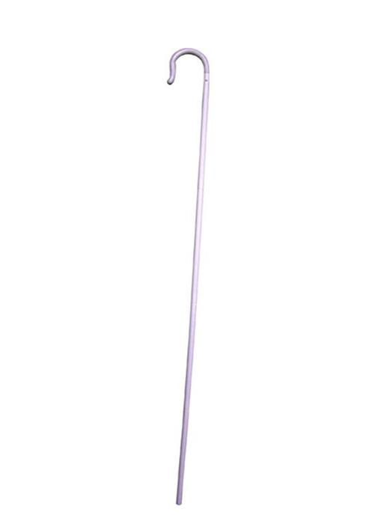

**Evaluate alternative designs:** Your research into possible solutions to a defined problem will reveal what has already been done by others to satisfy similar needs. You should consider at least two or three alternative designs and consider using available technology, modifying current designs, or inventing new solutions.

**Possible other designs for My Project are:**

Here are a few previous designs:

1. The Ulta Cane: “The UltraCane is a primary electronic mobility aid for use by people who are blind or visually impaired; it is a major "step forward" in assistive technology that allows safe obstacle avoidance and permits navigation around obstacles both in the user's forward path and just as importantly, giving valuable protection at head/chest height.” - [www.ultracane.com](http://www.ultracane.com)
2. The Eye Stick (By Wonjune Song): “It is the familiar red and white stick, but with enhanced features that make it quite a practical solution for blind commuters. The Eye Stick is fitted with a sensor lens towards the bottom part, from where it picks up location bearings, like is the person nearing a staircase, or is he near the traffic lights. It then sends feedback to the blind commuter via vibrations, communicating the scenario, so that the person can be aware of his surroundings and take his next step with confidence.” -<http://www.yankodesign.com/2009/09/08/blind-stick-with-eyes/>

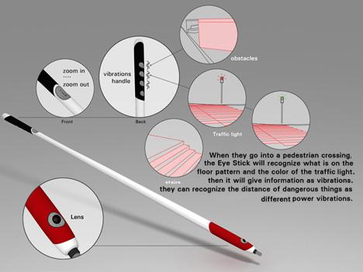

What is Unique about this project?: Before, blind people couldn’t cross streets without supervision. What our invention does is that it communicates with pedestrian signals. No other product can do this. We would base our idea off of some of these ideas such as the sensors.

**Build a prototype of best design.** Use your alternative analyses to choose the design that best meets criteria considering the constraints, then build a prototype. A prototype is the first full scale and usually functional form of a new type or design.

**My Project Design is shown below: insert photos, diagrams, or illustrations below.**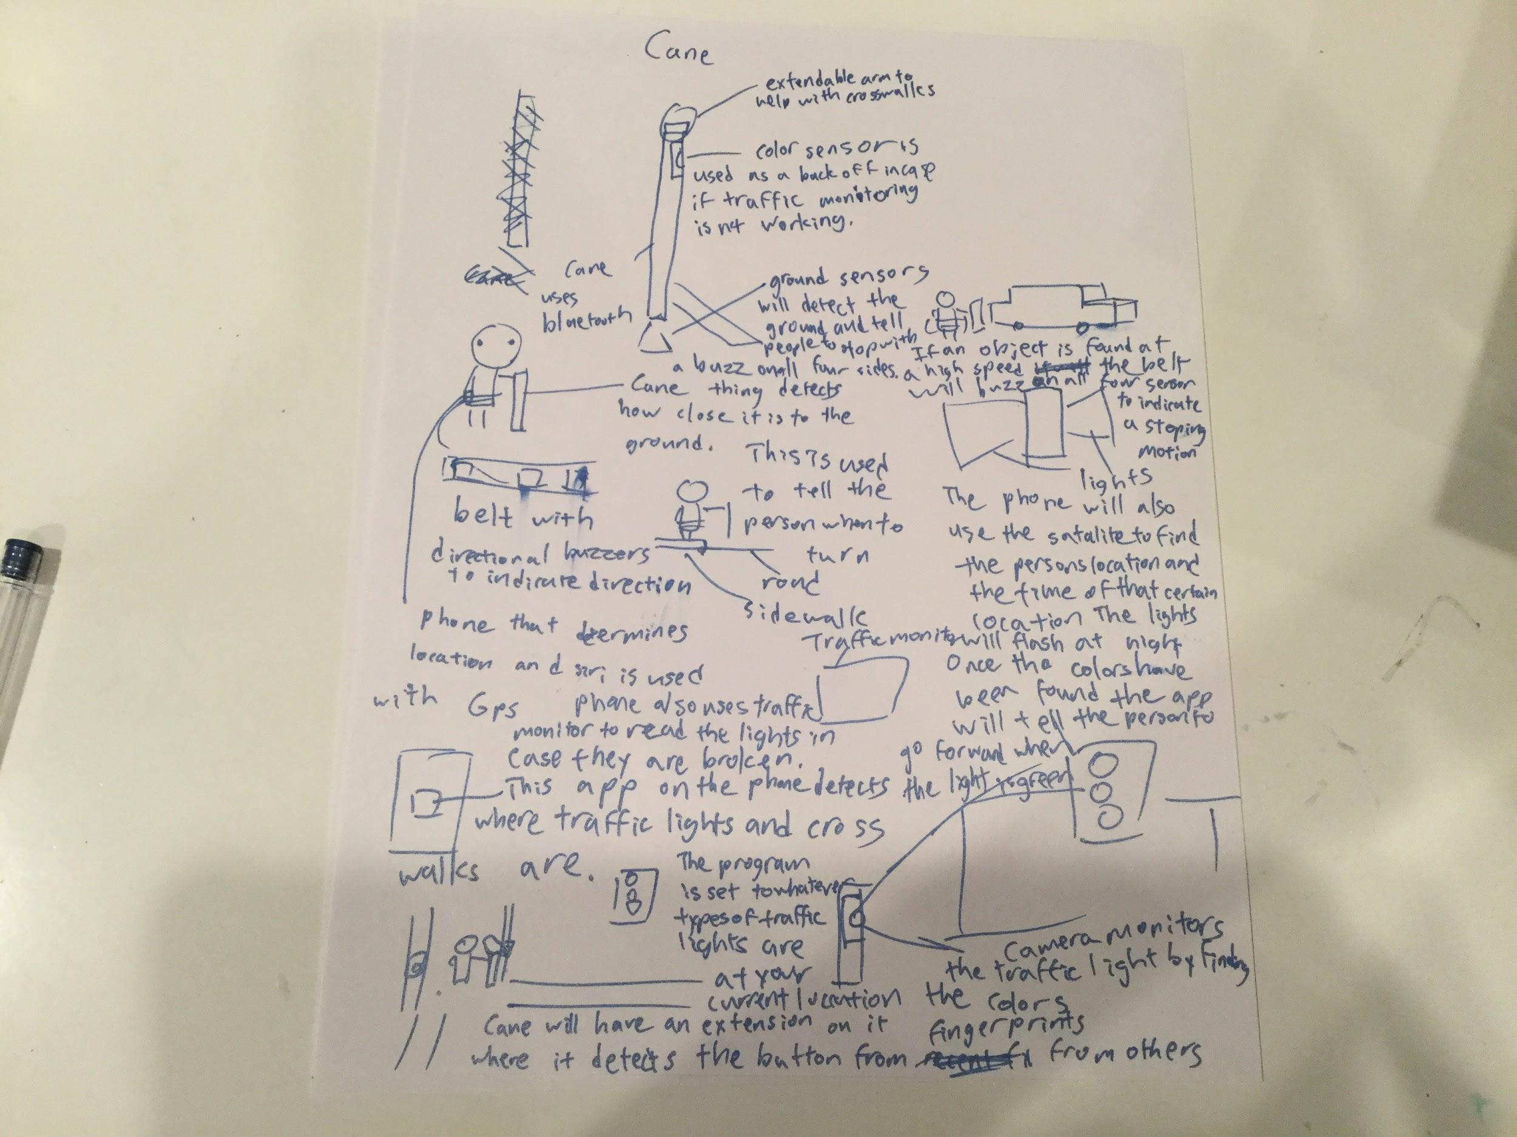

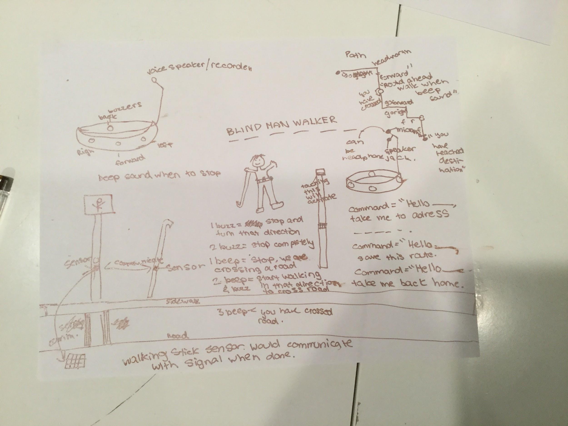

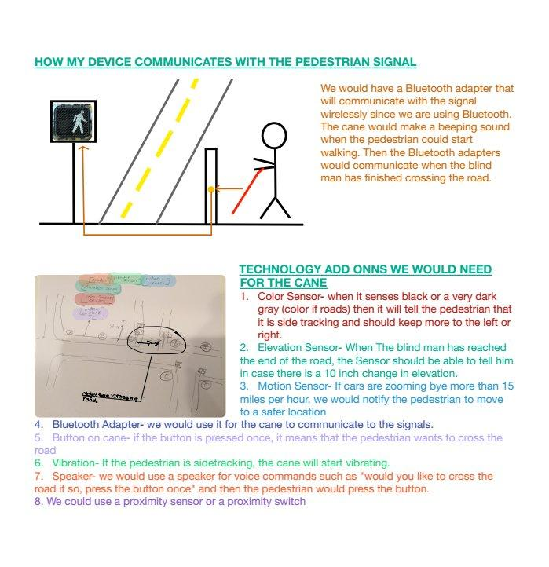

-

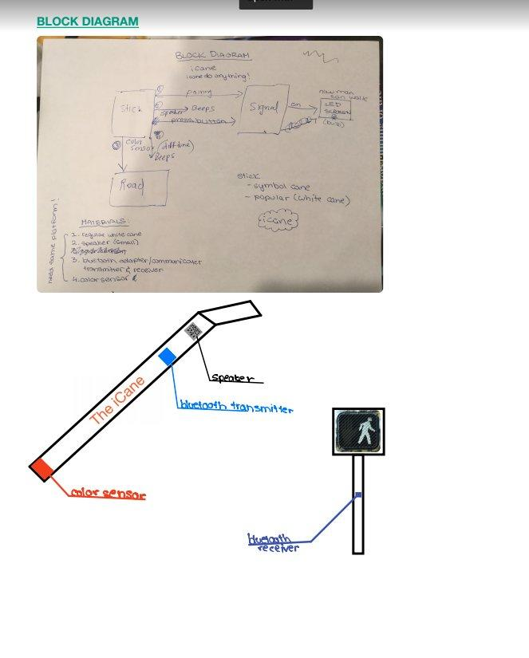



**Test and evaluate the prototype against important design criteria to show how well the product meets the need/goal.** Develop a test plan describing what you will test, how you will test, and how you’ll perform analysis. You must test your prototype under actual or simulated operating conditions.

**I will test my prototype for the following:**

What I will test: The independent manipulated variable (x-axis) would be a number of tries. The dependent responding variable (y-axis) would be the average success. We will test many graphs for success.

1. button on cane is pressed and light turns on to stop the car
2. the beep is heard when the car is stopped to be able to cross the road
3. The button is pressed on the cane to stop the beep after the road is crossed

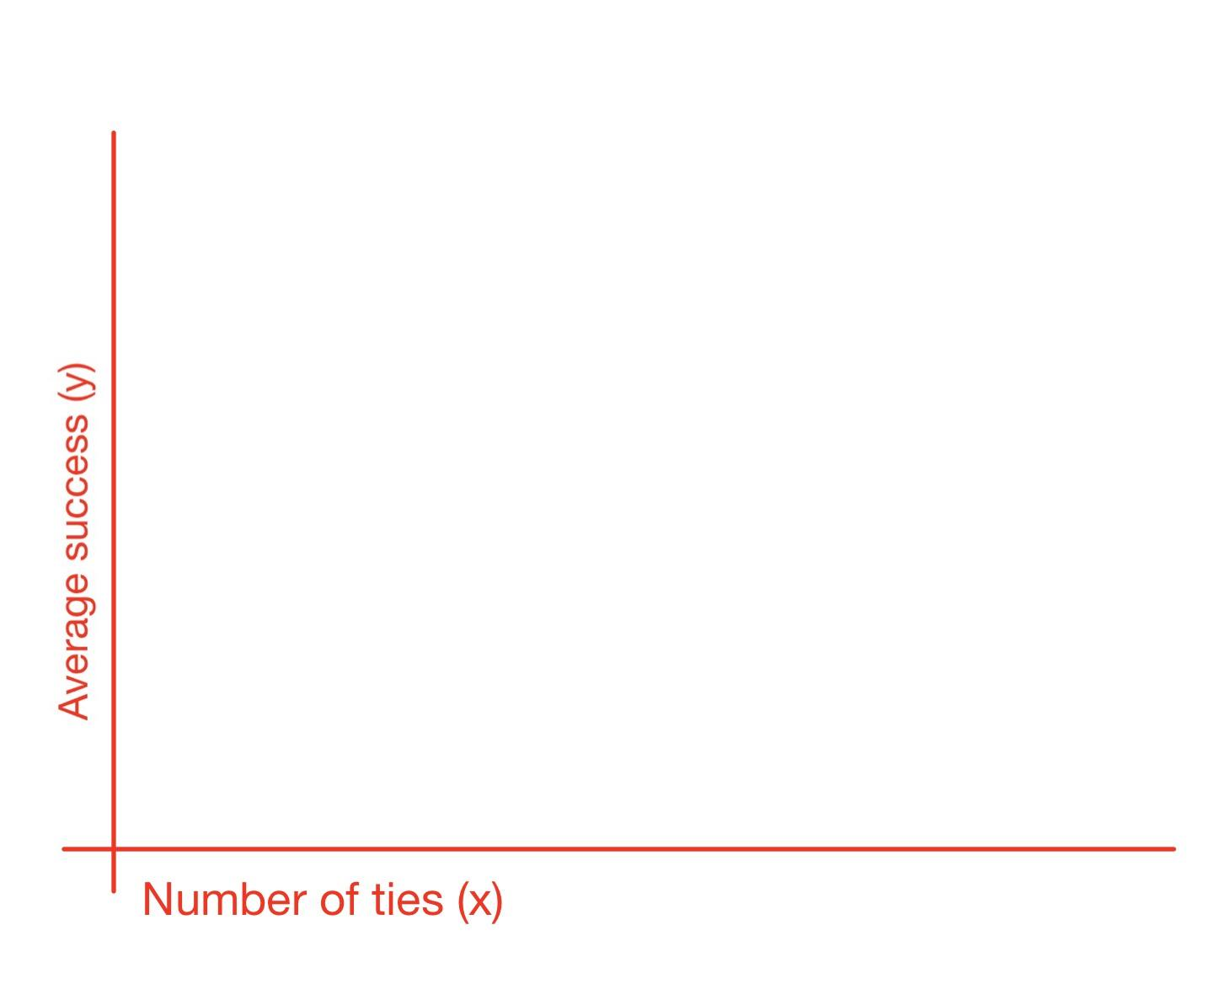

Controlled Variables:

1. The number of tries will stay the same because it is the number of tries we are testing our solution which means that the number of tries will be equal to the number of tries we tested our solution.
2. The length of the cane will stay the same because we are using the ame cane every time unless it gets broken
3. The length of the road(s) will stay the same for each attempt. We will use the same road to start out with and then later we will switch to different roads to make sure our solution works on all roads

How I will test: A prototype would be built using with Makeblock (an Arduino module) , to program our stick first. We would first build a small prototype. Then we would build an actual stick. A traffic signal would be built and tested on a real road. Data would be collect on the percentage of successful runs. Our tester wouldn’t even need to actually cross the road, because the main part of this device is communication. The color sensor is the only external communication that is required, and that is required at the end of crossing the road.

**Analyze test results, make design changes and retest.** Testing may disclose some deficiencies in your design. Make corrections and retest OR prepare an analysis of what went wrong and how you intend to fix it.

**My Project Analysis will involve the following:**

1. Did the cane work overall (70% successful runs?)
2. Was the cane able to survive all the tests without breaking?
3. Was it easy to use?
4. Were the connections fast and strong?
5. Did the program work?
6. Were the communications going smoothly?
7. Anything else that we can come up with in the future.

**Communicate the design.** Your product description will be conveyed in product/prototype drawings, photos, materials lists, assembly instructions, test plans and results. Prepare clear instructions on how to produce your design, along with production cost estimates.

**I will use the following methods to communicate to others about the success of My Project:**

What do we need to build?:

1. One iCane
2. One Pedestrian signal

What materials do we need?:

1. 1 Mbot kit by MakeblockTM - $94.99
2. One white cane/ symbol stick by Forum Novelties- $ 7.78
3. One long pole for the Pedestrian signal by Home Depot- $11
4. LED light display by Makeblock- $4
5. timer by Makeblock- $2
6. color sensor by Makeblock- $7
7. Miscellaneous- $50

Estimated Cost : $176.77

**Procedure**: How would I make this product?:

1. Take your regular white cane, and attach your remote that was provided in the mBot kit (using a nail or tape) to the top of your stick, it should be reachable by the thumb.
2. Time for hardware!
3. Take your Arduino module and attach it to the battery pack, make sure the light turns on, when you flip the switch.
4. using a wire, attach your timer ton Port 1
5. attach your color sensor to port 2
6. attach your LED light display to port 3.
7. Time to Program!
8. The program isn't finalized yet, but here is a flow chart of what we aim to do.
9. Place the Arduino breadboard onto the middle of the stick (with the cover)
10. With the wire connected, make sure the color sensor/ timer is at the bottom.
11. Upload program to Arduino
12. Test!
13. Please Note that not all of this is finalized yet, we may still need to make adjustments.

**Bibliography:** List at least five (5) major references (e.g. science journal articles, books, internet sites & dates of review) from your literature review. If you plan to use vertebrate animals, one of these references must be an animal care reference.

1. -Pallejà, Tomàs, Marcel Ter Sanchez, Mercè Teixidó, and Jordi Palacin. "Bioinspired Electronic White Cane Implementation Based on a LIDAR, a Tri-Axial Accelerometer and a Tactile Belt." *Sensors (Basel, Switzerland)*. Molecular Diversity Preservation International (MDPI), 10 July 2010. Web. 14 Nov. 2016.
2. -Okyle, Carly. “5 Amazing Inventions That Are Helping the Visually Impaired.” *Entrepreneur*, Carly Okyle, www.entrepreneur.com/slideshow/245443.
3. -Hill, Simon. “5 Amazing Gadgets That Are Helping the Blind See.” *Digital Trends*, 19 Nov. 2014, www.digitaltrends.com/mobile/blind-technologies/.
4. -Good News Network. “Teen's Amazing Invention Will Revolutionize The Way Blind People Get Around.” *Good News Network*, 16 Sept. 2015, www.goodnewsnetwork.org/teens-amazing-invention-to-help-blind-people-get-around/.
5. -Article by SA Rogers, filed under Gadgets & Geekery in the Technology category. “12 Ingenious Gadgets &Amp; Technologies Designed for the Blind.” *WebUrbanist*, 11 July 2013, weburbanist.com/2010/04/05/12-ingenious-gadgets-technologies-for-the-blind/.

END OF RESEARCH PLAN