Technologies

Backend : Spring Boot

Frontend: Angular

<http://localhost:4200>

Display all records

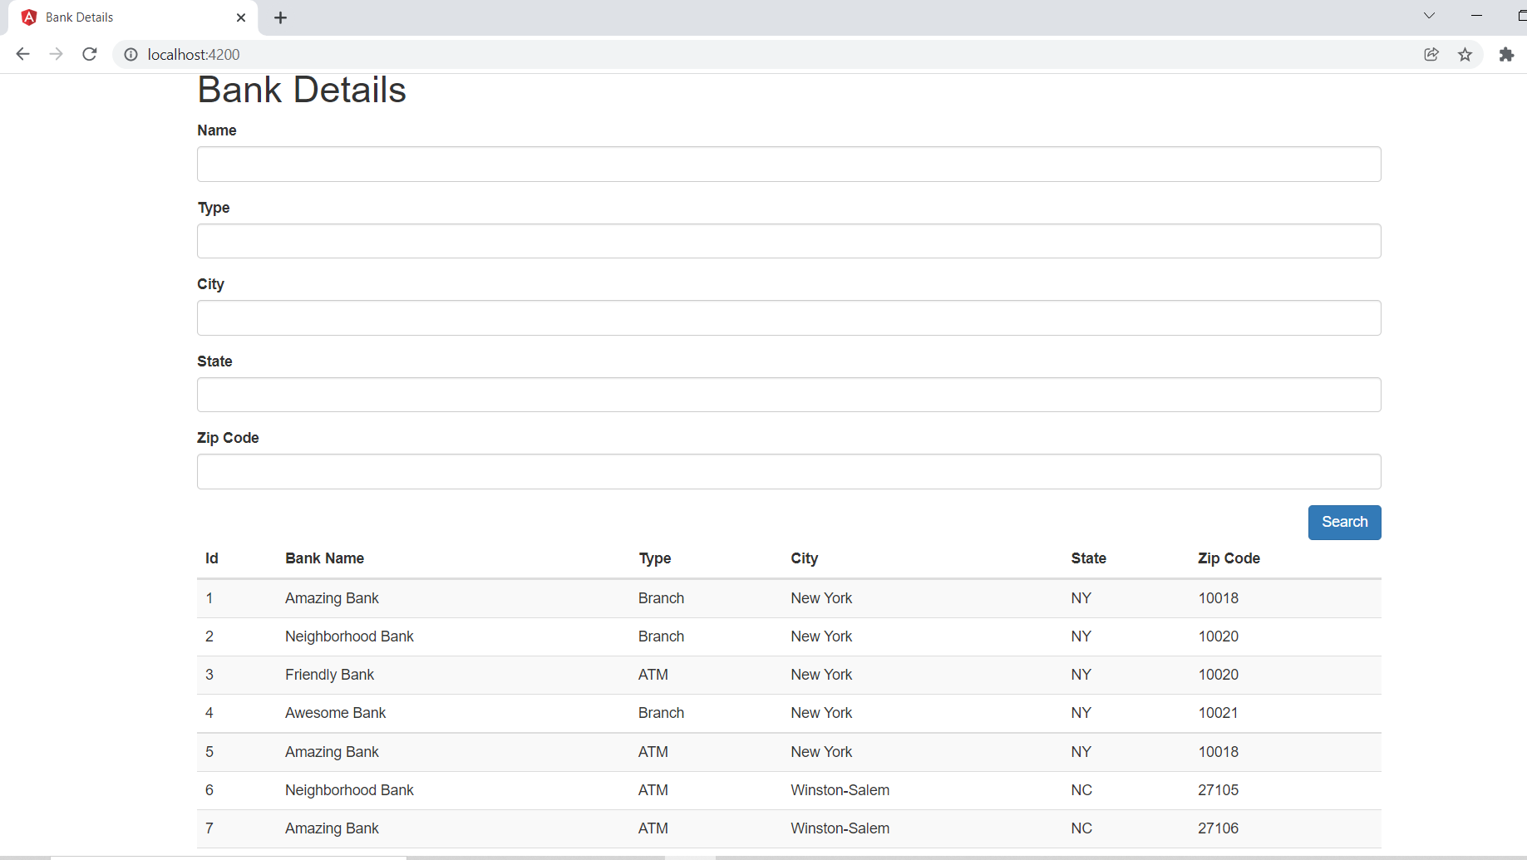

Search with Bank Name

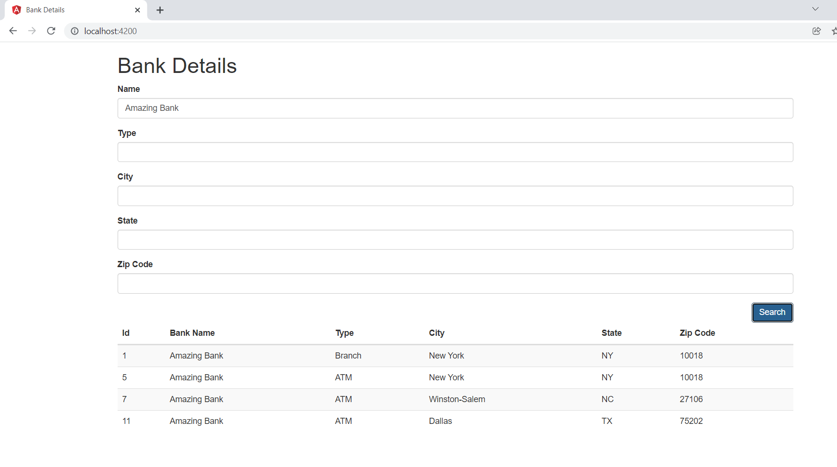

Search with Bank Name and State

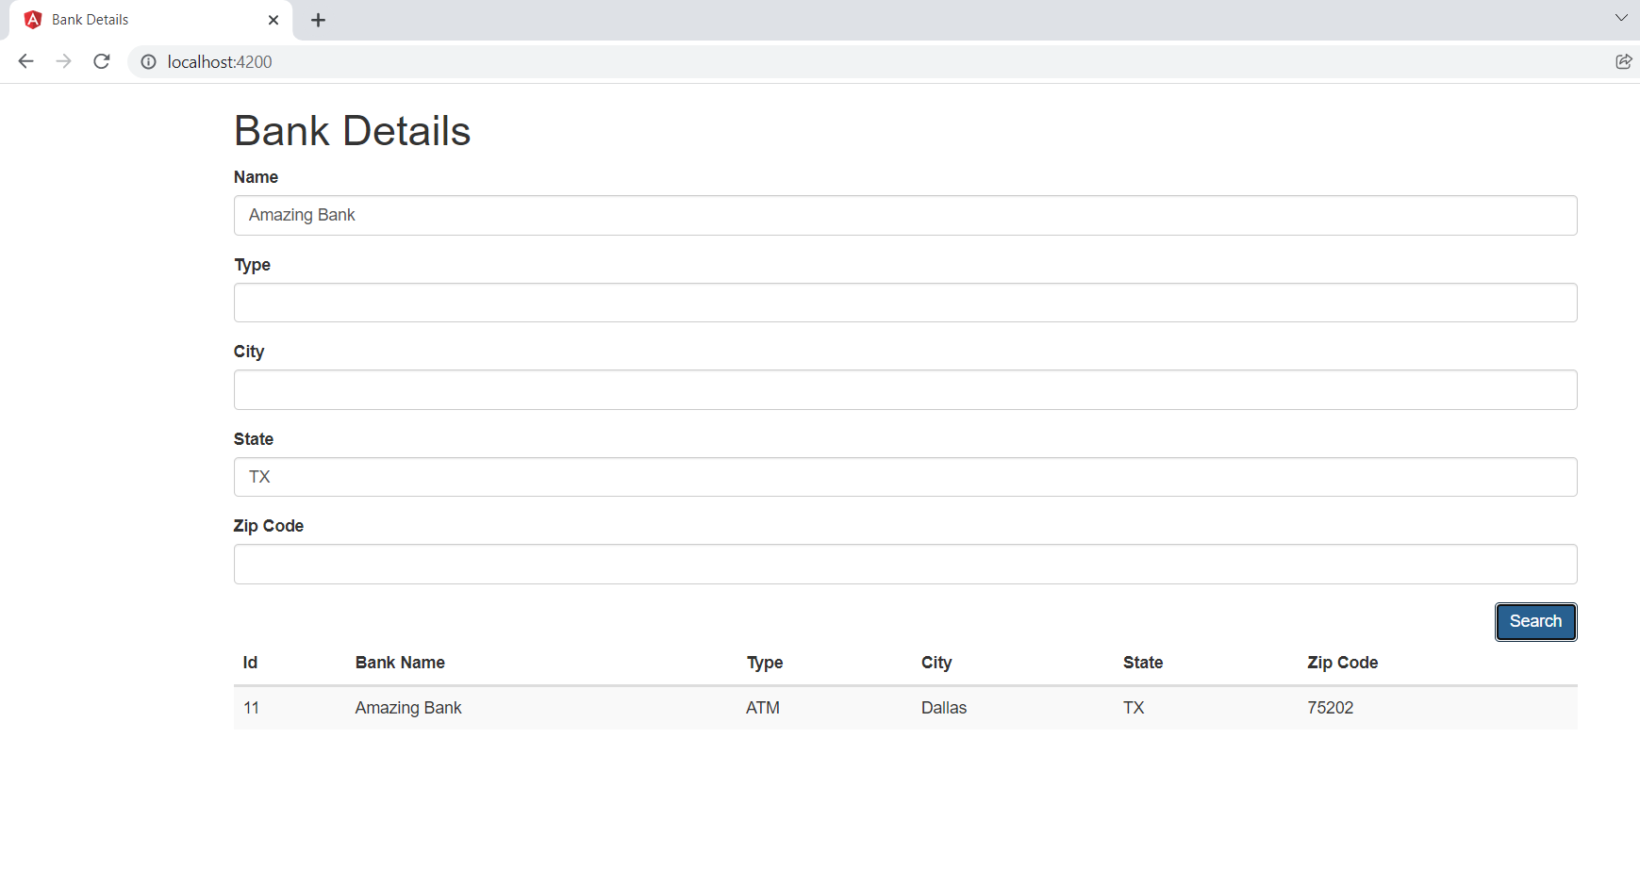

Search with Type and City

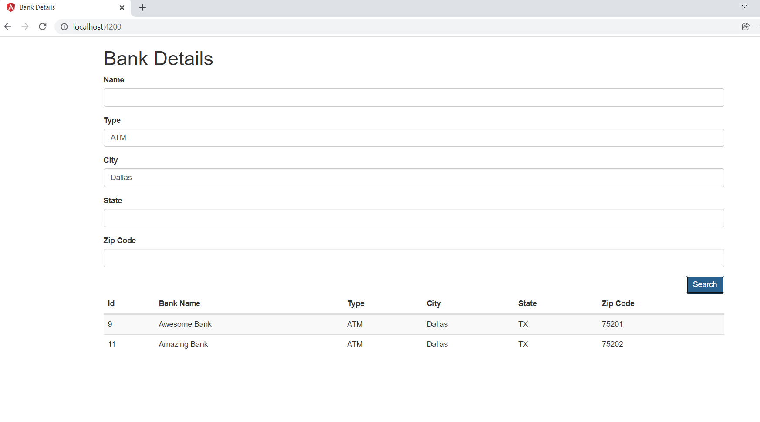

We can apply different combination of search filters.

Steps to run applications

**Backend :**

1. Goto “BankBackend” and do the mvn clean install
2. It will generate the jar file in target folder
3. Either run the application from eclipse or run the jar file from command line
4. From command line, mvn spring-boot:run

**Frontend:**

1. Goto “BankWeb” and do npm install
2. After successful of the 1st step, do ng serve

**For testcases ->** we can use junit for backend and Jasime, karma for frontend