**Project 2(150 pts. Due November 17, 2023, by 11:59pm)**

**Objectif of the project:**

1. **Be able to determine the solution technique that you will use to solve the given problem.**
2. **Be able to identify the data structures that fit your need in this problem.**
3. **Be able to analyze your algorithm.**

Before stating the problem, we give brief definitions. Let G= (V, E) be a simple connected graph with **n=|V|** vertices and **m=|E|** edged. We can color vertices of a given graph with different colors. The only restriction while coloring graph is:

*No two neighboring vertices can have the same color*.

**Example**: The following graph with 6 vertices.

This graph is colored 3 different colors. So, the graph is 3-colorable.

**Example**: The following graph is 2-colorable. All we need is two colors.

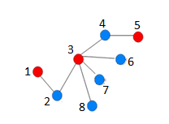

**Example**: The following graph is colored using 4 colors.

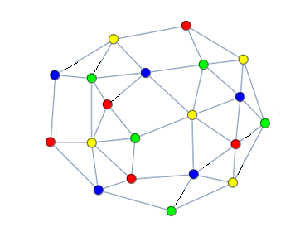



We can define color sequence as follows.

**Definition**: Let G be given connected simple graph which is colorable with k colors. Finite sequence $\left(n_{1},n_{2},..,n_{k}\right)$ is color sequence of the graph G in which $n_{1}≥n_{2}≥...≥n_{k}$ and color *j* is used ${ n}_{j}$.

**Definition: Almost Equal Color Sequence** is a color sequence $\left(n_{1},n_{2},..,n_{k}\right)$ such that:

$$\sum_{i=1}^{k-1}{|n_{i}-n_{i+1}|}$$

is minimum.

**Example 1**: Let us take the first graph as an example. There are two possible colorings with 3-colors.

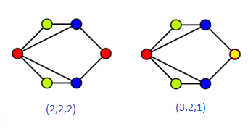

(2,2,2) is **almost equal coloring** **sequence** of the graph because |2-2| + |2-2|=0

**Example 2:**

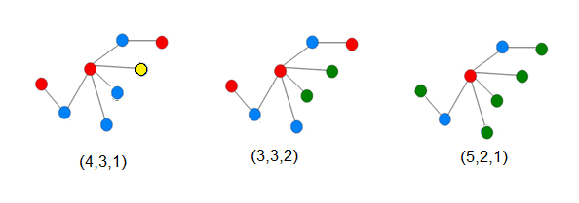

This graph has 8 vertices. If we use 3 colors, then (3,3,2) is the almost equal color sequence. If we use 2 colors, then we may have (5,3) almost equal color sequence.

**Example 3**: The third graph has (5,5,5,5) **almost equal color sequence** as you see in the above picture. Can you find almost color sequence with 3 colors? What it would be?

One of the applications of an almost equal color sequence is scheduling in a workplace like school where each instructor teaches the same number of courses (well almost).

**Problem**: For any given simple connected graph G. Find almost equal color sequence for given number of k-colors. If such a sequence exists, then your algorithm should return display:

1. The color sequence.
2. List of the vertices that have the same colors.

If no sequence exists, then your code should say “**no such a sequence exists.**”

For example, If the following graph G and color number k=3 are given

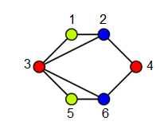

Then your code should display:

(2,2,2)

Blue : 2, 6

Red : 3, 4

Yellow : 1, 5

If the color number k=2 for the same graph above, then your code should display “**no such a sequence exists**”.

Input of your code is the graph G and integer k>0 color numbers. We will use adjacency matrix representation, that is, a two-dimensional 0-1 matrix. Input for the above example is:

3

6

0 1 1 0 0 0

1 0 1 1 0 0

1 1 0 0 1 1

0 1 0 0 0 1

0 0 1 0 0 1

0 0 0 1 1 0

The first number is the color number k=3. The second number, 6, is the size of the array. The last one is the two-dim array representing the graph G. Your code MUST read the input from a file. The adjacency matrix must have at least one white space between 0-1.

**Grading:**

**Describe which problem-solving techniques you have used (10 pts)**

**Describe the data structure you have used (10 pts)**

**List the major functions that you implemented (10 pts)**

**Complexity of your solution (30 pts)**

**Testing (100 pts)**