Lab 6: Complexation Reactions and EDTA Titrations

Introduction
Magnesium is the dominant divalent cation in hard water, and quantifying $[{\text{Mg}}^{2+}]$ matters for drinking-water standards, industrial scaling, and biological assays. I measured an unknown ${\text{MgCl}}_{2}$ solution two ways and compared them. EDTA titration with Calmagite gives an absolute, stoichiometric reading: EDTA’s $K_{f}$ for ${\text{MgY}}^{2-}$ ($∼{10}^{8.7}$) far exceeds Mg–Calmagite’s, so the indicator turns from wine-red to blue exactly when EDTA has matched the moles of ${\text{Mg}}^{2+}$, and the titrant volume is the answer. HQS fluorescence reads the same concentration from a calibration curve — faster and more sensitive, but only valid inside the calibrated fluorescence window and at pH ≈ 8. Running both lets each method’s working range and failure mode be tested against the same sample, which is what the cross-comparison is for.

Data Analysis

Part A

Q1. Overlaid absorbance spectra of Mg(II)/Calmagite at each titration point
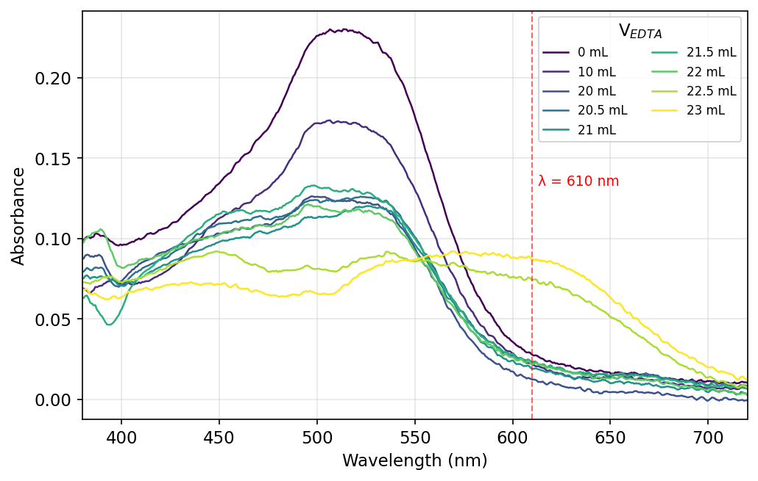
Figure 1. Absorbance of the 0.0100 M ${\text{MgCl}}_{2}$ solution at V = 0–23 mL of 0.0100 M EDTA. The wine-red Mg–Calmagite band at 510 nm decays and a blue free-Calmagite band rises near 610 nm; the dashed line marks $λ=610$ nm used in Q2.
The V = 28 mL spectrum was excluded: it shows $A_{500}=0.299$, higher than V = 0, which is impossible under dilution + Mg consumption (cuvette/sample handling error).

Q2. Absorbance at 610 nm vs. volume of EDTA added (Part A standardization)
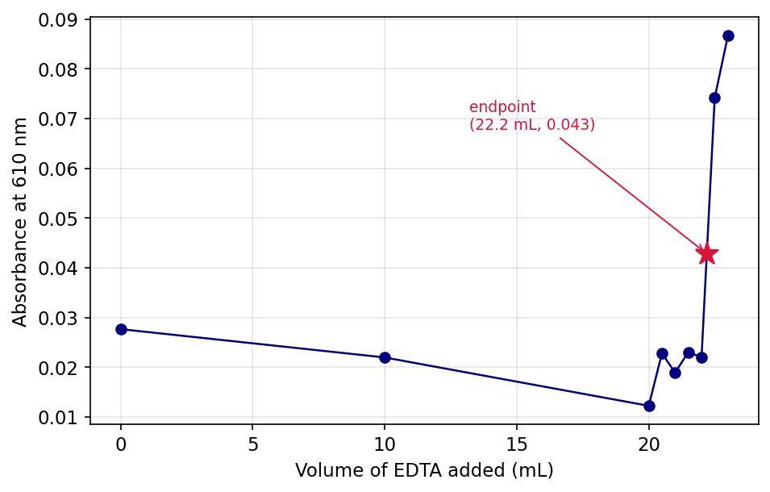
Figure 2. $A_{610}$ vs. V for the standardization. Baseline holds until V = 22 mL, then jumps as blue Calmagite forms; star marks the visual endpoint $(22.2 \text{mL},0.043)$.

Q3. Average [EDTA] and 95 % CI from shared Part A data
Three groups posted Part A endpoints: $V_{\text{eq}}=\{22.5, 22.7, 22.2\}$ mL. For each, $[\text{EDTA}]=(0.0100 \text{M})(25.00 \text{mL})/V_{\text{eq}}$:
$$[\text{EDTA}]_{i}=\{0.01111, 0.01101, 0.01126\} \text{M}$$
$\overset{‾}{x}=0.01113$ M, $s=1.25×{10}^{-4}$ M, $t_{0.05,2}=4.303$:
$$[\text{EDTA}]=\overset{‾}{x}±\frac{ts}{\sqrt{n}}=11.1±0.3 \text{mM}$$
Manual requested $≥5$ trials; only 3 groups have posted at the time of writing.

Part B

Q4. Overlaid absorbance spectra of unknown ${\text{MgCl}}_{2}$/Calmagite at each titration point
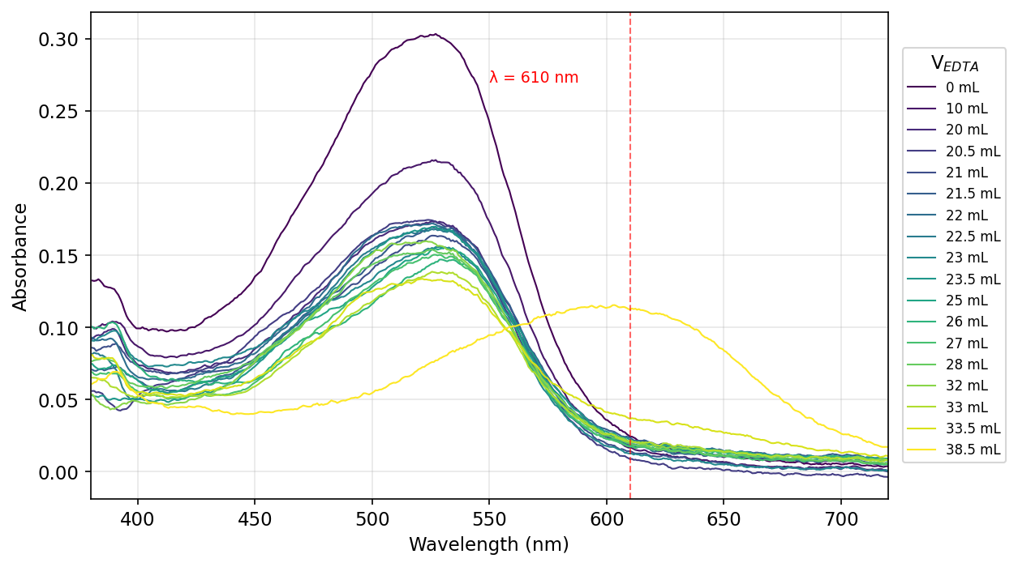
Figure 3. Absorbance of unknown ${\text{MgCl}}_{2}$ at V = 0–38.5 mL of 0.0113 M EDTA. The 525 nm Mg–Calmagite band dominates through V = 33.5 mL; at V = 38.5 mL it shifts to the blue free-Calmagite band at 603 nm. Dashed line: $λ=610$ nm.

Q5. Absorbance at 610 nm vs. volume of EDTA added (Part B unknown)
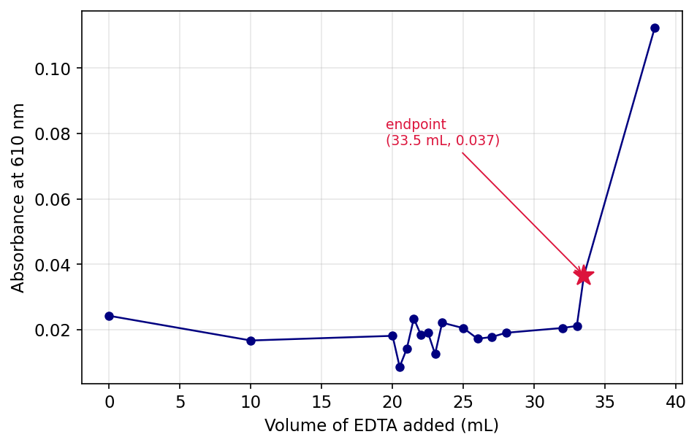
Figure 4. $A_{610}$ vs. V for the unknown. Baseline through V = 33.5 mL, jump to 0.11 at V = 38.5 mL; star marks the visual endpoint $(33.5 \text{mL},0.037)$.

Q6. Average $[{\text{MgCl}}_{2}]$ of unknown and 95 % CI from shared Part B data
Three groups posted Part B endpoints: $V_{\text{eq}}=\{33.0, 34.0, 33.5\}$ mL. Using the Q3 average $[\text{EDTA}]=0.01113$ M:
$$[{\text{MgCl}}_{2}]_{\text{unk},i}=\frac{(0.01113 \text{M})⋅V_{\text{eq}}}{25.00 \text{mL}}=\{0.01469, 0.01513, 0.01491\} \text{M}$$
$\overset{‾}{x}=0.01491$ M, $s=2.22×{10}^{-4}$ M:
$$[{\text{MgCl}}_{2}]_{\text{unk}}=14.9±0.6 \text{mM}$$
Only 3 groups posted; manual requested $≥5$.

Part C

Q7. Absorbance spectrum of the Mg(II)/HQS solution
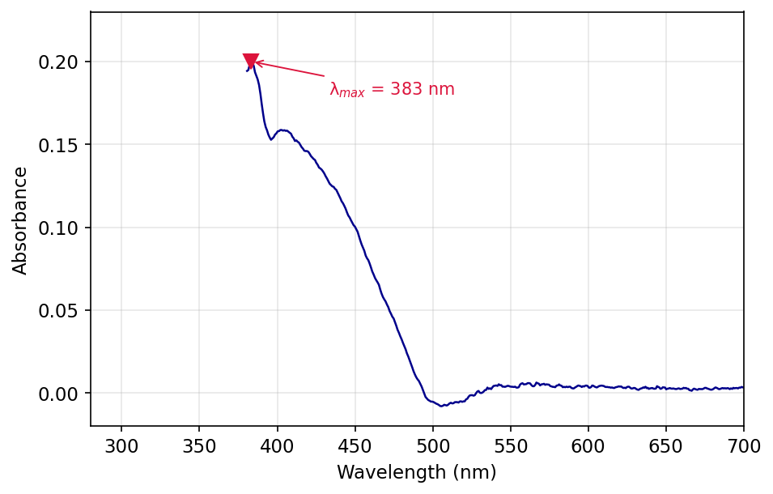
Figure 5. Absorbance of the unknown Mg–HQS solution. $λ_{max}=383$ nm with a shoulder near 405 nm.

Q8. Choice of $λ_{\text{excitation}}$ (405 nm vs. 500 nm)
405 nm: $A_{405}=0.16$ while $A_{500}≈0$, so the Mg–HQS complex absorbs at 405 nm but not at 500 nm.

Q9. Fluorescence spectrum of the unknown ${\text{MgCl}}_{2}$/HQS solution
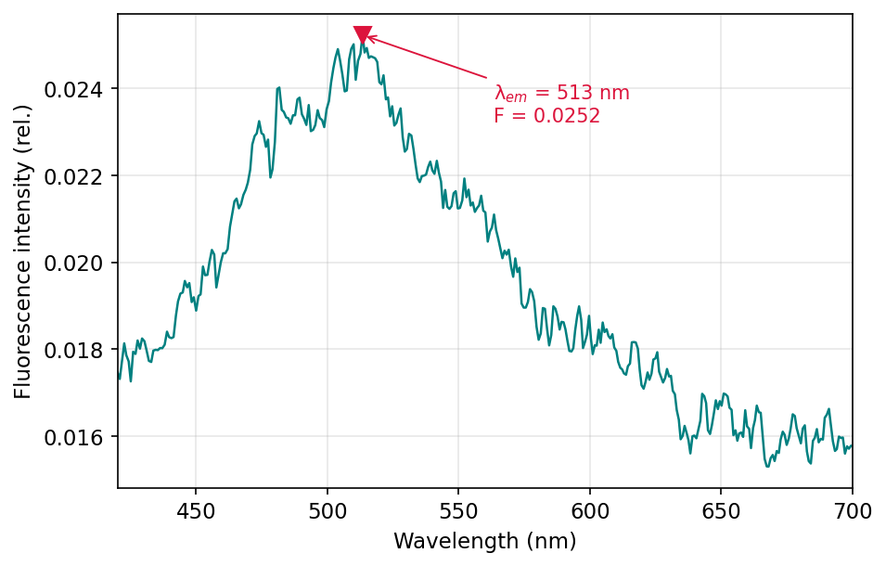
Figure 6. Fluorescence emission at $λ_{\text{exc}}=405$ nm: $λ_{\text{em}}=513$ nm, peak intensity 0.0252 (rel.). All three of my replicate readings (0.0233, 0.0243, 0.0252) fell below the 0.032–0.085 calibration window.

Q10. Mg–HQS fluorescence calibration curve
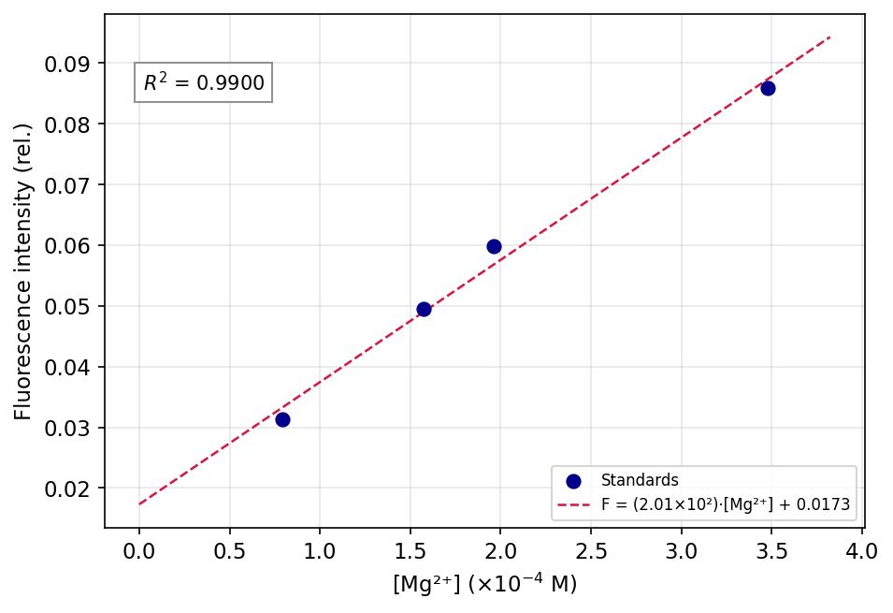
Figure 7. Calibration: $F=(2.01×{10}^{2} {\text{M}}^{-1})[{\text{Mg}}^{2+}]+0.0173$, $R^{2}=0.990$. Concentrations were back-calculated from the 0.0100 M ${\text{MgCl}}_{2}$ stock diluted into HQS, e.g. $(0.0100)(0.8)/(0.8+100)=7.94×{10}^{-5}$ M.

Q11. Slope and intercept with 95 % CI
For $n=4$, df = 2, $t_{0.05,2}=4.303$. Regression statistics: $s_{y|x}=2.79×{10}^{-3}$, $∑(x_{i}-\overset{‾}{x})^{2}=3.80×{10}^{-8} {\text{M}}^{2}$, giving ${SE}_{m}=14.3 {\text{M}}^{-1}$, ${SE}_{b}=3.12×{10}^{-3}$.
$$m=(2.0±0.6)×{10}^{2} {\text{M}}^{-1} b=0.02±0.01$$

Q12. Average $[{\text{MgCl}}_{2}]_{\text{unk}}$ and 95 % CI from fluorescence
Three groups posted Part C fluorescence values (each with the same 0.5 mL / 25.0 mL HQS dilution): $F=\{0.02170, 0.02166, 0.02430\}$. Inverse-regress each through $[{\text{Mg}}^{2+}]_{\text{dil}}=(F-b)/m$, then apply the 51× back-dilution factor:
$$[{\text{MgCl}}_{2}]_{\text{unk},i}=\frac{(F_{i}-0.01730)}{201.4 {\text{M}}^{-1}}×51.0=\{1.11, 1.10, 1.77\}×{10}^{-3} \text{M}$$
$\overset{‾}{x}=1.33×{10}^{-3}$ M, $s=3.83×{10}^{-4}$ M:
$$[{\text{MgCl}}_{2}]_{\text{unk}}=1.3±1.0 \text{mM}$$
Only 3 groups posted; manual requested $≥5$. The wide CI reflects the third group’s outlier-high $F$, and that all three measurements fell below the calibration window.

Discussion

Q13. Percent error for each method
$[{\text{MgCl}}_{2}]_{\text{true}}=0.0150$ M
EDTA: $\%\text{err}=|0.01491-0.0150|/0.0150×100\%=0.6\%$. HQS: $\%\text{err}=|0.00133-0.0150|/0.0150×100\%=91\%→90\%$ (1 sf). EDTA was the more accurate method.

Q14. One hypothesized source of error for each method
EDTA: $±0.2$ mL uncertainty on the visual endpoint over a $∼33$ mL titration is $∼0.6\%$ — accounts for the observed deviation.
HQS: all three measured intensities fell below the lowest calibration standard (0.031), so each back-calculation is an extrapolation. The 51× dilution factor amplifies any small offset (pH drift from 8, incomplete mixing of the 0.5 mL aliquot) into a large concentration error.

Q15. State of ${\text{Mg}}^{2+}$ before, during, and after the EDTA endpoint (Parts A/B)
Before EDTA: ${\text{Mg}}^{2+}$ is mostly aquated, with a small fraction bound to Calmagite as the wine-red complex. During titration: EDTA scavenges free ${\text{Mg}}^{2+}$ first (its $K_{f}$ exceeds water’s and Calmagite’s), then strips ${\text{Mg}}^{2+}$ off Calmagite into colourless ${\text{MgY}}^{2-}$. After the endpoint: all ${\text{Mg}}^{2+}$ is locked into ${\text{MgY}}^{2-}$, Calmagite reverts to its blue free form, and excess EDTA stays unreacted.

Q16. State of ${\text{Mg}}^{2+}$ before and after HQS is added (Part C)
Before HQS: ${\text{Mg}}^{2+}$ is aquated as $[\text{Mg}({\text{H}}_{2}\text{O})_{6}]^{2+}$, non-fluorescent. After HQS: it chelates ${\text{Mg}}^{2+}$ through phenolate-O and pyridine-N to form rigid ${\text{Mg(HQS)}}_{2}$, whose locked geometry suppresses non-radiative decay and emits at 513 nm under 405 nm excitation.

Instrumentation

Q17. What is HQS, and how is it different from EDTA?
HQS (8-hydroxyquinoline-5-sulfonic acid) is a bidentate chelator that forms fluorescent complexes with ${\text{Mg}}^{2+}$ through phenolate-O and ring-N. EDTA is a hexadentate chelator with much higher $K_{f}$ ($∼{10}^{8.7}$ vs. $∼{10}^{4-5}$ for Mg–HQS), so EDTA is used as the stoichiometric titrant; HQS is used as the spectroscopic probe — fluorescence, not binding strength, is the readout.

Q18. Why use a buffer in Parts A and B, and why check the pH in Part C?
Only fully deprotonated ${\text{Y}}^{4-}$ chelates ${\text{Mg}}^{2+}$ effectively, so higher pH favours the reaction — but above pH 10, ${\text{Mg}}^{2+}$ precipitates as ${\text{Mg(OH)}}_{2}$. The ${\text{NH}}_{4}\text{OH}$ buffer holds Parts A/B at pH 10 to maximise $[{\text{Y}}^{4-}]$ without losing Mg to hydroxide. In Part C, Mg–HQS fluorescence intensity is sharply pH-dependent and peaks at pH 8, so the pH paper check confirms the unknown sits in the same window as the calibration standards.

