Raspberry Pi Based Sprinkler Controller

Design Description
and
User’s Manual
09-Feb-2026

Table of Contents
Introduction 3
List of Hardware Components 3
Location of Software Components 3
List of Software Files 4
Wiring Diagrams 5
Software Operational Overview 7
Configuration File Setup 7
Accessing the RPi Desktop and Connecting to a Wi-Fi Network 7
Accessing the RPi Terminal Window 9
Editing the Configuration File with the Built-In Nano Editor. 9
Copying Files from the RPi to a Flash Drive. 10
Starting the Server Manually 10
Starting the Server Automatically at Boot Time 11
Starting the Command Line Client 12
Starting the GUI Client 14
Memory Utilization 16
Appendix 1. A Python Based Client-Server Architecture 17
Introduction 17
Overview of Client/Server Architectures 17
Closing a Client and Stopping the Server 17
Server’s Handling of Unexpected Events 18
Connection Types 19
A Potential Pitfall – Firewall 20
Functional Call Tree 22
Appendix 2. SSH, SCP and other Handy RPi Commands 23
Installing Python3 23
Installing Python Packages 23
Enabling SSH Sessions 23
Establishing and Closing SSH Sessions: 24
Copying Files to/from an RPi Using SCP: 24
Setting up an SSH/SCP Pass Key: 24
Enabling NTP Synchronization: 25
Determining Currently Running Python Scripts: 25
Determining Open TCP Ports: 25

Table of Figures
Figure 1. Functional Wiring Diagram 5
Figure 2. Physical Wiring Diagram 6
Figure 3. Relay Board Wiring 7
Figure 4. Raspberry Pi Connection Points 8
Figure 5. Raspberry Desktop 8
Figure 6. ifconfig Command Output Screenshot 9
Figure 7. Example cfg.cfg File Screenshot 10
Figure 8. Example ps Command Output Screenshot 10
Figure 9. Crontab Screenshot 11
Figure 10. Command Line Client Screenshot 13
Figure 11. GUI Client Screenshot 1 14
Figure 12. GUI Client Screenshot 2 14
Figure 13. GUI Client Screenshot 3 15
Figure A15. Connection Types 19
Figure A16. Functional Call Tree 22

Table of Photographs
No table of figures entries found.

Introduction
This document covers the hardware and software for a Raspberry Pi sprinkler controller. It details how to build and operate the device.

List of Hardware Components
Hardware components, with Amazon links, are listed below.
Item Link Comment
- Raspberry Pi 4B (RPi): RPi -
- RPi SD card (OS): SD_Card Download SD OS imager here
- RPi Power Supply: PWR -
- Expansion Board: ExpBrd
- AC Pwr Supply ACpwr

Location of Software Components
This document and (most of) the sprinkler’s software can be found here:
https://github.com/sgarrow/sprinkler2
Some of the sprinkler’s code is common with another, second, project. To prevent having to copy/paste changes/bug-fixes back and forth between projects, this common code resides in a third project. The common code can be found here:
https://github.com/sgarrow/sharedClientServerCode
Just as a matter of completeness the above-mentioned second project that also uses the shared code is an RPi sprinkler controller. Its documentation and (most of) its software can be found here:
Both the clock and sprinkler run within a client/server architecture. It is the Client and Server files/functionality that are common.
https://github.com/sgarrow/spiClock

List of Software Files
+--spirinkler2 --+ ALL CODE RESIDES IN THIS ROOT DIRECTORY.
| client.py | Only these files need to be on the client machine.
| clientCustomize | The last 2 (cfg.*) also need to be on the server
| gui.py | machine (RPi). Cfg.cfg contains IP addresses, etc.,
| cfg.py | that need to be shared between the client/server
| cfg.cfg | Files below only need to be on the RPi.
| |
| server.py | Clients send commands, via a socket, to the server.
| serverCustomize.py | The server looks up the command in a dictionary and
| cmdVectors.py | vectors to the worker function. In the dictionary,
| | the command string serves as the “key” and the
| | associated “value” is the worker function.
| |
| config.yml | Contains the profiles.
| |
| initRoutines.py |
| profileRoutines.py |
| relayRoutines.py |
| runActProfRtns.py |
| timeRoutines.py |
| utils.py |
| fileIO.py |
| rpiShellCmds.py --+

Note: the bold underlined files are in the shared GitHub Repository, the remaining files are in the sprinkler repository.

Wiring Diagrams

Wiring diagrams are provided below.
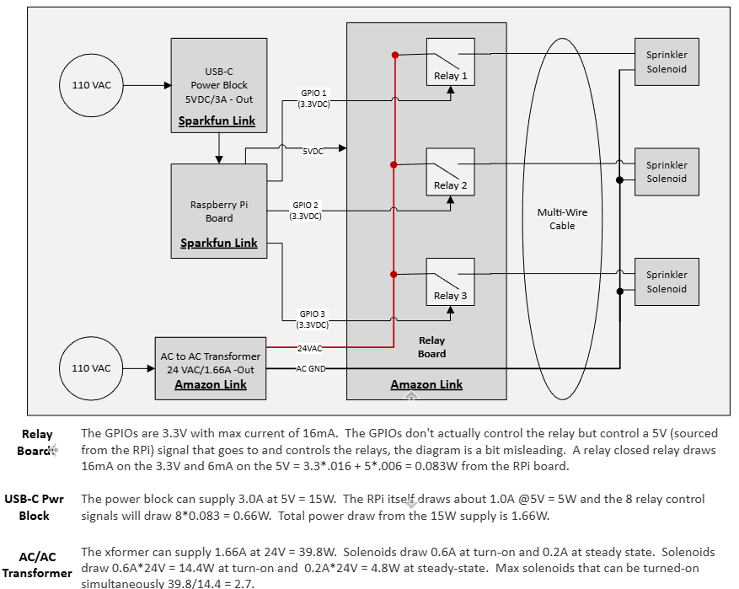
Figure 1. Functional Wiring Diagram

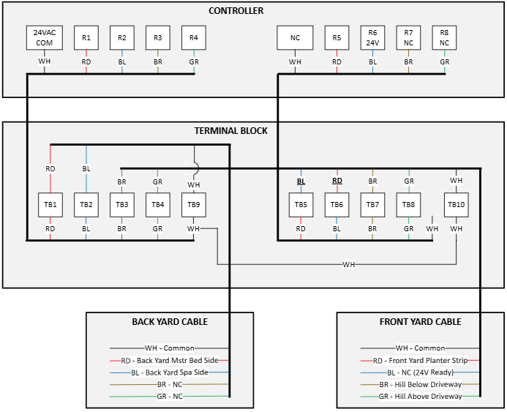
Figure 2. Physical Wiring Diagram

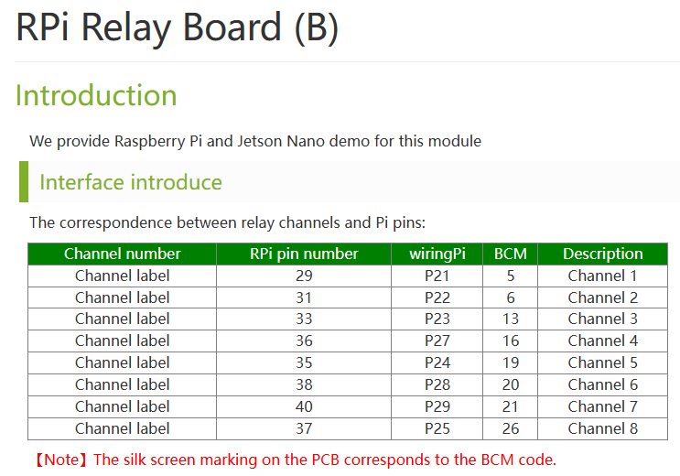
Figure 3. Relay Board Wiring

Software Operational Overview
The RPi runs two programs: a server and a sprinkler controller. A remote client (on a PC or phone) connects via socket over LAN or the internet to send commands. The server relays these commands to the controller for control. See Appendix 1 for details on this implementation.

Configuration File Setup
The client and server must share details like IP address and port numbers to communicate. Users need to enter this information in cfg.cfg.

Accessing the RPi Desktop and Connecting to a Wi-Fi Network
The file cfg.cfg is stored on the RPi’s Solid-State Drive. To edit it, connect an HDMI display and keyboard/mouse to the RPi as shown in Figure 4, then power on the device and access the desktop.
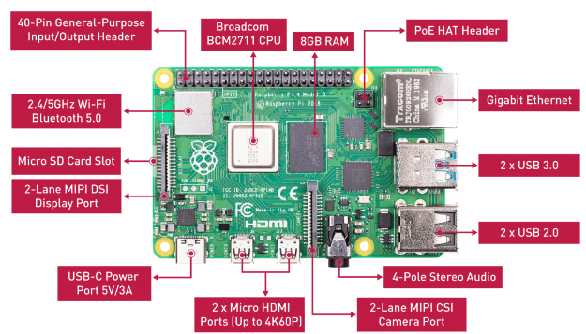
Figure 4. Raspberry Pi Connection Points
Once the display and mouse/keyboard are connected apply power via the USB-C connector. Once the RPi has booted the desktop shown in Figure 5 will be displayed.

Figure 5. Raspberry Desktop

Click the Wi-Fi icon, designated above by a single arrow on the right-hand side, select the Wi-Fi network and enter the password. Henceforth the RPi will automatically connect to this network whenever it is available.

Accessing the RPi Terminal Window
After connecting to the LAN, open a terminal by clicking on the icon, designated above by the double arrow, and enter the command ifconfig. An example output of the ifconfig command is shown in Figure 6. Take note of the inet address as it will be added to cfg.cfg.
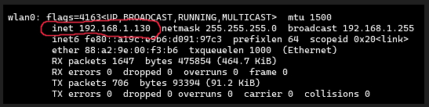
Figure 6. ifconfig Command Output Screenshot

Editing the Configuration File with the Built-In Nano Editor.
In a terminal window, enter the following command to navigate to the appropriate RPi directory:
cd python/sprinkler2
The following command opens cfg.cfg in the nano editor (mouse doesn’t work use arrow keys):
nano -e cgf.cfg Note: An example cfg.cfg is provided in Figure 7.
Edit an existing line or add a new line. The RPi name will be entered when starting the server (on the RPi) and when starting the client (on a remote machine, either a PC or a phone).
Enter a port number. Ports between 8000 and 9000 are safe to use. Enter the Lan address obtained by the ifconfig command. Enter your router’s IP address. The router IP address can be obtained via website www.whatismyip.com. Choose an enter your desired password.
Note that the password contained in the cfg.cfg file is the password that the client will send to the server when attempting to establish a connection. It is not the “user” password for the RPi itself. The RPi password for the RPi itself is used when, for example, when attempting, to establish an SSH connection to the RPi.
Save the file by entering the following commands:
ctrl-x # To begin the editor exiting process.
Y # Answer to the “save-file” prompt.
<RETURN> # Answer to the “save as cfg.cfg” (default) prompt.

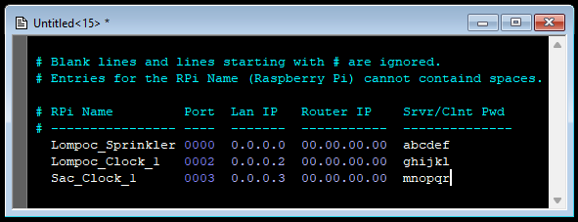
Figure 7. Example cfg.cfg File Screenshot

Copying Files from the RPi to a Flash Drive.
As mentioned in section 1.3, there are six files that need to be placed on the machine that will run the client. Insert a Flash Drive into a USB Port on the RPi and, using the RPi File Explorer (click on the File Explorer Icon designated be the dotted arrow in Figure 5. Raspberry Desktop), copy the following six files to it:
client.py, clientCustomize.py, gui.py, cfg.py, cfg.cfg

Starting the Server Manually
Start the server on the RPi by entering the following command in an RPi terminal window:
python3 server.py <RPi Name>
Replace <RPi Name> with the appropriate name from the cfg.cfg file.
Note that the RPi may be configured to start the server automatically at boot time. If so, attempting to start the server manually will not work – an error message displayed. If this error occurs, then the server must be terminated by either using the “kill” command or by running the client directly on the RPi.
To use the kill command the Process IDs (pid) of the server must first be determined. To determine the pids issue the following command in an RPi terminal:
ps aux | grep python
An example output of this command is shown in Figure 8, below.
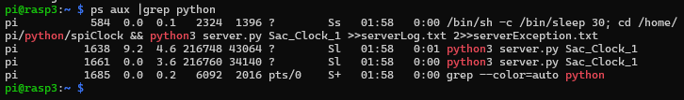
Figure 8. Example ps Command Output Screenshot
Note there are two lines associated with server.py (their pid are 1638 and 1661). There are two (or possibly more) pids because of the multi-processing nature of the server/clock – both processes must be killed. Kill the processes with the following two commands (substitute the pids with those shown on the actual output):
kill -9 1638
kill -9 1661
To terminate the server with the client instead issue the following command in the appropriate directory (probably /python/sprinkler2, use the cd cmd to navigate there) in an RPi terminal window:
python3 client.py Lompoc_Sprinkler
Replace Lompoc_Sprinkler as appropriate from the output of the ps command. Once the client connects issue the “ks” command.

Starting the Server Automatically at Boot Time
Cron is a shell command for scheduling a job (i.e., command or shell script) to run periodically at a fixed time, date, interval, or at boot-time.
Open the cron scheduling file for editing on the RPi enter the following command in a terminal window:
crontab -e
Add the line shown at the bottom of the screenshot provided in Figure 9 and then save the file by entering the following commands:
ctrl-x # To begin the editor exiting process.
Y # Answer to the “save-file” prompt.
<RETURN> # Answer to the “save as” prompt.
Cycle power to the RPi and the sprinkler will start after about 30 seconds. The 30 sleep is required to ensure that the RPi has completely booted (including connecting to the Wi-Fi) before the server script is started.
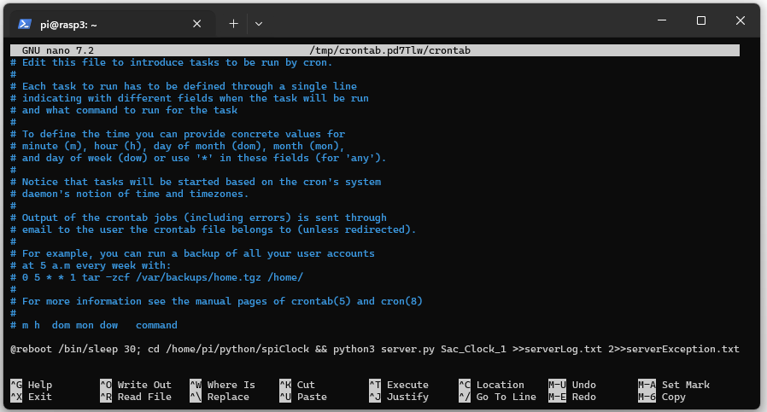
Figure 9. Crontab Screenshot

Starting the Command Line Client
Start the command line client on a remote machine by entering the following command:
python client.py <id>
Replace <id> as appropriate, see Section “Configuration File”, below.
Once the server accepts the connection a prompt is presented. Enter ‘m’ at the prompt to get a list of available commands. A screen shot of this is provided in Figure 10, below.
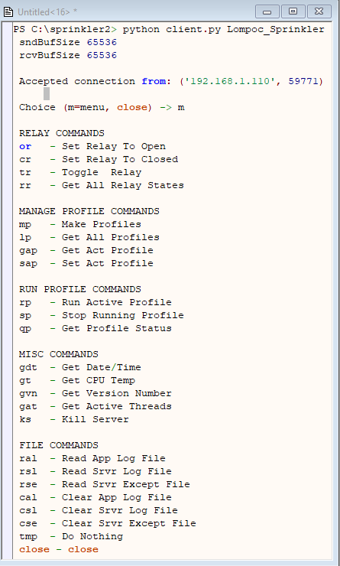
Figure 10. Command Line Client Screenshot

Starting the GUI Client
Start the GUI client with the following command:
python gui.py.
When the screen shown in Figure 11 is displayed, click on the appropriate UUT (this is the equivalent of the <id> parameter specified when starting the Command Line Client). Note that the list of available UUTs will be those listed in the cfg.cfg file.
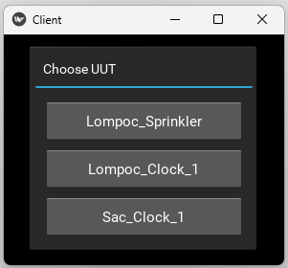
Figure 11. GUI Client Screenshot 1
Once a UUT is selected the screen shown in Figure 12 will be displayed. Select the desired/appropriate connection type.
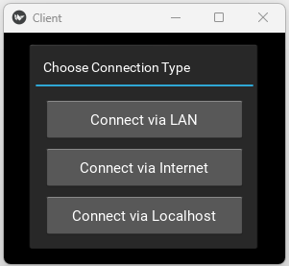
Figure 12. GUI Client Screenshot 2

When the GUI client is started and a connection is accepted by the server the ‘m’ command is automatically issued. The response is used to populate the GUIs buttons (GUI is ‘built’ at run time). A screen shot of the GUI is provided in Figure 13, below.
The ‘build at run time' architecture is what allows the sprinkler and clock applications to use the same GUI.
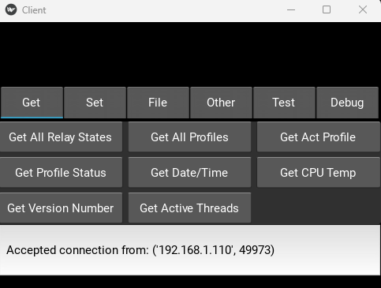
Figure 13. GUI Client Screenshot 3

Memory Utilization
The Amazon Link provided earlier for the RPi is a link to a 4GB (RAM) version of the RPi. However, the application can run on a 1GB version. Below is a screen capture of the output of four issuances of the free --mega Linux command. The first command was issued right after boot where only the OS is running, the second after the server was started, the third after a client was connected and the fourth after the sprinkler was started.
The data shows that after everything is up and running there is still over 76MB of free RAM. Plenty for dozens of more clients to connect.

pi@rasp3:~ $ free --mega # After Boot
total used free shared buff/cache available
Mem: 950 359 152 24 520 591
Swap: 536 0 536
pi@rasp3:~ $ free --mega # After Starting Server
total used free shared buff/cache available
Mem: 950 389 100 24 542 560
Swap: 536 0 536
pi@rasp3:~ $ free --mega # After Connecting Client
total used free shared buff/cache available
Mem: 950 387 102 24 542 562
Swap: 536 0 536
pi@rasp3:~ $ free --mega # After Starting Sprinkler
total used free shared buff/cache available
Mem: 950 410 76 24 545 539
Swap: 536 0 536
pi@rasp3:~ $

Appendix 1. A Python Based Client-Server Architecture

Introduction
This client-server architecture is written in the Python programming language. A client-server architecture is a structure where multiple clients request services from a centralized server and separates user interaction from data processing.
To start the server type "python server.py <device>" on the command line.
To connect a command line client to the server type "python client.py <device>" on the command line.
To connect a GUI client to the server type "python gui.py" on the command line.
A client can be run on the same machine as the server (in a different command window) or on a different machine entirely.

Overview of Client/Server Architectures
Servers are things that respond to requests. Clients are things that make requests.
A web browser is a type of client that can connect to servers that "serve" web pages - like the Google server.
When a web browser (a client) connects to the Google Server and sends it a request (e.g., send me a web page containing a bunch of links related to "I'm searching this") the Google Server will respond to the request by sending back a web page.
Requests are sent in "packets" over connections called "sockets". Included in the request is the IP address of the client making it - that is how the server knows where to send the response back to. A given machine has one IP address, so if more than one instance of a web browser is open on a single machine how is it that the response ends up in the "right" web browser and not the other browser? Port number.

Closing a Client and Stopping the Server
Every client has a unique (IP, port) tuple. The server tracks every client by (IP, port). The server maintains a list of (IP, port) for all active clients.
Each client has two unique things associated with it - (1) a socket and (2) an instance (a thread) running the client's handling function.

When a client issues a "close" command, its (IP, port) is removed from the list and as a result the handleClient’s infinite loop is exited thereby causing its socket to be closed and its thread to terminate.
When a client issues a "ks" (kill server) command, not only does that client terminate but all other clients terminate as well. Furthermore the "ks" command causes the server itself (it is still waiting for other clients to possibly connect) to terminate.

Upon receipt of the ks command the server (1) sends a message to all clients (including the one sent the command) indicating that the server is shutting down so that the client will exit gracefully, (2) terminates all clients and then finally (3) the server itself exits.
Additional details related to client connection types and to function calling sequences are provided in figures 1 and 2.

Server’s Handling of Unexpected Events
If a user clicks the red X in the client window (closes the window) that client unexpectedly (from the server's viewpoint) terminates. This contrasts with the client issuing the close or ks command where the server is explicitly notified of the client's termination. An unexpected termination results in a sort of unattached thread and socket that may continue to exist even when the server exits. This situation is rectified by two try/except blocks in function handleClient. Two are needed because it was empirically determined the Window and Linux systems seem to block (waiting for a command from the associated client) in different places.

Connection Types
Clients can connect to the sever under three different scenarios as described in Figure A15.
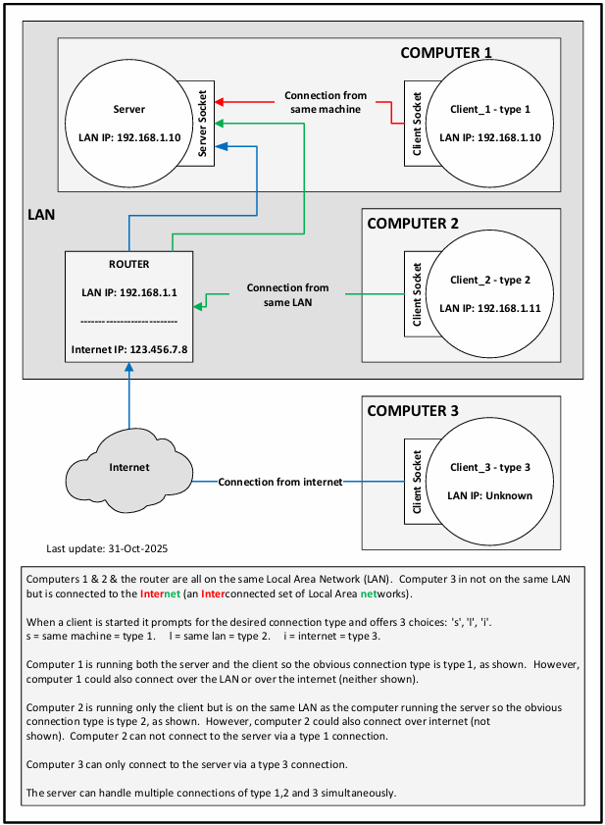
Figure A15. Connection Types
For connection type 2, in addition to the port number, the IP of the server needs to be known. The address can be found via the ifconfig command in a command window open on the machine that will be running the server.
For connection type 3, in addition to the port number, the external IP of the router needs to be known. The router’s external IP address can be found using by going to the following web page on a browser: https://whatismyipaddress.com/
The use of connection type 3 also requires port forwarding to be set up on the router. An example is shown below. The example shows forwarding port 1234 (substitute 1234 with whatever port is configured) to port 1234 for IP address 192.168.1.10. Substitute 192.168.1.10 with whatever the IP address of the machine running the server is. Again, this address can be obtained via use of the ipconfig command. Since only one port number needs to be forwarded the start and end port numbers are the same.
It seems weird that a port number needs to be forwarded to that same number, but it does.
Service Name | External Start Port | External End Port | Internal Start Port | Internal End Port | Internal IP address
My Service Name | 1234 | 1234 | 1234 | 1234 | 192.168.1.10

A Potential Pitfall – Firewall
The above was all initially done with the server running on a Raspberry Pi. The Raspberry Pi runs Linux and by default its firewall is disabled. As such, all connection types worked only by performing the “SOME ASSEMBLY REQUIRED” steps outlined above.
On windows to get all connection types working, specifically connection type 3, the Windows firewall will need to be changed to allow incoming python TCP connections.
These are the basic steps:
Control Panel\System and Security\Windows Defender Firewall --->
Advanced settings ---> Connection Security Rules ---> Inbound Rules
Screen shots for these various steps are provided below.
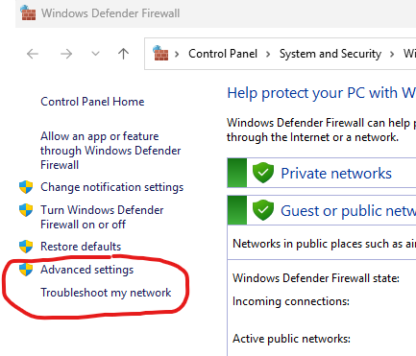
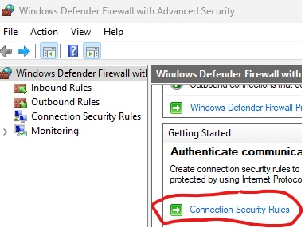
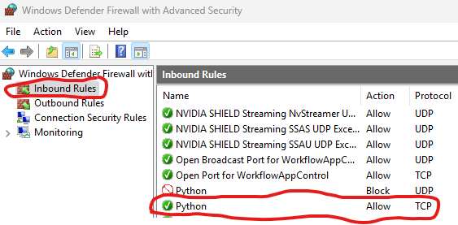
Right click on the Incoming Rule for Python TCP Protocol, select the General Tab, and change to Allow the connection.
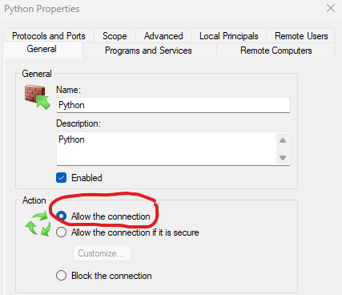

Functional Call Tree
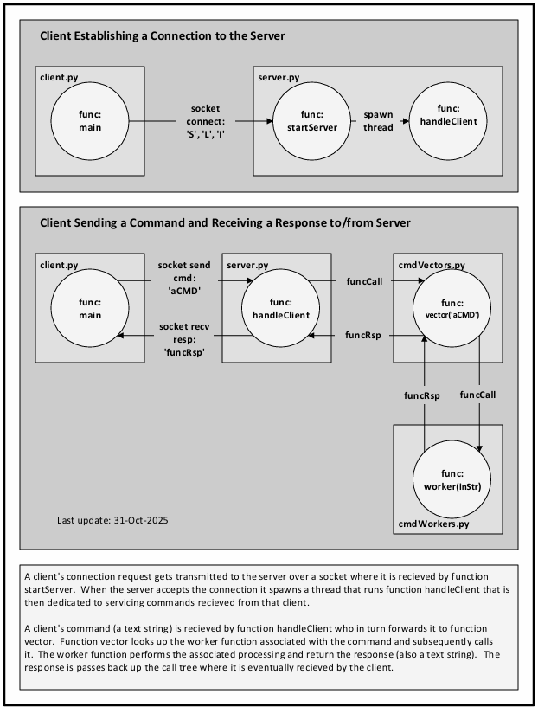
Figure A16. Functional Call Tree

Appendix 2. SSH, SCP and other Handy RPi Commands

Installing Python3
Most Linux distributions, including the Raspberry Pi distribution, come with python 2, not python 3 installed. To install python 3 on the Raspberry Pi, issue the following commands in a terminal window on the RPi:
Sudo apt update
sudo apt install python3 idle3

Installing Python Packages
Most python packages are installed using “pip.” yaml (Yet Another Markup Language) is an exception. To install yaml use the following command:
sudo apt install python3-yaml
To upgrade pip (Pip Installs Packages) to the latest version issue the following command:
python3 -m pip install --upgrade pip
To install a typical python package using pip use the following command:
pip install <package_name>

Enabling SSH Sessions
Opening a terminal on your Raspberry Pi is simple, but you need to have a monitor, keyboard, and mouse connected directly to it. If your Raspberry Pi and a remote PC are both on the same local network—or connected with an Ethernet cable—you can access a Raspberry Pi terminal window on your PC using SSH (Secure Shell). By default, SSH is disabled. To enable it, follow the steps below. Once SSH is enabled, it will stay enabled even after restarting the device.
Connect: Your Raspberry Pi to a monitor, keyboard, and mouse.
Open: The Raspberry Pi Configuration tool: Click the Raspberry Pi icon (menu) > Preferences > Raspberry Pi Configuration.
Navigate: To the "Interfaces" tab.
Enable: SSH: Select "Enabled" next to the SSH option.
Click: "OK" to save the changes.
Reboot: The Raspberry Pi for the changes to take effect.

Establishing and Closing SSH Sessions:
The command to start an SSH session varies by connection type—Ethernet or LAN. For LAN, use the RPi's IP address, which you can find by running `ifconfig` on a terminal window directly on the RPi with a monitor, keyboard, and mouse.
Establishing a connection over ethernet cable: ssh pi@raspberrypi.local
Establishing a connection over LAN: ssh pi@12.34.56.78
Closing a connection: ~.

Copying Files to/from an RPi Using SCP:
SCP (Secure Copy Protocol) is a command-line utility used for secure file transfers over a network. Again, use the RPI’s actual IP address in the command.
Copy a specified file from PCs current directory to a specified RPi directory:
scp .\myFile.py pi@12.34.56.78:~/python/spiClock
Copy all .py files from PCs current directory to a specified RPi directory:
scp *.py pi@12.34.56.78:~/python/spiClock
Copy a specified file from the RPi PCs to the PC’s current directory (.):
scp pi@192.168.1.130:~/python/spiClock/pics/240x320a.jpg .

Setting up an SSH/SCP Pass Key:
SSH and SCP commands prompt for a password each time, which can be inconvenient. Setting up a passkey eliminates the need to enter a password. Below is the setup procedure.
First, on the PC, create a key and copy it to RPi (replace stang with appropriate username and use correct IP address of the RPi):
ssh-keygen
scp -v "C:\Users\stang\.ssh\*.pub" pi@192.168.1.120:~/.
Next, on the RPi put the key in the right place:
mkdir -p ~/.ssh
chmod 700 ~/.ssh
mv ~/id_ed25519.pub ~/.ssh/
cat ~/.ssh/id_ed25519.pub >> ~/.ssh/authorized_keys
chmod 600 ~/.ssh/authorized_keys
rm ~/.ssh/id_ed25519.pub # Clean up (optional)
Finally, restart SSH on the RPi:
sudo systemctl restart ssh

Now when SSH-ing you will be prompted for the passphrase you used when you created the key so essentially, we are no better off than before. To not have to enter that every time follow the procedure provided below.
Run PowerShell as Administrator
Click on the Start Menu and search for PowerShell.
Right-click on Windows PowerShell and select Run as administrator.

Now, run:
Set-Service ssh-agent -StartupType Automatic
Start-Service ssh-agent

If no errors appear, run:
ssh-add ~/.ssh/id_ed25519

Verify the key is loaded using:
ssh-add -l

Enabling NTP Synchronization:
NTP synchronization is the process of using the Network Time Protocol (NTP) to align the clocks of networked computer systems to a single, accurate time source, like an atomic clock. This process ensures that all devices on a network agree on the time, which is crucial for accurate logging, security, and coordination of events like file updates or transactions.
NTP synchronization is enabled by default on a Raspberry Pi. However, if it has been disabled or becomes disabled for any reason, it can be re-enabled using the following command:
sudo timedatectl set-ntp true

Determining Currently Running Python Scripts:
To list all, if any, Python scripts are running use the following command:
ps aux | grep python

Determining Open TCP Ports:
To list all open ports, use one of the following commands:
ss -lntp
Netstat | grep -E ‘tcp|State’

