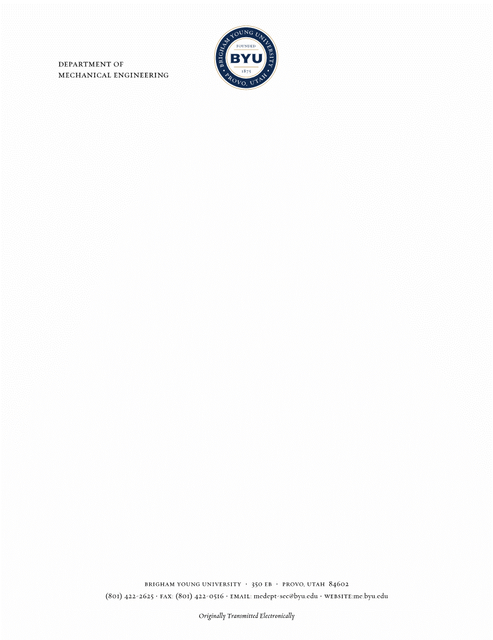

Editor February 2, 2020

Computational Materials Science

Dear Editor,

I attach herewith a manuscript entitled “Five Degree-of-Freedom Property Interpolation of Arbitrary Grain Boundaries via Voronoi Fundamental Zone Framework,” by myself (Sterling G. Baird), Eric R. Homer, David T. Fullwood, and Oliver K. Johnson. We would like to submit this paper to your consideration for publication in Computational Materials Science.

In this work, we present a new method for computing distances between grain boundaries (GBs) and predicting GB properties based on existing measurements (i.e. interpolation). Our approach builds on recent work by Francis, et al. who introduced the concept of grain boundary octonions. Our new approach, called the Voronoi Fundamental Zone (VFZ) framework reduces the computational cost of such distance calculations by several orders of magnitude (e.g. 7 CPU minutes vs. 153 CPU days). We find that scaled Euclidean distances in a Voronoi Fundamental Zone approximate the original octonion metric with reasonable enough accuracy to produce high accuracy interpolations for large datasets, and the ability to use Euclidean distances allows us to leverage many well established and highly efficient standard algorithms (e.g. Quickhull). Validation tests and application to two GB property databases from the literature result in higher accuracy predictions than prior work. Because evaluating structure-property model surrogates resulting from our approach is highly computationally efficient, we anticipate that it will enable the incorporation of higher-fidelity GB structure-property models, based on large experimental and computational datasets, into mesoscale simulations (e.g. anisotropic grain growth, GB mobility, etc.). We also believe it will help to improve understanding of GB properties as they relate to 5DOF fundamental zones.

We, hereby, certify that this manuscript has not been previously published nor is it under consideration for publication elsewhere. It has been approved by all co-authors and any relevant authorities at the locations where the work was performed. Below are the names and contact information for three suitable reviewers:

Dr. Gregory S. Rohrer (Carnegie Mellon University): [gr20@andrew.cmu.edu](mailto:gr20@andrew.cmu.edu)

Dr. Marc De Graef (Carnegie Mellon University): [degraef@cmu.edu](mailto:degraef@cmu.edu)

Dr. Elizabeth A. Holm (Carnegie Mellon University): [eaholm@andrew.cmu.edu](mailto:eaholm@andrew.cmu.edu)

We are looking forward to a review of this paper. Please advise if you require anything to proceed.

Sincerely,

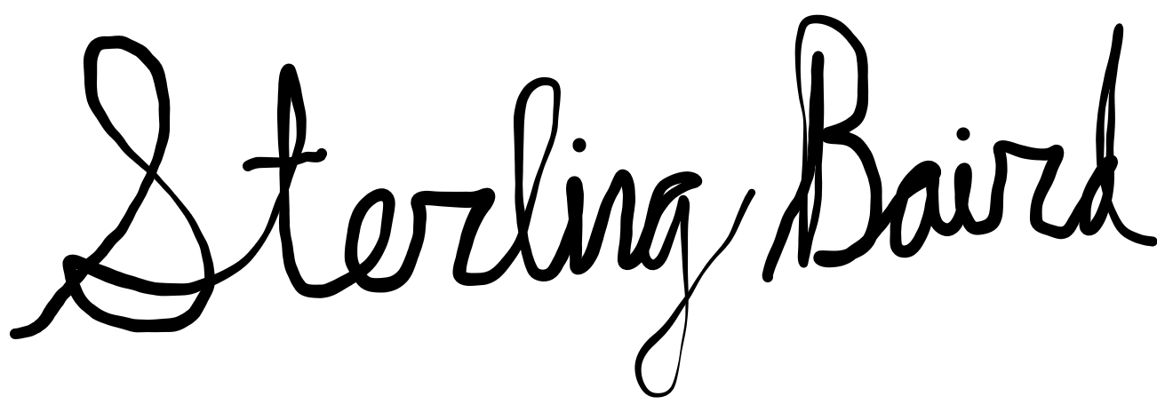

Sterling G. Baird

Graduate Student

Department of Mechanical Engineering

Brigham Young University