- CUDA event API is used to measure execution time of GPU and CPU code. Implemented by recording a time by creating an event just before and after the kernel function is called and then taking the difference of start time and end time recorded as shown below.
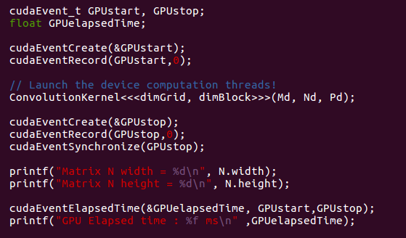
Results obtained for different tests inputs are as follows

Test Input I : (Random Size)
Size : 281 x 80
GPU Elapsed time : 0.048480 ms
CPU Elapsed time : 2.256992 ms
Total number of floating point operations : 2 * 5 * 5 * 281 * 80 = 1124000

GPU time for per floating point operations = 0.048480 / 1124000 = 43.13 x 10 ^{– 9} ms

CPU time for per floating point operations = 2.256992 / 1124000 = 2 x 10⁻⁶ ms

Test Input II :
Size : 32 x 32
GPU Elapsed time : 0.044768 ms
CPU Elapsed time : 0.099488 ms
Total number of floating point operations : 2 * 5 * 5 * 32 * 32 = 51200

GPU time for per floating point operations = 0.044768 / 51200 = 87.43 x 10 ⁻⁹ ms

CPU time for per floating point operations = 0.099488 / 51200 = 1.95 x 10 ⁻⁶ ms

Test Input III :
Size : 64 x 64
GPU Elapsed time : 0.043488 ms
CPU Elapsed time : 0.434176 ms
Total number of floating point operations : 2 * 5 * 5 * 64 * 64 = 204800

GPU time for per floating point operations = 0.043488 / 204800 = 212.34 x 10 ⁻⁹ ms

CPU time for per floating point operations = 0.434176 / 204800 = 2.1 x 10 ⁻⁶ ms

Test Input IV :
Size : 128 x 128
GPU Elapsed time : 0.047488 ms
CPU Elapsed time : 1.629376 ms
Total number of floating point operations : 819200

GPU time for per floating point operations = 0. 047488 / 819200 = 57.96 x 10 ⁻⁹ ms

CPU time for per floating point operations = 1.629376 / 819200 = 2 x 10 ⁻⁶ ms

Test Input V :
Size : 256 x 256
GPU Elapsed time : 0.060352 ms
CPU Elapsed time : 6.535136 ms
Total number of floating point operations : 2 * 5 * 5 * 256 * 256 = 3276800

GPU time for per floating point operations = 0.060352 / 3276800 = 18.42 x 10 ⁻⁹ ms

CPU time for per floating point operations = 6.535136 / 3276800 = 2 x 10 ⁻⁶ ms

Test Input V :
Size : 512 x 512
GPU Elapsed time : 0.113568 ms
CPU Elapsed time : 26.200705 ms
Total number of floating point operations : 2 * 5 * 5 * 512 * 512 = 13107200

GPU time for per floating point operations = 0.113568 / 13107200 = 8.66 x 10⁻⁹ ms

CPU time for per floating point operations = 26.200705 / 13107200 = 2 x 10 ⁻⁶ ms

Test Input VI :
Size : 1024 x 1024
GPU Elapsed time : 0.325024 ms
CPU Elapsed time : 104.868607 ms
Total number of floating point operations : 2 * 5 * 5 * 1024 * 1024 = 52428800
GPU time for per floating point operations = 0.325024 / 52428800 = 6.20 x 10 ⁻⁹ ms
CPU time for per floating point operations = 104.868607/ 52428800 = 2 x 10 ⁻⁶ ms

CPU computation time scales with size as shown below:
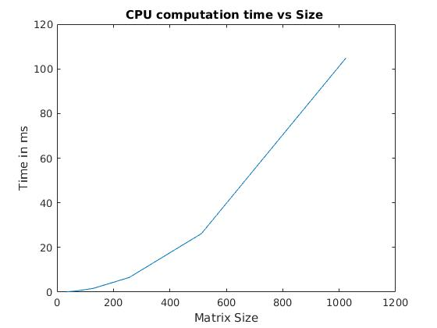
GPU computation time scales with size as shown below:
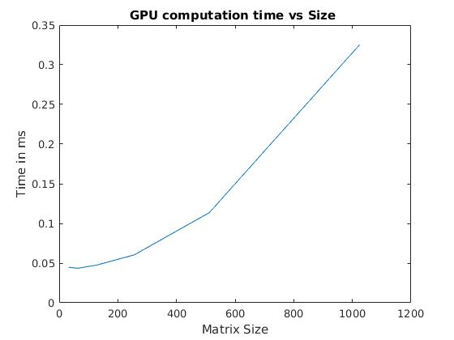
Image I Test :
Size : 32 x 32
GPU Elapsed time : 0.044768 ms
CPU Elapsed time : 0.099488 ms
Total number of floating point operations : 2 * 5 * 5 * 32 * 32 = 51200

Image II Test :
Size 1024 x 1024
GPU Elapsed time : 0.313120 ms
CPU Elapsed time : 105.495361 ms
Total number of floating point operations : 2 * 5 * 5 * 1024 * 1024 = 52428800

GPU FLOPS scaling with respect to input

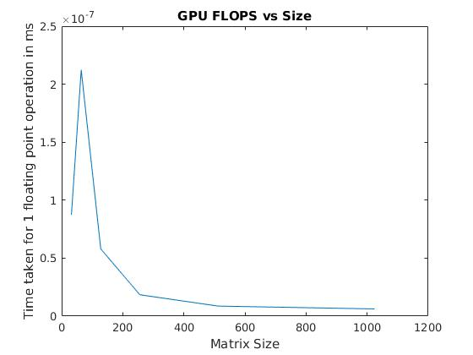

CPU FLOPS scaling with respect to input:

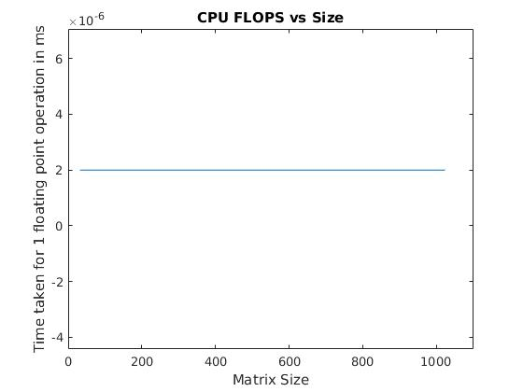

- Overhead cost for using the GPU for computation can be given by the difference between Overhead time and GPU Elapsed time.
Test Input I :
Size : 80 x 281
GPU Elapsed time : 0.048512 ms
Time including GPU computation : 1.144768 ms
Therefore, Overhead time = 1.144768 ms - 0.048512 ms = 1.096256 ms

Test Input II :
Size : 32 x 32
GPU Elapsed time : 0.043424 ms
Time including GPU computation : 0.897504 ms
Therefore, Overhead time = 0.897504 ms - 0.043424 ms = 0.85408 ms

Test Input III :
Size : 64 x 64
GPU Elapsed time : 0.043328 ms
Time including GPU computation : 0.941120 ms
Therefore, Overhead time = 0.941120 ms - 0.043328 ms = 0.897792 ms

Test Input IV :
Size : 128 x 128
GPU Elapsed time : 0.046880 ms
Time including GPU computation : 1.114784 ms
Therefore, Overhead time = 1.114784 ms - 0.046880 ms = 1.067904 ms

Test Input V :
Size : 256 x 256
GPU Elapsed time : 0.060128 ms
Time including GPU computation : 1.498880 ms
Therefore, Overhead time = 1.498880 ms - 0.060128 ms = 1.438752 ms

Test Input VI :
Size : 512 x 512
GPU Elapsed time : 0.126304 ms
Time including GPU computation : 3.621952 ms
Therefore, Overhead time = 3.621952 ms - 0.126304 ms = 3.495648 ms

Test Input VI :
Size : 1024 x 1024
GPU Elapsed time : 0.323392 ms
Time including GPU computation : 7.937344 ms
Therefore, Overhead time = 7.937344 ms - 0.323392 ms = 7.613952 ms

Test Image I :
Size : 32 x 32
GPU Elapsed time : 0.053504 ms
Time including GPU computation : 0.996128 ms
Therefore, Overhead time = 0.996128 ms - 0.053504 ms = 0.942624 ms

Test Image II :
Size 1024 x 1024
GPU Elapsed time : 0.324096 ms
Time including GPU computation : 7.857888 ms
Therefore, Overhead time = 7.533792 ms

Overhead scale with the size as shown below

