“Enmity” Amongst “Countrymen”: Evidence of Transnational Elite Cueing, the Turkish Migrant Electorate, and Erdoğan’s 2017 Anti-Endorsement in Germany

Samuel DeLong
Advisor: Andrew Gelman, PhD

Submitted to the faculty of the Department of Political Science in partial fulfillment of the requirements for the degree of Bachelor of Arts



Department of Political Science
Columbia University
April 1, 2026

Table of Contents
Abstract……………………………………………………………………………………………………..2
Introduction…………………………………………………………………………………………………2
Background
A History of German Nationality…………………………………………………………………..5
The Turkish in Germany: Guests to Citizens………………………………………………………7
The Political Identity of Turkish Germans………………………………………………………..11
2017: A Year of Controversy…………………………………...………………………………...16
2017: Through the Turkish-German Lens………………………………………………………..19
Literature Review
Assimilation and Identity Among Migrants………………………………………………………24
Theories of Ethnic Voting………………………………………………………………………...26
Theories of Migrant Voting……………………………………………………………………….29
Elite Cues in Transnational Politics……………………………………………………………...32
Hypothesis…………………………………………………………………………………………………35
Methods and Results
Research Design………………………………………………………………………………….37
Data………………………………………………………………………………………………39
Elections Analysis………………………………………………………………………………...39
DiD Model: North Rhine-Westphalia…………………………………………………………….47
DiD Model: Cologne……………………………………………………………………………...52
Discussion and Conclusion………………………………………………………………………………..54

Abstract
Modern demographic diversification in the West has provoked persistent questions in the field of political science regarding the voting behavior of diasporic communities. Existing literature has developed on modes in which migrant identity, home country politics, and transnational elite rhetoric serve as key influences in migrant voting. This study examines a rare natural quasi-experiment, grounded in Turkish President Erdoğan's August 2017 televised anti-endorsement of three major German parties. Aired ahead of that September's federal election, this elite cue was directed at Germany's over seven million ethnic Turks. Using a spatial difference-in-differences design on party list-vote panel data from the 2017 NRW state and federal elections, I exploit variation in Turkish population concentration across state municipalities and Cologne voting districts as a continuous treatment proxy for cue saliency. I find significant movement away from the Greens and toward the Erdoğan-aligned Alliance of German Democrats (ADD) in heavily-Turkish localities, with directionally consistent but statistically insignificant results at the Cologne voting district-level. As diaspora communities grow in electoral significance across the West, understanding the permeability of political informational landscapes by international actors becomes increasingly urgent in the field. These findings contribute to the nascent literature on transnational elite cueing, suggesting that origin-country elite signals can produce detectable host-country electoral effects, but that these effects are conditional on baseline partisan attachment and the affective structure of the diaspora's relationship to host country politics.

Introduction
On August 18, 2017, Turkish President Recep Tayyip Erdoğan, in a speech delivered after Friday prayers in Istanbul, declared that Germany’s “Christian Democrats, SPD, [and] Green Party are all enemies of Turkey”, and that his “countrymen” in Germany should “[g]ive necessary support to political parties that do not engage in enmity against Turkey” (Gülmen, 2017). For the leaders of those three parties, as well as the seven million ethnic Turks in Germany, this anti-endorsement ahead of that September’s federal legislative election carried both weight and worry. As the largest ethnic minority in Germany since the 1980s (Horrocks and Kolinsky, 1996; Potts, 2001), Turks have engendered significant discussions on the role of ethnicity in German politics. These debates span from disputes over naturalization law in the 1990s to present-day controversies regarding the Alternative for Germany (AfD) party’s anti-migration and anti-Muslim rhetoric. And, despite a strong historical association with Germany’s Social Democratic Party (SPD), studies have recently demonstrated complicating partisanship and political attitudes among the Turkish community (Goerres et. al, 2024; Krumm, 2018). Such changes contrast with continued extraordinary support among the German Turkish population for Erdoğan himself, whose contentious relationship with the German political establishment has complicated political information channels among Turkish German citizens. The political moment of 2017 exemplified the complexity of the informational relationship between Erdoğan and the Turkish diaspora, beginning with the April 2017 Turkish constitutional referendum and culminating in the August anti-endorsement, ultimately magnifying identity-based divisions within Germany and crystallizing the tension between Turkish Germans' dual political worlds.
In the globalized and diversified Western democracies of the 21st-century, migrant communities now act as powerful political blocs in the countries that host them. Minority interest parties determine parliamentary coalitions, turnout disparities across ethnic groups shape campaign strategies, and a candidate’s migration background or heritage can at times decide an election. Consequently, substantial attention has been afforded in the literature to the impact of transnational identity formation on political behavior. I link this to heuristic theories of voting, especially Zaller’s (1992) theory of elite cues, that are used to explain vote choices among low-information or weak-ideology populations. Previous studies have noted heuristics’ utility in explaining voting within migrant communities, due to the prevalence of informational barriers relative to native communities (Baretto, 2010; Bird, 2008; Ciuk and Tavarez, 2024). It is logical, then, that migrants who have retained significant interest in home country politics may prefer to look across national borders to receive political information and instruction.
Little attention has, as of yet, been paid to the phenomenon of transnational elite cueing, wherein home country political elites direct a diaspora’s political behavior in the host country. Erdoğan’s intervention is unusual and unique as a cross-national political message; it is normatively rare for other nation’s leaders to express direct opposition to the re-election efforts of a ruling party or parties in a traditionally geopolitically aligned (NATO co-member, strong EU linkages, etc.) country (Wittum, 2020). Erdoğan’s cue also met little interference from Turkish sources; the primary opposition forces in Turkey, the CHP and HDP, did not react to the announcement.
The strong reaction within Germany raised the profile of the announcement, and invoked both support and criticism from among the Turkish German community. Turkish political identities in Germany compound this controversy by defying the expected relationship between acculturation, homeland identification, and interest in transnational politics. Turkish Germans who are German citizens and identify with German nationality are not significantly less likely to indicate interest in Turkish politics than Turkish citizens residing in Germany (Sauer and Halm, 2018; Uslucan and Sauer, 2018). This is true despite decades of settlement and high rates of naturalization (Georres et. al, 2024), two typical measures of integration that would expectedly weaken home country political attachments (Ahmadov and Sasse, 2016; Nandi and Platt, 2020; Schiefer, 2013). This paradoxical dual engagement thus provides a functional space to explore the direct electoral impact of transnational elite messaging, and develop upon an untouched portion in the literature surrounding diasporic usage of home country heuristics in host country politics.

Background

A History of German Nationality and Migration
To understand the determinants of Turkish migrant’s political selection, it is important to first dissect the conditions of migrant political participation in Germany. The German regimes of the 20th century were all explicitly constructed on the basis of German ethno-nationalism. This dates back to Otto Von Bismarck’s Prussian Settlement Commission from 1886 to 1924 (Brubaker, 1992). Many of the territorial policies of the German Empire prior to the First World War hinged on the incorporation of ethnically German territory into the state, and the settlement of territories that were predominantly non-German (West Prussia, Posen, Silesia, etc.) with German-speaking Protestants (Brubaker, 1992). This was a clear philosophical predecessor to the genocidal politics of the Nazi regime under Adolf Hitler, under which non-ethnic Germans were indiscriminately deported or killed (Brubaker, 1992). And, under a joint effort of Winston Churchill, Joseph Stalin, and Polish communist groups, a massive resettlement project occurred in the 1940s to re-contain ethnic Germans in surrounding countries (known as Aussiedler) within the new borders of the two post-war German nation-states (Brubaker, 1992; Mandel, 2008). As a result of a near century of internal ethnic cleansing, resettlement, and geographic self-sorting, West Germany at its founding was almost completely ethnically homogenous (Mandel, 2008).
This demography structured the West German government’s reaffirmation of the original 1913 Reichs- und Staatsangehörigkeitsgesetz (Imperial and State Nationality Act) in 1955, which limited citizenship in Germany to descendants of two German-born parents (Farahat and Hailbronner, 2020; Kursat-Ählers, 1996). Until the 1990s, West Germany remained a prime example of jus sanguinis nationality law in Europe, refusing to formalize a naturalization process for migrants of almost any kind until 1991 (Brubaker, 1992; Farahat and Hailbronner, 2020). Initially, the rapidly growing West German economy in the 1950s was kept at pace by steady streams of Aussiedler migration from an isolating GDR (German Democratic Republic, or East Germany). However, the construction of the Berlin Wall in 1961 and severing of diplomatic ties between East and West stymied the flow of new workers, and the West German government turned towards non-German migrant labor instead (Kursat-Ählers, 1996; Mandel, 2008). The Gastarbeiter program, first signed into law as a bilateral agreement between the West German and Italian governments in 1955, was rapidly expanded to other countries to keep up with continuous labor shortages in blue-collar sectors (Brubaker, 1992; Farahat and Hailbronner, 2020). These visas were extended exclusively to workers on one- or two-year contracts and banned family members from migrating with the laborer during the contracted period, although many workers found ways around this provision (Mandel, 2008). By 1973, when all Gastarbeiter agreements were terminated, nearly 6.4% of Germany’s population and 11.6% of its workforce were foreigners (Horrocks and Kolinsky 1996).
The German government entered into a Gastarbeiter agreement with Turkey in 1961. Initially, the flow of guest workers from Turkey was slow compared to other Gastarbeiter partner nations like Spain or Yugoslavia (Kursat-Ählers, 1996). However, a 1969 reissuing of the original German-Turkish agreement led to a massive jump in the number of Turkish workers, and in 1973 more than a quarter of the foreign worker population in Germany was Turkish (Horrocks and Kolinsky 1996). In 1973 and 1974, Willy Brandt’s SPD-led government implemented several changes to the guest worker scheme in the form of the Anwerbestopp, or “hiring freeze.” First, all bilateral Gastarbeiter agreements were voided and guest worker term limits were lifted, allowing previously-restricted German companies to extend full-time employment to foreign nationals (Mandel, 2008). Secondly, bans on family settlement were also reversed, allowing remaining members of guest workers’ families to join them (Horrocks and Kolinsky, 1996; Kursat-Ählers, 1996). Both provisions were intended to resolve sector issues complicated by the guest worker program’s ephemerality, and generate economic resilience in a moment of global market shock (Kursat-Ählers, 1996). Despite the changes, the lack of an official scheme for visas drove out most of the European Gastarbeiter population, as the number of residents from traditional recruitment countries like Spain, Portugal, Italy, and Greece decreased by almost half (Horrocks and Kolinsky, 1996).

The Turkish in Germany: From Guests to Citizens
However, the period after the Anwerbestopp instead saw the Turkish population in Germany increase significantly, from approximately 250,000 in 1970 to just 1.5 million by 1987 (Horrocks and Kolinsky 1996; Potts, 2001). This was primarily owed to family reunification. The provision resulted particularly in a large uptick in the young Turkish population; by the mid-1970s, almost two-thirds of Turkish migrants to Germany were under the age of 18 (Horrocks and Kolinsky 1996). It is during this time that ethnic and social conceptions of the Turkish minority in Germany, ones still active today, first took shape. The segment of the Turkish population that migrated to Germany was very distinct culturally from the highly-educated, professionalizing West German population of the 1980s. Most came from small agricultural towns and were more religious on average than the general Turkish population (Ross, 2009). The jobs that Turkish families could find after the hiring stop in the 1970s were still predominantly blue-collar and industrial, fixing the social position of much of the Turkish population to the lower middle class (Ross, 2009; Potts 2001). By 1989, the proportion of Turkish Germans living in poverty had risen from 30% in 1984 to 38%, a function of the lack of government programs intended to address mass inequality or social stability prior to citizenship changes (Kürsat-Ahlers, 1996).
Additionally, social mobility among second-generation Turkish Germans was uncommon and difficult, primarily as a feature of the school system in Germany. The language barrier amongst German-learners of Turkish origin was intensified by the strong syntactic differences between Turkish and German. And the rigid pipeline of the German educational system, where fourth graders are permanently tracked into predetermined maximal educational attainment, frustrated matriculation into higher education programs (Ross, 2009). Studies have shown that, even by 2006, German-born children were 4 times as likely compared to those who reported Turkish migration background to be placed in Gymnasium, the only schooling track that offers eventual university placement (Ross, 2009). As a result, negative stereotypes gained traction among wealthier and more conservative German communities from the 1970s about Turkish youth as uneducated, dangerous, and “un-German” (Ross, 2009; Ünver, 2023, pp. 183). These social tensions, alongside educational and labor discrimination, generated a reputation of the Turkish community in Germany as insular and resistant to cultural assimilation (Ünver, 2023).
The first significant change in nationality law in 1990 was precipitated by the reunification of the East and West German governments, and the need to reconcile the relatively liberal naturalization laws of the East (Farahat and Hailbronner, 2020). This included the first official expansion of citizenship to non-ethnic Germans, allowing naturalization for noncitizens exclusively between the ages of 16 and 23 who could prove 8 or more years of residency and 6 or more years of German schooling (Farahat and Hailbronner, 2020). The extension was thus essentially limited to only second-generation migrants. Then-Chancellor Helmut Kohl, of the Christian Democratic Union (CDU), took on a project of slow, gradual, and limited extensions of the franchise until the 1998 federal elections (Heckmann, 2016; Ünver, 2023). During this election, the extension of citizenship became a significant public debate, codified into a term that maintains relevance today: Ausländerproblematik, or “the foreigner issue” (Farahat and Hailbronner, 2020; Heckmann, 2016). The debate centered on the fundamental question of immigrants’ place in German society. Kohl is famous for declaring that “Germany is not a country of immigrants,” a statement aimed implicitly at the millions of Turkish citizens who had made Germany their home by that time (Heckmann, 2016). Other opponents of migration offered thinly-veiled euphemisms about the danger of allowing the Turkish youth into the German citizenry (Ross, 2009). On the other side, second- and third-generation Turkish Germans formed advocacy groups like the Muslim Youth and the Turkish Community in Germany to advocate for expanding civil and educational rights for migrants and their families (Goerres, 2024; Schiffauer, 2016).
Finally, in 1999, under a new coalition of the SPD and the Greens, led by Gerhard Schröder of the SPD, the German government passed a new nationality law simplifying the naturalization process and establishing jus soli (birthright citizenship) for children born on German soil to foreign nationals (Goerres, et. al, 2024; Uslucan and Sauer, 2020). The tension between the SPD and CDU that year solidified the modern partisan attachments in Germany to migration support and reform. Until 2013, the CDU, with Angela Merkel’s tenure a notable exception that is later explored, has been the primary force of opposition to mass migration into Germany (Heckmann, 2016). In contrast, the SPD has generally been warmer towards migrants, supportive of refugee and asylee programs, and the main promulgator of assimilation rhetoric (Hess and Green, 2016). The minor parties, the FDP, the Greens, and Die Linke (The Left), have fluctuated in their positions, primarily to pick up ideological space left by minor variation in CDU and SPD stances. For instance, in 2011, as the Arab Spring sparked a sudden flow of refugees from the Middle East to Europe, both the Greens and Die Linke outflanked the SPD on support for progressive reforms to Germany’s asylum process (Hess and Green, 2016).
In 1999, the number of Turkish citizens residing in Germany hit a high-water mark of 2.1 million (Goerres et. al, 2024). It has since declined due to a combination of re-migration and naturalization, and stabilized at around 1.5 million in 2015 (Goerres et. al, 2024). Despite these changes, the communitarian acceptance of non-ethnic Germans into German nationality still faces semantic, institutional, and popular barriers today. While languages like French and English do not really distinguish linguistically between the communal sense of citizenship and a state-determined one, German does. Staatsaangehörigkeit, literally “national affiliation,” is a distinct social and legal concept from Staatsbürgerschaft, or “national citizenship” (Brubaker, 1992). There is a direct throughline from Bismarck’s original attempts at consolidating German citizenship into unitary ethnonationalism to these remaining distinctions today. One key example is the concept of Migrationshintergrund, or “immigration background.” The label imposes a retention of migrant identity, even among third- or successive-generation migrants who hold German citizenship from birth, ensuring that German nationality is an alienated feature regardless of citizenship status (Brubaker, 1992; Heckmann, 2016). Despite these vestiges of German ethnonationalism, and Kohl’s comments in the 1990s, it is undeniable that Germany has become a country of immigrants; today over 30% of German residents hold migration background status (Statistisches Bundesamt (Destatis), 2026).

The Political Identity of Turkish Germans
As a result of the strong limitations on naturalization, widespread political participation among Turkish ethnics in Germany was uncommon until the 1990s. Existing political engagement was primarily directed towards enfranchisement or labor rights due to the strong Turkish presence in industrial sectors (Pott, 2001; Ünver, 2023). After 1999, the public debate on the role of Turkish migrants in German society instead turned to questions of assimilation. These debates re-contested the social cleavages that opponents to the citizenship law a decade prior relied on, namely language, social class, and Muslim religion. Critics of Turkish assimilation often point to the large portion of Turkish nationals living permanently in Germany who do not indicate intent to naturalize as emblematic of a broader issue (Sauer, 2007; Ünver, 2023).
Prior to 2024, Germany required renunciation of foreign citizenships for complete naturalization, meaning that the modern population of Turkish migrants in Germany is overwhelmingly composed of either Turkish mono-citizens or German mono-citizens (Goerres, 2024). In 2021, of the 2.25 million voting-age German residents with Turkish migration background, about 46% were German mono citizens and 46% held foreign citizenship, while only 8% were dual citizens (Goerres et. al, 2024). Another complicating factor prior to 2024 is the mavi kart, or blue card, which is a Turkish identification status that allows those who have renounced Turkish citizenship and their children to retain most rights of Turkish citizens (permanent employment or residence in Turkey, inheritance rights, etc.) except for the right to vote (Goerres et. al, 2024). As a result, many have chosen to renounce Turkish citizenship and adopt German mono citizenship while maintaining economic and social links to Turkey.
Despite the strong split in citizenship amongst the diaspora, German mono citizens have largely retained similar attachment to Turkish identity as Turkish citizens. The Center for Turkish Studies and Integration Research (ZfTI) in Germany has conducted a tracking study in the state of North Rhine-Westphalia since 1999 to assess notions of national belonging and political interest over time. An analysis of the report in 2017 found that, while German citizens of Turkish origin were significantly more likely to report positive acculturation or assimilation in Germany than Turkish citizens, there was not a significant difference in homeland identification between the citizenship groups (Sauer and Halm, 2018). Additionally, German citizens were more likely to report homeland identification with both countries (38%) than with Germany alone (23%) (Sauer and Halm, 2018). Among both citizenship groups, homeland identification with Turkey or both countries had generally increased from 2015, whereas sole identification with Germany had decreased (Sauer, 2017).
The trends in measures of belonging also generally track with reported interest in the politics of both countries. Overall, there was a stronger interest in Turkish politics (35% strong interest, 34% middle interest) among the surveyed population compared to German politics (20% strong interest, 33% middle interest) across both citizenship groups, although a positive correlation was found between German citizenship and interest in German politics (Sauer, 2017). Interest in Turkish and German politics among were themselves correlated, rather than substitutive, and correlated with typical demographic controls like higher education or socioeconomic status (Sauer, 2017). The Turkish migrant population in Germany accordingly follows a typical demographic distribution of political interest across both citizenship groups, as more educated and wealthier individuals are more likely to be generally interested in politics, regardless of national context (Sauer, 2017). Data also suggests that the Turkish population is one of the most engaged diasporas in Germany; Wüst (2004), in a seminal study of German migrant politics, found that Turkish migrants exhibited higher rates of interest and knowledge of German politics compared to former Soviet, Polish, or Romanian migrant groups.
Notably, there was no significant association between sole identification with Turkey and higher interest in Turkish politics. And, overall, there was a positive relationship between German acculturation and interest in Turkish politics (Sauer, 2017). A positive correlation between German integration and Turkish politics is critical for the validity of the study, as the lack of substantive differences between Turkish and German mono citizens’ interest in Turkish politics across acculturation levels primes those voting in German elections to have vested interest in Erdoğan as a political elite. Additionally, the ZfTI survey shows strong engagements with other facets of migrant identity. Nearly 40% of respondents reported that they were an active member of a migrant organization, which was weakly associated with interest in both German and Turkish politics (Sauer, 2017).
The degree of direct involvement among Turkish migrants is also an important measure of engagement. Turkish Germans are the single most represented minority group in the federal parliament, constituting 11 of 37 immigration-background MPs in 2013 and 14 out of 58 in 2017 (de Fonseca, 2010; Krumm, 2018). In 2013, all except one of these representatives were affiliated with the German left (SPD, Greens, or Die Linke) (Krumm, 2018). This is unsurprising given the CDU’s strong association with Catholicism, the FDP’s economic liberalism running anti to labor support, and the AfD’s anti-migrant platform. Despite traditional conceptions of the positive impact of descriptive representation, a previous study (Goerres et. al, 2024) showed that a hypothetical SPD candidate being of Turkish-descent actually reduced Turkish voters’ indicated support.
Beyond the dimensions of engagement or representation, there is a critical paradox to explore regarding Turkish Germans’ political and partisan identity in Germany. Due to the diaspora’s historical association with labor politics and the party’s more liberal stances on naturalization in the 1980s and 1990s, the SPD became a natural home for Turkish migrants post-citizenship (Goerres and Mayer, 2018; Sauer and Halm, 2018; Uslucan and Sauer, 2018). Support for the SPD among the Turkish community until 2017 was near-ubiquitous. A 2016 study found that 69.8% of Turkish Germans indicated affiliation with the SPD, followed by 13.4% for the Greens, 9.8% for Die Linke, and 6.1% for the CDU (Krumm, 2018).
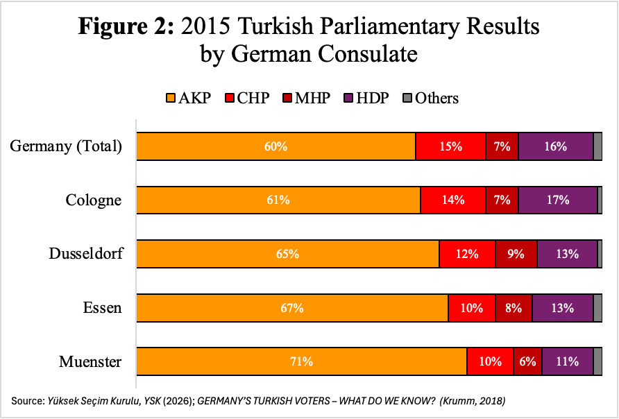
Despite their alignment with the German left, Turks in Germany by every metric overwhelmingly support President Erdoğan’s Justice and Development Party (AKP) and the conservative-religious policy it presents. In the November, 2015 Turkish parliamentary election, the AKP received more votes in Germany than in every other foreign consulate combined, and won 59.7% of the total vote share (Krumm, 2018; Uslucan and Sauer, 2018). This was strongest geographically in North Rhine-Westphalia (see Figure 2). The NRW consulates in Muenster, Essen, Dusseldorf, and Cologne saw the 1st, 2nd, 3rd, and 5th highest AKP vote shares out of the 13 total consulates nationwide (YSK, 2026). The party with the second-highest vote share nationally (15.94%) was the Peoples’ Democratic Party (HDP), a generally left-wing Kurdish interest party that has been continuously targeted with legality challenges by the AKP and Erdoğan (Krumm, 2018). This split indicates a political faultline between ethnic Turks and Kurds within Germany that mirrors that within Turkey. The HDP’s overperformance in 2015 relative to the Republican People’s Party (CHP), the typical opposition party to the AKP and the second largest party in Turkey itself, also indicates that, among ethnic Turks in Germany, support for the AKP is much stronger and concentrated than in the homeland. The coinciding strong preference among Turkish Germans for the nationalistic, Turkish-supremacist, and religious fundamentalist AKP in Turkey alongside the nationally inclusive, social welfare-oriented, and agnostic SPD in Germany is hard to resolve.
The Turkish diaspora in Germany is also one of few ethnic groups in Germany courted by specific minority-interest parties. The earliest of these was the Alliance for Innovation & Justice (BIG), a dedicated Muslim-interest party founded in Cologne in 2010, merging three existing regional voters’ associations from across Western Germany (Meiss, 2024). While not a Turkish-interest party expressly, one of its foremost policy positions was support for Turkish accession into the E.U., and has been accused of collaboration with the Union of International Democrats (UID), an AKP-linked lobbying organization criticized as an agent of foreign election interference (Meiss, 2024). This was followed by the Alliance of German Democrats (ADD), founded in NRW in 2016 after the failure of a Turkish military coup caused internal tensions between Erdoğan-supporting and E.U.-oriented Turkish-Germans. ADD candidates stood in their first election during the 2017 North Rhine-Westphalia state elections, earning .15% of the party-list vote, and expanded that share to .4% of the NRW vote during the higher-turnout 2017 federal elections (Krumm, 2018; Hedesheimmer, 2025). While both are now defunct, the ADD and BIG’s formation provided Turkish-German voters a political outlet to express dissatisfaction with their place within Germany’s ethnonational framework.

2017: A Year of Controversy
The Ausländerproblematik of the 1990s citizenship debate returned to the forefront of German politics in 2017. Today, considerable scholarly attention regarding Germany’s partisan landscape has been afforded to the Alternative for Germany’s rise (AfD) and the corresponding modern decline of the SPD and CDU. This has recently culminated in the AfD’s second-place finish in the 2025 federal election, marking the first time in Germany since the end of World War II that the top two parties by vote share were not the SPD and CDU (Hedesheimmer et. al, 2025). This remarkable shift is generally explained due to the CDU’s moderation under former chancellor Angela Merkel, leaving space for right-wing voters to gravitate towards another party, as well as a mark of disapproval of the German government’s response to the “migration crises” of 2015 and 2022 (Farahat and Hailbronner, 2020; Goerres et. al, 2024). In both years, Germany took in disproportionate waves of refugees from Syria and Ukraine, respectively, compared to other European nations. Both Merkel, who was elected from 2013 under a “grand coalition” composed of the CDU and SPD, and her successor, Olaf Scholz, whose coalition contained the SPD, Greens, and FDP, were forced to additionally navigate a stalling economy that increased public pressure on them and led dissatisfied voters to parties at the political extremes like the AfD and Die Linke (Heckmann, 2016; Hess and Green, 2016; Goerres et. al, 2024).
Introduced in 2010 as a response to labor market shortages, Wilkommenskultur (literally, “welcome culture”) became symbolic of German institutions’ attempts to change the hardened and monolithic ethnic image of past migration policy (Heckmann, 2016; Molodikova and Lyalina, 2017). Merkel and the CDU’s support for the term marked a stark departure from the German right’s position on migration under Helmut Kohl in the 1990s. In 2011, the German Marshall Fund of the United States (2011) found that only 28% of surveyed Germans agreed with the sentiment that there were “too many immigrants” in their country, the lowest out of any surveyed country and over 20% less than those surveyed in the U.S. and Italy. This positivity seemed, at the time, consistent with political results as well. In 2013, the newly-founded AfD and the NPD, the better-established far-right party at the time, received only a combined 6% of the vote at the federal election, and failed to win any seats in parliament (Heckmann, 2016).
But as Merkel’s popularity faded, so did the “Willkomenskultur” she had sought to promote in Germany and the wider European Union (E.U.). Social stressors introduced by the influx of asylees caused a large subset of the population to adjust their opinions on migrant integration and refugee policy. In December, 2016, the ARD-Deutschlandtrend tracking opinions survey found that 62% of Germans were concerned about the rate of incoming asylees alongside a 22% decrease (from 2014) in approval of the Merkel government’s refugee policy (Molodikova and Lyalina, 2017). This correlated with AfD’s unexpected strong performance in the September 2017 election. Only four years after the far-right party’s founding, the AfD placed third with 12.6% of the vote, ahead of all three of the traditional minor parties in the Greens, Die Linke, and the FDP (Hedesheimmer et. al, 2025). Merkel’s grand coalition ultimately returned to government in 2017, albeit with a much slimmer majority, and the AfD, entering parliament for the first time, became leader of the opposition (Goerres et. al, 2024; Krumm, 2018).
While the AfD capitalized on the emerging divide on migration in German society, even during the period of Wilkommenskultur dominance survey data showed that the approval of immigration in the German public was mostly illusory. In particular, existing views on Muslim migration among Germans was at parity with or lower than their European peers. The 2011 Marshall Fund study found only 37% of Germans agreed that Muslim immigrants were “well-” or “very-well integrated,” compared to 44% in the United Kingdom and 49% in France, and that 42% of Germans supported opening labor markets in response to the Arab Spring, similar to the 40% and 46% support in the U.K. and France respectively (German Marshall Fund of the United States, 2011). These questions of integration and labor participation harken back to the core issue of the 1990 debate concerning Turkish migrants and citizenship, and point to persistent issues among the German public with the inclusion of Muslims into culture and politics.
Figure 3: Party Vote Share Trends across Subdivisions
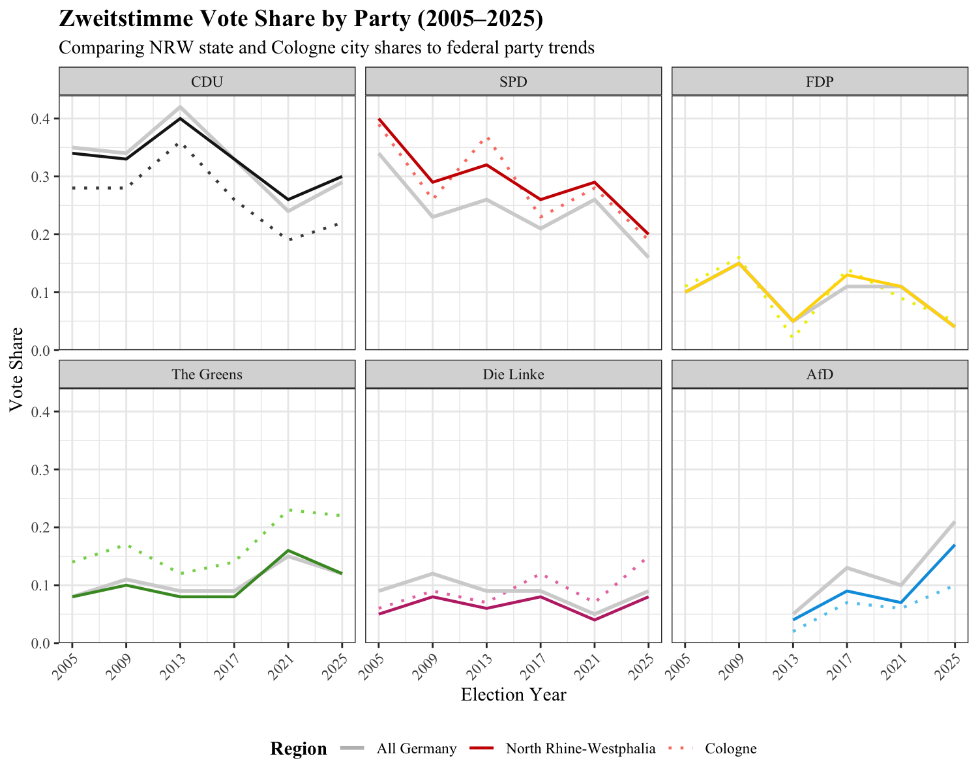
Source: GERDA Elections Database (Hedesheimmer et. al, 2025)

The 2017 election results also came as a massive rupture in the lengthy stability of Germany’s party competition system. Since the founding of West Germany in 1949, the tripartite competition between the democratic socialist SPD, the Christian conservative CDU, and the liberal FDP stood in contrast to the shorter lifespan of parties in the rest of Western Europe (Franzmann et. al, 2020). The AfD’s success marked the first time since the reunification election in 1990 that a new party had entered parliament, and the first since World War II that a party to the right of the CDU held a seat (Arzheimer, 2015). Germany’s political spectrum was essentially truncated right-of-center for over 50 years as a result of the de-Nazification programs of the 20th century (Arzheimer, 2015). While inter-party factions in the CDU were strongly conservative, especially amongst the affiliated Christian Social Union (CSU) in Bavaria, centrist Merkel’s dominance and ubiquity within the party created the pre-conditions for rightward flight among frustrated partisans (Arzheimer, 2015; Molodikova and Lyalina, 2017). Additionally, the continual renewing of the CDU-SPD grand coalition denied bipolar competition and drew both parties towards the center to avoid policy stagnation, leading dissatisfied voters to the political extremes (Franzmann et. al, 2020; Molodikova and Lyalina, 2017). The Greens and FDP were not obvious potential outlets for vote switching due to their issue specialization, on economic liberalism and environmental politics respectively (Franzmann et. al, 2020).

2017: Through the Turkish-German Lens
While the political situation among Turkish voters in Germany in 2017 was impacted by the general public’s shifting attitudes on migration, it was also influenced by the highly contentious Turkish constitutional referendum that had occurred in April of that year. The referendum, held under a state of emergency invoked in July 2016 after a failed military coup attempt, abolished the previous parliamentary system in favor of a single-executive system (Goerres et. al, 2024; Krumm, 2018). This greatly expanded Erdoğan’s constitutional authority and control over the legislative and judicial branches. In the months leading up to the referendum election date, Erdoğan courted Turkish citizens in the diaspora, with various AKP figures visiting heavily-Turkish communities in Germany to court voters (Kazim, 2018). The referendum was criticized heavily among E.U. member states for its authoritarian tilt, with one of the most vocal critics being Sigmar Gabriel, the then-SPD party leader, vice-chancellor, and federal minister for foreign affairs (Gülmen, 2017; Kazim, 2018). Gabriel and other other German leaders, especially within Merkel’s CDU-SPD coalition and the Greens, encouraged German localities to deny visitation rights for Turkish government agents in the run-up to the referendum (Gülmen, 2017).
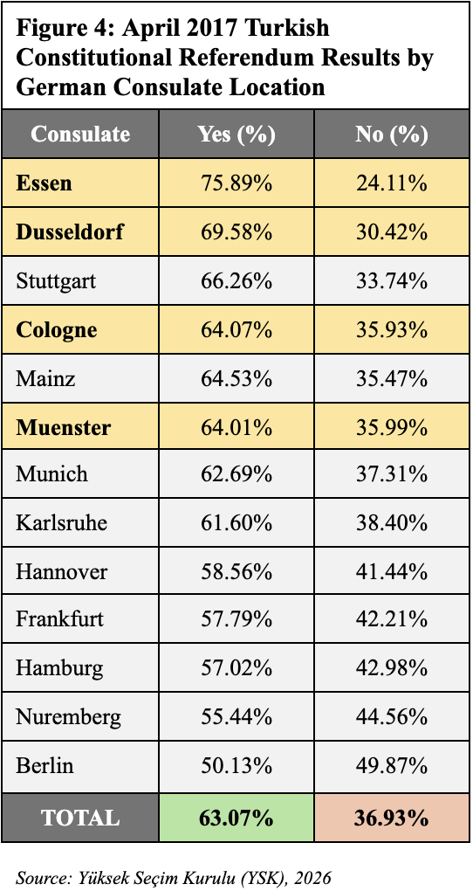
The referendum results exemplified both ideological alignment as well as divisions within the Turkish population in Germany. Despite a narrow win in Turkey overall, the referendum was overwhelmingly approved by Turkish citizens residing in Germany, winning a higher share and seeing higher turnout than any other expatriate population. For Turkish elections, foreign residents vote at individual consulates in host countries; no consulate in Germany recorded a referendum approval vote of less than 50% (Krumm, 2018). The approval vote share was generally higher in North Rhine-Westphalia than in the rest of the country. They composed 4 of the 6 consulates with higher than the federal “Yes” share, and they also constituted 3 of the 4 consulates that reached greater than 50% election turnout (YSK, 2026). In interviews and studies after the fact, many Turkish Germans cited poor treatment in Germany as a motivating factor in the vote, explicitly choosing to vote “yes” in reaction to leaders’ criticism of Turkish politics rather than as a policy approval of the referendum itself (Kazim, 2017). Unable to vote in Germany's election, these voters cast their ballots as a show of disapproval of the same leaders who had spent years dismissing their “German-ness” or iterating their foreignness in policy discussions on Islam and labor migration (Kazim, 2017). Umit Karakas, co-head of Data4U opinion-research institute, placed the subsequent transnational tensions in direct conversation with long-term mistreatment of the community, explaining that “German Turks no longer trust German parties as they used to because they don’t get treated as equals” (Thomas, 2017).
The referendum results, despite several surveys having already demonstrated Erdoğan’s high approval rate among the Turkish diaspora, shocked German political elites and media. CDU politician Wolfgang Bobasch expressed the widespread discomfort in his party by calling into question the loyalties of Turkish Germans, stating that Germans must accept their Turkish neighbors are loyal to Germany on an “economic and social level,” but on a “political and ideological level, they are loyal to Er­do­gan.” (Breitenbach 2017). While this rhetoric from the CDU was perhaps unsurprising, even the left bloc in Germany was generally critical of the results. One of the most prominent Turkish-background politicians in Germany, Cem Özdemir of the Greens, stated that fellow Turkish Germans think they can “get away with touching the constitution with just the tips of their toes,” and that, despite the results, the Turkish community must still commit to the “values and constitution of our country” (Breitenbach 2017).
These sentiments significantly strained relationships between German party leaders and German-Turkish voters, magnified by what was seen as a betrayal from SPD leadership towards one of their core constituencies.As Erdoğan cracked down on internal dissidents in the aftermath of the referendum, the public row between him and Merkel and Gabriel’s government intensified, culminating in the August 18th anti-endorsement. In a televised state conference, the Turkish president called on his “countrymen in Germany” to “teach a lesson” to the parties most critical of his politics (Gülmen, 2017). It is unmistakable that the use of highly nationalistic language like “countrymen” stands as an attempt to stress belonging in a moment of national insecurity amongst Turkish voters in Germany. The anti-endorsement drew intense criticism from both ethnically German and Turkish figures in Germany, positing Erdoğan as engaging in direct foreign election interference and ethnically divisive rhetoric. Atila Karaborklu, co-chairman of Germany’s Turkish Community Association, accused Erdoğan of attempting to “erode democracy” and “seeking to divide German society” (Thomas, 2017). Other Turkish organizations, such as the ADD and Union of International Democrats, capitalized on the moment of controversy and stressed linkages to Erdoğan. Campaign posters with Erdoğan’s face and the caption “Friend of Turkey, be with them, give them your vote,” were put up in several cities in North Rhine-Westphalia, in an attempt to raise their profile and draw in voters who had become frustrated with the German party choices and state of the cross-national relationship. (Gülmen, 2017). Empirical evidence suggests that these strategies worked. A cross-sectional survey in October 2017 following the federal election found that out of each German party’s members, voters who did not report a main party membership contained the largest proportion of AKP supporters (85%), compared to 50% of CDU members, 28% of SPD members, and 10% of Greens members (Uslucan and Sauer, 2018). In the final stretch of the national campaign, the “Turkish question” was now simultaneously a foremost rallying point and concern across the partisan spectrum.
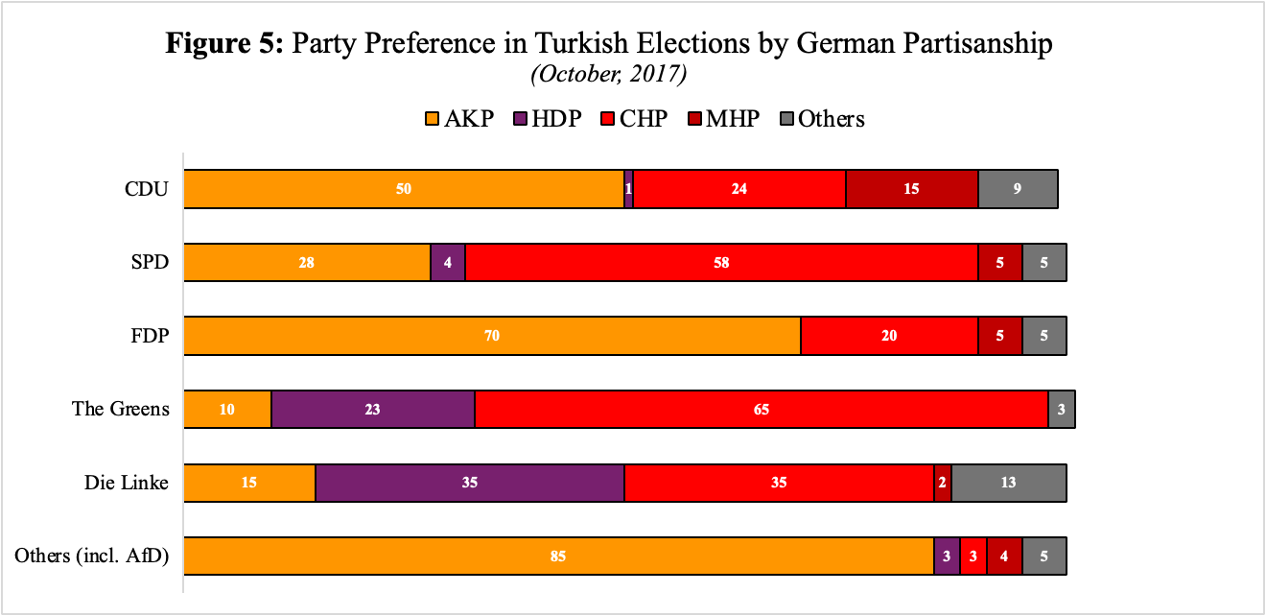
Source: Political Participation and Party Preferences among Immigrants of Turkish Origin in Germany (Uslucan and Sauer, 2018)

Sigmar Gabriel and SPD Minister of Justice Heiko Maas, co-writing an opinion piece for Der Spiegel, appealed to Turkish Germans to not buy into Erdoğan’s “culture war and propaganda” (Gabriel and Maas, 2017). Despite their attempts at consolidating the Turkish citizenry in Germany against Erdoğan, Gabriel and Maas’ rhetoric still promulgated the ethnonationalist sentiments that Turkish Germans had criticized in the run-up to the referendum. They criticized "parallel" or “counter-societies” within Germany, highlighted a “fundamental conflict of values” between Turks and Germans, and warned against the “import” of “these dangerous ideologies into Germany via certain mosques” (Gabriel and Maas, 2017). By the September election, the intense interplay between national identities was at the forefront of minds amongst the largest minority group in Germany, implying a choice that was more about self-conceptualization than partisan or ideological considerations. By September 2017, Turkish Germans thus faced an electoral choice shaped less by conventional partisan affiliations than questions of national identity, belonging, and cross-border loyalty.

Literature Review

Assimilation and Identity Construction Among Migrants
It is under these conditions that I explore the potential for transnational elite cues, rather than domestic party attachments, to drive migrants’ vote choices. Most theories explaining the relationship between migrant identity and political participation rely on Tajfel’s (1979) social identity theory and conception of group competition. The impact of migration and citizenship on self-identity is well-documented as part and parcel with Tajfel’s group identification theories; the question of nationality is inherently a competitive-inclusive dynamic between citizens (in-group) and non-citizens (outgroups). Tajfel’s conceptions have gained traction in critical migration theory as right-wing populist have re-politicized migration policy globally and utilize divisive rhetoric that relies on a racial out-group framing of migrants. These figures have problematized the supposed standard of Western democracies’ “civic nationalism” (Anderson, 1983; Brubaker, 1999; Reeskens and Wright, 2023; Vertovic, 2011), which posits national identity and belonging as dependent on political inclusion rather than ethnic or identitarian affiliation.
The rejection-identification model (Tajfel, 1981) has particular utility in the formation of migrant identity. This posits that discrimination presupposes identity formation, making discriminatory experience the motivator of new group formation rather than a feature of existing ingroup-outgroup distinction, and linking migrant groups across ethnic, religious, or socioeconomic lines (Adida and Robinson, 2023; Gonzales-Backen et. al, 2017; Yang et. al, 2022). Highly-visible markers, like language or race, structure ethnic grouping and are developed and experienced in adolescence due to ethnic clustering and familial socialization (Barua and Maheshwari, 2025). Migration status is not immediately obvious or experienced, especially among second-generation, host country-born migrants. Instead, over time, the shared negative psychological experiences of immigration bureaucracy and social discrimination eventually build a specifically “migrant” identity that transcends visible distinctions (.
The experience of labor and political discrimination amongst Turkish Germans reifies the social identity of “migrant” and emphasizes the gap in social belonging between Turkish-origin individuals and German ethnics. The migrant and ethnic identity of Turks is unique, in that a wide variety of features distinguish them from any other group in Germany society: religion (prominence of Alevi/Anatolian Muslim minority), language (linguistic distance of Turkish from German/other Indo-European languages), race, and socioeconomic status (Sandal-Önal et. al, 2022). Additionally, prohibitive policies to assimilation for successive-generation Turkish migrants, such as bans on certain Muslim religious practices in schools and generally poor social and occupational mobility, has extended the import of migrant identity well beyond the moment of transnational movement or acquisition of citizenship (Daniel et. al, 2014; Ross, 2009). It is thus the confluence of grouped Turkish ethnic and migrant identity that is relevant to the political decision-making of Turkish Germans.
Political gestures also become more salient among migrant groups that face greater discrimination (Fouka, 2019; Hainmueller et. al, 2017), increasing support for individual political actors. The Turkish population in Germany faced significant employment discrimination in the 20th century, and subsequently oriented themselves towards trade unions and the SPD in response to their social support (Pott, 2001; Uslucan and Sauer, 2021). Exposure to discrimination is empirically backed to indicate left-party support: ethnic clustering and minority identification are strong predictors of Labour party support in the U.K., even among ideologically conservative individuals (Dancygier and Saunders, 2006). There is a close linkage between self-perception as part of an “outgroup” and political alignment with the left, as seen in France among second-generation Arab, Caribbean and Turkish migrants (Tiberj and Michon, 2013), and among German migrant youth who report instances of racial discrimination (Dollmann, 2022). These instances of discrimination can also increase political participation and saliency among youth (Dollmann, 2022). These studies demonstrate that group identification with the term “migrant” may itself be a political motivator.
The sociopolitical identity of Turkish migrants in Germany was in flux in 2017 due to the extreme volatility of that transnational political moment. Consistent negative, xenophobic media coverage in Germany towards Turkey followed from the April 2017 referendum results and Erdoğan’s comments on German politics (Ünver, 2023). After two decades of express desire among both countries to construct stronger economic and diplomatic collaboration, spurred in large part by the persistent cross-border connections of Germany’s Turkish population, this change in rhetoric recalled the experience of Turkish migrants during the 1998 federal election. The rejection identification model can provide a theoretical framework through which to explain the rise in identification with Turkey as a homeland in a moment of particular controversy surrounding Turkey and Turkish politics, and the subsequent rise in surveyed interest in Turkish politics alongside high turnout in the constitutional referendum (Adida and Robinson, 2023; Sauer, 2018).

Theories of Ethnic Voting
Today’s political scientists generally accept there are several different models under which voters make ballot-box decisions. The most popular tend to fall into two camps. The first posits voters as rational decision-makers, selecting candidates or parties based on an ideological and personal cost-benefit analysis (Duverger, 1954). This camp includes the median voter theorem and the Downsian model of voting (Downs, 1957), and considers political choices as triggered by thresholds of acceptability in a high-dimensional space of policy issues. The other is constructivist, seeing voting as an action inextricable from other forms of social and identitarian participation, with little attention paid to actual ideological alignment. The literature refers to this as the “Michigan model” (Berelson et. al, 1954; Knoke, 1974), originally defined by innate partisan attachment as the strongest predictor of vote choice. There is substantial modern research expanding on ethnicity as a confounder of these models, separately or combined. Several studies have focused on “census voting” in various countries, wherein electoral analyses in especially ethnically-divided areas tend to closely resemble demographic breakdowns (Ferree, 2006; Huber, 2017). As a result, there is now general acceptance of ethnicity as one of the strongest predictors and explicators of vote choice in the field. I detail three predominant models to explain this: (1) the expressive hypothesis, (2) instrumentalism, and (3) the ethnic heuristic.
The expressive hypothesis was developed as a constructivist extension of the Downsian voting paradox. Downs (1957) argues that, since individual votes are not seen as likely to impact ultimate outcomes in large-scale elections, the general time and cost barriers should be significant deterrents to voting for the general population. The traditional way he resolves this tension is the social and psychological benefit of participating in “civic duty.” The expressive hypothesis of ethnic voting further explains voting as not simply a civic obligation or a means to a desirable policy outcome, but a moral action that affirms alignment with a group or belief system (Horowitz and Long, 2016; Schuessler, 2000). Voting is an expression of racial or ethnic identity, and voters derive psychological benefits from seeing co-ethnics in positions of power. Some studies have explained “social” policy considerations like ethnic programs or migration reform as rationally overwhelming the Downsian paradox. In these cases, the policy benefit of an issue perceived as within the social dimension of the ideological matrix does not diminish in saliency as individual vote import decreases (Edlin et. al, 2007).
The instrumentalist, or pork-barrel model, is also strongly Downsian. The traditional pork-barrel model defines the relationship between policy and politics as dependent on social groupings, wherein delimited in-groups and out-groups receive political benefits to reward and propagate support. Parties seek to build winning coalitions of just over 50% to minimize policy obligations once in office and maximize efficiency in the rewarding policy (Huber, 2017; Fearon, 1999). In ethnic politics, the “instrument” of group division is ethnicity, which is useful for resource allocation as it involves a strong spatial aspect and is less costly among geographically condensed ethnic groups (Bates, 1983; Fearon, 1999). The instrumentalist theory manifests in positive social policy in nations without a clear ethnic majority or a few dominant but competing ethnic groups. In most European cases, including Germany, the presence of a single dominant nation-state group means instrumentalism is more-often seen in punishing social policy towards the ethnic out-group in order to solidify in-group support. Scholars at times use this to explain the rise in far-right populism in Europe amongst working-class whites, despite right-wing populist parties often supporting free market or corporate-oriented economic policy (Gest et. al, 2017; Salmela and von Scheve, 2017). Right-wing parties “reward” working-class supporters psychologically rather than economically through out-group suppression, such as increasing restrictions on benefits for migrants or cutting social spending in heavily non-white urban areas. This is presented, at least rhetorically, as directly correlated with the availability of social spending or labor opportunities for in-group members.
The ethnic heuristic model attempts to reconcile both expressive voting and rational-decision theory. Under this model, ethnicity becomes an informational shortcut for voters who have insufficient or incomplete ideological information about candidates or parties. The ethnic heuristic assumes that co-ethnics are more likely to be aligned ideologically due to perceived ethnic political division within a country (Conroy-Krutz, 2013; Huber, 2017). Such a process is strongest in low-information environments, as poor media ecosystems force voters to make decisions without policy knowledge (Conroy-Krutz, 2013). Instead voters choose to default to a highly-visible and assumed strong indicator of political alignment: ethnicity. The use of ethnicity as a heuristic over party is important in countries without stable party competition, as the associated information costs of policy positions are much higher among newer parties or in complex, multi-party systems (Lau and Redlawsk, 2001). The ethnic heuristic also has additional utility among ethnic minorities that are commonly discriminated against or socially disadvantaged. As noted above, under social identity theory acts of discrimination increase group attachment and therefore trust of ingroup co-ethnics, which magnifies the willingness of a voter to use ethnicity as a heuristic (Lupia & McCubbins, 1998).

Theories of Migrant Voting
Although ethnicity as a predictor of political behavior is well-established, the study of political socialization and participation among diasporic communities is relatively new. While ethnicity and migration-status are intrinsically linked, I consider both aspects independently and in conjunction. The U.S. and Canada have longer histories of racial exclusion and incorporation in their democratic systems, spurred by civil rights movements amongst the Black and Native communities respectively. There is less existing literature of such a linkage in the European context Bird et. al, 2010; Schiefer, 2013). Late-20th century globalization generally disrupted the ethnic homogeneity of European democracies for the first time, spurring a gradual adjustment of the continental franchise to allow for naturalization among non-native born populations. Thus, in Europe, the utility of “migrant voting” for political organizations has only just started to gain traction.
To explain the vote choice of migrants, we can first assess the migrant family as a site of political socialization. The familial role in ideological transmission is well-established; parental ideology is a strong predictor of child ideology (Jennings et. al 2009; Glass et. al, 1986), and a parent’s civic practices in conjunction with their political attitudes are almost always noted by, and often influential in, their children (Jennings et. al, 2009). The direction of political socialization is not always top-down; there is significant evidence that ideological influence can occur upward as well, from the child to the parent (Glass et. al 1986). In the case of social issues such as gender equality, the more progressive attitude of the younger generation often corresponds to a lagged shift in the older generations as well (Glass et. al, 1986). This is compared to religiosity, which almost exclusively is transmitted from older generations downwards (Glass et. al, 1986; Jennings et. al, 2009). These concepts all demonstrate how the flow of political ideology within multigenerational households can occur in various directions.
The immigration context magnifies and interacts with these traditional conceptions of familial socialization. In host countries, where migrants often do not share basic linguistic, cultural, or religious attachments to their neighboring community, the family becomes a powerful site of socialization and development. Migrants often exhibit strong attachment to their home country’s cultural values and put up resistance to acculturation to their host country (Schiefer, 2013). Second-generation migrants specifically exhibit resistance to host culture acquisition. They sometimes show stronger attachment to their country of origin than their parents (Schiefer, 2013), potentially due to social pressures on first-generation migrants to more visibly integrate in professional or community settings (Fouka, 2019).
Additionally, the naturalization changes in the 1990s meant that, in many cases, second-generation Turkish Germans attained ballot access before or simultaneously with their parents (Uslucan and Sauer, 2018). First-generation migrants entered Germany with strong attachments to both the politics of their home country and the institutional conditions that structured their arrival. Their children and grandchildren, however, were socialized in a German political environment that was defined by changing citizenship policy, contentious debates over immigration and integration, and evolving party competition (Hochman et. al, 2018). As a result, the partisan preferences of Turkish Germans encompass a wide variety of migrant experiences across generations. These differences may be produced by distinct experiences of discrimination, where typical ethnic discrimination faced by German-speaking, largely less-religious, second-generation migrants is compounded by additional linguistic or religious discrimination in the case of their parents (Pott, 2001; Wüst, 2006). Survey data show this divide clearly: SPD support has fallen significantly among first-generation Turkish voters, while later generations maintain comparatively higher levels of support (Goerres et al., 2018; Uslucan and Sauer, 2020).
Despite the social divisions, the actual ideological belief systems of migrants are not always distinct from non-migrants. Several studies find that migrants, both youth (Dollmann, 2022) and adults (Dancygier and Saunders, 2006) are relatively politically indistinguishable from their native counterparts on policy issues. This serves as evidence for integration as a form of political socialization, where migrants adopt the norms of their host’s political system once they begin participating in it. It is possible that, especially among successive generations and over time of residency, migrants ultimately become indistinguishable from natives as integration spurs alignment of ideology and vote choice. There is additionally significant evidence that migrants tend to hold, by-and-large, the political values that those of similar demographics hold in their host countries. (Dancygier and Saunders, 2006; Dollman, 2022). If there is distinction in migrant vs. native ideology, migrants are potentially slightly more conservative on issues of social spending (Dancygier and Saunders, 2006).
Why then do migrant voters tend to contradict themselves in home vs. host country choices? One explanation for distinct and contradictory vote choices among migrants may be a difference in the dominant explanatory theory of voting between home and host countries. Because voting abroad often comes with more significant barriers and information costs in home countries surrounding relevant policy debates or issues, migrants may be more inclined to vote expressively as opposed to instrumentally. Goldberg and Lanz (2021) utilized the Swiss implementation of expatriate voting to assess this potential gap, and find that there is evidence that Swiss voters living abroad tend to utilize “socio-structural” divisions over policy calculus in vote choice. This was observed alongside significant increases in the importance of social class or religious affiliation in party selection. In a population like Turkish Germans, where the social cleavages associated with economic status and religion are more obvious and intense than the studied Swiss expatriates, this may explain the extreme support for a nationalist and economically populist party like the AKP. This may also be true in the reverse scenario, where costs associated with acquiring political information in host countries, like language barriers or complicated bureaucracy, cause migrant voters to fall back on social cleavages to explain vote choice.

Elite Cues in Transnational Politics
The previous section demonstrates the current range of theories that explain migrant voting patterns, which primarily test the validity of either expressive voting or rational instrumentalism. These studies do not assess the possibility migrants use migration background itself as a heuristic. In terms of descriptive representation, migrants as a whole are underrepresented at nearly every level of democratic government globally (Bird et. al, 2010), but it is unclear whether migrants assess migrant candidates of national origins other than their own as group affiliates (Baretto, 2010; Bird et. al, 2010), particularly in Germany (de Fonseca, 2010).
However another form of heuristic, known as “elite cueing,” has been explored. Elite cues assume that the costs and barriers to acquiring political knowledge cause individuals to look to public figures such as politicians to direct vote choice (Gilens and Murakawa, 2002; Zaller, 1992). In general, the theory of elite messaging assumes that the public is uncomfortable with making robust political decisions based on their own knowledge, and prefer to offload the cost of political decision-making to individuals trusted to have more sophisticated information on the decision. Alongside trust, a core tenet of cues is a perception of interest alignment between the voter and the elite figure. Elite cues do not necessarily fully replace ideological processing or belief construction (a la ethnic heuristics), but substitute the need to calculate alignment on every relevant policy issue in an election. Cues are, intuitively, less effective in influencing vote choice when initiated by an elite that is perceived as having divergent interests among whatever issues are deemed important by the voter (Forehand et. al, 2004; Gilens and Murakawa, 2002). Cueing is also bi-directional; lack of trust or dislike towards a figure can prime a voter to accept an opposite belief (Ciuk and Tavarez, 2025; Lupia and McCubbens, 1998).
Elite cue theory can be generalized to political parties, which are essentially assemblies of elites that originate joint political messaging. Parties generally have consistent ideological frameworks and are assumed to have developed these frameworks based on sophisticated information. Additionally, partisan cues combine social-identity theory by using in-group identification as a way to increase credibility with voters. The expressive benefits of party identification also help to obscure unclear distinctions in policy positions,which is important in multi-party systems like Germany where significant overlap exists in the ideological plane between, for instance, the SPD and the Greens on social issues. This builds on the already high utility of heuristics in multi-party systems, where information costs are baseline higher (Lau and Redlawsk, 2001). Partisan identification acts then as a magnifier of cue receptiveness. Given the creative potential of cues to prime new beliefs in voters, partisan identification tends to consolidate the ideological range of a party’s members, pulling inwards towards a centroid of whichever individual elites are shaping the party policy at a given moment. Turkish voters’ simultaneous SPD and AKP attachment bucks this expectation, as it is difficult for strong, long-standing partisan attachment to two parties with little ideological overlap to converge over time. Voters may then conceptualize different personal ideological matrices, or vote based on different criteria, in different national environments.
Existing literature on transnational elite cues, among migrants especially, is relatively limited. Zaller’s (1992) original theorization of elite cues relies on the assumption that the elite is embedded in the same institutional systems as the voter, which cannot be true in the case of transnational endorsement. Yet the pre-conditions of cueing are not inherently bounded by citizenship or political relevancy in the election polity. A study of cross-spectrum Dutch students demonstrated a significant effect on issue attitudes when exposed to tweets by U.S. President Donald Trump, causing a significant reversal of pre-existing beliefs on economic issues once exposed to an aligned cue from Trump (Nai, 2020). This is despite Trump’s issue position involving U.S. economic policy, and assessed attitudes among the participants in the context of the Dutch economy. The “anti-cue” dynamic is further backed in a study of Mexican nationals' attitudes on U.S. foreign aid following a Trump endorsement of increased aid, which showed broad willingness among participants to accept policy positions not in their personal interest (i.e. decreased aid) when exposed to Trump’s rhetoric (Ciuk and Tavarez, 2024). Existing precedence then exists that strong trust/favorability (or distrust/dislike) of an elite transcends individual national politics. Erdoğan, as a similarly controversial political figure to Trump, has potential to act as a potent source of elite cueing, especially given his strong approval among Turkish Germans in NRW.
The transnational reactions to Trump as a cue agent rely on a recent phenomenon known as “affective polarization”, a term referring to the worsening of interpersonal and social relationships among individuals with divergent political beliefs. Unlike programmatic polarization, which occurs at the ideological level, affective polarization operates at the identity and sentiment level, through a group formation logic that is particularly legible in multi-party systems (Bäck et. al, 2023). Affective polarization causes individuals to conceptualize two camps. One camp is composed of “acceptable” parties to align with (in-group), and the other an “unacceptable” cluster of parties (out-group), mirroring binary affective polarization even across multi-dimensional partisan spaces (Wagner, 2021). The elite cue in the Erdoğan example directly intervenes in the party-sorting process, delimiting the group bounds to polarize along. This distinction matters because, while transnational cues from figures like Erdoğan or Trump may not shift voters' positions directly on policy, they may powerfully activate the affective dimension of political identity by signaling which camp a voter is expected to belong to. Erdoğan’s usage of identitarian rhetoric in the anti-endorsement, positing the parties as “enemies of Turkey,” attempts to invoke a response of group loyalty, resolving the ambiguity of transnational belonging by providing a clear affective outline of the host country party system.

Hypothesis
I thus conceptualize Erdoğan’s anti-endorsement as an elite cue that attempts to use group-based affective polarization to collapse the cross-national political decision-making matrices of Turkish-German voters. The framework outlines several testable predictions about the electoral consequences of anti-endorsement for Turkish origin voters in North Rhine-Westphalia. I organize these predictions around two claims, the first dealing with the aggregate effect across the three anti-endorsed parties, and the second concerning the distribution of subsequent vote switching across the German party spectrum.
The first prediction follows from the basic logic of cue directionality. If foreign leaders can credibly signal group boundaries to diaspora audiences, and Turkish-origin voters in Germany are uniquely susceptible to these cues due to strength of association with cross-national politics, then Erdoğan’s designation of the SPD, Greens, and CDU as hostile to Turkish national identity should produce a measurable decline in support among Turkish communities. I expect this effect to be concentrated in municipalities with large Turkish populations rather than observed across the state. I use concentration as a proxy for exposure to Erdoğan’s cue under the logic that heavily Turkish areas are more likely to exhibit shared transnational informational networks that boost cue saliency. While the cue targeted the three parties jointly, existing attachments and vote preferences among Turkish voters should temper or strengthen the effect of the cue across individual parties. The historical strength of the SPD within the Turkish community in Germany and the AKP’s strength among CDU voters may create more room for a measurable effect compared to the Greens. Thus, the primary hypothesis follows:

H1: In the 2017 federal election, constituencies with higher shares of Turkish-origin residents will show greater decline in vote shares for the SPD, CDU, and the Greens relative to the preceding North Rhine-Westphalia state election. Specifically, the SPD and CDU will see greater declines in relative vote share, while effects will be attenuated among the Greens.

Secondly, the affective polarization, ethnic heuristic, and rejection-identification frameworks point to a consolidation of vote switching behind an ethnically-preferable alternative. The ADD’s explicit organizational ties to the AKP and positioning as a representative of Turkish-Muslim identity in German politics should be the natural beneficiary of this dynamic. Voters that are most sensitive to Erdoğan’s cue’s group-based reasoning would be most likely to shift towards a party that mirrors and promotes the in-group identity isolated by Erdoğan. Thus, the secondary hypothesis follows:

H2: Constituencies with higher shares of Turkish-origin residents will show greater gains in ADD vote share in the 2017 federal election relative to the preceding NRW state election.

Jointly, these two hypotheses explore both the existence and mechanism of the effect of Erdoğan’s as a transnational elite cue.

Methods and Results

Research Design
To test these two hypotheses, I utilize a quasi-experimental design to treat Erdoğan's August 2017 statement as an exogenous shock to the information environment of Turkish-origin voters in Germany. Under this framework, the effects of vote difference should vary systematically across localities with treatment intensity of different shares of Turkish-origin residents. I assume that absent the anti-endorsement, the trajectory of vote shares in high- and low-Turkish concentration constituencies between the two elections would have remained relatively stable.
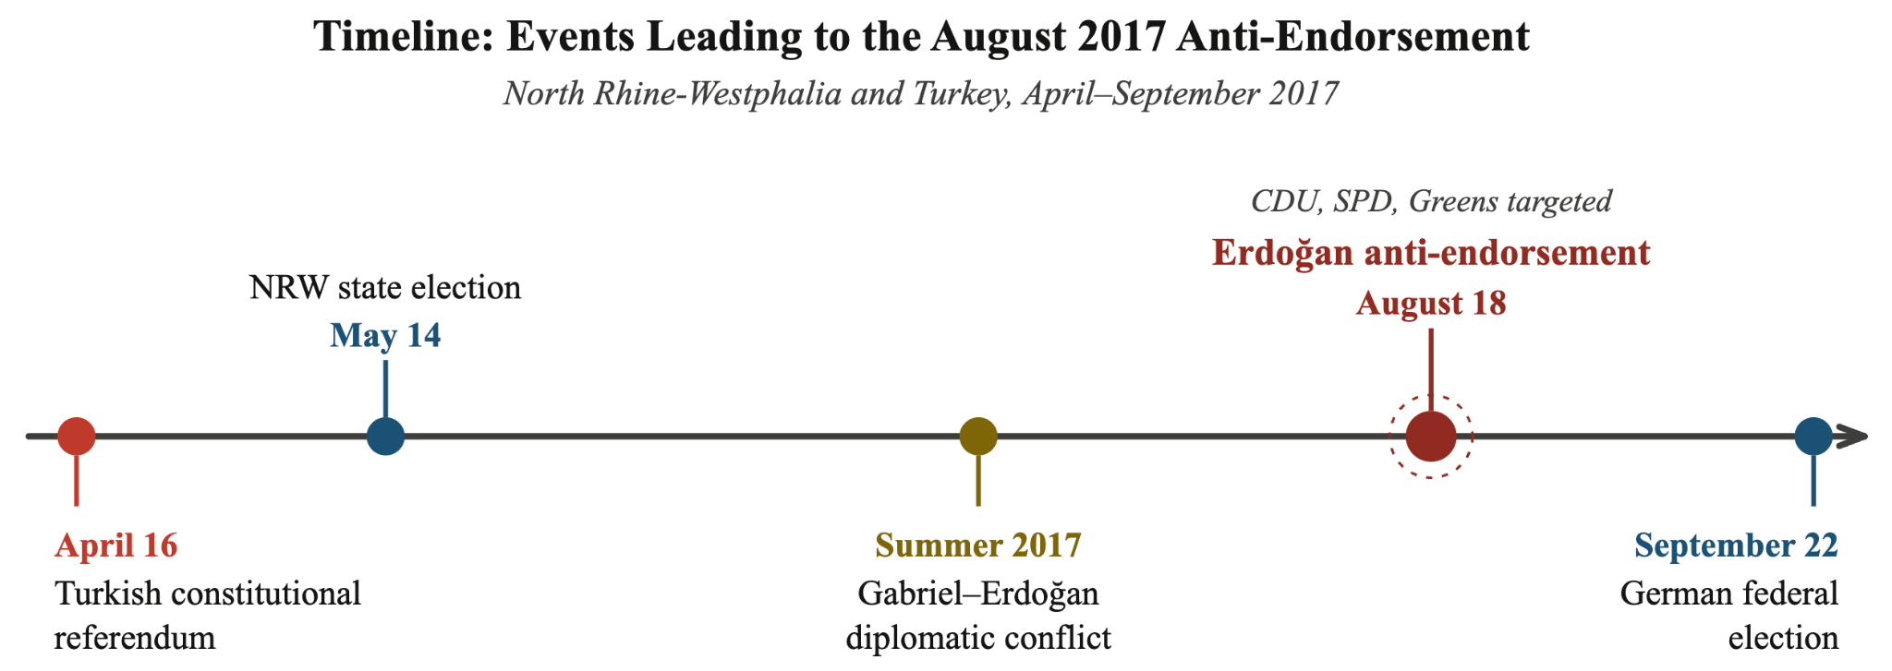
The design depends on two distinct theoretical conceptions. First, the unique timeline of transnational events over a 5-month span clearly increased both interest in and visibility of German politics for Turkish Germans. Secondly, the literature base on information networks and elite cueing implies that demography as an approximation of cue exposure is defensible, as heavily Turkish areas more likely contain community informational infrastructure that boosts messaging exposure. The sequence of cross-national events in 2017 creates a natural “before-and-after” comparison surrounding the anti-endorsement to assess its strength. While not all movement explained by the Turkish population can be attributed expressly to the anti-endorsement, the contention within the German public due to the referendum results triggering prior to the state election isolates the effect more.
In analyzing vote movement between the two German elections, I implement a two-level approach, first focusing on the state of NRW as a whole using Gemeinde-wide (municipality) returns for the 2017 state and federal elections, and then zooming into Stimmbezirke (voting districts) in Köln/Cologne for a finer-grain analysis. In both cases, a continuous-treatment difference-in-differences OLS model is implemented, with standard error clustering at the larger Kreise- (“districts”, for NRW) and Stadteile-levels (“city sector”, for Cologne) in order to account for spatial autocorrelation. Demographic covariates are kept constant in both cases, with slight differences due to the availability of demographic attribute data at each level.
I test two primary outcome variables: (1) the aggregated vote shares for the three anti-endorsed parties (SPD, Greens, and CDU), to test the general effect of the anti-endorsement across parties, and (2) party-specific outcomes to isolate any differences amongst the three parties, and to isolate which of the other major parties may have gained among Turkish voters. German elections are conducted under a mixed-member proportional system that includes both direct-election and party-list votes. For these analyses, I focus solely on the party-list (Zweitstimme) vote shares to avoid variation due to incumbency or candidate effects, and because the anti-endorsement was directed at parties, not individual politicians. Attention is also afforded to the performance of the ADD, due to its strong association with Erdoğan and the AKP. Lastly, a “placebo” analysis is done as a robustness check using the share of Italian-origin migrants to test the identifying assumption of Turkish concentration as a proxy for cue exposure.

Data Sources
All data was collected from publicly available official returns from German government offices. Demographic data was sourced from the Destatis’ GENESIS-Online Data Bank (Statistisches Bundesamt (Destatis), 2026) from the 2022 federal census and the Stadt Köln’s Office for City Development and Statistics (Kölner Stadtteilinformationen, 2020) from the 2020 city census. For elections data at the federal and NRW state level, I used GERDA, a published panel dataset of German federal, state, and local elections harmonized to 2021 municipal boundaries (Hedessheimer, et. al, 2025). Processed data in .csv format and R code for model and visualization reproductions are available within a GitHub repository here.

Elections Analysis and Visualization
I will first analyze broader trends in German voting to establish a baseline regarding the variation in party shares between elections. This is helpful in understanding whether the assessed variation between NRW’s 2017 state election and federal returns was truly notable, or primarily a result of natural variability.
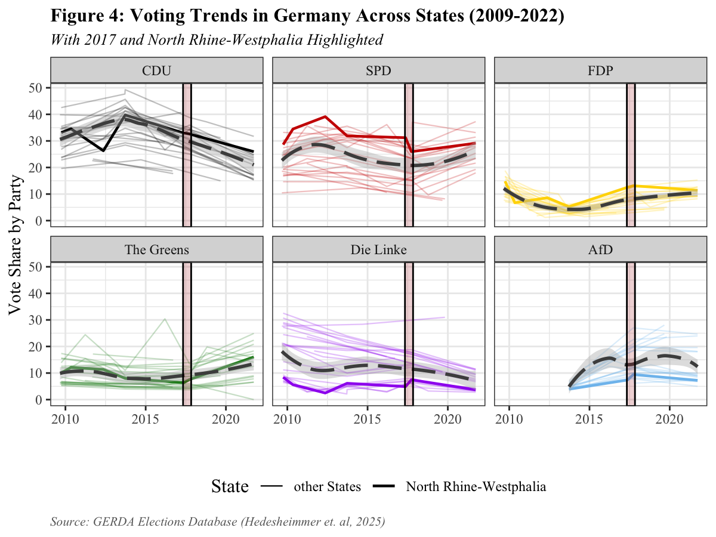
Includes only state and federal elections, with national trend computed with local estimated scatterplot smoothing (LOESS); Red
highlight area shown is from May 1st-October 1st, 2017.

Figure 4 visualizes the general national trends in vote share among each party compared to the results for NRW. Notable features include a generally lower vote share for Die Linke and AfD and higher vote share for the SPD across elections, whereas Green, CDU, and FDP vote shares pretty closely follow the national trends. The red highlighted area isolates the movement between state and national elections in 2017. The drop in the SPD share for NRW during this period is notable, as it tends to deviate from a flattening national trend in the SPD’s decline. In addition, NRW’s vote showed slight spikes in AfD and Die Linke support despite the national trend showing a concurrent decline in vote share across states. Other party movements in NRW are directionally consistent with the national trend, although The Greens do show a sharper increase in vote share comparatively.
This plot primes some of the analysis on the parties that may have benefitted from the decline in SPD and CDU vote shares shown. If a rational-decision model can explain the choice of NRW voters in 2017, it is likely that movement away from the SPD correlates strongly with the movement towards Die Linke or the Greens, as the two closest parties ideologically to the SPD. Conversely, the bump in AfD and FDP support may be owed to the CDU’s decline.
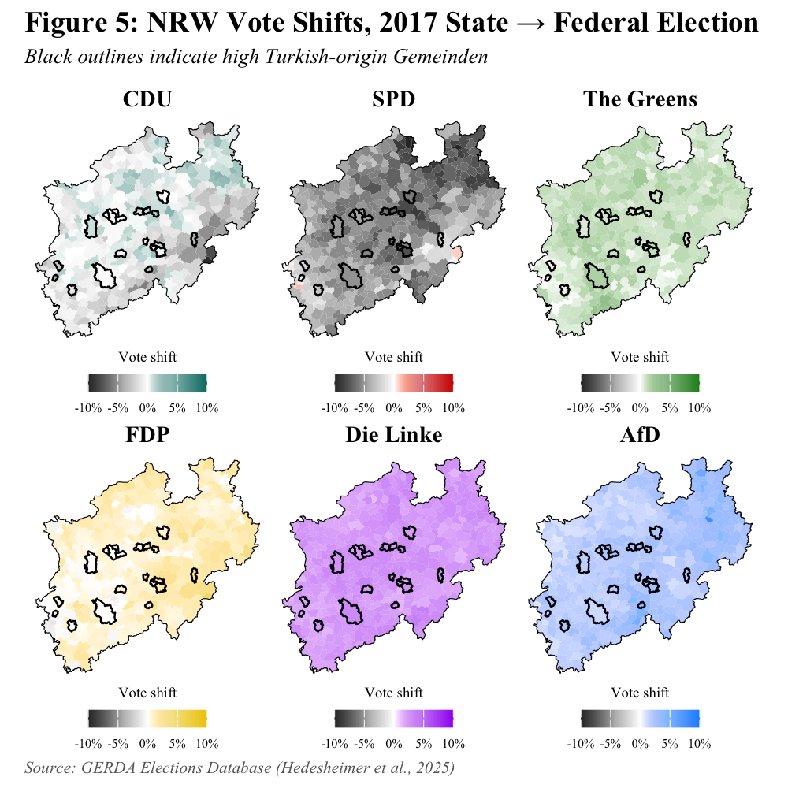

Figure 5 (cont.):


As a supplement to the discussion on the direction of vote switching from Figure 4, the map in Figure 5 demonstrates the mass movement away from the SPD in NRW, particularly among high Turkish population Gemeinde. Visually, it appears that the most heavily Turkish municipalities gained vote share for Die Linke and the AfD. The areas of greatest loss for the CDU, primarily in the southeastern region of the state, seemed to generally move towards the FDP or the AfD, which is in line with the theory of ideological vote switching I previously put forward. Interestingly, there were clearly Gemeinde where the SPD lost votes simultaneously as either the Greens or the CDU gained votes, indicating a bidirectional movement in vote-share among the anti-endorsed parties that complicates the use of aggregated vote share as an outcome variable in the regression analysis.
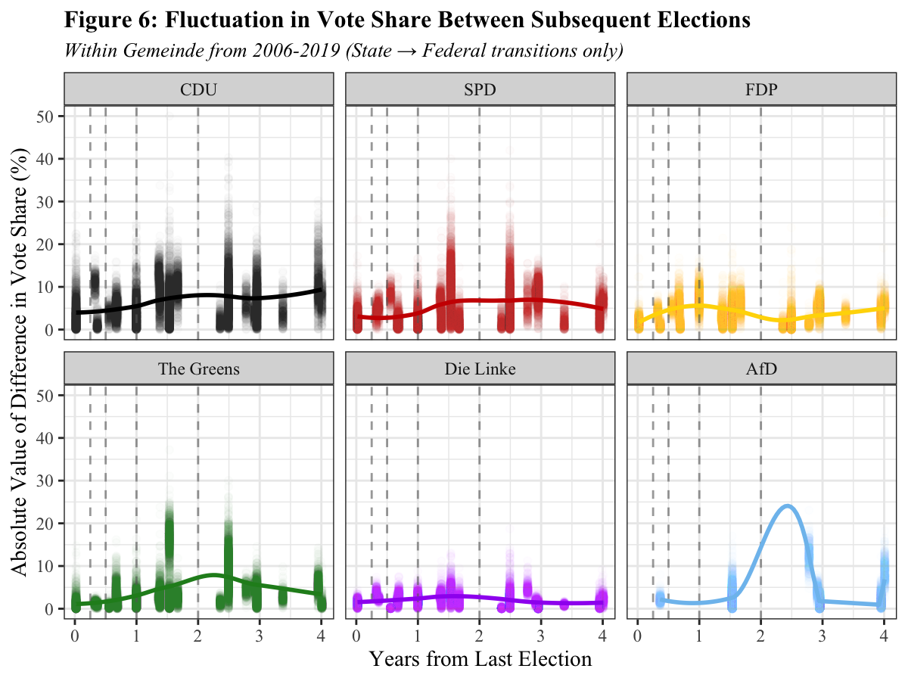
Vertical lines correspond to x-axis “bins”: 0-90 days, 90-180 days, 180-365 days, 365-730 days, and 730+ days; trendline
computed using LOESS.

A core assumption of the model is that state and federal elections that are temporally close to each other tend to see less variation than elections happening several years apart. To analyze this, I calculated the absolute value of differences in vote share between state and subsequent federal elections across national Gemeinde for the period 2006-2019, and compared it against the number of years between the two elections. I used the absolute value of the difference so as to assess the intensity rather than direction of vote share changes.
Although peak variation in vote share was different across parties, the data were consistent with the core assumption of lesser variation in results among closer elections. The Greens and Die Linke saw tighter variation overall, likely owing to their lower average vote share in both federal and state elections compared to the SPD and CDU. The few transition observations in the study period for AfD (as it was not competitive at the state- or federal-level prior to 2017) does make it difficult to draw conclusions about the shifts for that party among elections. The study period of the 2017 NRW and federal elections falls in the .25-.5 year bin, which for all parties except for the FDP shows >5% mean absolute difference.
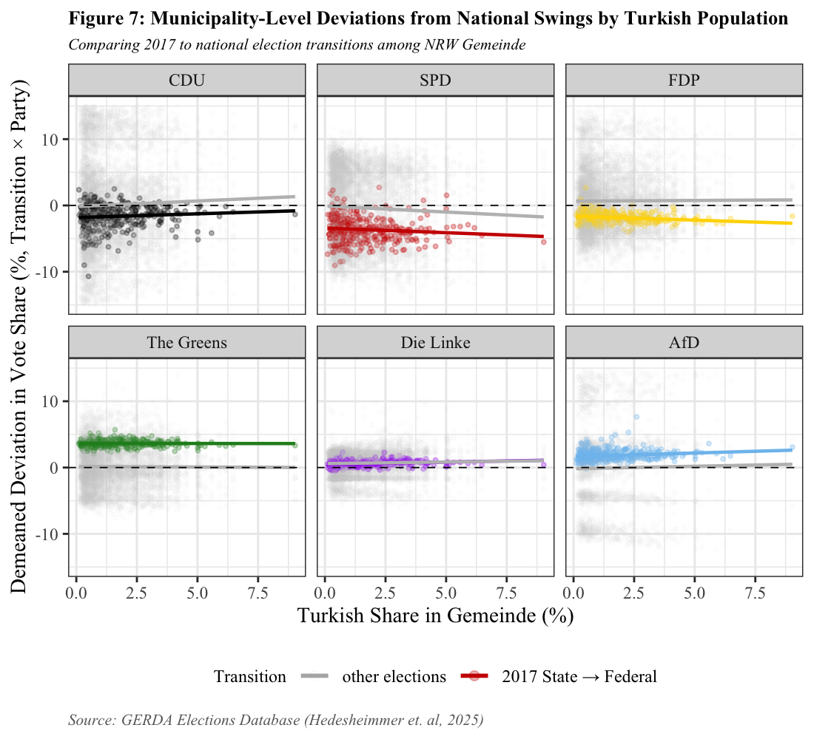
While mean vote change is calculated across all national Gemeinde, only NRW Gemeinde are included in the plot; 201 out of
n = 42,776 observations excluded for falling outside of y-range (-.1, .1); trendlines are calculated by OLS among NRW Gemeinden.

The diagnostic plot in Figure 7 shows the deviation in each Gemeinde from the mean vote change across all municipalities nationally across different shares of Turkish-German population. The mean difference between proximal elections is demeaned across each party, and across like transitions (state -> federal, federal -> federal, federal -> state), then differenced from each individual transition. Values close to zero indicate little variation from the mean change in similar elections, where positive values indicate greater gain or lesser loss (overperformance) relative to the mean, and negative values indicate greater loss or lesser gain (underperformance) in votes relative to the mean. A negative slope indicates that heavily Turkish municipalities tended to fall further below the national mean vote change for that party, underperforming the national swing, while a positive slope indicates that Turkish-heavy municipalities tended to exceed the national mean. A flat slope indicates no systematic relationship between Turkish population share and deviation from the national trend.
Figure 7 reveals several interesting features of between-election variation in NRW. Firstly, the 2017 trendline for the SPD is both negative in magnitude and direction, indicating that Gemeinde with a greater Turkish population did both underperform generally and relative to the mean vote-swing in similar elections. The general trendline is quite close to 0, meaning that generally there is little systematic under- or over-perfomance in NRW for the SPD. This is a promising finding for the next section’s analysis, as heavily-Turkish municipalities did lose more votes than expected given what was happening nationally and in the rest of the state. However, the general trendline has a similar negative slope to the 2017 trend, indicating that relative underperformance to the national trend is common in NRW for the SPD among strongly Turkish municipalities. This is perhaps owing to a “ceiling effect,” wherein the high typical vote share for the SPD in Turkish-heavy Gemeinde makes it difficult for the SPD to grow its vote share relative to the state shift, but has greater room to lose votes than in less initially-favorable municipalities.
The trendlines for the other anti-endorsed parties tell a more complicated story. The trendline in 2017 for the Greens is positive with a slight positive slope, indicating that they overperformed in general across the state and relative to the expected performance, and there was a marginally better performance in high-Turkish municipalities. The slope of the 2017 trendline is also positive for the CDU, although the magnitude of the line is negative, meaning that, while the CDU underperformed in general relative to expectations in NRW in 2017, they underperformed less in heavily-Turkish areas. Similar to the assessment in Figure 4, this indicates that any effect owing to Turkish voting behavior responding to the anti-endorsement did not have a uniform effect across the anti-endorsed parties.
The parties that were not anti-endorsed also exhibit interesting findings. The slope generally across elections is relatively flat with intercept close to 0 for all three, indicating little variation from national expectations. Die Linke shows almost no departure from other election variations, despite a general increase in vote share. The AfD has a slight positive slope, while the FDP has a slight negative slope, meaning that municipalities with larger Turkish populations actually saw overperformances and underperformance for the AfD and FDP, respectively relative to expectations. The FDP’s underperformance is unsurprising given the party’s popularity with wealthier, high-mobility Germans. The AfD’s overperformance is very interesting, as it is unintuitive that Turkish voters switching from the SPD would choose to move towards a party hostile (rhetorically and policy-wise) towards migrant communities. This could indicate a transnational consolidation of the rational-political decision matrix, as conservative Turkish Germans who favor the AKP seek out their policy equivalent in Germany in the wake of the SPD’s souring relationship with Erdoğan.
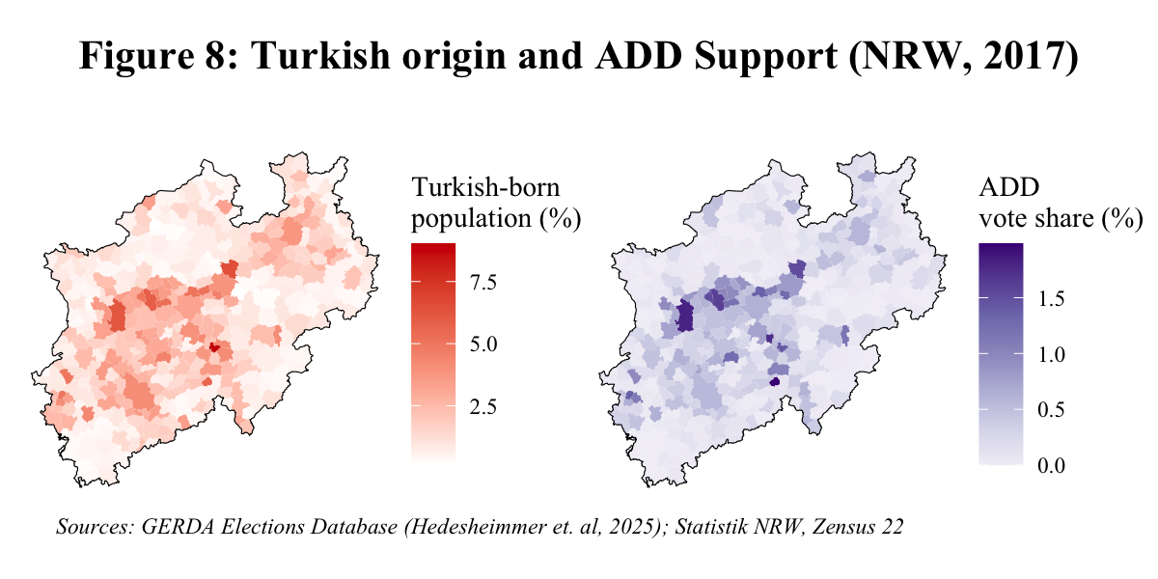

The vote movement patterns of the ADD are harder to explore given their founding in 2016, reduced vote-share in states other than NRW, and lack of prominence relative to the primary national parties. Figure 7 demonstrates the extent to which ADD support correlates almost exactly with the Turkish-born population in a given Gemeinde. Regressing the latter on the former across both elections without a DiD dummy shows this clearly: each additional percentage of Turkish-origin population share corresponds to an increase of .14% vote share for the ADD (p < .001), with an R-squared of .573. Given the party’s status as directly a Turkish-migrant party, this strong of an association in a relatively weakly-specified model is promising for further regressions, as it demonstrates the potential for variations in vote share to be explained by demographic variation at the Gemeinde level of analysis.

DiD Model: North Rhine-Westphalia
Moving now to the evaluation of the differences-in-differences (DiD) quasi-experiment at the state level in NRW, the general model used is below:

$$Y_{i, t}​=α_{i,t}+δ⋅{Post}_{t}+β({Post}_{t}​:Turkish_{i})+​γ({Post}_{t}{:X}_{i,t})+ε_{i, t}​$$

$Y$ represents vote share in district $i$ and election $t$, $α_{i,t}$ represents the intercept which captures any Gemeinde fixed-effects, $δ$ is the election dummy that captures aggregate shifts in partisan share across NRW, $β$ is the coefficient of interest which isolates movement based on continuous-treatment intensity (the share of Turkish Germans), and $γ({Post}_{t}{:X}_{i,t})$ are relevant demographic covariates interacted with the election dummy to capture election-dependent effects due to demographic composition of Gemeinde. Essentially, do municipalities with different Turkish populations move differently between the two elections, controlling for differential trends by other characteristics?
The covariates included are Gemeinde-specific and taken from the 2022 federal census in Germany. For the North Rhine-Westphalia analysis, the covariates used are the log of population density, as a measure of urbanicity; the average rent per sq. meter, as an assessment of the typical socioeconomic status of a resident; and the proportion of population between 18-25 and the proportion 65 or older, to capture age structure of the Gemeinde and generational vote trends. There are no Pearson correlation coefficients between covariates or the outcome variables that would indicate substantial collinearity issues (r > .7), with the largest being between the elder and young adult-shares (r = -.63) and the Turkish population share and municipality population density (r = .62). Each of the variables except for the population density metric are standardized for coefficient interpretability. The observations are further weighted by population. This is important due to the wide variation in Gemeinde populations in NRW: Cologne (and Dusseldorf cities are singular Gemeinde, but so are small townships like Bedburg-Hau (13,197 people in 2022). I downweight these small townships as they will naturally have wider variations in vote shares due to the Law of Large Numbers.

Table 1: Aggregated Anti-Endorsed Parties Model
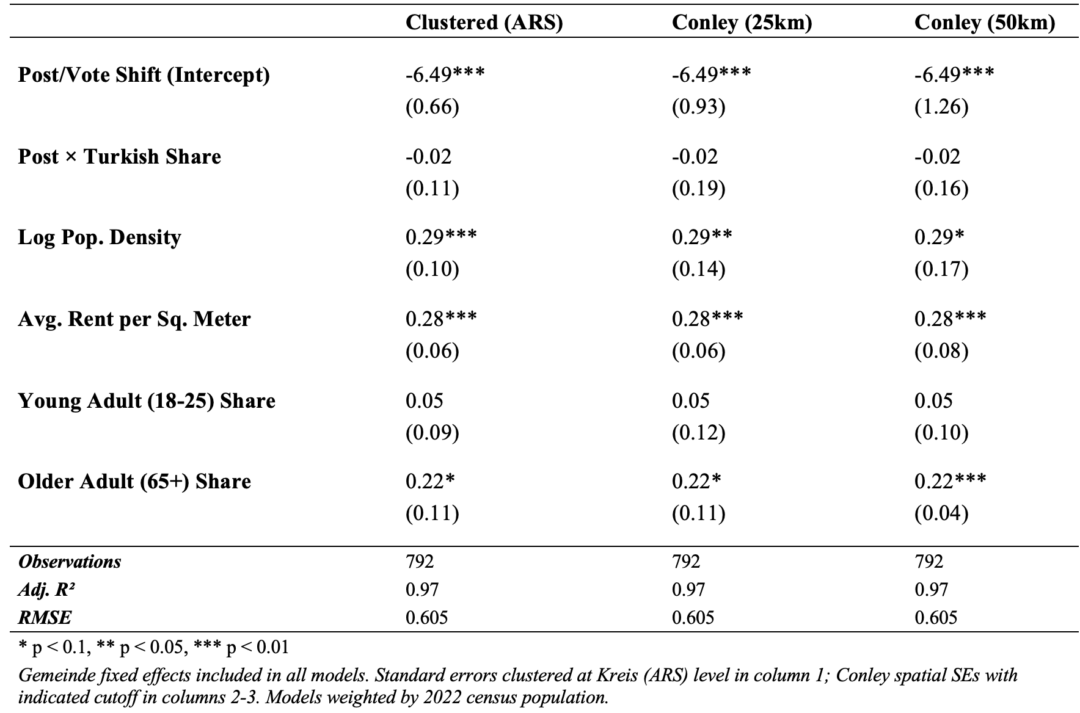
In handling standard errors, I analyze two different methods. The first clusters standard errors in Gemeinde by their corresponding Kreise (county). The second utilizes Conley (1995)’s method of handling spatial autocorrelation. This is important due to the clear geographic relationship between the demographic covariates, as population density, rent, and Turkish foreigner share are all strongly spatial in nature. The aggregated coefficient table shows differences amongst the two methods, with both a 25km and 50km bound for the Conley errors tested for sensitivity. Overall, the Conley standard errors are generally larger than the clustered errors, indicating potential autocorrelation that county-level discrete cutoffs do not pick up. One notable exception is in the interaction between the federal election dummy and the share of older adults in the municipality; here the standard errors are actually lower using the Conley method, to the extent that a 50km cutoff creates artificial significance in the interaction term coefficient.
As assessed in the previous analysis section, the utility of the aggregated anti-endorsed outcome variable is assumed to be less clear due to the difference in direction of vote changes amongst the three anti-endorsed parties. This is demonstrated in Table 1: while the coefficient of interest is negative, it is not significant (p = .513). The demographic covariates do suggest some basic model sensitivity; significant positive coefficients in the population density (p < .001) and rent (t < .001) interaction covariates may reflect the popularity of the Greens and SPD in urban areas, especially relative to the AfD which is typically strongest in rural communities. Overall, aggregating the anti-endorsed parties, while strong if able to pick up on a collective effect from the elite, is difficult to interpret due to the wide range of constituencies and policy platforms that the SPD, CDU, and Greens collectively represent.

Table 2: Party-Stratified Model
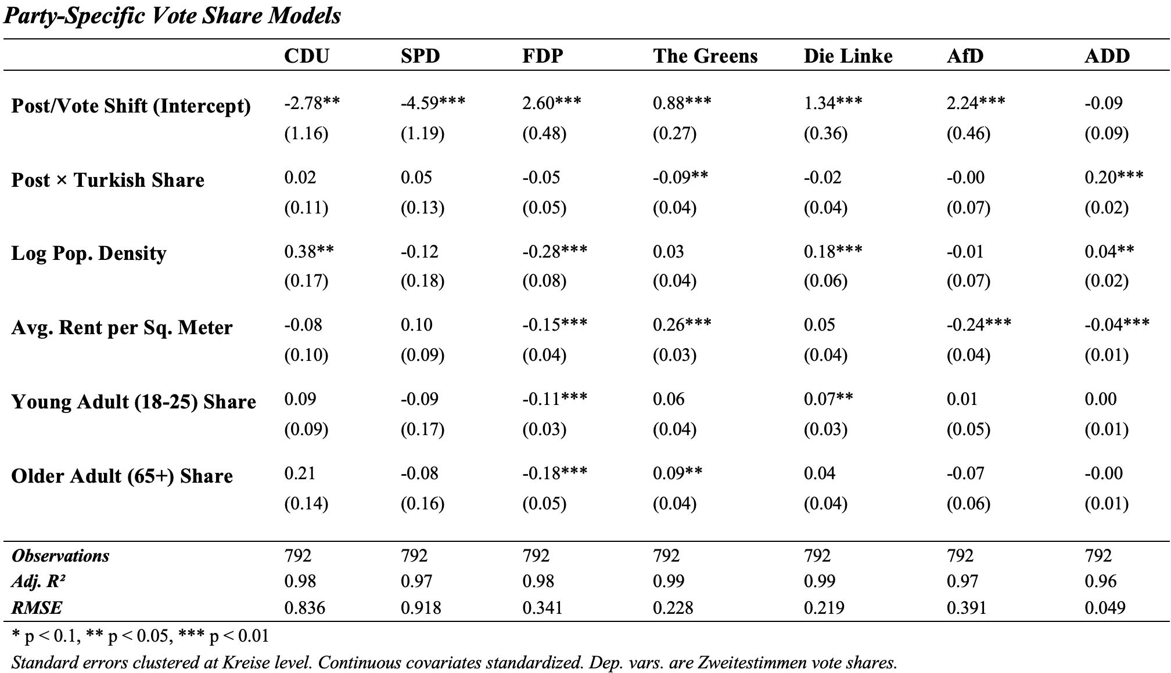
After stratifying results by party-specific movement, the finding that stands out is the ADD movement due to the strong coefficient and low p-value (p < .001). Because the ADD results to begin with among Gemeinde were very low, an additional .2% for each standard deviation in Turkish-German population share represents a large relative increase in vote-share. While it is intuitive at a knowledge-level that the ADD gained from party-switching in the months subsequent to the state election, especially among those who were prone to cueing from homeland politics, the model’s sensitivity to that result is a strong validity indicator. The very low RMSE is, however, likely more indicative of the small vote-shares of the ADD in relative terms rather than strength of prediction.
The other significant interaction in the coefficient of interest is the negative coefficient for the Greens share (p = .002). This finding is interesting given the graphical analyses not isolating a corresponding drop in vote share as with the SPD and CDU and as the Greens receive a generally lesser proportion of Turkish-German votes compared to the SPD. A relative underperformance among the Greens may suggest that Turkish-origin voters were already less attached to CDU and SPD going in to the federal election, while the Greens had meaningful Turkish support that had remained after initial spats between leadership and Erdoğan that was mobilized away by the anti-endorsement. Or it could reflect that the Greens were the most salient target among the three for Turkish-identified voters.

Table 3: Placebo Model (Italian Migrant Share)
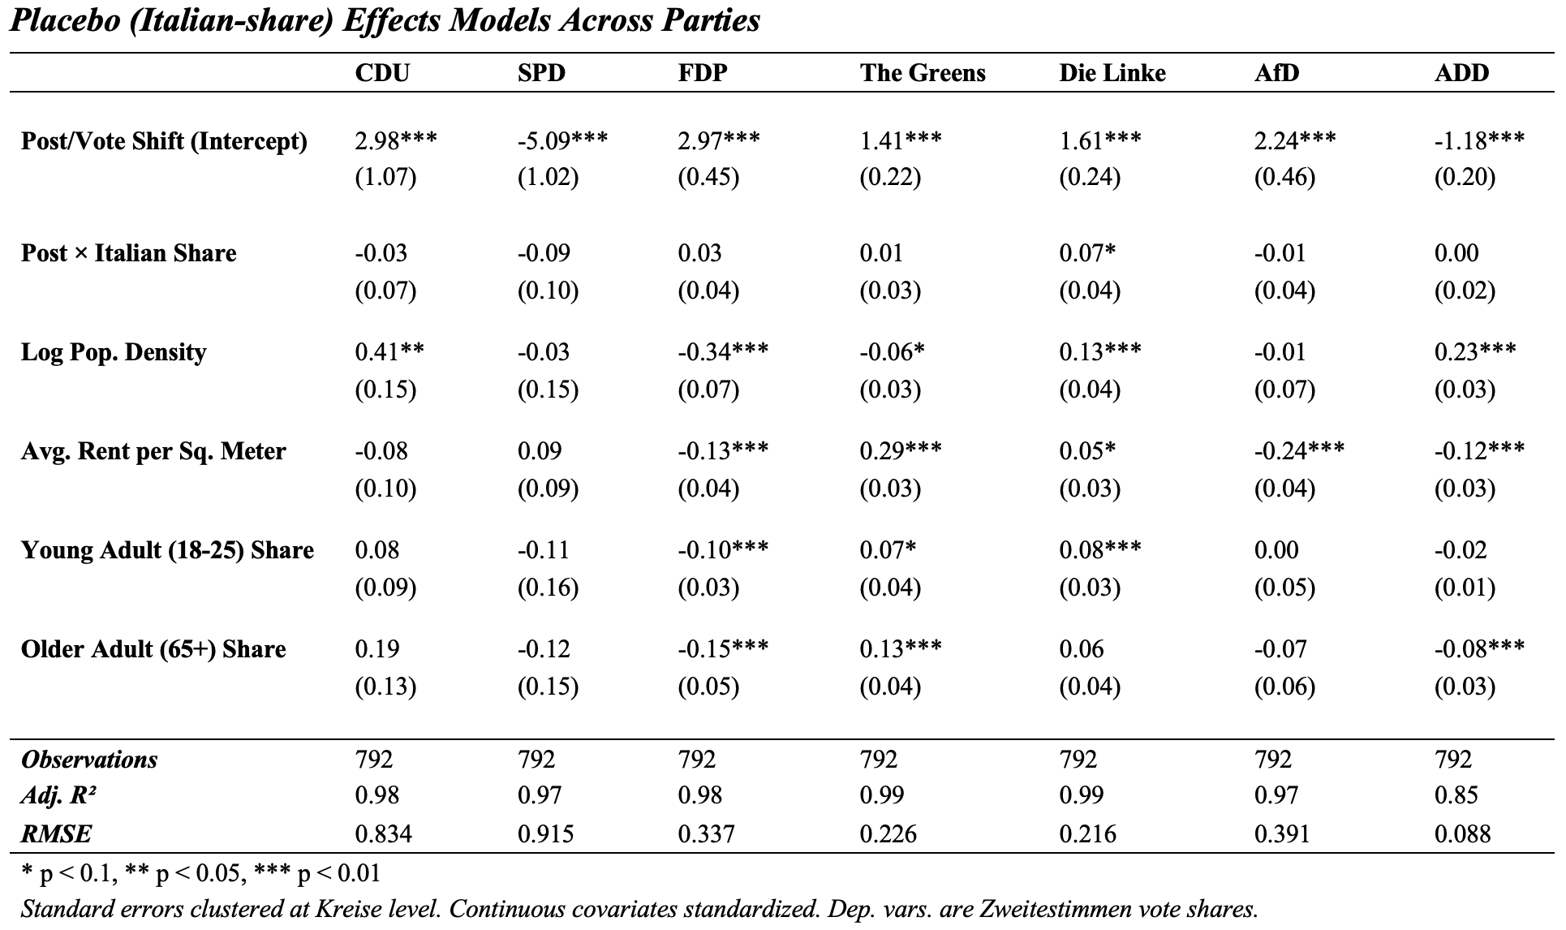
As a robustness measure, I additionally conducted a “placebo” analysis using the same technique but substituting Turkish-immigration background share for Italian. Italian heritage was selected due to the similarity in Gastarbeiter migration history in NRW, therefore controlling for the length of transnational linkage establishment within Gemeinde, but difference in ethnic perception and governmental alignments. In general, the RMSE and R-squared values are similar across each party, indicating that neither model is predictively superior to the other and indicating that, generally, the movement among Turkish migrants was not more unique or substantial than in other migrant communities. The lack of a significant finding or strong coefficient in the Greens model magnifies the assessment.The significant positive sign in the Die Linke coefficient of interest is notable given previous analysis that posited Die Linke as benefitting from the drop in SPD vote share. Since this was not sufficiently explained by the Turkish-specific model, it is possible that the observed shift was actually owed to other migrant communities, indicating movement among specific social groups unrelated to any transnational cueing or elite rhetoric.

DiD Model: Cologne
For a finer-grain analysis to further assess model validity, I also re-ran the party-stratified DiD on Stimmbezirke (voting districts) in Cologne. Cologne was selected for several reasons: (1) it is the largest city in North Rhine-Westphalia, with a population of over a million, allowing for voting block level analysis of ~1000-3000 people each, and (2) the city government regularly conducts and publishes high-quality demographic census findings at smaller subdivisions than available nationally or at the state-level. Additionally, there is generally wider variation of Turkish populations (range of 1.2% to 24.4%, s.d. of 5.6%) and ADD vote-share (0% to 7.7%, s.d. of 0.8%) across spatial units of analysis, and a strong-presence in Turkish and migrant community organizations in the city, indicating potentially stronger information networks that could inform migrant political behavior. These are important to resolve the population distribution and sensitivity concerns regarding the model’s ability to detect vote movement at the state-level within Gemeinde.
Based on available data from the Stadt Köln (2026) city database, the covariates in the model were adjusted slightly. As a measure of geographic socioeconomic landscape, the proportion of a Stimmbezirke that is eligible for social welfare is used instead of the rent measure, and the young adult population share now covers the 18-35 category. I exclude the aggregated regression in this case due to general evidence against its utility in the previous sections. All covariates are again standardized for interpretability in interactions.

Table 4: Cologne Party-Stratified Model
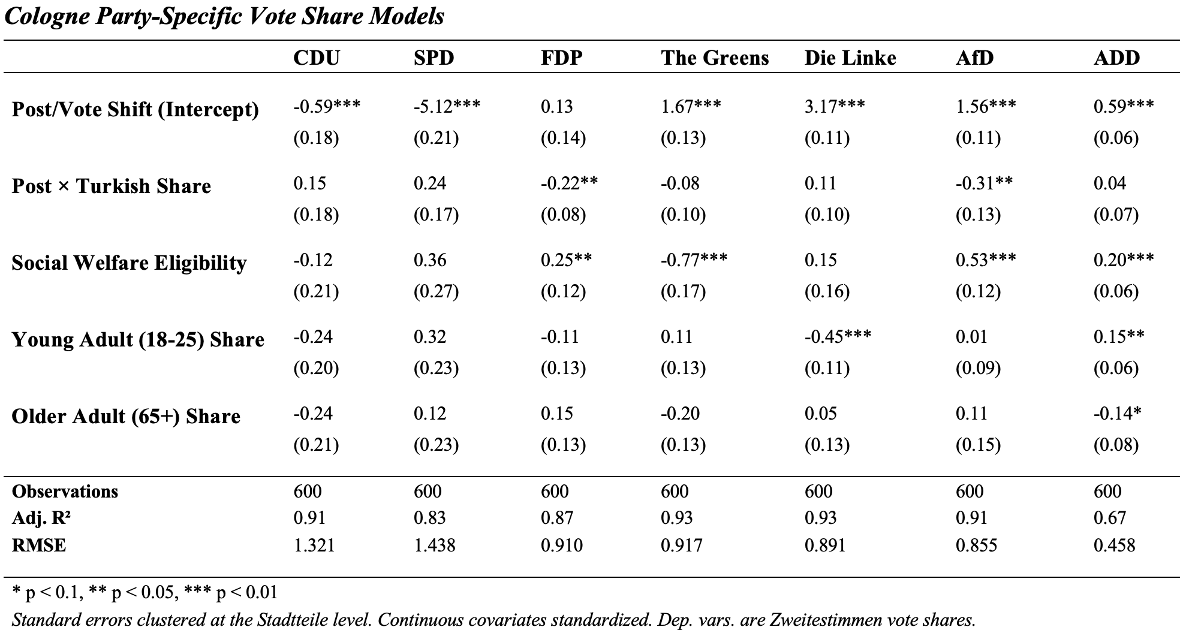
At the finer-grained level within Cologne, the party-specific results largely fail to replicate the NRW Gemeinde findings, with most coefficients in the interaction of interest both small and statistically insignificant. There are two exceptions: the FDP, which shows a significant negative interaction coefficient (-0.22%, p < 0.05) that is consistent with the direction but not the magnitude of the state-level result, and the AfD, which additionally shows a consistent negative interaction coefficient (-.31%, p < 0.05). The ADD coefficient, while positive (0.04%), falls far short of significance, in contrast to the stronger and more-precisely estimated ADD effect found at the statewide level. The interaction coefficient for the Greens is consistent in direction and magnitude with the significant finding from the statewide level as well. The increased strength of effects across the board is unsurprising, given the generally wider distribution of values for each variable at the Stimmbezirk level compared to the state Gemeinde.
Some considerations temper strong conclusions from this null result. First, the much larger RMSE value for the ADD suggests more noise at the level of standard error clustering, which would reduce power to detect effects similar to the magnitude of the Gemeinde level. Second, the adjusted R-squared values drops dramatically, particularly for the SPD and ADD, indicating that the fixed effects explain far less of the within-unit variation in Cologne voting districts, perhaps because Stimmbezirke are more demographically heterogeneous in ways not necessarily captured by the available covariates. It is also possible that feature variation among Turkish communities in rural vs. urban areas are critical to vote movement, and that focusing on an urban center leaves out this critical variation. Taken together, the Cologne results may instead be best interpreted as an underpowered robustness check rather than a necessary contradiction of the NRW findings. The direction of the interaction coefficient of interest is notably consistent across all parties with the state-level results, and the absence of significance may reflect the noisier measurement environment rather than a genuine absence of effect.

Discussion and Conclusions
The overall findings of the regression analysis generally do not point to a unified or substantial effect of Turkish population-share on the variation in vote-share between the 2017 elections. As discussed, the sequencing of events in 2017 may have impacted this. Because of the already very publicly contentious disputes between German and Turkish political elites in the wake of the April referendum, the support for German parties among the Turkish populations could have already experienced an effect on baseline favorability that is picked up in the 2017 NRW state election results. That may have then created a ceiling or floor effect in vote loss/gain, suppressing subsequent variation in the federal election. This indicates that the results are not necessarily inconsistent with theory that transnational elite cues can influence voter behavior, just that the sensitivity of direct election analysis in this instance is not great enough to pick up on movement from Erdoğan’s anti-endorsement or other events from May-September directly.
The heterogeneity across the anti-endorsed parties is an interesting finding itself. Based on the DiD analysis, the Greens faced substantially more of a negative effect between the elections than the SPD or CDU, at least at the statewide level, although the Cologne analysis showed similar magnitude and significance among the CDU and Greens with lesser measured effect for the SPD. If Turkish German voters were already weakly attached to the CDU prior to the anti-endorsement due to the parties' historical positions on immigration and dual citizenship, there may have been little remaining support to be mobilized away. Conversely, the SPD’s strength within the community may reflect a partisan identitarian attachment a la the Michigan Model that could not be sufficiently disrupted by conflicting transnational cues. The Greens, by contrast, may have cultivated stronger but conditional ties within minority communities, and may have held a larger share of persuadable Turkish-origin voters whose support proved contingent on the transnational signal. This interpretation is consistent with a broader logic of cue-taking in which the transigence of support or level of partisan/elite trust matters as much or more than the strength of the cue. The conditionality of effects based on pre-existing partisan attachments is theoretically important and undertheorized in the existing literature on elite cue-taking, which has tended to treat cue receptivity as a relatively uniform property of low-information or identity-activated voters, rather than varying with the nature of the intervened attachment.
The ADD findings in the NRW model, however, are encouraging regarding the transnational saliency in cueing. As discussed, there was a direct information channel between the AKP and the ADD elite network that coordinated cross-national messaging, and the findings isolate that whatever vote share was lost by the anti-endorsed parties flowed at least partially toward a party with explicit organizational ties to Erdoğan. The corresponding increase in ADD share at the statewide level serves as evidence of some sensitivity to minority party messaging in a moment of particularly heightened group identification. However, given the ADD's small overall vote share, the magnitude of this effect is weak and it should not be treated as evidence of broad pro-Erdoğan mobilization rather than movement among a cue-primed constituency.
The Cologne analysis, while showing exclusively effects that are statistically indistinguishable from zero, did validate the general directional findings of the statewide results, indicating that issues may exist with the power and validity of Turkish migration background as the continuous treatment variable. It is also possible that, due to differences in migrant identity cohesion or experiences of discrimination, the actual mechanism and impact of the cue may have varied widely in more urban and more rural Turkish communities. For example, rural Turkish voters, due to poorer social resources and infrastructure, may be more reliant on family- or transnationally-based information channels for political decision-making, that more reliably impart Erdoğan’s sentiment.
The limitations identified point toward a substantial agenda for future research on transnational elite cueing and diaspora political behavior more broadly. While the temporal moment of this particular experimental setup has passed, collection of individual-level data in similar future scenarios could expand model defensibility. Panel surveys tracking vote intentions before and after discrete transnational shocks would allow researchers to identify cue effects at the level of the individual voter, distinguish between demobilization and vote-switching as mechanisms, and test directly whether the conditionality suggested by the party-specific results holds at a micro level. This data would also permit examination of the moderating role of individual-level factors that are already theoretically backed, like strength of ethnic identification, media consumption habits, or generational distance from migration.
A second and perhaps more pressing direction concerns the evolving organizational landscape of diaspora politics itself. The 2017 anti-endorsement and the ADD's modest electoral gains did not result in meaningful directed representation, but it may have catalyzed further migrant advocacy efforts in Germany. The 2024 founding of the Democratic Alliance for Diversity and Awakening (DAVA) by journalist Teyfik Ozcan is one example of a continued energy among the Turkish diaspora toward alternative political configurations that speak directly to facets of migrant, Turkish, and Muslim identity (Topcu, 2024). DAVA's emergence suggests that the 2017 moment may have accelerated a longer-term process of political self-organization among Turkish Germans who feel inadequately represented by the existing party system, and who are seeking vehicles for political expression that are neither beholden to origin-country elites nor assimilated into the mainstream parties' frameworks. Examinations of other national contexts must consider existing modes of migrant advocacy within and without political parties.
The overall picture, then, is of fragile but positive evidence that has not disproven the salience of transnational elite cueing, but instead served as an example of difficulties in detecting diaspora-specific electoral effects through aggregate data. Broadly, this paper argues that the boundaries between domestic and transnational political spheres are more flexible than traditional models of voting behavior assume. The 2017 German case offers one answer, linking this process to conditional textures of partisan and identitarian attachments that hold similar import to the cue itself. As diaspora communities continue to grow in significance across democratic nations, the questions of how and under what conditions transnational elite signals translate into host country votes will become ever more consequential.

Works Cited
Adida, C. L., & Robinson, A. L. (2023). Why (Some) Immigrants Resist Assimilation: US Racism and the African Immigrant Experience. Quarterly Journal of Political Science, 18(3), 295–338. https://doi.org/10.1561/100.00021091
Ahmadov, A. K., & Sasse, G. (2016). A Voice Despite Exit: The Role of Assimilation, Emigrant Networks, and Destination in Emigrants’ Transnational Political Engagement. Comparative Political Studies, 49(1), 78–114. https://doi.org/10.1177/0010414015600468
Arzheimer, K. (2015). The AfD: Finally a Successful Right-Wing Populist Eurosceptic Party for Germany? West European Politics, 38(3), 535–556. https://doi.org/10.1080/01402382.2015.1004230
Barreto, M. A. (2010). Ethnic cues: The role of shared ethnicity in Latino political participation. University of Michigan Press.
Barua, H., & Maheshwari, N. (2025). The interplay between migration and self-identity: A structured review using TCCM and bibliometric analysis. Frontiers in Psychology, 16, 1563508. https://doi.org/10.3389/fpsyg.2025.1563508
Bird, K., Saalfeld, T., & Wüst, A. M. (2010). Ethnic diversity, political participation and representation: A theoretical framework. In The Political Representation of Immigrants and Minorities (p. 22). Routledge. https://doi.org/10.4324/9780203843604
Breitenbach, D. (2017, April 19). The Turkish vote in Germany: Why “yes” won. DW. https://www.dw.com/en/why-many-turks-in-germany-voted-yes-in-Erdoğans-referendum/a-38472130
Brubaker, R. (1992). Citizenship and Nationhood in France and Germany. Harvard University Press.
Ciuk, D. J., & Tavarez, L. (2025). The Effects of Foreign Elite Cues from a Dominant Neighboring Country: The Case of the United States and Mexico. Political Communication, 42(3), 527–547. https://doi.org/10.1080/10584609.2024.2434486
Conley T. G. (1995), Econometric Modelling of Cross-Sectional Dependence, Ph. D. thesis, University of Chicago.
Conroy-Krutz, J. (2013). Information and Ethnic Politics in Africa. British Journal of Political Science, 43(2), 345–373. https://doi.org/10.1017/S0007123412000300
Dancygier, R., & Saunders, E. N. (2006). A New Electorate? Comparing Preferences and Partisanship between Immigrants and Natives. American Journal of Political Science, 50(4), 962–981. https://doi.org/10.1111/j.1540-5907.2006.00227.x
de Fonseca, S. C. (n.d.). New citizens – new candidates: Candidate selection and the mobilization of immigrant voters in German elections. In K. Bird, A. M. Wüst, & T. Saalfeld (Eds.), The Political Representation of Immigrants and Minorities (pp. 109–125).
Downs, A. (1957). An Economic Theory of Political Action in a Democracy. Journal of Political Economy, 65(2), 135–150. http://www.jstor.org/stable/1827369
Duverger, M. (1954): Political Parties. New York: Wiley.
Farahat, A., & Hailbronner, K. (2020). REPORT ON CITIZENSHIP LAW: GERMANY (p. 40). Global Citizenship Observatory, Robert Schuman Centre for Advanced Studies. https://cadmus.eui.eu/server/api/core/bitstreams/37deae2b-0c3a-5c39-b930-bf2ffe3ea0c4/content
Fearon, James. (1999). Why Ethnic Politics and `Pork' Tend to Go Together. https://web.stanford.edu/group/fearon-research/cgi-bin/wordpress/wp-content/uploads/2013/10/Pork.pdf
Ferree, K. E. (2006). Explaining South Africa’s Racial Census. The Journal of Politics, 68(4), 803–815. https://doi.org/10.1111/j.1468-2508.2006.00471.x
Forehand, M., Gastil, J., & Smith, M. A. (2004). Endorsements as Voting Cues: Heuristic and Systematic Processing in Initiative Elections1. Journal of Applied Social Psychology, 34(11), 2215–2231. https://doi.org/10.1111/j.1559-1816.2004.tb01974.x
Franzmann, S. T., Giebler, H., & Poguntke, T. (2020). It’s no longer the economy, stupid! Issue yield at the 2017 German federal election. West European Politics, 43(3), 610–638. https://doi.org/10.1080/01402382.2019.1655963
Gabriel, V. S., & Maas, H. (2017, August 22). Für Erdogans Kulturkampf ist in Deutschland kein Platz. SPIEGEL International. https://www.spiegel.de/politik/ausland/recep-tayyip-erdogan-kein-kulturkampf-in-deutschland-gastbeitrag-von-maas-und-gabriel-a-1164041.html
German Marshall Fund of the United States. (2011, December 1). Transatlantic Trends: Immigration 2011. German Marshall Fund of the United States. https://www.gmfus.org/sites/default/files/2025-01/Transatlantic%20Trends%20Immigration%202011.pdf
Gest, J., Reny, T., & Mayer, J. (2018). Roots of the Radical Right: Nostalgic Deprivation in the United States and Britain. Comparative Political Studies, 51(13), 1694–1719. https://doi.org/10.1177/0010414017720705
Gilens, M., & Murakawa, N. (Eds.). (2002). Political decision-making, deliberation and participation (1. ed). Jai.
Glass, J., Bengtson, V. L., & Dunham, C. C. (1986). Attitude Similarity in Three-Generation Families: Socialization, Status Inheritance, or Reciprocal Influence? American Sociological Review, 51(5), 685. https://doi.org/10.2307/2095493
Goerres, A., Mayer, S. J., Diaz Garcia, M., & Elis, J. (2024). The National and Transnational Party Preferences of German Voters of Turkish Descent between 1999 and 2021. SSRN. https://doi.org/10.2139/ssrn.4889421
Goerres, A., Spies, D., & Mayer, S. (2018). How Did Immigrant Voters Vote at the 2017 Bundestag Election? First Results from the Immigrant German Election Study (IMGES). SSRN Electronic Journal. https://doi.org/10.2139/ssrn.3133559
Goldberg, A. C., & Lanz, S. (2021). Living abroad, voting as if at home? Electoral motivations of expatriates. Migration Studies, 9(2), 279–310. https://doi.org/10.1093/migration/mnz018
Gülmen, M. (2017). Ärger um Plakate mit Erdogan- Motiv. Bild. https://www.bild.de/regional/ruhrgebiet/recep-tayyip-erdogan/auf-wahlplakaten-in-duisburg-53150462.bild.html
Hamidou‐Schmidt, H., & Mayer, S. J. (2021). The Relation Between Social Identities and Outgroup Hostility Among German Immigrant‐Origin Citizens. Political Psychology, 42(2), 311–331. https://doi.org/10.1111/pops.12700
Heckmann, F. (2016). Understanding the Creation of Public Consensus: Migration and Integration in Germany, 2005 to 2015. http://www.migrationpolicy.org/
Heddesheimer, Vincent, Hanno Hilbig, Florian Sichart, and Andreas Wiedemann. (2025). “GERDA: The German Election Database.” Scientific Data 12(1): 618. doi:10.1038/s41597-025-04811-5.
Hess, C., & Green, S. (2016). Introduction: The Changing Politics and Policies of Migration in Germany. German Politics, 25(3), 315–328. https://doi.org/10.1080/09644008.2016.1172065
Hochman, O., Stein, A., Lewin‐Epstein, N., & Wöhler, T. (2018). Emotional Integration across Immigrant Generations in Baden‐Württemberg, Germany: The Role of Discrimination. International Migration, 56(3), 186–202. https://doi.org/10.1111/imig.12377
Horrocks, D. & Kolinsky, E. (1996). Turkish Culture in German Society. New York, Oxford: Berghahn Books. https://doi.org/10.1515/9781789204254
Huber, J. D. (2017). Exclusion by Elections: Inequality, Ethnic Identity, and Democracy (1st ed.). Cambridge University Press. https://doi.org/10.1017/9781316863497
Jennings, M. K., Stoker, L., & Bowers, J. (2009). Politics across Generations: Family Transmission Reexamined. The Journal of Politics, 71(3), 782–799. https://doi.org/10.1017/S0022381609090719
Jensenius, F. R. (2015). Development from Representation? A Study of Quotas for the Scheduled Castes in India. American Economic Journal: Applied Economics, 7(3), 196–220. https://doi.org/10.1257/app.20140201
Kaya, A. (2019). Turkish Origin Migrants and Their Descendants. Springer International Publishing. https://doi.org/10.1007/978-3-319-94995-6
Kazim, H. (2017, April 18). The Bizarre Behavior of Turkish-German Voters. SPIEGEL International. https://www.spiegel.de/international/germany/referendum-in-turkey-the-bizarre-behavior-of-turkish-german-voters-a-1143735.html
Kolinsky, E. (1996). Non-German Minorities in Contemporary German Society.
Krumm, T. (2018, May). Germany_Brief_8. stanbul Turkish-German University. https://eu.bilgi.edu.tr/media/files/Germany_Brief_8.pdf
Kürsat-Ahlers, E. (1996). The Turkish Minority in German Society. In Turkish Culture in German Society. Berghahn Books. https://doi.org/10.1515/9781789204254
Mandel, R. (2008). Cosmopolitan Anxieties: Turkish Challenges to Citizenship and Belonging in Germany. https://doi.org/10.1215/9780822389026
Molodikova, I. N., & Lyalina, A. V. (2017). Territorial differences in the attitudes to the migration crisis in Germany: The political aspect. Baltic Region, 9(2), 60–75. https://doi.org/10.5922/2079-8555-2017-2-5
Nandi, A., & Platt, L. (2020). The relationship between political and ethnic identity among UK ethnic minority and majority populations. Journal of Ethnic and Migration Studies, 46(5), 957–979. https://doi.org/10.1080/1369183X.2018.1539286
Nicholson, S. P. (2011). Dominating Cues and the Limits of Elite Influence. The Journal of Politics, 73(4), 1165–1177. https://doi.org/10.1017/S002238161100082X
Oskooii, K. A. R. (2020). Perceived Discrimination and Political Behavior. British Journal of Political Science, 50(3), 867–892. https://doi.org/10.1017/S0007123418000133
Pott, A. (2001). Ethnicity and social mobility: The case of Turks in Germany. Journal of International Migration and Integration / Revue de l’integration et de La Migration Internationale, 2(2), 169–186. https://doi.org/10.1007/s12134-001-1026-8
Reeskens, T., & Wright, M. (2013). Nationalism and the Cohesive Society: A Multilevel Analysis of the Interplay Among Diversity, National Identity, and Social Capital Across 27 European Societies. Comparative Political Studies, 46(2), 153–181. https://doi.org/10.1177/0010414012453033
Ross, C. J. (2009). Perennial Outsiders: The Educational Experience of Turkish Youth in Germany, 24 Am. U. Int'l L. Rev. 685
Salmela, M., & Von Scheve, C. (2017). Emotional roots of right-wing political populism. Social Science Information, 56(4), 567–595. https://doi.org/10.1177/0539018417734419
Sandal-Önal, E., Bayad, A., Zick, A., & Düzen, N. E. (2022). Transnational Influences on Migrant Identities and Social Cohesion: A Study Protocol. Genealogy, 6(1), 9. https://doi.org/10.3390/genealogy6010009
Sauer, M. (2007, March 1). Perspektiven des Zusammenlebens: Die Integration türkischstämmiger Migrantinnen und Migranten in Nordrhein-Westfalen. Stiftung Zentrum für Türkeistudien und Integrationsforschung Institut an der Universität Duisburg-Essen. https://nbn-resolving.org/urn:nbn:de:0168ssoar-349749
Sauer, M. (2018, July 24). Identifikation und politische Partizipation türkeistämmiger Zugewanderter in Nordrhein-Westfalen und in Deutschland. Stiftung Zentrum für Türkeistudien und Integrationsforschung. https://e-pflicht.ulb.hhu.de/urn/urn:nbn:de:hbz:061:3-476979
Schiefer, D. (2013). Cultural Values and Group-Related Attitudes: A Comparison of Individuals With and Without Migration Background Across 24 Countries. Journal of Cross-Cultural Psychology, 44(2), 245–262. https://doi.org/10.1177/0022022112444898.
Schuessler, A. A. (2000). EXPRESSIVE VOTING. Rationality and Society, 12(1), 87–119. https://doi.org/10.1177/104346300012001005
Tiberj, V., & Michon, L. (2013). Two-tier Pluralism in ‘Colour-blind’ France. West European Politics, 36(3), 580–596. https://doi.org/10.1080/01402382.2013.773725
Ünver, O. C. (2023). Transnational Turkish–German community in limbo. Consequences of political tensions between migrant receiving and sending countries. International Migration, 61(2), 179–197. https://doi.org/10.1111/imig.13005
Uslucan, H. H., & Sauer, M. (2018). Political Participation and Party Preferences among Immigrants of Turkish Origin in Germany.
Wagner, M. (2021). Affective polarization in multiparty systems. Electoral Studies, 69, 102199. https://doi.org/10.1016/j.electstud.2020.102199
Wüst, A. M. (2004). Naturalised citizens as voters: Behaviour and impact. German Politics, 13(2), 341–359. https://doi.org/10.1080/0964400042000229972
Yüksek Seçim Kurulu. (2017). 2017. Halkoylaması Arşivi; Sorgu Kriterleri Bazında Seçim Sonuçları Bilgisi. https://sonuc.ysk.gov.tr/sorgu

Appendix
Appendix 1: Descriptive statistics (NRW and Cologne)

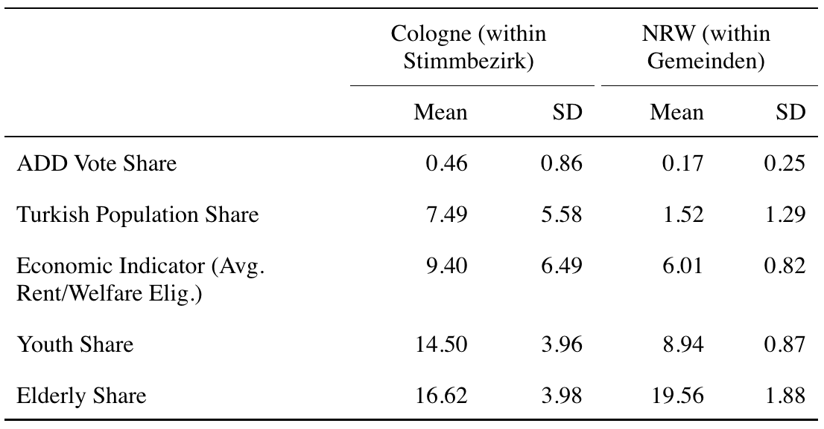
Numbers are expressed in percentages of total subdivision population.

Appendix 2: Covariate correlations

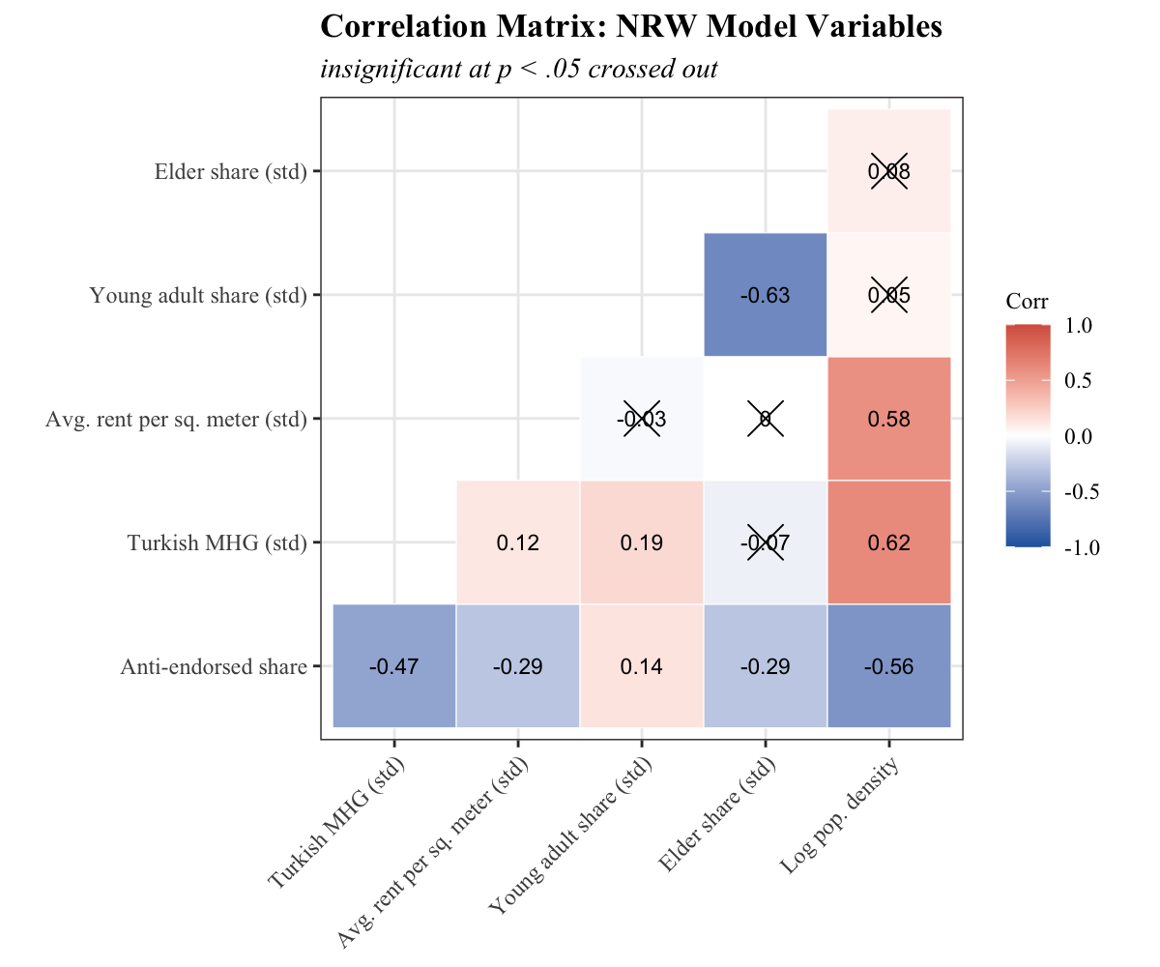 | 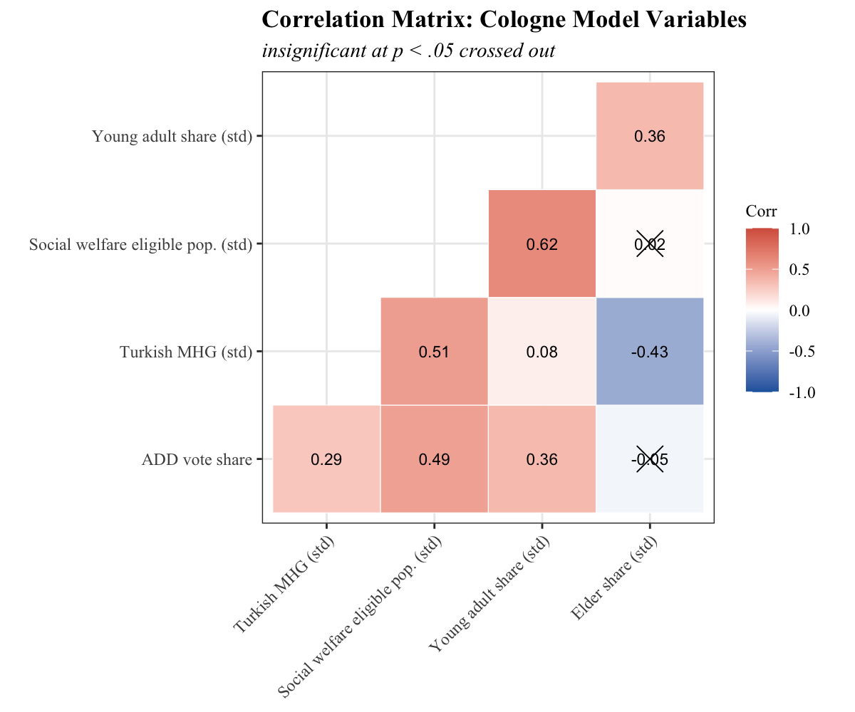

Appendix 3: ADD Simple Regression

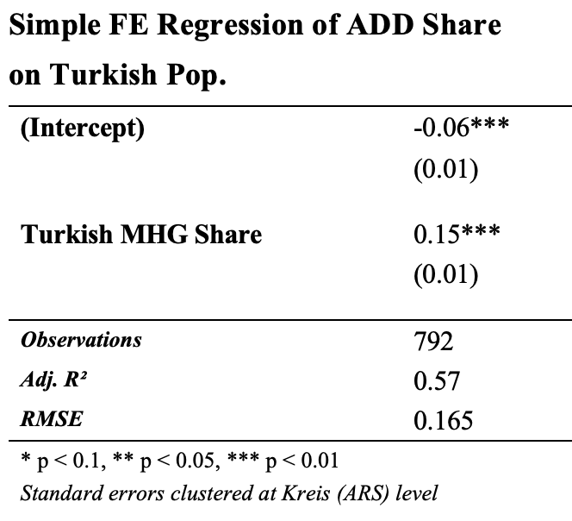

Appendix 4: Miscellaneous Plots
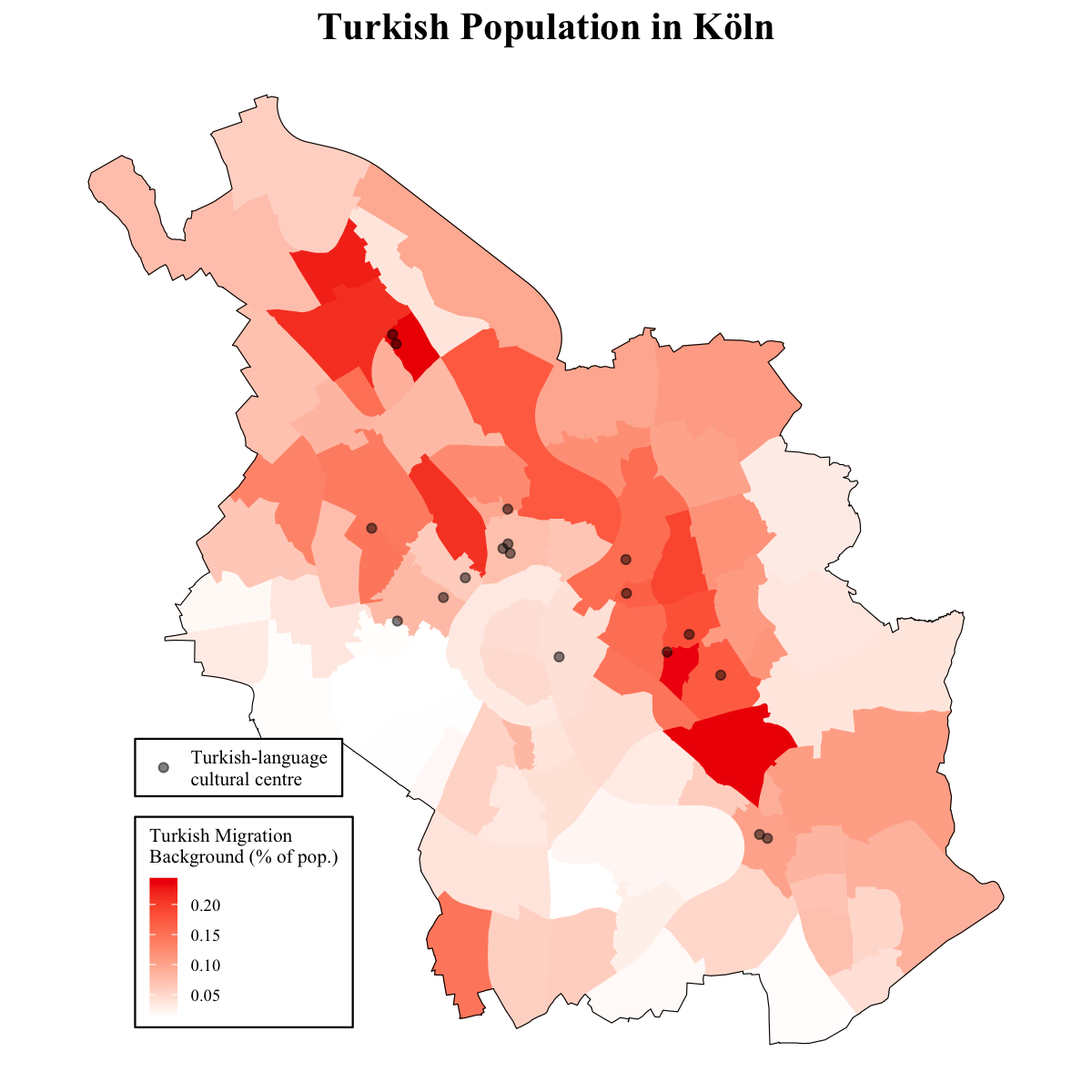 | 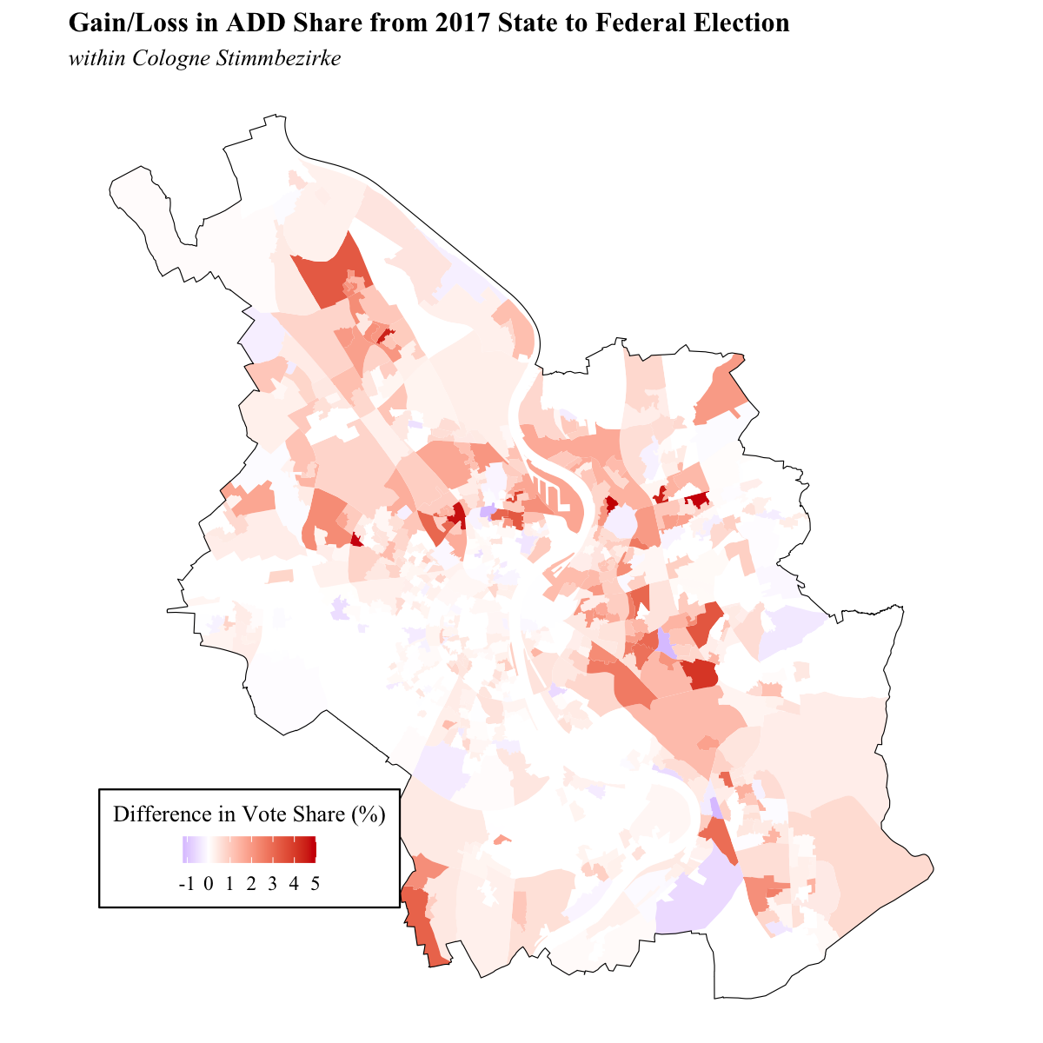

Exceptions were made in 1956 for Austrian-born residents of Germany and citizens of the GDR. The latter was reversed in 1967 (Farahat and Hailbronner, 2020)
The Netherlands (69.7%), Belgium (69.4%), and Austria (68.4%) saw higher vote shares but much lower raw totals for the AKP (Krumm, 2018; Uslucan and Sauer, 2018)
The Party of Democratic Socialism (PDS), the legal successor of the DDR’s Socialist Unity Party of German (SED). In 2007, merged with Labour and Social Justice – The Electoral Alternative (WASG) to become Die Linke. (Franzmann et. al, 2020)
Full differences in covariates are explained in individual methods subsections. Major difference is measure of general socioeconomic status of the electoral subdivision (average rent per sq. meter vs. proportion of population eligible for social benefits)
See appendix 3
See Appendix 2
See Appendix 1

