Coe768 Project: P2P Application

General Description

In a P2P environment, a network application (peer) can be both a client and a server. Whenever a peer (Peer A) wants to make one of its files (contents) available for download, it will register the content to the index server. Once the content is registered, Peer A becomes the server of the content. Another peer (Peer B) that wants to download the content will first contact the index server and obtain the address of Peer A. Peer B then, as a client, downloads the content from Peer A. After the download, Peer B will register the content to the index server, thus also becomes the server of the content.

Protocol Data Unit Format

The protocol data unit (PDU) exchanged among peers and the index server has the following simple format:

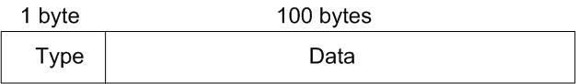

The "type" field specifies the PDU type. There are eight PDU types. The following table summarizes the functions of these PDU.

PDU type | Function
R | Content Registration
D | Content Download
S | Search Content Server
T | Content De-Registration
C | Content Data
O | List of On-Line Registration Content
A | Acknowledgement
E | Error

Protocol Description

- Content Registration
A peer can register its content to the index server by sending an R-type PDU using UDP. The data portion of the PDU contains the peer name, content name, and the address (IP address + port number) where the content can be downloaded. The following figure shows the format.

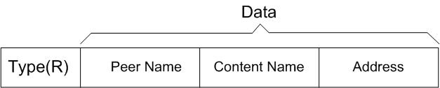

To simplify the implementation, fix the sizes of the peer name and content name fields (says 20 bytes each). When the index server receives an R-type PDU, it will first check if another peer with the same name registered the same content name. If this happens, the index server will send an E-type PDU to prompt the peer to choose another peer name. If there is no conflict of peer name, the content server will register the content and store the associated address. Subsequently, it will send back an A-type PDU to acknowledge the success of content registration. Note that before sending a registration request, a peer must first create a TCP socket for content download. The address associated with the socket (i.e. content server address) is part of the data in the R-type PDU. The following diagram illustrates the registration procedure performed between a peer and the index server in the situation where the peer needs to choose another peer name due to the peer name conflict.

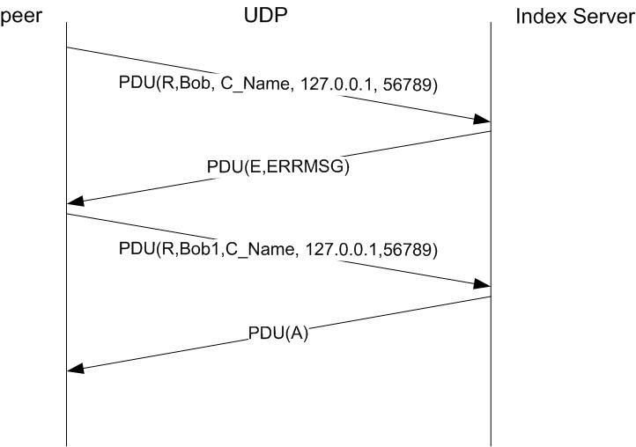

- Content Download
To download a piece of content, a peer first contacts the index server to look for the address of the corresponding content server. It does that by sending an S-type PDU with the following format:
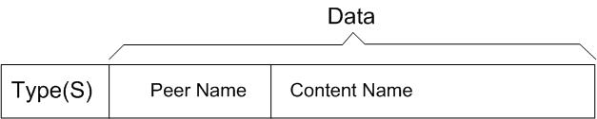

The index server responds by sending either an S-type PDU which contains the address of a content server or an E-type PDU which implies that no such content is available.

If the peer receives an S-type PDU back from the index server, it will extract the address from the PDU and setup a TCP connection with the content server. If the TCP connection is successfully established, the peer sends a D-type PDU to the content server to request a download. If the content is available, the content server delivers the content by sending a series of C-type PDUs which contain the content.

Once the peer downloads the content, it will register the content to the index server, thus, becomes the server of the content itself. Note that the index server may have more than one server for a given content. In order to distribute the load of downloading evenly, the index server should always choose the latest registered content server as the server for the current content download request. For example, support Peer A is the first to register as the content server of a given content; subsequently, Peer B downloads the content from Peer A and in turn registers as the server of the content. If another peer wants to download the content, the index server should send the address of the content server associated with Peer B.

The following figure illustrates the PDU transaction for the content downloading and the subsequent content registration.

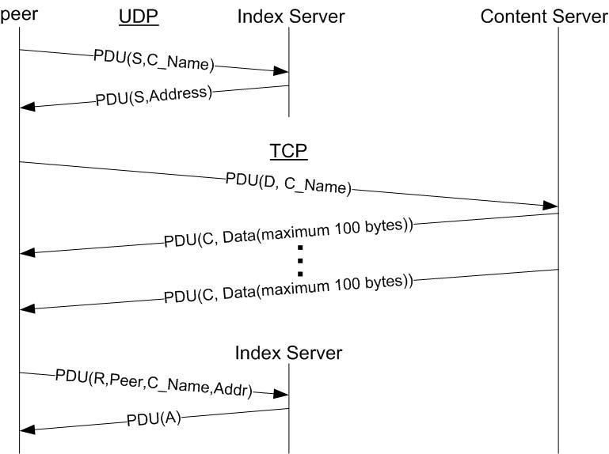

- Content Listing
The user can find out the list of contents registered by sending an O-type PDU to the index server. The index server will respond with an O-type PDU that contains a list of registered content.

- Content De-Registration
The application should provide an option to allow a peer to de-register the content. To do this, the peer sends a T-PDU to the index server to de-register the content.

- Quit
In order to keep the content registration information at the index server up-to-date, whenever a peer wants to quit, it must first de-register all its registered content. This can be accomplished by sending a series of T-type PDUs to the index server. Each T-type PDU will de-register one content.

Since a peer can both be a client and a server, it usually has a number of sockets opened. Some sockets are associated with its roles of the clients. They are used for downloading from the content servers and communication with the index server. Some sockets are associated with its roles of content servers from which other peers can download contents. Since each socket has a set of addresses associated with it, a peer has many addresses. In this document, the address of a peer is usually referred to the address of the content server hosted by the peer.

