Ticket Booking

Description:

This is implementation of Use Case study.

* Build a simple Java application for the use case of booking a Show. The program must take input from command line.
* The program would setup available seats per show, allow buyers to select 1 or more available seats and buy/cancel tickets.
* The application shall cater to the below 2 types of users & their requirements – (1) **Admin** and (2) **Buyer**

Tool:

Dev Tool: IntelliJ(SpringBoot + Java 11)

DataBase: MySQL/H2(Configurable in application.properties)

TestCase: Postman  
Server URL: localhost:9095/api/v1/adminsetupshow

Unit Test: JUNIT5(src/test/java/*)

SourceCode:



TestCase:



## Admin:

1. **Setup**

Method**:**

@PostMapping("/adminsetupshow")  
public ResponseEntity<Map> setupShow(@Valid @RequestBody ShowSetupDto showSetupDto) {

1. **View**

Method:

@GetMapping("/adminviewshow")  
public ResponseEntity<ShowInfoDto> viewShow(@RequestParam long showNumber) {

## Buyer:

1. **Availability**

Method**:**

@GetMapping("/adminviewshow")  
public ResponseEntity<ShowInfoDto> viewShow(@RequestParam long showNumber) {

1. **Book**

Method:

@PostMapping("/buyershowbooking")  
public ResponseEntity<ShowBooking> bookShow(@RequestBody BookSeatsDto bookSeatsDto) {

1. **Cancel**

Method**:**

@DeleteMapping("/buyershowcancelling")  
public ResponseEntity<Map> cancelShow(@RequestParam String ticketNumber, @RequestParam String phoneNumber) {

*Test Case & Test Result*

Admin

1. **Setup**

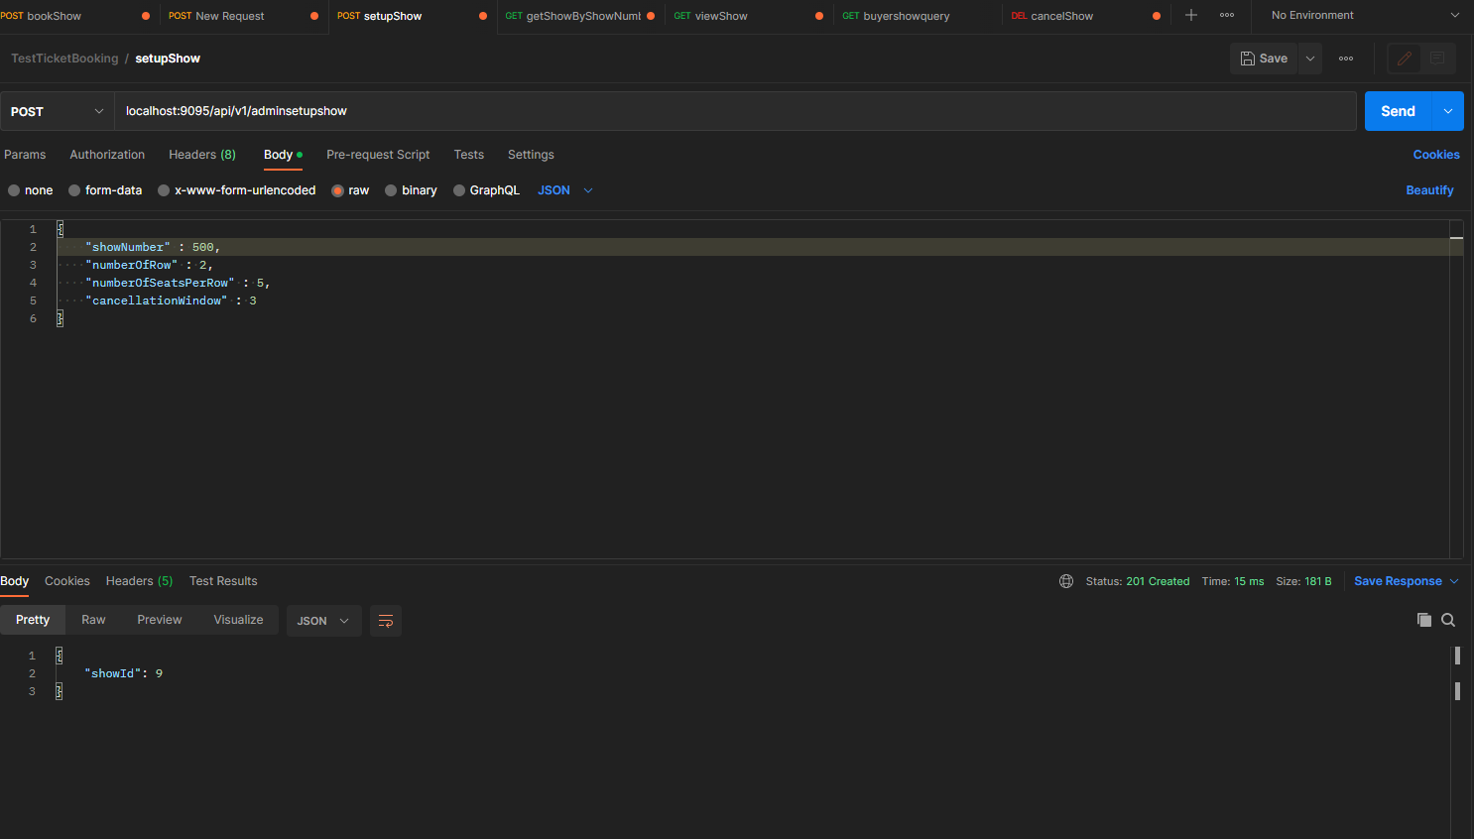

2. **View**

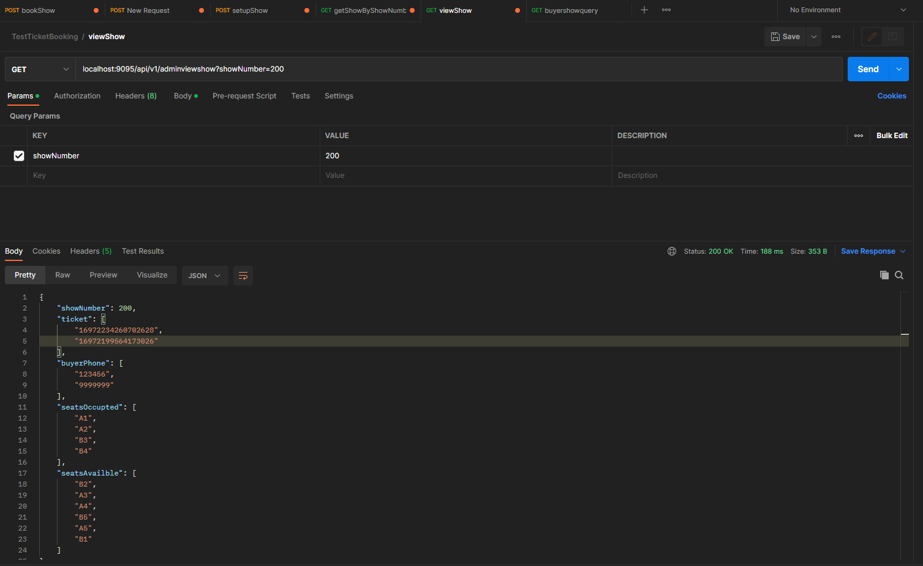

## Buyer:

**1. Availability**

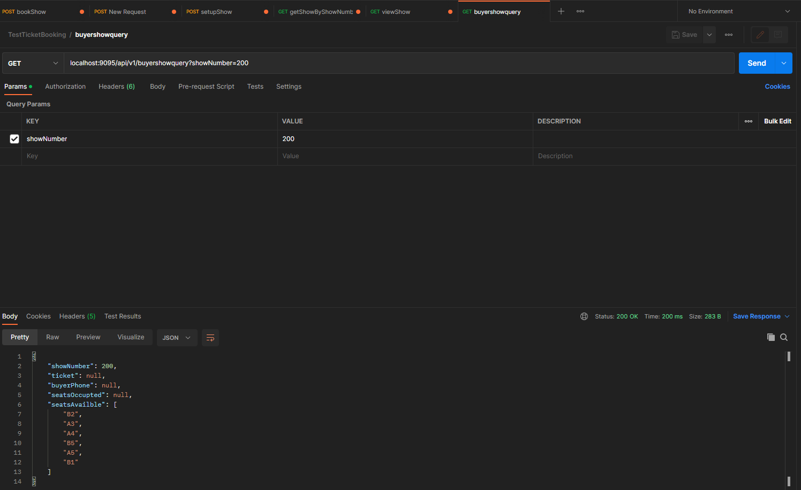

2. Book

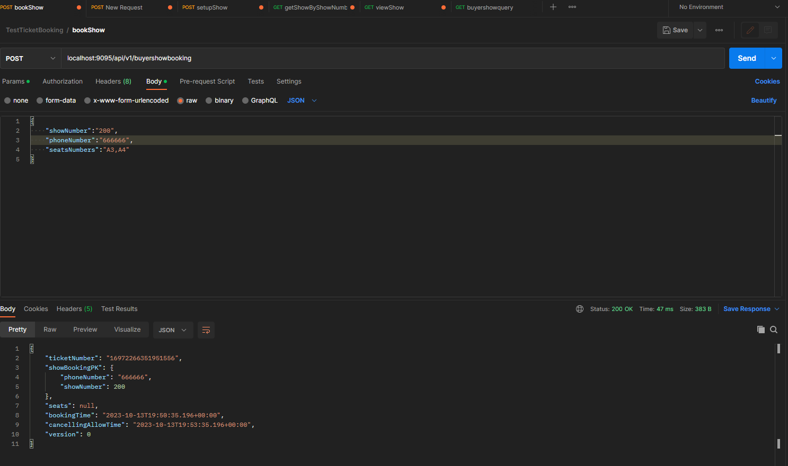

3. Cancel

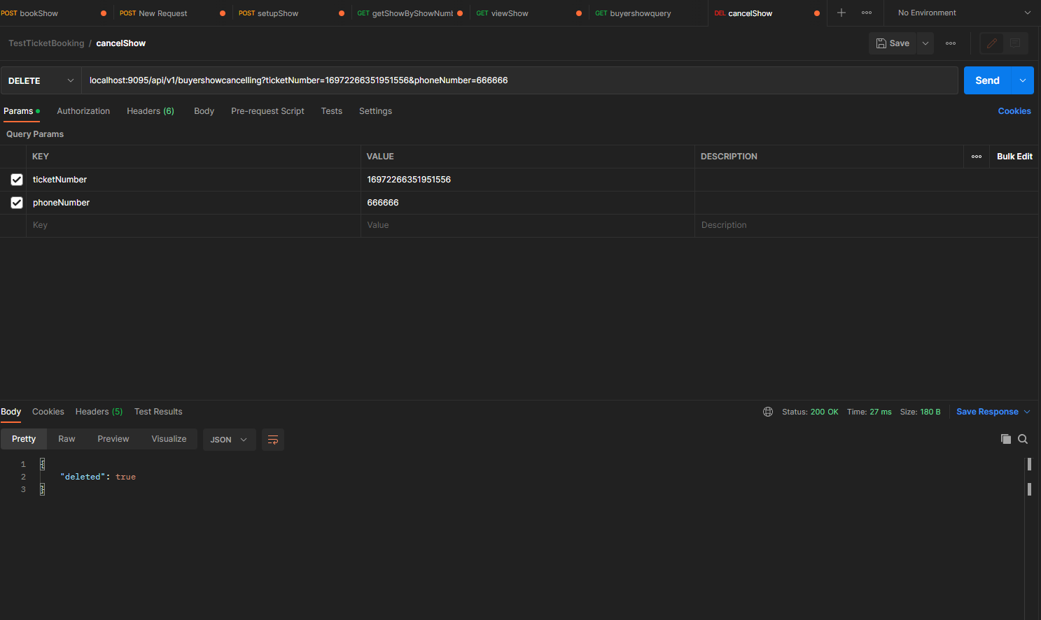

Exception:

Assume max seats per row is 10

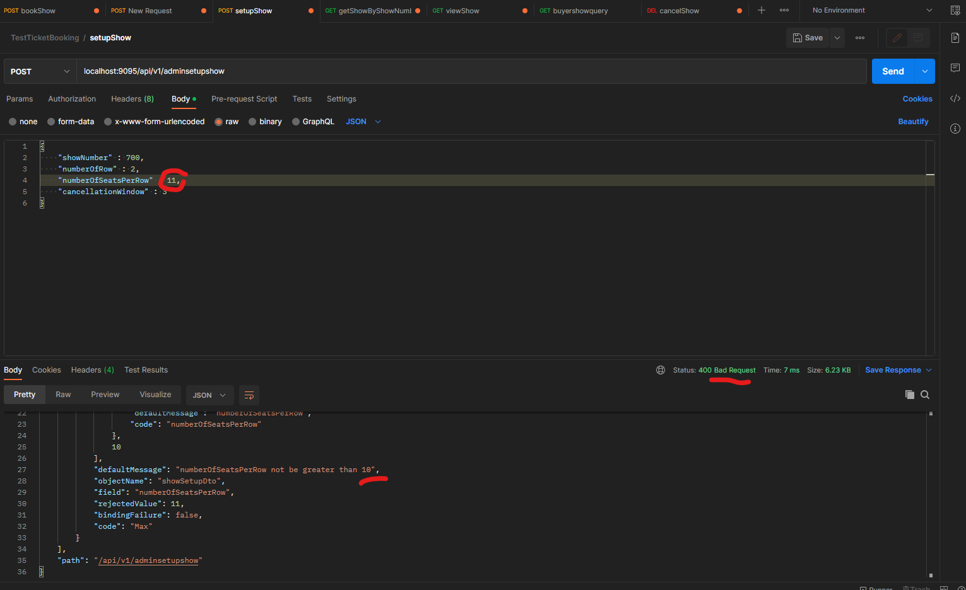

max rows are 26, The “Add” command for admin must ensure rows cannot be added beyond the upper limit of 26.

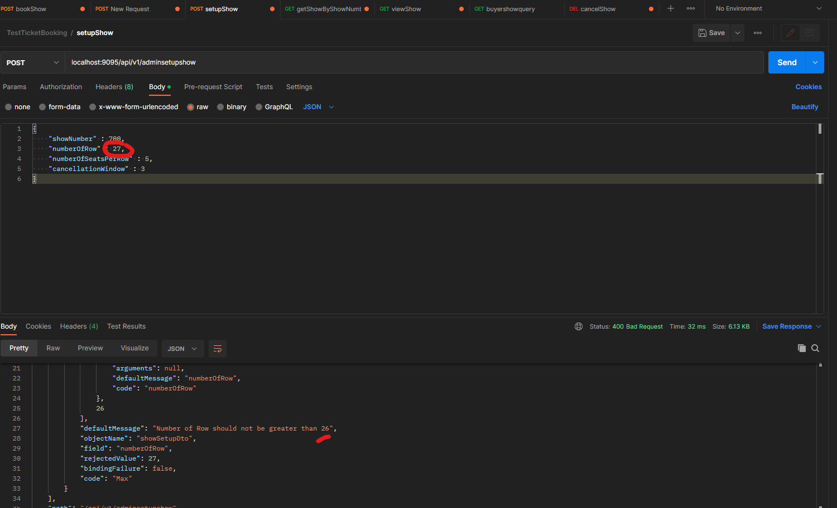

User can cancel the seats within a time window of 2 minutes (configurable).     
1st Pcs: There is database record with cancelling_allow_time at 03:00, and system time at 4:07. 2nd Pcs: We trigger cancelling request, backend reject   
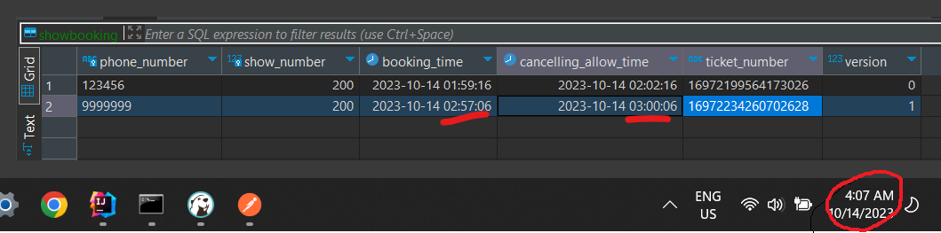

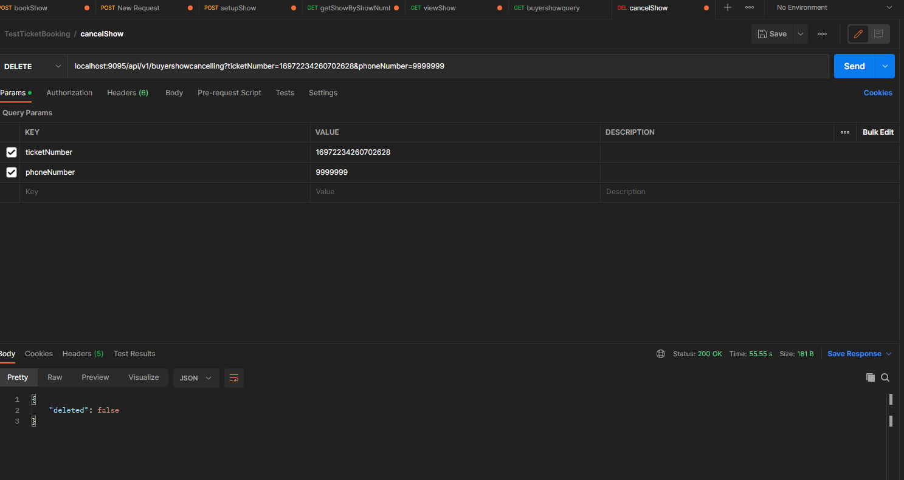

Only one booking per phone# is allowed per show.  
1st Pcs: There is a record with phone number 999999 and show number 200. 2nd Pcs: We trigger booking request for this phone, backend throw reject(500)

