Sharon Dorsey
Project 1
9/20/2026
The Works Progress Administration Inventory of Church Archives was completed In 1936 as part of the Historical Records Survey, which aimed to prepare “inventories and other bibliographical guides which will render more accessible the great masses of unpublished official documents” of states, countries, cities, and towns. The Church Records Form collected vital information about a church’s location, date of organization, building condition and value, clergymen, and origin. While it provided employment to those suffering during the economic crisis of the Great Depression, the Inventory of Church Archives also created valuable tools for researchers studying religion. As it relates to the study of upstate South Carolina textile mill communities, the Church Archives provide incredibly important information regarding the mills’ involvement with establishing and supporting churches in their towns. These records usually tell if churches received land, money, or other support from the mills.
In constructing a database to track these records, numerous items had to be considered. First, the goal of the project, which was to be able to compare the property values of different denominations in Anderson County. I specifically wanted to see if certain denominations received less financial support from mills. To do this, I decided to compare the property values as stated in the archival records. Some churches, such as Holy Trinity Kreps Memorial Lutheran Church, did not receive financial assistance from the mills but were the church homes of prominent manufacturing company owners or presidents. These cases were few and far between, though, and with the current state of the database I was able to exclude them by hand (though I am aware that as the database grows, I will likely become unable to continue excluding records that do not fit a pattern by myself or by hand).
With these questions in mind, I began constructing the database. My schema file included four tables: a church table that includes information about each church from the 1936 survey, a city table that lists the county and state as well as the city, a people table that tracks the workers, mill owners, and other important persons in the church’s record; and the church_people table, which connects people and church IDs. The mermaid diagram below shows these tables and the relation between them clearly.
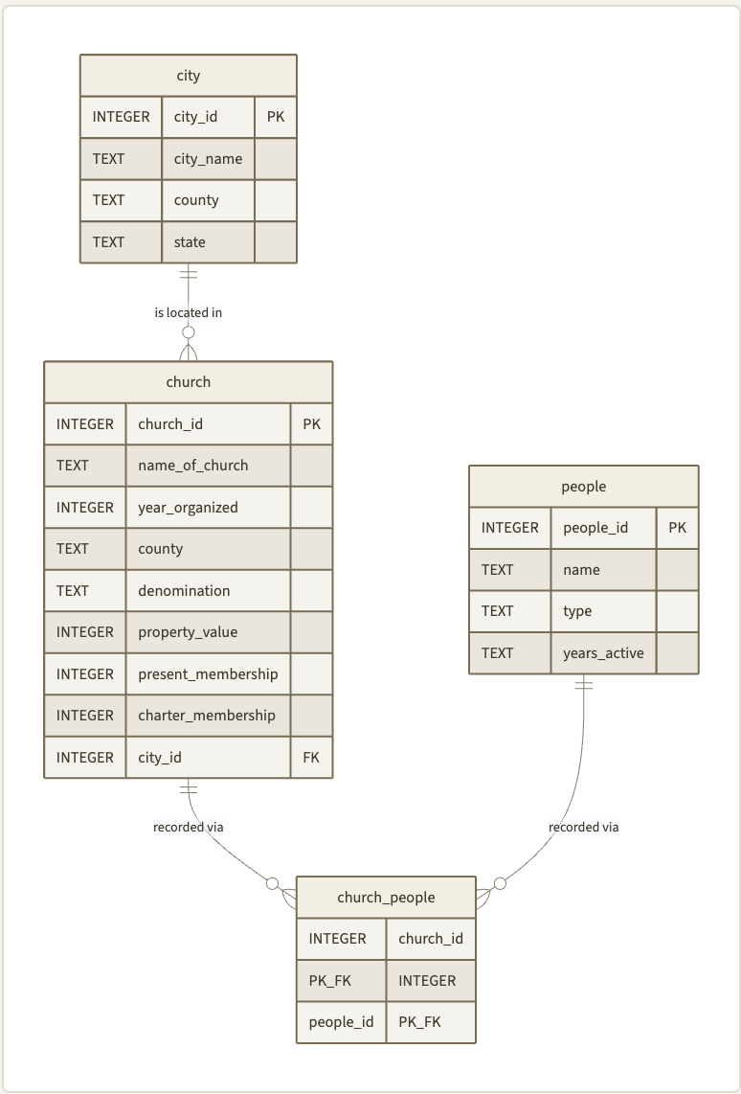
Figure 1. Mermaid Diagram of Relational Database for WPA Church Archives Records

After the structure of the database was complete, I imported the CSVs with information and began querying. I began by organizing the Anderson County churches by their property value, which showed me the Baptist and Orrville Methodist churches in Anderson had the highest property values. From there, I attempted to sort the data by the year organized, which was not helpful. That being said, I did limit this to the first 15 results and I found that all of the churches with the highest property values in Anderson County were either Southern Baptist or a version of Methodist (Methodist Episcopal Church South, Methodist, or Wesleyan Methodist), with the exception of one Presbyterian U.S. congregation that was established prior to the mill’s existence in Belton, and a Lutheran church that was not founded with financial assistance from the mill. A quick glance at the founding dates also shows that these churches with mill connections were founded between 1886 and 1905, which also confirms the theory that older churches generally had higher property values by the time of the survey in 1936, though I would need to look closer at the individual records to determine if this increased property value is a direct result of the assistance of a manufacturing company, or if the congregation upgraded their building at some point. This would require including a column to track the results of the survey’s question as to whether or not the church had been rebuilt at some point.
After this, I decided to query the database to find the average property value of each church by city and denomination. Just sorting the results by city showed the result I expected: The city of Anderson had the highest average property value of the cities in the county (barring Belton, though I am pretty sure that I am missing records that would significantly lower the average property value and so I excluded it from the results). However, Honea Path, which is significantly smaller than Anderson, had the next highest result in Anderson County with an average property value of $11958.33 over three churches. This is interesting because it ranks higher than Pelzer, which only has an average property value of $8137.50 over four churches. Pelzer was considered to be a large-scale success among mill villages and was considered by many to be a “model mill town,” with the most modern of amenities. This difference is interesting, and it requires further research to understand why Honea Path (the site of the Chiquola Mill) seems to have invested more money into their churches than Pelzer.
Grouping by denomination supports the original idea that some denominations had particularly lower property values. In all the churches in Anderson County, Methodist Episcopal Church, South and Southern Baptist congregations consistently had a higher average property value than their counterparts in Pentecostal or Wesleyan Methodist denominations. One of the most striking examples of this is in Williamston, where the Southern Baptist and Methodist churches had average property values of $8000 and $7000, respectively. In contrast, the church part of the denomination with “Holliness Headquarters in Tenn.” (most likely a reference to the Church of God in Cleveland, Tennessee or a related group) and Wesleyan Methodist congregations’ average property value was only $1650 and $1250, respectively.
Overall, the database and queries I used did provide a baseline response to my initial questions, though in many cases, I require more in depth research to confirm suspicions or be able to give a determination of why these suspicions were confirmed. As it is with much of historical research, I almost feel that I have more questions than answers.

Luther Harris Evans and Historical Records Survey (U.S.), The Historical Records Survey: A Statement on Its Program and Accomplishments Presented to the Sub-Committee of the Senate Committee on Education and Labor, in Connection with the Bill to Create a Permanent Bureau of Fine Arts, March 1, 1938, Historical Records Survey, Division of Women’s and Professional Projects, Works Progress Administration, 1938, https://catalog.hathitrust.org/Record/102013724, 2.

