Refer (OR.properties; config.properties; TestProperties.java)

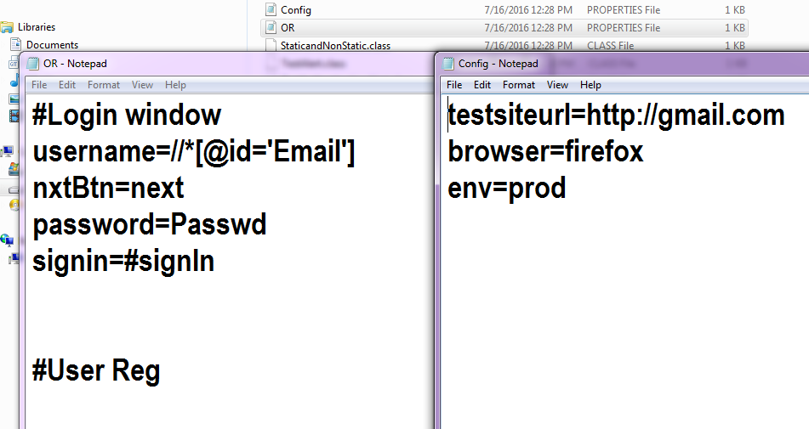

**How to have centerlized place of collection of web elements, that we want to locate and configuration kind of part**

For doing this create file (Right click on project => file => type (elements.properties {for collection of locating web element along with xpath} ; config.properties {for collection of configuration settings like page url, browser type, enviornment settings})

**how config.properties look alike**

testsiteurl=http://gmail.com

browser=firefox

env=prod

**how elements properties looks alike**

#Login window

username=//*[@id='Email']

nxtBtn=next

password=Passwd

signin=#signIn

#User Reg

#Compose Email

**How to read properties file**

**How to capture entire page screen shot and store into some file.**

***import java.io.File;***

***import java.io.FileInputStream;***

***import java.io.IOException;***

***import java.util.Properties;***

***import org.apache.commons.io.FileUtils;***

***import org.openqa.selenium.By;***

***import org.openqa.selenium.OutputType;***

***import org.openqa.selenium.TakesScreenshot;***

***import org.openqa.selenium.WebDriver;***

***import org.openqa.selenium.chrome.ChromeDriver;***

***import org.openqa.selenium.firefox.FirefoxDriver;***

***import org.openqa.selenium.ie.InternetExplorerDriver;***

***public class TestProperties {***

***public static WebDriver driver;***

***public static void captureScreenshot(String path) throws IOException{***

***File scrFile = ((TakesScreenshot)driver).getScreenshotAs(OutputType.FILE);***

***FileUtils.copyFile(scrFile, new File(path));***

***}***

***public static void main(String[] args) throws IOException {***

***Properties OR = new Properties();***

***Properties Config = new Properties();***

***System.out.println(System.getProperty("user.dir")); //will print working directory path***

***FileInputStream fis = new FileInputStream(System.getProperty("user.dir")+"\\src\\OR.properties");***

***OR.load(fis);***

***fis = new FileInputStream(System.getProperty("user.dir")+"\\src\\Config.properties");***

***Config.load(fis);***

***System.out.println(OR.getProperty("username"));***

***System.out.println(Config.getProperty("testsiteurl"));***

***if(Config.getProperty("browser").equals("firefox")){***

***driver = new FirefoxDriver();***

***}else if(Config.getProperty("browser").equals("ie")){***

***driver = new InternetExplorerDriver();***

***}if(Config.getProperty("browser").equals("chrome")){***

***driver = new ChromeDriver();***

***}***

***driver.get(Config.getProperty("testsiteurl"));***

***driver.findElement(By.xpath(OR.getProperty("username"))).sendKeys("rajanitclasses@gmail.com");***

***driver.findElement(By.id(OR.getProperty("nxtBtn"))).click();***

***captureScreenshot("f:\\screenshot\\newscreenshot.jpg");***

***}***

***}***