1) points to remember before using driver specific class

2) which exception may come, if not follow up with 1st point

3) point to remember while creating the object IE driver.

4) what maven does at broad level

1*) refer webdrivermanager.jar file and call required setup method like

webdrivermanager.chrome.setup

1*) use system.setproperty

1*) put driver's exe at root location of project

**How to launch firefox browser**

* 1. download single jar of selenium
  2. include jar file into our java program
  3. create the class having method main
  4. create an object of firefoxdriver class and hit run, u will find a firefox browser is lanunched

**import** org.openqa.selenium.firefox.*;

**public** **class** LaunchFireFoxBrowser {

**public** **static** **void** main(String[] args) {

FirefoxDriver ffd = **new** FirefoxDriver();

ffd.get("http://www.google.com");

String title = ffd.getTitle();

String expTitle = "yahoo.com";

**if** (title.equals(expTitle))

{

System.***out***.println("matched");

}

**else**

{

System.***out***.println("un-matched");

}

}

}

For latest Mozilla firefox, download below metion driver and use it accordingly



**How to launch chrome browser**

**import** org.openqa.selenium.chrome.ChromeDriver;

**public** **class** LaunchChromeBrowser {

**public** **static** **void** main(String[] args) {

System.*setProperty*("webdriver.chrome.driver", "chrome-plugin\\chromedriver.exe");

ChromeDriver ffd = **new** ChromeDriver();

ffd.get("http://www.google.com");

String title = ffd.getTitle();

String expTitle = "yahoo.com";

**if** (title.equals(expTitle))

{

System.***out***.println("matched");

}

**else**

{

System.***out***.println("un-matched");

}

}

}

download chrome driver, by click on 2.21

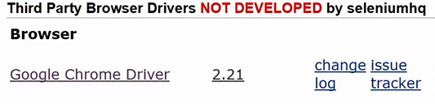

click on respective operating system zip file

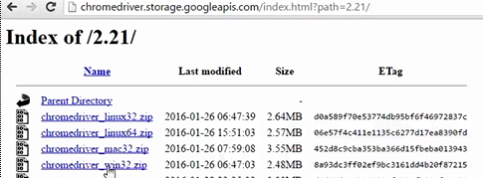

**How to launch IE Browser (Zoom Level must set to 100%)**

**import** org.openqa.selenium.ie.InternetExplorerDriver;

**import** org.openqa.selenium.remote.DesiredCapabilities;

**public** **class** LaunchIEBrowser {

**public** **static** **void** main(String[] args) {

DesiredCapabilities capabilities = DesiredCapabilities.*internetExplorer*();

capabilities.setCapability(InternetExplorerDriver.***INTRODUCE_FLAKINESS_BY_IGNORING_SECURITY_DOMAINS***, **true**);

System.*setProperty*("webdriver.ie.driver", "ie-plugin\\IEDriverServer_64.exe");

InternetExplorerDriver ffd = **new** InternetExplorerDriver(capabilities);

ffd.get("http://www.google.com");

String title = ffd.getTitle();

String expTitle = "yahoo.com";

**if** (title.equals(expTitle))

{

System.***out***.println("matched");

}

**else**

{

System.***out***.println("un-matched");

}

}

}

**Failing in launching IE browser**

1. IE is heavily secured browser, to launch IE browser through selenium, go inside internet options=>security=> unchecked "enable protected mode" inside all security zones. + zoom level must be 100%
2. To overcome as discussed in step 1, we can use class. there is class, which will bypass this security issue and pass "capability" object to InternetExplorer class See Below Code

***DesiredCapabilities capabilities = DesiredCapabilities.internetExplorer();***

***Capabilities.setCapability(InternetExplorerDriver.INTRODUCE_FLAKINESS_BY_IGNORING_SECURITY_DOMAINS, true);***

***Capabilities.setCapability(InternetExplorerDriver.IGNORE_ZOOM_SETTING, true);***

***WebDriver d = new InternetExplorerDriver(capabilities);***

Note:

1. WebDriver is the interface which is implemented by browser driver classes. We can instantiate the web driver reference by the object of browser driver class to launch the browser
2. If you will copy the browser drivers exe file at the root of the project, then no need to use system.setproperty statement.
3. To make the code dynamic, specify the name of the browser in some file and use web driver interface.
4. **IllegalStateException** is raised, if don’t consider driver.exe belongs to specific browser.
5. In case of IE driver.exe file, download 32 bit even we are on 64 bit, because execution of 64 bit is slower.
6. Chrome browser gets updated automatically whereas firefox gives prompt before getting update, so in this way our respective exe must also be updated. To implement this must checkin the code at centerlized repository and use maven project, so that it auto takes care for adding suggested dependencies and driver .exe in the project (**maven automate the process for reffering JARs file and exe in the project, means no need to download and put them into the project** )