**Understanding MAVEN and GIT**

**How To Quit From Browser**

driver.quit(); //will close the entire instance of browser, which is opened during automation process

**How To Maximize Window**

driver.manage().window().maximize();

**How to close the browser**

driver.close();

//will close current browser window, where your focus is

//if ten browser windows are opened, we can close the particular window as well.

//there is known issue when we use close and quit together in the case of firefox browser. It will throw an exception i.e. NoSuchSessionException. To get rid of it, use either of them

**How to check wheather maven plugin is exist in eclipse or not**

Windows

Preferences

On left side, if u will see maven, then it means it exist

**Going forward create maven project rather than java project as per industry guidelines.**

Select maven project

Checked = create a simple project

Group id (domain or company name) = com.wipro

Artifactid (project name) = WebDriverMavenProject

Version

Packaging = jar

Rest is ur choice and click on finish

Once created, u will see structure like below

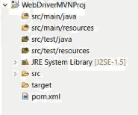

**As we created maven project, so we don’t include the jar file manually**

**This will automate the referring JAR process**.

Pom.xml file

Add = dependencies tag

Add the tag as suggested in below screen shot. In some milliseconds u will see that all the required selenium jar will be added into the project (log4j, mysql etc)

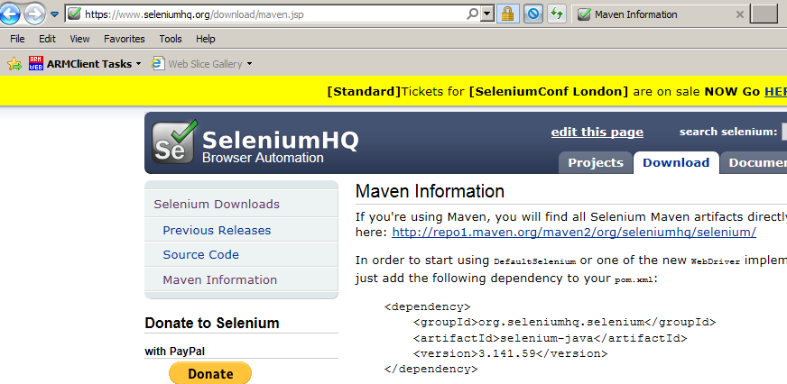

the above code, u can get from maven repository site mvrepository.com, where all java api are uploaded or checked in

in the profile, a .m2 folder is created, under that folder u will see repository folder, and under that u will see APIs vendor specific, lets search selenium API



If version is not present at above location, then only it will download else refer this location itself

**How to automate the process belongs to refer driver exe files**

In mvnrepository, find “webdrivermanager”, click on this, refer the latest version and copy the dependencies info

U will see “webdrivermanager.jar” file is successfully added

Use below line of code instead of writing the code to refer the respective browser driver.exe file

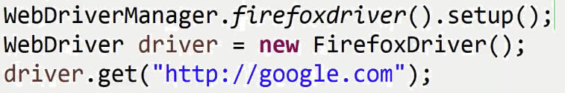

**Problem while downloading exe and jars files through maven on system**

Reasons like proxy setting, firewall settings

So, Create setting.xml as suggested below and specify the proxy settings as suggested by IT team

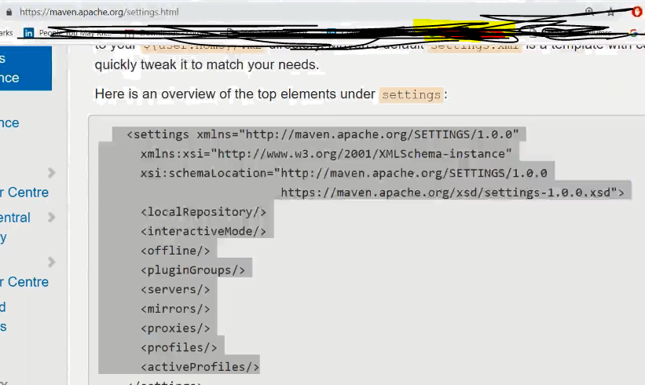

Put settings.xml file in .m2 folder

If problem persist again while building the project, then try to delete the repository folder from .m2 folder. If respository is not getting deleted, then it means some exe belongs to browser are running.

If still problem persist, try to connect with mobile net

Once above problems is sorted out, do update the maven project, it will start again downloading artifacts, plugin, jars, exe from maven repo to .m2 and to your project as well.

Right click on project

Select maven

Update project