GhostService

Purpose
- At the very least notify the client via GhostConvey of an update that is available to them.
- At the very most (for NOW) download and apply the GhostConvey update.
- Keep itself (GhostService) up-to-date.

Perfect Environment (System Requirements)
- .Net Framework (2.5, shipped with GhostConvey).
- Always on computer.
- Always connected Internet access.
- Write access to GhostConvey Server share.
- Access to GhostConvey SQL Server (same as GhostConvey).
- Only need to install it on one machine per site.

How to install
- Double click MSI.
  - Might produce warnings/errors about Service Packs and/or .Net framework if they are not available.
- All default settings will be applied to GhostService. The service will start itself automatically and a shortcut will be added to the start menu.

Defaults
- GhostConvey, notify user of updates : YES
- GhostConvey, download update automatically: YES
- GhostConvey, apply update automatically: YES
- GhostConvey, check for update at: 11:30pm every night.
- GhostConvey, make copy of downloaded update: NO
- GhostService, check for an update every hour from start time.
- GhostService, download update automatically: YES
- GhostService, apply update automatically: YES
- GhostService, start-up delay: 3 minutes
- GhostService, Proxy set: True (use a proxy)
- GhostService, Use proxy settings for IE: True

How to setup (Notifications and Auto updates)
- To enable a user to receive update notifications open GC, go to setup.
- In security select a user and edit their details.
- Check the "Notify this user of updates …" check box and save.
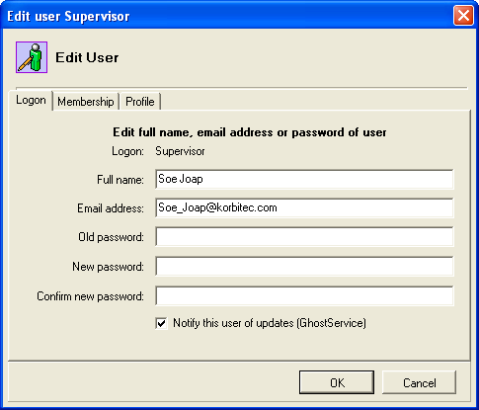
- If an update is available and GS is running the selected user will be notified by a message about the update. This message's is set by HQ and can change depending on release.
- Once GS is installed, start the setup client (Start Menu -> Korbitec -> GhostService -> GhostService Setup.
- Click GhostConvey -> Configure Databases.
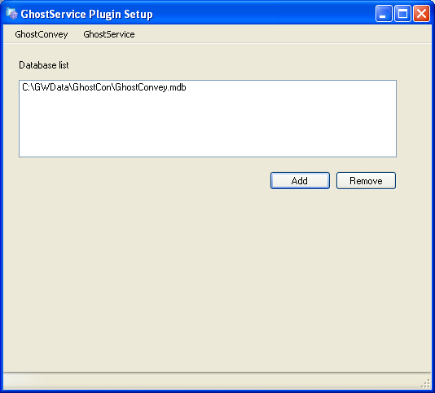
- Add one or more GhostConvey databases by clicking Add and directing it to a database configuration file or the Microsoft Access database file. (Please note that it will look for and/or apply the update to the select databases (installs)).
- Make sure that the LicenseCode of the site (each database) is sent to HQ so we can enable then for auto updates.
- Click on GhostService -> Service Management. Stop and Start the service.

What gets installed?
- Plugins
  - Small "applications" written by Korbitec that gets "scheduled" and executed.
  - Currently there are only two plugins shipped, one to auto update GhostConvey and the other to auto update GhostService.
  - Plugins can have a visual part, used for setup purpose.
- Service
  - It is a normal windows service.
  - Runs in the background and "schedules" and executes the plugins.
  - The service has a visual setup client.
- Setup Client
  - Application can be found on Start Menu -> Korbitec -> GhostService -> GhostService Setup.
  - Used to setup plugins and the service itself.
  - Can force an update of GC or GS.
- Manual Updater
  - Application used to force an update of the GhostService, should something go wrong.
Setup explained in full.
- Start the setup client (Start Menu -> Korbitec -> GhostService -> GhostService Setup.
- Items loaded onto the menu will depend on the plugins installed during the MSI install.
- Click GhostConvey -> Configure Databases.
The GhostConvey databases (.mdb or .cfg files) added is seen as a GhostConvey install and update checks will occur for each.

- Click on GhostConvey -> Auto Updates.
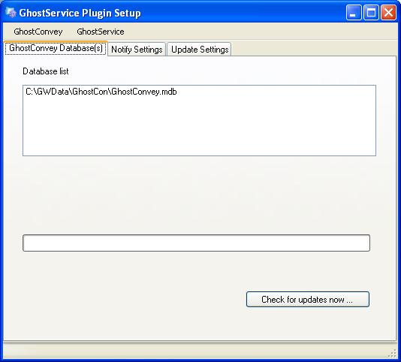
This will list the GC databases and a manual update check can be done by selecting the database and clicking the button.

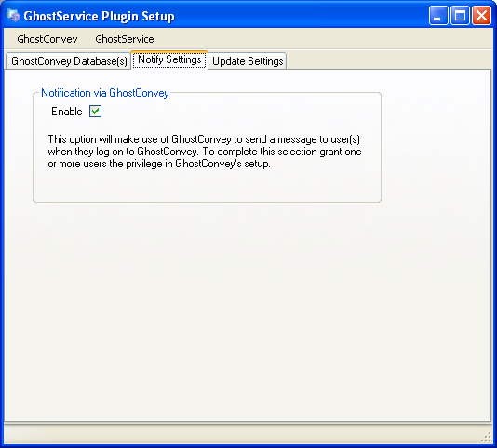
This will enable update notifications sent to the user via GhostConvey. This is only if they are setup in GC to receive notifications.

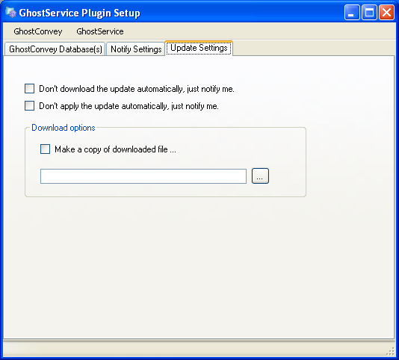
Here you can specify not to download and/or apply the update automatically. You can also specify a path that a copy of the downloaded update is made.

- Click on GhostService -> Service Management.
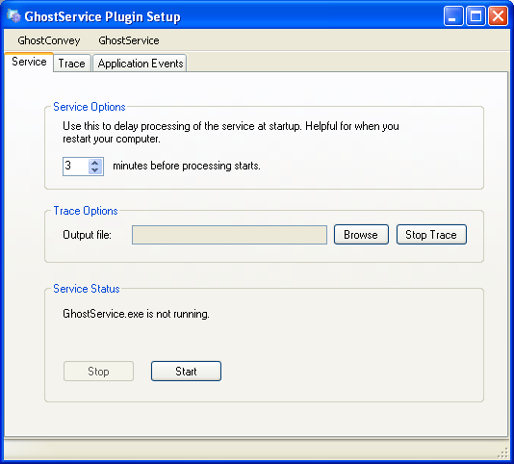
Service Options allow you to specify a delay to allow other depend services to start or the like. Trace Options is for debugging purposes. If a file is specified the service needs to be restarted (Stop, Start). The specified file will be filled with messages from GS. Stop and Start will be enabled depending on the current status of the service.

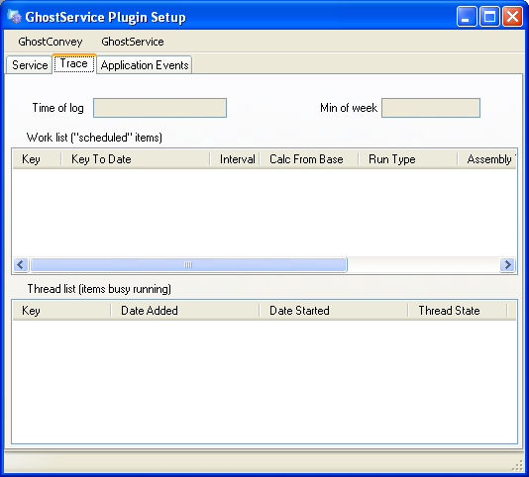
This screen will only function once a trace file has been specified and the service restarted. It is used for debugging purposes and will display the current scheduled items and the current running items.

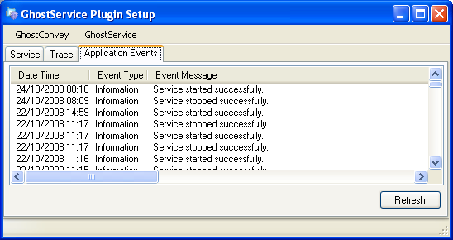
This tab will display any message written to the event log by GhostService. For more detail check the event log.

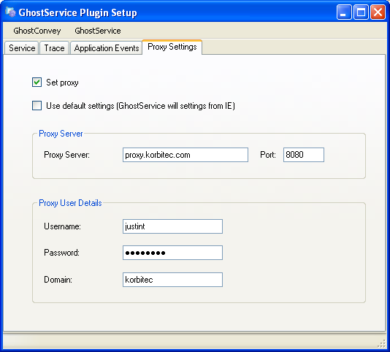
This tab is where the use of a proxy can be configured. Set proxy enables the use of a proxy. Use default settings will use the same settings as IE (internet Explorer) uses. If it is not checked you can fill in the details of the proxy. Keep in mind that these settings will be used by the service to access the internet.

- Click GhostService -> Installed Plugins.
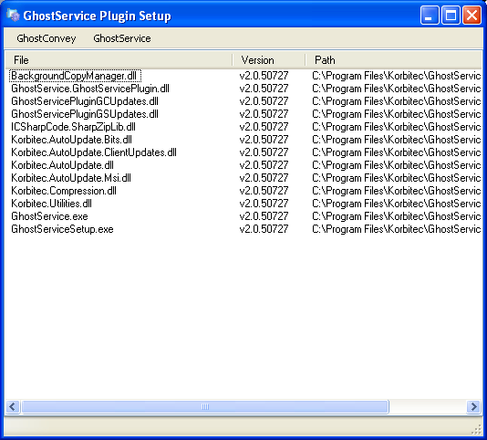
This will show you a list and details of installed plugins. Please note they might not all be running or even active.

- Click GhostService -> Auto Updates.
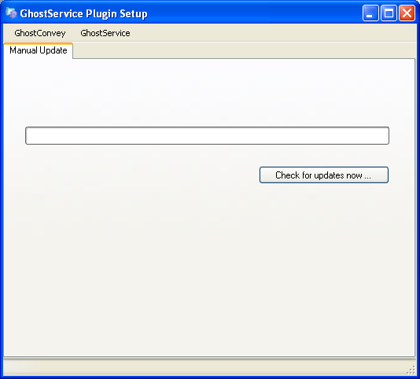
A manual update check for GhostService can be done by clicking the button.

How to reset all settings?
- All the settings set in the Setup Client can be restored to the default.
- Stop the service.
- Close the Setup Client.
- Go to the install directory (default c:\program files\korbitec\GhostService).
- Delete or rename all the .xml files to something else.
- Start the Setup Client, setup everything and start the service.

"Hidden" settings.
- There are various hidden settings that can be changed just to make it more flexible. These settings will also depend on the plugin. They include:
  - Run time or interval.
  - Autoupdate server url.
  - Plugin active.

Troubleshooting
- Most problems and errors will be report to the windows application event log. Right click on My Computer -> Manage.
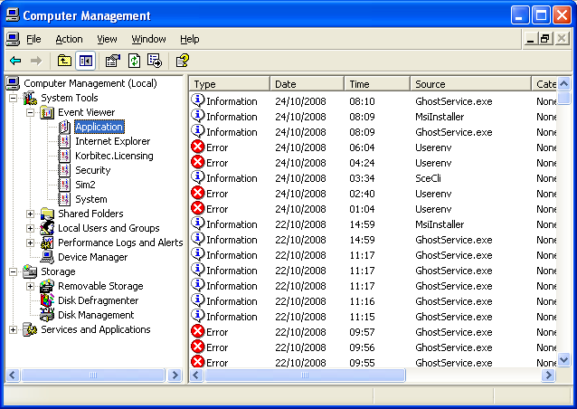

- For a more detailed report on events and the like, a trace log can be setup via the Setup Client – please see above for details.

- There is a screen available that will show items running and show the scheduling as it occurs. This does require a trace log.

- Manual Updater can be used to force an update. It has the default values in for an update but they can be changed.

