

**DIMES - Computer Engineering for the Internet of Things**

**Low level and Embedded System programming**

Student: Samantha Sanchez 214563

Wheelchair for handicapped people with Gestural controlled by hand gestures.

**Application**

Let handicapped people control a wheelchair through hand gesture and reduce the risk of accidents using an ultrasonic sensor, and an alarm that notify an obstacle too near, and stop the system, offers the possibility of controlling the movement manually with a joystick control too.

**About Project**

The Project use a microelectromechanical system, 3-axis accelerometers, a digital motion processor and a temperature sensor, in addition with an ultrasonic sensor and a status display. Coupled with an alternative manual control system, which a joystick module that command the movements easily.

The GY-521 Module situated in the hand, or the arm of the user allow him/her to control the wheelchair movement in function of the hand gesture read, the Arduino controlled a motor connected to the principal wheels, that gives the back-and-forth movement, and a servomotor connected to the auxiliar wheels, given right and left movement.

An ultrasonic sensor has been integrated in the front of this wheelchair provides the possibility of avoiding accidents, stopping the forward movement when is necessary.

It also has manual control, in case of losing the functionality of any of its sensors or actuators. The system in use can be monitored by means of a display that shows the status of the device (wheelchair).

**Components**

* 2 Arduino UNO
* LCD Display 16x2
* 2 DC Motor 3-6V
* Servomotor SG90
* Ultrasonic sensor
* GY-521 Module
* Joystick Module
* Active Buzzer
* L293D bridge
* Potentiometer 10K
* Buttons
* Leds
* Resistors
* Battery
* USB wire
* Prototype expansion module
* 9V1A Adapter
* Breadboard Jumper wire
* Breadbord

**Software and Methods**

Is an integrated development platform (IDP) for developing and debugging [SMART](https://microchipdeveloper.com/atstart:start) ARM®-based and AVR® microcontroller (MCU) applications. Studio 7 supports all AVR and SMART MCUs gives an environment to write, build and debug your applications written in C/C++ or assembly code.

For this project two Arduino UNO have been used, the first as Base, the second as a command, so the code generated in Atmel studio 7 is compatible with an ATmega328p microcontroller, and the communication method between the two is serial, through the TX, RX pins.

**Command:**

The signals for the movements of the device are read processed and sent by an Arduino, connected to an MPU6050 Module (gyroscope) using a communication with I2C master-slave protocol, receives 7 variables of 16 bits between values of accelerometer, gyroscope, and temperature, in automatic mode.

On the other hand, manually, it processes values obtained in an analog way from the joystick module.

The control mode is selected by means of external hardware interrupts, INT0 by a button located near the MPU6050 module, INT1 by the SW pin integrated in the joystick, sends in any mode, four 8bit variables; x-axis, y-axis, temperature, mode control.

**Base:**

The Arduino used as a base, receives 4 variables, to reinforce the functions of the system, for the DC motor that controls the forward and backward movement, two output pins connected to the L293D, an output pin with a PMW signal to level the speed.

Movement on the y-axis is controlled by a PMW signal from a servomotor, adjusted to a range of motion of 45-135, two pins are intended for the ECHO and TRIGER of the ultrasonic sensor, an output pin connects to the active buzzer, which gives an alarm when the distance between the device and an obstacle is less than 8 centimeters.

Another PMW signal is used to simulate the level of movement of de DC motor, shared by a led. Finally, the pins of PORT B are intended for the LCD screen, 4 for bits 7 6 5 4, one in E (enable) and one in RS (write).

**Status**

Mode: Manual | Automatic | select...

Velocity: 0 – 9 (level)

Movement: Alert!, Stop X

Obstacle Distance(cm)

Temperature(ºC)

**additional settings**

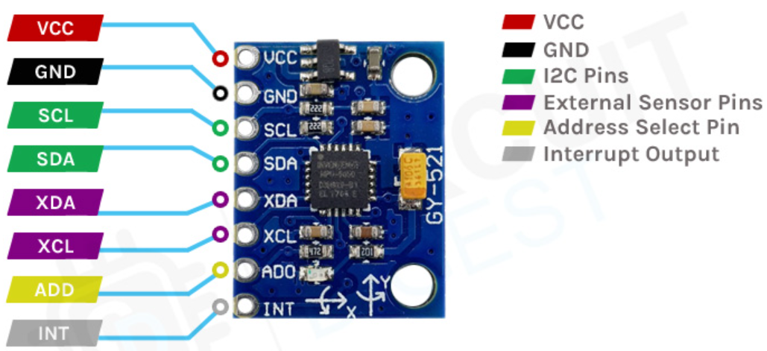

This module also has a (DMP) Digital Motion Processor inside it which is powerful enough to perform complex calculations and thus free up the work for Microcontroller, the acceleration is calculated from the rate of change in capacitance. In **MPU6050** this is then converted into readable value and then it’s transferred to the I2C master device.

int16_t Temperature = MPU6050_ReadRawData(0x41);

temp = ((Temperature / 340.0) + 36.53);

rangoY = ((accelerometerY - (-16000)) / 125)/12;

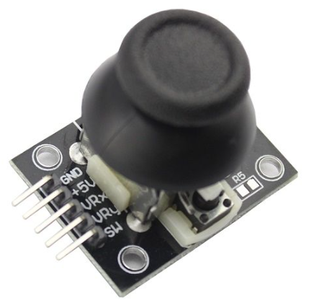

A **Joystick Module** is an input device consisting of a stick that pivots on a base and reports its angle and direction to the device it is controlling. It detects the direction of the stick by use of an electronic switch.

uint16_t joystickY = ADC_Read(1);

joystX = (joystickX * 21) / 1023;

An **Ultrasonic Sensor** uses a transducer to send and receive ultrasonic pulses that relay back information about an object's proximity, measures the distance to an object using ultrasonic sound waves.

*uint16_t* pulse_width = TCNT1;

return pulse_width/(58*2);

In function of the measure got from the sensor, if the sensor detects an object at least at 12 centimeters of distance, is shown the “Stop X” notification on the LCD

If there is an obstacle at least at 8 centimeters of distance, the “Alarm!” notification is shown on the LCD and an **Active Buzzer** emits an alarm at the same time turn on a red led that notify, that the system is stoped.

To control the servo motor, a conventional servo motor expects to receive a pulse every 20 milliseconds with a duty cycle of 50Hz the length of the pulse determines the angle of the servo shaft. If the pulse is high for 1ms, then the servo angle will be at a 0-degree position. The 1.5ms pulse to a 90-degree position, and a pulse of 2ms, 180 degrees.

PWM period = 20ms (at 16MHz and prescaler = 8)

ICR1 = 40000;

pmw_ang= (120*axis)+1800;

OCR1B=pmw_ang;

**LCD Animation**

Figure1.- Starting animation system.

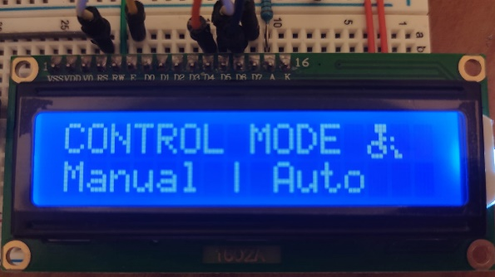

Figure2.- Show System’s Control Modes

Figure3.- Show icons, Temperature and Distance

**Functionality**

Figure4.- Example of System Functions

Description: Red led active to notify there is an obstacle and the movement is constrained, show ALERT! on the LCD; Control selected is “MANUAL”, temperature is: 46ºC, velocity is on level 0, the distance of the obstacle is 5 centimeters.

Figure4.- Example of System Functions

Description: Blue led active to simulate the level of velocity, show STOPX on the LCD, that notify there is an obstacle, and you should stop or chance direction; Control selected is “AUTO” (automatic), temperature is: 45ºC, velocity is on level 3, the distance of the obstacle is 10 centimeters.

**Structure of Wheelchair**

**Statement**

Wheelchairs available in the market are too expensive and are beyond the reach of poor middle-class people. Most of the electronic Wheelchairs are single function and use a joystick to control the movement. The objective of this project is to design a low cost and multifunctional wheelchair, to make easier its control for a person with a limited strength or movement of their hands or arms, even a person who has lost part of their upper limbs, (Disabled and elderly people) It can even be adaptable to prostheses.

**Further uses and upgrade.**

The current project is designed to give control of the wheelchair to its user.

In a further development, control can be given by manual gestures to a third person, remotely, thus applying it in hospitals, where nurses must transport several patients. Or when the wheelchair user is a young child, control of the device would be in the hands of the mother or guardian.