Multi-Bunch Operation of the NDR and FACET Linac
Test Beam Proposal

Authors:
Spencer Gessner, Franz-Joseph Decker, Marc Ross, Keith Jobe

Abstract

This Test Beam Proposal is a supplement to the new experimental proposal “Plasma Wakefield Acceleration (PWFA) in Relativistically Hot (High-Repetition Rate) Plasma.” For details on the scientific merit of high-repetition rate PWFA experiments, please see that proposal.

This proposal aims to answer a single question: Can the SLAC Linac deliver two bunches with 2×10¹⁰ electrons each separated by integer multiples of 5.6 ns up to 61.6 ns to the FACET IP with the present hardware configuration?

There is a wealth of physics related to the question posed above. The most important topics that must be addressed are:

- Doubly pulsing the thermionic cathode to produce two closely separated bunches.
- Achieving flat fields for both bunches in the NDR injection and extraction kickers.
- Managing instabilities in the ring.
- Managing pi-mode coupling between bunches in the ring.
- Managing transverse wakefields in the Linac.
- Compensating for beam loading by adjusting SLED timing in the Linac.

Experimental Team

Spencer Gessner, Franz-Joseph Decker, Marc Ross, Keith Jobe

Scientific Case

This Test Beam Proposal advances the goals of FACET as a user facility by expanding the scope of possible experiments that can be done at FACET. High-repetition rate experiments are critical in establishing PWFA as a feasible method for use in a high luminosity collider. In addition, the narrowly separated bunches may be interesting for other experiments that study wakefields at FACET.

This proposal focuses on the production of two electron bunches separated by integral multiples of 5.6 ns. The value of 5.6 ns was chosen to comply with the existing hardware configuration of the machine. Specifically, 5.6 ns is the bucket spacing of the subharmonic buncher (SHB) in Sector 0, which is 16 times the S-band wavelength.

The SHB is needed for full charge capture at the start of the Linac, but if it is turned off, it is possible to fill subsequent S-band buckets resulting in bunch separations of only 350 ps. However, 350 ps bunch separation is incompatible with operation of the NDR, which has bucket spacing of 1.4 ns, and without the NDR the beam emittance is too large to be used in PWFA experiments. The results of this study might merit a future study for bunch separations of 1.4 ns.

Finally, we note that the range of bunch separations that we would like to investigate (61.6 ns to 5.6 ns) may provide valuable insights into how PWFA might be used in conjunction with proposed linear colliders. The bunch separation in the ILC is about 360 ns, which is typical of superconducting RF [1]. The bunch separation at the proposed NLC is 1.4 ns [2] and at CLIC it is 0.5 ns [3]. These smaller separations are typical for x-band accelerators.

Experimental Procedure

INJECTOR
The thermionic cathode will be double pulsed using the multi-channel pulser [4]. At the end of the 2012 FACET run, the gun was double pulsed with pulse separation of X ns. (Need to contact Turner and find out exactly what they did at the end of last summer.) According to [4], the pulser “is capable of producing two pulses of the required charge for any (including zero) interval.”

Beam charge, energy, energy spread, and bunch separation will be determined using toroids, profile monitors, and gap monitors in the injector.

NDR
The bunches travel to the NDR and are injected on a single pulse of the injection kicker. The pulse width is roughly 60 ns and was designed to accommodate the 60 ns electron bunch separation that was used during SLC operation [5]. Small missteerings from the injection kicker are tolerable because oscillations are damped in the ring.

Since 1994, the instability threshold in the damping rings has been roughly 2×10¹⁰ electrons per bunch [6]. However, the ring has been successfully operated with over 4.5×10¹⁰ electrons per bunch during the SLC era. The instability arises from inductive impedance in the ring vacuum chamber and has been found to be a single bunch effect [6].

Given the 3.2 nC bunch charge, we do not expect the instability to be a large effect. Nevertheless, we may have the opportunity to study longitudinal bunch lengthening due to the saw-tooth instability and potential well distortion by streaking synchrotron light and analyzing BPM signals as described in [7].

We note that the saw-tooth instability is microwave, single-bunch effect. However, a pi-mode instability may also occur in the ring due to coupling between the two bunches. In 1992, a passive cavity was installed in the ring to extract the pi-mode oscillation frequency [8]. The cavity was tuned to 1062.4, corresponding to the lower sideband of the 125th harmonic of the revolution frequency, which is 8.5 MHz. The cavity can be tuned remotely to match the desired frequency. (I have no clue how to choose the frequency. Need to contact Marc Ross and Keith Jobe about this.) We can use the BPM signal analysis to confirm that the pi-mode is damped.

Assuming, the bunches are not grossly distorted by the instabilities described above, the final challenge with regard to the NDR is the extraction kicker. During SLC operation, the extraction kicker was equipped with a special charge carrying cables that ensured a flat field for the duration of 60 ns extraction period [9]. The bunches received the same kick to less than one part in a thousand. It is critical that the bunches see the same field coming out of the NDR, as missteerings are amplified in the Linac. However, the special cables are no longer in place and this may limit us to smaller bunch separations.

To get around this problem, we will try to time the extraction of the bunches so that the lead bunch sees a field on the rising edge of the pulse and the trailing bunch sees the same field on the falling edge. It is always possible to find two such points, and we also expect that these points are near the peak of the pulse because even without the special PFN the flat peak of the pulse should be close to 30 ns long. However, we will be extremely sensitive to timing jitter in the extraction kicker because moving the pulse relative to the bunches in either direction will result in relative change in kick (Figure 1).

NRTL
After being extracted from the NDR, the bunches enter the Linac via the NRTL. There is compressor cavity in the RTL that is used to compress the bunch and provide phase stability for the beam entering the Linac. RTL compressor is S-band so the bunches will see the same phase in the compressor cavity assuming that there is no pi-mode coupling in the Linac and that they receive the same kick upon extraction. The compressor klystron is set to the zero-crossing phase, so beam loading should not be an issue.

LINAC
If we’ve made it this far we deserve a pat on the back. Now only 2000 meters to go. . .

The two main challenges after the beam enters the Linac are transverse wakefields that lead to emittance growth and beam breakup, and beam loading which leads to a large energy spread between the bunches. The mean energy spread between the two bunches must be small because each bunch will have a large energy spread from the chirp in LI02-LI10 and there are momentum apertures in the S10 and S20 chicanes.

The magnitude of the transverse wakefields in the Linac has been measured and this data is recorded as Green’s functions that are unique to SLAC’s S-band accelerating structures [10]. (However, I have only found these data sets extending out to 0.5 m. I will contact Karl Bane to see if there are wakefunctions extending out to a couple meters.) Simulations using the Lucretia package are underway to determine offset tolerances in the Linac.

We assume that the inter-bunch longitudinal wakefield is much smaller than the effect of beam loading for two 3.2 nC bunches separated by 5.6 ns. The beam induced voltage must be compensated by adjusting the SLED timing. At the end of the E158 experiment, beam loads of up to 20% were accommodated for pulses with 9×10¹¹ electrons that were 320 ns long [11]. For this Test Beam Proposal we have 4×10¹⁰ electrons in 5.6 ns pulse, corresponding to a beam loading of. . . (From P. Wilson’s paper it seems that this should be I_p * (5.6 ns / 800 ns)^2 but this gives me a ridiculously large V_b so I am not sure.)

Finally, we note that the digital BPM readout will not be able to distinguish between the two pulses in the Linac. We can readout the BPM signal for each beam separately by attaching the BPM tables directly to a scope, but we will only be able to do this for one or two BPMs at a time. Special cables will need to be used to avoid high frequency cut off of the BPM signal.

1. ILC RDR. Volume 3: Accelerator. 2007.
2. NLC ZDR. SLAC-PUB 474. 1996.
3. CLIC CDR. SLAC-PUB 985. 2012.
4. M. J. Browne et al., “A Multi-Channel Pulser for the SLC Thermionic Electron Source.” SLAC-PUB 3546. 1985.
5. T. Mattison et al., “Status of the SLC Damping Ring Kicker Systems.” SLAC-PUB 5462. 1991.
6. K. Bane et al., “High-Intensity Single Bunch Instability Behavior In The New SLC Damping Ring
Vacuum Chamber.” SLAC-PUB 6894. 1995.
7. B. Podobedov, “Saw-Tooth Instability Studies at the Stanford Linear Collider Damping Rings.” Ph.D. Thesis. SLAC-R 543. 1999.
8. Y. Chao et al., “Damping the Pi-Mode Instability in the SLC Damping Rings with Passive Cavity.” SLAC-PUB 5868. 1992.
9. T. Mattison et al., “Pulse Shape Adjustment for the SLC Damping Ring Kickers.” SLAC-PUB 5461. 1991.
10. K. Bane et al., “Measurement of Longitudinal Wakefield in the SLAC Linac for Extremely Short Bunches.” SLAC-PUB 9905. 2003.
11. F-J Decker et al., “A Test of NLC-Type Beam Loading in the SLAC Linac.” SLAC-PUB 10726. 2003.

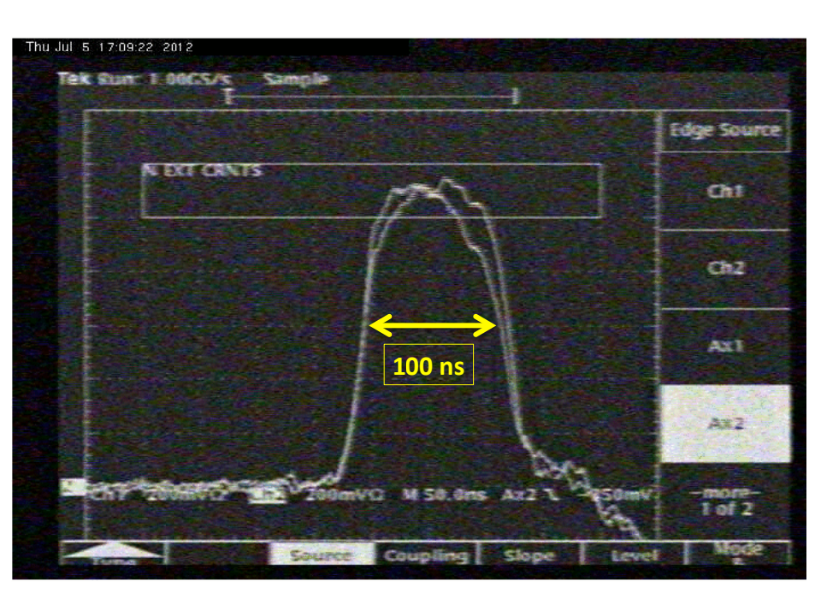
Figure 1: Scope readout of the extraction kicker pulse. The FWHM of the pulse is much wider than 60 ns. However, there is no “flat top” on the pulse.

