INDUSTRIAL TECHNOLOGY VALIDATION

Ahlstrom-Munksjö Black Liquor Membrane Supplemental Technical Annex
  - Supporting source exhibits omitted from the restructured technical report
Companion report: Ahlstrom_Munksjo_Black_Liquor_Membrane_Technical_Report.docx
Primary source PDF: iedo-itv-ahlstrom-munskjo-paper-mill.pdf
Project report title: Project Technical Report

Purpose and Use
This annex preserves detailed evidence from the source PDF that is not reproduced in full in the restructured project report. It is intended as a companion for audit and technical review; the completed report remains the primary reading document for conclusions and interpretation.

Project Summary from the Completed Report
The pilot membrane system dewatered weak black liquor (WBL) upstream of the mill’s multi-effect evaporators (MEEs). At a mean WBL flow of 0.55 gpm, the analysis estimated a water-removal rate of 0.11 gpm per gpm WBL and calculated 1.28 kW of pump demand. Because Ahlstrom-Munksjö did not provide baseline MEE data, steam savings were calculated from typical MEE steam economies rather than measured against the host’s baseline. Only two days of usable pilot data were available. The results do not establish full-scale annual savings or payback.

Source Pages Included
The selected pages reproduce source technical material, including instrumentation/data coverage, operating conditions, equations and model diagnostics, uncertainty and detailed result exhibits, equipment information, figures, and scale-up or market analysis where present. Each page is reproduced directly from the original PDF. Original page headers, captions, tables, and printed page numbers remain visible; “PDF page” labels refer to the file page index.
Included source PDF pages: 14-16, 19, 21, 25-27, 29-30, 32-36, 43-44.
These are facsimile reproductions, not a new analysis. Values, chart scales, and qualifications are as presented in the source. Refer to the completed report for the summarized findings and project-specific interpretation.

Source PDF page 14 | Ahlstrom-Munksjö Black Liquor Membrane
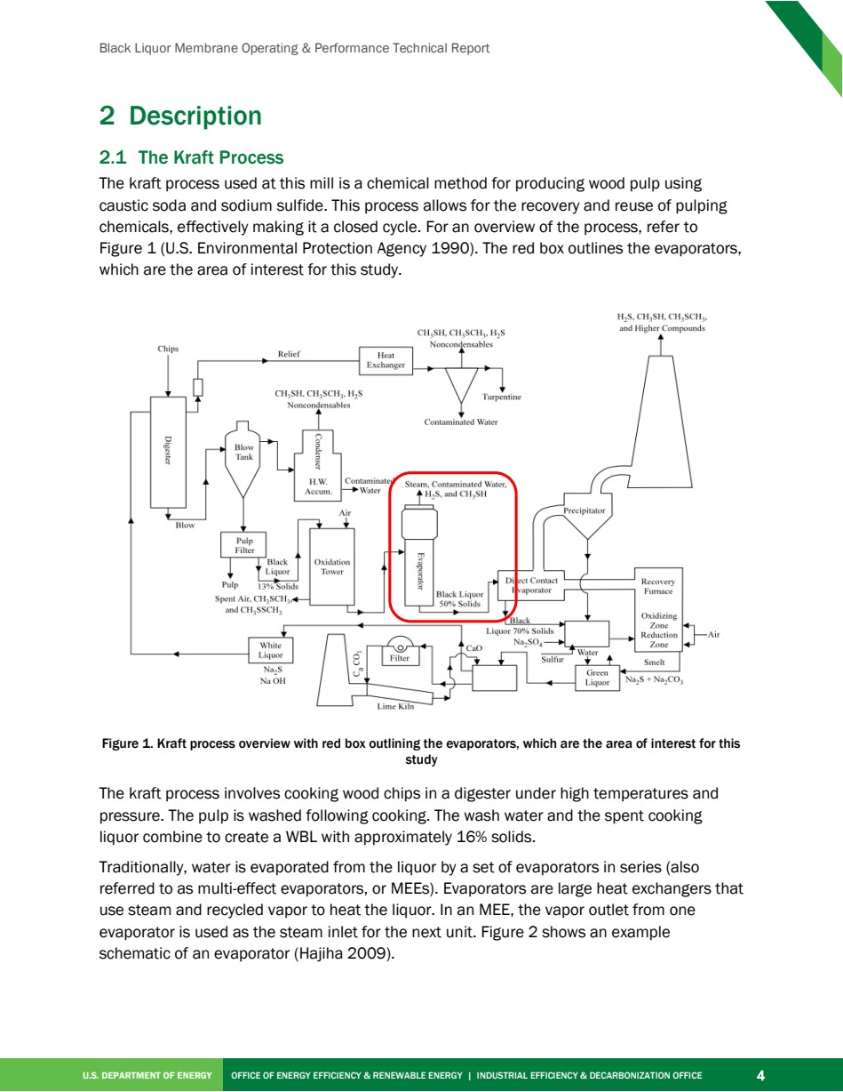

Source PDF page 15 | Ahlstrom-Munksjö Black Liquor Membrane
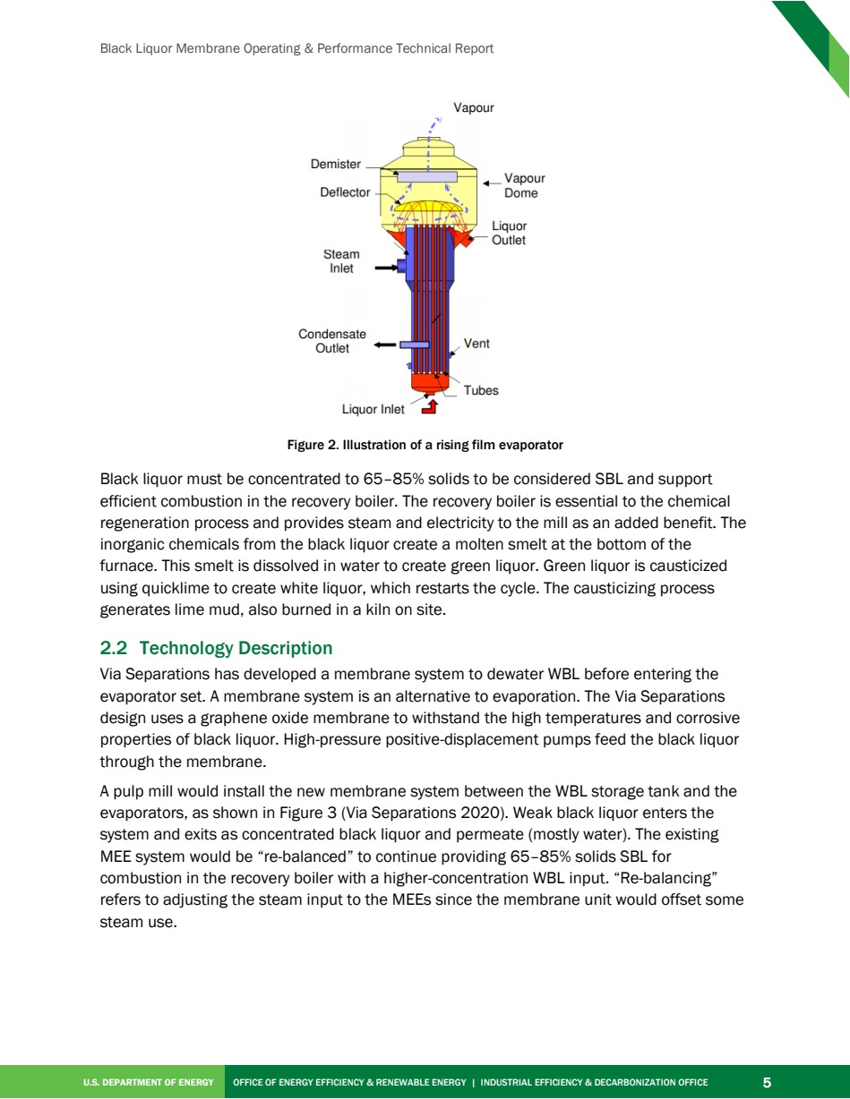

Source PDF page 16 | Ahlstrom-Munksjö Black Liquor Membrane
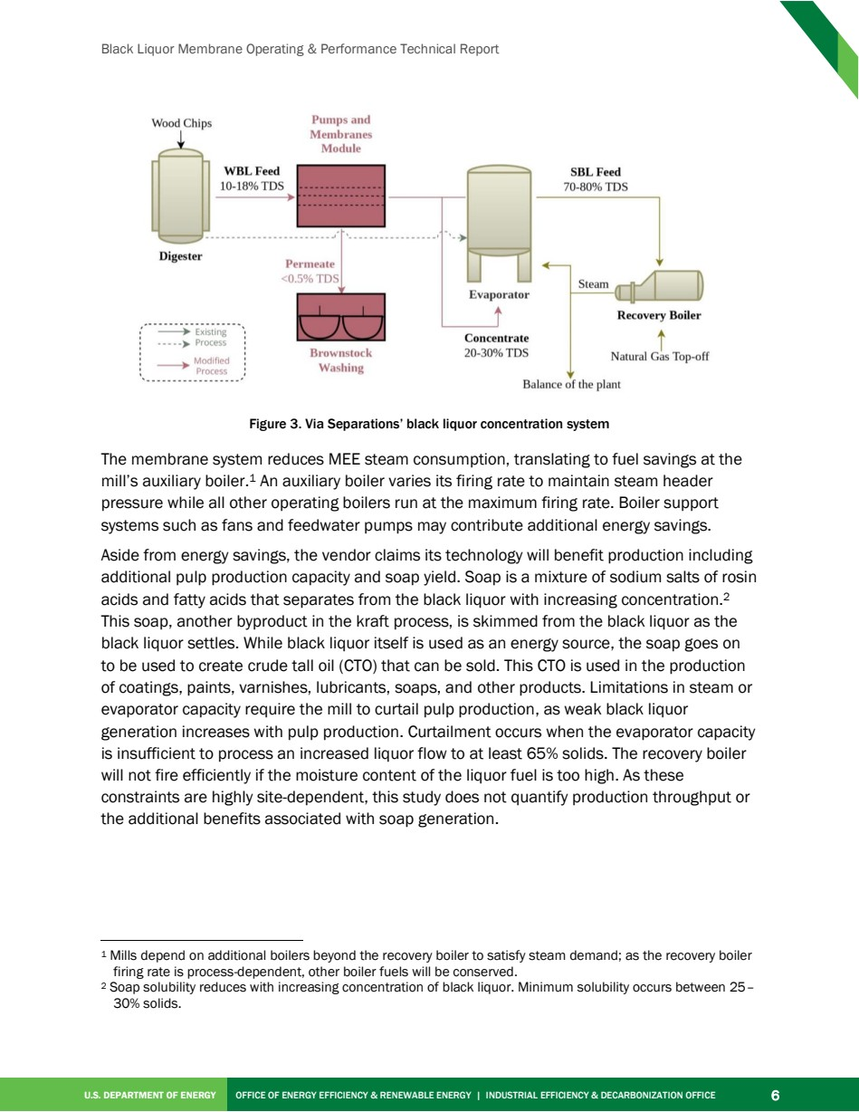

Source PDF page 19 | Ahlstrom-Munksjö Black Liquor Membrane
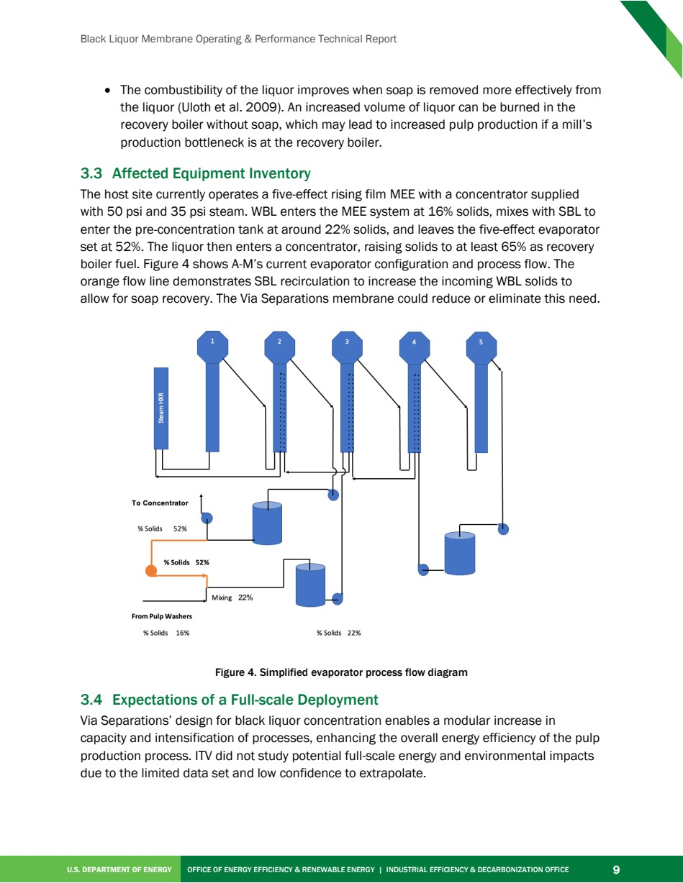

Source PDF page 21 | Ahlstrom-Munksjö Black Liquor Membrane
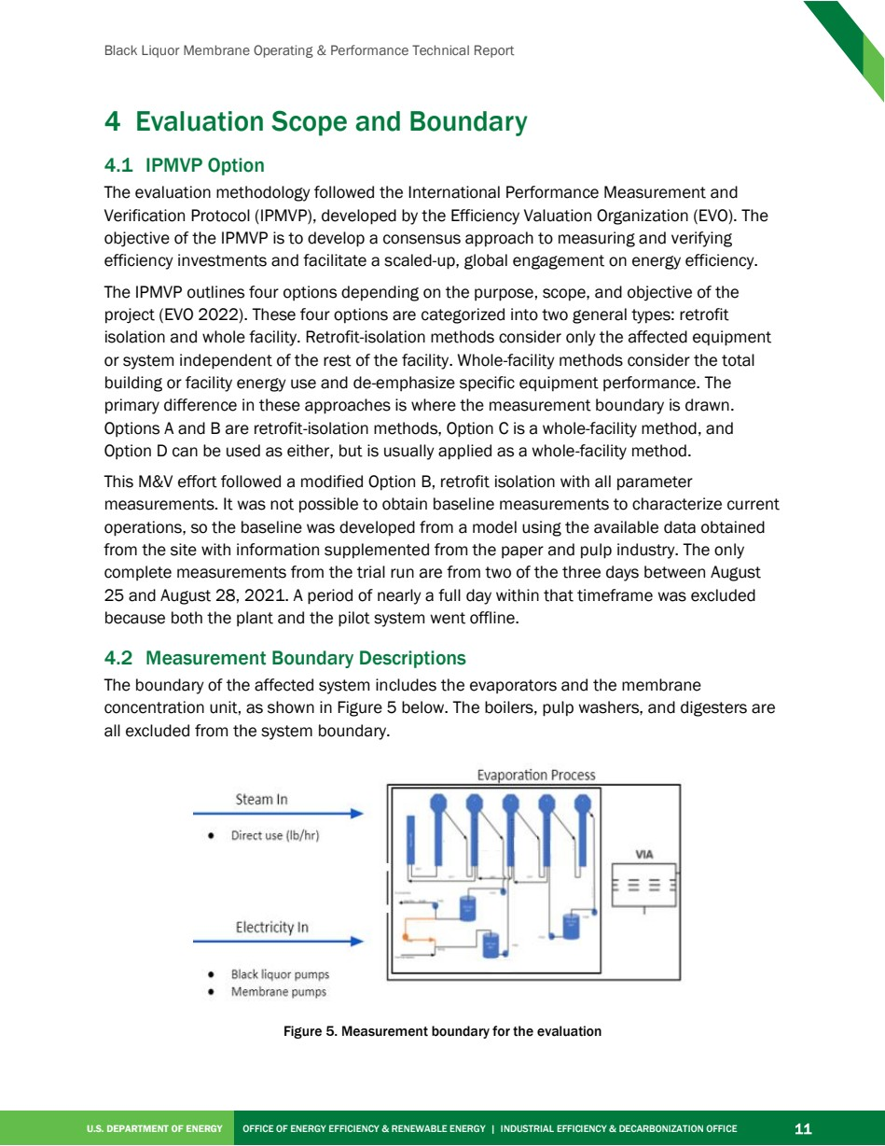

Source PDF page 25 | Ahlstrom-Munksjö Black Liquor Membrane
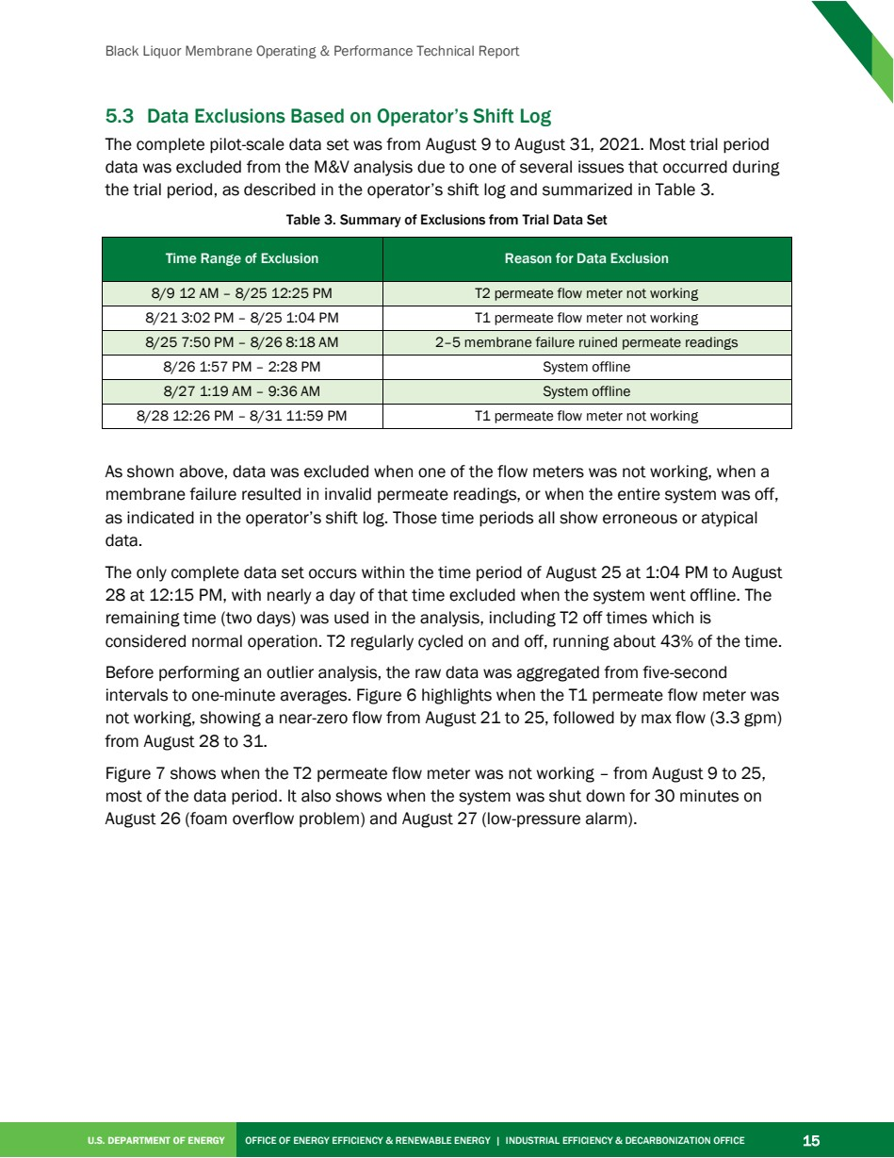

Source PDF page 26 | Ahlstrom-Munksjö Black Liquor Membrane
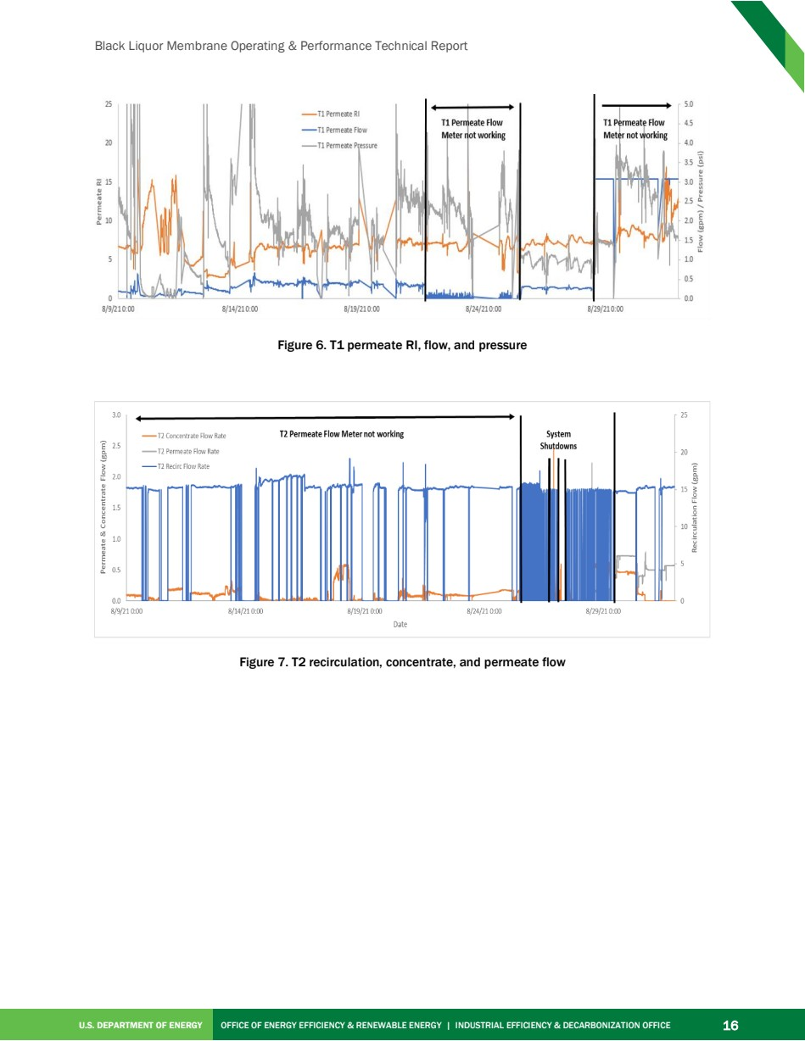

Source PDF page 27 | Ahlstrom-Munksjö Black Liquor Membrane
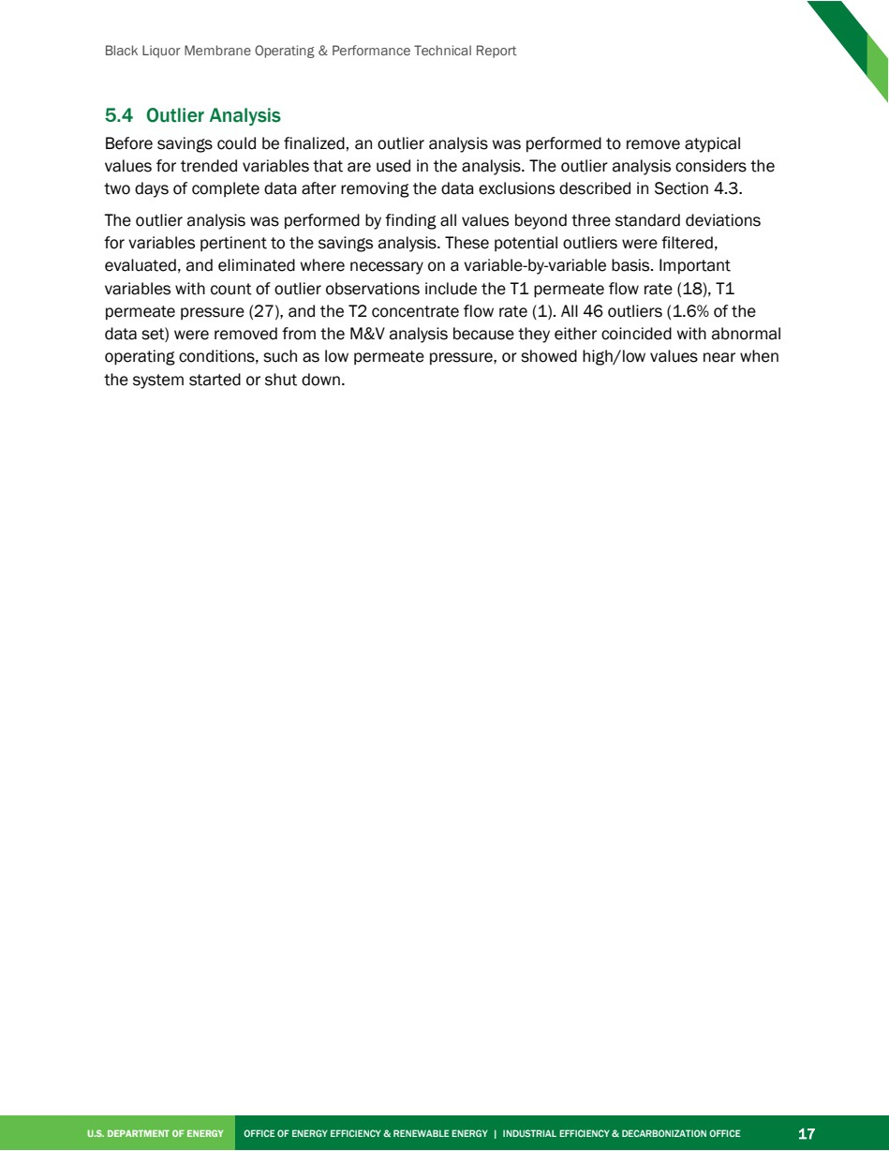

Source PDF page 29 | Ahlstrom-Munksjö Black Liquor Membrane
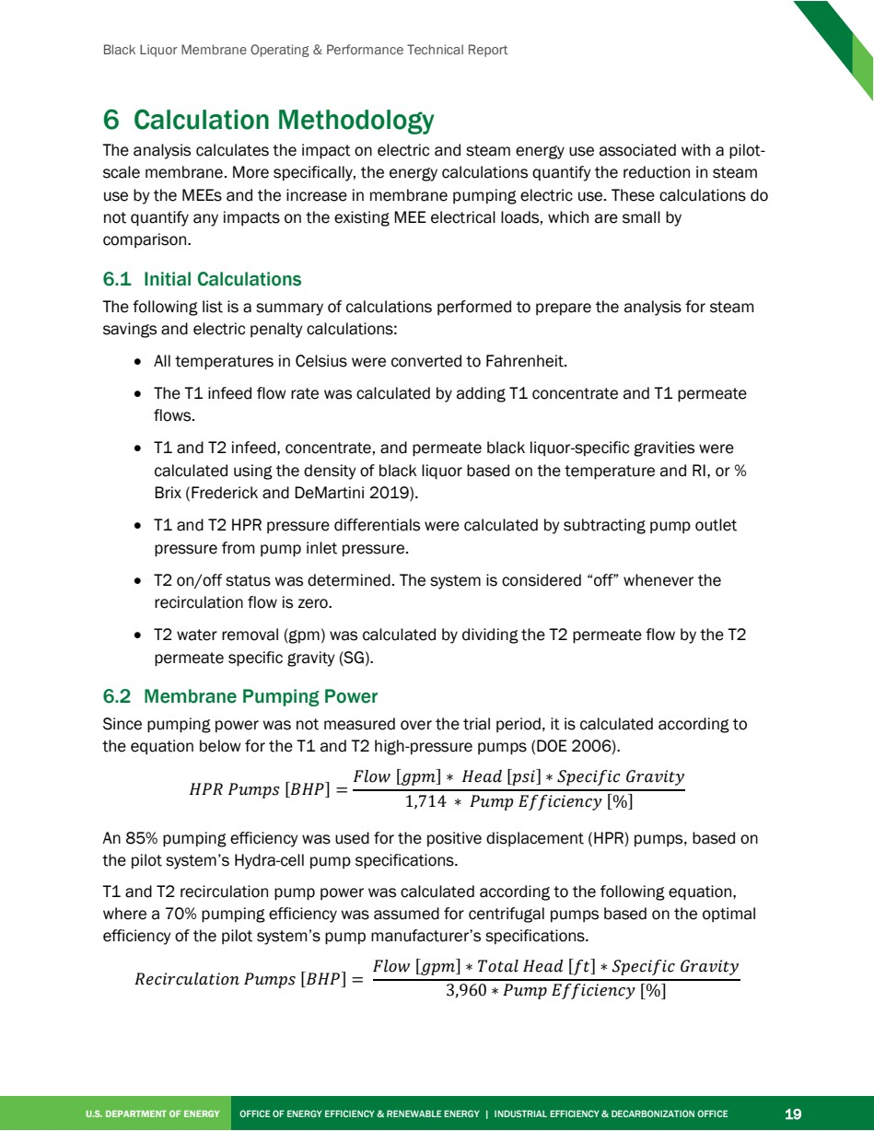

Source PDF page 30 | Ahlstrom-Munksjö Black Liquor Membrane
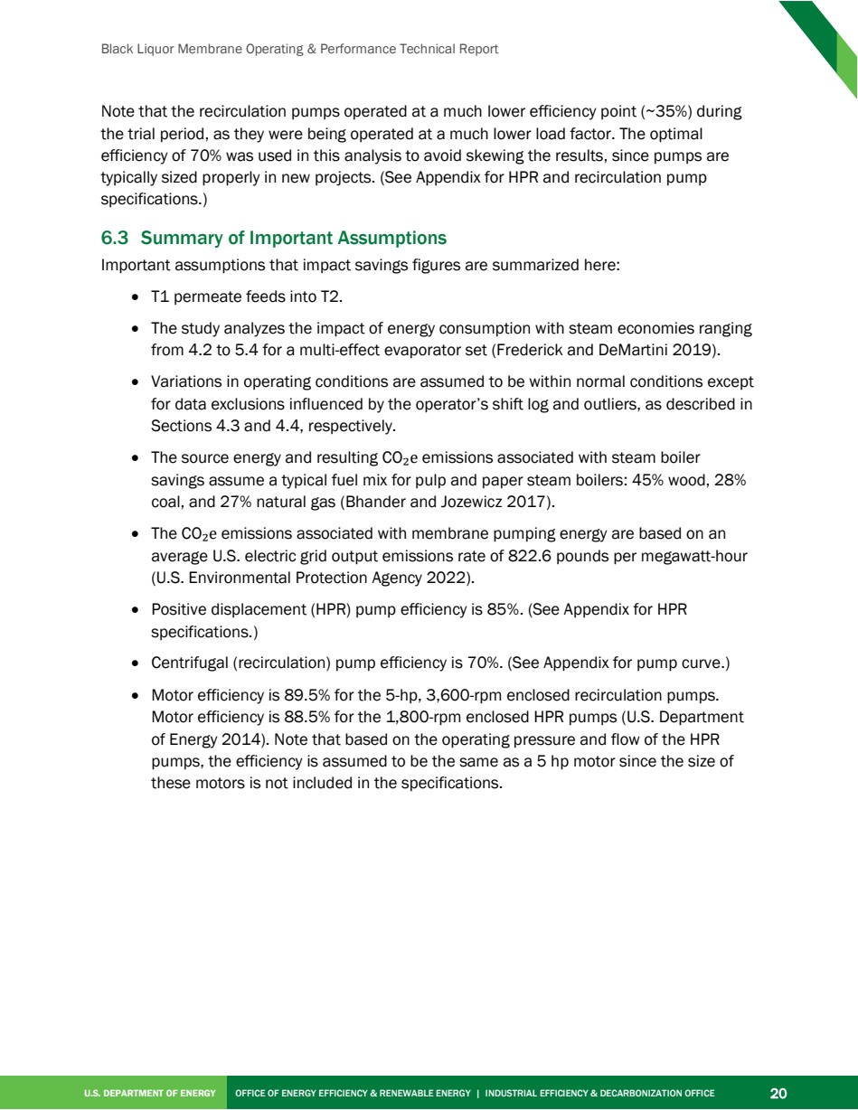

Source PDF page 32 | Ahlstrom-Munksjö Black Liquor Membrane
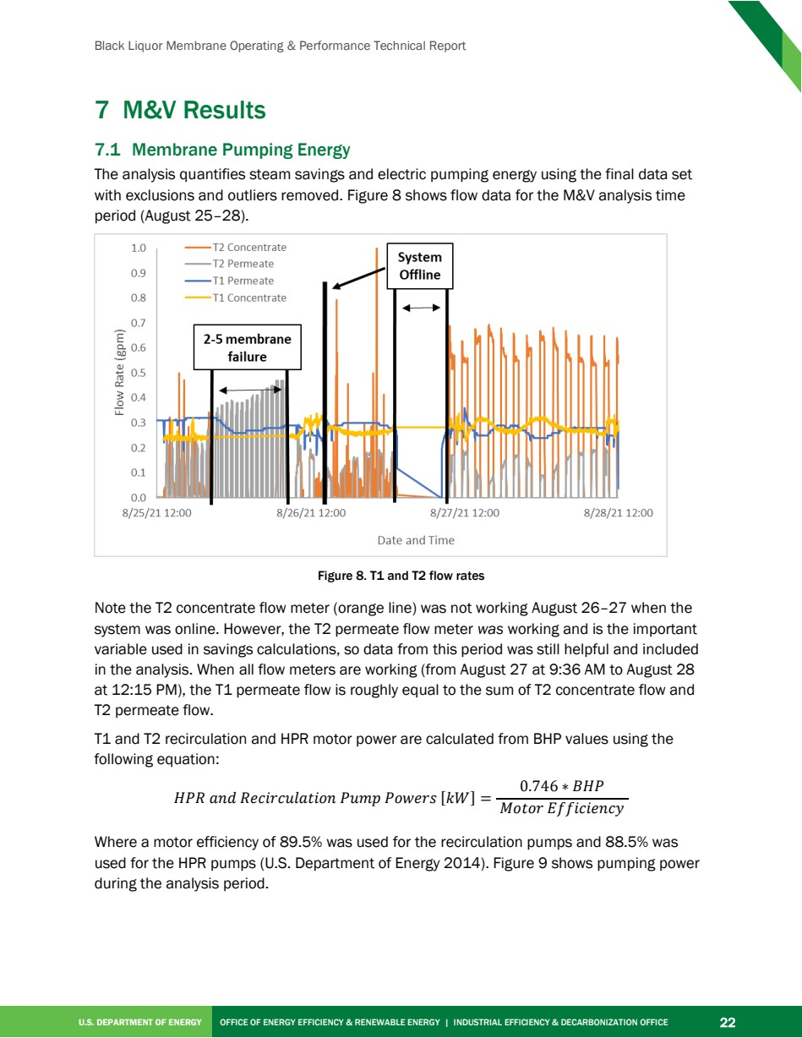

Source PDF page 33 | Ahlstrom-Munksjö Black Liquor Membrane
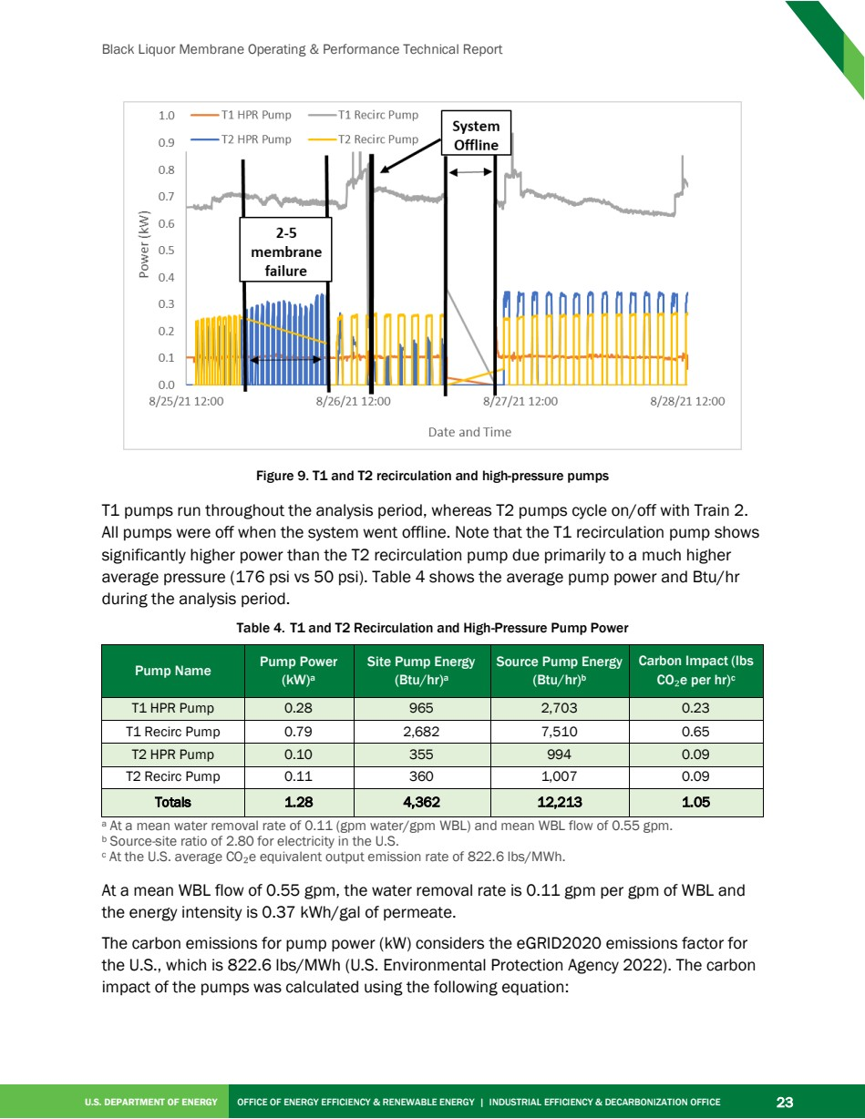

Source PDF page 34 | Ahlstrom-Munksjö Black Liquor Membrane
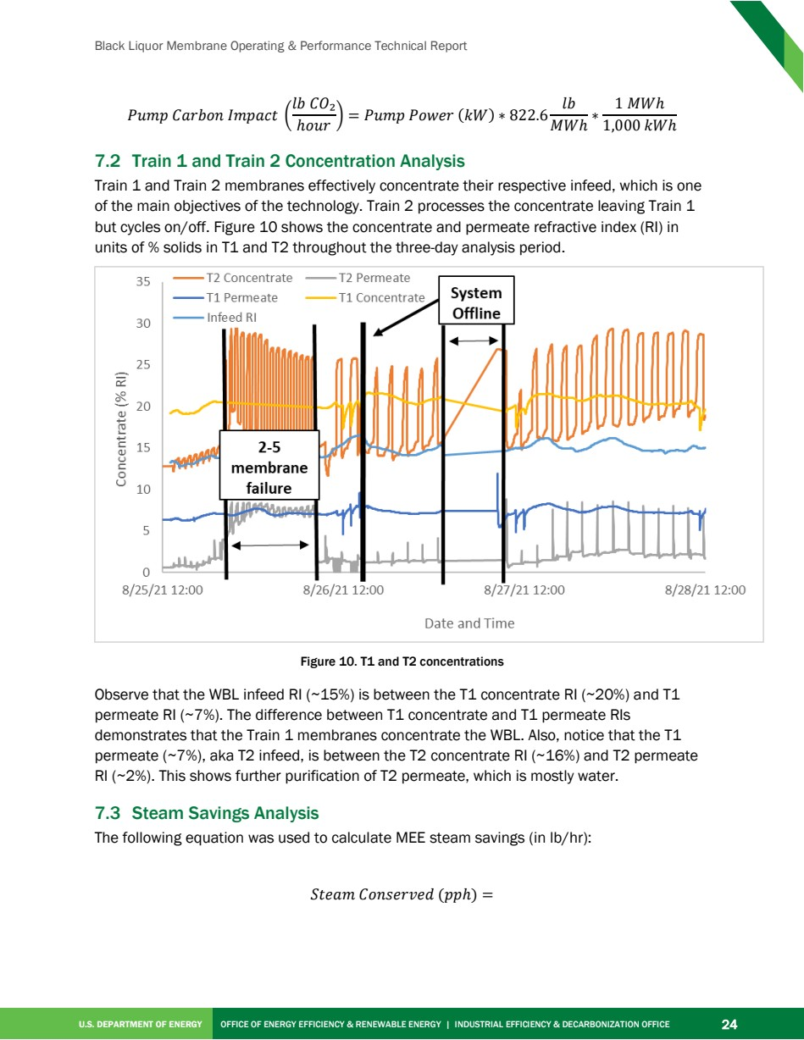

Source PDF page 35 | Ahlstrom-Munksjö Black Liquor Membrane
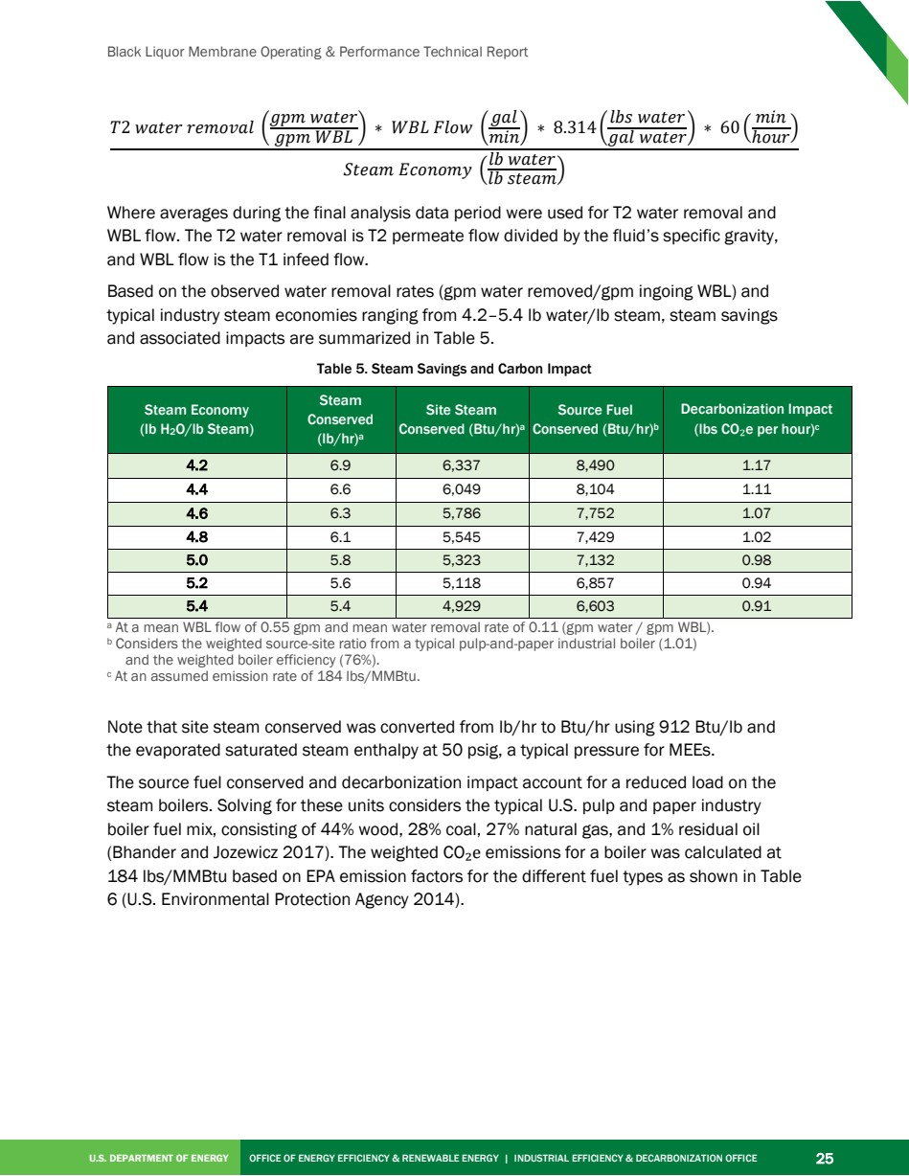

Source PDF page 36 | Ahlstrom-Munksjö Black Liquor Membrane
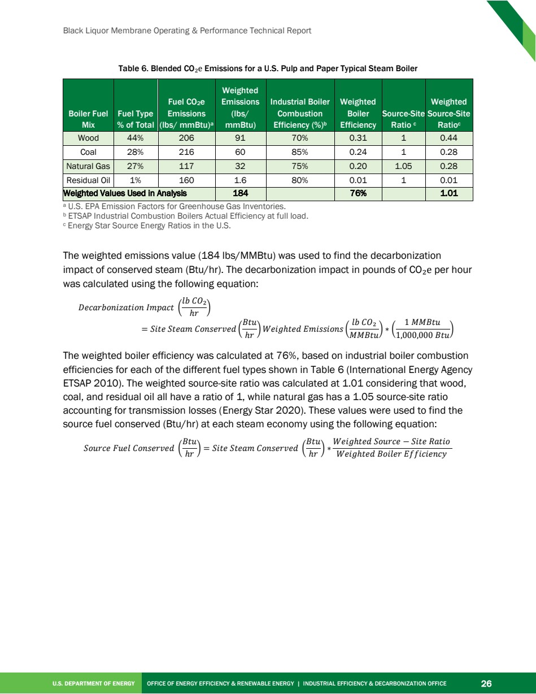

Source PDF page 43 | Ahlstrom-Munksjö Black Liquor Membrane
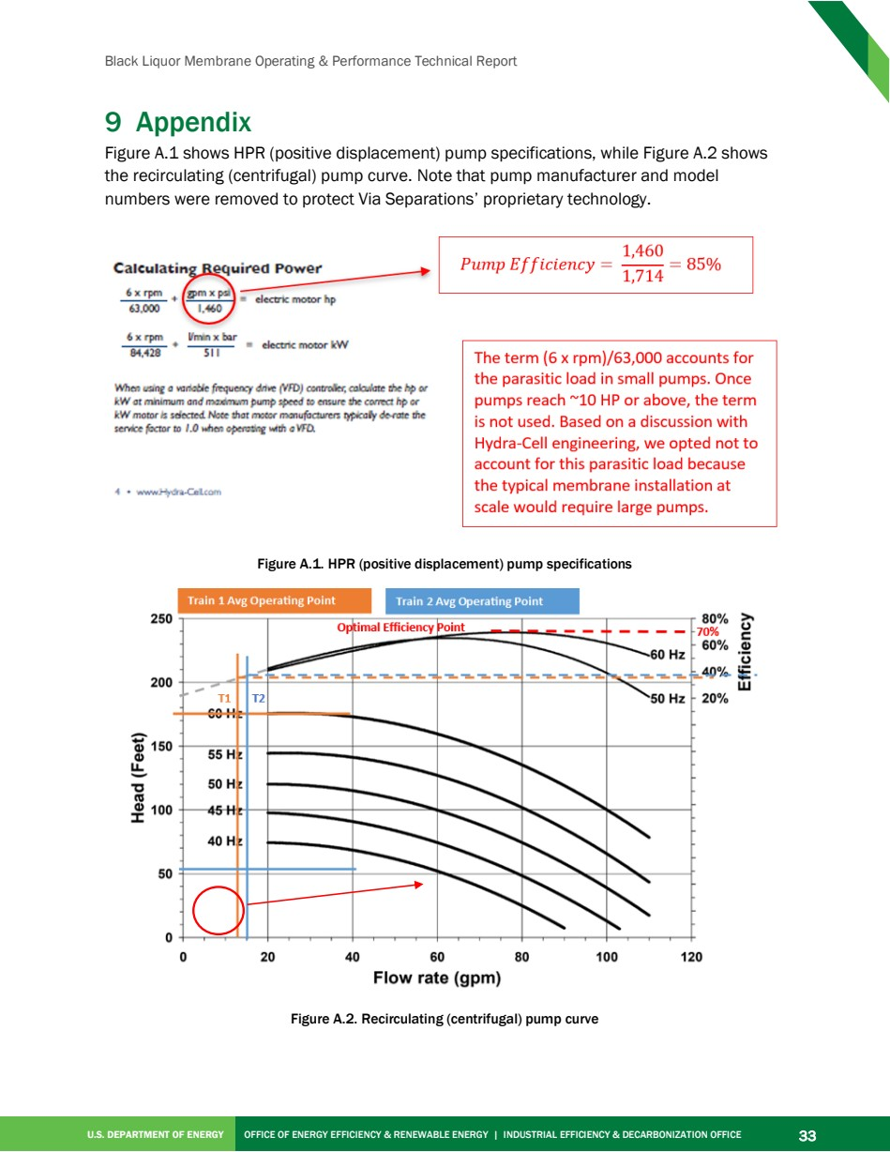

Source PDF page 44 | Ahlstrom-Munksjö Black Liquor Membrane


