INDUSTRIAL TECHNOLOGY VALIDATION

Cleveland-Cliffs Electrocoagulation Supplemental Technical Annex
  - Supporting source exhibits omitted from the restructured technical report
Companion report: Cleveland_Cliffs_Electrocoagulation_Technical_Report.docx
Primary source PDF: iedo-itv-cleveland-cliffs-steel.pdf
Project report title: Project Technical Report

Purpose and Use
This annex preserves detailed evidence from the source PDF that is not reproduced in full in the restructured project report. It is intended as a companion for audit and technical review; the completed report remains the primary reading document for conclusions and interpretation.

Project Summary from the Completed Report
This evaluation tested a 100-gpm design electrocoagulation system as a side stream at Cleveland-Cliffs’ oily wastewater treatment plant. The EC pilot treated about 11% of the wastewater during the four-week evaluation (475,536 gallons over 152 operating hours; average flow about 50 gpm). The existing chemical-flocculation (CF) system continued to operate. EC showed strong contaminant removal from its own incoming stream and collected about 25% more tramp oil per million gallons treated, while the final comparison water showed slightly higher mean turbidity than CF. EC consumed much more electricity and reduced chemical use. A 60-million-gallon annual scenario estimated $322,860/year in net cost savings, but excluded anode costs and assumed similar O&M; it is a projection, not observed annual savings.

Source Pages Included
The selected pages reproduce source technical material, including instrumentation/data coverage, operating conditions, equations and model diagnostics, uncertainty and detailed result exhibits, equipment information, figures, and scale-up or market analysis where present. Each page is reproduced directly from the original PDF. Original page headers, captions, tables, and printed page numbers remain visible; “PDF page” labels refer to the file page index.
Included source PDF pages: 15, 17, 19, 24, 27, 32-44, 47, 51, 55-58.
These are facsimile reproductions, not a new analysis. Values, chart scales, and qualifications are as presented in the source. Refer to the completed report for the summarized findings and project-specific interpretation.

Source PDF page 15 | Cleveland-Cliffs Electrocoagulation
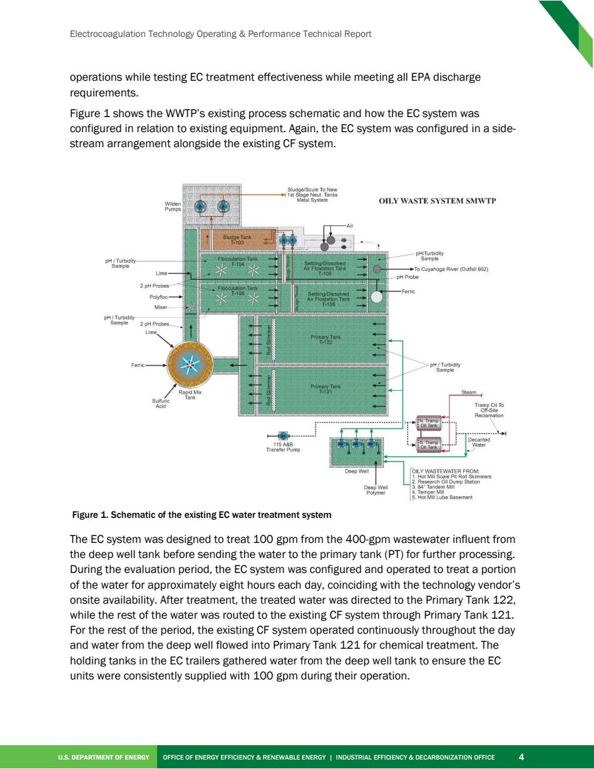

Source PDF page 17 | Cleveland-Cliffs Electrocoagulation
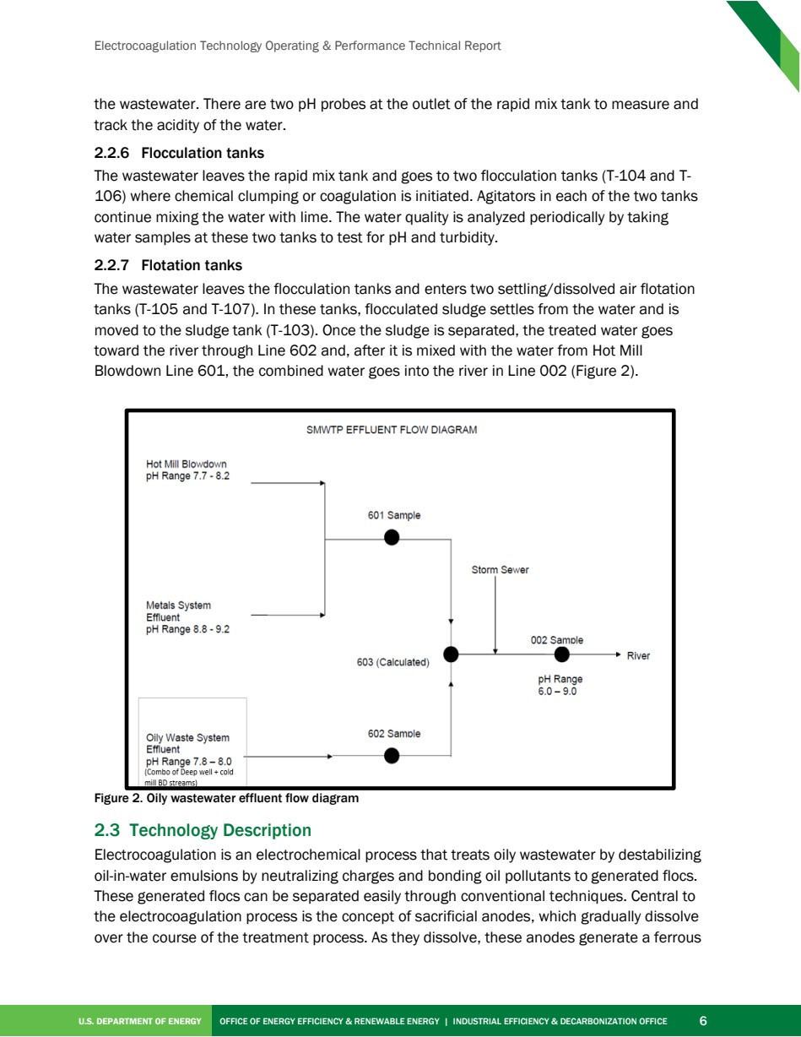

Source PDF page 19 | Cleveland-Cliffs Electrocoagulation
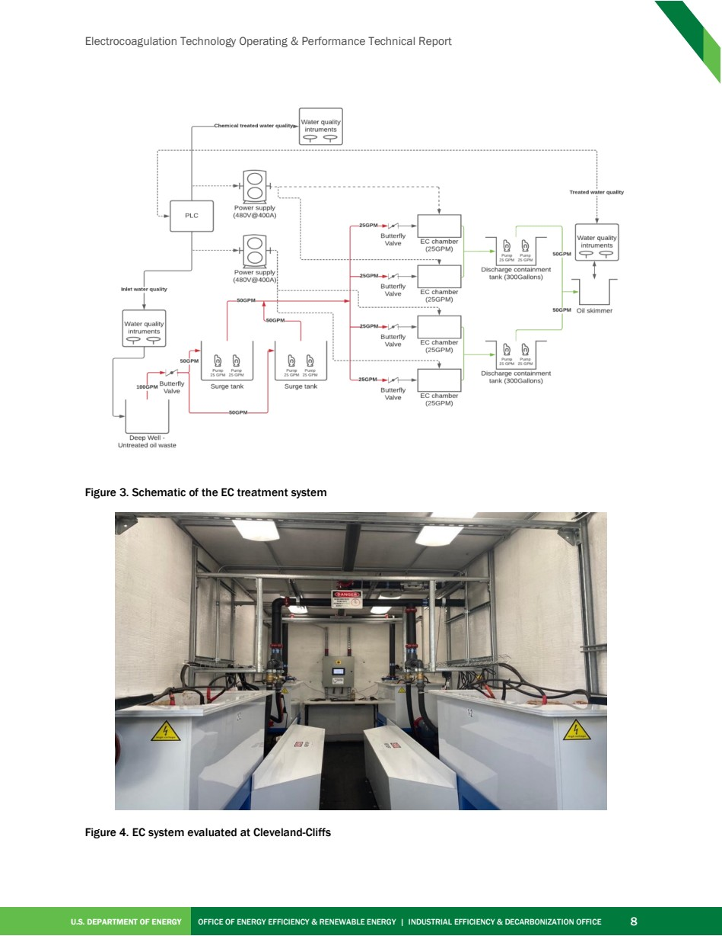

Source PDF page 24 | Cleveland-Cliffs Electrocoagulation
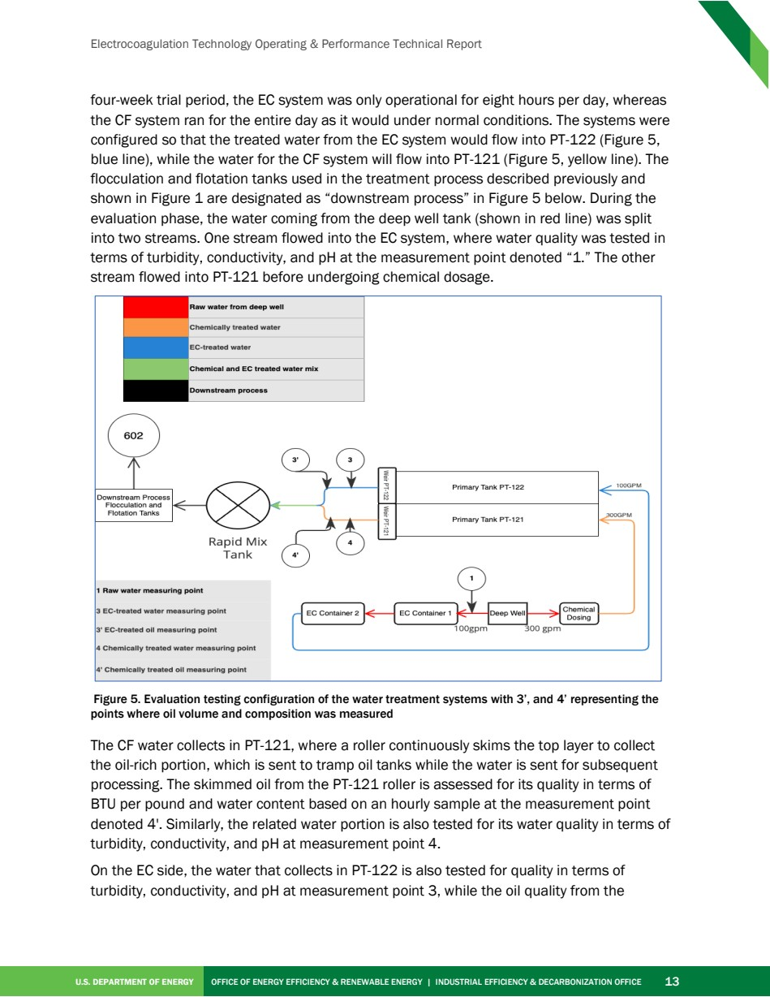

Source PDF page 27 | Cleveland-Cliffs Electrocoagulation
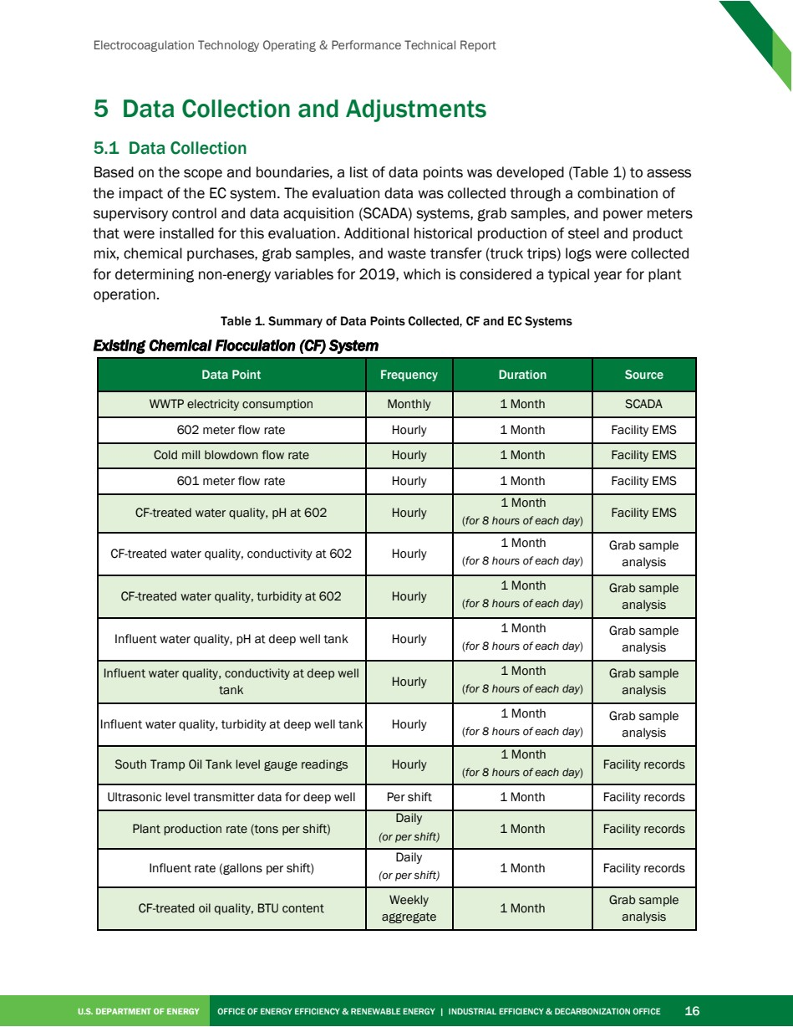

Source PDF page 32 | Cleveland-Cliffs Electrocoagulation
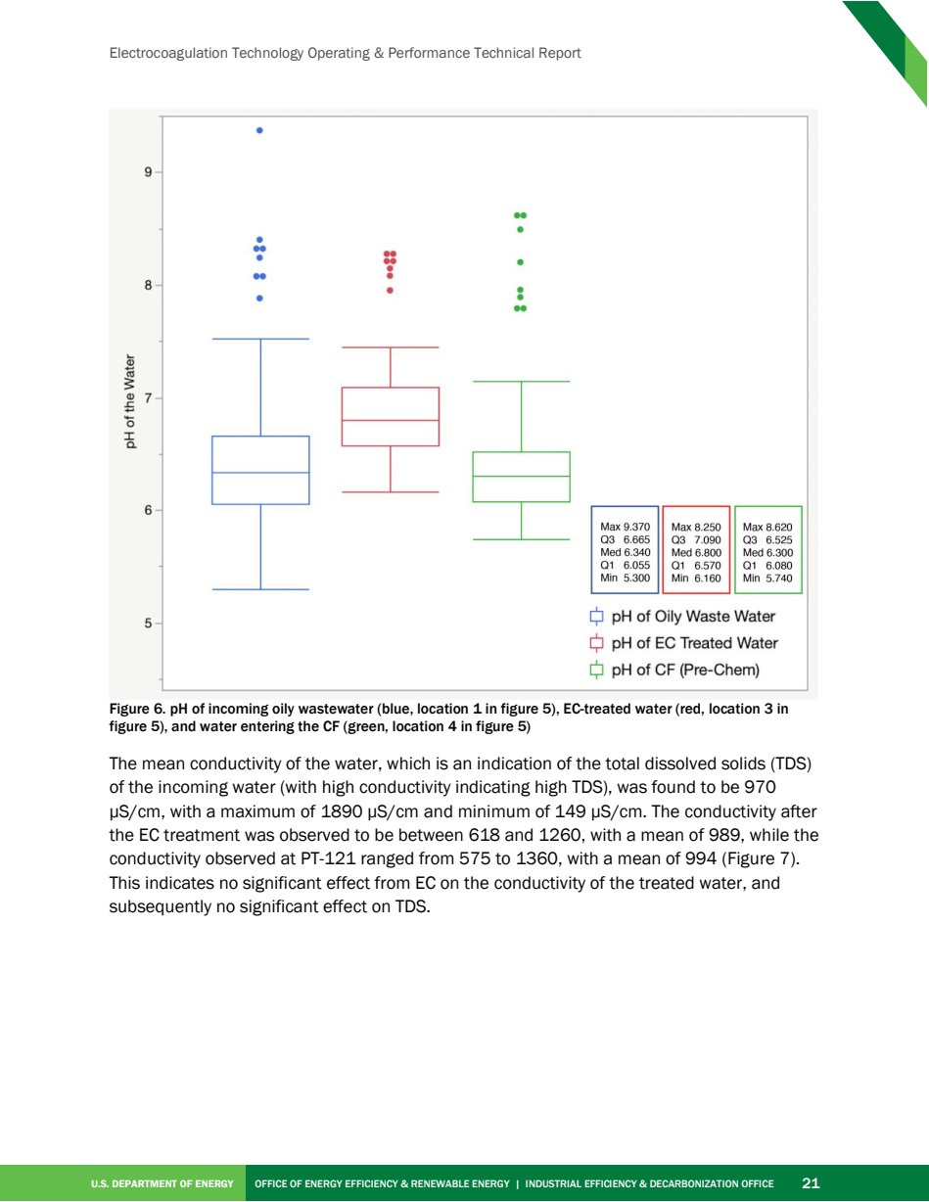

Source PDF page 33 | Cleveland-Cliffs Electrocoagulation
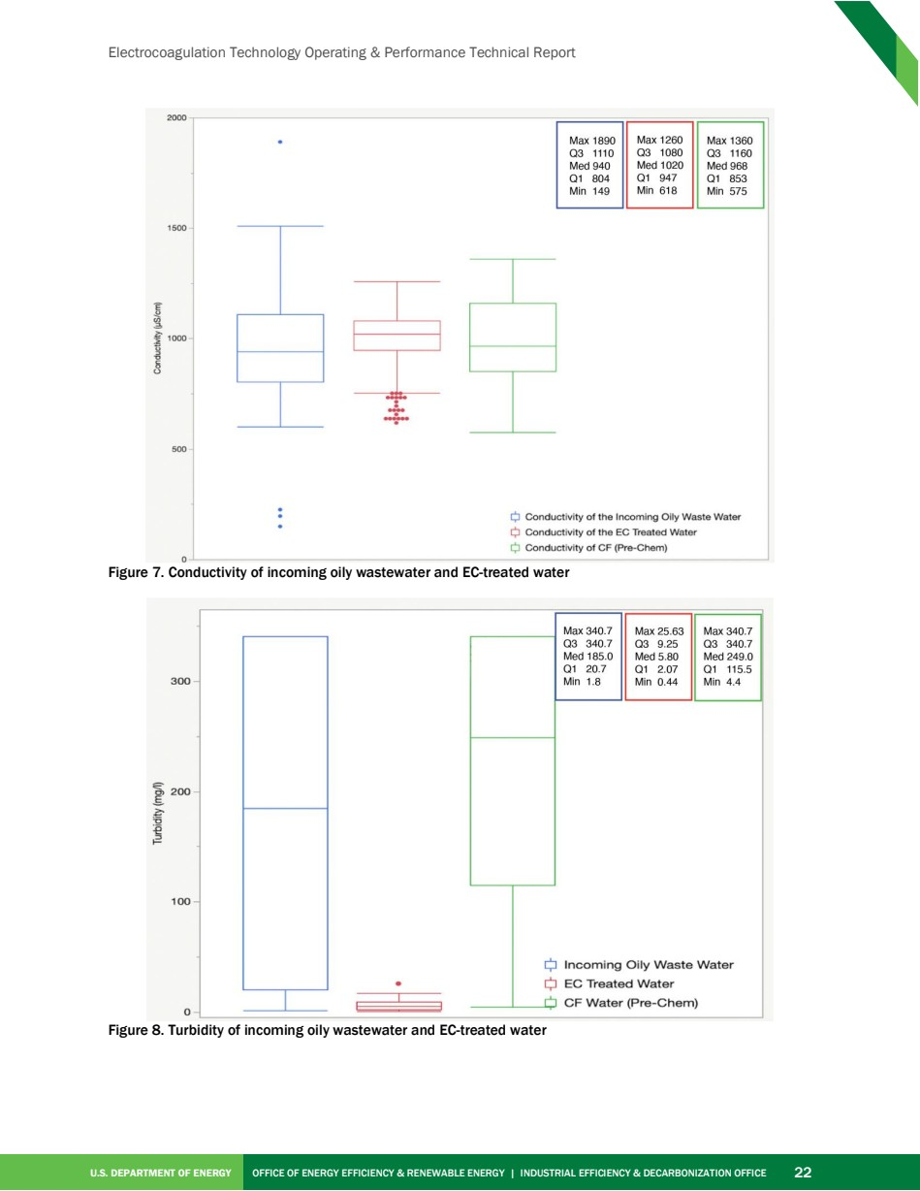

Source PDF page 34 | Cleveland-Cliffs Electrocoagulation
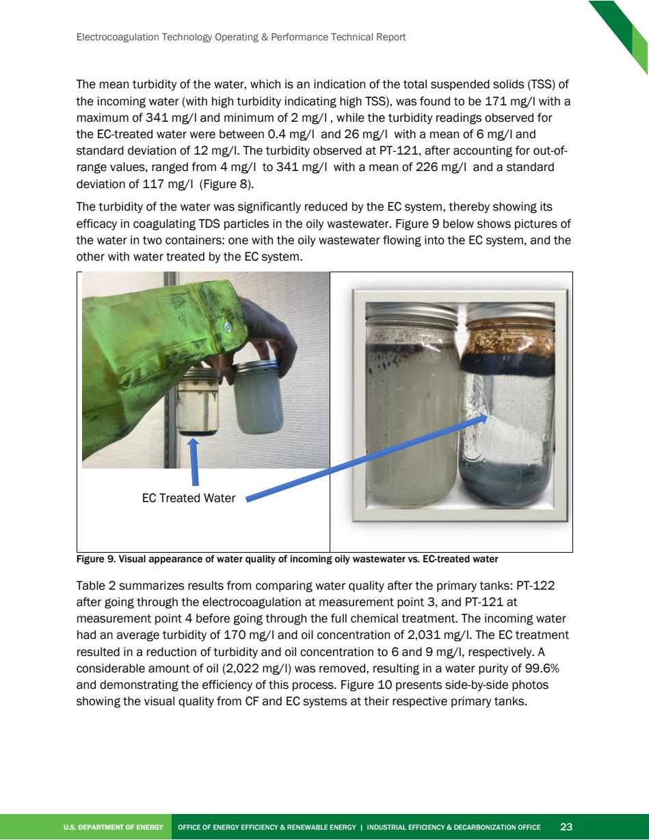

Source PDF page 35 | Cleveland-Cliffs Electrocoagulation
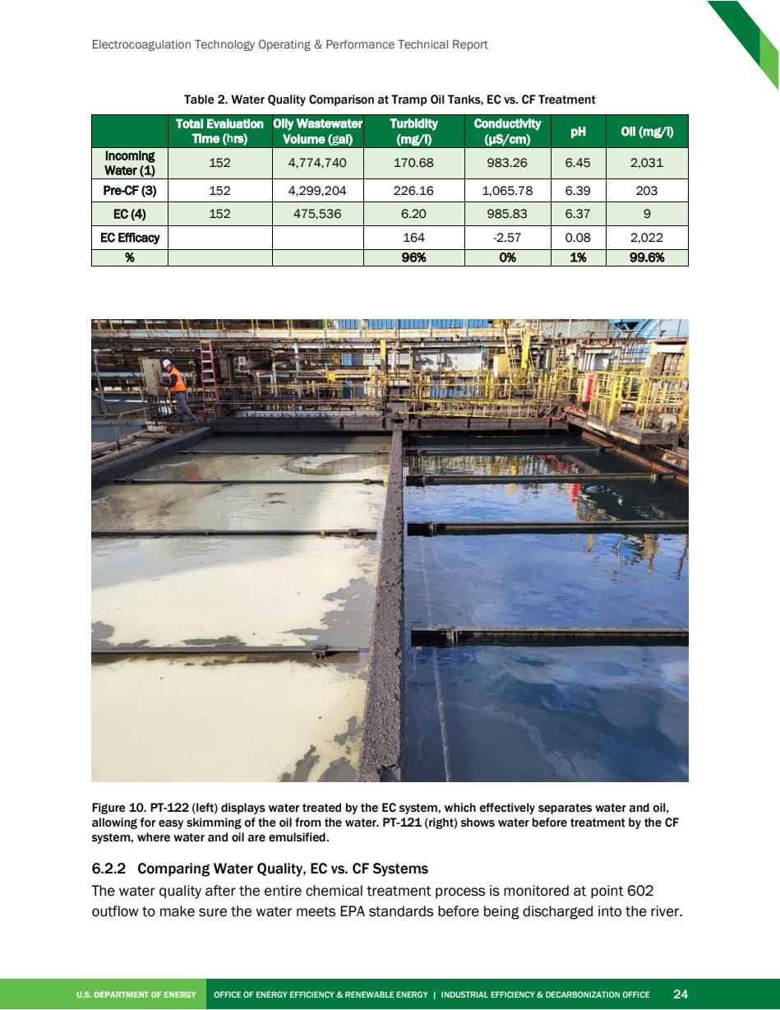

Source PDF page 36 | Cleveland-Cliffs Electrocoagulation
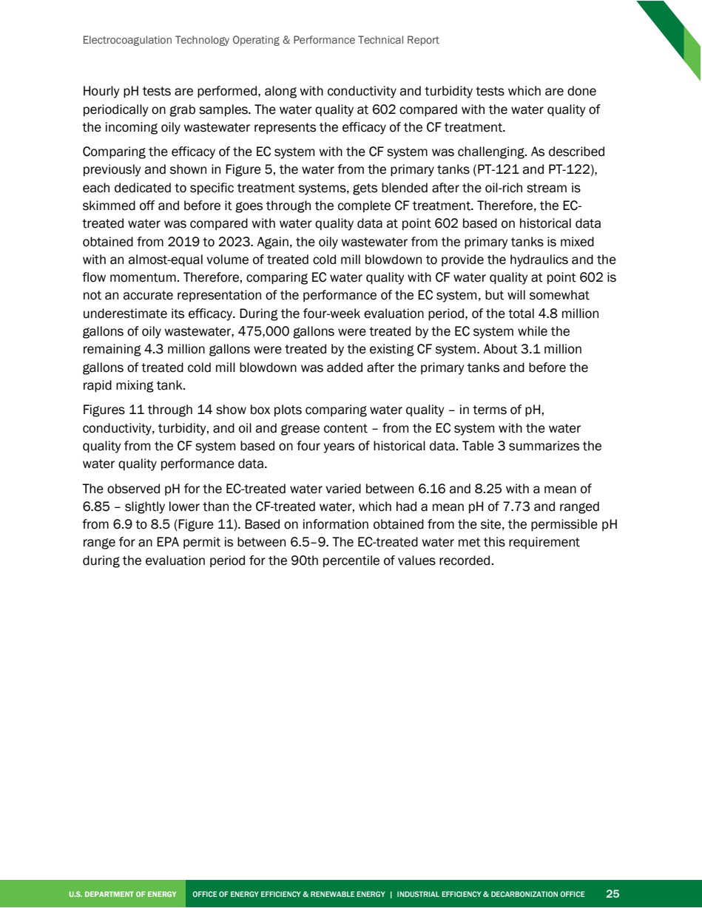

Source PDF page 37 | Cleveland-Cliffs Electrocoagulation
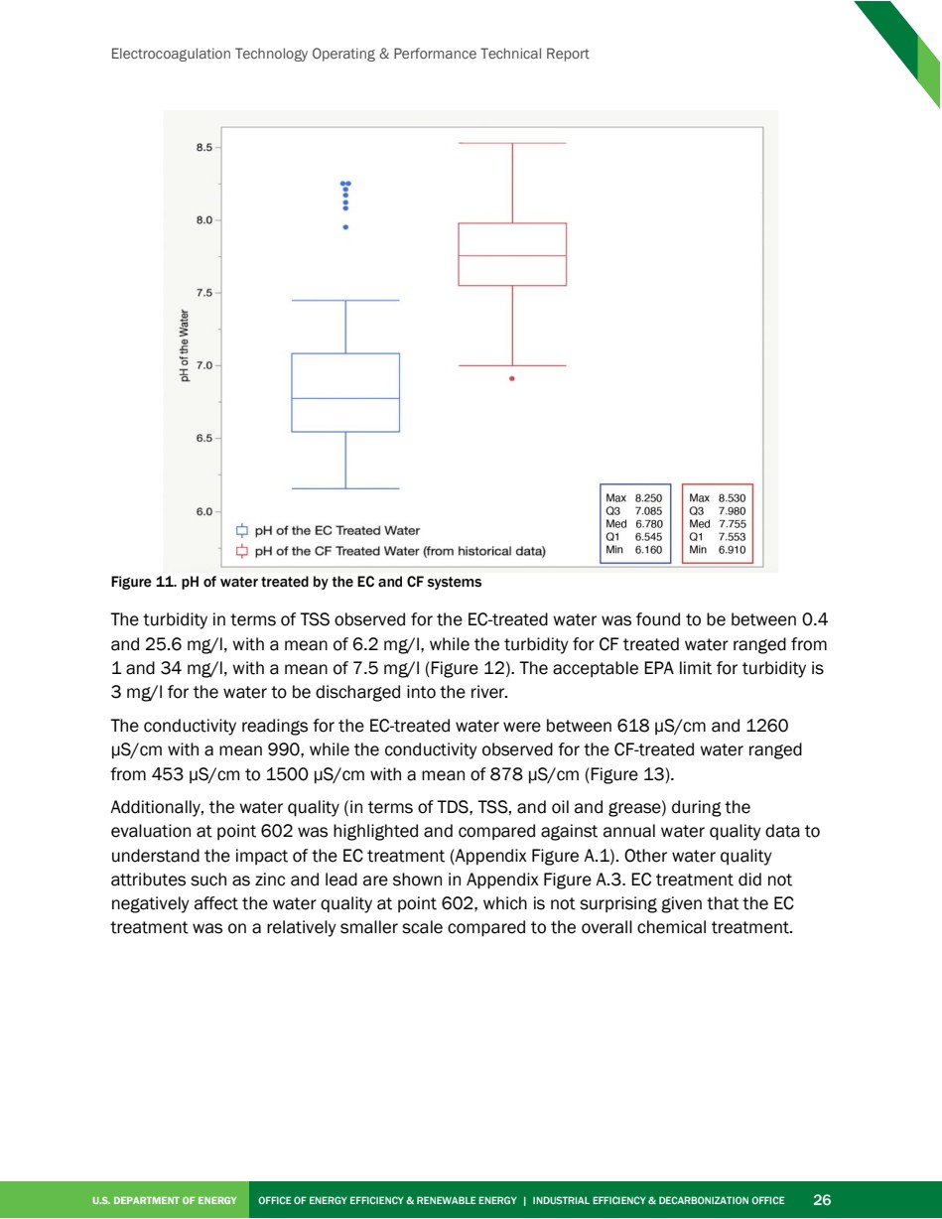

Source PDF page 38 | Cleveland-Cliffs Electrocoagulation
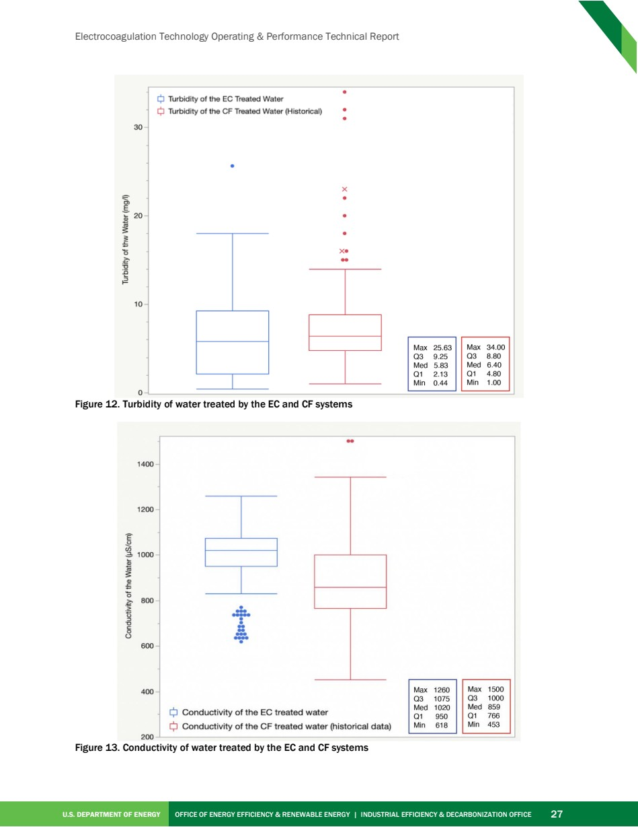

Source PDF page 39 | Cleveland-Cliffs Electrocoagulation
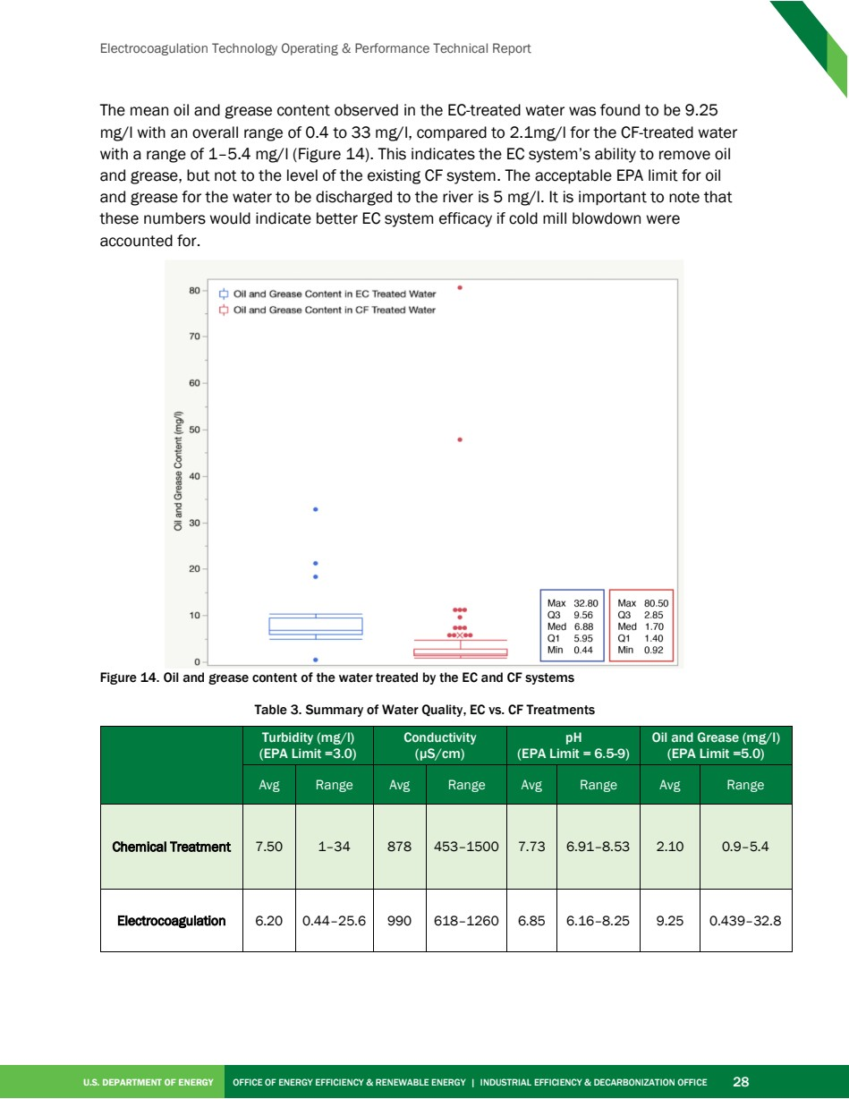

Source PDF page 40 | Cleveland-Cliffs Electrocoagulation
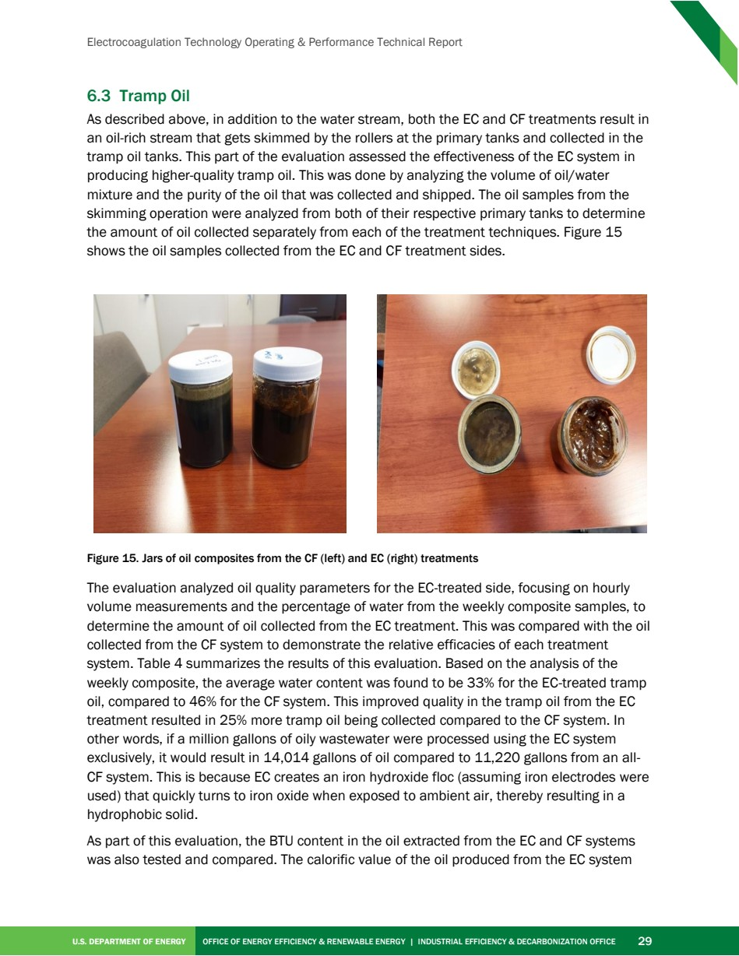

Source PDF page 41 | Cleveland-Cliffs Electrocoagulation
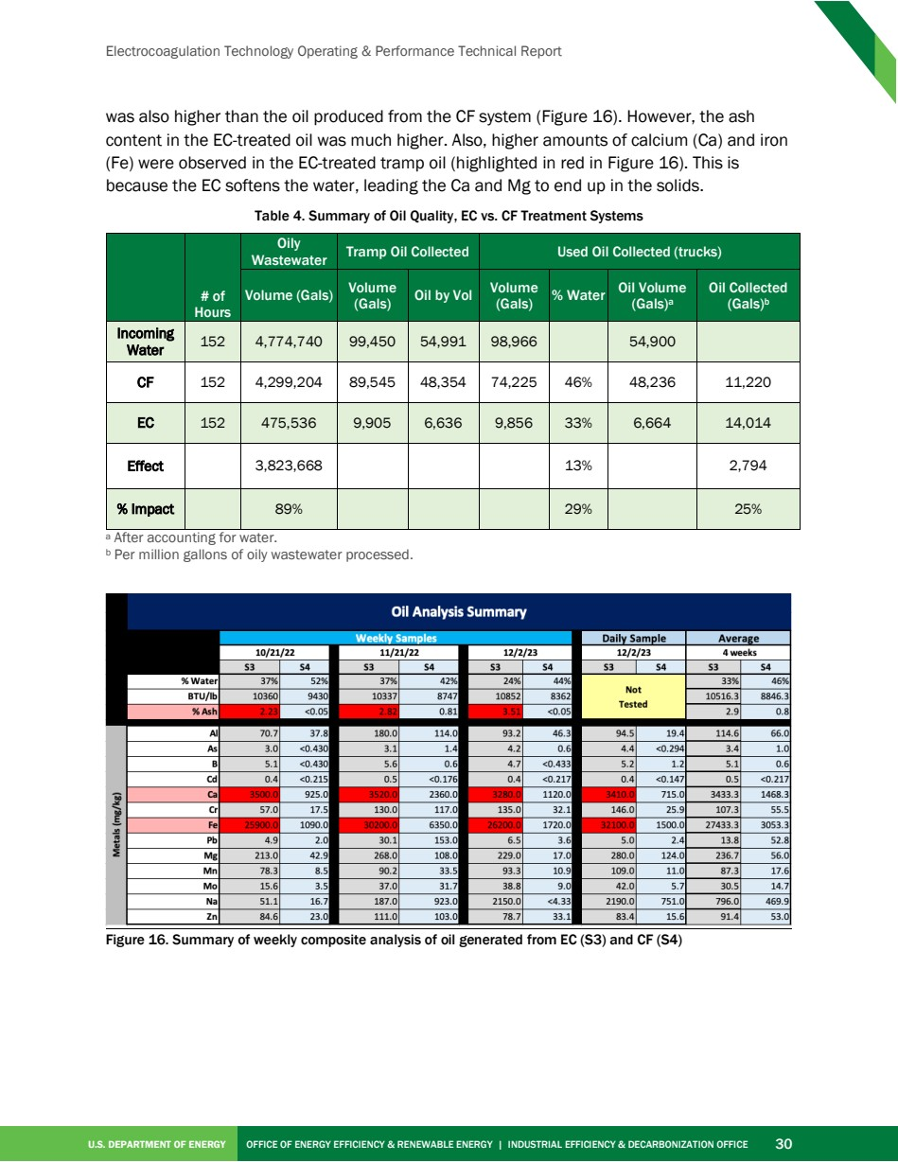

Source PDF page 42 | Cleveland-Cliffs Electrocoagulation
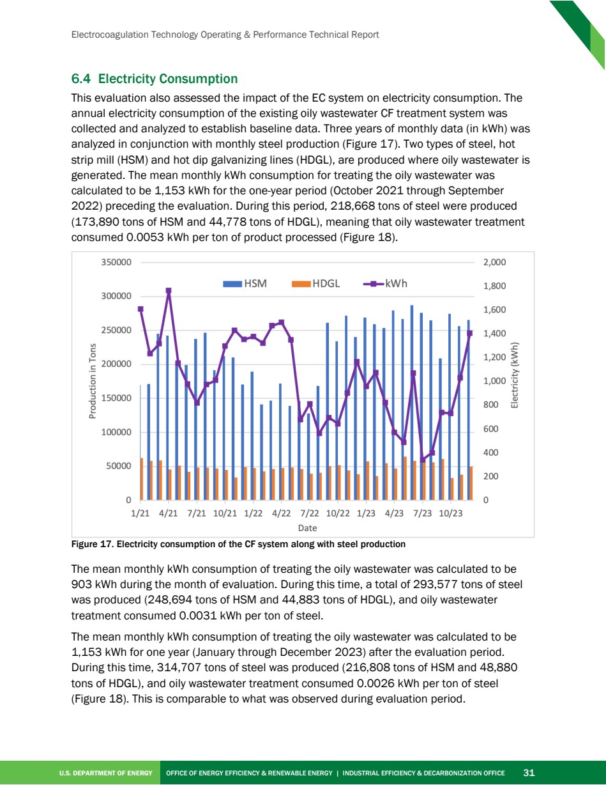

Source PDF page 43 | Cleveland-Cliffs Electrocoagulation
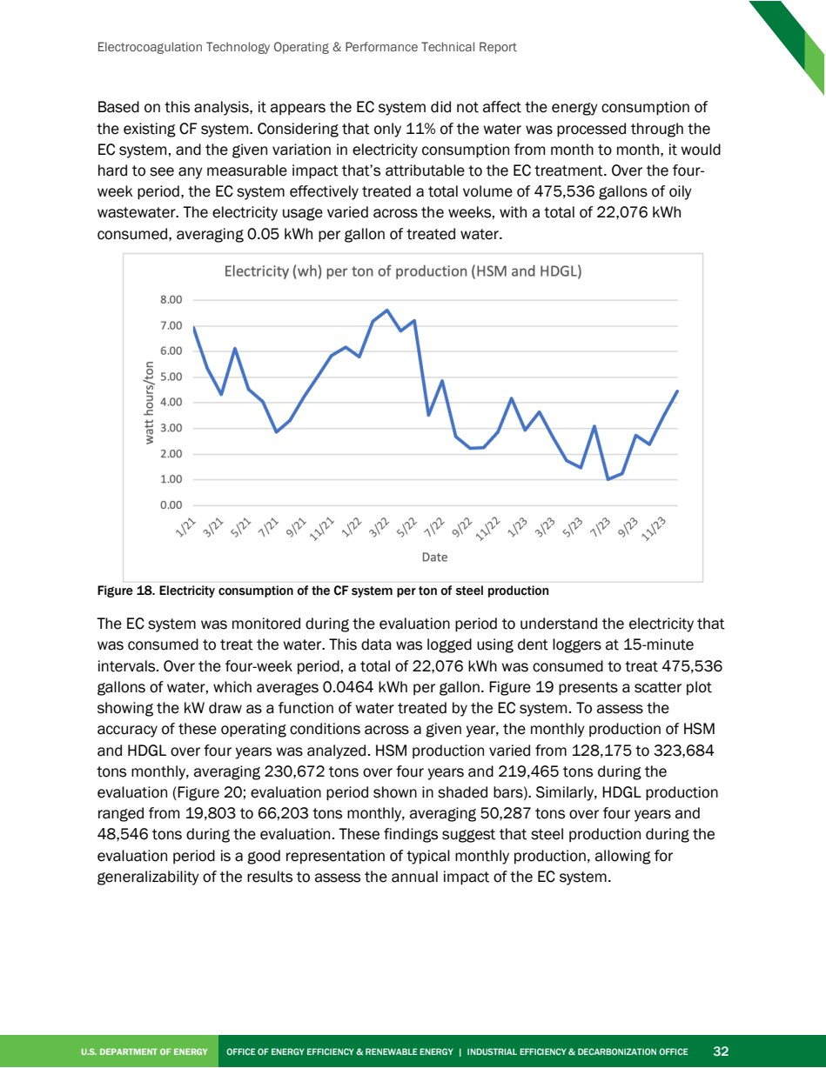

Source PDF page 44 | Cleveland-Cliffs Electrocoagulation
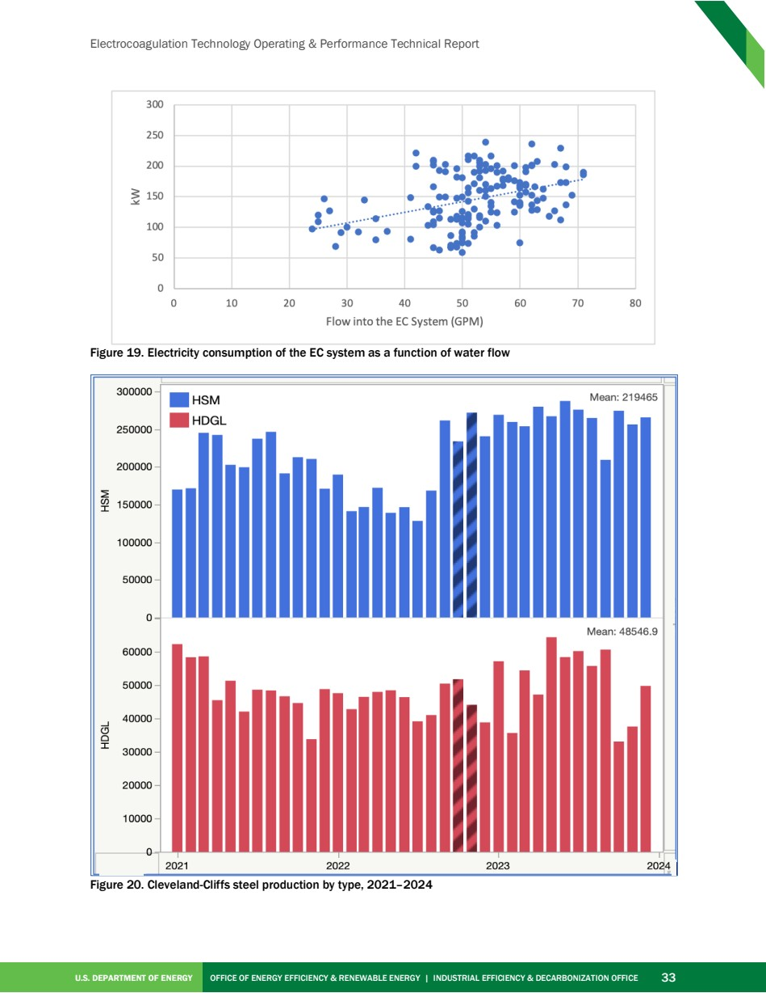

Source PDF page 47 | Cleveland-Cliffs Electrocoagulation
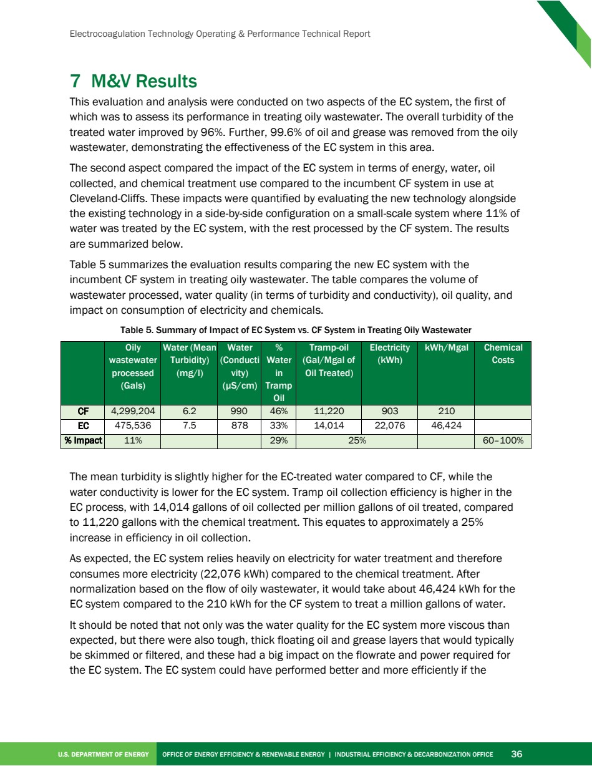

Source PDF page 51 | Cleveland-Cliffs Electrocoagulation
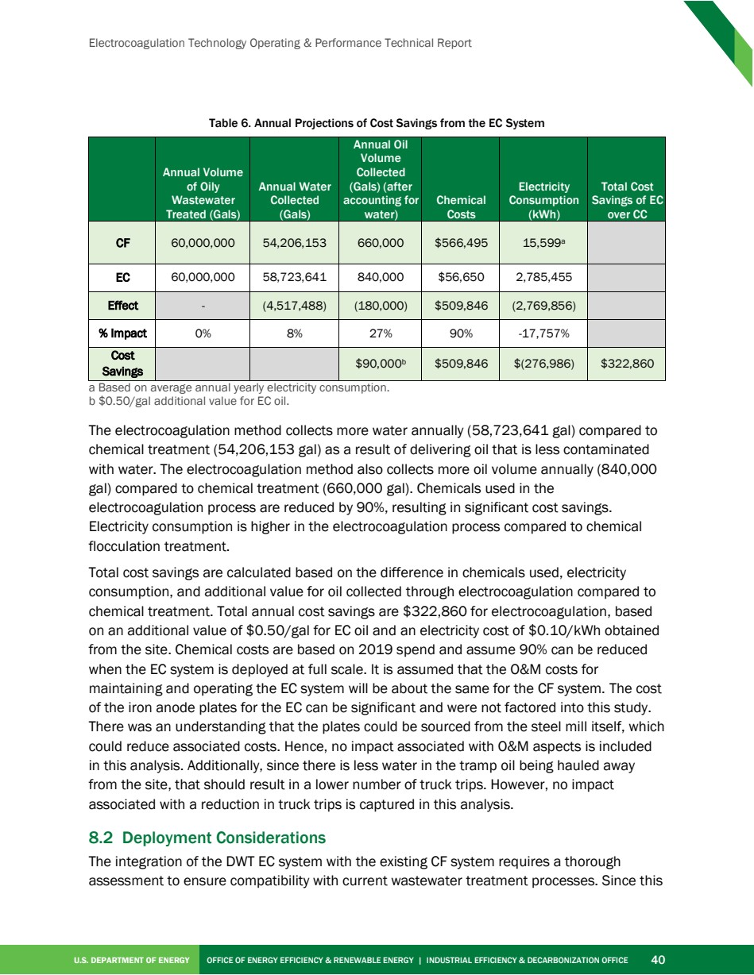

Source PDF page 55 | Cleveland-Cliffs Electrocoagulation
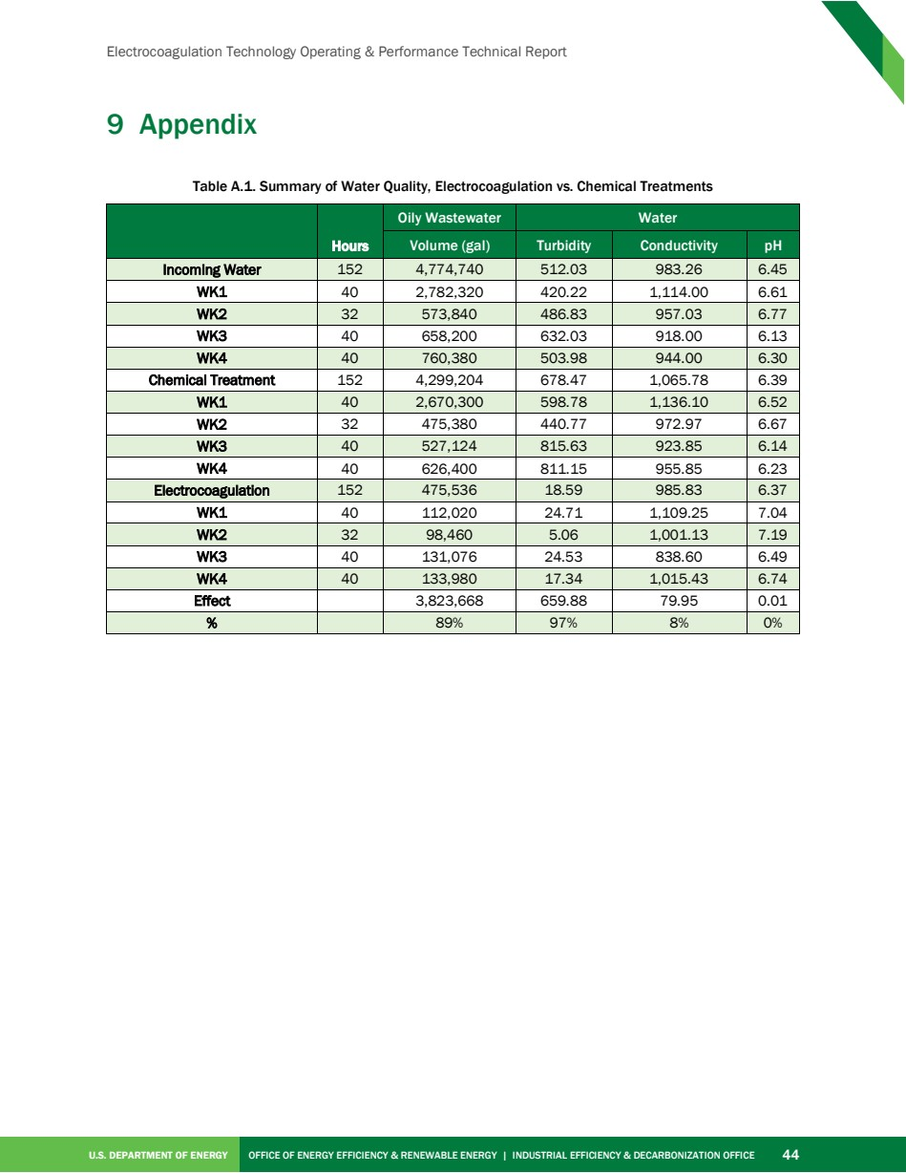

Source PDF page 56 | Cleveland-Cliffs Electrocoagulation
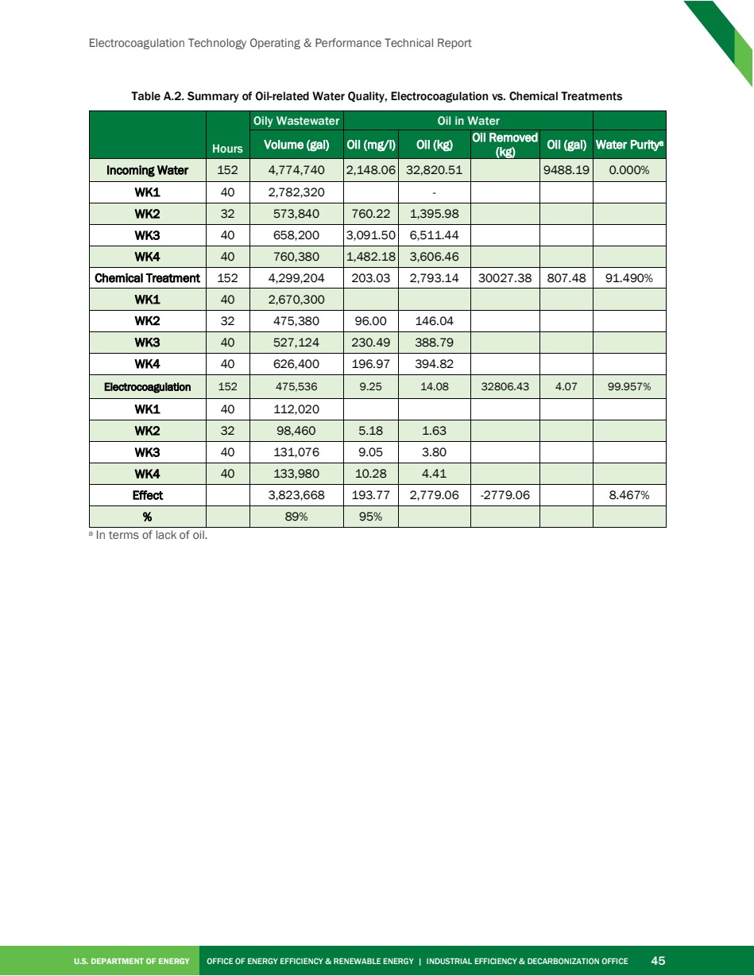

Source PDF page 57 | Cleveland-Cliffs Electrocoagulation
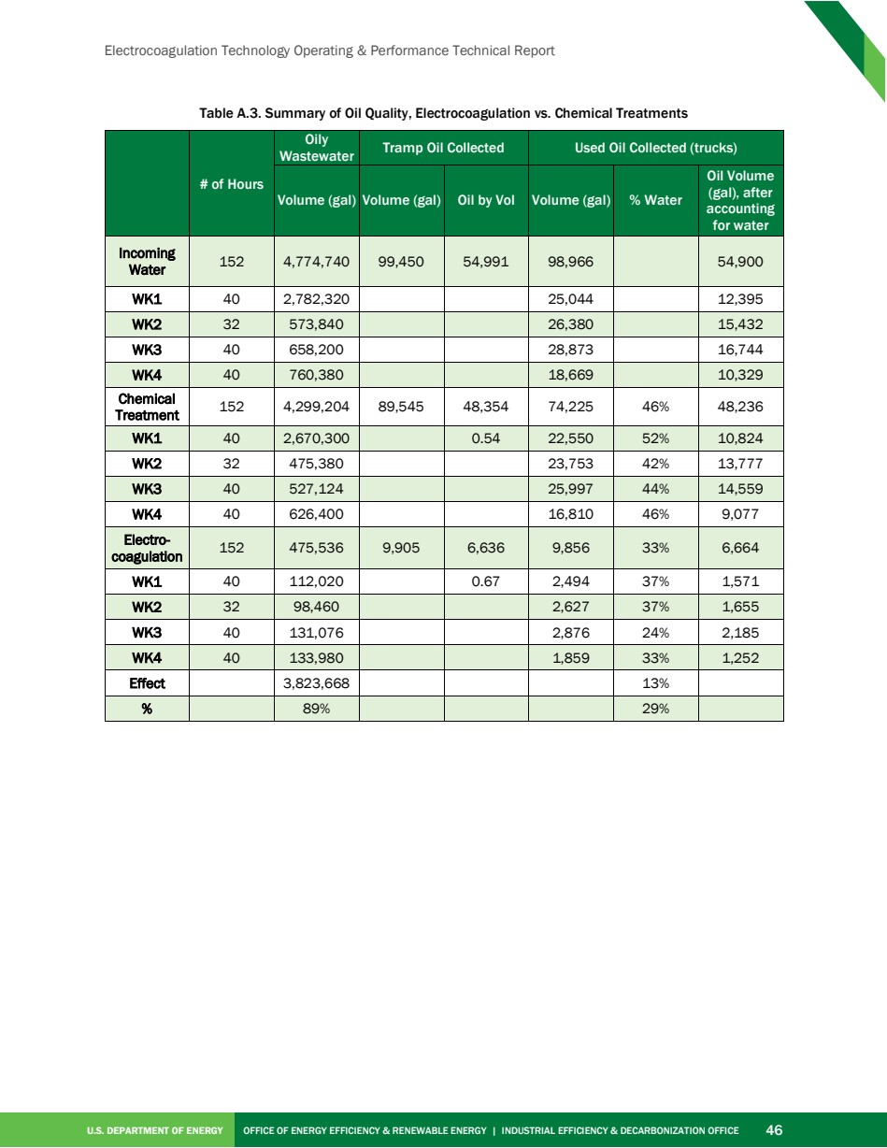

Source PDF page 58 | Cleveland-Cliffs Electrocoagulation


